Supplementary Information for
A full computational search of CO₂ electroreduction pathways using graph theory
Ziyun Wang¹, Yuguang C. Li¹, Jacob R. Boes², Ying Wang¹, Edward H. Sargent^{*,1}
¹Department of Electrical and Computer Engineering, University of Toronto, 10 King’s College Road, Toronto, ON, M5S 3G4, Canada.
²Stanford University, Department of Chemical Engineering, Stanford, California 94305, USA
^{(*)} Correspondence and requests for materials should be addressed to Edward H. Sargent (ted.sargent@utoronto.ca) (E.H.S)
Computational methods. All the DFT calculations were carried out using the ab initio simulation program (VASP)¹⁻⁴ with the Perdew-Burke-Ernzerhof (PBE)⁵ exchange-correlation functional. The projector-augmented wave (PAW) method^{6,7} was used to describe the electron-ion interactions, and the cut-off energy for the plane-wave basis set was 450 eV. In order to illustrate the long-range dispersion interactions between the adsorbates and catalysts, we employed the D3 correction method by Grimme et al.⁸. Brillouin zone integration was accomplished using a 3×3×1 Monkhorst-Pack k-point mesh. All the adsorption geometries were optimized using a force-based conjugate gradient algorithm. The crystal structure of copper was optimized, and the lattice parameter is 3.63 Å. For Cu(111) and Cu(100), the four-layer p(3×3) slab was used with the upper two layer relaxed and bottom two layer fixed. The initial structures of all the intermediate states were obtained using the Catkit package developed by Stanford University (https://github.com/SUNCAT-Center/CatKit).
To consider the entropy effect, we used the following entropy values from NIST⁹: 197.66 J/mol/K for CO, 192.8 J/mol/K for 1-propanol, 117.3 J/mol/K for acetaldehyde, 200.4 J/mol/K for acetone, 159.86 J/mol/K for ethanol, 219.32 J/mol/K for ethylene, 166.9 J/mol/K for ethylene glycol, 186.25 J/mol/K for methane, 127.2 J/mol/K for methanol, 212.9 J/mol/K for propionaldehyde, 229.6 J/mol/K for ethane, 269.91 J/mol/K for propane, 180.58 J/mol/K for 2-propanol, and 200.93 J/mol/K for acetylene. For the products not in NIST, we used the entropy values of similar products: 200.4 J/mol/K for allyl alcohol and hydroxyacetone from acetone, 166.9 J/mol/K for glycolaldehyde and glyoxal from ethylene glycol, 192.8 J/mol/K for 1,2-propylene glycol, 1,3-propylene glycol, and glycerol from 1-propanol.
Implementation of pH and applied potential. The computational hydrogen electrode (CHE) assumes at U=0 V vs. RHE, protons and electrons are at equilibrium with H₂ at 1 atm, 298 K, and all pH values:
$H^{+}+e^{-}→H_{2}(g)$ (S1)
At potential U_{RHE} ≠ 0 V vs. RHE,
$μ\left(H^{+}\right)+μ\left(e^{-}\right)=\frac{1}{2}μ\left(H_{2}\right)-eU_{RHE}$ (S2)
where $μ\left(H^{+}\right)$, $μ\left(e^{-}\right)$, and $μ\left(H_{2}\right)$ are the chemical potentials of proton, electron, and hydrogen, respectively. $U_{RHE}$ is the applied potential on the scale of reversible hydrogen electrode (RHE). With this equilibrium, the free energy change of a proton-electron transfer step, C_{x}H_{y}O_{z} to C_{x}H_{y+1}O_{z} can be calculated using:
$$ΔG=μ\left(C_{x}H_{y+1}O_{z}\right)-μ\left(C_{x}H_{y}O_{z}\right)-μ\left(H^{+}\right)+μ\left(e^{-}\right)$$
$=μ\left(C_{x}H_{y+1}O_{z}\right)-μ\left(C_{x}H_{y}O_{z}\right)-[\frac{1}{2}μ\left(H_{2}\right)-eU_{RHE}]$ (S3)
where $μ\left(C_{x}H_{y+1}O_{z}\right)$ and $μ\left(C_{x}H_{y}O_{z}\right)$ are the chemical potentials of C_{x}H_{y}O_{z} and C_{x}H_{y+1}O_{z}.The pH dependence can be released by converting the reference potential from RHE to SHE scales using Nernst equation:
$U_{RHE}=U_{SHE}+\frac{k_{B}T}{e}ln⁡[H^{+}]$ (S4)
where$U_{SHE}$ is the applied potential on the SHE scale, and$k_{B}$ and $T$ are the Boltzmann constant and temperature, respectively. $⁡[H^{+}]$ is the proton concentration. Therefore, the free energy change in Equation S3 can be written as:
$ΔG=μ\left(C_{x}H_{y+1}O_{z}\right)-μ\left(C_{x}H_{y}O_{z}\right)-[\frac{1}{2}μ\left(H_{2}\right)-eU_{SHE}-k_{B}Tln\left[H^{+}\right]]$ (S5)
With the approximation in this work, the forward reaction rate of the step, C_{x}H_{y}O_{z} to C_{x}H_{y+1}O_{z} are written as:
$r_{f}=k\exp{\frac{ΔG}{k_{B}T}=k\exp{\frac{μ\left(C_{x}H_{y+1}O_{z}\right)-μ\left(C_{x}H_{y}O_{z}\right)-[\frac{1}{2}μ\left(H_{2}\right)-eU_{SHE}-k_{B}Tln\left[H^{+}\right]]}{k_{B}T}=k[H^{+}]\exp{\frac{μ\left(C_{x}H_{y+1}O_{z}\right)-μ\left(C_{x}H_{y}O_{z}\right)-[\frac{1}{2}μ\left(H_{2}\right)-eU_{SHE}]}{k_{B}T}}}}$ (S6)
Therefore, the applied potential correction on the SHE scale is used.
Steady-state equation. The rate equation for step i, C_{x}H_{y}O_{z}* +H⁺ ↔ C_{x}H_{y+1}O_{z}*, can be written as:
$r_{i}=k_{i}θ_{C_{x}H_{y}O_{z}}\left[H^{+}\right]-k_{-i}θ_{C_{x}H_{y+1}O_{z}}$ (S7)
where, $r_{i}$ is the rate of step i which is equal to the rate of the forward reaction minus the rate of the reverse reaction. $θ_{C_{x}H_{y}O_{z}}$ and $θ_{C_{x}H_{y+1}O_{z}}$ are the surface coverage of C_{x}H_{y}O_{z}* and C_{x}H_{y+1}O_{z}*, respectively. k_{i} is the rate constant of the forward reaction, while k_{-i} is that of the reverse reaction. Both rate constants are derived from transition state theory (TST), which is given by:
$k=\frac{k_{B}T}{h}e^{-∆G^{≠,°}/k_{B}T}$ (S8)
where $∆G^{≠,°}$ is the change of standard molar Gibbs free energy barrier at 0 V vs. SHE. In this work, we used the reaction energies to describe the favourability of one step. For a reaction with a reaction energy $∆G^{°}$, the forward and reverse reaction barrier is $max⁡(∆G^{°},0)$ and $max⁡(-∆G^{°},0)$, respectively.
The steady-state approximation was used in our model, which assumes that the changes in all the coverages of surface species X are zero at the steady-state:
$\frac{dθ_{x}}{dt}=\sum{r_{x}}-\sum{r_{-x}}=0$ (S9)
where $r_{x}$ and $r_{-x}$ are the reactions with species X generating and consuming, respectively.
With all the coverages above, the coverage of free sites is obtained using:
$θ_{*}=1-\sum{θ_{X}}$ (S10)
In our kinetic modelling, the adsorption energies and activation energies were calculated at 1/9 ML, which corresponds to a reaction condition of low coverage regime.
Steady-state solver. For the steady-state solver, we used the stiff differential equation function, ode15s, to generate reasonable initial guess for the following fsolve function. For the ode15s, we used 10⁻⁵⁰ for the AbsTol and 100×ε for RealTol (ε is the epsilon of the machine, which is the minimum distance that MATLAB can recognize). The fsolve function solves a system of equations by minimizing the sum of squares of the components using the Trust-region algorithm. 1000 decimal were considered, and the convergence criteria were set to be 10⁻¹⁰⁰.
For example, for a reaction with 3 intermediates, the input of the ode15s is the initial coverage values of all the intermediates (0, 0, 0). The output is the surface coverage values at t = 100 s using the ode15s, ($θ_{1, ODE}$, $θ_{2, ODE}$, $θ_{3, ODE}$). Then, this surface coverage values, ($θ_{1, ODE}$, $θ_{2, ODE}$, $θ_{3, ODE}$), are passed to fsolve as input to solve the steady-state coverage.
For the concentration/partial pressure of reactants and products, the partial pressures of CO and products are 0.1 bar and 10⁻²⁰ bar, respectively, to describe the reaction condition at the beginning. The partial pressure of liquid water was determined using the ideal gas approximation at its vapour pressure at room temperature, 3534 Pa (3.49×10⁻² bar).
Directed graph. We used the directed graph to find all the simple paths from reactant node to product nodes using a modified depth-first search algorithm implemented in networkx package. With the directed graph, the numbers of possible simple pathways without repeating nodes were evaluated as listed in Table S1. After the evaluation of simple paths, the pre-set direction was removed, and the directions of reactions were determined from sign of the steady-state solver. The directed graph has no connections with the steady-state solver.
Graph-based enumeration of the intermediate structure. To generate all the possible structures for given chemical formula, a graph-based enumeration method implemented in the Catkit is used, which treats the atoms in one intermediate as nodes and the bonds as edges (more details can be found in ref. 10). We used the connectivity matrix of all the species to remove the intermediates using the rules, no O-O, C-O-C, O-C-O bonds. For the definition of unsaturated, we assumed the coordination numbers of carbon, oxygen, and hydrogen are 4, 2, and 1, respectively. The degree of unsaturation is calculated by subtracting the true coordination numbers from the pre-set coordination numbers. The site with highest degree of unsaturation is defined as most unsaturated. For saturated species, the gas-phase formation energies are used.
After optimization, the connectivity matrix of the intermediate is compared to that of the initial structure. The difference in the connectivity matrix suggests that the intermediate reconstructs or dissociates. If all the geometries of this intermediate reconstruct or dissociate, this intermediate will be treated as unstable and removed from the node list. The reactions with this unstable species will also be removed. The numbers of stable species and reactions are listed in Supplementary Table 2.
Thermodynamics vs. kinetics. We chose the energies of the intermediates to describe the kinetics due to the following reasons:
1. Considering both transition states and initial states accurately can give a better description on the reaction rate. However, there are still debates in the computational methods for the accurate transition state calculations. For example, with no solvent considered the barrier for CO dimerization in CO₂RR was calculated to be 0.98 eV on Cu(100), while 0.38 eV was found using a charged water model¹¹. For the same system, this barrier value was reported to be 0.69 eV using the biased ab initio molecular dynamics¹². Therefore, the huge differences in the transition state energies using different methods lead to difficulties in calculating the transition state accurately.
2. The purpose of this work is to obtain the most likely reaction pathways of all products instead of reporting the selectivity of different products. Among all the pathways to one product, the reaction types and intermediate states are similar. For example, there are ten pathways from CO to CH₄ (Figure 1b), in which the intermediate structures and the reaction types are similar. For the same groups of reaction with similar structures of reactants and products, the Bronsted-Evans-Polanyi (BEP) relation was found between reaction barriers and enthalpy changes^{13,14}. Therefore, a thermodynamically favorable pathway is likely to be also kinetically favorable for pathways with similar intermediates.
3. The intermediate energy is used in literature to explain the reaction rate in oxygen reduction reaction¹⁵ and oxygen evolution reaction¹⁶ by Nørskov and co-workers. Furthermore, the selectivity of CO₂RR was also investigated using the intermediate energy by Koper¹⁷ and Nørskov¹⁸. Without the consideration of transition states, these papers reported reasonable reaction mechanisms.
4. Calculating the transition states on large scales are extremely challenging using the current transition state location methods. The state-of-the-art nudged elastic band for transition state was estimated to take ~ 300 CPU hours (CPU-h), 15x slower than intermediate state calculation¹⁹. Furthermore, each transition state requires more attempts with different orientations and reaction sites. Assuming that four orientations, x+, y+, x-, and y-, on the surface in the xy direction are considered, the total resources for the transition state calculations are estimated to be 4 (orientations) × 7 (3 sites for Cu(100) and 4 sites for Cu(111)) × 4506 (reaction numbers) × 300 (CPU-h in literature) = 37,850,400 CPU-h. With the current computational resources. Therefore, calculating the transition state is currently not feasible based on the current computational resources.
Codes. We used Catkit (github.com/SUNCAT-Center/CatKit) for the graph-based enumeration, RDkit (www.rdkit.org) for drawing the species structures, networkx (networkx.github.io) and Gelphi (gephi.org) to draw the reaction graphs.
Enviroment effects. There are several methods to consider the environment effects, including (i) the ab initio molecular dynamics with biased sampling method¹², (ii) the grand canonical quantum mechanics (GCQM) method^{20,21}, and (iii) charged water model using global optimization method¹¹.
As comparision, we implemented the GCQM method, which considers the effect of potential, solvent, and ions all together. We used JDFTx²² to calculate the all the energies at the 0 V potential vs. SHE with the presence of 0.1 M K⁺ and 0.1 M F⁻ according to the settings in ref. 20. As shown in Figure S1, the energies from GCQM are similar to those from the polarizable continuum model (PCM). However, the energies from GCQM are more positive for both Cu(100) and Cu(111), and the mean absolute errors (MAE) are 0.18 eV and 0.17 eV on Cu(100) and Cu(111), respectively. The MAEs of the calculated enthalpy changes are much lower than those of the formation energies and the energy values distributed on both sides of the diagonal line, suggesting that the formation energy differences of these two methods are cancelled to some extends. Therefore, our PCM implementation gives similar reaction energy values compared to those using GCQM.
Reaction mechanisms. For the reaction mechanisms from CO to the products, the fastest pathway will be given if explains 100% of the product formation, otherwise the top two pathways are listed (Supplementary Table 2-37). The lists of these tables are:
Supplementary Table 3 | Reaction pathway(s) to ethylene at pH=7 and U=-0.5 V vs. SHE on Cu(100).
Supplementary Table 4 | Reaction pathway(s) to acetaldehyde at pH=7 and U=-0.5 V vs. SHE on Cu(100).
Supplementary Table 5 | Reaction pathway(s) to ethane at pH=7 and U=-0.5 V vs. SHE on Cu(100).
Supplementary Table 6 | Reaction pathway(s) to glycolaldehyde at pH=7 and U=-0.5 V vs. SHE on Cu(100).
Supplementary Table 7 | Reaction pathway(s) to ethanol at pH=7 and U=-0.5 V vs. SHE on Cu(100).
Supplementary Table 8 | Reaction pathway(s) to ethylene glycol at pH=7 and U=-0.5 V vs. SHE on Cu(100).
Supplementary Table 9 | Reaction pathway(s) to acetylene at pH=7 and U=-0.5 V vs. SHE on Cu(100).
Supplementary Table 10 | Reaction pathway(s) to glyoxal at pH=7 and U=-0.5 V vs. SHE on Cu(100).
Supplementary Table 11 | Reaction pathway(s) to ethylene at pH=7 and U=-0.5 V vs. SHE on Cu(111).
Supplementary Table 12 | Reaction pathway(s) to acetaldehyde at pH=7 and U=-0.5 V vs. SHE on Cu(111).
Supplementary Table 13 | Reaction pathway(s) to ethane at pH=7 and U=-0.5 V vs. SHE on Cu(111).
Supplementary Table 14 | Reaction pathway(s) to glycolaldehyde at pH=7 and U=-0.5 V vs. SHE on Cu(111).
Supplementary Table 15 | Reaction pathway(s) to ethanol at pH=7 and U=-0.5 V vs. SHE on Cu(111).
Supplementary Table 16 | Reaction pathway(s) to ethylene glycol at pH=7 and U=-0.5 V vs. SHE on Cu(111).
Supplementary Table 17 | Reaction pathway(s) to acetylene at pH=7 and U=-0.5 V vs. SHE on Cu(111).
Supplementary Table 18 | Reaction pathway(s) to glyoxal at pH=7 and U=-0.5 V vs. SHE on Cu(111).
Supplementary Table 19 | Reaction pathway(s) to 1-propanol at pH=7 and U=-0.5 V vs. SHE on Cu(100).
Supplementary Table 20 | Reaction pathway(s) to 1,3-propylene glycol at pH=7 and U=-0.5 V vs. SHE on Cu(100).
Supplementary Table 21 | Reaction pathway(s) to propionaldehyde at pH=7 and U=-0.5 V vs. SHE on Cu(100).
Supplementary Table 22 | Reaction pathway(s) to acetone at pH=7 and U=-0.5 V vs. SHE on Cu(100).
Supplementary Table 23 | Reaction pathway(s) to allyl alcohol at pH=7 and U=-0.5 V vs. SHE on Cu(100).
Supplementary Table 24 | Reaction pathway(s) to propane at pH=7 and U=-0.5 V vs. SHE on Cu(100).
Supplementary Table 25 | Reaction pathway(s) to 2-propanol at pH=7 and U=-0.5 V vs. SHE on Cu(100).
Supplementary Table 26 | Reaction pathway(s) to 1,2-propylene glycol at pH=7 and U=-0.5 V vs. SHE on Cu(100).
Supplementary Table 27 | Reaction pathway(s) to glycerol at pH=7 and U=-0.5 V vs. SHE on Cu(100).
Supplementary Table 28 | Reaction pathway(s) to hydroxyacetone at pH=7 and U=-0.5 V vs. SHE on Cu(100).
Supplementary Table 29 | Reaction pathway(s) to 1-propanol at pH=7 and U=-0.5 V vs. SHE on Cu(111).
Supplementary Table 30 | Reaction pathway(s) to 1,3-propylene glycol at pH=7 and U=-0.5 V vs. SHE on Cu(111).
Supplementary Table 31 | Reaction pathway(s) to propionaldehyde at pH=7 and U=-0.5 V vs. SHE on Cu(111).
Supplementary Table 32 | Reaction pathway(s) to acetone at pH=7 and U=-0.5 V vs. SHE on Cu(111).
Supplementary Table 33 | Reaction pathway(s) to allyl alcohol at pH=7 and U=-0.5 V vs. SHE on Cu(111).
Supplementary Table 34 | Reaction pathway(s) to propane at pH=7 and U=-0.5 V vs. SHE on Cu(111).
Supplementary Table 35 | Reaction pathway(s) to 2-propanol at pH=7 and U=-0.5 V vs. SHE on Cu(111).
Supplementary Table 36 | Reaction pathway(s) to 1,2-propylene glycol at pH=7 and U=-0.5 V vs. SHE on Cu(111).
Supplementary Table 37 | Reaction pathway(s) to glycerol at pH=7 and U=-0.5 V vs. SHE on Cu(111).
Supplementary Table 38 | Reaction pathway(s) to hydroxyacetone at pH=7 and U=-0.5 V vs. SHE on Cu(111).

References
1 Kresse, G. & Furthmüller, J. Efficient iterative schemes for ab initio total-energy calculations using a plane-wave basis set. Phys. Rev. B 54, 11169-11186 (1996).
2 Kresse, G. & Furthmuller, J. Efficiency of ab-initio total energy calculations for metals and semiconductors using a plane-wave basis set. Comp. Mater. Sci. 6, 15-50 (1996).
3 Kresse, G. & Hafner, J. Ab-Initio Molecular-Dynamics Simulation of the Liquid-Metal Amorphous-Semiconductor Transition in Germanium. Phys. Rev. B 49, 14251-14269 (1994).
4 Kresse, G. & Hafner, J. Ab initio molecular dynamics for liquid metals. Phys. Rev. B 47, 558-561 (1993).
5 Perdew, J. P., Burke, K. & Ernzerhof, M. Generalized Gradient Approximation Made Simple. Phys. Rev. Lett. 77, 3865-3868 (1996).
6 Kresse, G. & Joubert, D. From ultrasoft pseudopotentials to the projector augmented-wave method. Phys. Rev. B 59, 1758-1775 (1999).
7 Blöchl, P. E. Projector augmented-wave method. Phys. Rev. B 50, 17953-17979 (1994).
8 Grimme, S., Antony, J., Ehrlich, S. & Krieg, H. A consistent and accurate ab initio parametrization of density functional dispersion correction (DFT-D) for the 94 elements H-Pu. The Journal of Chemical Physics 132, 154104 (2010).
9 NIST Chemistry WebBook, NIST Standard Reference Database Number 69. (National Institute of Standards and Technology, 2005).
10 Boes, J. R., Mamun, O., Winther, K. & Bligaard, T. Graph Theory Approach to High-Throughput Surface Adsorption Structure Generation. J. Phys. Chem. A 123, 2281-2285 (2019).
11 Montoya, J. H., Shi, C., Chan, K. & Nørskov, J. K. Theoretical Insights into a CO Dimerization Mechanism in CO₂ Electroreduction. J. Phys. Chem. Lett. 6, 2032-2037 (2015).
12 Cheng, T., Xiao, H. & Goddard, W. A. Full atomistic reaction mechanism with kinetics for CO reduction on Cu(100) from ab initio molecular dynamics free-energy calculations at 298 K. Proc. Natl. Acad. Sci. U. S. A. 114, 1795-1800 (2017).
13 Logadottir, A. et al. The Bronsted-Evans-Polanyi relation and the volcano plot for ammonia synthesis over transition metal catalysts. J. Catal. 197, 229-231 (2001).
14 Cheng, J. et al. Bronsted-Evans-Polanyi relation of multistep reactions and volcano curve in heterogeneous catalysis. J. Phys. Chem. C 112, 1308-1311 (2008).
15 Norskov, J. K. et al. Origin of the overpotential for oxygen reduction at a fuel-cell cathode. J. Phys. Chem. B 108, 17886-17892 (2004).
16 Rossmeisl, J., Qu, Z. W., Zhu, H., Kroes, G. J. & Nørskov, J. K. Electrolysis of water on oxide surfaces. J. Electroanal. Chem. 607, 83-89 (2007).
17 Calle-Vallejo, F. & Koper, M. T. M. Theoretical Considerations on the Electroreduction of CO to C₂ Species on Cu(100) Electrodes. Angew. Chem. Int. Ed. 52, 7282-7285 (2013).
18 Peterson, A. A., Abild-Pedersen, F., Studt, F., Rossmeisl, J. & Norskov, J. K. How copper catalyzes the electroreduction of carbon dioxide into hydrocarbon fuels. Energ. Environ. Sci. 3, 1311-1315 (2010).
19 Ulissi, Z. W., Medford, A. J., Bligaard, T. & Nørskov, J. K. To address surface reaction network complexity using scaling relations machine learning and DFT calculations. Nat. Commun. 8, 14621 (2017).
20 Xiao, H., Cheng, T. & Goddard, W. A. Atomistic Mechanisms Underlying Selectivities in C₁ and C₂ Products from Electrochemical Reduction of CO on Cu(111). J. Am. Chem. Soc. 139, 130-136 (2017).
21 Goodpaster, J. D., Bell, A. T. & Head-Gordon, M. Identification of Possible Pathways for C–C Bond Formation during Electrochemical Reduction of CO₂: New Theoretical Insights from an Improved Electrochemical Model. J. Phys. Chem. Lett. 7, 1471-1477 (2016).
22 Sundararaman, R. et al. JDFTx: Software for joint density-functional theory. SoftwareX 6, 278-284 (2017).

Supplementary figure and tables.
Supplementary Figure 1 | Comparisons between the formation energies on (a) Cu(100) and (c) Cu(111), and the enthalpy changes of all reactions on (b) Cu(100) and (d) Cu(111) with the mean absolute errors (MAE) using polarizable continuum model (PCM) and those using the grand canonical quantum mechanics (GCQM).

Supplementary Figure 2 | Pipelines of catalyst screening for C₃ products. Host metal atoms are shown in blue, while the dopant metal atoms are shown in yellow.

Supplementary Table 1 | Index, chemical formula, number of electron transfer per carbon atom (#e/#C), number of carbon (#C), product name, number of elementary steps from CO (#step), and numbers of possible reaction pathways using simple path algorithm (#path) of products up to C₃. The index is corresponding to the index of full species list in Supplementary Sheet 1.
Index | formula | #e/#C | #C | name | #step | #path
16 | CH₄O | 4 | 1 | methanol | 4 | 4
24 | C₂H₂O₂ | 1 | 2 | glyoxal | 3 | 4
18 | CH₄ | 6 | 1 | methane | 6 | 10
43 | C₂H₄O₂ | 2 | 2 | glycolaldehyde | 5 | 57
58 | C₂H₄O | 3 | 2 | acetaldehyde | 7 | 233
57 | C₂H₂ | 3 | 2 | acetylene | 7 | 355
63 | C₂H₆O₂ | 3 | 2 | ethylene glycol | 7 | 355
71 | C₂H₆O | 4 | 2 | ethanol | 9 | 4351
70 | C₂H₄ | 4 | 2 | ethylene | 9 | 4744
73 | C₂H₆ | 5 | 2 | ethane | 11 | 13472
366 | C₃H₆O₂ | 2.7 | 3 | hydroxyacetone | 10 | 16965
425 | C₃H₆O | 3.3 | 3 | acetone | 12 | 52066
381 | C₃H₈O₃ | 2.7 | 3 | glycerol | 10 | 75602
422 | C₃H₆O | 3.3 | 3 | propionaldehyde | 12 | 703758
437 | C₃H₈O₂ | 3.3 | 3 | 1,3-propylene glycol | 12 | 1022501
436 | C₃H₈O₂ | 3.3 | 3 | 1,2-propylene glycol | 12 | 1526256
434 | C₃H₆O | 3.3 | 3 | allyl alcohol | 12 | 3448671
455 | C₃H₈O | 4 | 3 | 2-propanol | 14 | 6864268
454 | C₃H₈O | 4 | 3 | 1-propanol | 14 | 27675948
458 | C₃H₈ | 4.7 | 3 | propane | 16 | 166094999

Supplementary Table 2 | Numbers of species, all reactions, hydrogenation, dehydroxylation, coupling, and adsorption reactions in different systems.
 | Cu(100)-C₂ | Cu(111)-C₂ | Cu(100)-C₃ | Cu(111)-C₃
# species | 69 | 67 | 366 | 353
# reactions | 197 | 188 | 1616 | 1523
# hydrogenation | 105 | 98 | 779 | 732
# dehydroxylation | 33 | 33 | 236 | 225
# coupling | 53 | 51 | 591 | 556
# adsorption | 6 | 6 | 10 | 10

Supplementary Table 3 | Intermediate index (IM index) and intermediate structure of each step intermediate in the two fastest reaction pathways to ethylene at pH=7 and U=-0.5 V vs. SHE on Cu(100). The index is corresponding to the index of full species list in Supplementary Sheet 1.
 | fastest pathway |  | second fastest pathway
step | IM index | structure | IM index | structure
1 | IM(20) | 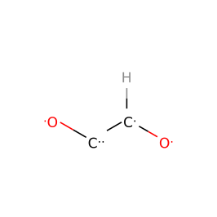 | IM(20)
2 | IM(24) | 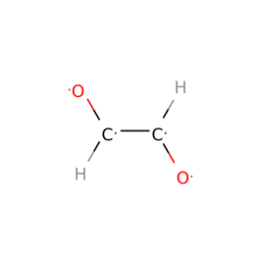 | IM(24)
3 | IM(34) | 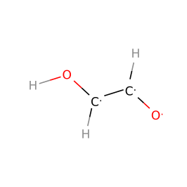 | IM(34)
4 | IM(39) | 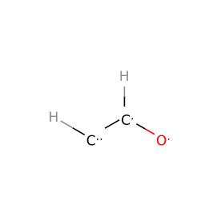 | IM(39)
5 | IM(53) | 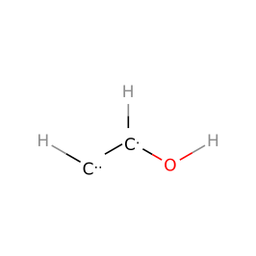 | IM(53)
6 | IM(62) | 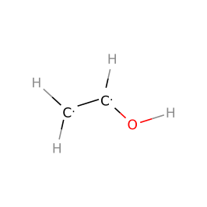 | IM(57) | 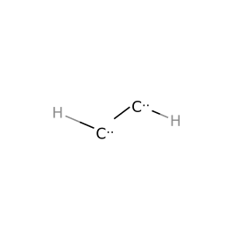
7 | IM(68) | 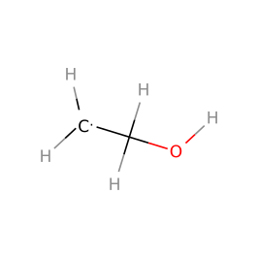 | IM(65) | 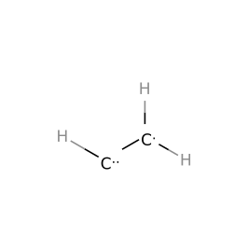
8 | IM(70) | 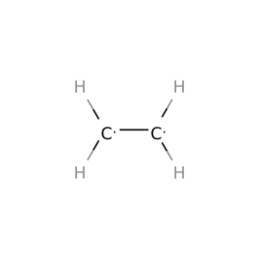 | IM(70)

Supplementary Table 4 | Intermediate index (IM index) and intermediate structure of each step intermediate in the two fastest reaction pathways to acetaldehyde at pH=7 and U=-0.5 V vs. SHE on Cu(100).
 | fastest pathway |  | second fastest pathway
step | IM index | structure | IM index | structure
1 | IM(20) |  | IM(20)
2 | IM(24) |  | IM(25) | 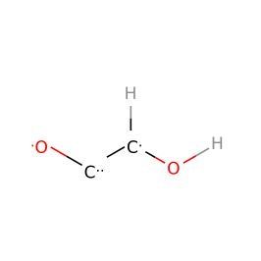
3 | IM(34) |  | IM(29) | 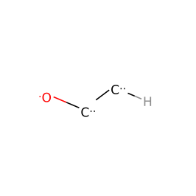
4 | IM(39) |  | IM(38) | 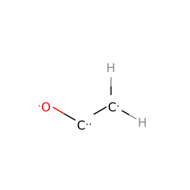
5 | IM(50) | 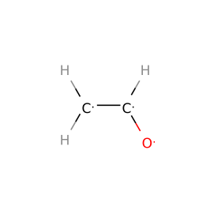 | IM(50)
6 | IM(58) | 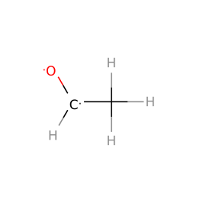 | IM(58)

Supplementary Table 5 | Intermediate index (IM index) and intermediate structure of each step intermediate in the two fastest reaction pathways to ethane at pH=7 and U=-0.5 V vs. SHE on Cu(100).
 | fastest pathway |  | second fastest pathway
step | IM index | structure | IM index | structure
1 | IM(20) |  | IM(20)
2 | IM(24) |  | IM(24)
3 | IM(34) |  | IM(34)
4 | IM(39) |  | IM(39)
5 | IM(53) |  | IM(53)
6 | IM(62) |  | IM(62)
7 | IM(67) | 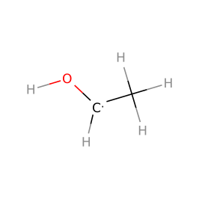 | IM(67)
8 | IM(69) | 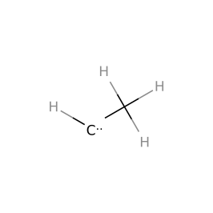 | IM(71) | 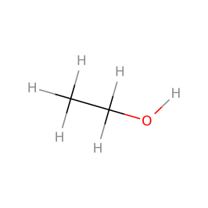
9 | IM(72) | 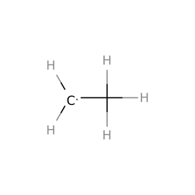 | IM(72)
10 | IM(73) | 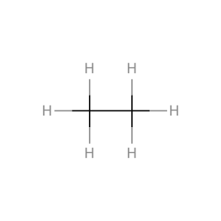 | IM(73)

Supplementary Table 6 | Intermediate index (IM index) and intermediate structure of each step intermediate in the two fastest reaction pathways to glycolaldehyde at pH=7 and U=-0.5 V vs. SHE on Cu(100).
 | fastest pathway |  | second fastest pathway
step | IM index | structure | IM index | structure
1 | IM(20) |  | IM(20)
2 | IM(24) |  | IM(25)
3 | IM(34) |  | IM(32) | 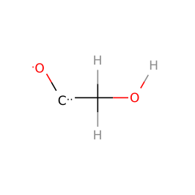
4 | IM(43) | 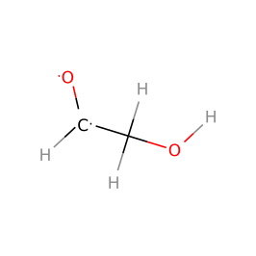 | IM(43)
Supplementary Table 7 | Intermediate index (IM index) and intermediate structure of each step intermediate in the two fastest reaction pathways to ethanol at pH=7 and U=-0.5 V vs. SHE on Cu(100).
 | fastest pathway |  | second fastest pathway
step | IM index | structure | IM index | structure
1 | IM(20) |  | IM(20)
2 | IM(24) |  | IM(24)
3 | IM(34) |  | IM(34)
4 | IM(39) |  | IM(39)
5 | IM(53) |  | IM(53)
6 | IM(62) |  | IM(62)
7 | IM(67) |  | IM(68)
8 | IM(71) |  | IM(71)

Supplementary Table 8 | Intermediate index (IM index) and intermediate structure of each step intermediate in the two fastest reaction pathways to ethylene glycol at pH=7 and U=-0.5 V vs. SHE on Cu(100).
 | fastest pathway |  | second fastest pathway
step | IM index | structure | IM index | structure
1 | IM(20) |  | IM(20)
2 | IM(24) |  | IM(24)
3 | IM(34) |  | IM(34)
4 | IM(46) | 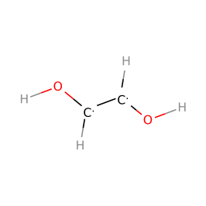 | IM(43)
5 | IM(55) | 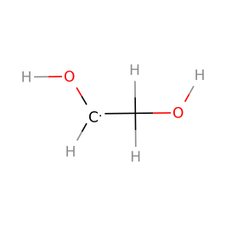 | IM(54) | 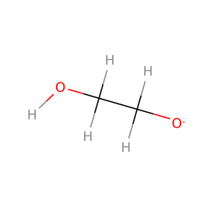
6 | IM(63) | 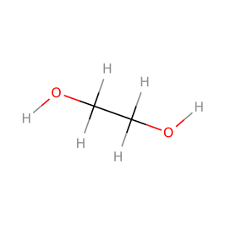 | IM(63)

Supplementary Table 9 | Intermediate index (IM index) and intermediate structure of each step intermediate in the fastest reaction pathway to acetylene at pH=7 and U=-0.5 V vs. SHE on Cu(100).
 | fastest pathway
step | IM index | structure
1 | IM(20)
2 | IM(24)
3 | IM(34)
4 | IM(39)
5 | IM(53)
6 | IM(57)

Supplementary Table 10 | Intermediate index (IM index) and intermediate structure of each step intermediate in the fastest reaction pathway to glyoxal at pH=7 and U=-0.5 V vs. SHE on Cu(100).
 | fastest pathway
step | IM index | structure
1 | IM(20)
2 | IM(24)

Supplementary Table 11 | Intermediate index (IM index) and intermediate structure of each step intermediate in the two fastest reaction pathways to ethylene at pH=7 and U=-0.5 V vs. SHE on Cu(111).
 | fastest pathway |  | second fastest pathway
step | IM index | structure | IM index | structure
1 | IM(20) |  | IM(20)
2 | IM(25) |  | IM(26) | 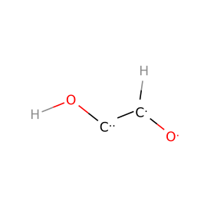
3 | IM(29) |  | IM(34)
4 | IM(41) | 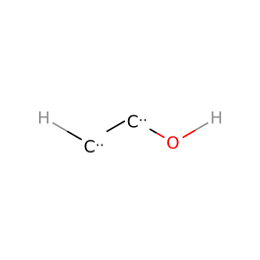 | IM(46)
5 | IM(53) |  | IM(53)
6 | IM(57) |  | IM(57)
7 | IM(65) |  | IM(65)
8 | IM(70) |  | IM(70)

Supplementary Table 12 | Intermediate index (IM index) and intermediate structure of each step intermediate in the two fastest reaction pathways to acetaldehyde at pH=7 and U=-0.5 V vs. SHE on Cu(111).
 | fastest pathway |  | second fastest pathway
step | IM index | structure | IM index | structure
1 | IM(20) |  | IM(20)
2 | IM(25) |  | IM(26)
3 | IM(32) |  | IM(34)
4 | IM(38) |  | IM(39)
5 | IM(48) | 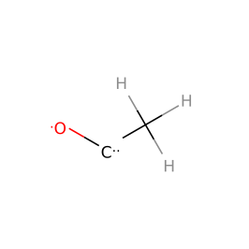 | IM(50)
6 | IM(58) |  | IM(58)

Supplementary Table 13 | Intermediate index (IM index) and intermediate structure of each step intermediate in the two fastest reaction pathways to ethane at pH=7 and U=-0.5 V vs. SHE on Cu(111).
 | fastest pathway |  | second fastest pathway
step | IM index | structure | IM index | structure
1 | IM(20) |  | IM(20)
2 | IM(25) |  | IM(26)
3 | IM(29) |  | IM(34)
4 | IM(41) |  | IM(46)
5 | IM(53) |  | IM(53)
6 | IM(57) |  | IM(57)
7 | IM(65) |  | IM(65)
8 | IM(69) |  | IM(69)
9 | IM(72) |  | IM(72)
10 | IM(73) |  | IM(73)

Supplementary Table 14 | Intermediate index (IM index) and intermediate structure of each step intermediate in the two fastest reaction pathways to glycolaldehyde at pH=7 and U=-0.5 V vs. SHE on Cu(111).
 | fastest pathway |  | second fastest pathway
step | IM index | structure | IM index | structure
1 | IM(20) |  | IM(20)
2 | IM(26) |  | IM(25)
3 | IM(34) |  | IM(32)
4 | IM(43) |  | IM(43)
Supplementary Table 15 | Intermediate index (IM index) and intermediate structure of each step intermediate in the two fastest reaction pathways to ethanol at pH=7 and U=-0.5 V vs. SHE on Cu(111).
 | fastest pathway |  | second fastest pathway
step | IM index | structure | IM index | structure
1 | IM(20) |  | IM(20)
2 | IM(24) |  | IM(24)
3 | IM(34) |  | IM(34)
4 | IM(46) |  | IM(46)
5 | IM(53) |  | IM(53)
6 | IM(62) |  | IM(62)
7 | IM(68) |  | IM(67)
8 | IM(71) |  | IM(71)

Supplementary Table 16 | Intermediate index (IM index) and intermediate structure of each step intermediate in the two fastest reaction pathways to ethylene glycol at pH=7 and U=-0.5 V vs. SHE on Cu(111).
 | fastest pathway |  | second fastest pathway
step | IM index | structure | IM index | structure
1 | IM(20) |  | IM(20)
2 | IM(24) |  | IM(24)
3 | IM(34) |  | IM(34)
4 | IM(46) |  | IM(43)
5 | IM(55) |  | IM(54)
6 | IM(63) |  | IM(63)

Supplementary Table 17 | Intermediate index (IM index) and intermediate structure of each step intermediate in the fastest reaction pathway to acetylene at pH=7 and U=-0.5 V vs. SHE on Cu(111).
 | fastest pathway
step | IM index | structure
1 | IM(20)
2 | IM(24)
3 | IM(34)
4 | IM(39)
5 | IM(53)
6 | IM(57)

Supplementary Table 18 | Intermediate index (IM index) and intermediate structure of each step intermediate in the fastest reaction pathway to glyoxal at pH=7 and U=-0.5 V vs. SHE on Cu(111).
 | fastest pathway
step | IM index | structure
1 | IM(20)
2 | IM(24)

Supplementary Table 19 | Intermediate index (IM index) and intermediate structure of each step intermediate in the two fastest reaction pathways to 1- at pH=7 and U=-0.5 V vs. SHE on Cu(100).
 | fastest pathway |  | second fastest pathway
step | IM index | structure | IM index | structure
1 | IM(76) | 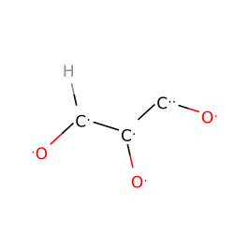 | IM(76)
2 | IM(83) | 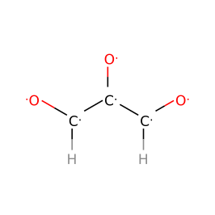 | IM(83)
3 | IM(108) | 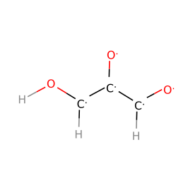 | IM(108)
4 | IM(154) | 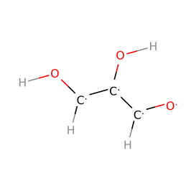 | IM(154)
5 | IM(190) | 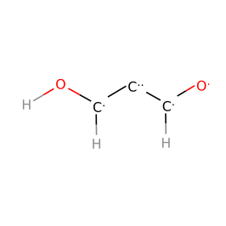 | IM(190)
6 | IM(247) | 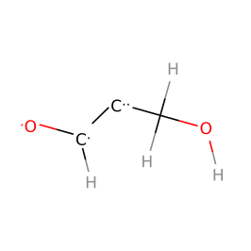 | IM(255) | 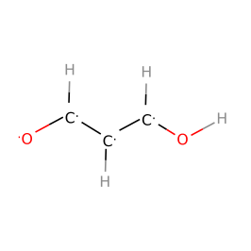
7 | IM(312) | 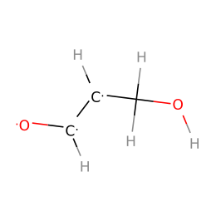 | IM(328) | 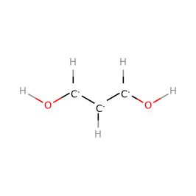
8 | IM(347) | 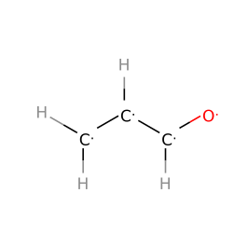 | IM(360) | 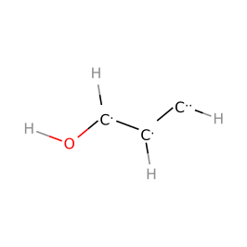
9 | IM(406) | 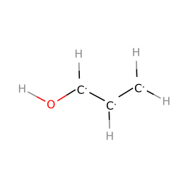 | IM(403) | 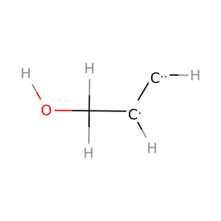
10 | IM(429) | 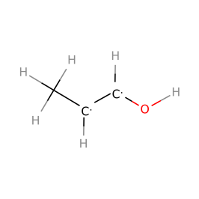 | IM(432) | 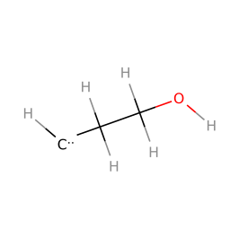
11 | IM(445) | 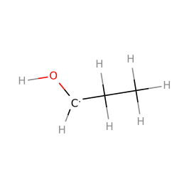 | IM(449) | 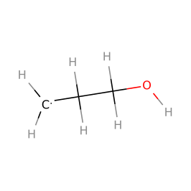
12 | IM(454) | 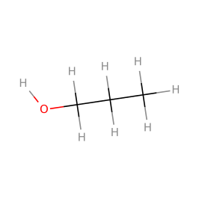 | IM(454)

Supplementary Table 20 | Intermediate index (IM index) and intermediate structure of each step intermediate in the two fastest reaction pathways to 13-propylene glycol at pH=7 and U=-0.5 V vs. SHE on Cu(100).
 | fastest pathway |  | second fastest pathway
step | IM index | structure | IM index | structure
1 | IM(76) |  | IM(76)
2 | IM(83) |  | IM(83)
3 | IM(108) |  | IM(108)
4 | IM(154) |  | IM(154)
5 | IM(190) |  | IM(190)
6 | IM(255) |  | IM(247)
7 | IM(328) |  | IM(312)
8 | IM(377) | 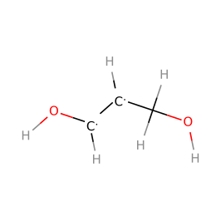 | IM(367) | 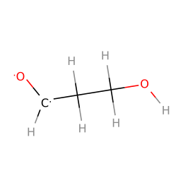
9 | IM(415) | 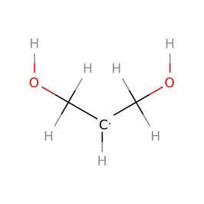 | IM(410) | 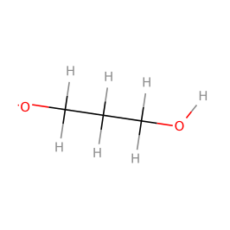
10 | IM(437) | 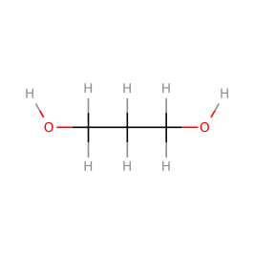 | IM(437)

Supplementary Table 21 | Intermediate index (IM index) and intermediate structure of each step intermediate in the two fastest reaction pathways to propionaldehyde at pH=7 and U=-0.5 V vs. SHE on Cu(100).
 | fastest pathway |  | second fastest pathway
step | IM index | structure | IM index | structure
1 | IM(76) |  | IM(76)
2 | IM(83) |  | IM(83)
3 | IM(109) | 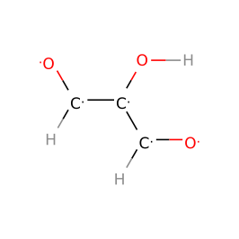 | IM(109)
4 | IM(126) | 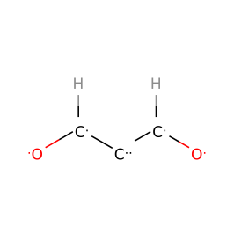 | IM(126)
5 | IM(174) | 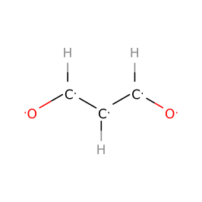 | IM(190)
6 | IM(255) |  | IM(255)
7 | IM(312) |  | IM(312)
8 | IM(347) |  | IM(347)
9 | IM(389) | 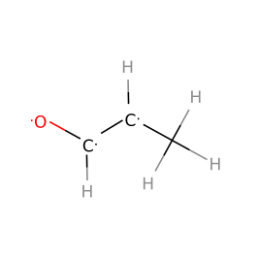 | IM(389)
10 | IM(422) | 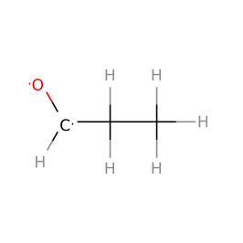 | IM(422)

Supplementary Table 22 | Intermediate index (IM index) and intermediate structure of each step intermediate in the two fastest reaction pathways to acetone at pH=7 and U=-0.5 V vs. SHE on Cu(100).
 | fastest pathway |  | second fastest pathway
step | IM index | structure | IM index | structure
1 | IM(76) |  | IM(76)
2 | IM(83) |  | IM(83)
3 | IM(108) |  | IM(108)
4 | IM(155) | 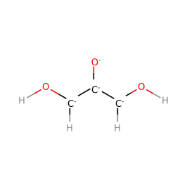 | IM(155)
5 | IM(206) | 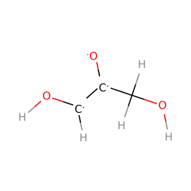 | IM(206)
6 | IM(252) | 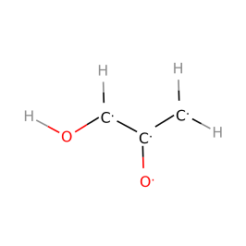 | IM(245) | 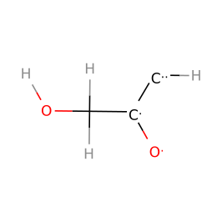
7 | IM(314) | 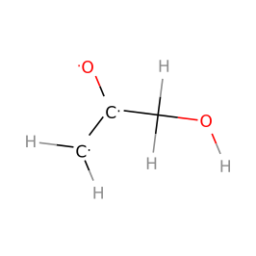 | IM(314)
8 | IM(348) | 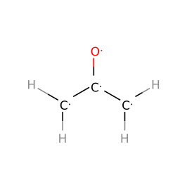 | IM(348)
9 | IM(390) | 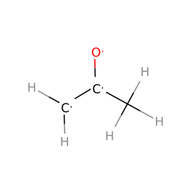 | IM(390)
10 | IM(425) | 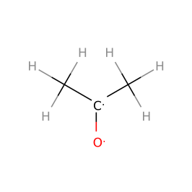 | IM(425)

Supplementary Table 23 | Intermediate index (IM index) and intermediate structure of each step intermediate in the two fastest reaction pathways to allyl alcohol at pH=7 and U=-0.5 V vs. SHE on Cu(100).
 | fastest pathway |  | second fastest pathway
step | IM index | structure | IM index | structure
1 | IM(76) |  | IM(76)
2 | IM(83) |  | IM(83)
3 | IM(109) |  | IM(108)
4 | IM(126) |  | IM(155)
5 | IM(174) |  | IM(206)
6 | IM(255) |  | IM(273) | 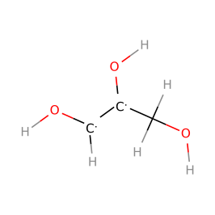
7 | IM(312) |  | IM(331) | 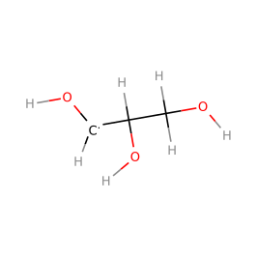
8 | IM(347) |  | IM(377)
9 | IM(406) |  | IM(406)
10 | IM(434) | 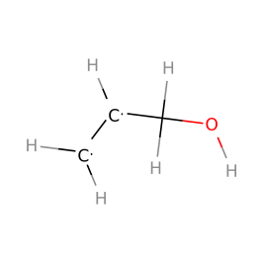 | IM(434)

Supplementary Table 24 | Intermediate index (IM index) and intermediate structure of each step intermediate in the two fastest reaction pathways to propane at pH=7 and U=-0.5 V vs. SHE on Cu(100).
 | fastest pathway |  | second fastest pathway
step | IM index | structure | IM index | structure
1 | IM(76) |  | IM(76)
2 | IM(83) |  | IM(83)
3 | IM(109) |  | IM(108)
4 | IM(126) |  | IM(155)
5 | IM(174) |  | IM(206)
6 | IM(255) |  | IM(252)
7 | IM(312) |  | IM(314)
8 | IM(347) |  | IM(348)
9 | IM(406) |  | IM(390)
10 | IM(429) |  | IM(430) | 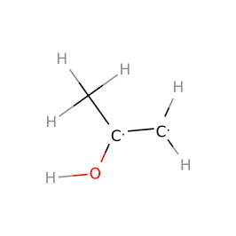
11 | IM(439) | 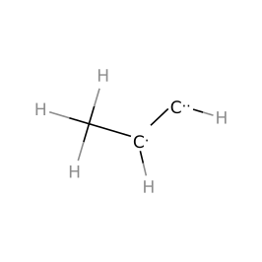 | IM(446) | 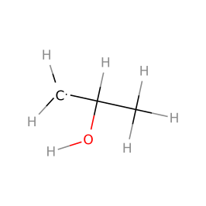
12 | IM(451) | 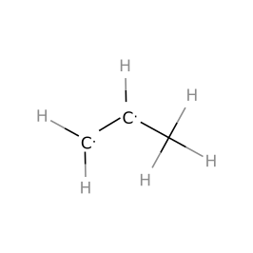 | IM(451)
13 | IM(456) | 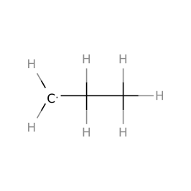 | IM(456)
14 | IM(458) | 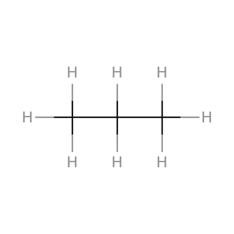 | IM(458)

Supplementary Table 25 | Intermediate index (IM index) and intermediate structure of each step intermediate in the two fastest reaction pathways to 2-propanol at pH=7 and U=-0.5 V vs. SHE on Cu(100).
 | fastest pathway |  | second fastest pathway
step | IM index | structure | IM index | structure
1 | IM(76) |  | IM(76)
2 | IM(83) |  | IM(86) | 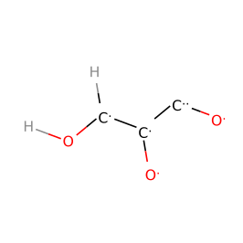
3 | IM(108) |  | IM(102) | 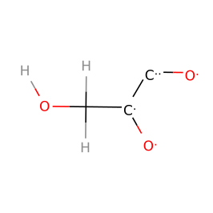
4 | IM(155) |  | IM(140) | 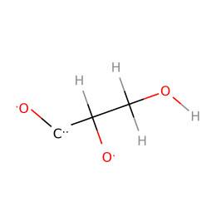
5 | IM(206) |  | IM(202) | 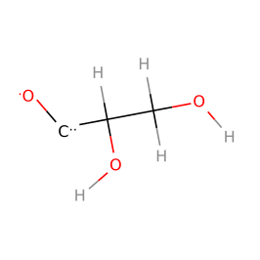
6 | IM(252) |  | IM(267) | 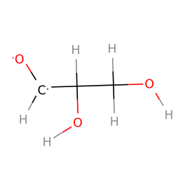
7 | IM(314) |  | IM(329) | 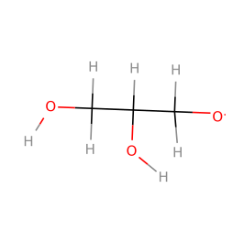
8 | IM(348) |  | IM(381) | 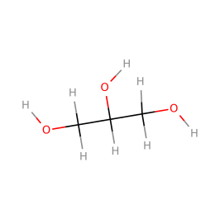
9 | IM(390) |  | IM(414) | 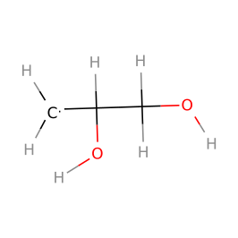
10 | IM(430) |  | IM(436) | 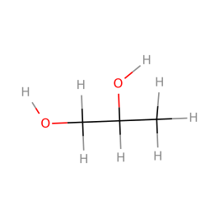
11 | IM(446) |  | IM(446)
12 | IM(455) | 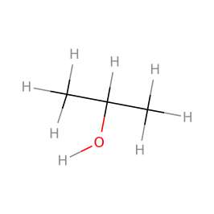 | IM(455)

Supplementary Table 26 | Intermediate index (IM index) and intermediate structure of each step intermediate in the two fastest reaction pathways to 12-propylene glycol at pH=7 and U=-0.5 V vs. SHE on Cu(100).
 | fastest pathway |  | second fastest pathway
step | IM index | structure | IM index | structure
1 | IM(76) |  | IM(76)
2 | IM(83) |  | IM(83)
3 | IM(108) |  | IM(108)
4 | IM(155) |  | IM(125) | 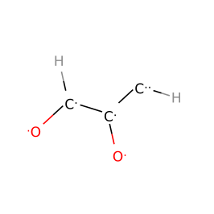
5 | IM(206) |  | IM(172) | 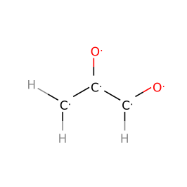
6 | IM(252) |  | IM(229) | 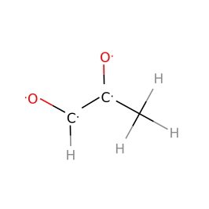
7 | IM(306) | 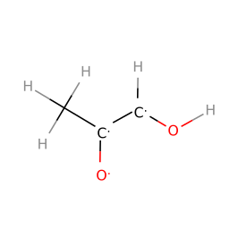 | IM(298) | 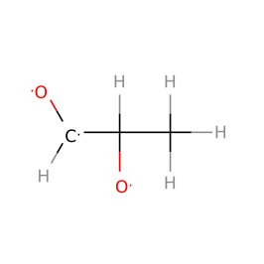
8 | IM(373) | 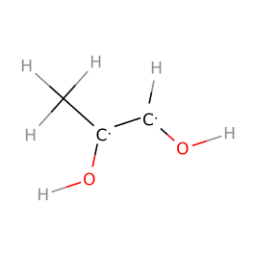 | IM(363) | 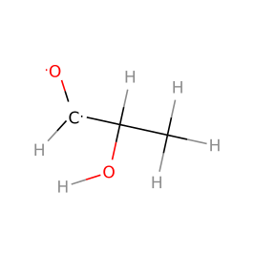
9 | IM(411) | 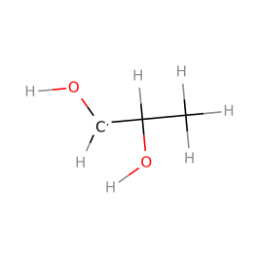 | IM(408) | 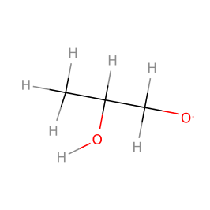
10 | IM(436) |  | IM(436)

Supplementary Table 27 | Intermediate index (IM index) and intermediate structure of each step intermediate in the two fastest reaction pathways to glycerol at pH=7 and U=-0.5 V vs. SHE on Cu(100).
 | fastest pathway |  | second fastest pathway
step | IM index | structure | IM index | structure
1 | IM(76) |  | IM(76)
2 | IM(83) |  | IM(83)
3 | IM(108) |  | IM(108)
4 | IM(155) |  | IM(155)
5 | IM(206) |  | IM(206)
6 | IM(271) | 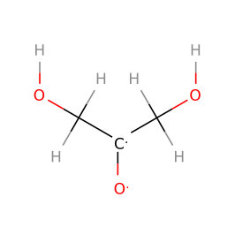 | IM(271)
7 | IM(332) | 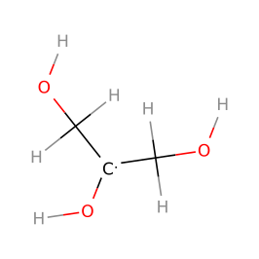 | IM(330) | 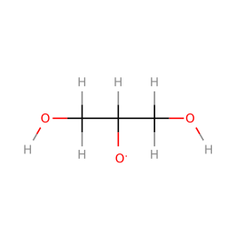
8 | IM(381) |  | IM(381)

Supplementary Table 28 | Intermediate index (IM index) and intermediate structure of each step intermediate in the two fastest reaction pathways to hydroxyacetone at pH=7 and U=-0.5 V vs. SHE on Cu(100).
 | fastest pathway |  | second fastest pathway
step | IM index | structure | IM index | structure
1 | IM(76) |  | IM(76)
2 | IM(83) |  | IM(83)
3 | IM(108) |  | IM(108)
4 | IM(155) |  | IM(155)
5 | IM(206) |  | IM(206)
6 | IM(252) |  | IM(245)
7 | IM(314) |  | IM(314)
8 | IM(366) | 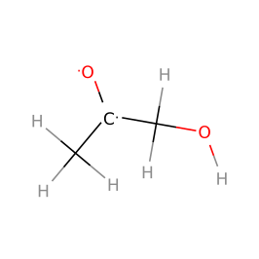 | IM(366)

Supplementary Table 29 | Intermediate index (IM index) and intermediate structure of each step intermediate in the two fastest reaction pathways to 1-propanol at pH=7 and U=-0.5 V vs. SHE on Cu(111).
 | fastest pathway |  | second fastest pathway
step | IM index | structure | IM index | structure
1 | IM(76) |  | IM(76)
2 | IM(83) |  | IM(83)
3 | IM(108) |  | IM(108)
4 | IM(154) |  | IM(125)
5 | IM(190) |  | IM(189) | 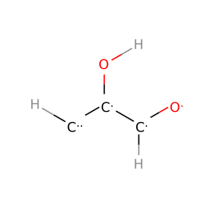
6 | IM(247) |  | IM(251) | 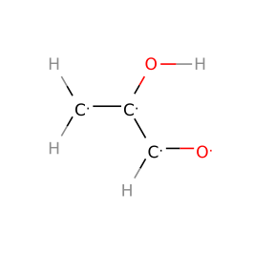
7 | IM(312) |  | IM(305) | 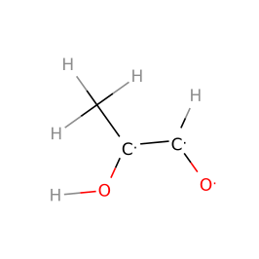
8 | IM(377) |  | IM(373)
9 | IM(403) |  | IM(399) | 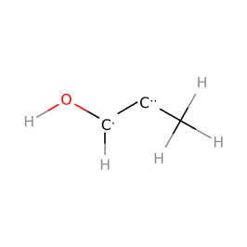
10 | IM(432) |  | IM(429)
11 | IM(449) |  | IM(445)
12 | IM(454) |  | IM(454)

Supplementary Table 30 | Intermediate index (IM index) and intermediate structure of each step intermediate in the two fastest reaction pathways to 1,3-propylene glycol at pH=7 and U=-0.5 V vs. SHE on Cu(111).
 | fastest pathway |  | second fastest pathway
step | IM index | structure | IM index | structure
1 | IM(76) |  | IM(76)
2 | IM(83) |  | IM(83)
3 | IM(109) |  | IM(109)
4 | IM(154) |  | IM(126)
5 | IM(190) |  | IM(174)
6 | IM(255) |  | IM(255)
7 | IM(312) |  | IM(312)
8 | IM(367) |  | IM(367)
9 | IM(410) |  | IM(410)
10 | IM(437) |  | IM(437)

Supplementary Table 31 | Intermediate index (IM index) and intermediate structure of each step intermediate in the two fastest reaction pathways to propionaldehyde at pH=7 and U=-0.5 V vs. SHE on Cu(111).
 | fastest pathway |  | second fastest pathway
step | IM index | structure | IM index | structure
1 | IM(76) |  | IM(76)
2 | IM(83) |  | IM(86)
3 | IM(109) |  | IM(112) | 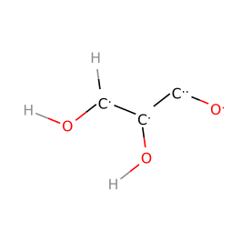
4 | IM(154) |  | IM(132) | 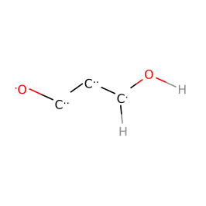
5 | IM(190) |  | IM(186) | 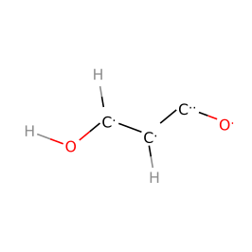
6 | IM(255) |  | IM(243) | 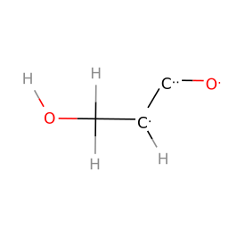
7 | IM(312) |  | IM(284) | 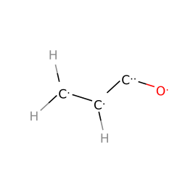
8 | IM(347) |  | IM(338) | 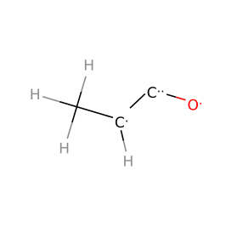
9 | IM(389) |  | IM(387) | 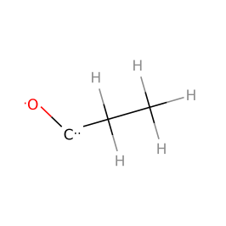
10 | IM(422) |  | IM(422)

Supplementary Table 32 | Intermediate index (IM index) and intermediate structure of each step intermediate in the fastest reaction pathway to acetone at pH=7 and U=-0.5 V vs. SHE on Cu(111).
 | fastest pathway
step | IM index | structure
1 | IM(76)
2 | IM(83)
3 | IM(108)
4 | IM(125)
5 | IM(188) | 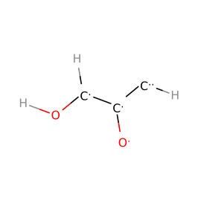
6 | IM(245)
7 | IM(314)
8 | IM(348)
9 | IM(390)
10 | IM(425)

Supplementary Table 33 | Intermediate index (IM index) and intermediate structure of each step intermediate in the two fastest reaction pathways to allyl alcohol at pH=7 and U=-0.5 V vs. SHE on Cu(111).
 | fastest pathway |  | second fastest pathway
step | IM index | structure | IM index | structure
1 | IM(76) |  | IM(76)
2 | IM(83) |  | IM(83)
3 | IM(109) |  | IM(109)
4 | IM(154) |  | IM(126)
5 | IM(190) |  | IM(174)
6 | IM(255) |  | IM(255)
7 | IM(312) |  | IM(312)
8 | IM(347) |  | IM(347)
9 | IM(406) |  | IM(406)
10 | IM(434) |  | IM(434)

Supplementary Table 34 | Intermediate index (IM index) and intermediate structure of each step intermediate in the two fastest reaction pathways to propane at pH=7 and U=-0.5 V vs. SHE on Cu(111).
 | fastest pathway |  | second fastest pathway
step | IM index | structure | IM index | structure
1 | IM(76) |  | IM(76)
2 | IM(83) |  | IM(83)
3 | IM(109) |  | IM(109)
4 | IM(154) |  | IM(126)
5 | IM(190) |  | IM(174)
6 | IM(255) |  | IM(255)
7 | IM(312) |  | IM(312)
8 | IM(347) |  | IM(347)
9 | IM(406) |  | IM(406)
10 | IM(429) |  | IM(429)
11 | IM(439) |  | IM(439)
12 | IM(450) | 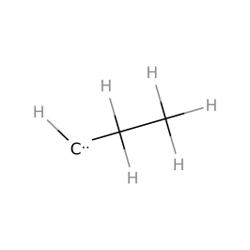 | IM(450)
13 | IM(456) |  | IM(456)
14 | IM(458) |  | IM(458)

Supplementary Table 35 | Intermediate index (IM index) and intermediate structure of each step intermediate in the two fastest reaction pathways to 2-propanol at pH=7 and U=-0.5 V vs. SHE on Cu(111).
 | fastest pathway |  | second fastest pathway
step | IM index | structure | IM index | structure
1 | IM(76) |  | IM(76)
2 | IM(83) |  | IM(83)
3 | IM(108) |  | IM(108)
4 | IM(154) |  | IM(154)
5 | IM(189) |  | IM(189)
6 | IM(251) |  | IM(263) | 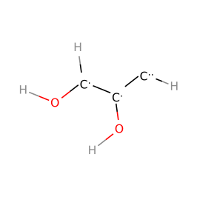
7 | IM(305) |  | IM(326) | 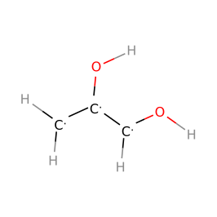
8 | IM(373) |  | IM(373)
9 | IM(398) | 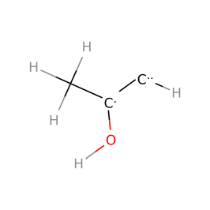 | IM(398)
10 | IM(430) |  | IM(430)
11 | IM(446) |  | IM(446)
12 | IM(455) |  | IM(455)

Supplementary Table 36 | Intermediate index (IM index) and intermediate structure of each step intermediate in the two fastest reaction pathways to 1,2-propylene glycol at pH=7 and U=-0.5 V vs. SHE on Cu(111).
 | fastest pathway |  | second fastest pathway
step | IM index | structure | IM index | structure
1 | IM(76) |  | IM(76)
2 | IM(83) |  | IM(83)
3 | IM(108) |  | IM(108)
4 | IM(154) |  | IM(154)
5 | IM(189) |  | IM(189)
6 | IM(251) |  | IM(251)
7 | IM(305) |  | IM(326)
8 | IM(363) |  | IM(378) | 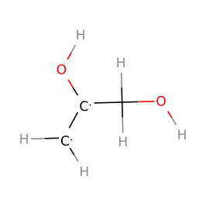
9 | IM(408) |  | IM(412) | 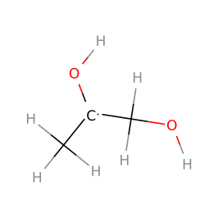
10 | IM(436) |  | IM(436)

Supplementary Table 37 | Intermediate index (IM index) and intermediate structure of each step intermediate in the two fastest reaction pathways to glycerol at pH=7 and U=-0.5 V vs. SHE on Cu(111).
 | fastest pathway |  | second fastest pathway
step | IM index | structure | IM index | structure
1 | IM(76) |  | IM(76)
2 | IM(83) |  | IM(83)
3 | IM(108) |  | IM(108)
4 | IM(154) |  | IM(154)
5 | IM(205) | 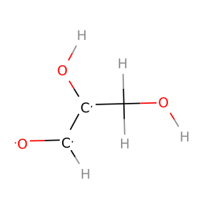 | IM(205)
6 | IM(267) |  | IM(267)
7 | IM(329) |  | IM(331)
8 | IM(381) |  | IM(381)

Supplementary Table 38 | Intermediate index (IM index) and intermediate structure of each step intermediate in the two fastest reaction pathways to hydroxyacetone at pH=7 and U=-0.5 V vs. SHE on Cu(111).
 | fastest pathway |  | second fastest pathway
step | IM index | structure | IM index | structure
1 | IM(76) |  | IM(76)
2 | IM(83) |  | IM(83)
3 | IM(108) |  | IM(108)
4 | IM(125) |  | IM(125)
5 | IM(188) |  | IM(172)
6 | IM(245) |  | IM(229)
7 | IM(314) |  | IM(306)
8 | IM(366) |  | IM(366)

