Supplementary file

Feature importance for Alternative Models

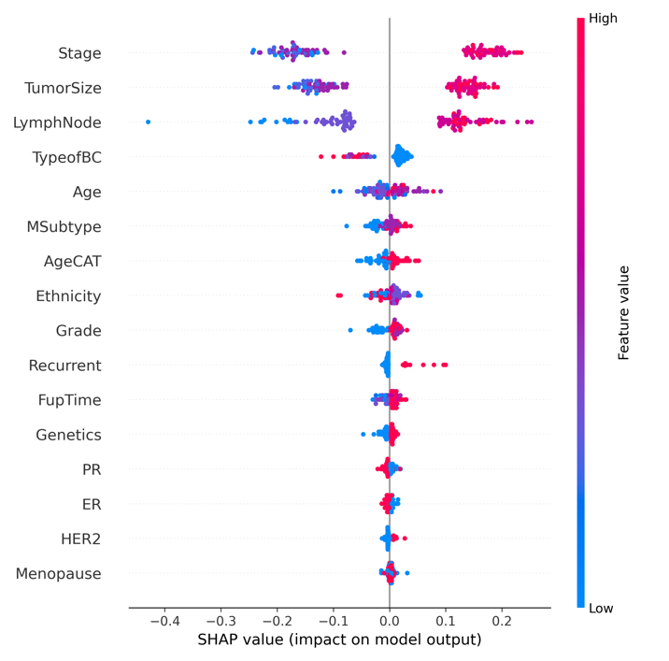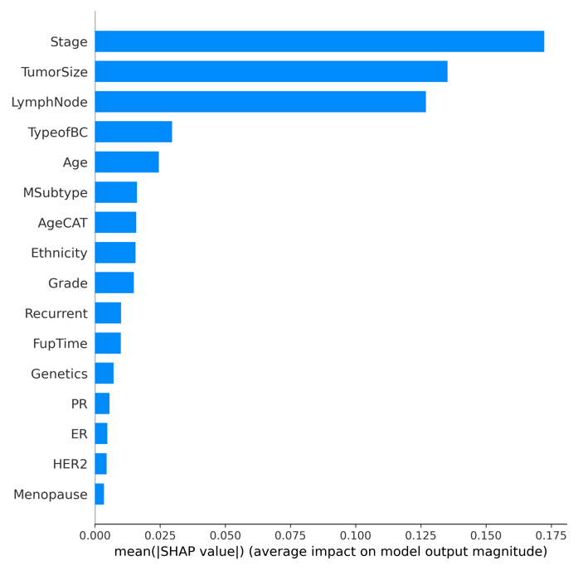
Figure 1S: SHAP feature importance visualization for the Random Forest model predicting breast cancer metastasis in a Ghanaian cohort. The beeswarm plot (left) displays the individual impact of each feature on model predictions, with red indicating high feature values and blue indicating low values. The bar plot (right) shows the average magnitude of SHAP values for each feature. Stage, tumor size, and lymph node involvement were the top predictors of metastasis, while hormonal receptor status, genetics, and menopausal status had relatively minimal influence

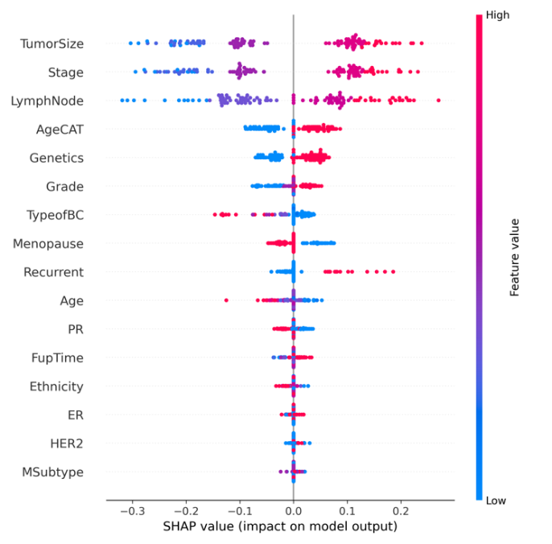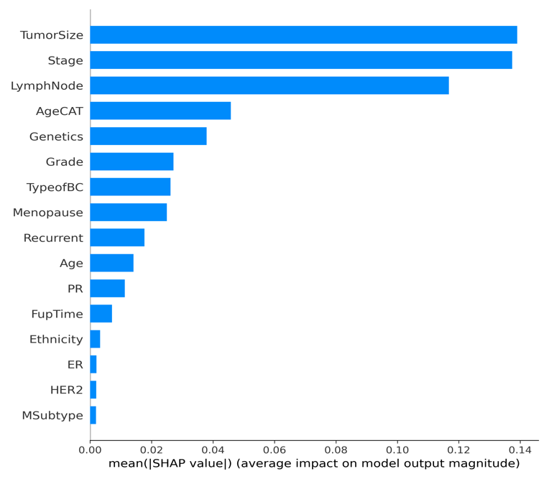

Figure 2S: SHAP-based feature importance analysis of the Naive Bayes model used for predicting breast cancer metastasis in a Ghanaian cohort. The beeswarm plot (left) displays the impact of individual feature values on the model’s output, where red represents high feature values and blue represents low. The bar chart (right) shows the average absolute SHAP value for each feature, reflecting its overall importance. Tumor size, cancer stage, and lymph node involvement were the most influential predictors, while features such as HER2, ER, and molecular subtype (MSubtype) had minimal effect on model predictions.

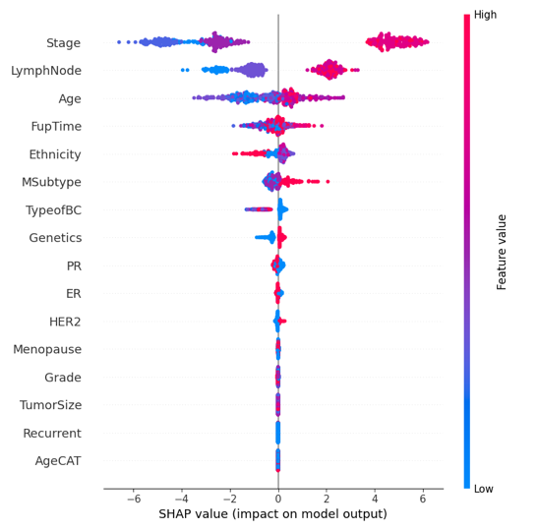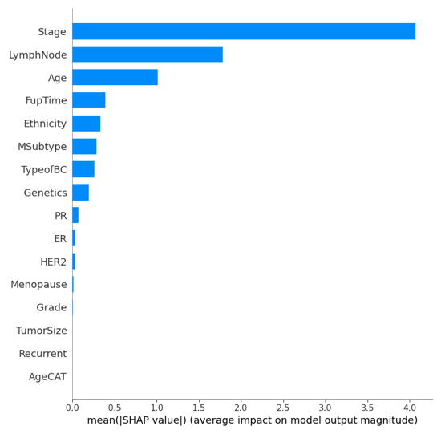
Figure 3S: SHAP-based interpretation of feature importance in the XGBoost model for predicting breast cancer metastasis in a Ghanaian cohort. The beeswarm plot (left) displays the direction and magnitude of individual feature effects, with red indicating high feature values and blue indicating low. The bar chart (right) shows the mean absolute SHAP values, reflecting average feature contribution to model predictions. Stage, lymph node involvement, and age were the most dominant predictors, while tumor size, recurrence, and AgeCAT exhibited minimal influence on the model output.

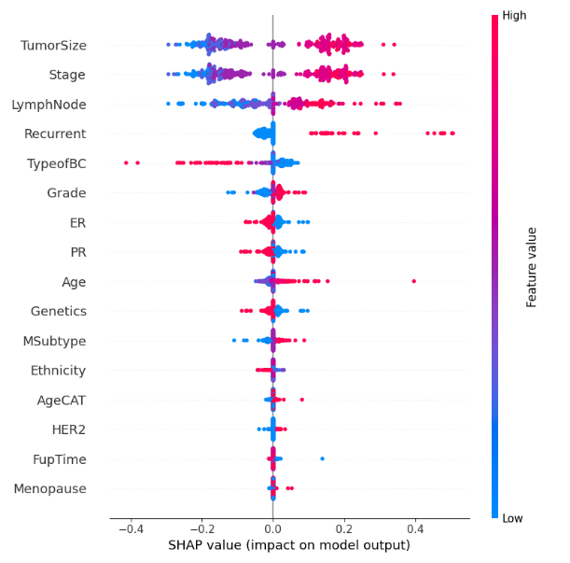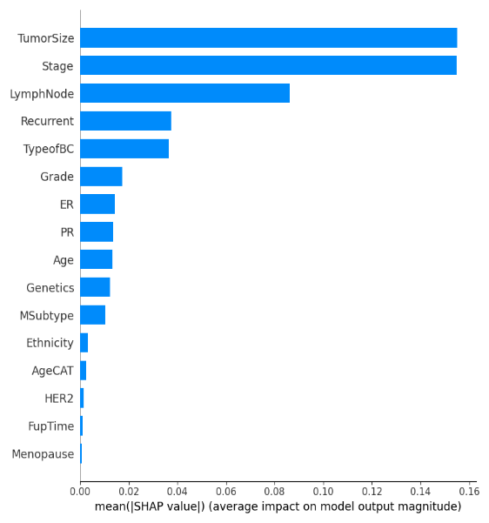
Figure 4S: SHAP feature importance analysis for the XGBoost model predicting breast cancer metastasis in a Ghanaian cohort. The beeswarm plot (left) displays the individual SHAP values for each feature, with red indicating high feature values and blue indicating low. The bar plot (right) shows the mean absolute SHAP values, representing the average impact of each feature on the model’s output. Tumor size, stage, and lymph node involvement were the most influential predictors, while menopause, follow-up time, HER2 status, and AgeCAT had minimal contributions to the model's predictions.

Risk Stratification for Models

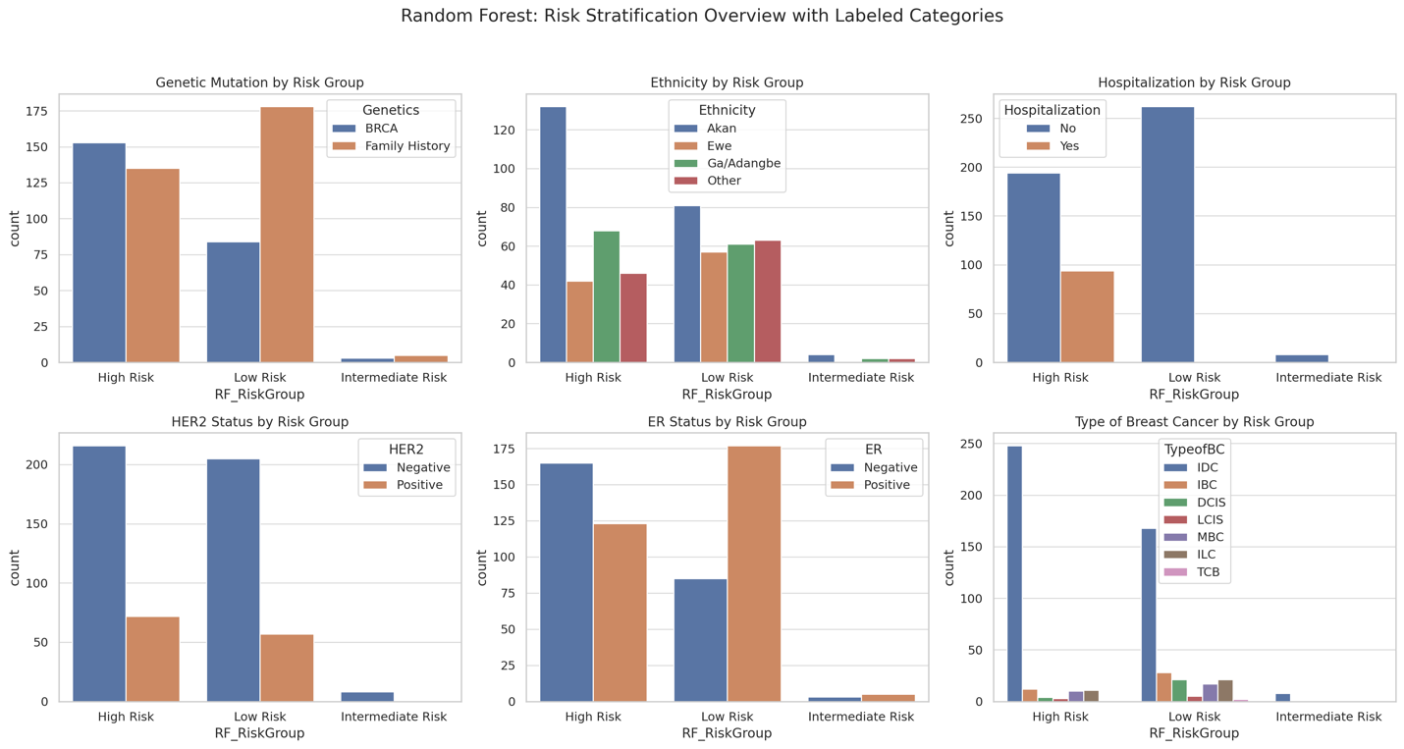

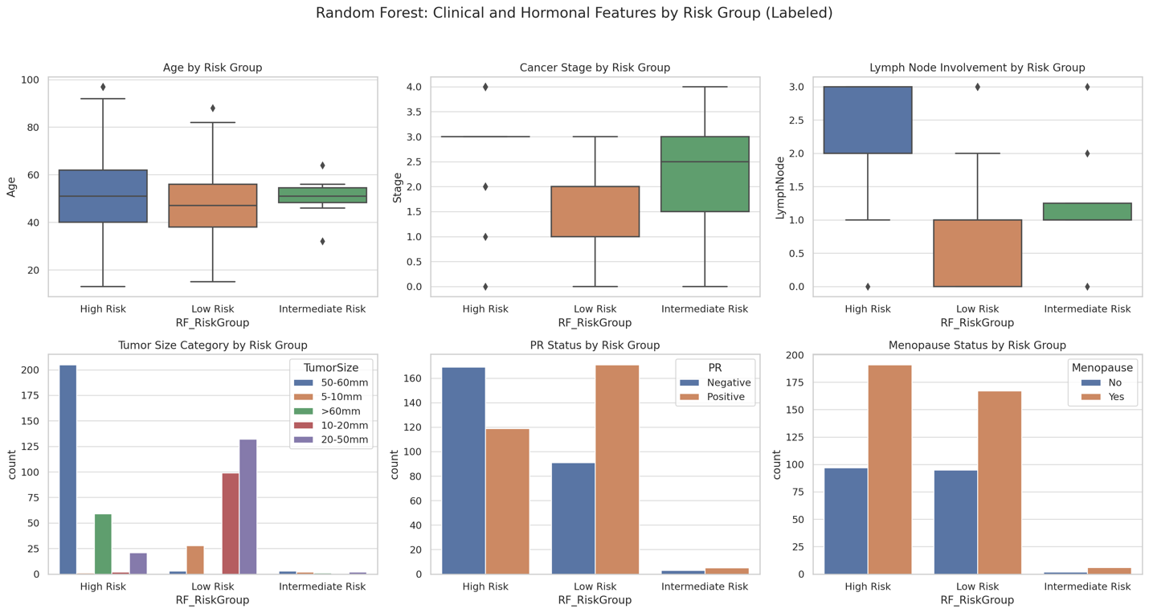

Figure 5S: Comprehensive visualization of clinical, hormonal, molecular, and demographic features across risk groups predicted by the Random Forest model for breast cancer metastasis (High Risk, Intermediate Risk, and Low Risk). The top panel shows categorical distributions including genetic mutations, ethnicity, hospitalization status, HER2 and ER receptor expression, and breast cancer subtypes. High-risk patients had elevated frequencies of genetic mutations, HER2 positivity, ER negativity, and were predominantly classified as triple-negative or HER2-enriched subtypes. The bottom panel displays box and bar plots for clinical and hormonal features. High-risk patients were generally older, had higher tumor stages, and greater lymph node involvement. Additionally, the high-risk group exhibited a larger proportion of postmenopausal patients, PR-negative status, and tumors above 5 cm. These patterns demonstrate the model’s ability to stratify patients by biologically meaningful variables and differentiate between low and high metastatic potential.

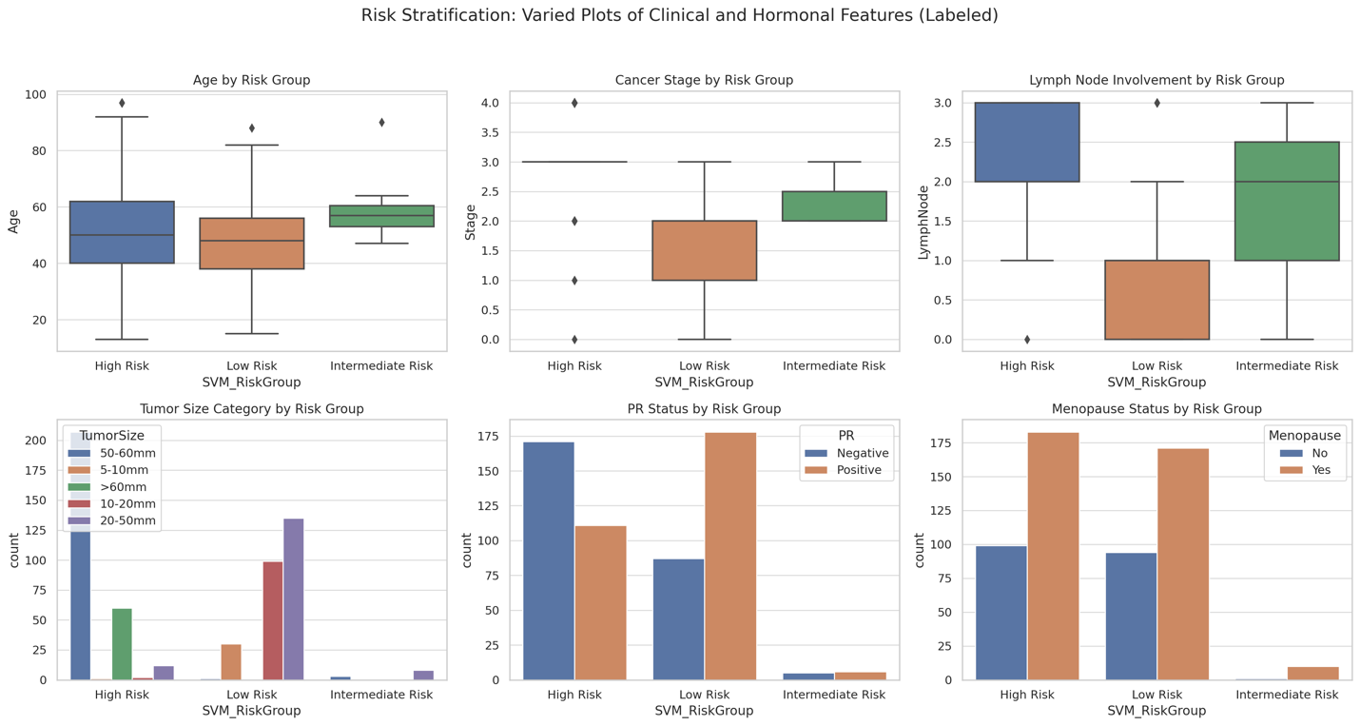

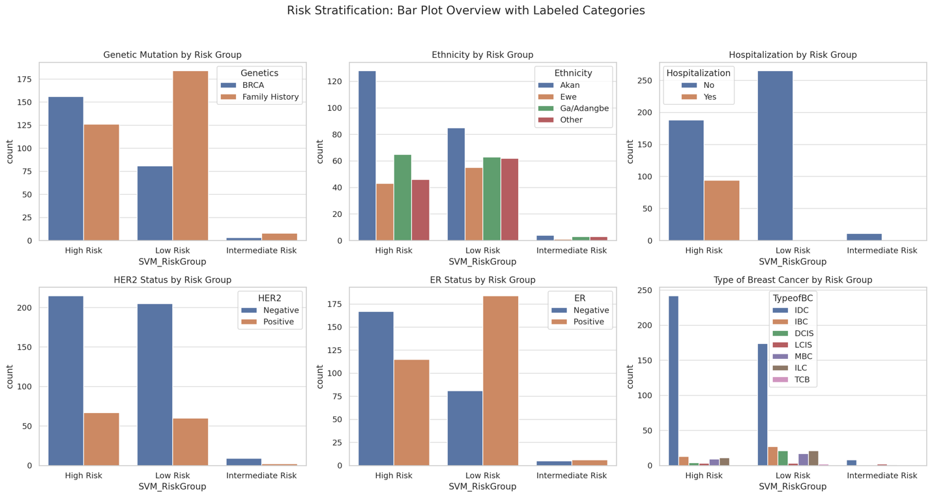

Figure 6S: Visualization of clinical and hormonal feature distributions across Support Vector Machine (SVM)-predicted risk groups for breast cancer metastasis (High Risk, Intermediate Risk, and Low Risk). Box plots display continuous features such as age, cancer stage, and lymph node involvement, while bar plots represent categorical variables including tumor size category, PR status, and menopausal status. High-risk patients were generally older, had more advanced cancer stages, greater lymph node involvement, larger tumors, and were more frequently postmenopausal and PR-negative. These patterns highlight the SVM model’s ability to distinguish patients with higher metastatic potential based on biologically relevant characteristics.

Figure 7S: Visualization of clinical, hormonal, and demographic features across risk groups predicted by the XGBoost model for breast cancer metastasis (High Risk, Intermediate Risk, and Low Risk). The box plots display continuous variables such as age, stage, and lymph node involvement, while bar plots represent categorical distributions of tumor size, PR status, and menopausal status. High-risk patients were typically older, with higher tumor stages, lymph node involvement, larger tumor size, PR-negativity, and postmenopausal status.

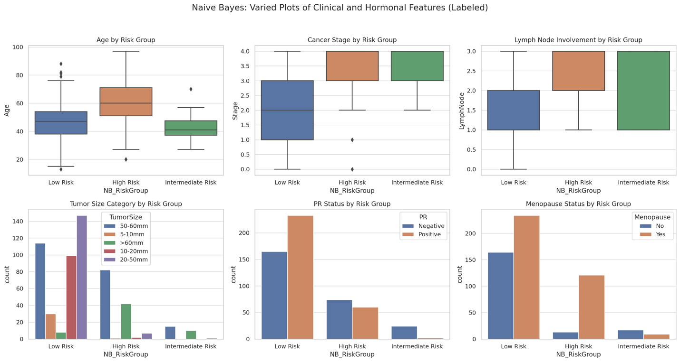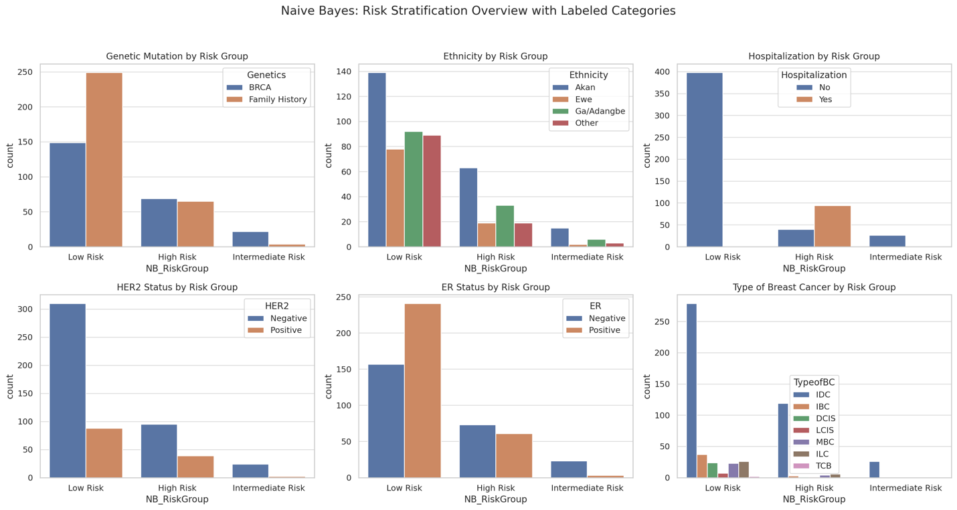
Figure 8S: Comprehensive visualization of clinical, hormonal, molecular, and demographic features stratified by predicted breast cancer metastasis risk groups (High Risk, Intermediate Risk, and Low Risk) using the XGBoost model. The top panel includes box plots and bar charts showing distributions for age, cancer stage, lymph node involvement, tumor size, PR status, and menopausal status. High-risk patients were generally older, had more advanced-stage disease, greater lymph node involvement, larger tumors, were more likely to be PR-negative and postmenopausal. The bottom panel provides bar plots for additional variables, including genetic mutation status, ethnicity, hospitalization history, HER2 and ER expression, and breast cancer subtype. The high-risk group exhibited higher proportions of genetic mutations, HER2 positivity, ER negativity, and triple-negative or HER2-enriched subtypes. These patterns underscore the XGBoost model’s strong ability to differentiate patients across biologically and clinically relevant strata of metastatic risk.

