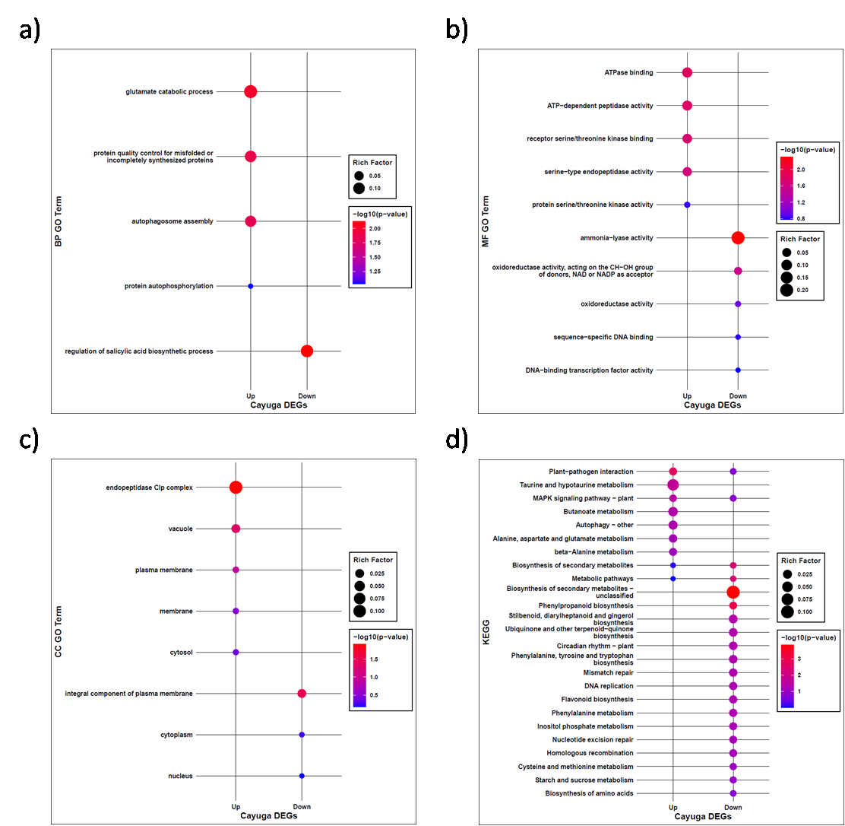
Fig. S1. Enrichment of Cayuga DEGs in (a) GO biological processes (BP), (b) GO molecular function (MF), (c) GO cellular component (CC) categories, and (d) KEGG pathways.

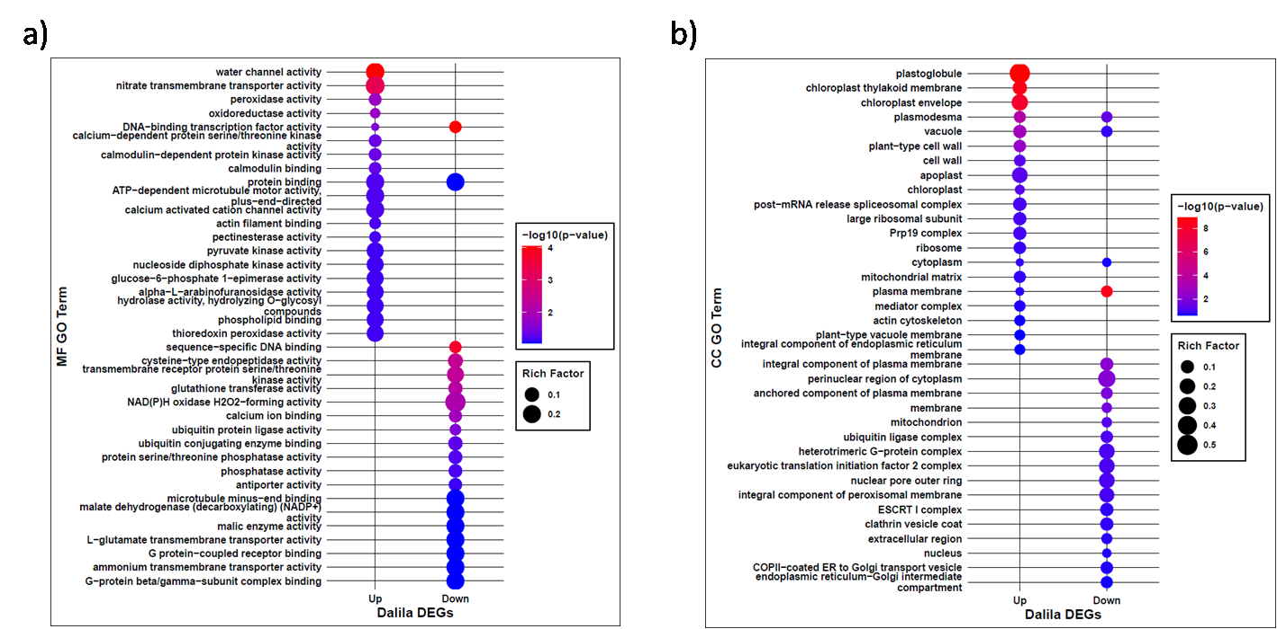
Fig. S2. Enrichment of Dalila DEGs in (a) GO molecular function (MF) and (b) GO cellular component (CC) categories.

