Electronic Supplementary Information (ESI)
Intermediate Physical State of Gel and LC in Cellulose Solution and Its Synergetic Effects
Taeho Kim, Younghan Song, Jungbin Ahn, Minhyung Kim, Hyungsup Kim*

Department of Organic and Nano System Engineering, Konkuk University, Seoul, 05029, Republic of
*iconclast@konkuk.ac.kr

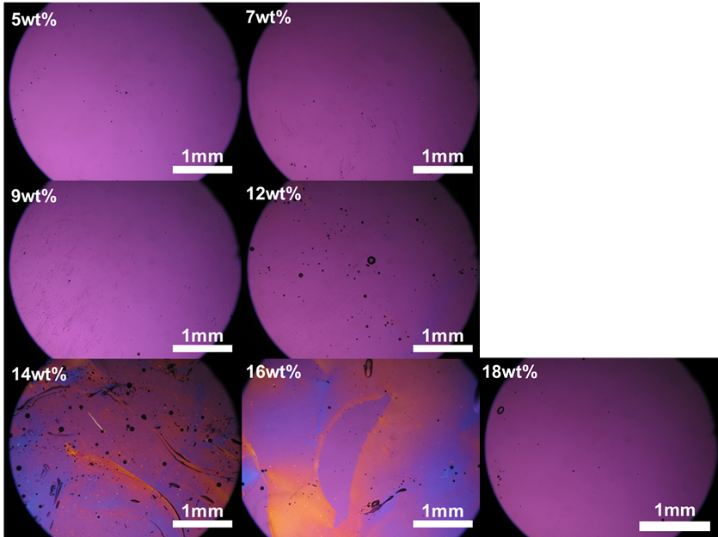
Figure S1. The polarized optical micrographs of the prepared solutions.

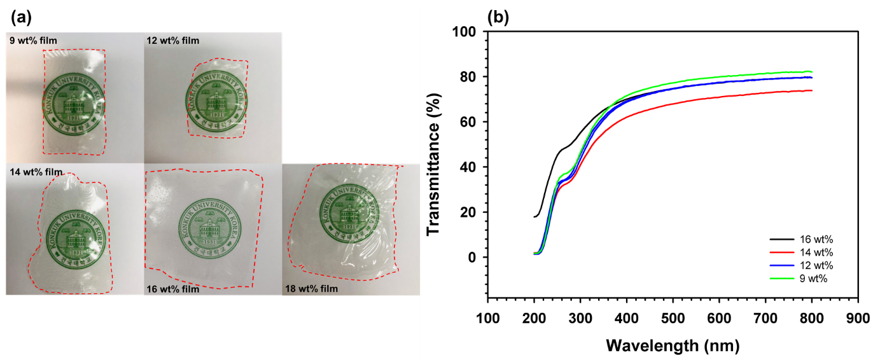
Figure S2. (a) The digital images of the cellulose film regenerated from each solution. (b) The UV-visible spectra of the regenerated cellulose films.

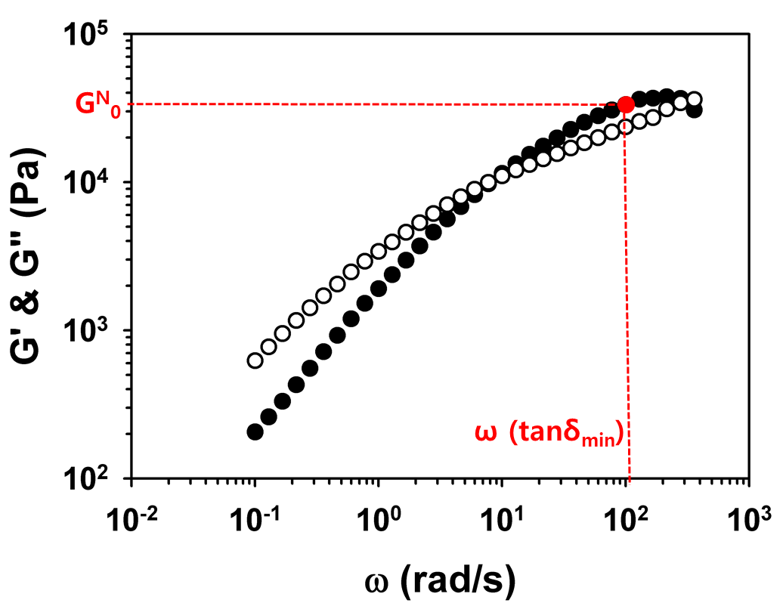
Figure S3. The plateau modulus determination of the 16 wt% cellulose solution.

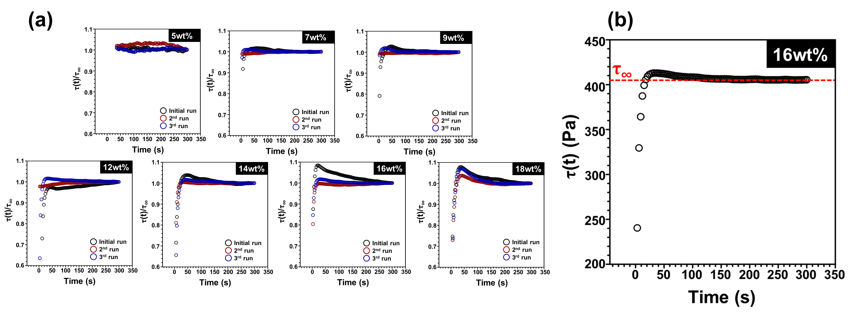
Figure S4. (a) The effect of concentration on shear stress over-shoots after different rest times at shear rate of 0.1s⁻¹ at 30ºC. (b) The determination of τ∞ in the stress sweep test.

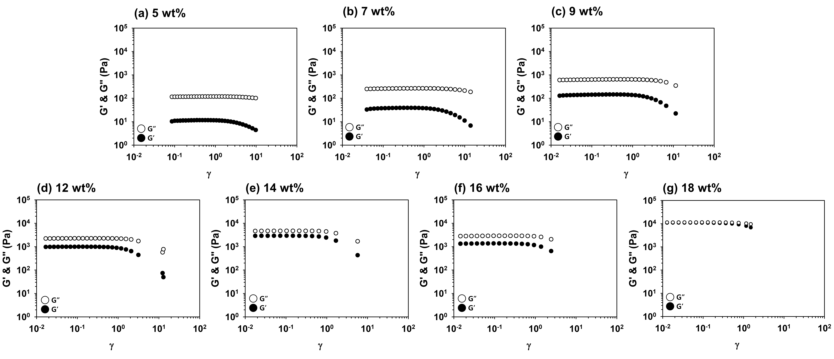
Figure S5. The changes of storage (G') and loss (G") moduli as a function of strain at 1 rad/s.

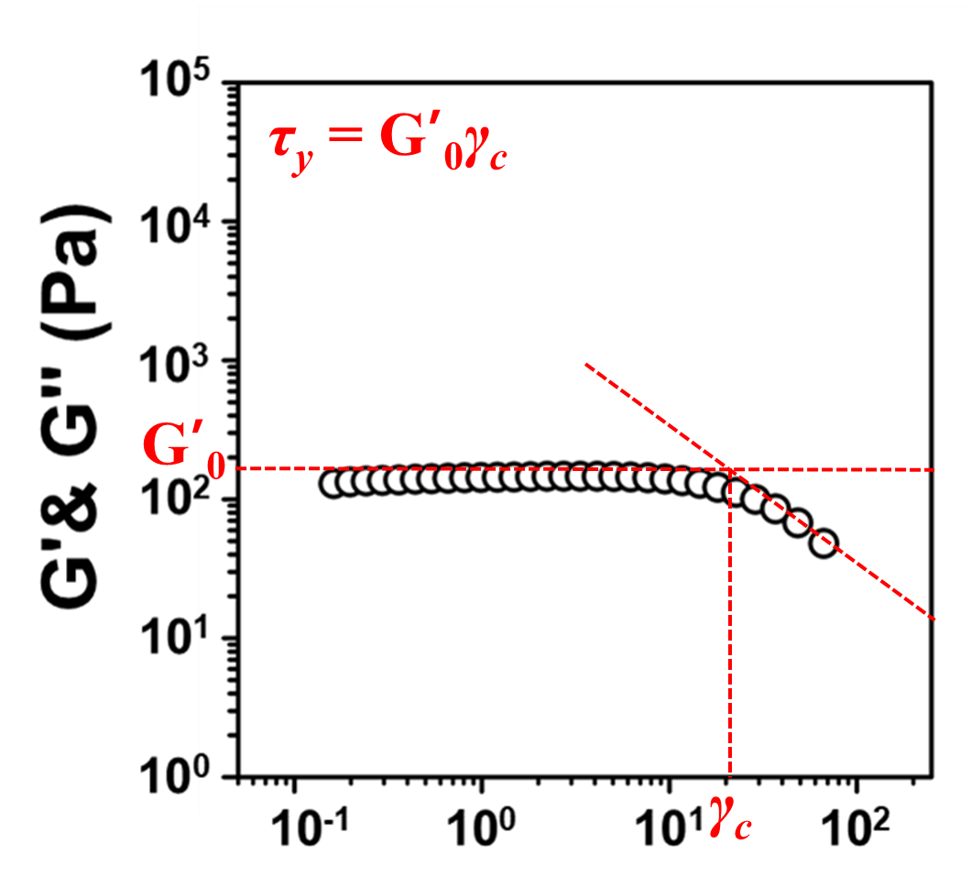
Figure S6. The critical strain (γ_{c}) definition of 9 wt% solution.

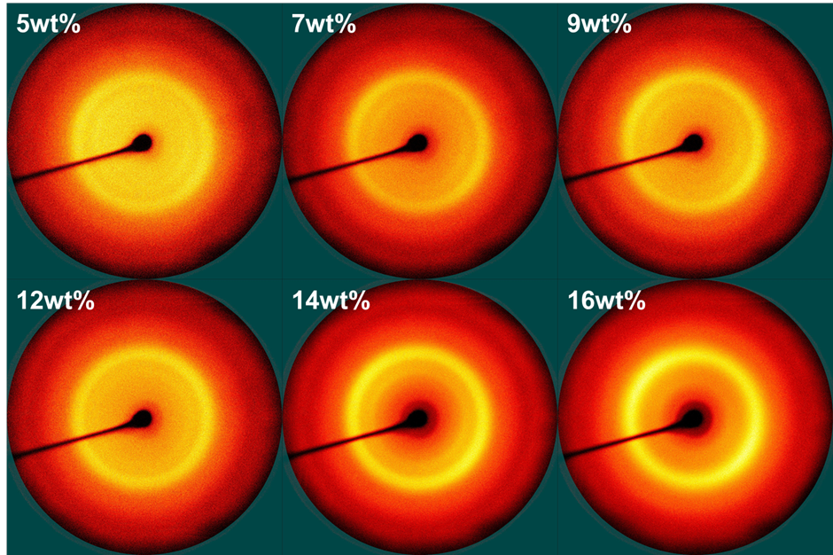
Figure S7. The 2D-WAXS patterns of the regenerated cellulose films.

Table S1. The mechanical properties reported in other works
Materials | DP | Form | Method | Tensile strength  (MPa) | Initial modulus  (GPa) | Reference
Kraft pulp/LiBr  aqueous solution | ~768 | Film | Casting | 66.80 | 1.51 | (1)
5.0 wt% cotton linter fiber/AmimCl | ~920 | Film | Casting | 74 | 0.5 | (2)
5.0 wt%  MCC/EmimAc solution | ~200 | Film | Casting | 69 | - | (3)
6.0 wt% cotton  pulp/LiOH/urea aqueous solution | ~600 | Film | Casting & drawing | 253.2 | ~5.0 | (4)
18.0 wt%  MCC/EmimDEP solution | ~200 | Fiber | Dry-jet wet spinning | 304.7 (±12.7) | 22.4 (±1.4) | (5)
10.0 wt% MCC/kraft pulp/EmimAc | MCC~330  Kraft pulp~1340 | Fiber | Dry-jet wet spinning | - | 0.58 | (6)
Microfibrillated cellulose | ~720 | Paper | Hot press | 105.7 | 6.9 | (7)
16.0 wt%  MCC/AmimCl solution | ~200 | Film | Casting | 420.2 (±28.7) | 9.44 (±1.55) | This work

References
- Zhang X, Xiao N, Wang H, Liu C, Pan X (2018) Preparation and characterization of regenerated cellulose film from a solution in lithium bromide molten salt hydrate. Polymers 10(6): 614. https://doi.org/10.3390/polym10060614
- Pang J, Liu X, Zhang X, Wu Y, Sun R (2013) Fabrication of cellulose film with enhanced mechanical properties in ionic liquid 1-allyl-3-methylimidaxolium chloride (AmimCl). Materials 6(4): 1270-1284. https://doi.org/10.3390/ma6041270
- Pang JH, Wu M, Zhang QH, Tan X, Xu F, Zhang XM, Sun R (2015) Comparison of physical properties of regenerated cellulose films fabricated with different cellulose feedstocks in ionic liquid. Carbohydrate Polymers 121: 71-78. https://doi.org/10.1016/j.carbpol.2014.11.067
- Ye D, Lei X, Li T, Cheng Q, Chang C, Hu L, Zhang L (2019) Ultrahigh tough, super clear, and highly anisotropic nanofiber-structured regenerated cellulose films. ACS nano 13(4): 4843-4853. https://doi.org/10.1021/acsnano.9b02081
- Zhu C, Richardson RM, Potter KD, Koutsomitopoulou AF, van Duijneveldt JS, Vincent SR, Wanasekara ND, Eichhorn SJ, Rahatekar SS (2016) High modulus regenerated cellulose fibers spun from a low molecular weight microcrystalline cellulose solution. Acs Sustainable Chemistry & Engineering 4(9): 4545-4553. https://doi.org/10.1021/acssuschemeng.6b00555
- Olsson C, Westman G (2013) Wet spinning of cellulose from ionic liquid solutions–viscometry and mechanical performance. Journal of Applied Polymer Science 127(6): 4542-4548. https://doi.org/10.1002/app.38064
- Duchemin BJC, Mathew AP, Oksman K (2009) All-cellulose composites by partial dissolution in the ionic liquid 1-butyl-3-methylimidazolium chloride. Composites Part A: Applied Science and Manufacturing 40(12): 2031-2037. https://doi.org/10.1016/j.compositesa.2009.09.013

*Corresponding author: Hyungsup Kim, Tel: +82-2-450-4197; Fax: +82-2-457-8895. E-mail : iconclast@konkuk.ac.kr

