Supplementary Information: Intelligent configuration of integrated microwave photonic filter with programmable response and self-stabilization

Yutong Shi^{1,2}, Yuan Yu^{1,2,3}, Yifan Liu^{1,2}, Kaixiang Cao^{1,2}, Mengmeng Deng^{1,2}, Fangzheng Zhang⁴, Hailong Zhou^{1,2}, and Xinliang Zhang^{1,2,3}
¹Wuhan National Laboratory for Optoelectronics, Huazhong University of Science and Technology, Wuhan 430074, China
²School of Optical and Electronic Information, Huazhong University of Science and Technology, Wuhan, 430074, China
³Optics Valley Laboratory, Wuhan, 430074, China
⁴National Key Laboratory of Microwave Photonics, Nanjing University of Aeronautics and Astronautics, Nanjing 210016, China
e-mail: yuan_yu@hust.edu.cn; xlzhang@mail.hust.edu.cn

Contents
Supplementary Note I: Details of the optimization sub-algorithm 2
Supplementary Note II: FOM definitions of IMPF configuration 3
Supplementary Note III: Procedure and challenges of manual manipulation 4
Supplementary Note IV: Measured optical spectra of modulated signals 5
Supplementary Note V: Intelligent configuration of DUT with MOMS-HO algorithm 5

Supplementary Note I: Details of the optimization sub-algorithm
Particle swarm optimization algorithm is a population-based algorithm. Each individual (particle) of the PSO algorithm has position and velocity attributes within the search space. Its movement is guided jointly by the personal historical best solution ($pbest_{i}$) and the population global best solution ($\text{gbest}$). Particles perform searches via velocity-position updating mechanisms:
$$\begin{aligned}v_{i}^{k+1}=ωv_{i}^{k}+c_{1}r_{1}\left(pbest_{i}-x_{i}^{k}\right)+c_{2}r_{2}\left(gbest-x_{i}^{k}\right)\text{,}\#\left(\text{S-1}\right)\end{aligned}$$

and
$$\begin{aligned}x_{i}^{k+1}=x_{i}^{k}+v_{i}^{k+1}\text{,}\#\left(\text{S-2}\right)\end{aligned}$$
where the adaptive linear inertia range ($ω$ varies from 0.1 to 1.1) balances the global and local search capabilities, and self-adjusting weight ($c_{1}$=1.5) and social-adjusting weight ($c_{2}$=2.0) control the individual experience and social information weights. The fitness function directly evaluates the value of the FOM corresponding to the particle position. PSO balances exploration and development through the group information-sharing mechanism and is classified as a global search algorithm.
Genetic Algorithm, also known as the Evolutionary Algorithm, simulates the mechanisms of natural selection and genetic variation. Individuals are represented through gene encoding, and their fitness is directly measured by the FOM. The population evolves iteratively through selection, crossover, and mutation operations. In this work, the selection operation retains individuals with high fitness, and the crossover operation recombines genes to explore new solutions (crossover rate=0.8). The uniform mutation operation introduces random perturbations to avoid premature convergence (mutation rate=0.01). The mutation intensity decays exponentially with generations to balance early global exploration and later local optimization.
Simulated Annealing algorithm is inspired by the annealing process in metal heat treatment and achieves optimization by simulating the physical mechanism of the slowly cooling high-temperature materials. In this algorithm, the individual (current solution) is associated with a fitness function (FOM) characterizing the energy of the system. The algorithm employs a temperature parameter to regulate the search process. During high-temperature phase, solutions with degraded objective values are accepted to enable global exploration. The subsequent cooling then shifts the search focus toward local refinement. New solutions are generated by random perturbations, and the decision to update the state is based on the Metropolis criterion. Overall, the SA algorithm simulates the two phases of the physical annealing process: high-temperature rapid search and low-temperature precise optimization. This mechanism aligns well with the ideal evolution process of thermo-optic tunable optical devices. In this work, we set the initial annealing temperature of SA to 110, enabling a broad search range. The exponential cooling function (ECF) is then applied to accelerate temperature reduction. We also set an exit mechanism for the algorithm. Once the IMPF achieves the target frequency response, the algorithm exits immediately. This not only saves computational overhead but also avoids unnecessary voltage searching that could cause temperature fluctuations.

Supplementary Note II: FOM definitions of IMPF configuration
During the configuration process based on the MOMS-HC algorithm, the FOM for each different algorithm stage is defined as follows.
PSO: In Stage II, the nine voltages are rapidly optimized to make the IMPF preliminarily approach the target response. We define $T(\text{f})$ as the transmittance at a specified frequency $\text{f}$. To enhance the robustness of the global optimization in Stage II, we take a linear combination of four points in the 5 GHz range around the target center frequency as one item in the ${\text{FOM}}_{PSO}$. The FOM is expressed by
$$\begin{aligned}{\text{FOM}}_{\text{PSO}}=\left[T\left({\text{center}}_{\text{target}}\right)+\sum_{i=0}^{4}{T\left({\text{center}}_{i}\right)}\right]⋅\frac{1}{5}.\#\left(\text{S}\text{-3}\right)\end{aligned}$$
GA: In Stage III, the configuration of the nine voltages is refined according to multi-objective optimization requirements. The definition of FOM comprehensively considers all properties, and is expressed by
$${\text{FOM}}_{\text{GA}}=\exp\left(-λ_{1}{\left|\frac{Δ{\text{f}}_{\text{center}}}{{\text{f}}_{\text{target}}}\right|}^{2}\right)⋅\exp\left(-λ_{2}{\left|\frac{Δ{\text{BW}}_{\text{FWHM}}}{{\text{BW}}_{\text{target_FWHM}}}\right|}^{2}\right)⋅\exp\left(-λ_{3}{\left|\frac{Δ{\text{BW}}_{\text{10dB}}}{{\text{BW}}_{\text{target_10dB}}}\right|}^{2}\right)⋅\exp\left(-λ_{4}⋅{\text{EF}}_{\text{sym}}\text{⋅}{\text{EF}}_{\text{flat}}\right)⋅\frac{\text{RR}}{{\text{RR}}_{\text{target}}}⋅δ\left({\text{Num}}_{\text{peaks}}=1\right)\text{, } \text{ (S-4)}$$
$\begin{aligned}\text{where }Δ{\text{f}}_{\text{center}}\end{aligned}$ denotes the deviation between the current and target the center frequencies, $Δ{\text{BW}}_{\text{FWHM}}$ denotes the deviation between the current and target FWHM bandwidths, $Δ{\text{BW}}_{\text{10dB}}$ denotes the deviation between the current and target 10-dB bandwidths, $λ_{i} (\text{i}=\text{1,2,3,4})$ denotes the i-th optimized intensity coefficient, and ${\text{EF}}_{\text{symmetry}}$ and ${\text{EF}}_{\text{flatness}}$ denote evaluation factors for the symmetry and flatness of the IMPF response, respectively. To ensure high-performance filtering in the IMPF, we impose a strict constraint via an indicator function $δ\left({\text{Num}}_{\text{peaks}}=1\right)$ to guarantee that the amplitude frequency response contains only one single peak. All parameters have been normalized to eliminate dimensional discrepancies.
SA: In the Stage IV, the nine voltages need to be fine-tuned dynamically to offset thermal drift and environmental disturbances. The FOM combines the degradation of multiple core properties, expressed by
$$\begin{aligned}\begin{matrix}{\text{FOM}}_{\text{SA}} & \text{=}\frac{\text{1}}{\text{1+}\prod_{k=1}^{4}{ }\left(\text{1+}α_{k}\left|Δ_{k}\right|\right)}\text{⋅}\text{exp}\left(\text{-}β\text{(}{\text{Num}}_{\text{peaks}}\text{-1}{\text{)}}^{\text{2}}\right)\end{matrix}\text{,}\#\left(\text{S}\text{-5}\right)\end{aligned}$$
$\begin{aligned}\text{where }&Δ_{1},{ Δ}_{2}, { Δ}_{3},\text{ and}{ Δ}_{4}\end{aligned}$ denote the deviations of center frequency, FWHM bandwidth, SF (defined as the ratio of 3-dB to 10-dB bandwidth), and RR, respectively. Meanwhile, $β$ denotes penalty intensity for peaks count ($β$>10), and $α_{k}$ denotes a normalization factor, respectively. The multiplicative form of the FOM ensures that the degradation in any one property will significantly reduce the overall FOM. This mathematical interdependence requires real-time synchronized optimization of all four key properties to ensure stable and sustained operation of the IMPF.
Based on the above FOM definition framework, configuring the IMPF only needs to determine the target and current values of key properties according to specific requirements. Notably, the frequency response reshaping of the IMPF primarily relies on two methods to define these values. The first method extracts the responses of IMPF in multiple specific frequency bands based on the targets of response reshaping, thereby determining the target and current values of key properties from the sliced response. The second method employs the frequency response of the microwave photonic (MWP) link with the 4th-order CROW as the configuration object and directly determines these values according to equalization targets.

Supplementary Note III: Procedure and challenges of manual manipulation
The operator can also manually manipulate the control voltages to achieve the desired response. Based on our experimental experience, the specific procedure for manipulating the 4th-order CROW-based IMPF is as follows. Firstly, the voltages applied to H₁-H₄ are adjusted with large steps to roughly align the resonant wavelengths of the four microrings. Subsequently, the voltages applied to H₅-H₉ are adjusted to optimize the filter shape by modifying coupling coefficients. Experiments indicate that H₇ exhibits the most significant influence on device response, owing to thermal crosstalk and coupling dependence, followed by H₆ and H₈. Notably, adjusting either microheater of MZI-based coupler not only modifies the coupling coefficient but also alters resonant wavelengths of MRRs due to simultaneous optical phase shift. Moreover, the thermal crosstalk can further exacerbate this inter-coupling between coupling coefficient and resonant wavelengths. Therefore, the voltages applied to H₁-H₄ need to be readjusted for compensation. Meanwhile, resonant wavelength adjustments also influence the coupling coefficients of MRRs due to optical phase shift and thermal crosstalk. This bidirectional coupling relationship forces the operator to repeatedly adjust the resonant wavelength and the coupling coefficient alternately to find the dynamic balance, which is very challenging for manual manipulation.

Supplementary Note IV: Measured optical spectra of modulated signals
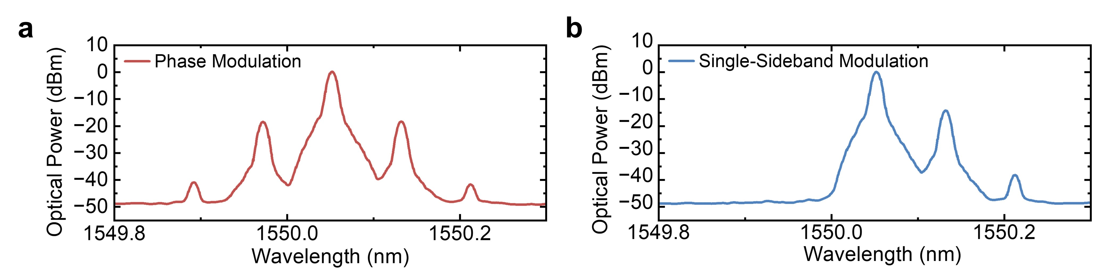
Fig. S1 Optical spectra of a the phase-modulated signal, and b the SSB signal at a modulation frequency of 10.0 GHz.
Fig. S1a and S1b show the measured optical spectra of the phase-modulated signal and the SSB signal after OBPF when the modulation frequency is 10 GHz, respectively. The wavelength of the optical carrier is 1550.05 nm. The SSB modulation is used to maximize the tuning range of the microwave photonic filter.

Supplementary Note V: Intelligent configuration of DUT with MOMS-HO algorithm
To measure the optical spectrum across a broader wavelength range and extract the free spectral range (FSR) of the device under test (DUT), we first characterize the optical transmission spectrum of the DUT using the experimental setup shown in Fig. S2a. The broadband light emitted from a broadband optical source (BOS) is first injected into a polarization beam splitter (PBS) to obtain linearly polarized light. Then, the state of polarization (SOP) is adjusted to be aligned with that of the grating couplers (GC₁) of the DUT using a polarization controller (PC). Finally, the processed optical signal is coupled out from GC₃ and received by an optical spectrum analyzer (OSA, YOKOGAWA AQ6319).
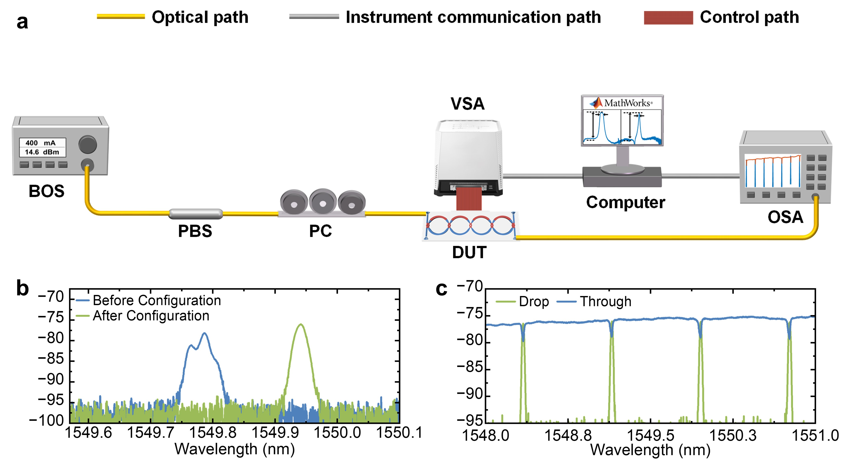
Fig. S2 a Experimental setup for measuring the optical transmission spectrum of DUT. b Optical transmission spectra of the 4th-order CROW at the output port before configuration (blue curve) and after configuration (green curve). c Measured optical transmission spectra of the 4th-order CROW from GC₁ to GC₄ (through port, blue curve) and GC₃ (drop port, green curve). BOS broadband optical source, PBS polarization beam splitter, PC polarization controller, DUT, device under test, VSA, voltage source array, OSA optical spectrum analyzer.
When all the voltages applied to the microheaters are 0 V, the measured optical transmission spectrum of DUT is shown as the blue curve in Fig. S2b. We can see that the passband of DUT is not flat and even splits into two peaks, which are caused by misalignment of the MRR resonant wavelengths and coupling coefficients owing to fabrication error.
Considering that manual manipulation cannot rapidly and efficiently configure these multiple parameters to attain optimal solutions (see Supplementary Notes III), we directly demonstrate the intelligent configuration of DUT based on the MOMS-HC algorithm. The target response of DUT is set to be an optical bandpass filter with a bandwidth of 0.016 nm (2 GHz) and an RR higher than 15 dB. The measured optical transmission spectrum of DUT is shown as the green curve in Fig. S2b, indicating that an optical filter with an RR of 18.93 dB and an FWHM bandwidth of 0.018 nm (2.25 GHz) is realized. We can observe that the configured FWHM bandwidth deviates from the target by as much as 0.25 GHz. This is because the resolution of OSA is only 0.02 nm, which cannot precisely characterize the FWHM bandwidth of DUT. By contrast, the VNA can achieve a much higher resolution than the OSA. Therefore, accurate configuration, measurement, and characterization of the IMPF will be performed using the experimental setup shown in Fig. S2c illustrates the optical transmission spectra from GC₁ to GC₄ (through port, blue curve) and from GC₁ to GC₃ (drop port, green curve) over multiple FSRs. We can see that the measured FSR of DUT is 0.8 nm (100 GHz).

