Appendices
Appendix A
Benthic groups, label sets, class, and morphology allocations used to annotate the benthic data set.
Benthic group | Code ReefCloud | Code CoralNet | Class | Morphology
Algae Other | ALG_OTH | ALG_OTH | Algae | Algae
Chlorodesmis | Chlor | Chlor | Algae | Algae
Crustose Coralline Algae (on dead coral) | CAL_CCA_DC | CAL_CCA_DC | Algae | Algae
Crustose Coralline Algae (on rubble) | CAL_CCA_RB | CAL_CCA_RB | Algae | Algae
Caulerpa | Caul | Caul | Algae | Algae
Cyanobacteria | Cya_spe | Cya_spe | Algae | Algae
Dictyota | Dicsp | Dicsp | Algae | Algae
Halimeda | MACR_Cal_H | MACR_Cal_H | Algae | Algae
Lobophora | Lobph | Lobph | Algae | Algae
Padina | Pad | Pad | Algae | Algae
Turbinaria | Turbin | Turbin | Algae | Algae
Turf algae/DHC | EAM_DHC | EAM_DHC | DHC | Turf algae/DHC
Turf algae/DHC (rubble) | EAM_RB | EAM_RB | DHC | Turf algae/DHC
Acropora Branching | ACR-BRA | ACR_BRA | Hard coral | Branching
Acropora Digitate | BRA_DIG_Ac | BRA_DIG_Ac | Hard coral | Branching
Acropora hispidose | ACR-HIP | ACR_HIP | Hard coral | Branching
Acropora Other | ACR-OTH | ACR_OTH | Hard coral | Branching
Acropora Tabulate and Corymbose | BRA_TAB-Ac | BRA_TAB_Ac | Hard coral | Plate
Acropora Plate/Encrusting | ACR-PE | ACR_PE | Hard coral | Plate
Branching Other | BRA_OTH | BRA_OTH | Hard coral | Branching
Favid Mussid | FAV-MUS | FAV_MUS | Hard coral | Massive
Foliose or Plate with Ridges | TFP_RDG_Al | TFP_RDG_Al | Hard coral | Plate
Foliose or Plate with Round Corallites | TFP_RND_Al | TFP_RND_Al | Hard coral | Plate
Hard Coral Other | OTH-HC | OTH_HC | Hard coral | Massive
Massive Other | MASE_OTH | MASE_OTH | Hard coral | Massive
Mobile Invertebrate | MOB-INV | MOB-INV | Hard coral | Invertebrates
Pocillopora | POCI | POCI | Hard coral | Branching
Branching Porites | POR-BRA | POR_BRA | Hard coral | Branching
Encrusting Porites | POR-ENC | POR_ENC | Hard coral | Massive
Massive Porites | POR-MASS | POR_MASS | Hard coral | Massive
Other | Other | Other | Other | Other
Crown of Thorns | MINV_COTS | MOB_INV | Other | Invertebrates
Sargassum | MAECBS | MAECBS | Other | Other
Seagrass | Seagrass | Seagrass | Other | Other
Sessile Invertebrate | OTH-SINV | OTH_SINV | Other | Invertebrates
Transect Gear | *TAPE | X_TAPE | Other | Other
Unclear | Unc | Unc | Other | Other
Unknown | Unk | Unk | Other | Other
Water | WATE | Other | Other | Other
Sand | BMA_sand | BMA_sand | Sand | Sand
Sand | Sand | Sand | Sand | Sand
Alcyoniidae | ALC-SF | ALC-SF | Soft coral | Soft
Gorgonian | GORG | GORG | Soft coral | Soft
Soft Coral Other | OTH-SF | OTH_SF | Soft coral | Soft

Appendix B
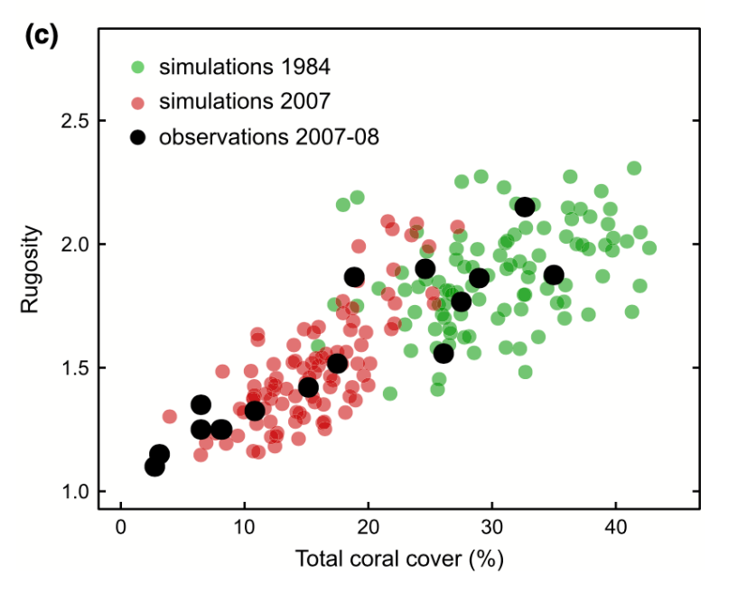

The relationship between simulated reef rugosity and total coral cover at the start (green dots) and at the end (red dots) of the modelled period. Black dots represent the observed site averages and open dots are the global averages for a given season. Regression equations in 2007–2008 observations, y = 1.072 + 0.027 x (R2 = 0.85, P < 0.001, N = 16); 2007 predictions, y = 0.914 + 0.037 x (R2 = 0.37, P < 0.001, N = 100). Adapted from Bozec et al. (2015).

Appendix C
Parameters used in calculating carbonate production per geomorphic zone and benthic group, as sourced from literature.
GZ | Genera/taxon | Linear extension (cm/year) | Density (g/cm³) | Calcification rate (g/cm²) | Conversion factor | Reference
Northern reef slope | Acropora Branching | 5,0282 | 1,2150 | 6,1093 | 0,2560 | Perry et al. (2018)
Northern reef slope | Acropora Digitate | 5,0282 | 1,2150 | 6,1093 | 0,2560 | Perry et al. (2018)
Northern reef slope | Acropora hispidose | 5,0282 | 1,2150 | 6,1093 | 0,2560 | Perry et al. (2018)
Northern reef slope | Acropora Other | 5,0282 | 1,2150 | 6,1093 | 0,2560 | Perry et al. (2018)
Northern reef slope | Acropora Tabulate and Corymbose | 4,8210 | 1,3870 | 6,6867 | 0,1900 | Perry et al. (2018)
Northern reef slope | Acropora Plate/Encrusting | 2,3200 | 1,3743 | 3,1883 | 1,0000 | Perry et al. (2018)
Northern reef slope | Branching Other | 2,3319 | 1,4323 | 3,3400 | 0,2560 | Perry et al. (2018)
Northern reef slope | Crustose Coralline Algae | 0,0404 |  | 1,1465 | 1,0000 | Perry et al. (2018); Kennedy et al. (2017)
Northern reef slope | Favid Mussid | 0,7341 | 1,2826 | 0,9415 | 1,0000 | Perry et al. (2018)
Northern reef slope | Foliose or Plate with Ridges | 2,2966 | 1,3963 | 3,2068 | 1,0000 | Perry et al. (2018)
Northern reef slope | Foliose or Plate with Round Corallites | 2,2966 | 1,3963 | 3,2068 | 1,0000 | Perry et al. (2018)
Northern reef slope | Hard Coral Other | 2,2966 | 1,3963 | 3,2068 | 1,0000 | Perry et al. (2018)
Northern reef slope | Halimeda |  |  | 3,3575 | 1,0000 | Brown et al. (2020)
Northern reef slope | Massive Other | 1,7001 | 1,3355 | 2,2705 | 1,0000 | Perry et al. (2018)
Northern reef slope | Pocillopora | 3,1009 | 1,4357 | 4,4520 | 0,3510 | Perry et al. (2018)
Northern reef slope | Branching Porites | 2,1974 | 1,3080 | 2,8741 | 0,2210 | Perry et al. (2018)
Northern reef slope | Encrusting Porites | 1,1671 | 1,2636 | 1,4748 | 1,0000 | Perry et al. (2018)
Northern reef slope | Massive Porites | 1,1671 | 1,2636 | 1,4748 | 1,0000 | Perry et al. (2018)
Southern reef slope | Acropora Branching | 5,0282 | 1,2150 | 6,1093 | 0,2560 | Perry et al. (2018)
Southern reef slope | Acropora Digitate | 5,0282 | 1,2150 | 6,1093 | 0,2560 | Perry et al. (2018)
Southern reef slope | Acropora Hispidose | 5,0282 | 1,2150 | 6,1093 | 0,2560 | Perry et al. (2018)
Southern reef slope | Acropora Other | 5,0282 | 1,2150 | 6,1093 | 0,2560 | Perry et al. (2018)
Southern reef slope | Acropora Tabulate and Corymbose | 4,8210 | 1,3870 | 6,6867 | 0,1900 | Perry et al. (2018)
Southern reef slope | Acropora Plate/Encrusting | 2,3200 | 1,3743 | 3,1883 | 1,0000 | Perry et al. (2018)
Southern reef slope | Branching Other | 2,3319 | 1,4323 | 3,3400 | 0,2560 | Perry et al. (2018)
Southern reef slope | Crustose Coralline Algae | 0,0404 |  | 1,0490 | 1,0000 | Perry et al. (2018); Kennedy et al. (2017)
Southern reef slope | Favid Mussid | 0,7341 | 1,2826 | 0,9415 | 1,0000 | Perry et al. (2018)
Southern reef slope | Foliose or Plate with Ridges | 2,2966 | 1,3963 | 3,2068 | 1,0000 | Perry et al. (2018)
Southern reef slope | Foliose or Plate with Round Corallites | 2,2966 | 1,3963 | 3,2068 | 1,0000 | Perry et al. (2018)
Southern reef slope | Hard Coral Other | 2,2966 | 1,3963 | 3,2068 | 1,0000 | Perry et al. (2018)
Southern reef slope | Halimeda |  |  | 0,1280 | 1,0000 | Brown et al. (2020)
Southern reef slope | Massive Other | 1,7001 | 1,3355 | 2,2705 | 1,0000 | Perry et al. (2018)
Southern reef slope | Pocillopora | 3,1009 | 1,4357 | 4,4520 | 0,3510 | Perry et al. (2018)
Southern reef slope | Porites Branching | 2,1974 | 1,3080 | 2,8741 | 0,2210 | Perry et al. (2018)
Southern reef slope | Porites Encrusting | 1,1671 | 1,2636 | 1,4748 | 1,0000 | Perry et al. (2018)
Southern reef slope | Porites Massive | 1,1671 | 1,2636 | 1,4748 | 1,0000 | Perry et al. (2018)
Outer reef flat | Acropora Branching | 5,0282 | 1,2150 | 6,1093 | 0,2560 | Perry et al. (2018)
Outer reef flat | Acropora Digitate | 5,0282 | 1,2150 | 6,1093 | 0,2560 | Perry et al. (2018)
Outer reef flat | Acropora Hispidose | 5,0282 | 1,2150 | 6,1093 | 0,2560 | Perry et al. (2018)
Outer reef flat | Acropora Other | 5,0282 | 1,2150 | 6,1093 | 0,2560 | Perry et al. (2018)
Outer reef flat | Acropora Tabulate and Corymbose | 4,8210 | 1,3870 | 6,6867 | 0,1900 | Perry et al. (2018)
Outer reef flat | Acropora Plate/Encrusting | 2,3200 | 1,3743 | 3,1883 | 1,0000 | Perry et al. (2018)
Outer reef flat | Branching Other | 2,3319 | 1,4323 | 3,3400 | 0,2560 | Perry et al. (2018)
Outer reef flat | Crustose Coralline Algae | 0,0404 |  | 1,5965 | 1,0000 | Perry et al. (2018); Kennedy et al. (2017)
Outer reef flat | Favid Mussid | 0,7341 | 1,2826 | 0,9415 | 1,0000 | Perry et al. (2018)
Outer reef flat | Foliose or Plate with Ridges | 2,2966 | 1,3963 | 3,2068 | 1,0000 | Perry et al. (2018)
Outer reef flat | Foliose or Plate with Round Corallites | 2,2966 | 1,3963 | 3,2068 | 1,0000 | Perry et al. (2018)
Outer reef flat | Hard Coral Other | 2,2966 | 1,3963 | 3,2068 | 1,0000 | Perry et al. (2018)
Outer reef flat | Halimeda |  |  | 1,5685 | 1,0000 | Brown et al. (2020)
Outer reef flat | Massive Other | 1,7001 | 1,3355 | 2,2705 | 1,0000 | Perry et al. (2018)
Outer reef flat | Pocillopora | 3,1009 | 1,4357 | 4,4520 | 0,3510 | Perry et al. (2018)
Outer reef flat | Porites Branching | 2,1974 | 1,3080 | 2,8741 | 0,2210 | Perry et al. (2018)
Outer reef flat | Porites Encrusting | 1,1671 | 1,2636 | 1,4748 | 1,0000 | Perry et al. (2018)
Outer reef flat | Porites Massive | 1,1671 | 1,2636 | 1,4748 | 1,0000 | Perry et al. (2018)
Inner reef flat | Acropora Branching | 5,0282 | 1,2150 | 6,1093 | 0,2560 | Perry et al. (2018)
Inner reef flat | Acropora Digitate | 5,0282 | 1,2150 | 6,1093 | 0,2560 | Perry et al. (2018)
Inner reef flat | Acropora Hispidose | 5,0282 | 1,2150 | 6,1093 | 0,2560 | Perry et al. (2018)
Inner reef flat | Acropora Other | 5,0282 | 1,2150 | 6,1093 | 0,2560 | Perry et al. (2018)
Inner reef flat | Acropora Tabulate or Corymbose | 4,8210 | 1,3870 | 6,6867 | 0,1900 | Perry et al. (2018)
Inner reef flat | Acropora Plate/Encrusting | 2,3200 | 1,3743 | 3,1883 | 1,0000 | Perry et al. (2018)
Inner reef flat | Branching Other | 2,3319 | 1,4323 | 3,3400 | 0,2560 | Perry et al. (2018)
Inner reef flat | Crustose Coralline Algae | 0,0404 |  | 0,9490 | 1,0000 | Perry et al. (2018); Kennedy et al. (2017)
Inner reef flat | Favid Mussid | 0,7341 | 1,2826 | 0,9415 | 1,0000 | Perry et al. (2018)
Inner reef flat | Foliose or Plate with Ridges | 2,2966 | 1,3963 | 3,2068 | 1,0000 | Perry et al. (2018)
Inner reef flat | Foliose or Plate with Round Corallites | 2,2966 | 1,3963 | 3,2068 | 1,0000 | Perry et al. (2018)
Inner reef flat | Hard Coral Other | 2,2966 | 1,3963 | 3,2068 | 1,0000 | Perry et al. (2018)
Inner reef flat | Halimeda |  |  | 1,5685 | 1,0000 | Brown et al. (2020)
Inner reef flat | Massive Other | 1,7001 | 1,3355 | 2,2705 | 1,0000 | Perry et al. (2018)
Inner reef flat | Pocillopora | 3,1009 | 1,4357 | 4,4520 | 0,3510 | Perry et al. (2018)
Inner reef flat | Porites Branching | 2,1974 | 1,3080 | 2,8741 | 0,2210 | Perry et al. (2018)
Inner reef flat | Porites Encrusting | 1,1671 | 1,2636 | 1,4748 | 1,0000 | Perry et al. (2018)
Inner reef flat | Porites Massive | 1,1671 | 1,2636 | 1,4748 | 1,0000 | Perry et al. (2018)

