Thermal Conductivity Modeling Beyond the Dilute Limit: A Body-Centered Cubic Framework for Densely Packed Polymer Composites

Lu He¹, Kai Wu¹ *, Qiang Fu¹

¹ College of Polymer Science and Engineering, National Key Laboratory of Advanced Polymer Materials, Sichuan University, Chengdu 610065, China

*Corresponding author.
E-mail: (K. Wu) kaiwu@scu.edu.cn (K. Wu)

Supplementary Figures
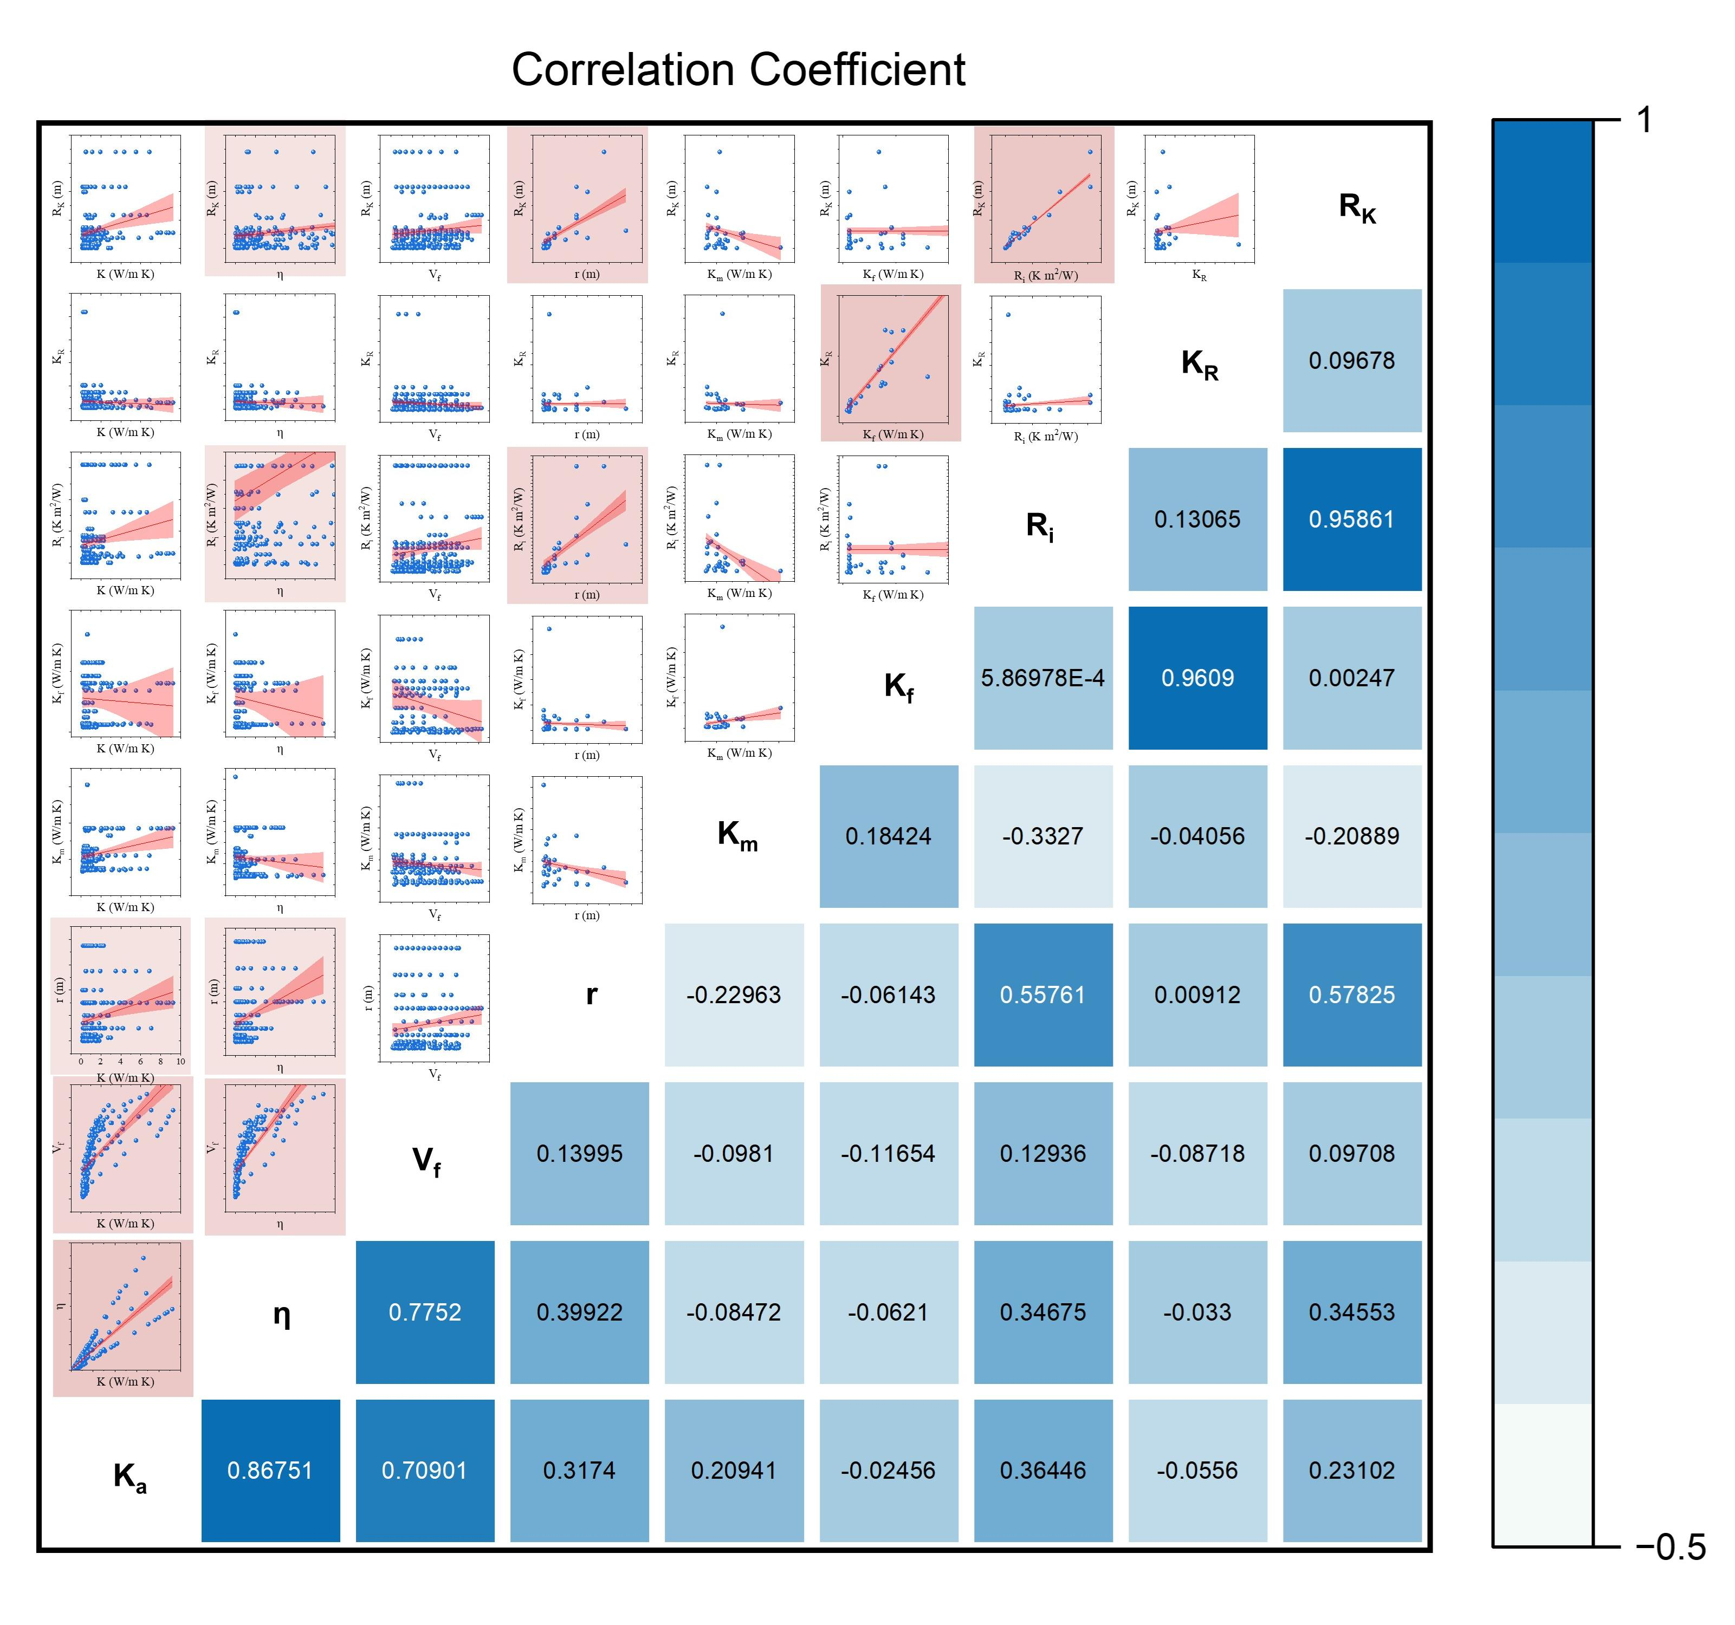
Supplementary Figure 1. Interparameter correlation analysis of polymer composites, showing the relationships between thermal conductivity of composite (K_{a}), thermal enhancement ratio of composite (η), volume fraction (V_{f}), filler radius (r), matrix thermal conductivity (K_{m}), filler thermal conductivity (K_{f}), filler-matrix interfacial thermal resistance (R_{i}), relative thermal conductivity (K_{R}), and Kapitza radius (R_{K}).

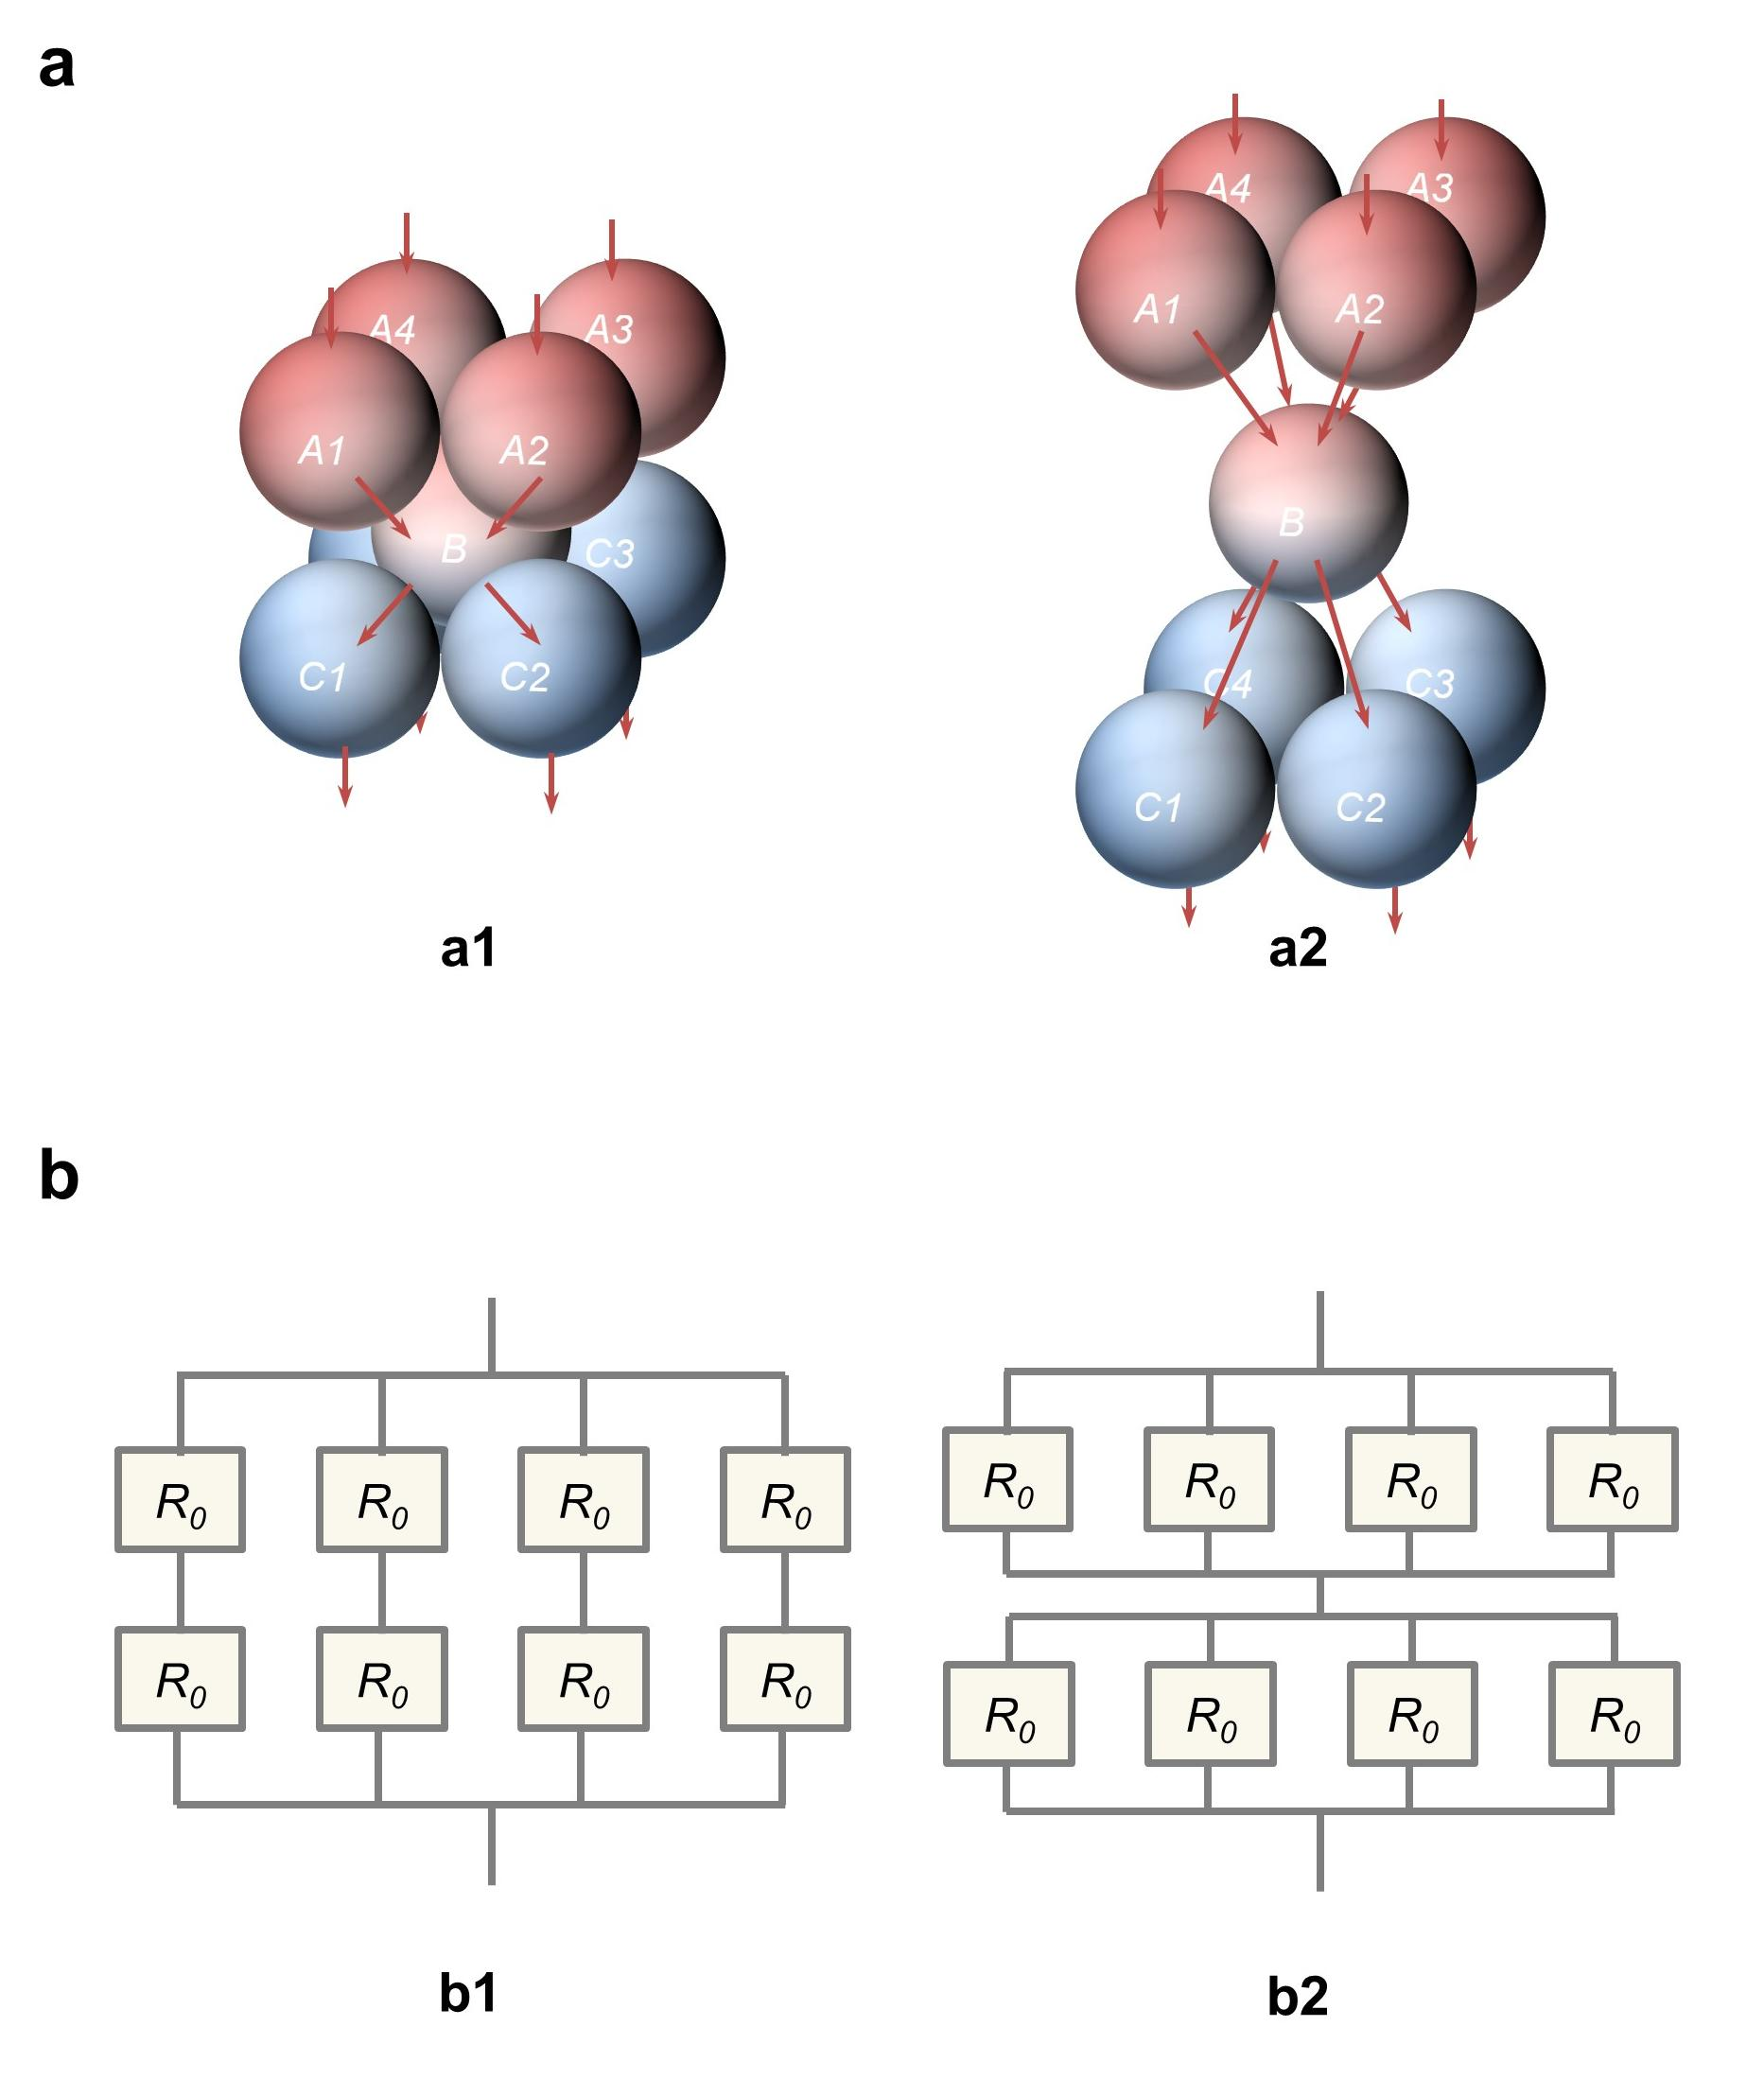
Supplementary Figure 2. (a) Different heat transfer pathway configurations of a body-centered cubic (BCC) structure. (a1) Heat flux is transferred from A to B and subsequently to C, where each heat transfer path, A_{x} → B → C_{x} (x=1,2,3,4), is arranged in parallel. (a2) Heat flux first converges at B after being transferred from A and then propagates from B to C. In this configuration, the heat transfer paths A_{x} → B (x=1,2,3,4) are arranged in parallel, as are the paths B → C_{x} (x=1,2,3,4), while the two stages A → B and B → C are connected in series. (b) Schematic representation of the thermal conduction network. (b1) Series-connected pathways followed by parallel arrangement. (b2) Parallel-connected pathways followed by series arrangement.

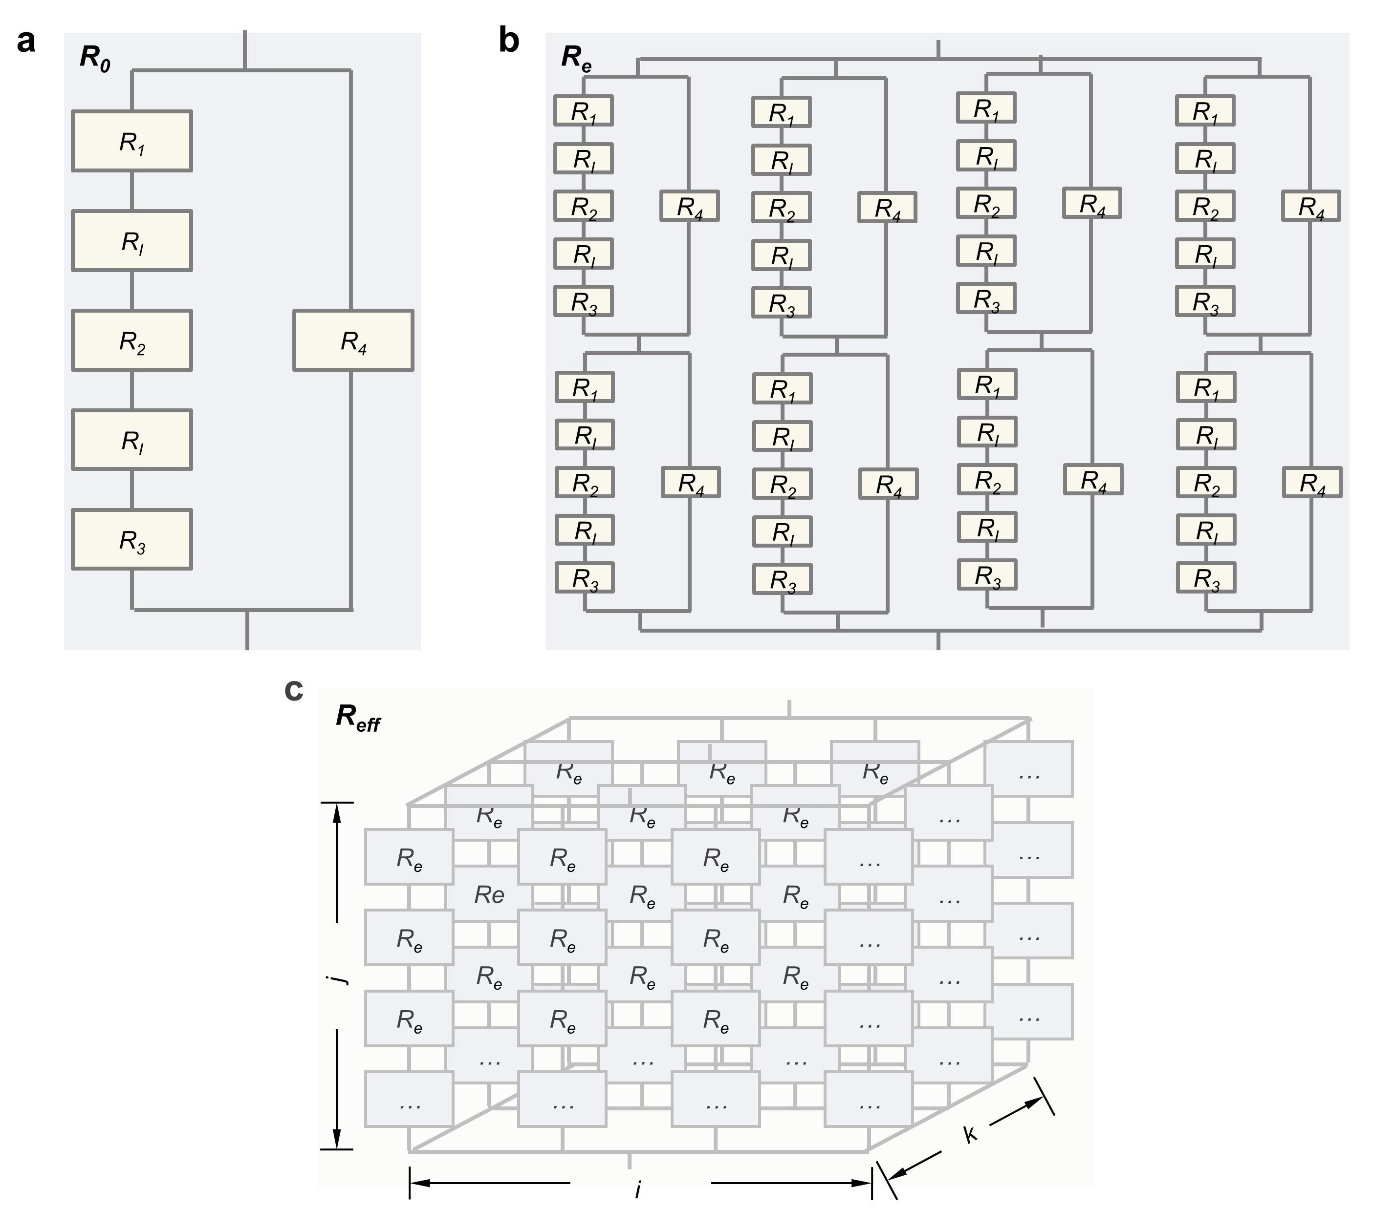
Supplementary Figure 3. (a) Schematic representation of the internal series-parallel thermal resistance network of R₀, which corresponds to 1/8 of BCC representative volume element. The network consists of series-connected resistances R₁, R₂, R₃, R_{I} and a parallel resistance R₄. (b) Illustration of the overall thermal resistance R_{e} of a complete BCC structure, composed of multiple R₀ units. (c) Schematic representation of the effective thermal resistance R_{eff} of a macroscopic polymer composite material, constructed from multiple BCC representative volume element. The number of BCC representative volume element along the length, width, and height directions is denoted as i, k, j, respectively.

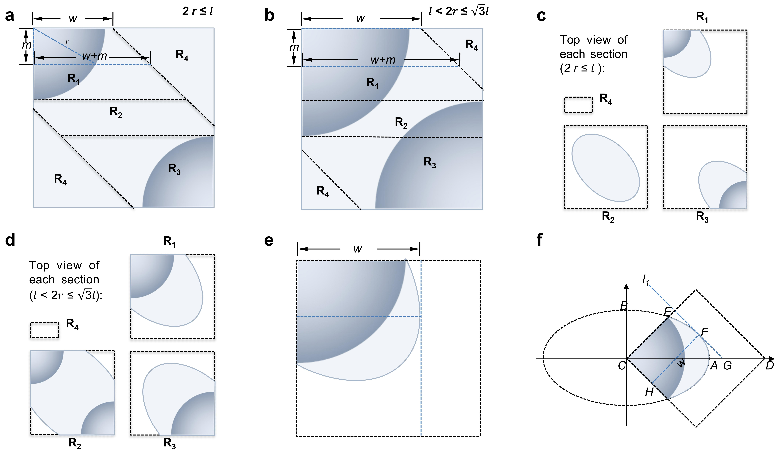
Supplementary Figure 4. (a) Schematic representation of the structural division of R₀ when $2r≤l$ ($l={(\frac{π}{3V_{f}})}^{\frac{1}{3}}r$). R₁ and R₃ each contain a single filler particle, while R₂ and R₄ consist entirely of the polymer matrix. Here, w represents the horizontal projection length at the interface between the least-resistance pathway and unit boundary and m represents the depth of heat transfer. (b) Structural division of R₀ when $l<2r≤\sqrt{3}l$. R₁ and R₃ each contain a single filler particle, R₂ contains two filler particles, and R₄ remains as the pure polymer matrix. (c) Illustration of the heat transfer cross-sections corresponding to different thermal resistances when $2r≤l$ . The cross-sections of R₁, R₂ and R₃ are defined by the intersection of the horizontal projection of the minimum heat transfer path's cylindrical region and the square boundary, while R₄ occupies the remaining portion of the square. (d) Illustration of the heat transfer cross-sections for different thermal resistances when $l<2r≤\sqrt{3}l$.. (e) Geometric interpretation of parameter w. (f) Schematic representation of the key coordinate points when embedding (e) into a Cartesian coordinate system, where the ellipse’s major and minor axes align with the coordinate system’s axes. In this geometric configuration, line l₁ with a slope of -1 is tangent to the ellipse at point F and intersects the x-axis at point G. The line segment FH is perpendicular to l₁.

Note: V_{f} of composite within the BCC representative volume element can be mathematically formulated as $V_{f}=\frac{\frac{1}{4}*\frac{4}{3}πr^{3}}{l^{3}}$ (there are only 1/4 filler in the representative volume elements), thereby establishing the functional relationship: $l={(\frac{π}{3V_{f}})}^{\frac{1}{3}}r$.The critical condition $2r≤l$ corresponds to the inequality ${2r≤(\frac{π}{3V_{f}})}^{\frac{1}{3}}r$, which constrains the volume fraction to V_{f} ≤ 13%. The critical condition $l<2r≤\sqrt{3}l$ corresponds to the inequality ${{(\frac{π}{3V_{f}})}^{\frac{1}{3}}r<2r≤\sqrt{3}(\frac{π}{3V_{f}})}^{\frac{1}{3}}r$, which constrains the volume fraction to 13% < V_{f} ≤ 68%.

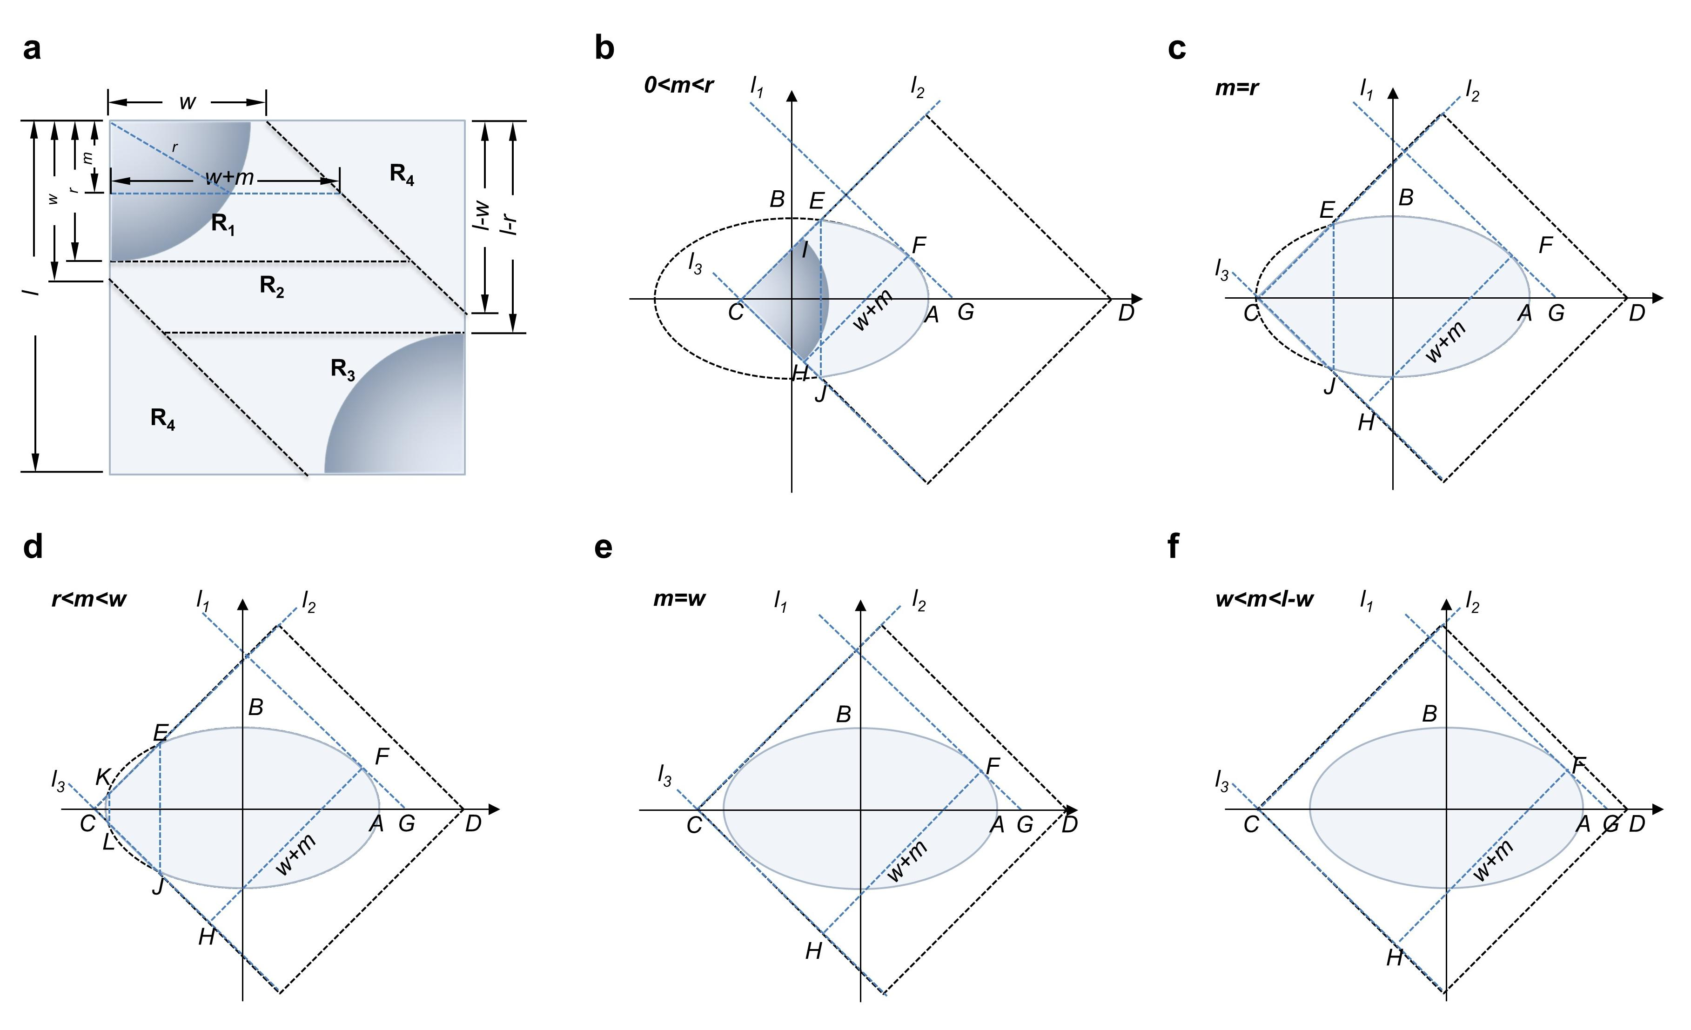
Supplementary Figure 5. (a) Geometric parameter relationships defining the structural segmentation of R₀ when 2 r < l. (b–f) Schematic illustrations of the heat transfer cross-sections in a Cartesian coordinate system and corresponding key points under different heat transfer distance conditions: 0 < m < r, m = r, r < m < w, m = w, and w < m < l−w. In (b) and (c), the ellipse intersects the x-axis and y-axis at points A and B, respectively, while the square intersects the x-axis at C and D. Line l₁ (slope = -1) is tangent to the ellipse at F and intersected the x-axis at G. Line l₂ (slope = 1) lies along the square's side and intersects the ellipse at E, whereas l₃ (slope = -1) also lies on the square's side. The line FH is parallel to l₂ with length w+m. Here, the heat transfer area comprises: (i) triangle CEJ and (ii) ellipse area right of EJ. The particle cross-section radius in (b) can be expressed as $CI=\sqrt{r^{2}-m^{2}}$. In (d), for ellipse intersections at K, E (l₂) and L, J (l₃), the area includes: (i) ellipse left of KL, (ii) trapezoid KEJL and (iii) ellipse right of EJ. In (e), both l₂ and l₃ are tangent to the ellipse. In (f), l₂ and l₃ do not intersect with the ellipse. The heat transfer area of (e) and (f) equals the full ellipse area.

Supplementary Figure 6. (a) Geometric parameter relationships defining the structural segmentation of R₀ when 2 r > l. (b–f) Schematic illustrations of the heat transfer cross-sections in a Cartesian coordinate system and corresponding key points for various heat transfer distances: 0 < m < l−w, m = l−w, l−w < m < l−r, m = l−r, and l−r < m < r. In (b), the ellipse intersects the x-axis and y-axis at points A and B, respectively, while the square intersects the x-axis at C and D. Line l₁ (slope = -1) is tangent to the ellipse at F and intersects the x-axis at G. Lines l₂ (slope = 1) and l₃ (slope = -1) lie along square edges, with l₂ intersecting the ellipse at E. FH is parallel to l₂ with length w+m. The heat transfer area comprises: (i) triangle CEJ area and (ii) ellipse area right of EJ. The particle cross-section radius is $CI=\sqrt{r^{2}-m^{2}}$. The only difference between (c) and (b) is that l₁ coincides with the square edge, where w+m = l. In (d), line l₄ intersects the ellipse at M and O on the square edge, with a perpendicular through M and O intersecting at N and P. Heat transfer area includes: (i) triangle CEJ, (ii) ellipse between EJ and MN, (iii) trapezoid MNPO and (iiii) Ellipse area right of OP. In (e), square vertex D coincides with A, with l₄ intersecting the ellipse at M and A. Heat transfer area comprises: (i) triangle CEJ, (ii) ellipse between EJ and MN, and (iii) triangle MND. In (f), features a second filler particle (radius QD), with heat transfer area calculated as in (e).

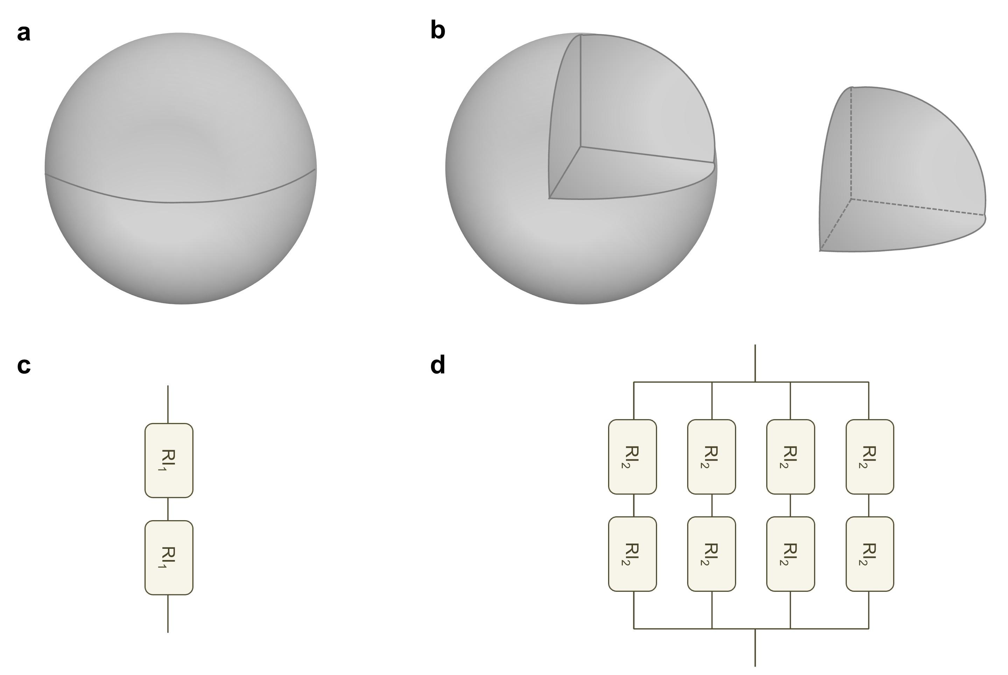
Supplementary Figure 7. Interfacial thermal resistance configurations. (a) Partitioning of a filler particle into two distinct segments, corresponding to the dual interfacial thermal resistance components: heat transfer from the upper polymer to the filler and subsequent dissipation from the filler to the lower polymer. (b) Each filler particle is partitioned into eight geometrically identical sectors, establishing four quadrantal upper interfaces for heat influx from the overlying polymer matrix and four complementary lower interfaces for heat efflux to the underlying polymer matrix. (c) Schematic representation of interfacial thermal resistance connections corresponding to case (a). (d) Schematic representation of interfacial thermal resistance connections corresponding to case (b).

Derivation of Interfacial Thermal Resistance. The area-specific interfacial resistance (R_{i}) is derived using the effective medium theory:
$R_{i}=\frac{r}{K_{m}}(\frac{K_{f}-K_{m}}{K_{f}}+\frac{3\left(K_{m}-K_{eff}\right)}{2K_{m}\left(V_{f}-1\right)+K_{eff}\left(2+V_{f}\right)})$ (S1)
The interfacial thermal resistance R_{I} in the heat transfer path is expressed as:
$R_{I}=\frac{R_{i}}{A}$ (S2)
For configuration (a) and (b):
${RI}_{a}=2*\frac{R_{i}}{2πr^{2}}=\frac{R_{i}}{πr^{2}}$ (S3)
${RI}_{b}=\frac{1}{\frac{4}{2*\frac{R_{i}}{\frac{πr^{2}}{2}}}}=\frac{R_{i}}{πr^{2}}$ (S4)
This equivalence validates the interfacial resistance calculation methodology regardless of filler segmentation.

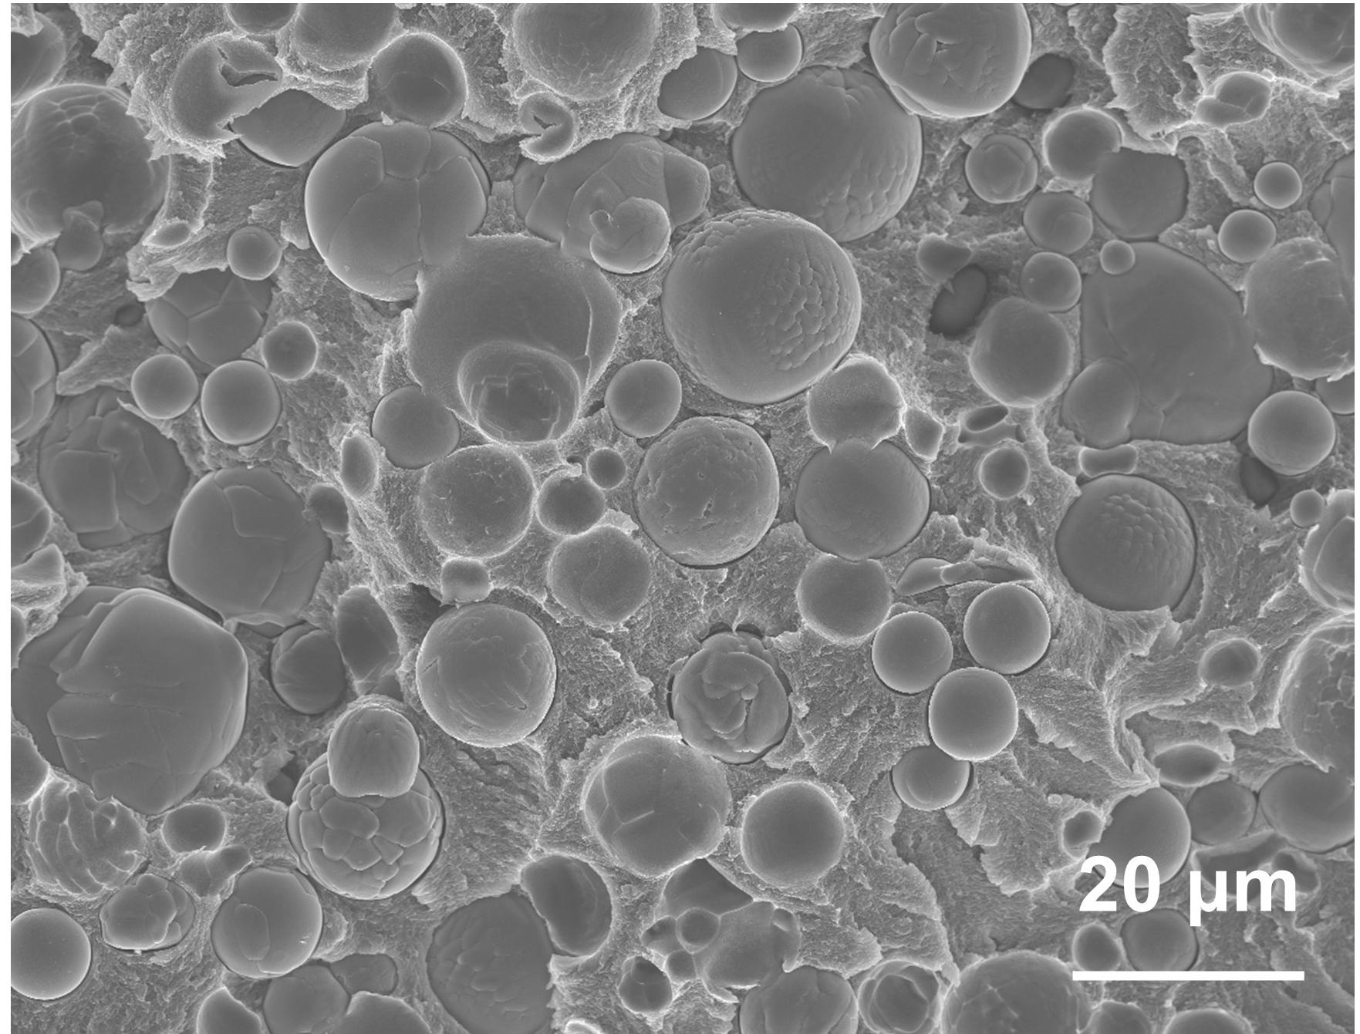
Supplementary Figure 8. SEM image of the Al₂O₃-PTFE system confirming random filler distribution.

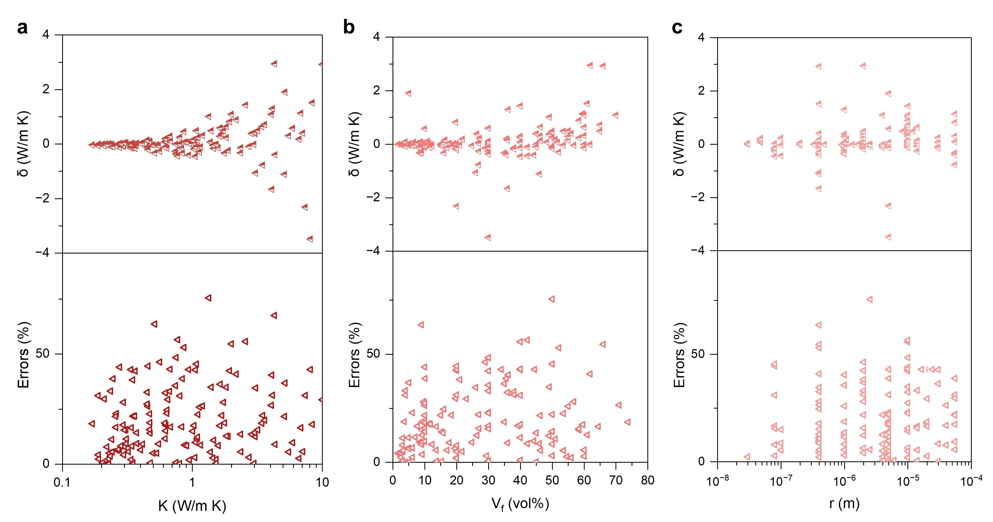
Supplementary Figure 9. (a-c) Distribution of prediction residuals and relative error from the BCC model across thermal conductivity of composites, varying filler volume fractions and different filler particle sizes.
Note: The random distribution of residuals indicates the absence of systematic bias in the BCC model across different composite systems.

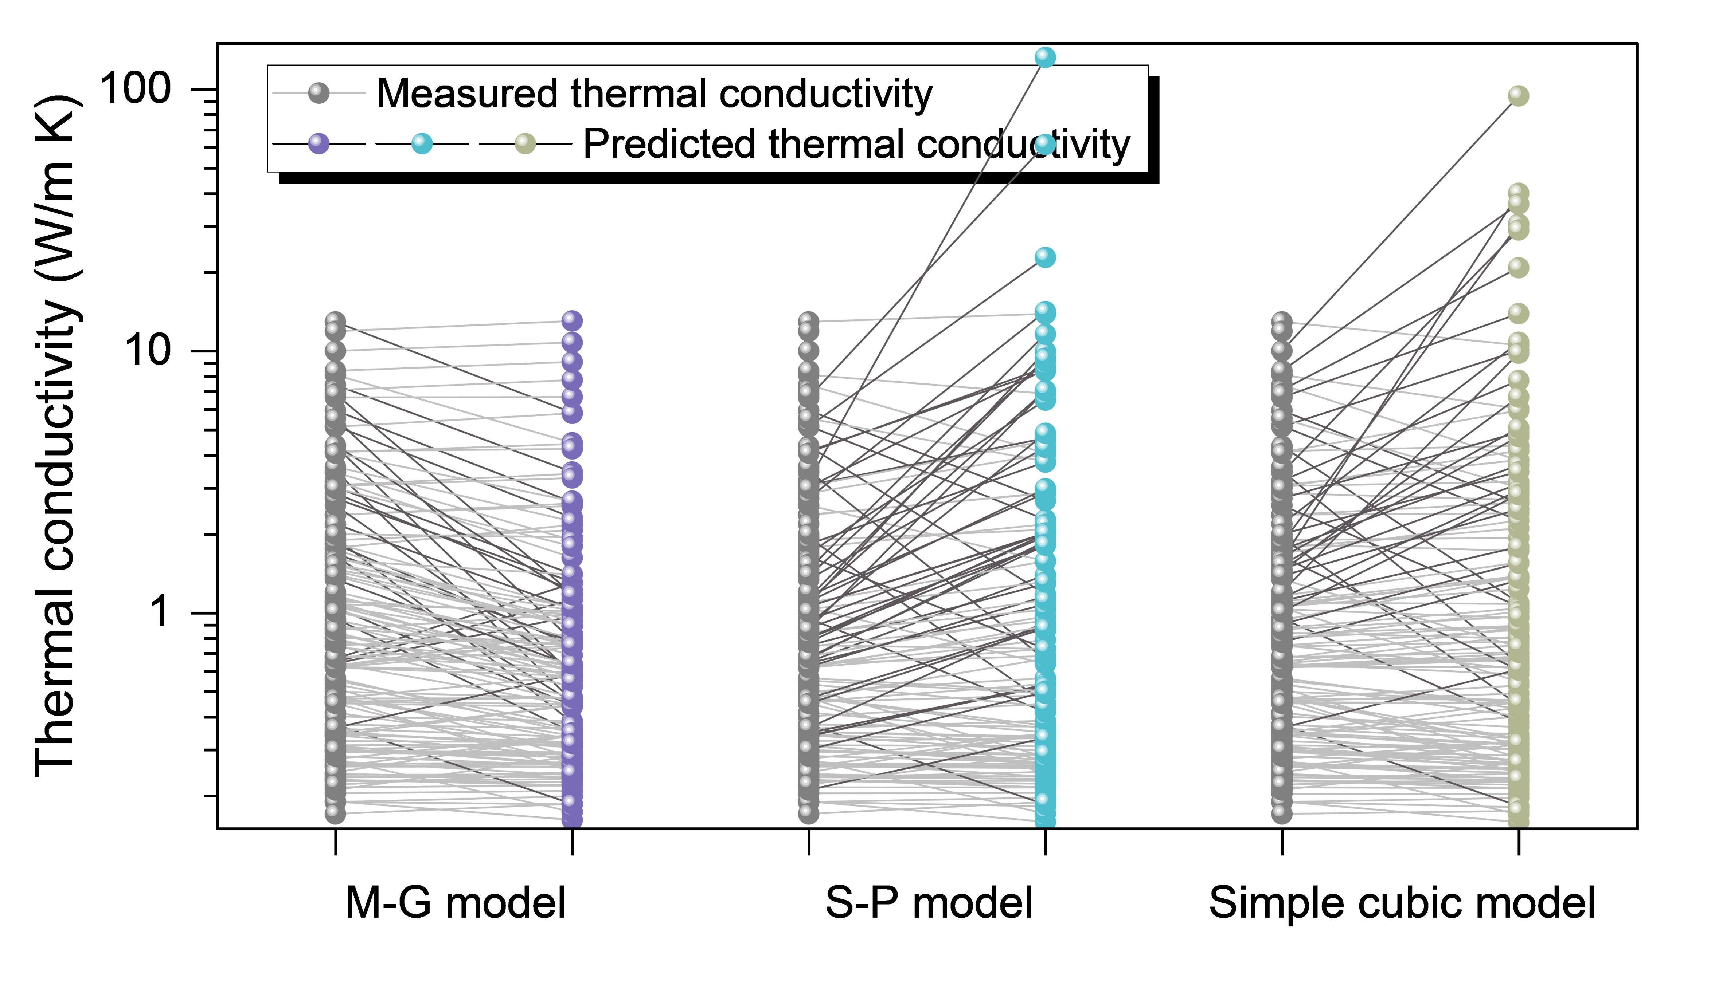
Supplementary Figure 10. Correlation between experimental thermal conductivity and predictions from Maxwell-Garnet (M-G), Series-Parallel (S-P), and Simple Cubic models, with darker lines indicating polymer composite systems exhibiting prediction errors exceeding 50%.

Supplementary Figure 11. Predictive performance analysis: (a–f) Predicted vs. experimental thermal conductivity for BCC, Bruggeman, Hasselman-Johnson (H-J), M-G, S-P, and Simple cubic models.
Note: S-P and Simple Cubic models exhibit limited predictive capability above 40 vol%, with their coefficient of determination (R²) calculated only within valid prediction ranges.
Calculation of R²
$R^{2}=1-\frac{\sum_{i=1}^{n}{{(K_{a}-K_{i})}^{2}}}{\sum_{i=1}^{n}{{(K_{a}-\overline{K})}^{2}}}$ (S5)
where R² value closer to 1 indicates a higher degree of fit and greater predictive accuracy of the model.

Supplementary Figure 12. Error distribution analysis: (a–f) Distribution of prediction residuals and relative errors as a function of thermal conductivity K for the BCC, Bruggeman, H-J, M-G, S-P, and Simple Cubic models.

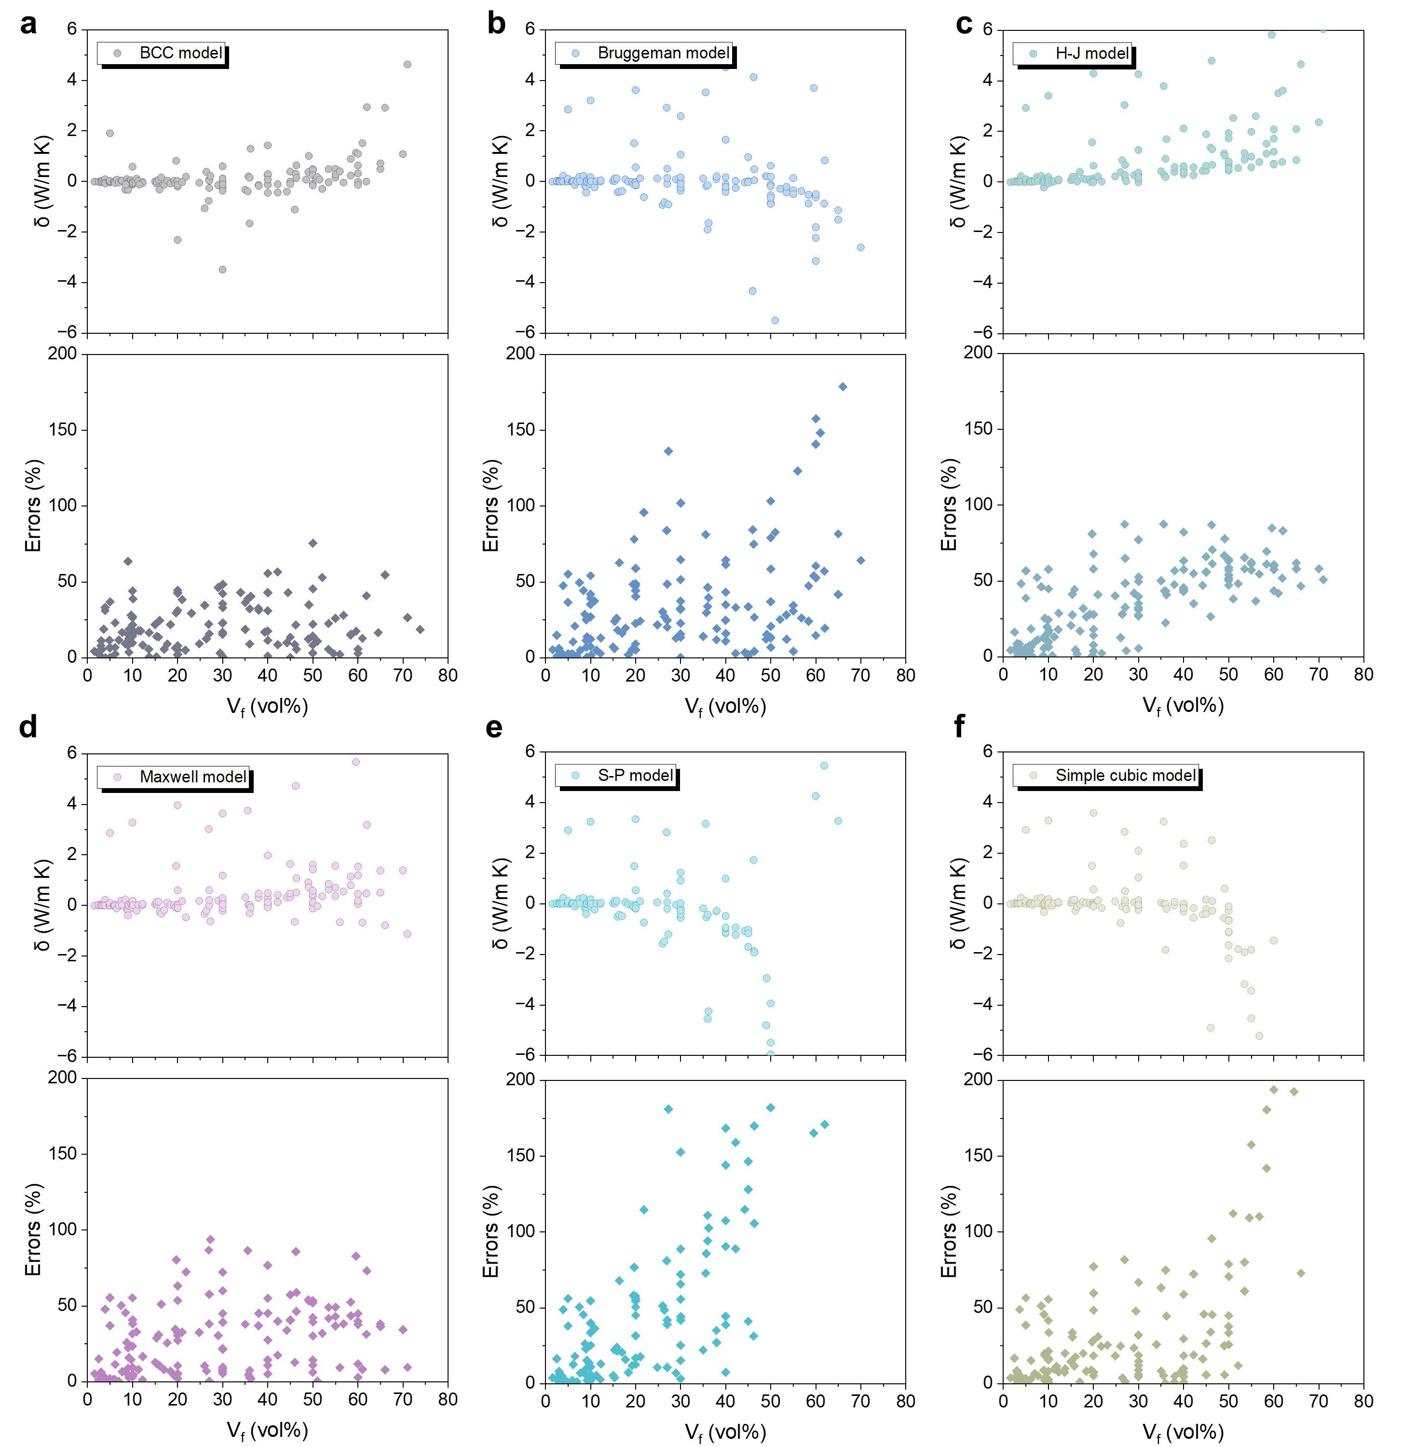
Supplementary Figure 13. Error dependence on filler fraction: (a–f) Distribution of prediction residuals and relative errors as a function of filler volume fraction V_{f} for the BCC, Bruggeman, H-J, M-G, S-P, and Simple Cubic models.

Supplementary Figure 14. Error dependence on filler size: (a–f) Distribution of prediction residuals and relative errors as a function of filler particle size r for the BCC, Bruggeman, H-J, M-G, S-P, and Simple Cubic models.

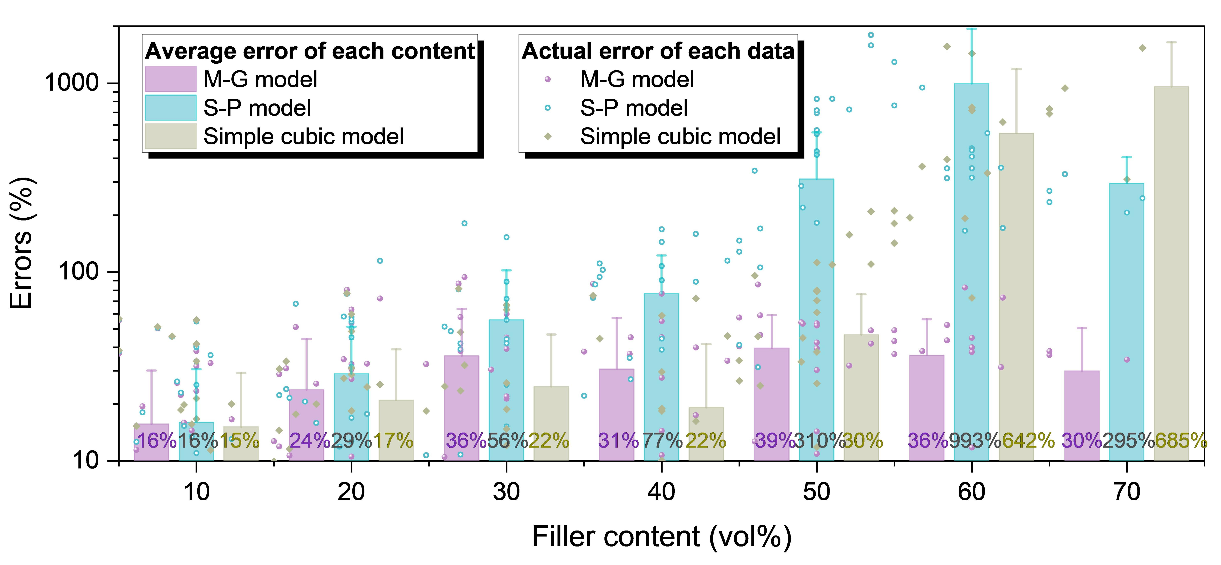
Supplementary Figure 15. Distribution of the relative prediction error for different thermal conductivity models (M-G, S-P, and Simple Cubic) across various filler volume fractions, along with the average relative error within each volume fraction range.

Table S1. Nomenclature.
Symbols | Descriptions
Vc | Critical thresholds
R² | Coefficient of determination
V_{f} | Volume fraction of filler
K_{f} | Thermal conductivity of filler
r | Radius of filler
K_{m} | Thermal conductivity of polymer
R_{i} | Interface thermal resistance per unit area
R_{K} | Kapitza radius
Ka | Experimental thermal conductivity of composites
η | Thermal enhancement ratio
K_{R} | thermal conductivity ratio
R₀ | 1/8 of the BCC unit cell thermal resistance
R_{e} | Total thermal resistance of the BCC structure
R_{eff} | Macroscopic effective thermal resistance
R_{x} (x=1, 2, 3, 4) | Thermal resistance of each part
RI | Interface thermal resistance
l | Unit cell length
Q̇ | Local heat flux
K | Thermal conductivity of the material
∇T | Temperature gradient across the material thickness
ΔT | Temperature difference between two surfaces
A | Heat transfer area
d | Heat transfer length
R | Thermal resistance
q | Rate of thermal energy conduction through the surfaces
Ai | Interfacial contact area
K_{eff} | Effective thermal conductivity of composite
W | Watts
K | Kelvin
m | Meter
δ | Residual
ω | Quality score

Table S2. Abbreviations used in this work.
Abbreviations | Descriptions
EMT | Effective medium theory
M-G model | Maxwell-Garnet model
H-J model | Hasselman-Johnson model
BCC | Body-centered cubic
MRE | Mean relative error
S-P model | Series-Parallel model
Al₂O₃ | Alumina
Si₃N₄ | Silicon nitride
CBN | Cubic boron nitride
PDMS | Polydimethylsiloxane
PEG | Polyethylene glycol
PTFE | Polytetrafluoroethylene
AlN | Aluminum nitride
ZnO | Zinc oxide
SiC | Silicon carbide

Table S3 Experimental and literature source data.
Systems | K_{a}  (W/m K) | V_{f}  (vol) | ω  (wt) | R  (m) | K_{m}  (W/m K) | K_{f}  (W/m K) | R_{i}  (K m²/W)
AlN-PTFE¹ | 0.30 | 0.03 | 0.04 | 2.00E-06 | 0.27 | 60 | 9.4E-07
AlN-PTFE¹ | 0.31 | 0.05 | 0.07 | 2.00E-06 | 0.27 | 60 | 9.4E-07
AlN-PTFE¹ | 0.37 | 0.10 | 0.14 | 2.00E-06 | 0.27 | 60 | 9.4E-07
AlN-PTFE¹ | 0.50 | 0.20 | 0.27 | 2.00E-06 | 0.27 | 60 | 9.4E-07
AlN-PTFE¹ | 0.68 | 0.30 | 0.39 | 2.00E-06 | 0.27 | 60 | 9.4E-07
AlN-LDPE² | 0.46 | 0.10 | 0.28 | 4.00E-06 | 0.36 | 180 | 1.4E-06
AlN-LDPE² | 0.75 | 0.30 | 0.60 | 4.00E-06 | 0.36 | 180 | 1.4E-06
AlN-LDPE² | 2.00 | 0.60 | 0.84 | 4.00E-06 | 0.36 | 180 | 1.4E-06
Al₂O₃-Epoxy³ | 0.17 | 0.10 | 0.27 | 2.00E-07 | 0.14 | 30 | 2.1E-07
Al₂O₃-Epoxy³ | 0.22 | 0.20 | 0.45 | 2.00E-07 | 0.14 | 30 | 2.1E-07
Al₂O₃-Epoxy³ | 0.30 | 0.30 | 0.59 | 2.00E-07 | 0.14 | 30 | 2.1E-07
Al₂O₃-Epoxy⁴ | 0.26 | 0.06 | 0.17 | 1.10E-06 | 0.23 | 30 | 7.2E-07
Al₂O₃-Epoxy⁴ | 0.32 | 0.12 | 0.32 | 1.10E-06 | 0.23 | 30 | 7.2E-07
Al₂O₃-Epoxy⁴ | 0.40 | 0.19 | 0.44 | 1.10E-06 | 0.23 | 30 | 7.2E-07
Al₂O₃-Epoxy⁴ | 0.47 | 0.27 | 0.55 | 1.10E-06 | 0.23 | 30 | 7.2E-07
Al₂O₃-Epoxy⁴ | 0.62 | 0.36 | 0.65 | 1.10E-06 | 0.23 | 30 | 7.2E-07
Cu-PVP⁵ | 0.62 | 0.07 | 0.27 | 4.80E-08 | 0.61 | 401 | 3.3E-08
Cu-PVP⁵ | 0.62 | 0.09 | 0.34 | 4.80E-08 | 0.61 | 401 | 3.3E-08
Cu-PVP⁵ | 0.63 | 0.11 | 0.39 | 4.80E-08 | 0.61 | 401 | 3.3E-08
Cu-PVP⁵ | 0.64 | 0.16 | 0.51 | 4.80E-08 | 0.61 | 401 | 3.3E-08
Cu-PVP⁵ | 0.65 | 0.22 | 0.60 | 4.80E-08 | 0.61 | 401 | 3.3E-08
Cu-PVP⁵ | 0.67 | 0.27 | 0.67 | 4.80E-08 | 0.61 | 401 | 3.3E-08
AlN-PVDF⁶ | 2.73 | 0.50 | 0.65 | 2.55E-06 | 0.33 | 186 | 2.7E-07
AlN-PVDF⁶ | 2.99 | 0.60 | 0.73 | 2.55E-06 | 0.33 | 186 | 2.7E-07
AlN-Epoxy⁷ | 0.77 | 0.42 | 0.66 | 1.00E-07 | 0.20 | 285 | 2.0E-08
AlN-Epoxy⁷ | 1.52 | 0.54 | 0.76 | 1.00E-07 | 0.20 | 285 | 2.0E-08
AlN-Epoxy⁷ | 1.84 | 0.58 | 0.79 | 1.00E-07 | 0.20 | 285 | 2.0E-08
AlN-Epoxy⁷ | 1.06 | 0.42 | 0.66 | 1.00E-05 | 0.20 | 285 | 2.5E-06
AlN-Epoxy⁷ | 1.74 | 0.54 | 0.76 | 1.00E-05 | 0.20 | 285 | 2.5E-06
AlN-Epoxy⁷ | 2.18 | 0.58 | 0.79 | 1.00E-05 | 0.20 | 285 | 2.5E-06
AlN-Epoxy⁸ | 0.47 | 0.04 | 0.10 | 5.50E-05 | 0.22 | 170 | 2.9E-06
AlN-Epoxy⁸ | 0.51 | 0.08 | 0.20 | 5.50E-05 | 0.22 | 170 | 2.9E-06
AlN-Epoxy⁸ | 1.94 | 0.20 | 0.40 | 5.50E-05 | 0.22 | 170 | 2.9E-06
AlN-Epoxy⁸ | 3.48 | 0.27 | 0.50 | 5.50E-05 | 0.22 | 170 | 2.9E-06
AlN-Epoxy⁸ | 4.34 | 0.36 | 0.60 | 5.50E-05 | 0.22 | 170 | 2.9E-06
AlN-Epoxy⁸ | 5.52 | 0.46 | 0.70 | 5.50E-05 | 0.22 | 170 | 2.9E-06
AlN-Epoxy⁸ | 6.86 | 0.60 | 0.80 | 5.50E-05 | 0.22 | 170 | 2.9E-06
Aluminum-PVDF⁹ | 0.30 | 0.03 | 0.04 | 8.00E-08 | 0.26 | 230 | 1.5E-08
Aluminum-PVDF⁹ | 0.34 | 0.08 | 0.11 | 8.00E-08 | 0.26 | 230 | 1.5E-08
Aluminum-PVDF⁹ | 0.46 | 0.20 | 0.27 | 8.00E-08 | 0.26 | 230 | 1.5E-08
Aluminum-PVDF⁹ | 0.74 | 0.30 | 0.39 | 8.00E-08 | 0.26 | 230 | 1.5E-08
Aluminum-PVDF⁹ | 1.06 | 0.40 | 0.50 | 8.00E-08 | 0.26 | 230 | 1.5E-08
Aluminum-PVDF⁹ | 1.46 | 0.50 | 0.60 | 8.00E-08 | 0.26 | 230 | 1.5E-08
Aluminum-PVDF⁹ | 1.59 | 0.60 | 0.69 | 8.00E-08 | 0.26 | 230 | 1.5E-08
Aluminum-PDMS¹⁰ | 0.19 | 0.04 | 0.10 | 1.40E-05 | 0.17 | 230 | 4.3E-06
Aluminum-PDMS¹⁰ | 0.56 | 0.27 | 0.50 | 1.40E-05 | 0.17 | 230 | 4.3E-06
Aluminum-PDMS¹⁰ | 1.10 | 0.46 | 0.61 | 1.40E-05 | 0.17 | 230 | 4.3E-06
Aluminum-Polythioctic acid¹⁰ | 0.24 | 0.04 | 0.07 | 1.40E-05 | 0.21 | 230 | 3.5E-06
Aluminum-Polythioctic acid¹⁰ | 1.05 | 0.27 | 0.40 | 1.40E-05 | 0.21 | 230 | 3.5E-06
Aluminum-Polythioctic acid¹⁰ | 1.83 | 0.46 | 0.61 | 1.40E-05 | 0.21 | 230 | 3.5E-06
ZnO-Gutta percha¹¹ | 0.19 | 0.02 | 0.09 | 4.00E-07 | 0.19 | 20 | 7.5E-08
ZnO-Gutta percha¹¹ | 0.20 | 0.03 | 0.16 | 4.00E-07 | 0.19 | 20 | 7.5E-08
ZnO-Gutta percha¹¹ | 0.22 | 0.05 | 0.23 | 4.00E-07 | 0.19 | 20 | 7.5E-08
ZnO-Gutta percha¹¹ | 0.23 | 0.06 | 0.27 | 4.00E-07 | 0.19 | 20 | 7.5E-08
ZnO-Gutta percha¹¹ | 0.23 | 0.09 | 0.37 | 4.00E-07 | 0.19 | 20 | 7.5E-08
ZnO-Gutta percha¹¹ | 0.28 | 0.11 | 0.43 | 4.00E-07 | 0.19 | 20 | 7.5E-08
ZnO-Gutta percha¹¹ | 0.42 | 0.18 | 0.56 | 4.00E-07 | 0.19 | 20 | 7.5E-08
ZnO-Gutta percha¹¹ | 0.55 | 0.25 | 0.66 | 4.00E-07 | 0.19 | 20 | 7.5E-08
ZnO-Gutta percha¹¹ | 0.83 | 0.38 | 0.78 | 4.00E-07 | 0.19 | 20 | 7.5E-08
ZnO-Gutta percha¹¹ | 0.94 | 0.44 | 0.82 | 4.00E-07 | 0.19 | 20 | 7.5E-08
ZnO-Gutta percha¹¹ | 1.14 | 0.52 | 0.87 | 4.00E-07 | 0.19 | 20 | 7.5E-08
ZnO-Gutta percha¹¹ | 1.44 | 0.57 | 0.89 | 4.00E-07 | 0.19 | 20 | 7.5E-08
ZnO-Gutta percha¹¹ | 1.53 | 0.62 | 0.91 | 4.00E-07 | 0.19 | 20 | 7.5E-08
AlN-PU¹² | 0.24 | 0.04 | 0.09 | 0.000005 | 0.21 | 200 | 3.0E-06
AlN-PU¹² | 0.26 | 0.07 | 0.16 | 0.000005 | 0.21 | 200 | 3.0E-06
AlN-PU¹² | 0.29 | 0.10 | 0.22 | 0.000005 | 0.21 | 200 | 3.0E-06
AlN-PU¹² | 0.47 | 0.16 | 0.32 | 0.000005 | 0.21 | 200 | 3.0E-06
AlN-Methylphenyl silicone¹³ | 0.23 | 0.03 | 0.10 | 0.000004 | 0.20 | 200 | 2.2E-06
AlN-Methylphenyl silicone¹³ | 0.27 | 0.06 | 0.19 | 0.000004 | 0.20 | 200 | 2.2E-06
AlN-Methylphenyl silicone¹³ | 0.31 | 0.09 | 0.27 | 0.000004 | 0.20 | 200 | 2.2E-06
AlN-Methylphenyl silicone¹³ | 0.34 | 0.12 | 0.34 | 0.000004 | 0.20 | 200 | 2.2E-06
AlN-Methylphenyl silicone¹³ | 0.35 | 0.15 | 0.40 | 0.000004 | 0.20 | 200 | 2.2E-06
AlN-Methylphenyl silicone¹³ | 0.36 | 0.18 | 0.45 | 0.000004 | 0.20 | 200 | 2.2E-06
AlN-Epoxy¹⁴ | 0.75 | 0.30 | 0.54 | 0.000001 | 0.20 | 200 | 2.3E-07
AlN-Epoxy¹⁴ | 0.84 | 0.35 | 0.59 | 0.000001 | 0.20 | 200 | 2.3E-07
AlN-Epoxy¹⁴ | 1.09 | 0.40 | 0.64 | 0.000001 | 0.20 | 200 | 2.3E-07
AlN-Epoxy¹⁴ | 1.16 | 0.45 | 0.69 | 0.000001 | 0.20 | 200 | 2.3E-07
AlN-Epoxy¹⁴ | 1.38 | 0.50 | 0.73 | 0.000001 | 0.20 | 200 | 2.3E-07
AlN-Epoxy¹⁴ | 1.63 | 0.55 | 0.77 | 0.000001 | 0.20 | 200 | 2.3E-07
AlN- Lithium aluminosilicate ¹⁵ | 5.17 | 0.05 | 0.06 | 0.000005 | 2.00 | 200 | 9.3E-08
AlN- Lithium aluminosilicate ¹⁵ | 5.92 | 0.10 | 0.12 | 0.000005 | 2.00 | 200 | 9.3E-08
AlN- Lithium aluminosilicate ¹⁵ | 7.41 | 0.20 | 0.24 | 0.000005 | 2.00 | 200 | 9.3E-08
AlN- Lithium aluminosilicate ¹⁵ | 8.11 | 0.30 | 0.35 | 0.000005 | 2.00 | 200 | 9.3E-08
AlN- Lithium aluminosilicate ¹⁵ | 12.91 | 0.40 | 0.45 | 0.000005 | 2.00 | 200 | 9.3E-08
AlN-PU¹² | 0.24 | 0.03 | 0.07 | 0.000005 | 0.22 | 200 | 2.5E-06
AlN-PU¹² | 0.26 | 0.06 | 0.14 | 0.000005 | 0.22 | 200 | 2.5E-06
AlN-PU¹² | 0.30 | 0.09 | 0.20 | 0.000005 | 0.22 | 200 | 2.5E-06
AlN-PU¹² | 0.48 | 0.15 | 0.31 | 0.000005 | 0.22 | 200 | 2.5E-06
AlN-Borosilicate glass¹⁶ | 1.77 | 0.09 | 0.13 | 0.0000004 | 1.68 | 200 | 1.8E-08
AlN-Borosilicate glass¹⁶ | 2.36 | 0.16 | 0.22 | 0.0000004 | 1.68 | 200 | 1.8E-08
AlN-Borosilicate glass¹⁶ | 3.07 | 0.26 | 0.34 | 0.0000004 | 1.68 | 200 | 1.8E-08
AlN-Borosilicate glass¹⁶ | 4.10 | 0.36 | 0.45 | 0.0000004 | 1.68 | 200 | 1.8E-08
AlN-Borosilicate glass¹⁶ | 5.13 | 0.46 | 0.56 | 0.0000004 | 1.68 | 200 | 1.8E-08
AlN-Borosilicate glass¹⁶ | 6.64 | 0.51 | 0.61 | 0.0000004 | 1.68 | 200 | 1.8E-08
AlN-Borosilicate glass¹⁶ | 7.08 | 0.56 | 0.65 | 0.0000004 | 1.68 | 200 | 1.8E-08
AlN-Borosilicate glass¹⁶ | 8.40 | 0.61 | 0.70 | 0.0000004 | 1.68 | 200 | 1.8E-08
AlN-Borosilicate glass¹⁶ | 10.00 | 0.66 | 0.74 | 0.0000004 | 1.68 | 200 | 1.8E-08
AlN-Borosilicate glass¹⁶ | 11.90 | 0.71 | 0.78 | 0.0000004 | 1.68 | 200 | 1.8E-08
AlN-Epoxy¹⁷ | 0.45 | 0.10 | 0.23 | 0.00001 | 0.20 | 200 | 2.5E-06
AlN-Epoxy¹⁷ | 0.95 | 0.20 | 0.40 | 0.00001 | 0.20 | 200 | 2.5E-06
AlN-Epoxy¹⁷ | 1.64 | 0.30 | 0.54 | 0.00001 | 0.20 | 200 | 2.5E-06
AlN-Epoxy¹⁷ | 2.57 | 0.40 | 0.64 | 0.00001 | 0.20 | 200 | 2.5E-06
AlN-PI¹⁸ | 0.23 | 0.05 | 0.11 | 0.000002 | 0.20 | 200 | 4.6E-07
AlN-PI¹⁸ | 0.31 | 0.10 | 0.19 | 0.000002 | 0.20 | 200 | 4.6E-07
AlN-PI¹⁸ | 0.35 | 0.15 | 0.28 | 0.000002 | 0.20 | 200 | 4.6E-07
AlN-PI¹⁸ | 0.53 | 0.21 | 0.37 | 0.000002 | 0.20 | 200 | 4.6E-07
AlN-PI¹⁸ | 0.64 | 0.29 | 0.48 | 0.000002 | 0.20 | 200 | 4.6E-07
AlN-PI¹⁸ | 1.03 | 0.38 | 0.58 | 0.000002 | 0.20 | 200 | 4.6E-07
AlN-PI¹⁸ | 1.69 | 0.49 | 0.68 | 0.000002 | 0.20 | 200 | 4.6E-07
AlN-PI¹⁸ | 4.36 | 0.62 | 0.79 | 0.000002 | 0.20 | 200 | 4.6E-07
Al₂O₃-Epoxy¹⁹ | 0.19 | 0.03 | 0.08 | 0.00000003 | 0.15 | 30 | 7.3E-09
Al₂O₃-Epoxy¹⁹ | 0.28 | 0.05 | 0.15 | 0.00000003 | 0.15 | 30 | 7.3E-09
Al₂O₃-Epoxy¹⁹ | 0.37 | 0.08 | 0.21 | 0.00000003 | 0.15 | 30 | 7.3E-09
Al₂O₃-Epoxy²⁰ | 0.21 | 0.20 | 0.45 | 0.00001 | 0.17 | 30 | 9.2E-06
Al₂O₃-Epoxy²⁰ | 0.45 | 0.36 | 0.65 | 0.00001 | 0.17 | 30 | 9.2E-06
Al₂O₃-Epoxy²⁰ | 1.34 | 0.49 | 0.76 | 0.00001 | 0.17 | 30 | 9.2E-06
CBN-PTFE | 0.25 | 0.10 | 0.15 | 0.00003 | 0.24 | 30 | 1.0E-05
CBN-PTFE | 0.35 | 0.20 | 0.28 | 0.00003 | 0.24 | 30 | 1.0E-05
CBN-PTFE | 0.62 | 0.30 | 0.40 | 0.00003 | 0.24 | 30 | 1.0E-05
CBN-PTFE | 0.87 | 0.40 | 0.51 | 0.00003 | 0.24 | 30 | 1.0E-05
CBN-PTFE | 1.11 | 0.50 | 0.61 | 0.00003 | 0.24 | 30 | 1.0E-05
Al₂O₃-PTFE | 0.26 | 0.10 | 0.17 | 1.00E-05 | 0.26 | 30 | 7.5E-06
Al₂O₃-PTFE | 0.34 | 0.20 | 0.31 | 1.00E-05 | 0.26 | 30 | 7.5E-06
Al₂O₃-PTFE | 0.47 | 0.30 | 0.44 | 1.00E-05 | 0.26 | 30 | 7.5E-06
Al₂O₃-PTFE | 0.67 | 0.40 | 0.55 | 1.00E-05 | 0.26 | 30 | 7.5E-06
Al₂O₃-PTFE | 0.86 | 0.50 | 0.65 | 1.00E-05 | 0.26 | 30 | 7.5E-06
Si₃N₄-PTFE | 0.28 | 0.10 | 0.15 | 2.00E-06 | 0.26 | 85 | 1.0E-06
Si₃N₄-PTFE | 0.34 | 0.20 | 0.28 | 2.00E-06 | 0.26 | 85 | 1.0E-06
Si₃N₄-PTFE | 0.36 | 0.30 | 0.40 | 2.00E-06 | 0.26 | 85 | 1.0E-06
Si₃N₄-PTFE | 0.80 | 0.40 | 0.51 | 2.00E-06 | 0.26 | 85 | 1.0E-06
Si₃N₄-PTFE | 1.08 | 0.50 | 0.61 | 2.00E-06 | 0.26 | 85 | 1.0E-06
Al₂O₃-PDMS | 0.80 | 0.45 | 0.77 | 1.00E-05 | 0.14 | 30 | 3.5E-06
Al₂O₃-PDMS | 0.91 | 0.50 | 0.80 | 1.00E-05 | 0.14 | 30 | 3.5E-06
Al₂O₃-PDMS | 1.01 | 0.55 | 0.83 | 1.00E-05 | 0.14 | 30 | 3.5E-06
Al₂O₃-PDMS | 1.20 | 0.60 | 0.86 | 1.00E-05 | 0.14 | 30 | 3.5E-06
Al₂O₃-PDMS | 1.40 | 0.65 | 0.88 | 1.00E-05 | 0.14 | 30 | 3.5E-06
Al₂O₃-PEG | 2.86 | 0.45 | 0.75 | 1.00E-05 | 0.37 | 30 | 9.9E-07
Al₂O₃-PEG | 3.02 | 0.50 | 0.78 | 1.00E-05 | 0.37 | 30 | 9.9E-07
Al₂O₃-PEG | 3.19 | 0.55 | 0.81 | 1.00E-05 | 0.37 | 30 | 9.9E-07
Al₂O₃-PEG | 3.43 | 0.60 | 0.84 | 1.00E-05 | 0.37 | 30 | 9.9E-07
Al₂O₃-PEG | 3.61 | 0.65 | 0.87 | 1.00E-05 | 0.37 | 30 | 9.9E-07
Al₂O₃-PEG | 4.07 | 0.70 | 0.89 | 1.00E-05 | 0.37 | 30 | 9.9E-07

Reference
1. Pan, C., Kou, K., Zhang, Y., Li, Z. & Wu, G. Enhanced through-plane thermal conductivity of PTFE composites with hybrid fillers of hexagonal boron nitride platelets and aluminum nitride particles. Compos. Part B 153, 1–8 (2018).
2. Lee, G. W., Park, M., Kim, J., Lee, J. I. & Yoon, H. G. Enhanced thermal conductivity of polymer composites filled with hybrid filler. Compos. Part A 37, 727–734 (2006).
3. Xie, X. & Yang, D. Multi-functionalization of Al₂O₃ nanoparticles for enhancing thermal conductivity of epoxy natural rubber composites. Appl. Surf. Sci. 602, 154335 (2022).
4. Feng, Y. et al. Simultaneous improvement in the flame resistance and thermal conductivity of epoxy/Al₂O₃ composites by incorporating polymeric flame retardant-functionalized graphene. J. Mater. Chem. A 5, 13544–13556 (2017).
5. Bhanushali, S. et al. Enhanced thermal conductivity of copper nanofluids: The effect of filler geometry. ACS Appl. Mater. Interfaces 9, 18925–18935 (2017).
6. Dang, T. M. L. et al. Enhanced thermal conductivity of polymer composites via hybrid fillers of anisotropic aluminum nitride whiskers and isotropic spheres. Compos. Part B 114, 237–246 (2017).
7. Choi, S. & Kim, J. Thermal conductivity of epoxy composites with a binary-particle system of aluminum oxide and aluminum nitride fillers. Compos. Part B 51, 140–147 (2013).
8. Lee Sanchez, W. A. et al. Highly thermally conductive epoxy composites with AlN/BN hybrid filler as underfill encapsulation material for electronic packaging. Polymers 14, 2950 (2022).
9. Zhou, W., Chen, Q., Sui, X., Dong, L. & Wang, Z. Enhanced thermal conductivity and dielectric properties of Al/β-SiCw/PVDF composites. Compos. Part A 71, 184–191 (2015).
10. Wang, Z. et al. Superior stretchable, low thermal resistance and efficient self-healing composite elastomers for thermal management. J. Mater. Chem. A 10, 21923–21932 (2022).
11. Dong, M. et al. New gutta percha composite with high thermal conductivity and low shear viscosity contributed by the bridging fillers containing ZnO and CNTs. Compos. Part B 173, 106903 (2019).
12. Yang, C. T., Hsiang, H. I., Huang, T. S., Huang, P. C. & Han, Y. K. Thermal conductivity and dielectric properties of PEDOT:PSS-AlN filler reinforced water-soluble polymer composites. Ceram. Int. 43, S710–S716 (2017).
13. Han, J. et al. SiO₂ bridged AlN/methylphenyl silicone resin composite with integrated superior insulating property, high-temperature resistance, and high thermal conductivity. J. Colloid Interf. Sci. 661, 91–101 (2024).
14. Zhao, Z. et al. Synergistic effects of oriented AlN skeletons and 1D SiC nanowires for enhancing the thermal conductivity of epoxy composites. J. Alloys Compd. 963, 171244 (2023).
15. Li, Z. et al. Significant improvement of thermal conductivity for AlN/LAS composite with low thermal expansion. Ceram. Int. 46, 28668–28675 (2020).
16. Ma, M., Liu, Z., Li, Y., Zeng, Y. & Yao, D. Enhanced thermal conductivity of low-temperature sintered borosilicate glass–AlN composites with β-Si₃N₄ whiskers. J. Eur. Ceram. Soc. 33, 833–839 (2013).
17. Kim, K. & Kim, J. Magnetic aligned AlN/epoxy composite for thermal conductivity enhancement at low filler content. Compos. Part B 93, 67–74 (2016).
18. Jiajun, W. & XiaoSu, Y. Effects of interfacial thermal barrier resistance and particle shape and size on the thermal conductivity of AlN/PI composites. Compos. Sci. Technol. 64, 1623–1628 (2004).
19. Bian, W. et al. The synergistic effects of the micro-BN and nano-Al₂O₃ in micro-nano composites on enhancing the thermal conductivity for insulating epoxy resin. Compos. Sci. Technol. 168, 420–428 (2018).
20. Im, H. & Kim, J. The effect of Al₂O₃ doped multi-walled carbon nanotubes on the thermal conductivity of Al₂O₃/epoxy terminated poly(dimethylsiloxane) composites. Carbon 49, 3503–3511 (2011).

