Supporting Information
Synthesis and Germination Activity of 5-(thio)phenol-3-methylfuran-2(5H)-one Analogues as Strigolactone Mimics
Linfeng Kai,¹ Chao Qin,¹ Hongfei He,¹ Qing X. Li,² Rimao Hua, ¹ Pei Lv¹*
1 Department of Plant and Environmental Health, Anhui Provincial Key Laboratory of Hazardous Factors and Risk Control of Agri-food Quality Safety, Anhui Agricultural University, No. 130 Changjiang West Road, Hefei 230036, China
2 Department of Molecular Biosciences and Bioengineering, University of Hawaii at Manoa, 1955 East-West Road, Honolulu, Hawaii 96822, United States

Table of Contents

1.General Procedures and NMR Data 1
2.Biological Assay. 19
3. NMR spectra 21

1.General Procedures and NMR Data
Synthesis of 5-hydroxy-3-methylfuran-2 (5H) -one (1).
A total of 10 drops of H₂SO₄ were added to a solution of methylmalonic acid (7.00 g, 59.3 mmol) and glyoxal (3.4 g, 59.3 mmol) in H₂O (60 mL). The mixture was stirred at 110 °C for 12 h. Then, NaCl was added to the mixture to saturation at room temperature and extracted three times with EtOAc. The combined organic layers were dried over Na₂SO₄, filtered, and concentrated. The residue was purified by silica gel column chromatography to afford 5-hydroxy-3-methylfuran-2(5H)-one as a solid (3.15 g, 46%).
Synthesis of 5-hydroxy-3-methylfuran-2(5H)-one（2).
SOCl₂ (1.2 mL, 16.5 mmol) and DMF (160 µL, 2.07 mmol) were charged in a flask. A solution of 5-hydroxy-3-methylfuran-2(5H)-one (3.15 g, 27.64 mmol) in a minimum amount of CH₂Cl₂ (4 mL) was added to the above mixture. The mixture was stirred at 90 °C for 10 min and cooled to room temperature. Then, the mixture was diluted with CH₂Cl₂-hexane (1:1) and quenched with sat. aq. NaHCO₃ at 0 °C. The mixture was extracted three times with CH₂Cl₂-hexane (1:4). The combined organic layers were washed with brine, dried over Na₂SO₄, filtered, and concentrated. The residue was purified by silica gel column chromatography (10-20% EtOAc/hexane) to afford 5-chloro-3-methylfuran-2(5H)-one as a yellowish oil (1.76 g，47%).
General Procedure to Prepare novel strigolactone mimics (3a-3y).
Phenols (1.89 mmol), 4A molecular sieve (1 g), and potassium iodide (31 mg, 0.189 mmol) were added to a dry round-bottomed flask containing tetrahydrofuran (20 mL) under N₂ and potassium tert-butoxide (2 mL of a 1.0 M solution in tert-butanol, 2 mmol) was introduced with cooling (ice bath) and the mixture was stirred for 10 min.Freshly compound 2 (250 mg, 1.89 mmol) was added and the reaction mixture was stirred for 3 h.Water(10 mL)was added and the product was extracted with EtOAc(25 mL) three times and dried over anhydrous Mg₂SO₄. The residue was purified by silica gel column chromatography to afford 3a-3y.
General Procedure to Prepare novel strigolactone mimics(4a-4i).
Thiophenols (1.89 mmol), 4A molecular sieve (1 g), and potassium iodide (31 mg, 0.189 mmol) were added to a dry round-bottomed flask containing tetrahydrofuran (20 mL) under N₂ and potassium tert-butoxide (2 mL of a 1.0 M solution in tert-butanol, 2 mmol) was introduced with cooling (ice bath) and the mixture was stirred for 10 min .Freshly compound 2 (250 mg, 1.89 mmol) was added and the reaction mixture was stirred for 3 h .Water(10 mL)was added and the product was extracted with EtOAc (25 mL) three times and dried over anhydrous Mg₂SO₄. The residue was purified by silica gel column chromatography to afford 4a-4i.

5-hydroxy-3-methylfuran-2 (5H) -one (1):
R_{f}=0.3, (PE/EA=1/5), 3.15g, 46%; m.p. 105-106 °C.
¹H NMR (600 MHz, CDCl₃) δ 6.93 – 6.81 (m, 1H), 6.13 – 6.03 (m, 1H), 1.93 (s, 3H).
¹³C NMR (150 MHz, CDCl₃) δ 170.78, 145.92, 131.87, 85.21, 10.38. HRMS [ESI⁻] for C₁₁H₉ClO₃[(M-H)⁻], m/z Calcd:114.0317; Found: 114.0315.
5-hydroxy-3-methylfuran-2(5H)-one (2):
R_{f}=0.3, (PE/EA=1/10), 1.76g, 47%; m.p.15-16°C.
¹H NMR (600 MHz, CDCl₃) δ 7.07 (m= 1.8 Hz, 1H), 6.53 (m= 1.7 Hz, 1H), 2.00 (s, 3H).
¹³C NMR (150 MHz, CDCl₃) δ 173.04,144.86,133.50, 97.07, 10.38. HRMS [ESI⁻] for C₁₁H₉ClO₃[(M-H)⁻], m/z Calcd:131.9978; Found: 131.9977.
3-methyl-5-phenoxyfuran-2(5H)-one(3a):
R_{f}=0.3, (PE/EA=1/10), 215mg, 91%; m.p. 132-134 °C
¹H NMR (600 MHz, DMSO-d₆) δ 7.43 – 7.35 (m, 3H), 7.11-7.16 (m = 8.1 Hz, 3H), 6.73 – 6.68 (m, 1H), 1.90 (s, 3H).
¹³C NMR (150 MHz, DMSO-d₆) δ 171.37, 156.01, 144.26, 132.80, 129.82, 123.24, 116.64, 98.64, 10.16.
HRMS [ESI⁻] for C₁₁H₁₀O₃ [(M-H)⁻], m/z Calcd: 109.0630; Found: 109.0633.
5-(4-bromophenoxy)-3-methylfuran-2(5H)-one (3b):
R_{f}=0.3, (PE/EA=1/10), 205mg, 95%; m.p. 147-148 °C
¹H NMR (600 MHz, DMSO-d₆) δ 7.54 (d, J = 11.3 Hz, 2H), 7.38 (s, 1H), 7.09 (d, J = 11.3 Hz, 2H), 6.68 (s, 1H), 1.88 (s, 3H).
¹³C NMR (150 MHz, DMSO-d₆) δ 155.66, 144.42, 133.34, 132.94, 119.35, 115.35, 98.94, 10.55.
HRMS [ESI-] for C₁₁H₉BrO₃ [(M-H)-], m/z Calcd: 267.9735; Found: 267.726.
5-(4-chlorophenoxy)-3-methylfuran-2(5H)-one (3c):
R_{f}=0.3, (PE/EA=1/10), 300mg, 89%; m.p. 122-123 °C
¹H NMR (600 MHz, DMSO-d₆) δ 7.41 (d, J = 8.8 Hz, 2H), 7.38 (s, 1H), 7.14 (d, J = 9.0 Hz, 2H), 6.68 (s, 1H), 1.88 (s, 3H).
¹³C NMR (150 MHz, DMSO-d₆) δ 195.08, 171.61, 155.19, 144.43, 133.34, 130.02, 127.53, 118.91, 99.02, 10.55.
HRMS [ESI-] for C₁₁H₉ClO₃ [(M-H)-], m/z Calcd: 224.0240; Found: 224.0236.
5-(4-fluorophenoxy)-3-methylfuran-2(5H)-one (3d):
R_{f}=0.3, (PE/EA=1/10), 280 mg, 90%; m.p. 133-134 °C
¹H NMR (600 MHz, CDCl₃) δ 7.12-7.08(m, 2H), 7.04-6.98(m, 2H), 6.97 (s, 1H), 6.21 (s, 1H), 2.01 (s, 3H).
¹³C NMR (150 MHz, DMSO-d₆) δ 171.66,159.32, 157.74,152.59,144.50,133.30,119.06,116.71,116.55,99.61,10.52.
HRMS [ESI-] for C₁₁H₉FO₃ [(M-H)-], m/z Calcd:208.1884; Found: 208.1885.
methyl4-((4-methyl-5-oxo-2,5-dihydrofuran-yl)oxy)benzoate(3e): R_{f}=0.3, (PE/EA=1/10), 310 mg, 89%; m.p. 112-113 °C
¹H NMR (600 MHz, DMSO-d₆) δ 7.99 (d, J = 8.9 Hz, 2H), 7.43 (s, 1H), 7.25 (d, J = 9.0 Hz, 2H), 6.84 (s, 1H), 3.84 (s, 3H), 1.92 (s, 3H).
¹³C NMR (150 MHz, DMSO-d₆) δ 171.56, 166.08, 160.02, 144.36, 133.39, 131.79, 124.79, 116.69, 98.30, 52.44, 10.56.
HRMS [ESI-] for C₁₃H₁₂O₅ [(M-H)-], m/z Calcd:248.0685; Found:248.0684.
4-methyl-2-((4-methyl-5-oxo-2,5-dihydrofuran-2- yl)oxy)benzaldehyde (3f):
R_{f}=0.3, (PE/EA=1/15), 300 mg, 92%; m.p.115-116 °C
¹H NMR (600 MHz, CDCl₃) δ 10.21 (s, 1H), 7.53 – 7.37 (m, 1H), 7.26 (s, 1H), 7.09 (d, J = 7.9 Hz, 1H), 6.86 – 6.67 (m, 1H), 2.40 (s, 3H), 1.91 (s, 3H).
¹³C NMR (150 MHz, DMSO-d₆) δ 171.79, 156.51, 144.71, 139.49, 133.07, 125.12, 114.66, 99.12, 21.38, 10.53.
HRMS [ESI-] for C₁₃H₁₄O₃ [(M-H)-], m/z Calcd: 218.2520; Found:218.2522.
5-(3,5-dimethylphenoxy)-3-methylfuran-2(5H)-one(3g):
R_{f}=0.3, (PE/EA=1/10), 315 mg, 94%; m.p. 125-126 °C
¹H NMR (600 MHz, CDCl₃) δ 6.95 (s, 1H), 6.80-6.70 (m, 3H), 6.26 (s, 1H), 2.30 (s, 6H), 2.00 (s, 3H).
¹³C NMR (150 MHz, DMSO-d₆) δ 171.79, 156.51, 144.71, 139.49, 133.07, 125.12, 114.66, 99.12, 21.38, 10.53.
HRMS [ESI⁻] for C₁₃H₁₄O₃[(M-H)⁻], m/z Calcd: 218.2520; Found:218.2522.
3-methyl-5-(4-nitrophenoxy)furan-2(5H)-one (3h):
R_{f}=0.3, (PE/EA=1/10), 216 mg, 85%; m.p. 110-111 °C
¹H NMR (600 MHz, DMSO-d₆) δ 9.92 (s, 1H), 7.93 (d, J = 6.6 Hz, 2H), 7.43 (s, 1H), 7.31 (d, J = 8.7 Hz, 2H), 6.86 (s, 1H), 1.91 (s, 3H).
¹³C NMR (150 MHz, DMSO-d₆) δ 171.40, 161.22, 144.13, 143.16, 133.60, 126.40, 117.26, 98.19, 10.58.
HRMS [ESI⁻] for C₁₁H₉NO₅ [(M-H)⁻], m/z Calcd: 235.0481; Found: 235.0475.
4-((4-methyl-5-oxo-2,5-dihydrofuran-2-yl)oxy)benzaldehyde(3i): R_{f}=0.3, (PE/EA=1/10), 300 mg, 90%; m.p. 12-14 °C
¹H NMR (600 MHz, DMSO-d₆) δ 9.92 (d, J = 2.9 Hz, 1H), 7.93 (dd, J = 8.4, 2.9 Hz, 2H), 7.43 (s, 1H), 7.31 (dd, J = 8.5, 2.7 Hz, 2H), 6.86 (s, 1H), 1.91 (s, 3H).
¹³C NMR (150MHz, DMSO-d₆) δ 191.98, 171.54, 160.92, 144.32, 133.46, 132.24, 132.02, 117.07, 98.18, 10.57.
HRMS [ESI⁻] for C₁₂H₁₀O₄[(M-H)⁻], m/z Calcd: 218.0579; Found: 218.0573.
3-methyl-5-(4-(trifluoromethyl )phenoxy)furan-2(5H)-one (3j):
R_{f}=0.3, (PE/EA=1/10), 263 mg, 92%; m.p. 142-143 °C
¹H NMR (600 MHz, DMSO-d₆) δ 7.76 (dd, J = 9.0, 2.6 Hz, 2H), 7.44 (s, 1H), 7.33 (dd, J = 9.1, 2.6 Hz, 2H), 6.84 (s, 1H), 1.92 (s, 3H).
¹³C NMR (150 MHz, DMSO-d₆) δ 191.98, 171.54, 160.92, 144.32, 133.46, 132.24, 132.02, 117.07, 98.18, 10.57.
HRMS [ESI⁻] for C₁₂H₁₀O₄ [(M-H)⁻], m/z Calcd: 218.0579; Found: 218.0573.
3-methyl-5-(4-(methylsulfonyl)phenoxy)furan-2(5H)-one (3k):
R_{f}=0.3, (PE/EA=1/10), 356 mg, 91%; m.p. 135-136 °C
¹H NMR (600 MHz, DMSO-d₆) δ 7.94 (d, J = 8.7 Hz, 2H), 7.45 (s, 1H), 7.37 (d, J = 8.8 Hz, 2H), 6.87 (s, 1H), 3.19 (s, 3H), 1.92 (s, 3H).
¹³C NMR (151 MHz, DMSO-d₆) δ 171.48, 159.95, 144.25, 135.69, 133.51, 129.83, 117.26, 98.28, 44.27, 10.57.
HRMS [ESI-] for C₁₂H₁₂O₅S [(M-H)-], m/z Calcd: 268.2830; Found: 268.2825.
5-(4-(tert-butyl)phenoxy)-3-methylfuran-2(5H)-one (3l):
R_{f}=0.3, (PE/EA=1/10), 305 mg, 91%; m.p. 141-142 °C.
¹H NMR (600 MHz, DMSO-d₆) δ 7.41 – 7.33 (m, 3H), 7.03 (d, J = 8.8 Hz, 2H), 6.63 (s, 1H), 1.88 (s, 3H), 1.25 (s, 9H).
¹³C NMR (150 MHz, DMSO-d₆) δ 171.79, 154.23, 146.00, 144.73, 133.14, 126.79, 116.60, 99.32, 34.41, 31.71, 10.56.
HRMS [ESI⁻] for C₁₅H₁₈O₃ [(M-H)⁻], m/z Calcd: 246.1256; Found: 246.1259.
5-([1,1'-biphenyl]-4-yloxy)-3-methylfuran-2(5H)-one (3m):
R_{f}=0.3, (PE/EA=1/15), 291 mg, 89%; m.p. 135-136 °C.
¹H NMR (600 MHz, DMSO-d₆) δ 7.66 (d, J = 6.7 Hz, 2H), 7.62 (d, J = 7.8 Hz, 2H), 7.46 – 7.39 (m, 3H), 7.32 (s, 1H), 7.20 (d, J = 6.7 Hz, 2H), 6.74 (s, 1H), 1.90 (s, 3H).
¹³C NMR (150 MHz, DMSO-d₆) δ 171.74, 155.98, 144.60, 139.88, 135.67, 133.26, 129.35, 128.45, 127.59, 126.86, 117.48, 99.05, 10.57.
HRMS [ESI⁻] for C₁₇H₁₄O₃ [(M-H)⁻], m/z Calcd: 266.0943; Found: 266.0935.
5-(3-methoxyphenoxy)-3-methylfuran-2(5H)-one (3n):
R_{f}=0.3, (PE/EA=1/10), 340 mg, 92%; m.p. 16-17 °C
¹H NMR (600 MHz, DMSO-d₆) δ 7.37 (s, 1H), 7.25 (s, 1H), 6.72-6.64 (m = 15.2, 8.8 Hz, 4H), 3.73 (s, 3H), 1.88 (s, 3H).
¹³C NMR (150 MHz, DMSO-d₆) δ 171.74, 160.94, 157.53, 144.58, 133.17, 130.72, 109.31, 108.97, 103.31, 98.94, 55.74, 10.54.
HRMS [ESI⁻] for C₁₂H₁₂O₄[(M-H)⁻], m/z Calcd: 220.0736; Found: 220.0725.
3-methyl-5-(naphthalen-2-yloxy)furan-2(5H)-one (3o):
R_{f}=0.3, (PE/EA=1/10), 256 mg, 95%; m.p. 119-120 °C
¹H NMR (600 MHz, DMSO-d₆) δ 7.91 (d, J = 8.8 Hz, 1H), 7.89-7.83 (m, 2H), 7.61 (s, 1H),7.62-7.59 (m, 1H), 7.42 (dd, J = 14.3, 6.7 Hz, 2H), 7.28 (dd, J = 8.9, 2.6 Hz, 1H), 6.83 (s, 1H), 1.91 (s, 3H).
¹³C NMR (150 MHz, DMSO-d₆) δ 171.75, 154.45, 144.64, 139.06, 133.11, 129.29, 117.04, 99.34, 27.75, 16.14, 10.50.
HRMS [ESI⁻] for C₁₅H₁₂O₃ [(M-H)⁻], m/z Calcd:240.0786; Found: 240.0785.
3-methyl-5-(pyridin-4-yloxy)furan-2(5H)-one (3p):
R_{f}=0.3, (PE/EA=1/10), 345 mg, 90%; m.p. 126-127 °C.
¹H NMR (600 MHz, DMSO-d₆) δ 7.69 (d, J = 7.3 Hz, 2H), 7.38 (s, 1H), 6.75 (s, 1H), 6.11 (d, J = 7.8 Hz, 2H), 1.93 (s, 3H).
¹³C NMR (150 MHz, DMSO-d₆) δ 171.46, 143.19, 139.16, 134.89, 118.35, 90.06, 10.88.
HRMS [ESI⁻] for C₁₀H₉NO₃ [(M-H)⁻], m/z Calcd:191.0582; Found: 191.0574.
3-methyl-5-(p-tolyloxy)furan-2(5H)-one (3q):
R_{f}=0.3, (PE/EA=1/10), 345 mg, 92%; m.p. 120-121 °C.
¹H NMR (600 MHz, DMSO-d₆) δ 7.37 (s, 1H), 7.17 (d, J = 8.8 Hz, 2H), 7.01 (d, J = 8.7 Hz, 2H), 6.63 (s, 1H), 2.27 (s, 3H), 1.89 (s, 3H).
¹³C NMR (150 MHz, DMSO-d₆) δ 171.77, 154.29, 144.66, 133.14, 132.65, 130.48, 117.07, 99.38, 20.57, 10.52.
HRMS [ESI⁻] for C₁₂H₁₂O₃ [(M-H)⁻], m/z Calcd: 204.2250; Found: 204.2249.
5-(4-ethylphenoxy)-3-methylfuran-2(5H)-one (3r):
R_{f}=0.3, (PE/EA=1/10), 293 mg, 88%; m.p. 129-130 °C
¹H NMR (600 MHz, DMSO-d₆) δ 7.38 (s, 1H), 7.20 (d, J = 8.7 Hz, 2H), 7.04 (d, J = 8.7 Hz, 2H), 6.64 (s, 1H), 2.57 (q, J = 7.6 Hz, 2H), 1.92 – 1.84 (m, 3H), 1.16 (s, 3H).
¹³C NMR (150 MHz, DMSO-d₆) δ 171.75, 154.45, 144.64, 139.06, 133.11, 129.29, 117.04, 99.34, 27.75, 16.14, 10.50.
HRMS [ESI⁻] for C₁₃H₁₄O₃ [(M-H)⁻], m/z Calcd: 218.0943; Found: 218.0942.
3-methyl-5-(2,3,5-trimethylphenoxy)furan-2(5H)-one (3s):
R_{f}=0.3, (PE/EA=1/20), 369mg, 90%; m.p. 138-139 °C
¹H NMR (600 MHz, DMSO-d₆) δ 7.41 (s, 1H), 6.88 (s, 1H), 6.76 (s, 1H), 6.54 (s, 1H), 2.25 (s, 3H), 2.19 (s, 3H), 2.03 (s, 3H), 1.91 (s, 3H).
¹³C NMR (150 MHz, CDCl₃) δ 171.53, 154.70, 142.56, 138.08, 136.03, 134.27, 126.03, 114.31, 100.09, 21.07,19.96, 11.60, 10.58.
HRMS [ESI⁻] for C₁₄H₁₆O₃ [(M-H)⁻], m/z Calcd:232.1099; Found: 232.1088.
5-(isoquinolin-6-yloxy)-3-methylfuran-2(5H)-one (3t):
R_{f}=0.3, (PE/EA=1/20), 288mg, 92%; m.p. 10-11 °C
¹H NMR (600 MHz, DMSO-d₆) δ 9.32 (s, 1H), 8.52 (d, J = 5.8 Hz, 1H), 7.88-7.82 (m, 2H), 7.70-7.64 (m, 1H), 7.58 (d, J = 7.7 Hz, 1H), 7.54 (s, 1H), 6.89 (s, 1H), 1.94 (s, 3H).
¹³C NMR (150 MHz, DMSO-d₆) δ 171.64, 152.45, 150.98, 144.51, 143.51, 133.50, 129.45, 128.09, 122.71, 114.61, 114.24, 99.37, 10.64.
HRMS [ESI⁻] for C₁₄H₁₁NO₃ [(M-H)⁻], m/z Calcd:241.0739; Found: 241.0726.
5-(4-aminophenoxy)-3-methylfuran-2(5H)-one (3u):
R_{f}=0.3, (PE/EA=1/10),316mg, 92%; m.p. 156-157 °C
¹H NMR (600 MHz, DMSO-d₆) δ 7.29 (s, 1H), 6.79 (d, J = 8.8 Hz, 2H), 6.51 (d, J = 8.8 Hz, 2H), 6.39 (s, 1H), 4.92 (s, 2H), 1.84 (s, 3H).
¹³C NMR (150 MHz, DMSO-d₆) δ 171.90, 147.18, 145.21, 144.87, 133.01, 118.96, 115.04, 100.81, 10.52.
HRMS [ESI⁻] for C₁₁H₁₁NO₃ [(M-H)⁻], m/z Calcd:205.0739; Found: 250.0736.
5-(3-chlorophenoxy)-3-methylfuran-2(5H)-one (3v):
R_{f}=0.3, (PE/EA=1/10), 239mg, 91%; m.p. 143-144 °C.
¹H NMR (600 MHz, DMSO-d₆) δ 7.43-7.38 (m, 2H), 7.24 (s, 1H), 7.19 (d, J = 5.7 Hz, 1H), 7.11 (d, J = 8.4 Hz, 1H), 6.77 (s, 1H), 1.94 – 1.89 (m, 3H).
¹³C NMR (150 MHz, CDCl3) δ171.27, 157.28, 142.21, 135.35, 134.97, 130.80,124.09,117.85,115.46,98.99, 10.87.
HRMS [ESI⁻] for C₁₁H₉ClO₃ [(M-H)⁻], m/z Calcd:224.0240; Found: 224.0239.
5-(3,4-dichlorophenoxy)-3-methylfuran-2(5H)-one (3w):
R_{f}=0.3, (PE/EA=1/10), 395mg, 93%; m.p. 138-139 °C.
¹H NMR (600 MHz, DMSO-d₆) δ 7.61 (dd, J = 8.8, 3.0 Hz, 1H), 7.44 (d, J = 3.0 Hz, 1H), 7.41 – 7.36 (m, 1H), 7.14 (dd, J = 8.9, 3.0 Hz, 1H), 6.82 – 6.69 (m, 1H), 1.91 – 1.83 (m, 3H).
¹³C NMR (150 MHz, CDCl₃) δ 170.81, 155.23, 141.71, 134.87, 133.21, 130.91, 127.25, 119.17, 116.69, 98.78, 10.59.
HRMS [ESI⁻] for C₁₁H₈Cl₂O₃ [(M-H)⁻], m/z Calcd:257.9850; Found: 257.9843.
5-(3,5-dichlorophenoxy)-3-methylfuran-2(5H)-one (3x):
R_{f}=0.3, (PE/EA=1/10), 321mg, 93%; m.p. 147-149 °C.
¹H NMR (600 MHz, DMSO-d₆) δ 7.39 (s, 1H), 7.34 (s, 1H), 7.23 (d, J = 1.9 Hz, 2H), 6.80 (s, 1H), 1.89 (s, 3H).
¹³C NMR (150 MHz, DMSO-d₆) δ 171.38, 157.53, 144.07, 135.20, 133.56, 123.38, 116.28, 98.55, 10.54.
HRMS [ESI⁻] for C₁₁H₈Cl₂O₃ [(M-H)⁻], m/z Calcd:257.9850; Found: 257.9839.
5-(2,3-dichlorophenoxy)-3-methylfuran-2(5H)-one (3y):
R_{f}=0.3, (PE/EA=1/10), 253mg, 95%; m.p. 120-121 °C.
¹H NMR (600 MHz, DMSO-d₆) δ 7.44 (s, 1H), 7.41-7.37 (m, 3H), 6.77 (s, 1H), 1.91 (s, 3H).
¹³C NMR (150 MHz, CDCl₃) δ 170.80, 153.39, 141.73, 134.99, 134.07, 127.62, 125.66, 123.77, 116.75, 99.59, 10.58.
HRMS [ESI⁻] for C₁₁H₈Cl₂O₃ [(M-H)⁻], m/z Calcd:257.9850; Found: 257.9853.
5-((4-fluorophenyl)thio)-3-methylfuran-2(5H)-one (4a):
R_{f}=0.3, (PE/EA=1/20),3 26mg, 85%; m.p. 125-126 °C.
¹H NMR (600 MHz, CDCl₃) δ 7.53-7.49 (m, 2H), 7.05-7.01 (m, 2H), 6.94-6.92(m, 1H), 6.04-6.02 (m, 1H), 1.82 (s, 3H).
¹³C NMR (150 MHz, CDCl₃) δ 172.45, 164.32, 162.66, 144.72, 136.85, 136.79, 132.12, 124.76, 116.35, 85.60, 10.37.
HRMS [ESI⁻] for C₁₁H₉FO₂S [(M-H)⁻], m/z Calcd:224.0307; Found: 224.0301.
5-((4-bromophenyl)thio)-3-methylfuran-2(5H)-one (4b):
R_{f}=0.3, (PE/EA=1/20), 363mg, 82%; m.p. 118-119 °C.
¹H NMR (600 MHz, CDCl₃) δ 7.43 (d, J = 8.8 Hz, 2H), 6.94-6.90 (m, 1H), 6.84 (d, J = 8.8 Hz, 2H), 6.01-5.97 (m, 1H), 3.80 (s, 3H), 1.79 (s, 3H).
¹³C NMR (150 MHz, CDCl₃) δ 172.37, 144.45, 135.37, 132.42, 132.30, 129.32, 123.64, 85.41, 10.46.
HRMS [ESI⁻] for C₁₁H₉BrO₂S [(M-H)⁻], m/z Calcd:285.1550; Found: 285.1543.
3-methyl-5-(m-tolylthio)furan-2(5H)-one (4c):
R_{f}=0.3, (PE/EA=1/20), 312mg, 88%; m.p. 14-15 °C.
¹H NMR (600 MHz, CDCl₃) δ 7.56 (d, J = 7.3 Hz, 1H), 7.25 – 7.21 (m, 2H), 7.19-7.15 (m, 1H),6.99-6.95 (m, 1H), 6.10-6.06 (m, 1H), 2.46 (s, 3H), 1.84 (s, 3H).
¹³C NMR (150 MHz, CDCl₃) δ 172.61, 144.68, 141.22, 134.89, 131.84, 130.62, 129.70, 129.15, 126.68, 85.80, 21.04, 10.45.
HRMS [ESI⁻] for C₁₂H₁₂O₂S [(M-H)⁻], m/z Calcd:220.0558; Found: 220.0549.
5-((4-methoxyphenyl)thio)-3-methylfuran-2(5H)-one (4d):
R_{f}=0.3, (PE/EA=1/20), 356mg, 89%; m.p. 123-124 °C.
¹H NMR (600 MHz, CDCl₃) δ 7.44-7.41 (m, 2H), 6.91 (p, J = 1.6 Hz, 1H), 6.86-6.82 (m, 2H), 5.99 (p, J = 1.9 Hz, 1H), 3.80 (s, 3H), 1.79 (t, J = 1.8 Hz, 3H).
¹³C NMR (150 MHz, CDCl₃) δ 172.72, 160.74, 145.13, 136.90, 131.65, 119.61, 114.61,85.93,55.34,10.35.
HRMS [ESI⁻] for C₁₂H₁₂O₃S [(M-H)⁻], m/z Calcd:236.0507; Found: 236.0493.
5-((4-(tert-butyl)phenyl)thio)-3-methylfuran-2(5H)-one (4e):
R_{f}=0.3, (PE/EA=1/20), 413mg, 81%; m.p. 135-136 °C.
¹H NMR (600 MHz, CDCl₃) δ 7.45 (d, J = 8.5 Hz, 2H), 7.35 (d, J = 8.7 Hz, 2H), 6.96-6.92 (m, 1H), 6.09-6.05 (m, 1H), 1.81 (s, 3H), 1.30 (s, 9H).
¹³C NMR (150 MHz, CDCl₃) δ 172.69, 152.53, 144.87, 133.70, 131.83, 126.57, 126.15, 85.98, 34.66, 31.16, 10.35.
HRMS [ESI⁻] for C₁₅H₁₈O₂S [(M-H)⁻], m/z Calcd:262.1028; Found: 262.1019.
3-methyl-5-(naphthalen-2-ylthio)furan-2(5H)-one (4f):
R_{f}=0.3, (PE/EA=1/20), 396mg, 90%; m.p. 124-125 °C.
¹H NMR (600 MHz, CDCl₃) δ 8.05 (s, 1H), 7.84-7.78 (m, 3H), 7.56 (dd, J = 8.5, 1.9 Hz, 1H),7.54-7.79 (m, 2H), 7.03-6.98 (m, 1H), 6.21-6.17 (m, 1H), 1.82 (s, 3H).
¹³C NMR (150 MHz, CDCl₃) δ 172.63, 144.72, 133.47, 133.24, 133.01, 132.16, 130.24, 128.77, 127.79, 127.75, 127.71, 126.97, 126.79, 85.99, 10.43.
HRMS [ESI⁻] for C₁₅H₁₈O₂S [(M-H)⁻], m/z Calcd:256.0558; Found: 256.0846.
5-((4-chlorophenyl)thio)-3-methylfuran-2(5H)-one (4g):
R_{f}=0.3, (PE/EA=1/20), 360mg, 88%; m.p. 147-148 °C.
¹H NMR (600 MHz, CDCl₃) δ 7.46 (d, J = 8.5 Hz, 2H), 7.31 (d, J = 8.5 Hz, 2H), 6.97-6.94 (m, 1H), 6.09-6.04 (m, 1H), 1.86 (s, 3H).
¹³C NMR (150 MHz, CDCl₃) δ 172.38, 144.51, 135.52, 135.08, 132.35, 129.33, 128.56, 85.48, 10.43.
HRMS [ESI⁻] for C₁₁H₉O₂S [(M-H)⁻], m/z Calcd:240.0012; Found: 240.0003.
5-((3,5-dimethylphenyl)thio)-3-methylfuran-2(5H)-one (4h):
R_{f}=0.3, (PE/EA=1/30), 313mg, 85%; m.p. 124-125 °C.
¹H NMR (600 MHz, CDCl₃) δ 7.39 (s, 1H), 7.11 (d, J = 7.7 Hz, 1H), 7.05 (dd, J = 7.8, 1.8 Hz, 1H), 7.01-6.97 (m, 1H), 6.11-6.07 (m, 1H), 2.41 (s, 3H), 2.30 (s, 3H), 1.86 (s, 3H).
¹³C NMR (150 MHz, CDCl₃) δ 172.68, 144.68, 137.78, 136.41, 135.11, 131.84, 130.37, 129.55, 85.97, 20.72, 20.50, 10.42.
HRMS [ESI⁻] for C₁₃H₁₄O₂S [(M-H)⁻], m/z Calcd:234.0715; Found: 234.0709.
5-((4-isopropylphenyl)thio)-3-methylfuran-2(5H)-one (4i):
R_{f}=0.3, (PE/EA=1/30), 296mg, 95%; m.p. 5-6 °C.
¹H NMR (600 MHz, CDCl₃) δ 7.44 (d, J = 6.5 Hz, 2H), 7.19 (d, J = 8.2 Hz, 2H), 6.95-6.91 (m, 1H), 6.07-6.03 (m, 1H),2.93-2.88 (m, 1H), 1.81 (s, 3H), 1.23 (d, J = 5.1 Hz, 6H).
¹³C NMR (150 MHz, CDCl₃) δ 172.71, 150.29, 144.92, 134.40, 131.81, 127.26, 126.71, 85.98, 33.84, 23.59, 10.35.
HRMS [ESI⁻] for C₁₂H₁₂O₅S[(M-H)⁻], m/z Calcd:268.0405; Found: 268.0394.

2.Biological Assay.
Promotion germination activity. Emulsions of GR-24 and the target compounds were prepared as follows: 10 mg of these materials were weighed and dissolved in DMSO-D6 (100 μL), Tween-80 (100 μL) was added and then added to 10 mL of medium-pure water, and the control group is a mixture containing the same amount of DMSO-D6, Tween-80, and water, with pure water as the blank control. Seeds of corn, sorghum, sunflower and soybean were surface sterilized by soaking in 1% NaClO for 2 min and 75% alcohol for 2 min, rinsed thoroughly with sterilized deionized water, and dried naturally. In each 9-cm Petri dish, 15 seeds of corn, sorghum, sunflower and soybean were placed in on double filter paper and delivered 1 mL of each concentration of the substance to be tested. The petri dishes were placed in a constant temperature incubator and the seeds were allowed to grow at 24 °C with a photoperiod of 12 h for 3 d. Ten plants to be tested were randomly selected from each petri dish. Root and bud lengths were measured and mean values were calculated. Each experiment was repeated three times. The rate (%) on length promotion in these tests is expressed as:
growth promotion rate (%)
$$=\frac{Processing group root/bud length- Control group root/bud length}{Processing group root/bud length}×100\%$$
Where growth promotion rate (%) indicates the percentage of root and bud growth promotion rate compared to the control, greater than 0 indicates growth promotion, less than 0 indicates growth inhibition, and equal to 0 indicates no rate.
Dose effect of target compounds on Corn Plants. Emulsions of target compounds and GR24 at concentrations of 100, 50, 10, 1, 0.1 and 0.01 mg/L were prepared according to the above procedure. The control group is a mixture containing the same amount of DMSO-d₆, Tween-80, and water, with pure water as the blank control. The rate of each concentration on the promotion of root length and bud length of corn was tested according to the Petri dish bioassay method described above, and each experiment was repeated three times. The growth promotion rate (%) on length promotion in these tests is expressed as the formula above.
Growth promotion rate of target compounds on Corn Plants. The mechanism of action was investigated using 3s and 4h to promote plant height, aboveground biomass, and belowground biomass of corn. In the growth experiment, 2 kg of nutrient soil moistened with water was added to an experimental pot with a diameter of 15.5 cm. Then 10 corn seeds in the same growth state were sown at a depth of 2 cm and cultivated in a greenhouse. The compounds an above method were configured to 10 mg/L concentration, and the content of DMF and Tween-80 in the solution was 1%. The compounds were applied directly after sowing. Apply a mixture containing the same amount of DMF, water and Tween-80 as a control, with pure water as a blank control. The mixtures were sprayed at 7 d intervals during subsequent growth. After 21 d, the plant height, aboveground biomass, and belowground biomass of each pot of corn plants were determined determine its growth promotion rate. Each experiment was repeated three times. The growth promotion rate (%) on corn plant height in these tests is expressed as:
$Corn plant height growth promotion rate（\%）$
$$=\frac{ corn plant height of the treatmen- corn plant height of the control }{corn plant height of the control }×100\%$$
Biomass promoting rate（%）on corn in these tests is expressed as:
$corn biomass promotion rate（\%）$
$$=\frac{ corn biomass of the treatmen- corn biomass of the control }{corn biomass of the control }×100\%$$
Where growth promotion rate (%) indicates the percentage of root and bud growth promotion rate compared to the control, greater than 0 indicates growth promotion, less than 0 indicates growth inhibition, and equal to 0 indicates no rate.

3. NMR spectra
¹H NMR of Intermediate 1
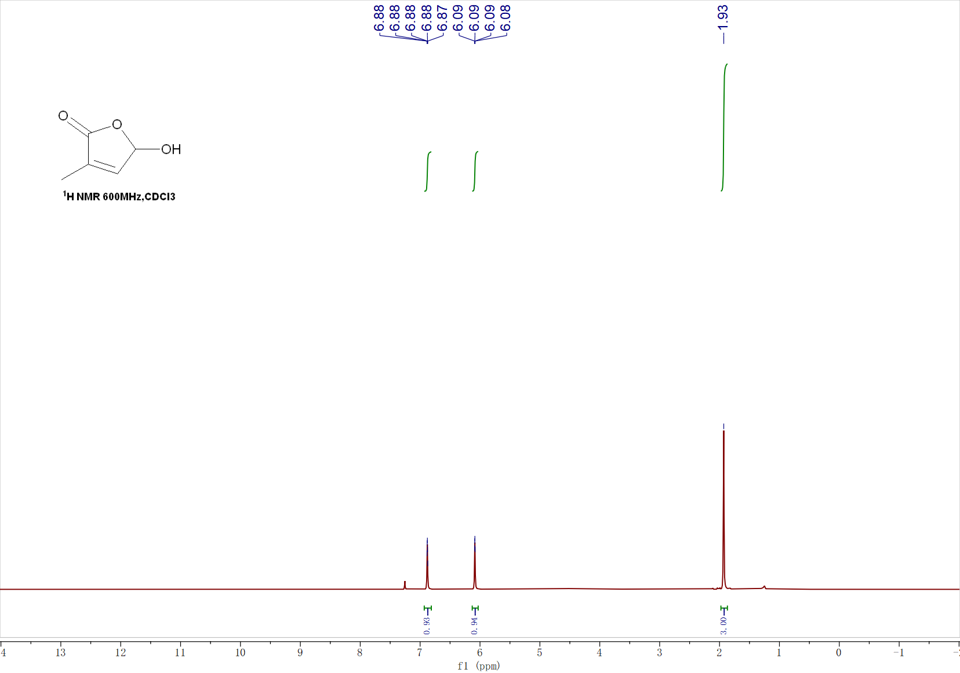
¹³C NMR of Intermediate 1
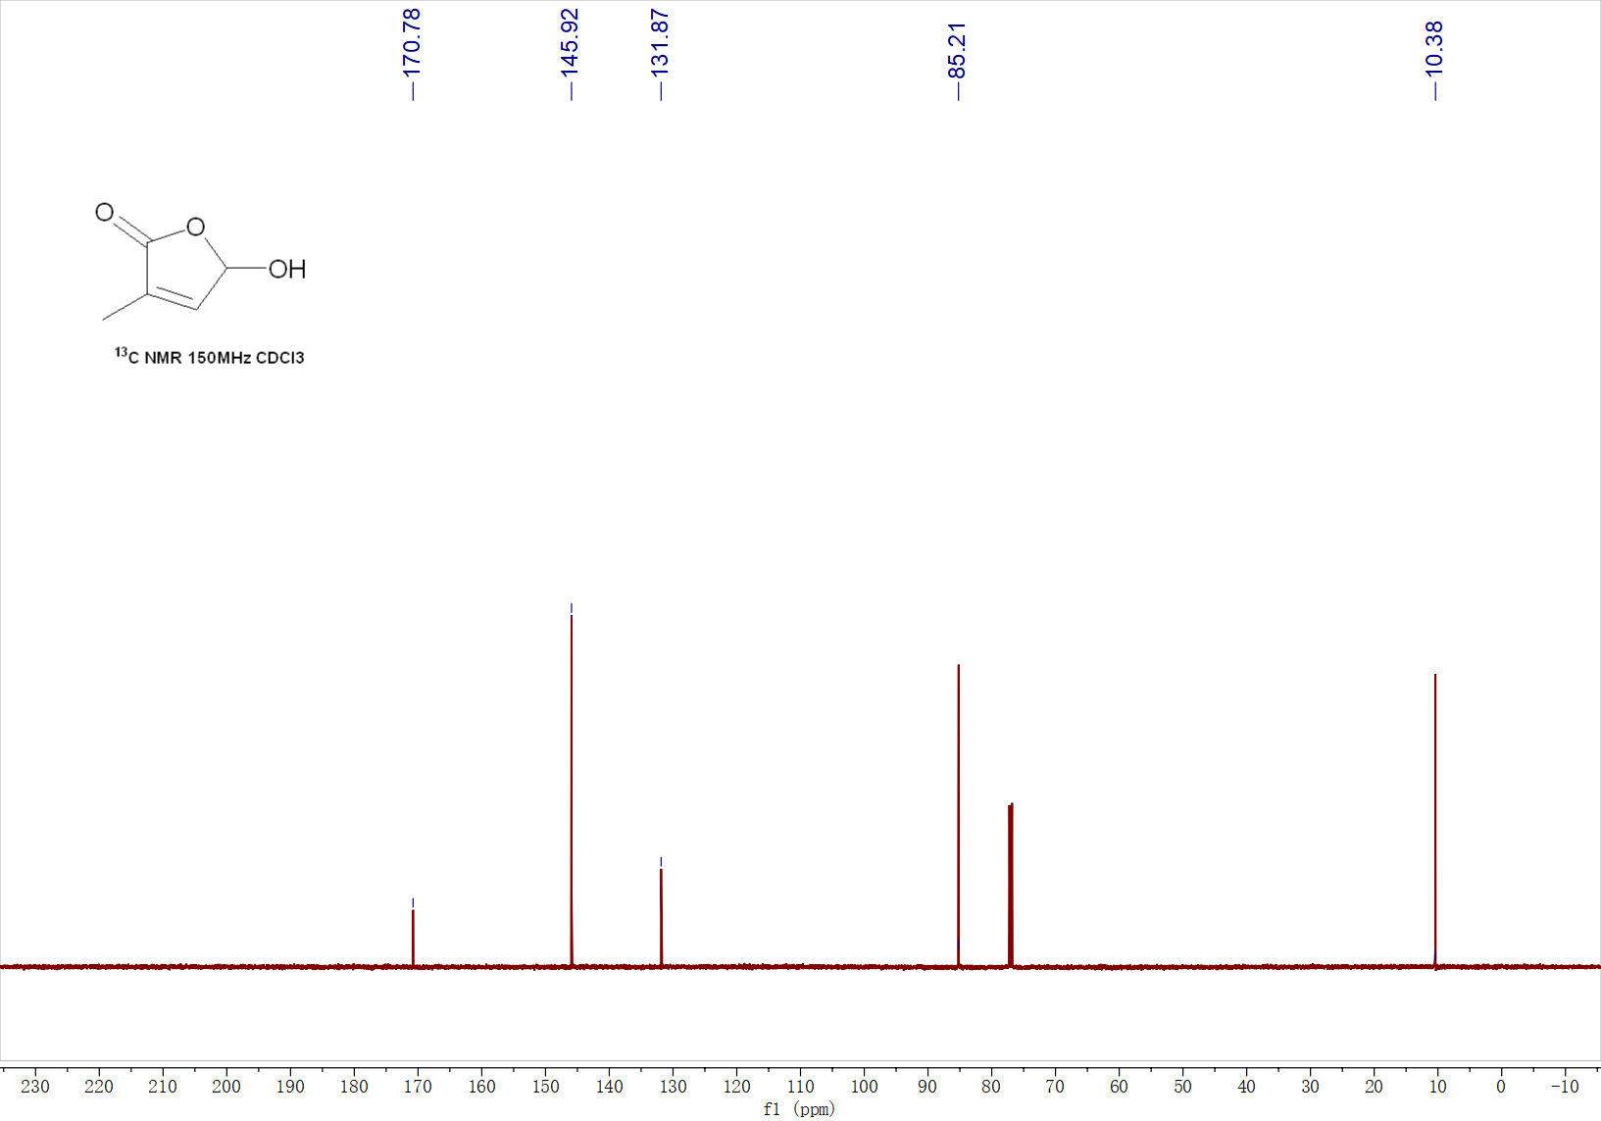

¹H NMR of Intermediate 2
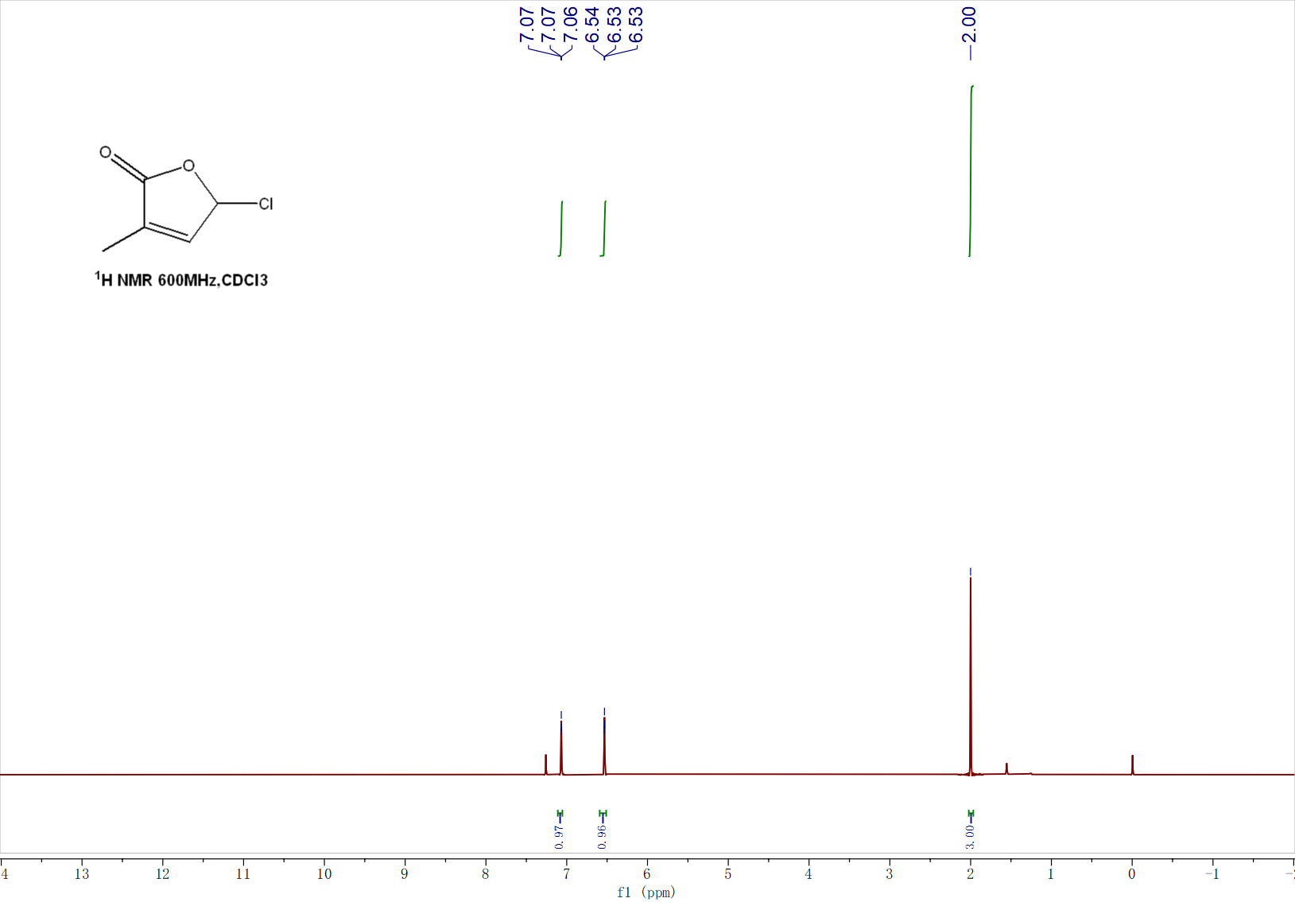
¹³C NMR of Intermediate 2
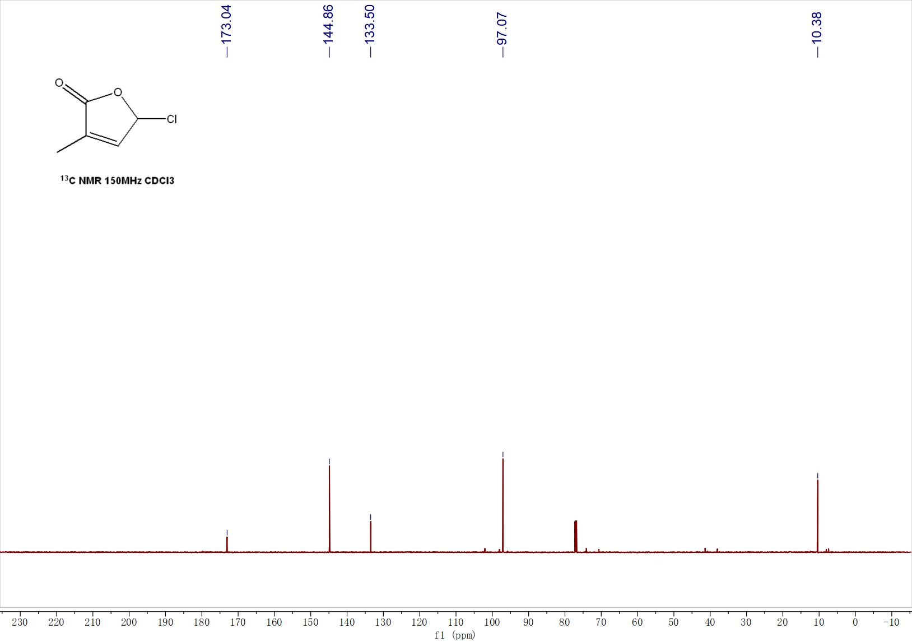

¹H NMR of 3a
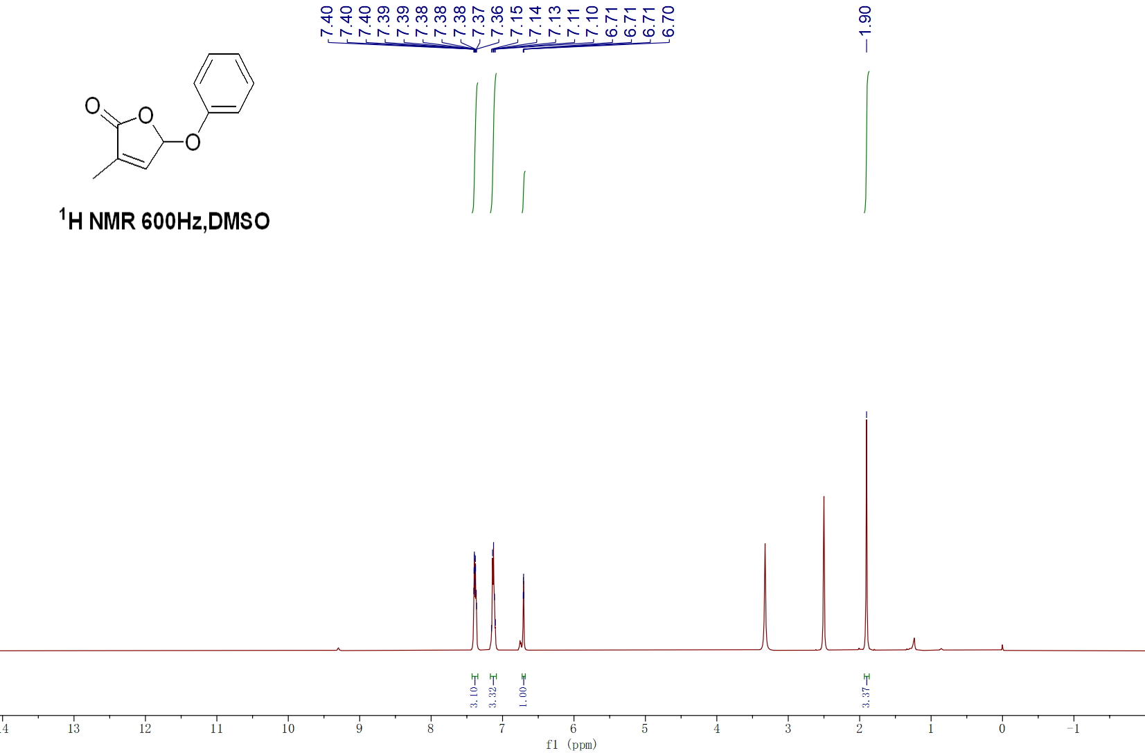¹³C NMR of 3a
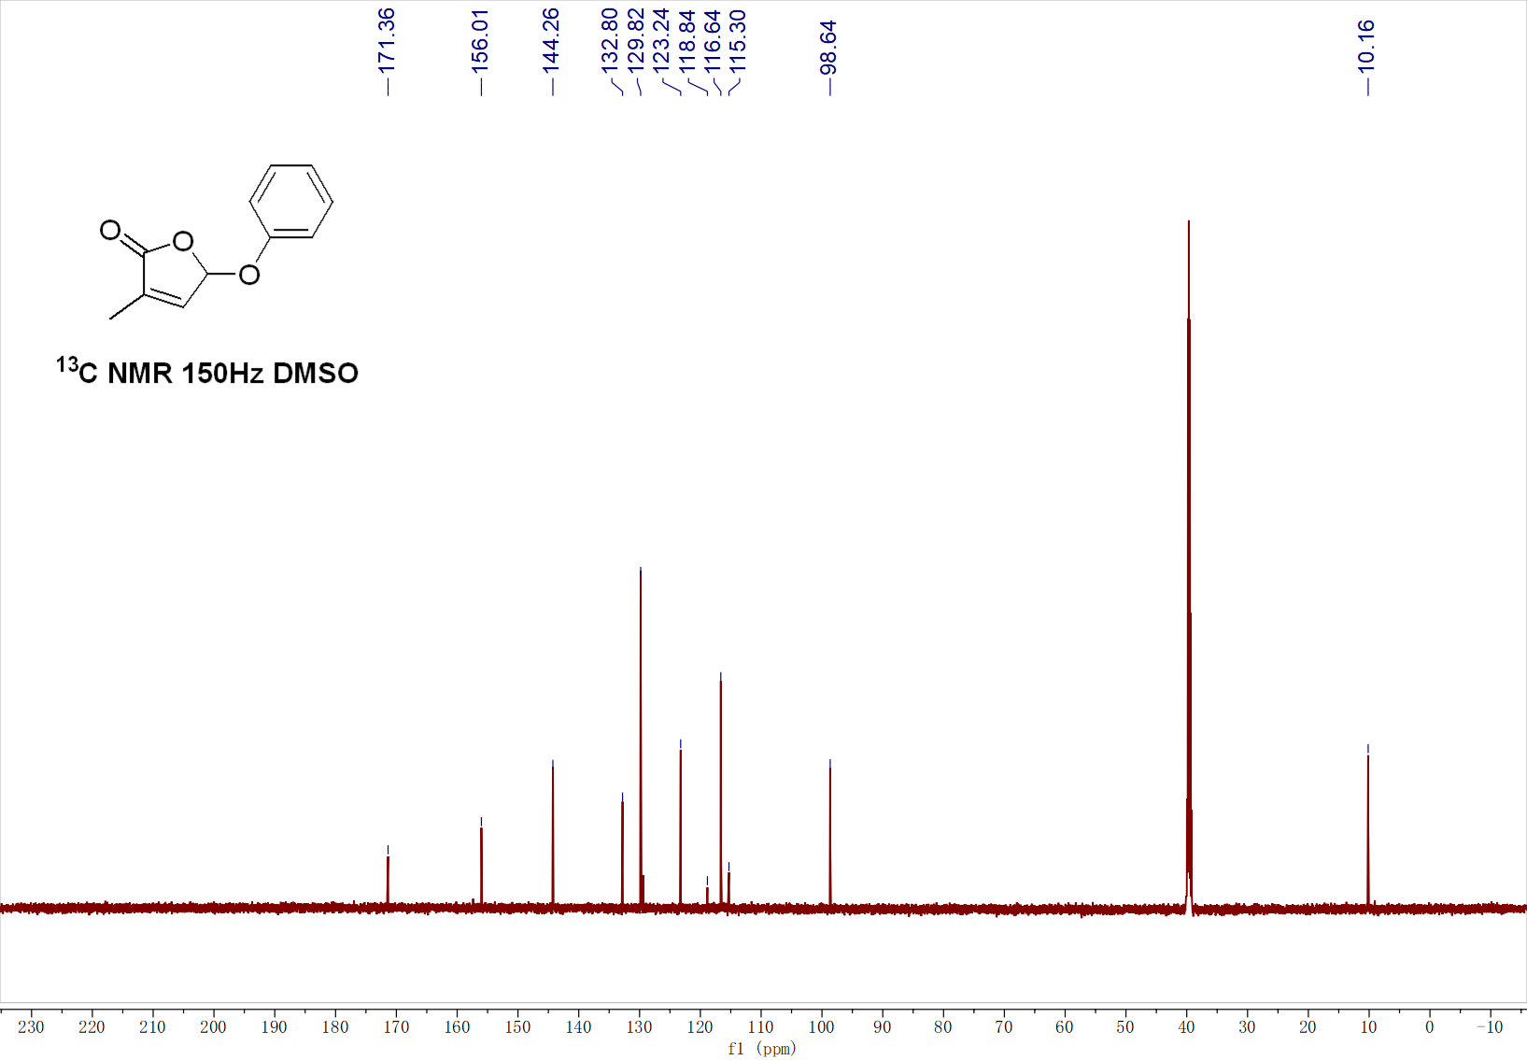
¹H NMR of 3b
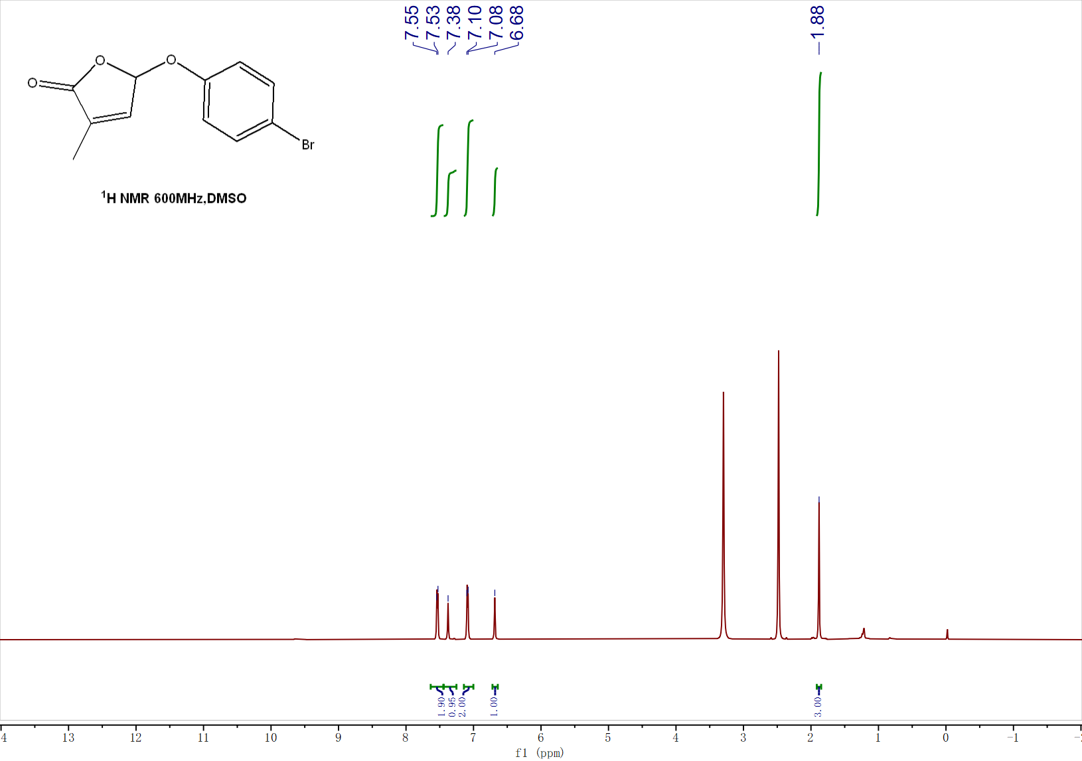
¹³C NMR of 3b
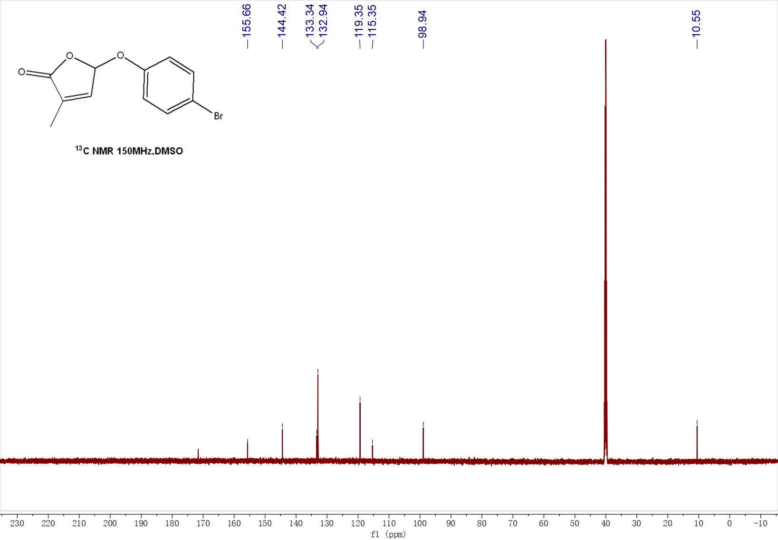
¹H NMR of 3c
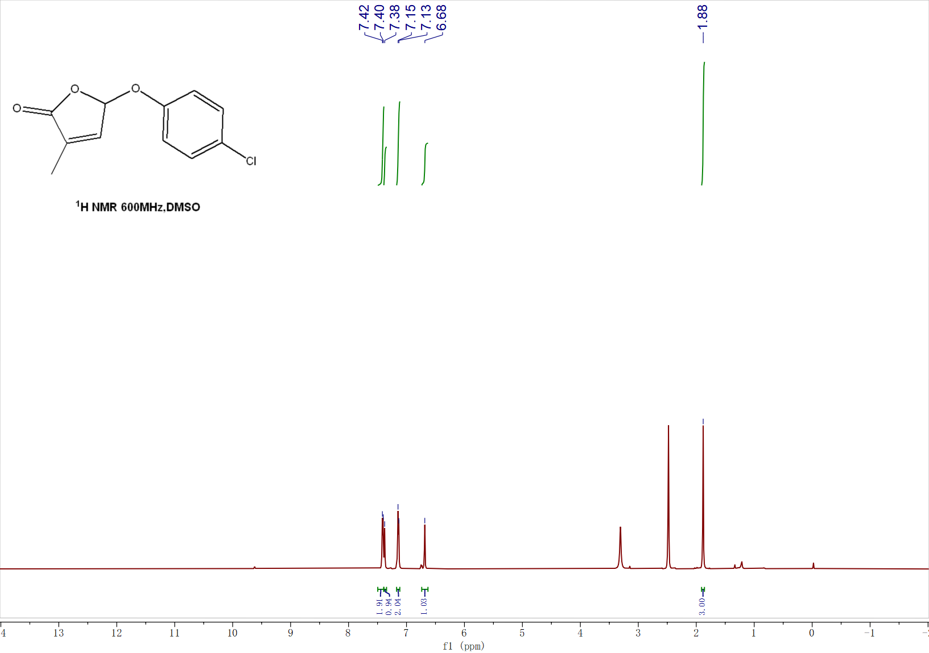
¹³C NMR of 3c
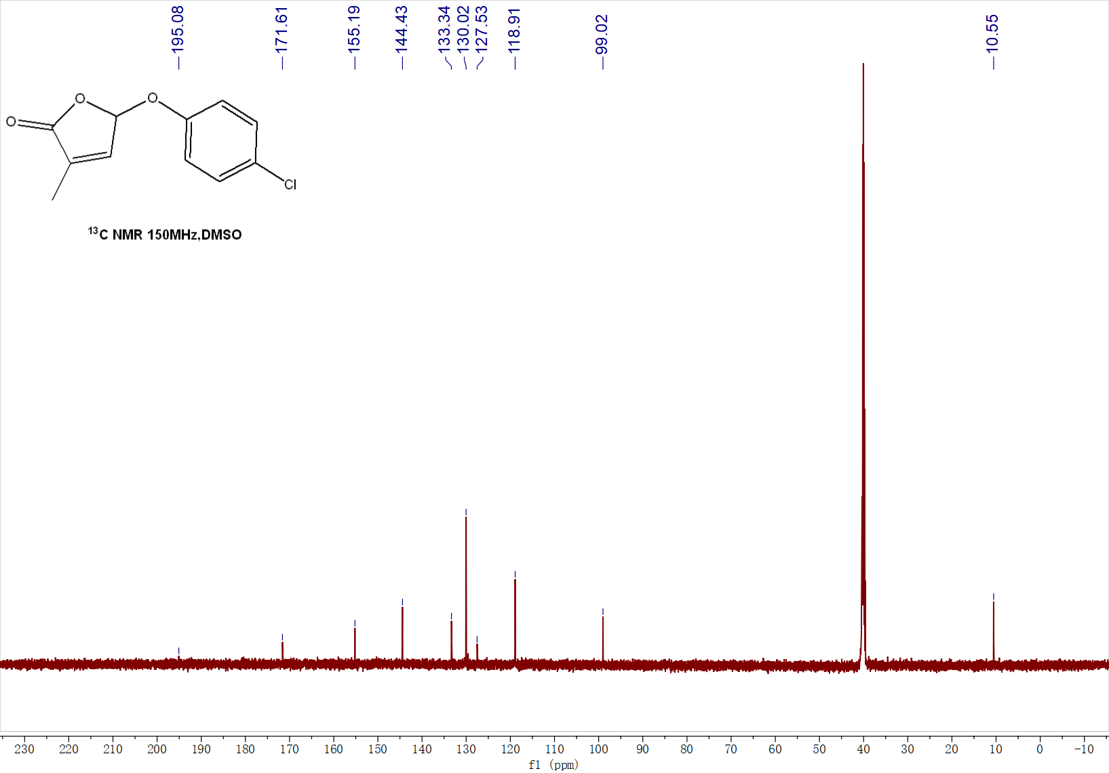
¹H NMR of 3d
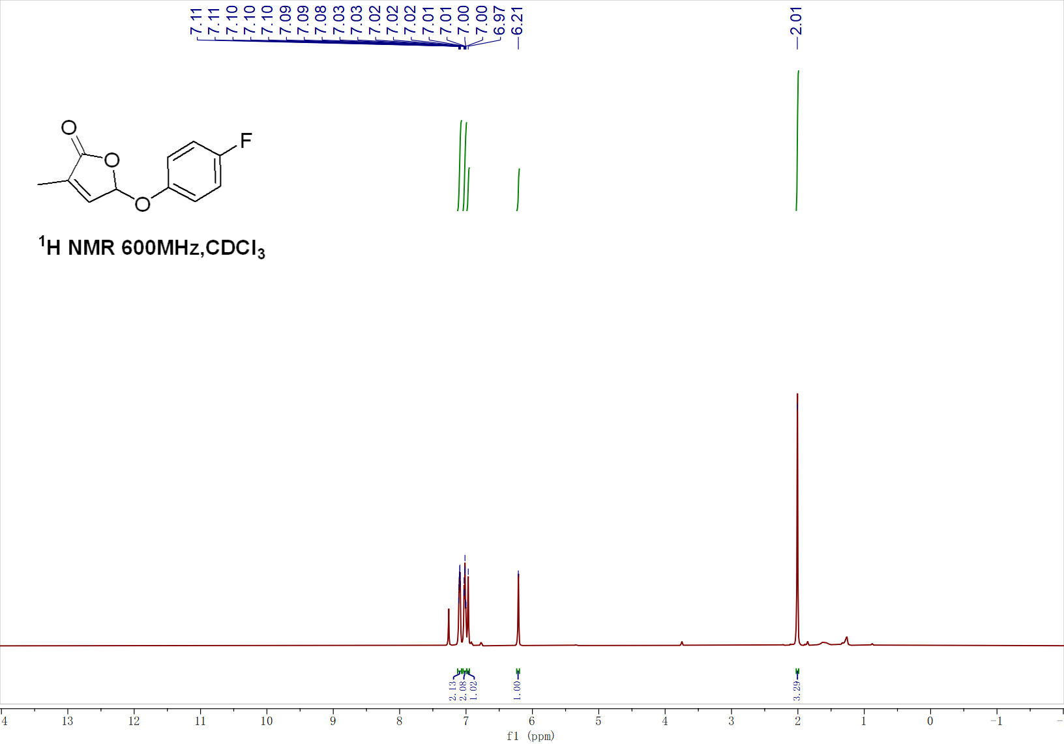
¹³C NMR of 3d
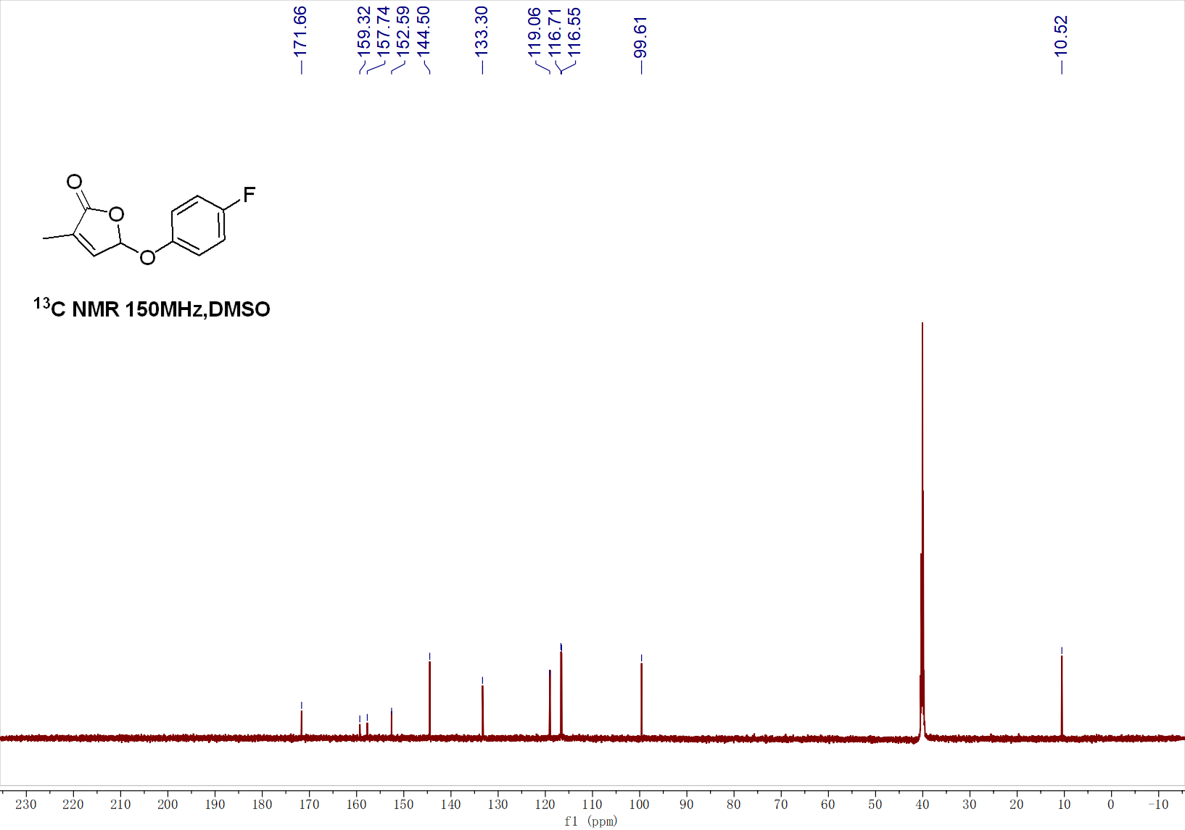

¹H NMR of 3e
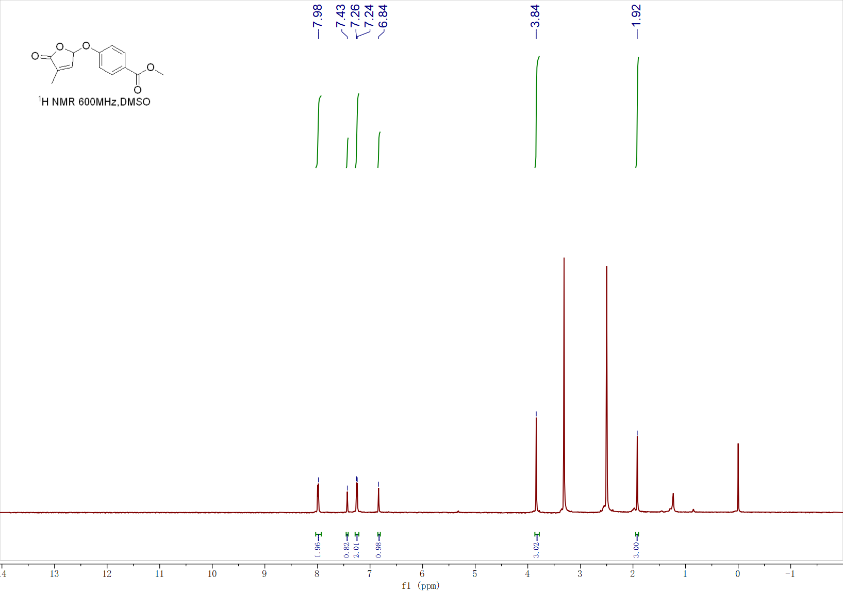
¹³C NMR of 3e
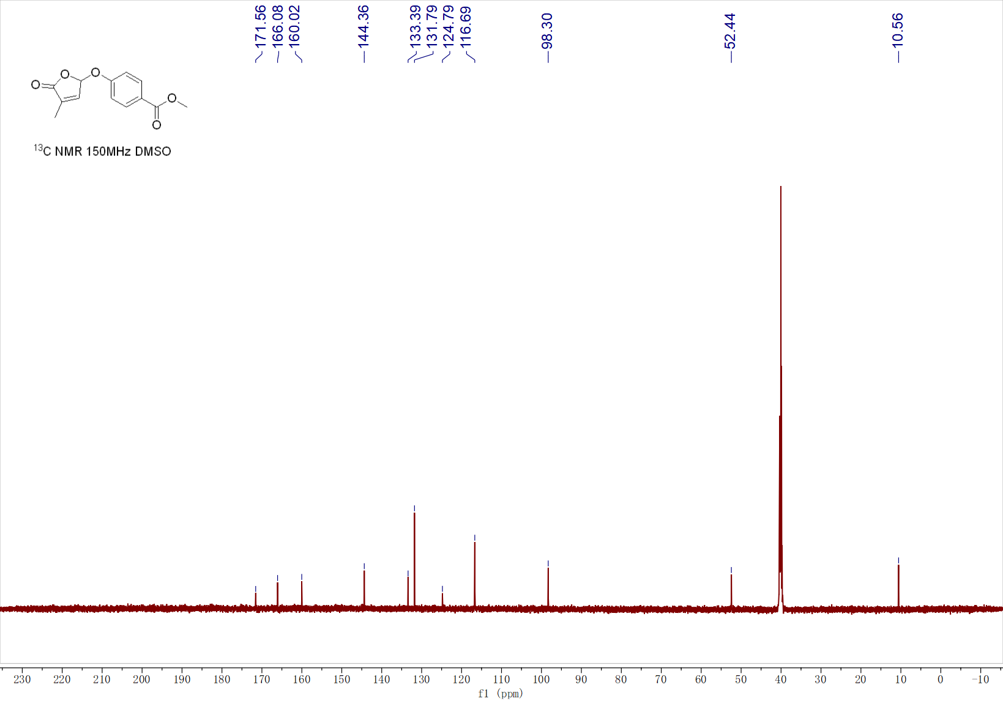

¹H NMR of 3f
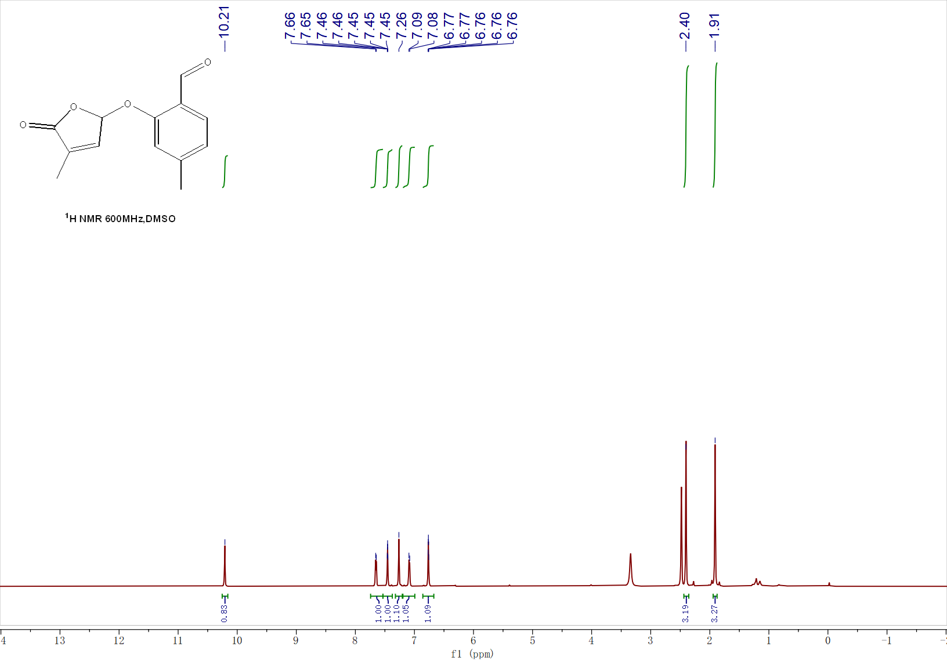
¹³C NMR of 3f
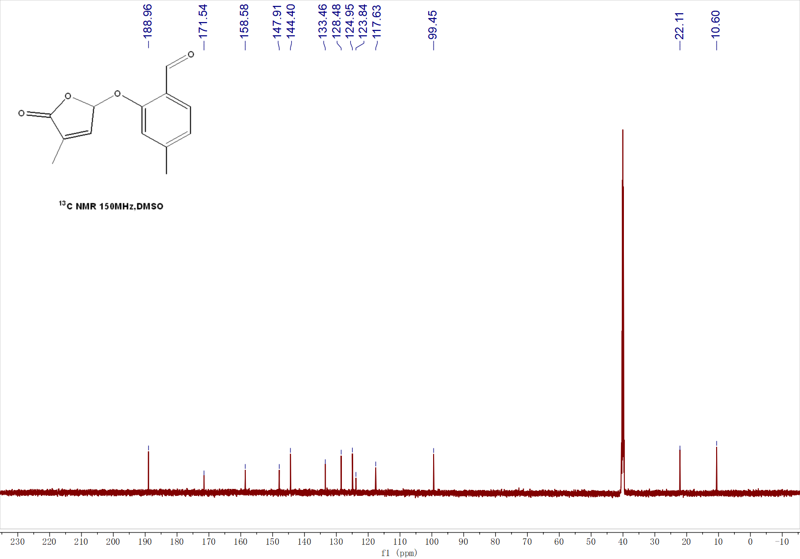

¹H NMR of 3g
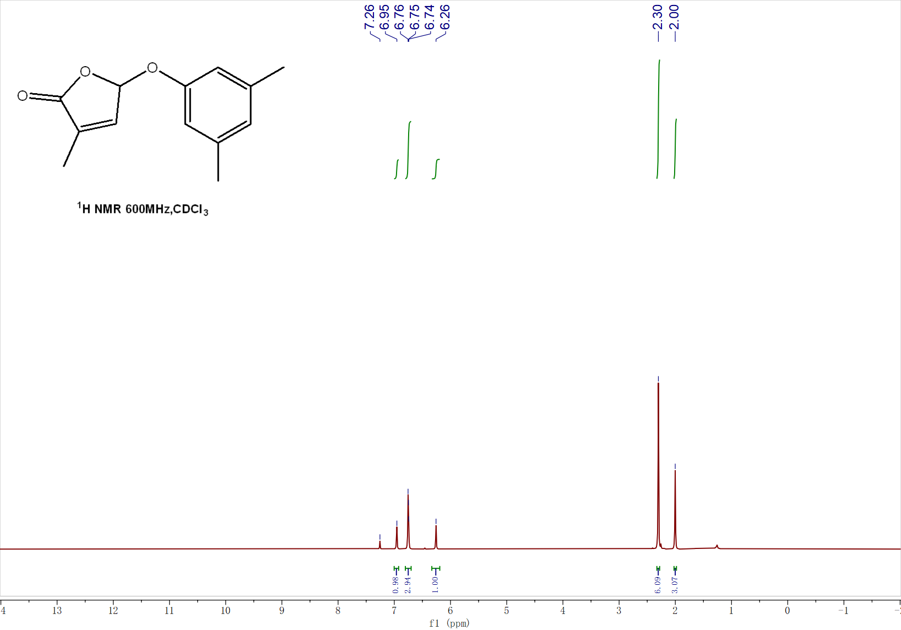
¹³C NMR of 3g
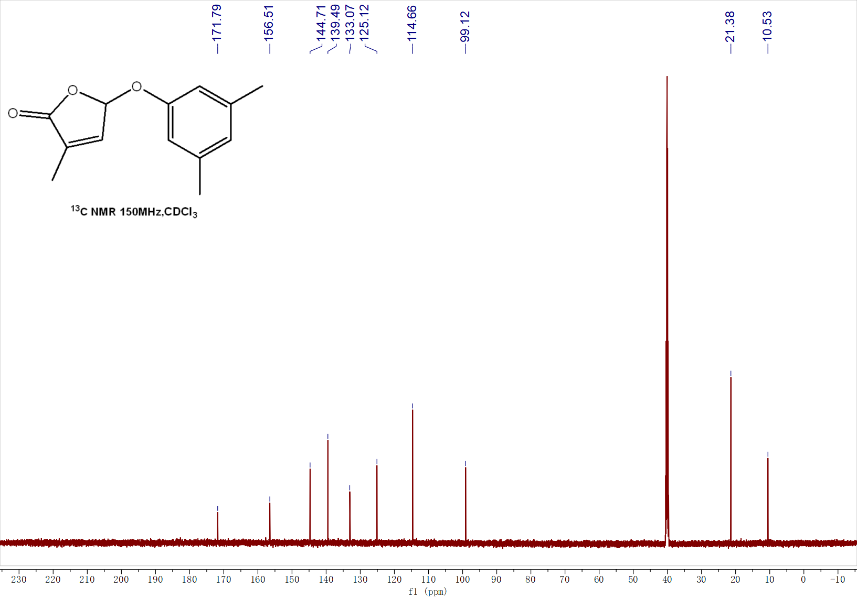

¹H NMR of 3h
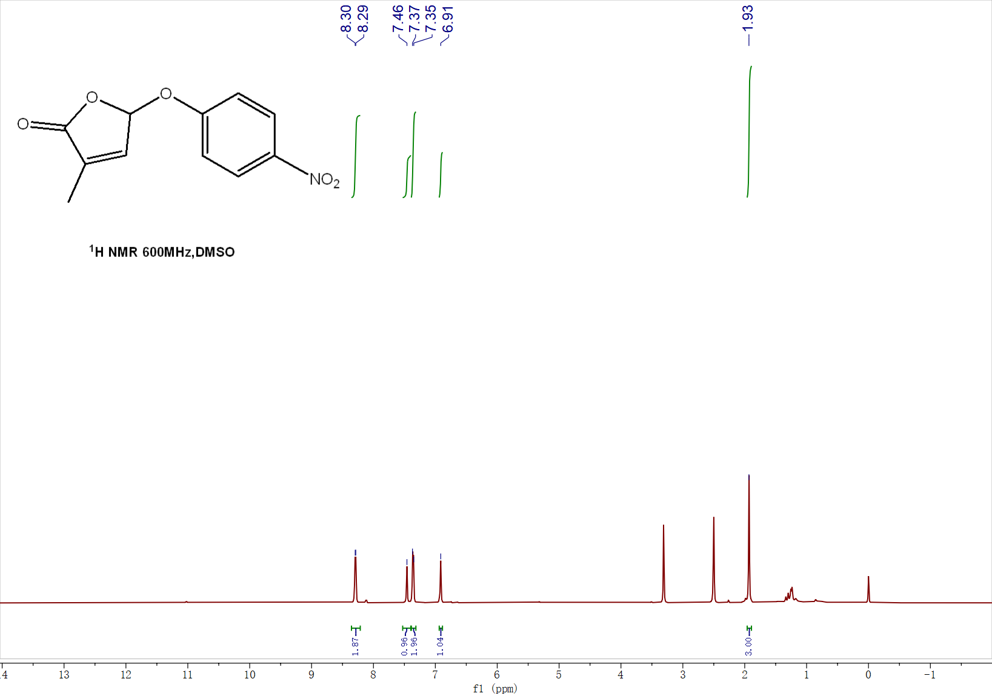
¹³C NMR of 3h
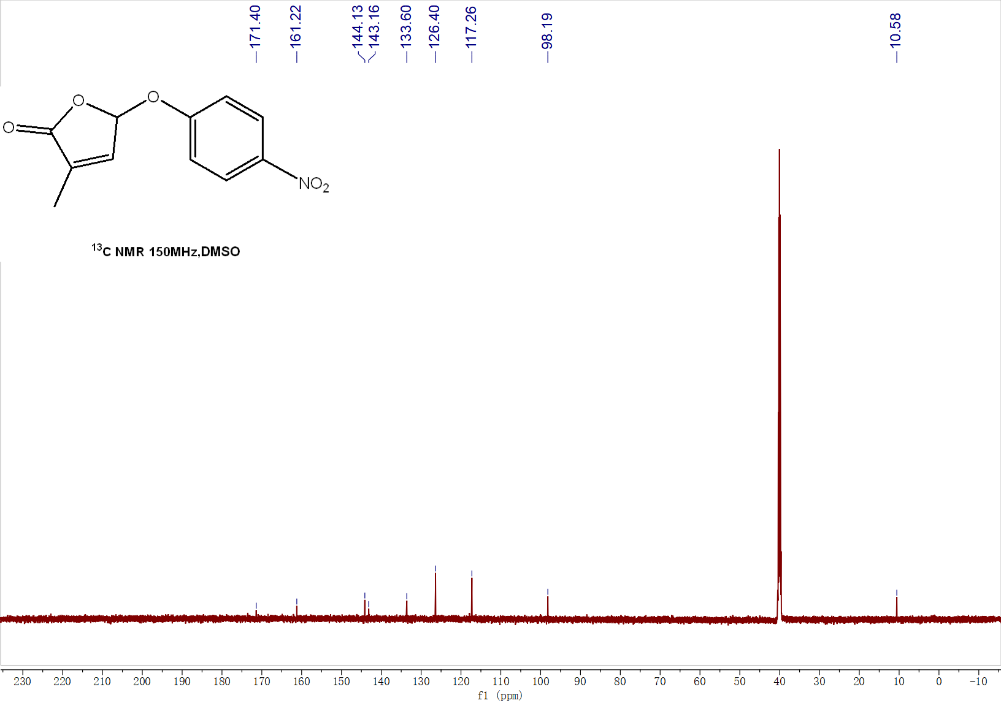

¹H NMR of 3i
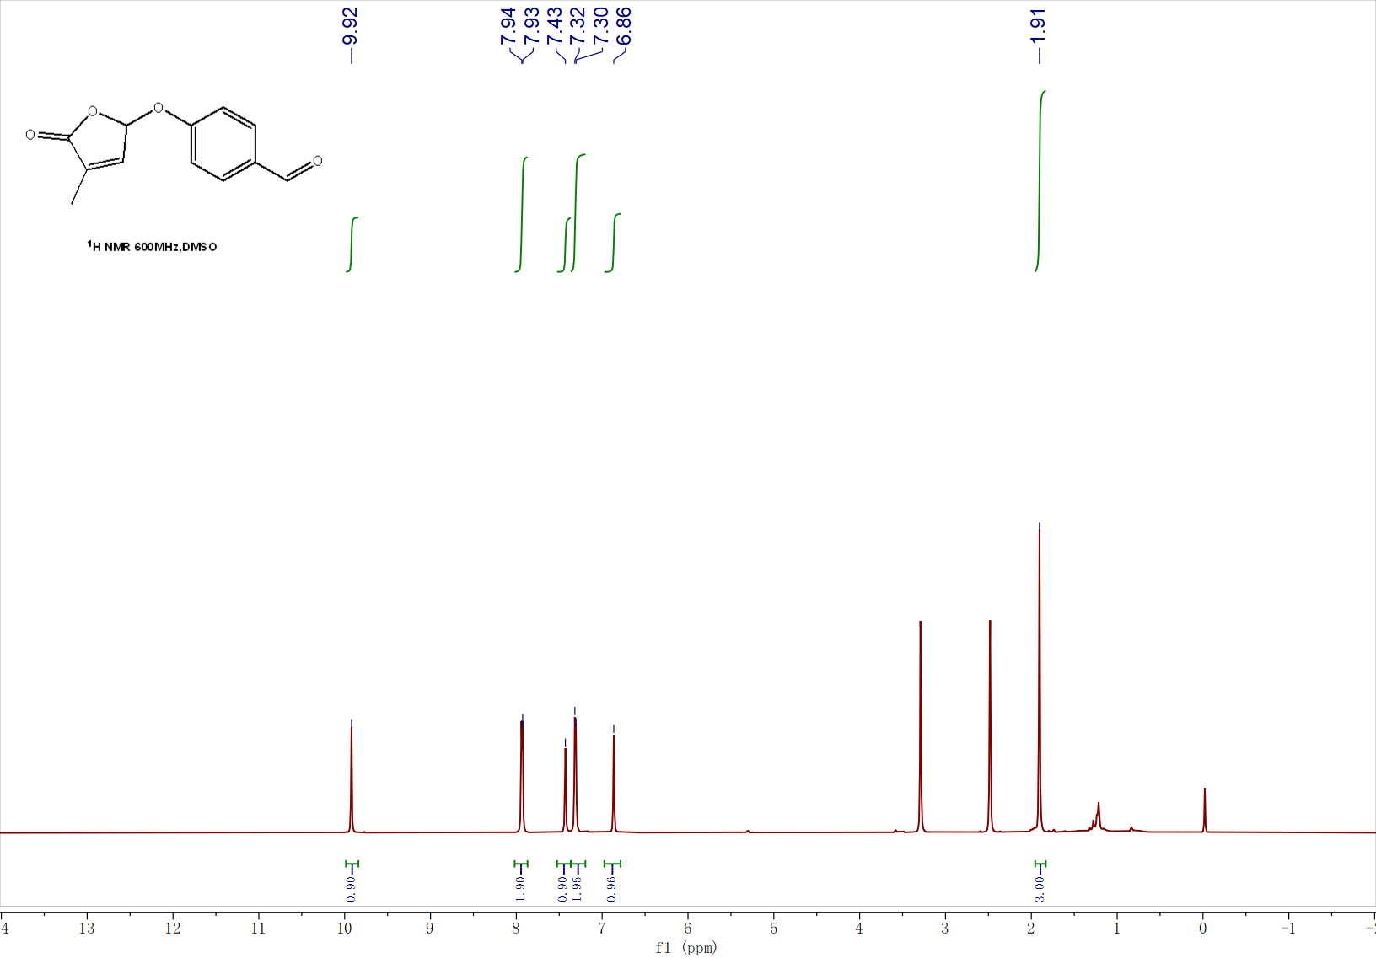
¹³C NMR of 3i
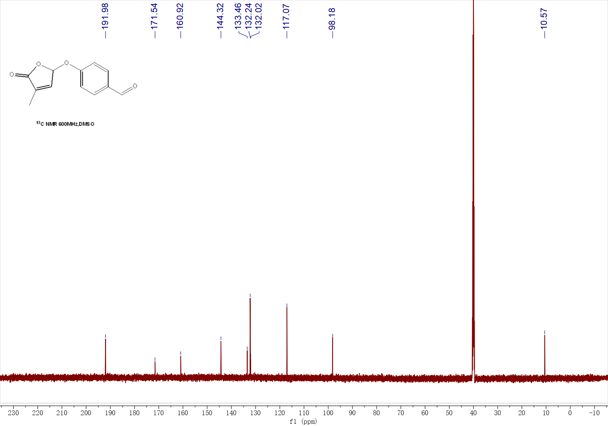

¹H NMR of 3j
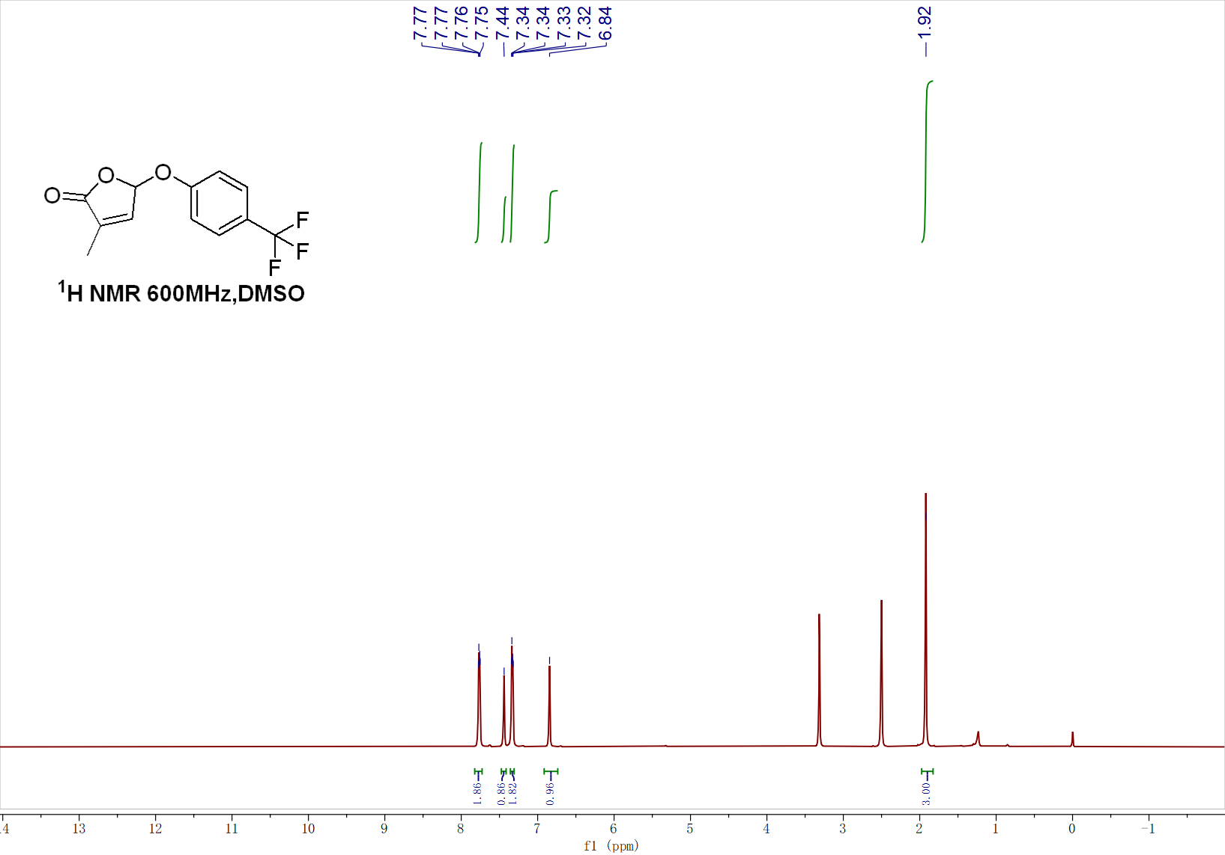
¹³C NMR of 3j
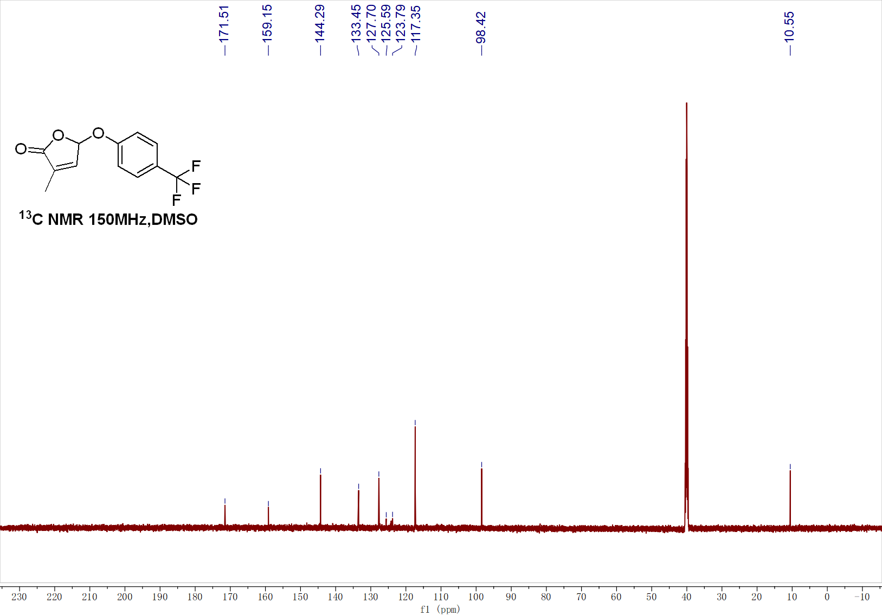

¹H NMR of 3k
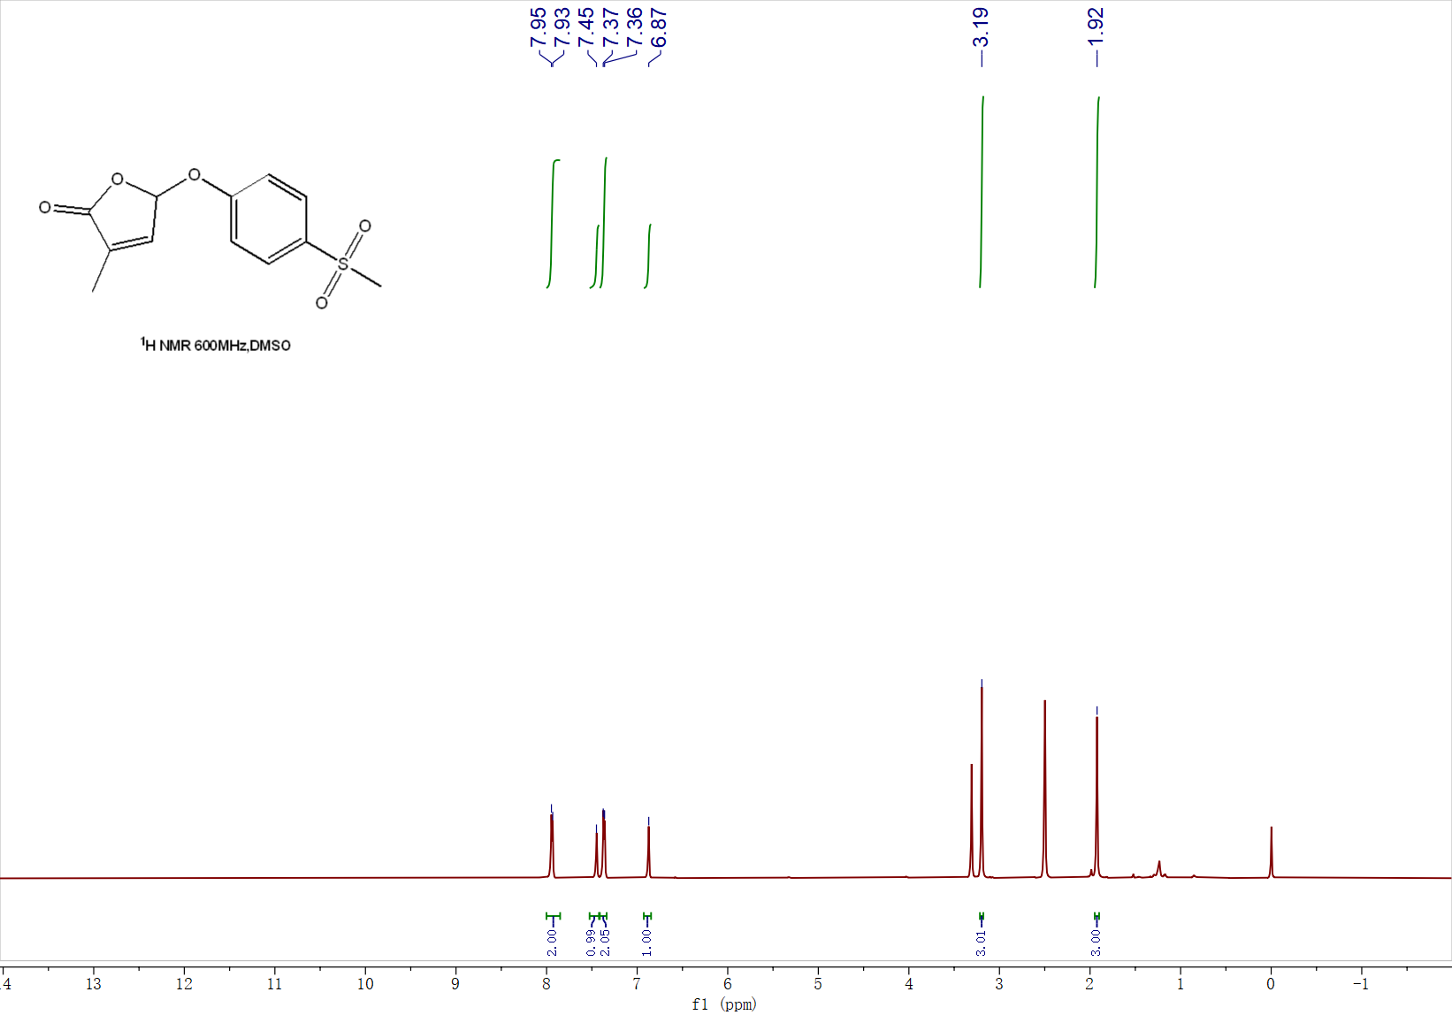
¹³C NMR of 3k
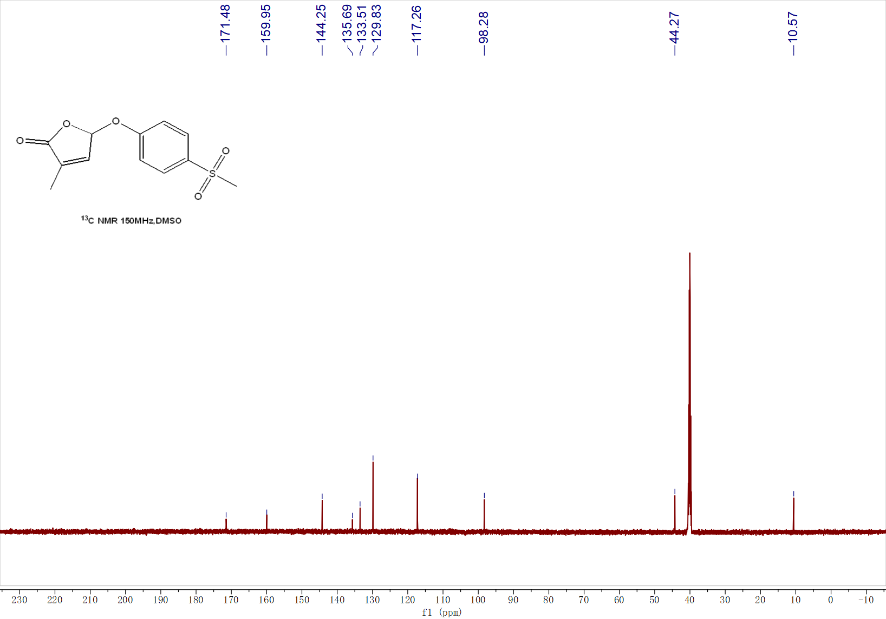

¹H NMR of 3l
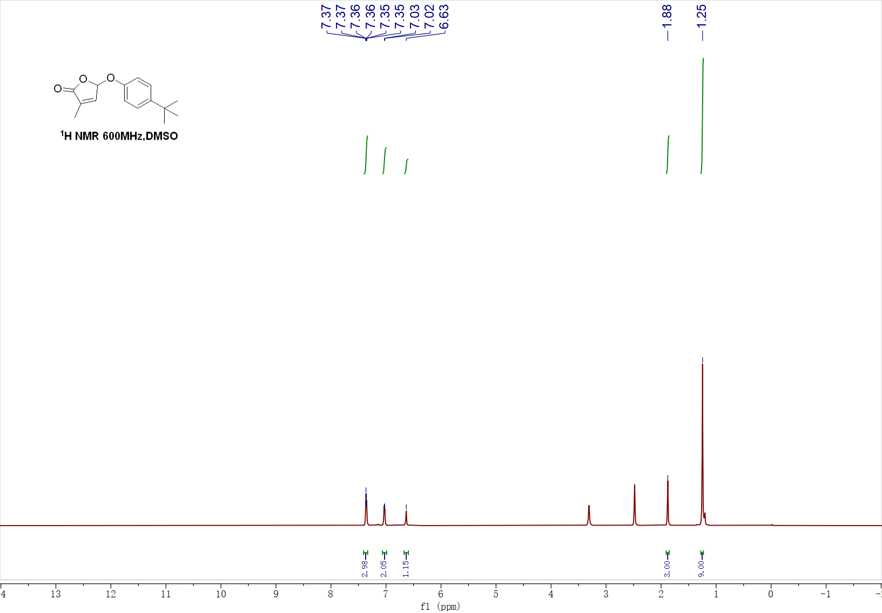
¹³C NMR of 3l
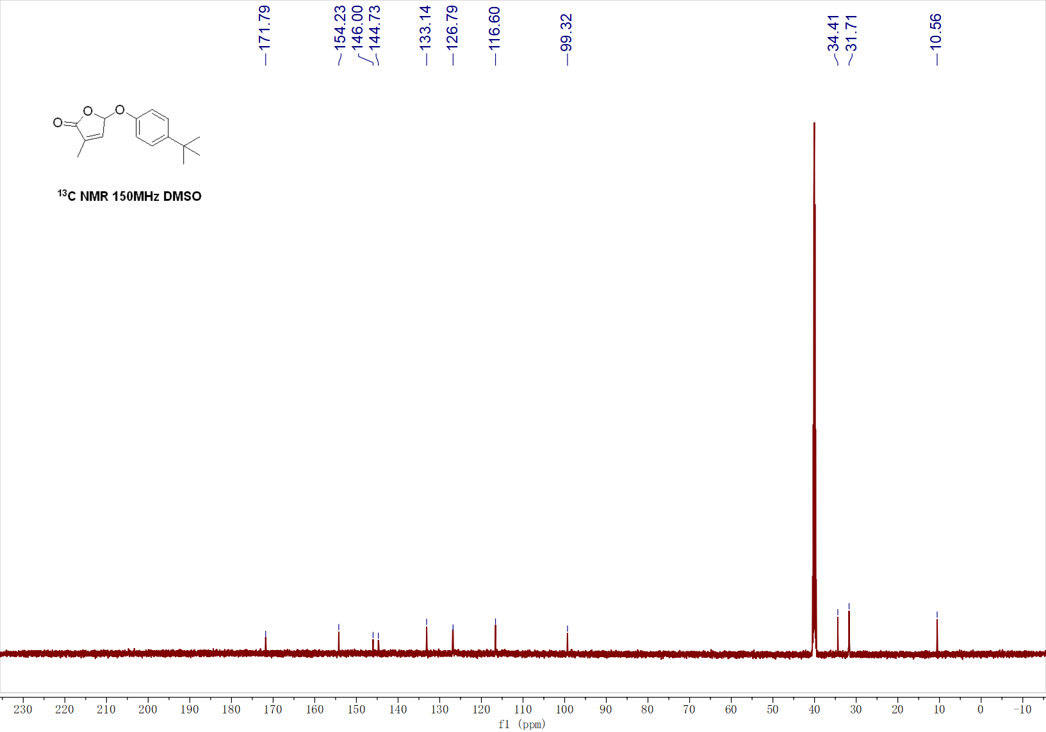

¹H NMR of 3m
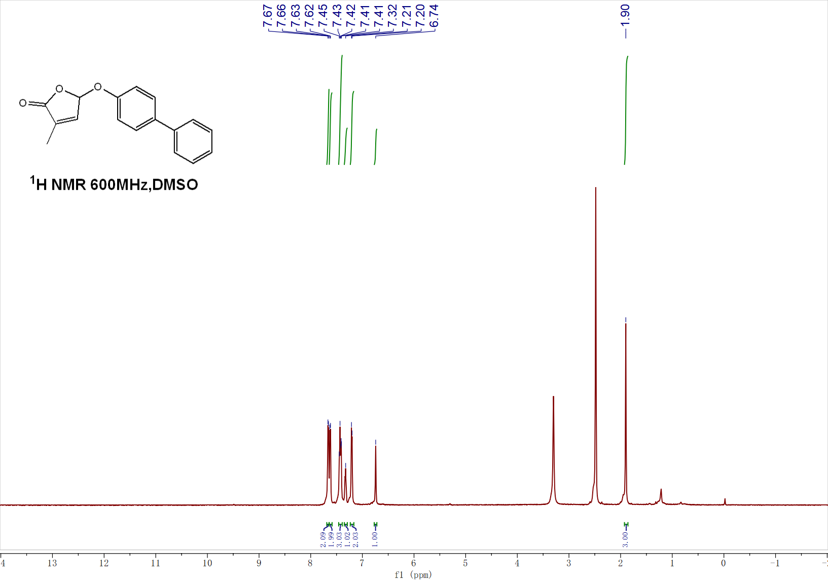
¹³C NMR of 3m
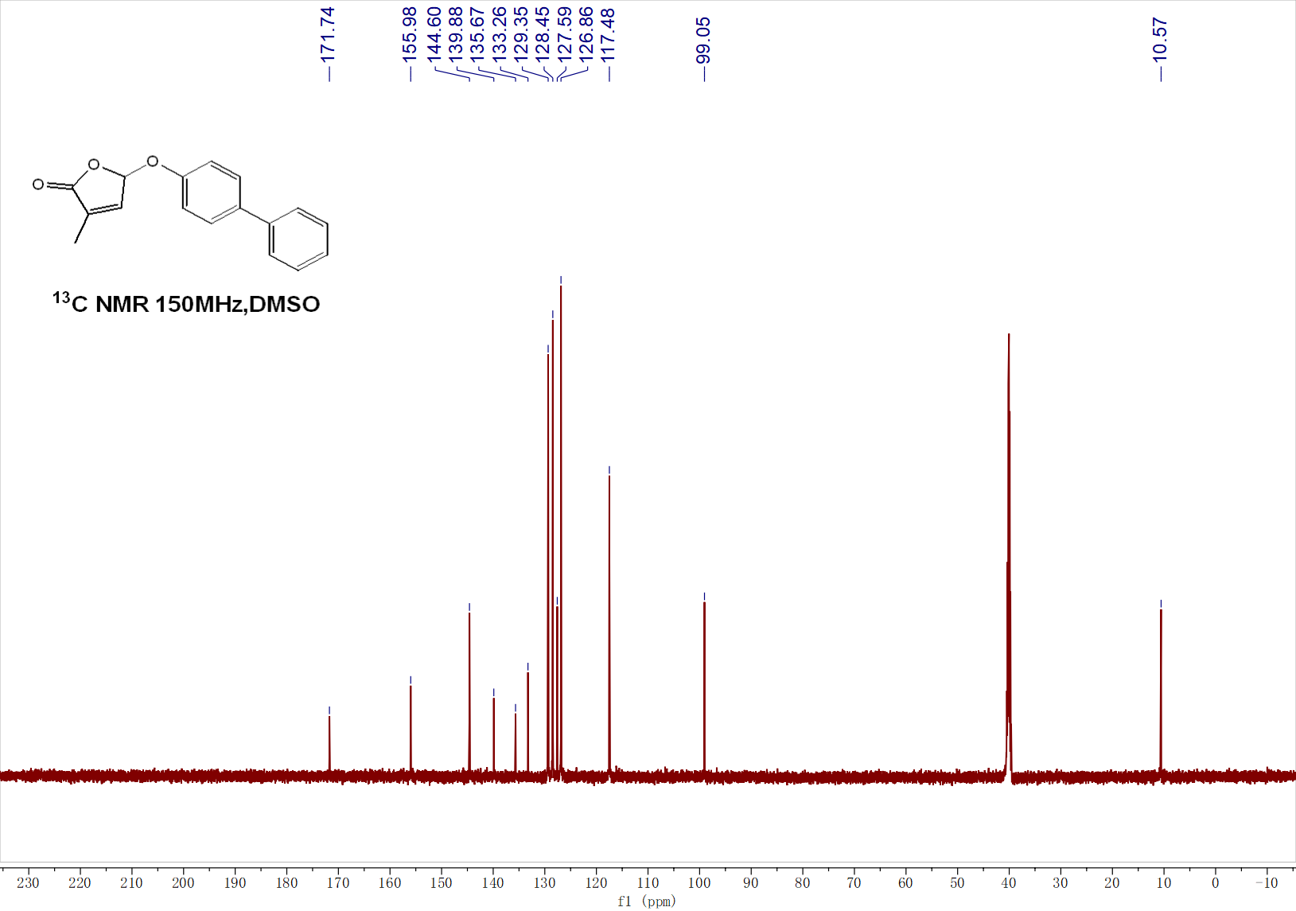

¹H NMR of 3n
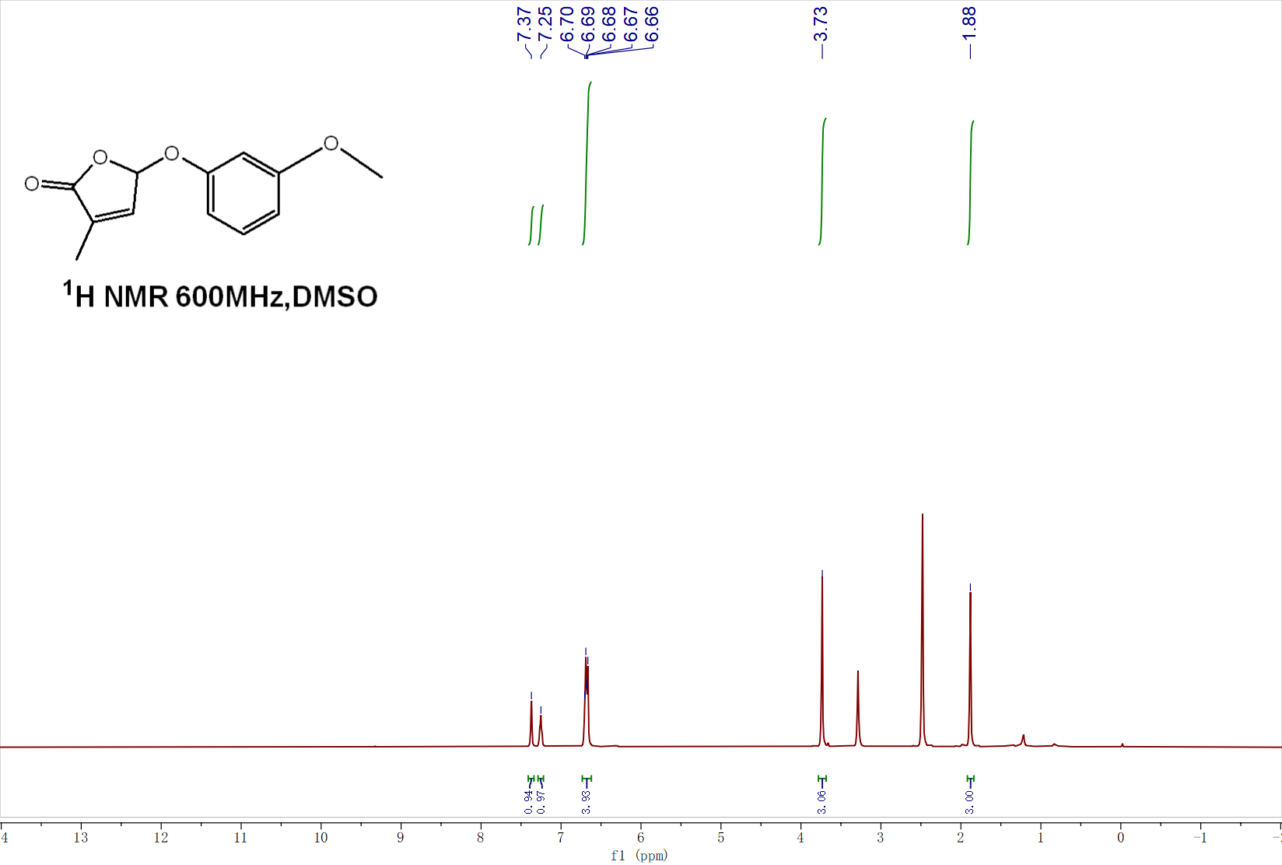
¹³C NMR of 3n
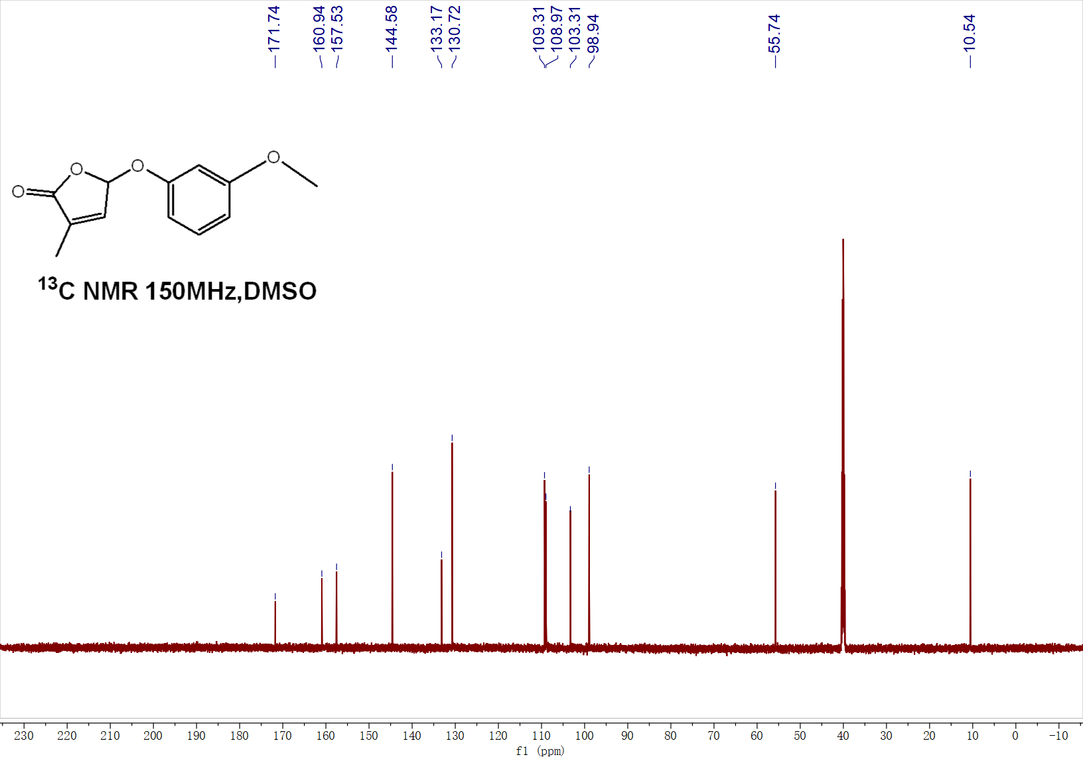

¹H NMR of 3o
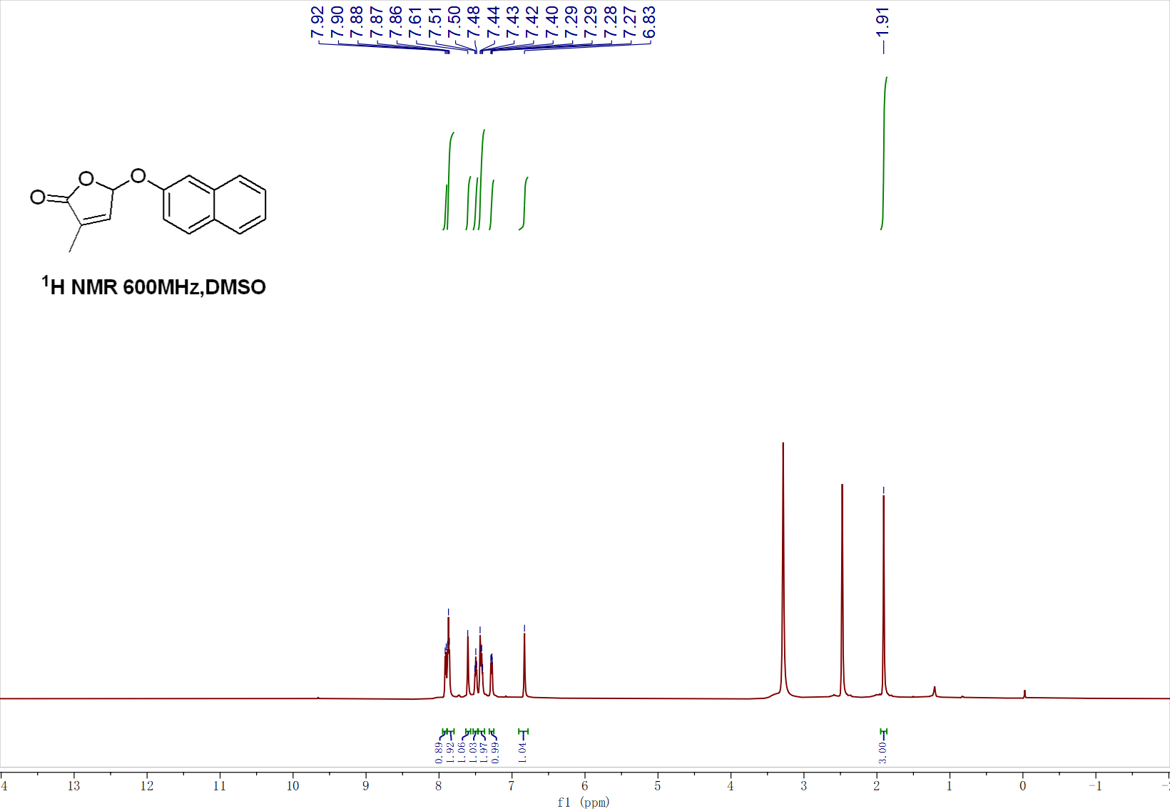
¹³C NMR of 3o
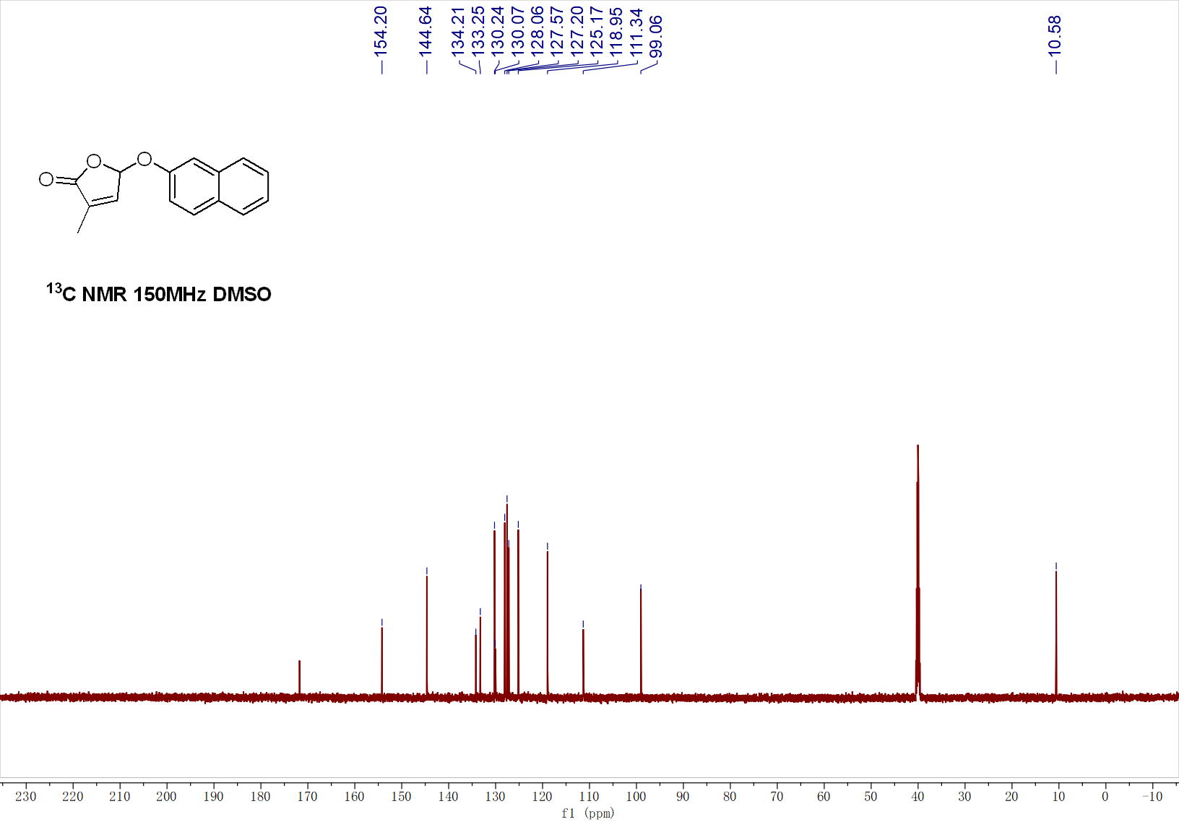

¹H NMR of 3p
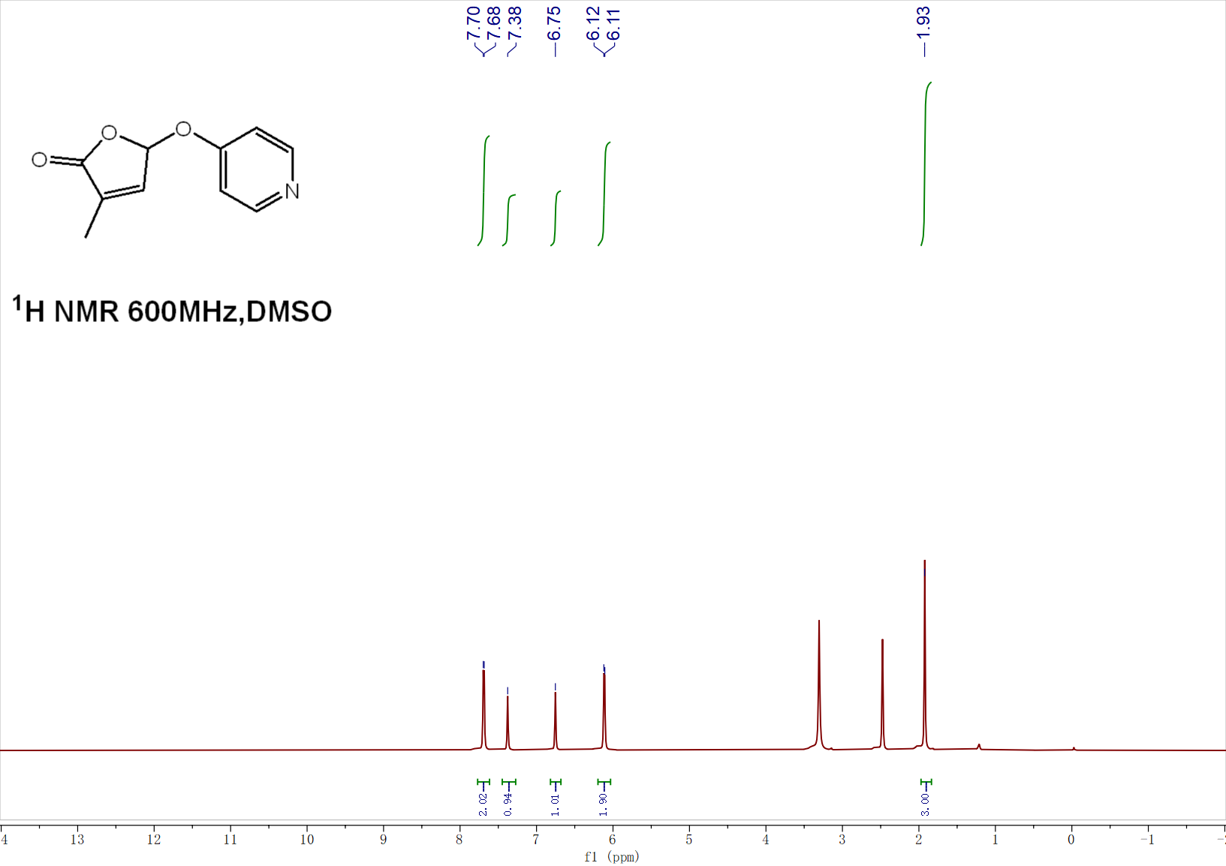
¹³C NMR of 3p
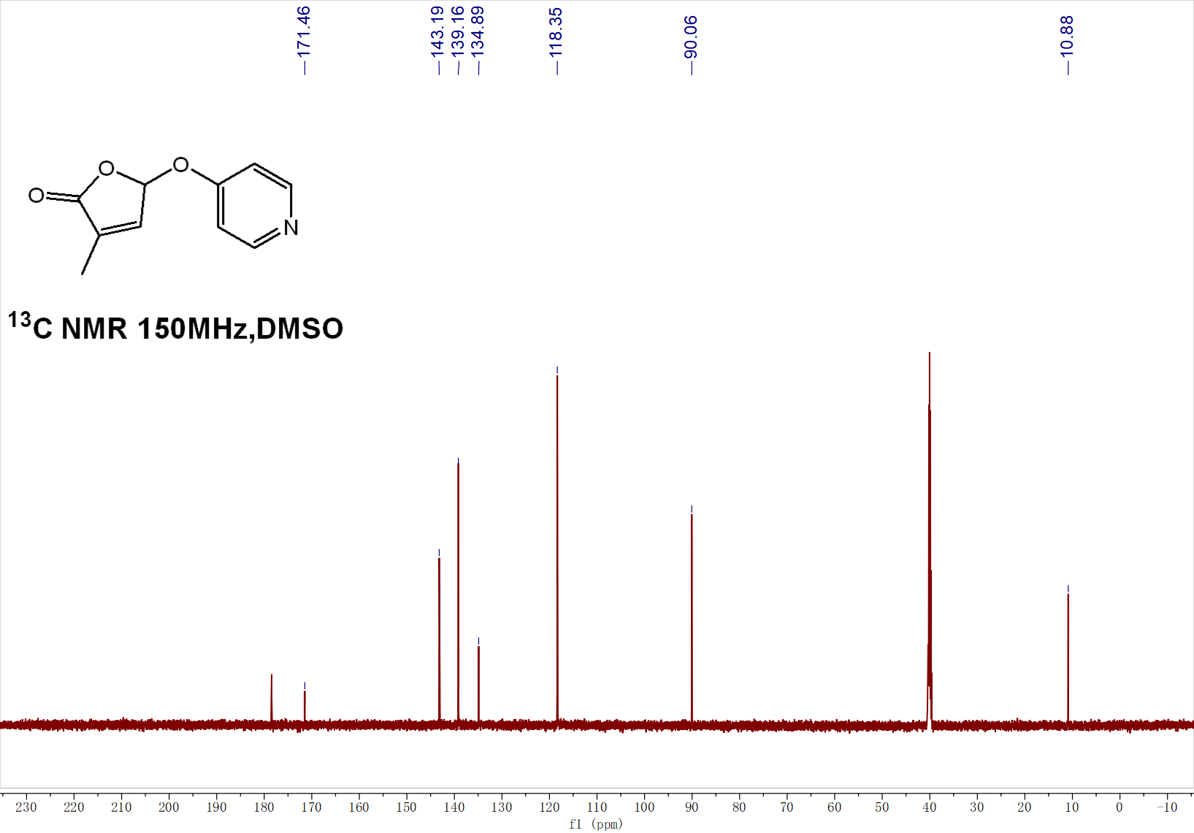

¹H NMR of 3q
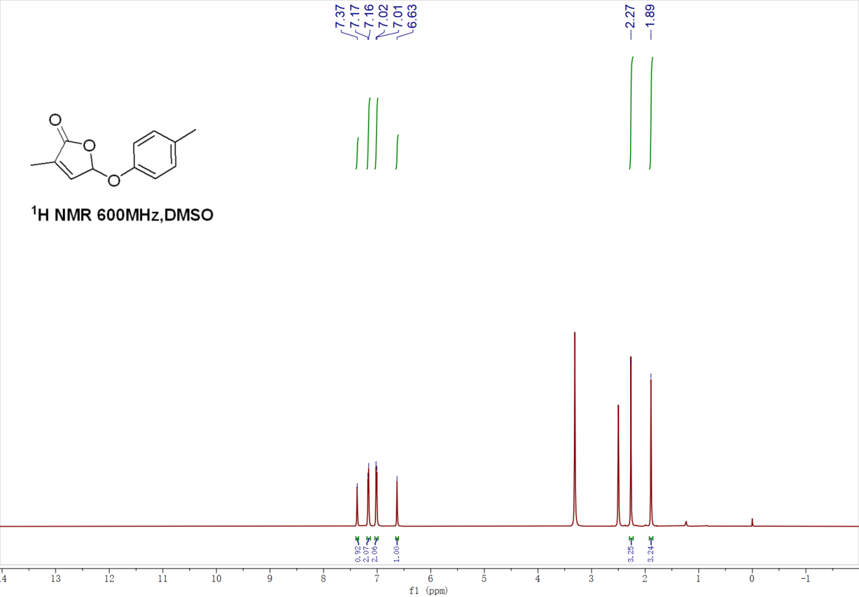
¹³C NMR of 3q
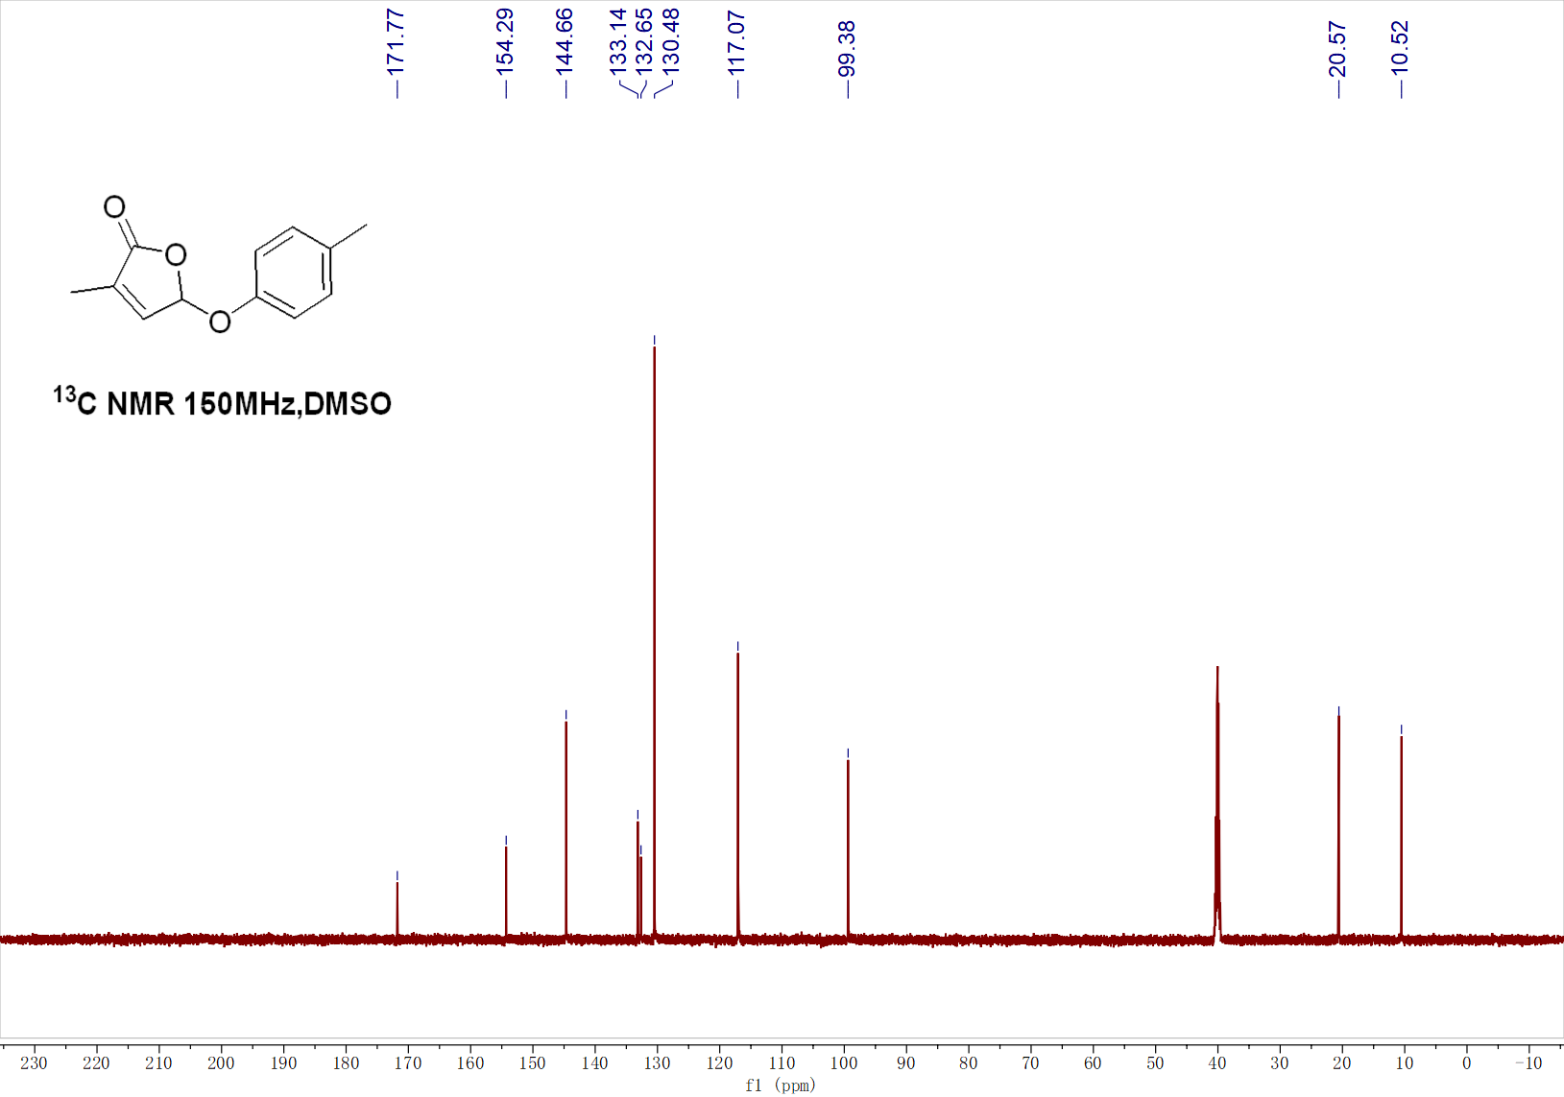
¹H NMR of 3r
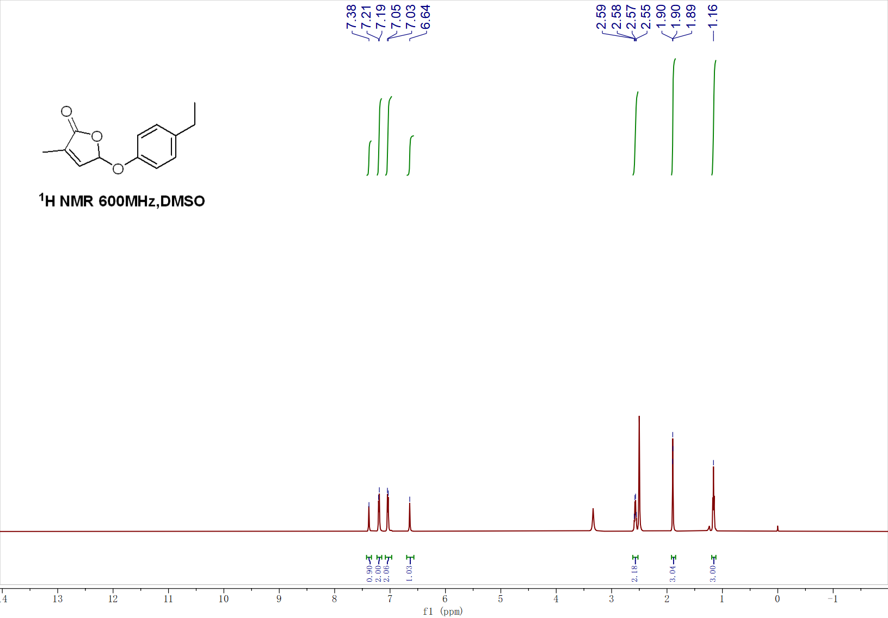
¹³C NMR of 3r
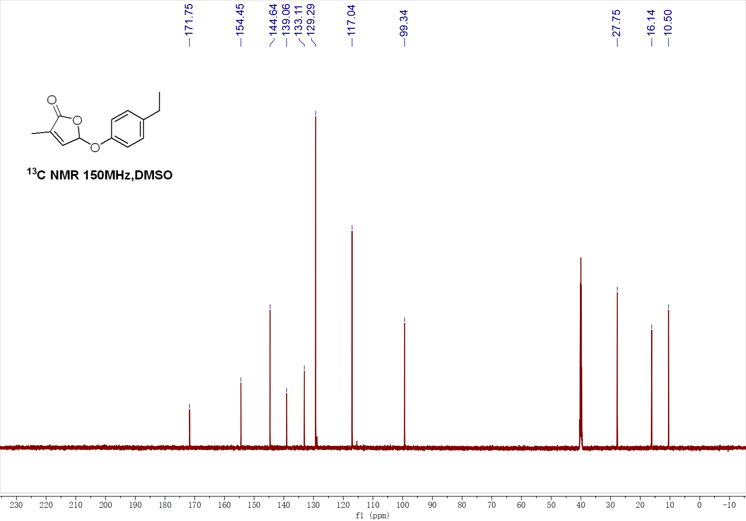
¹H NMR of 3s
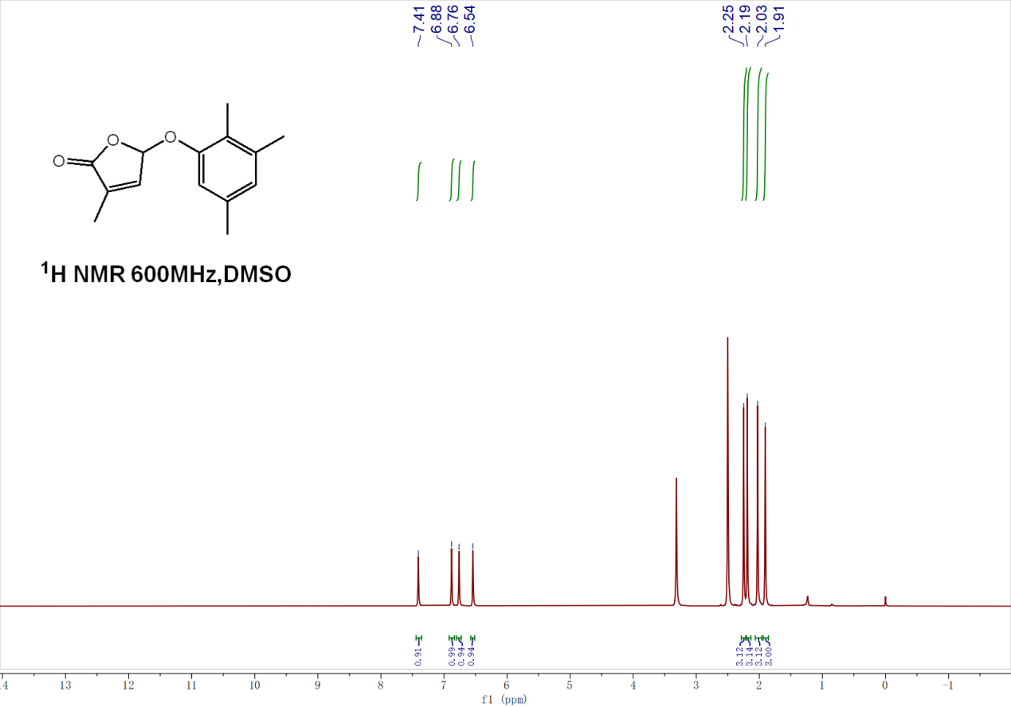
¹³C NMR of 3s
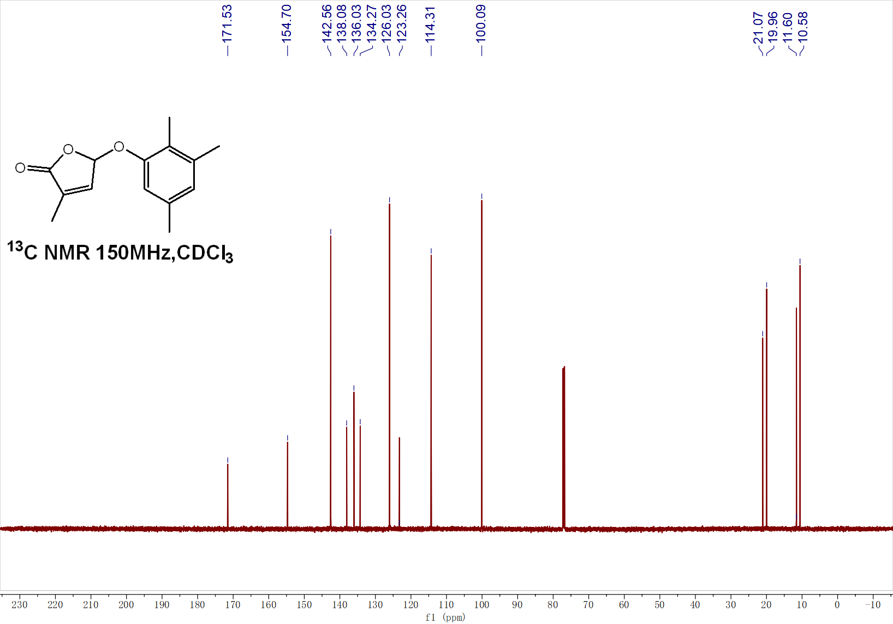

¹H NMR of 3t
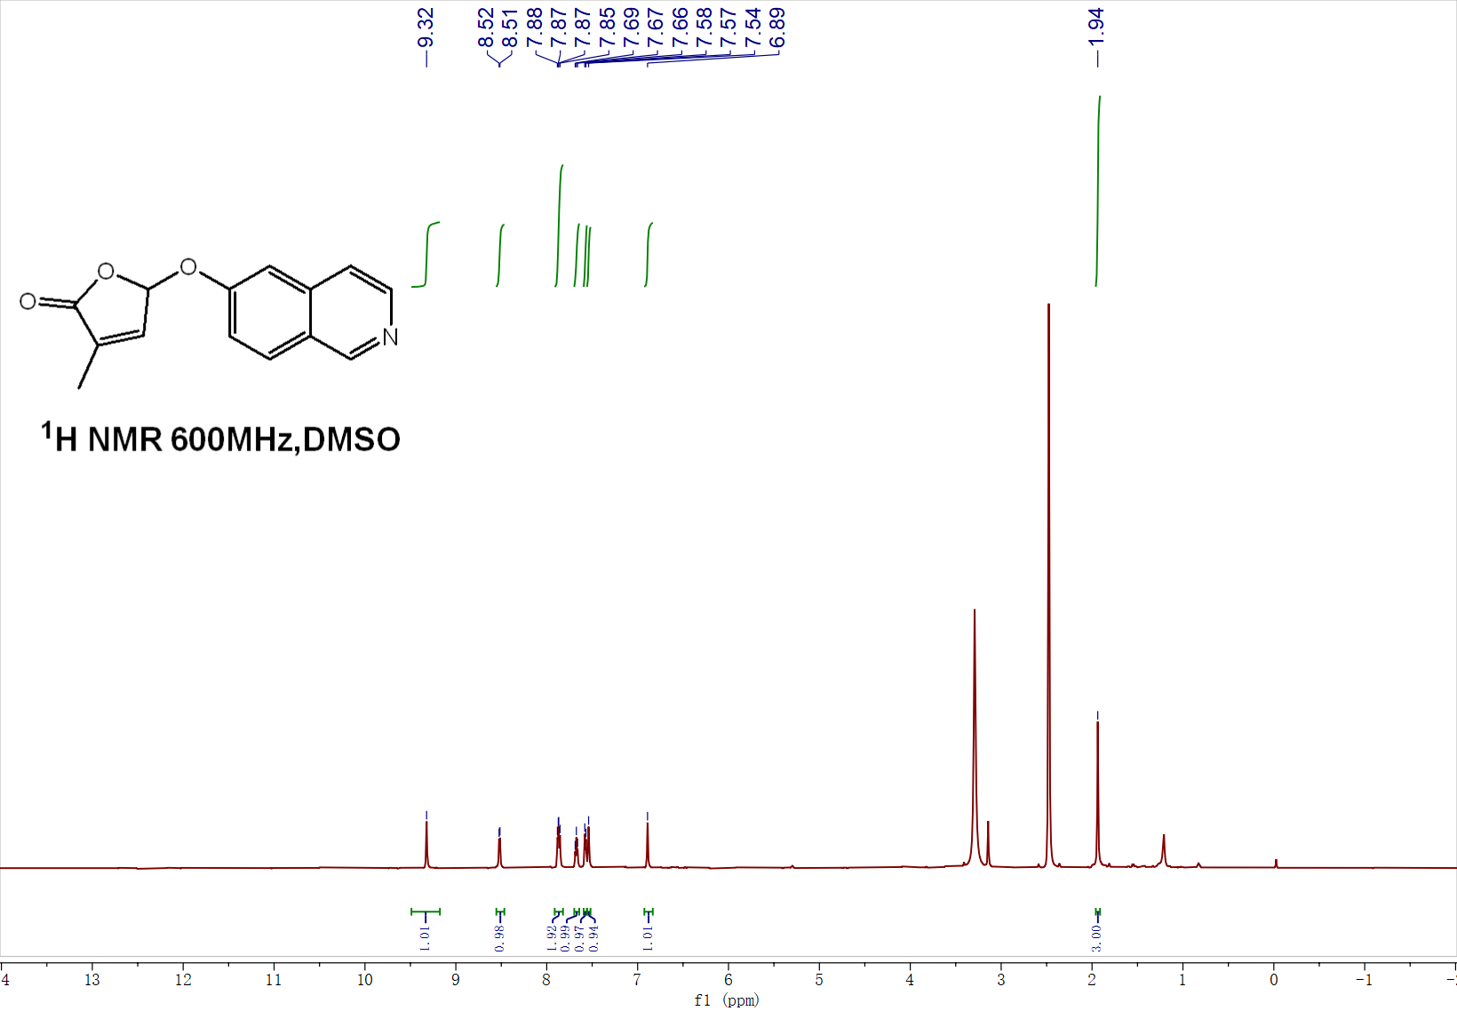
¹³C NMR of 3t
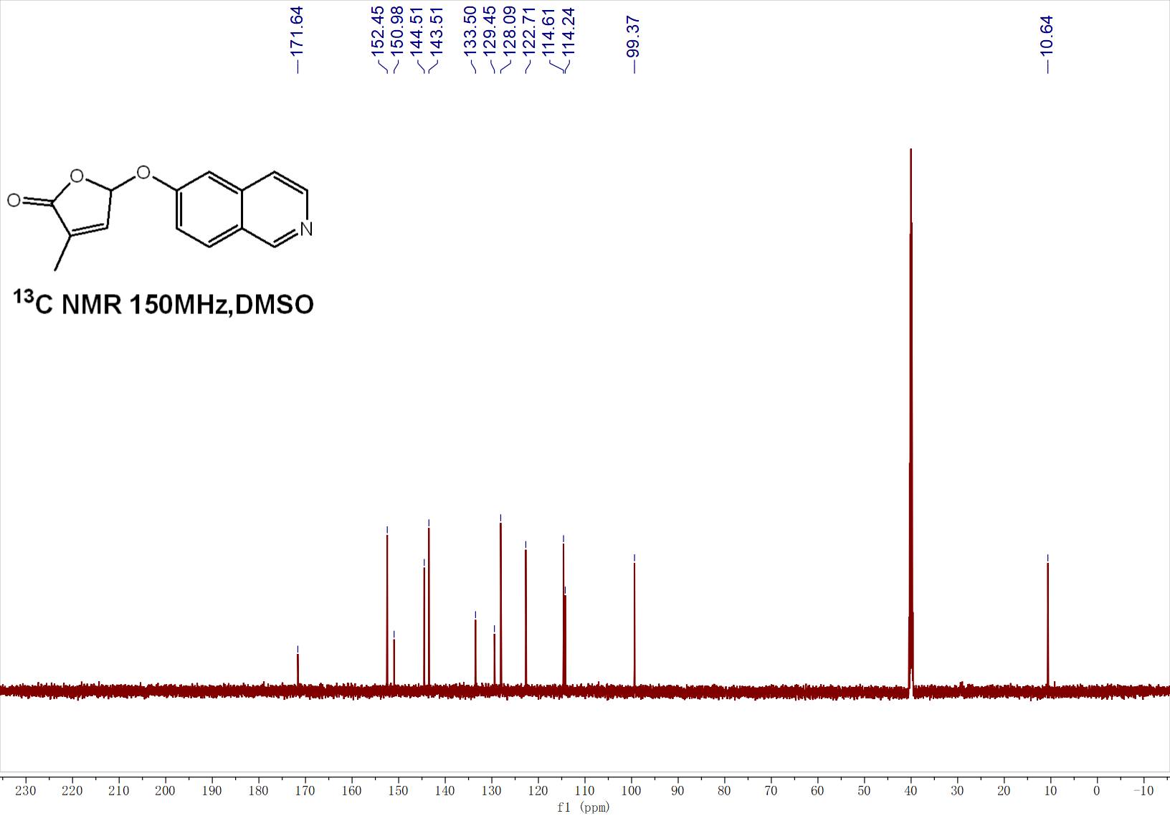

¹H NMR of 3u
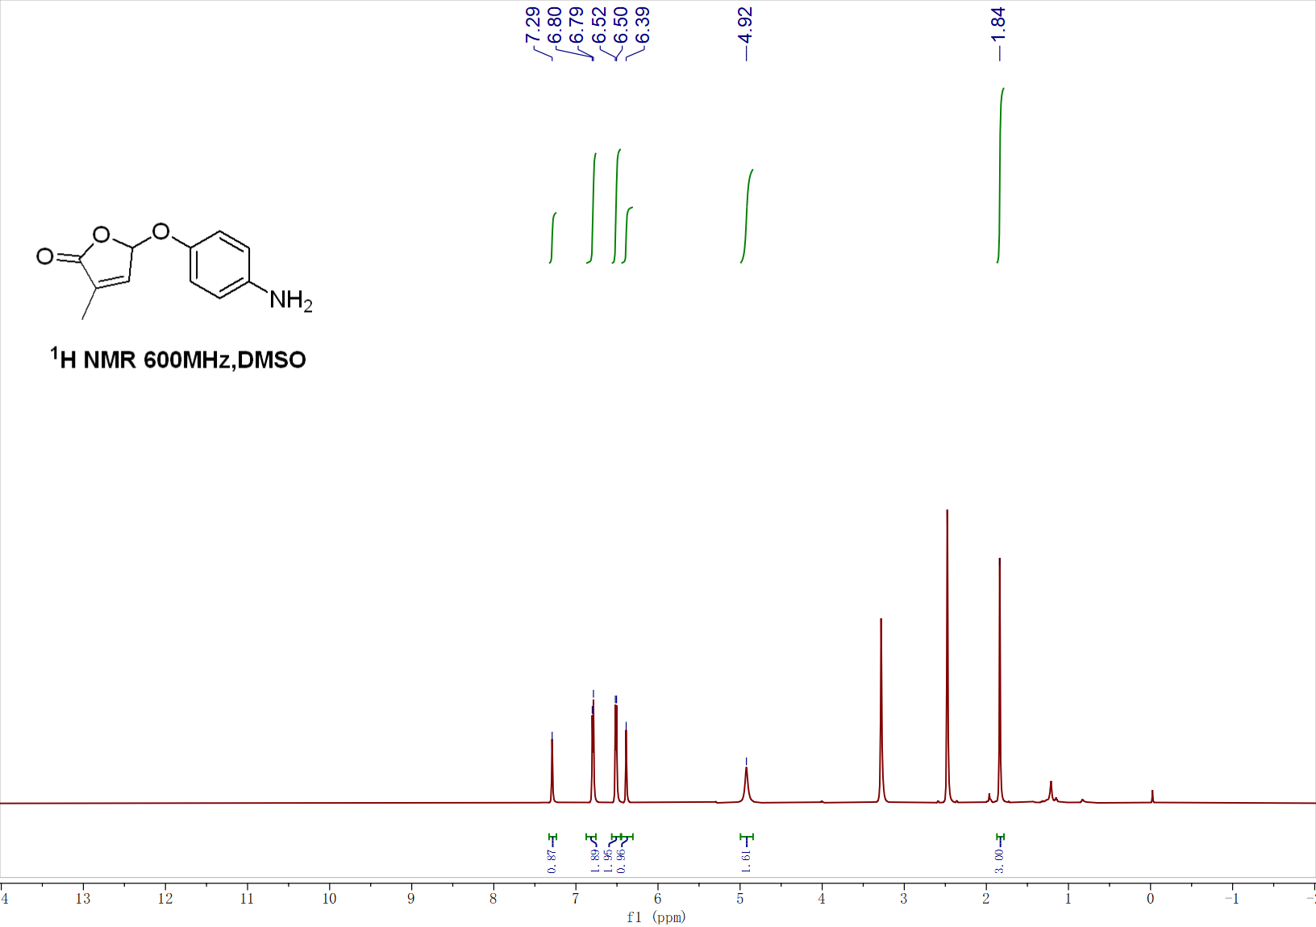
¹³C NMR of 3u
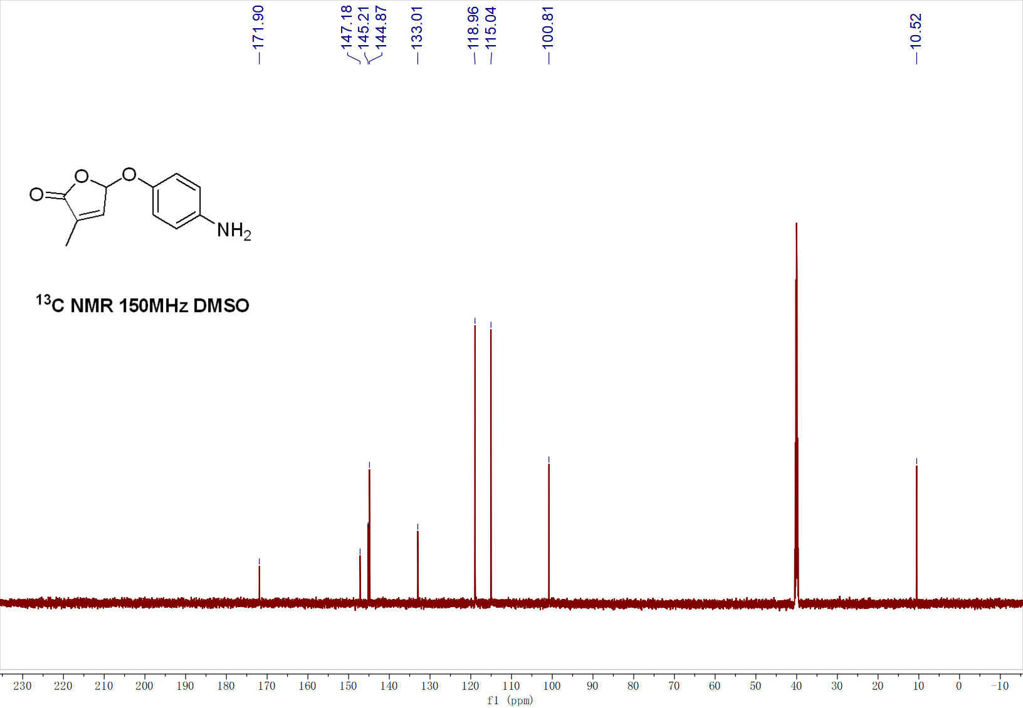

¹H NMR of 3v
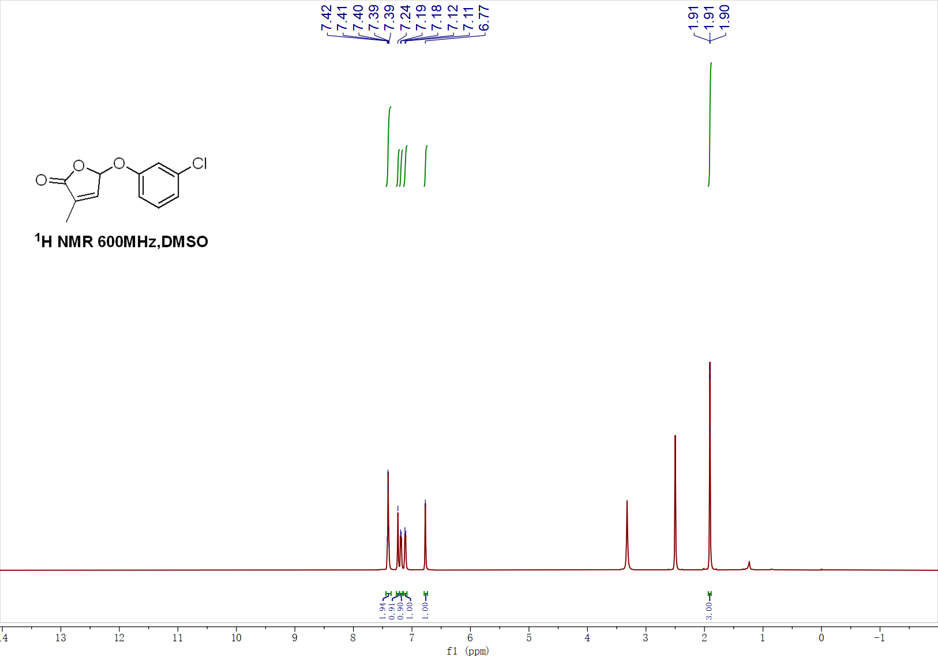
¹³C NMR of 3v
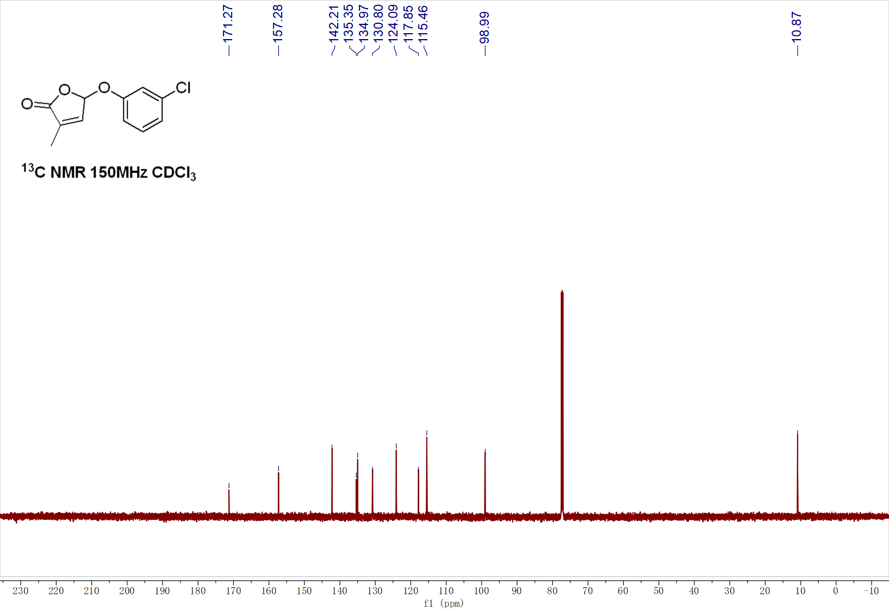

¹H NMR of 3w
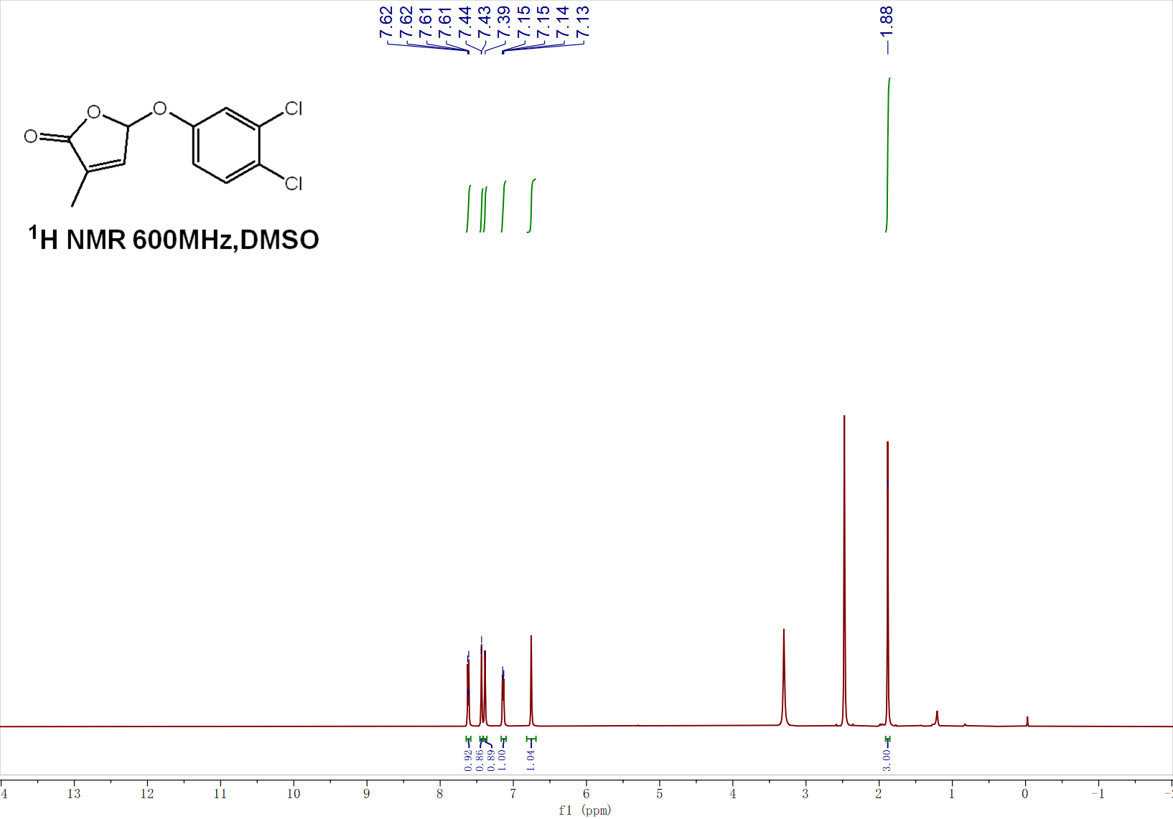
¹³C NMR of 3w
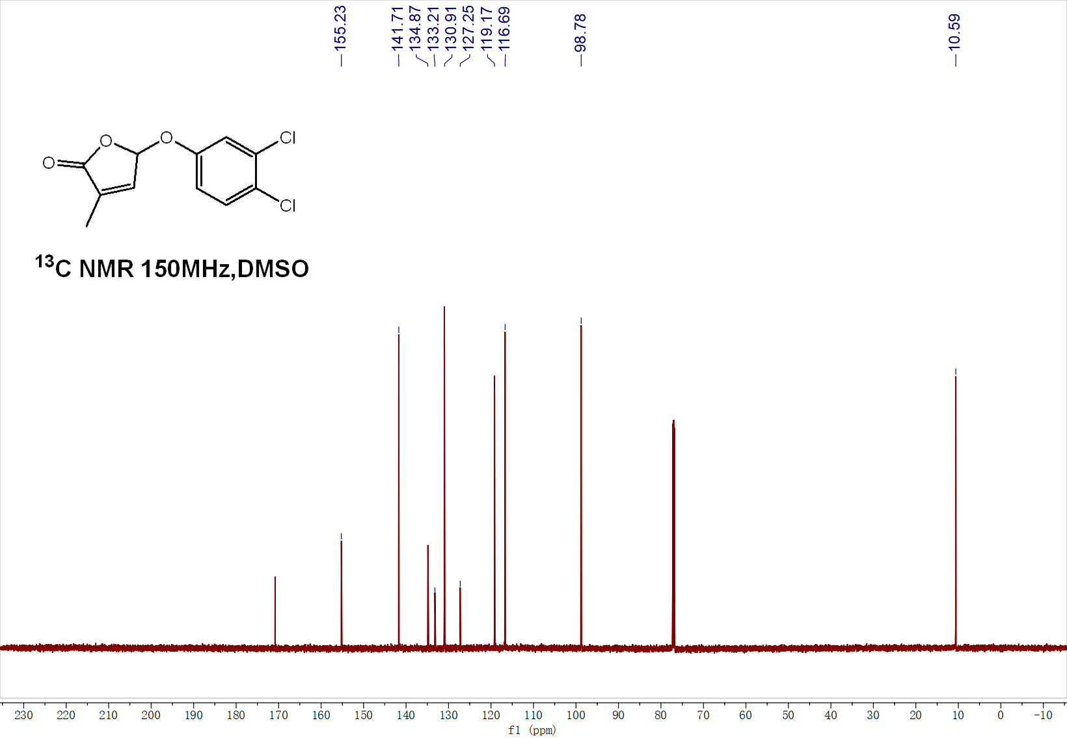

¹H NMR of 3x
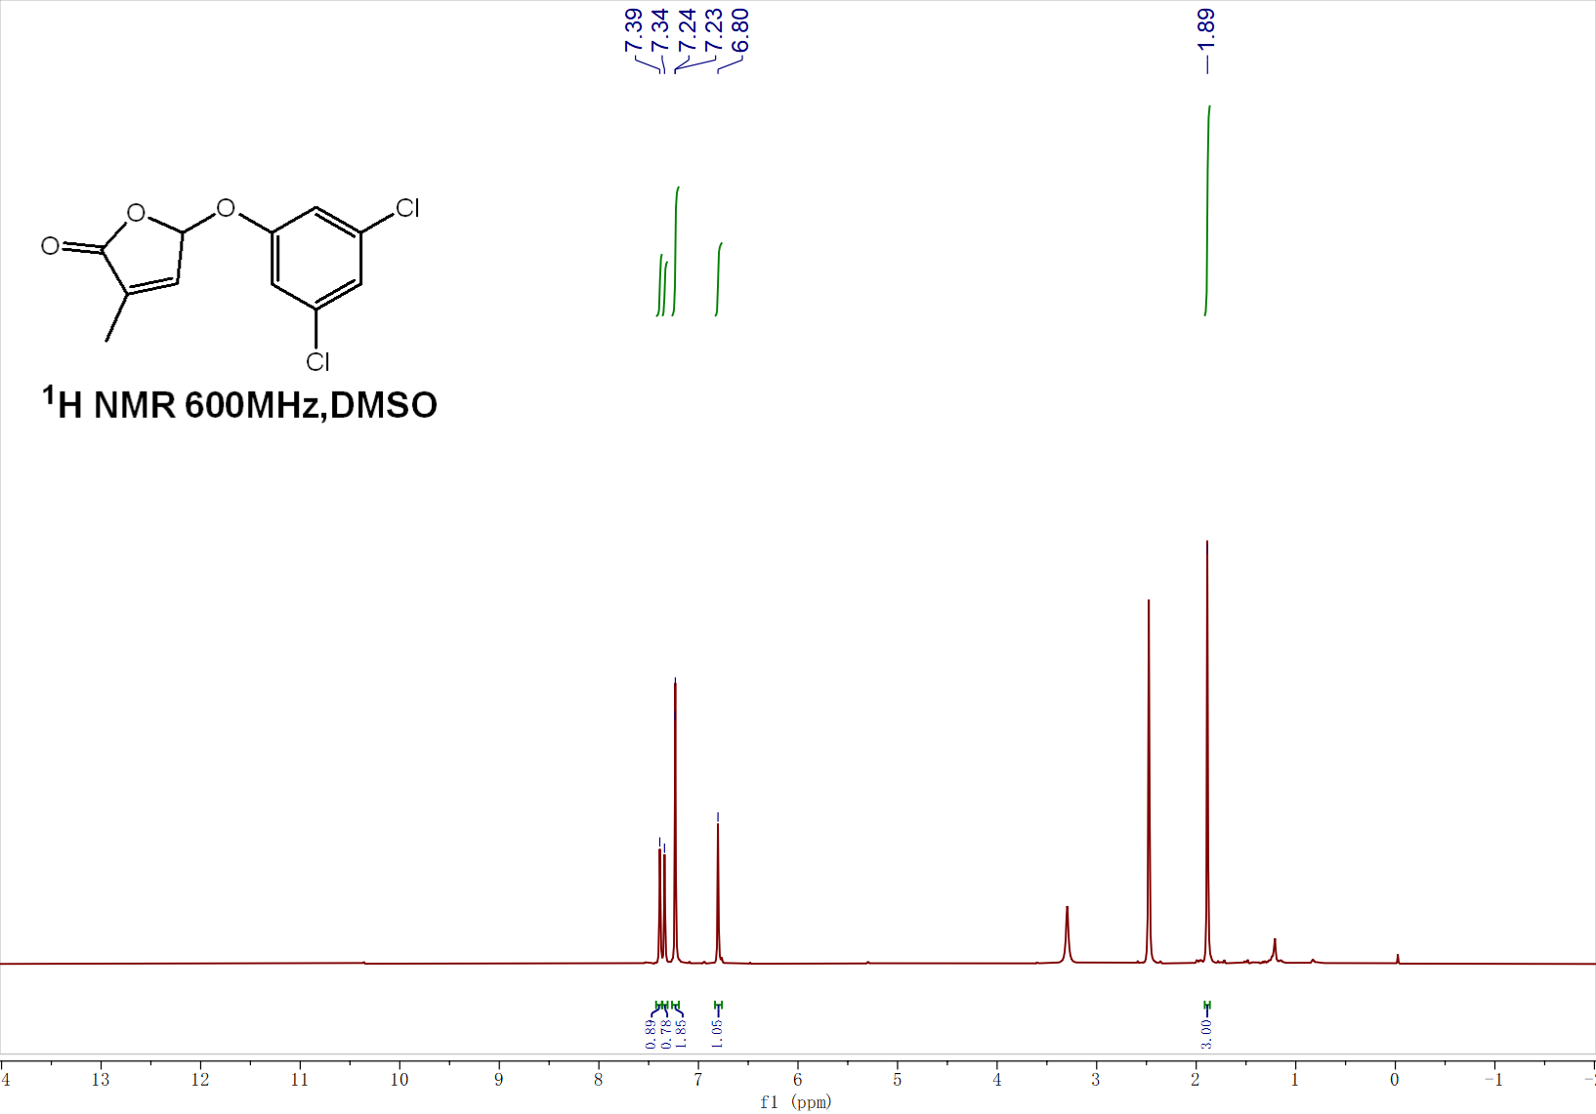
¹³C NMR of 3x
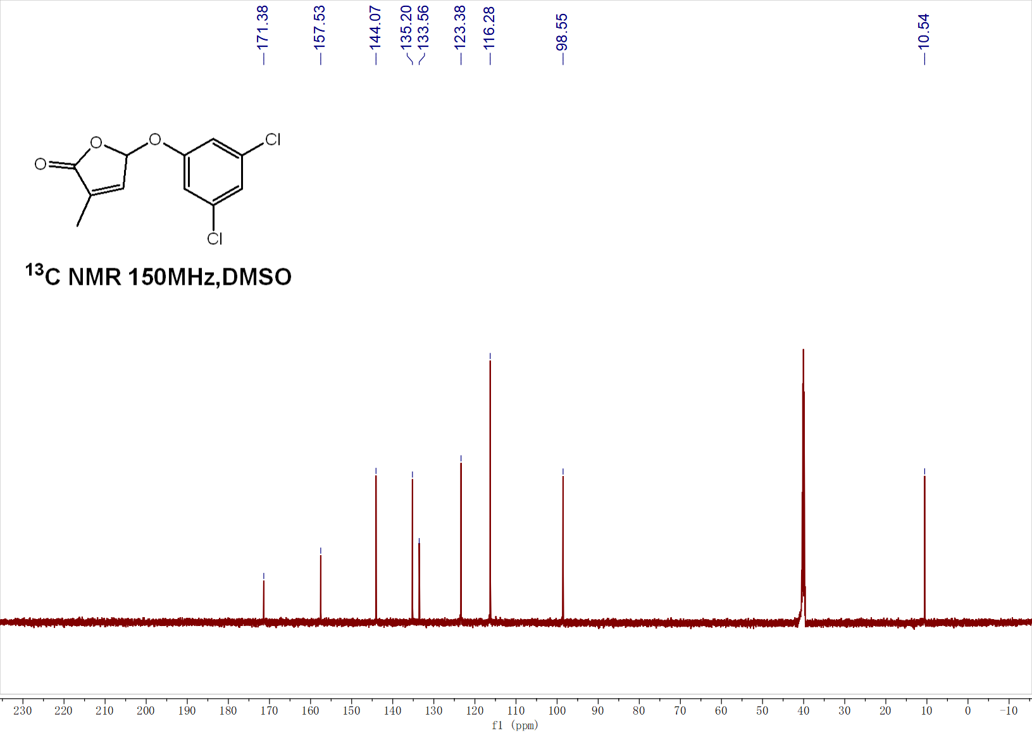

¹H NMR of 3y
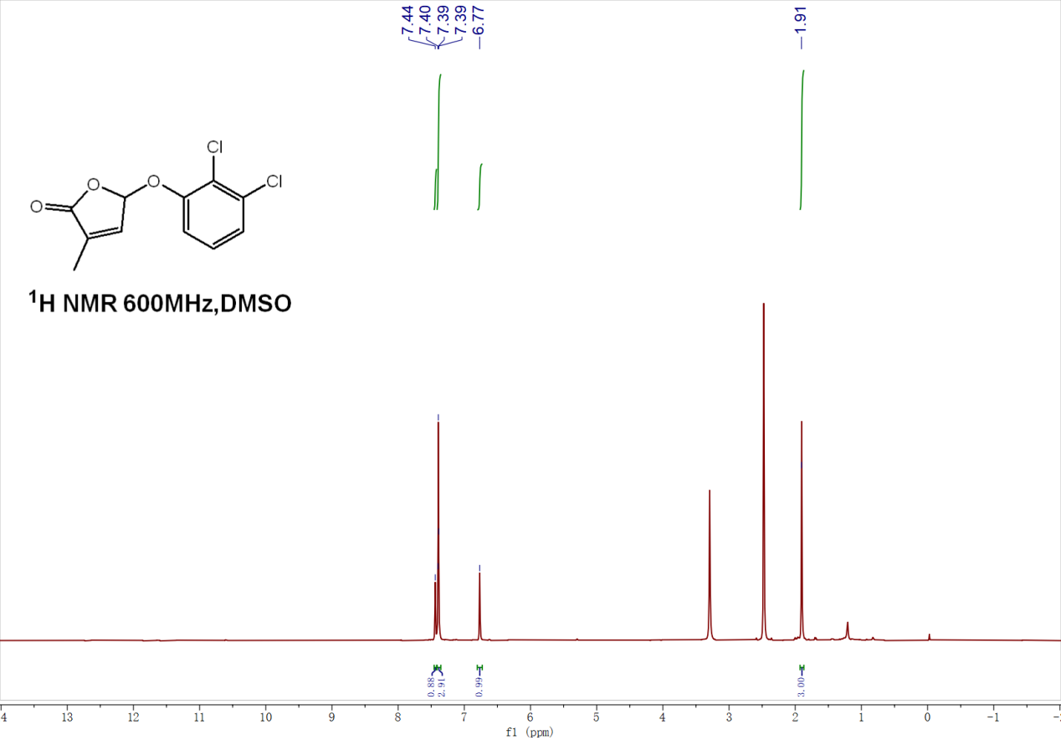
¹³C NMR of 3y
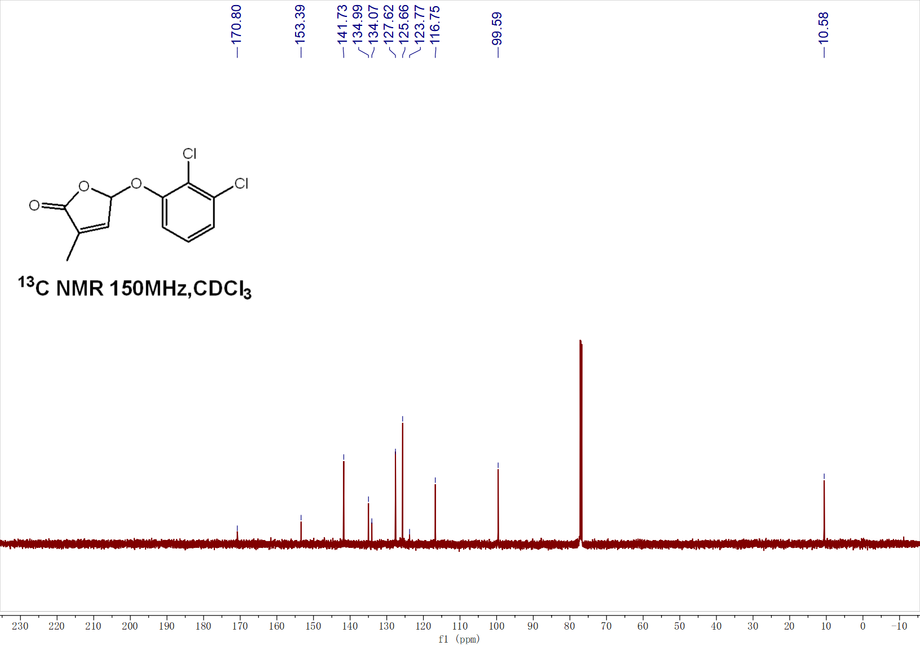

¹H NMR of 4a
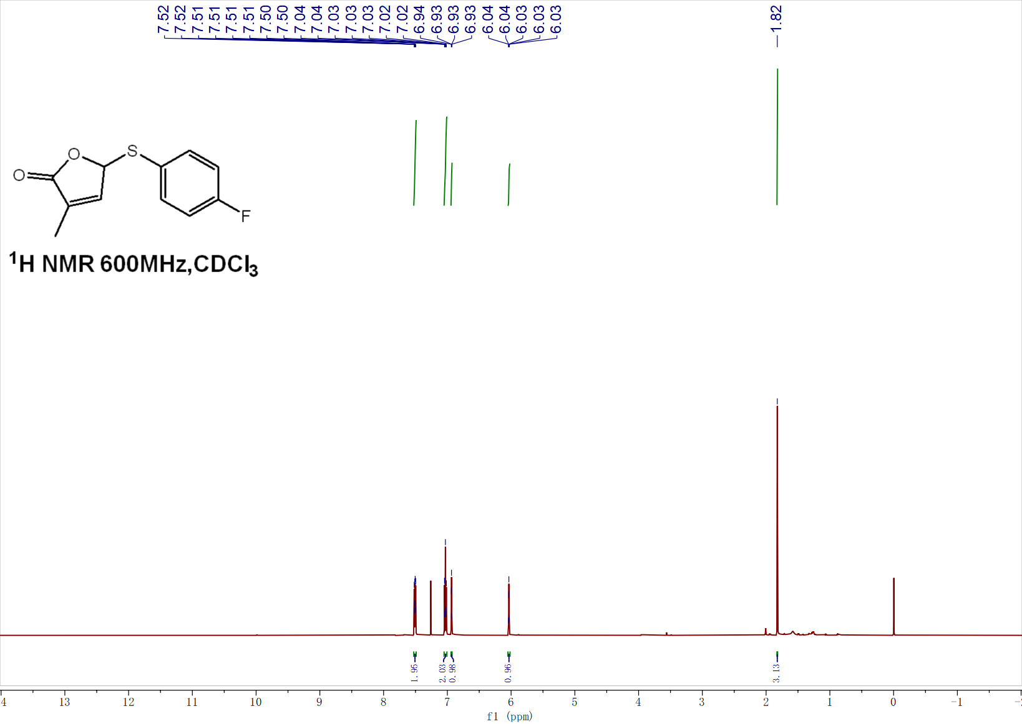
¹³C NMR of 4a
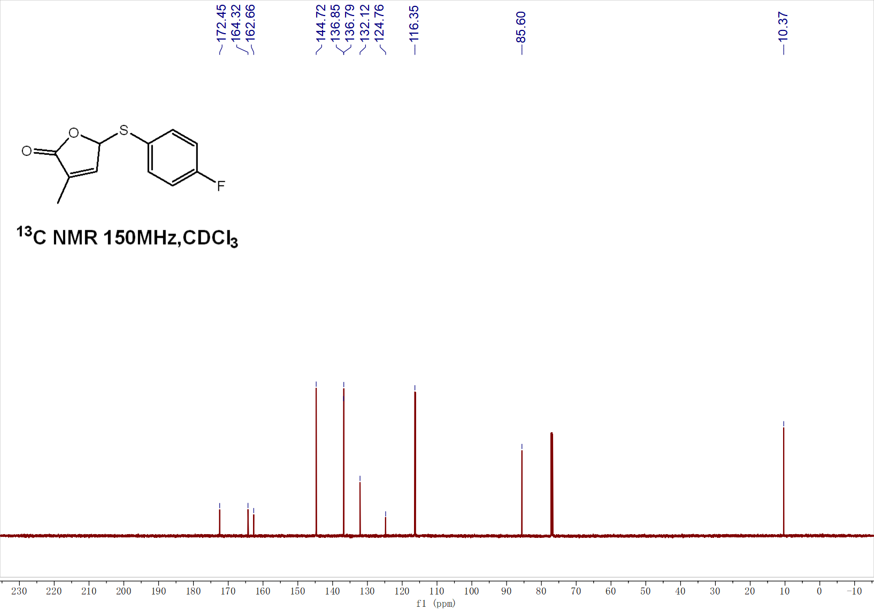

¹H NMR of 4b
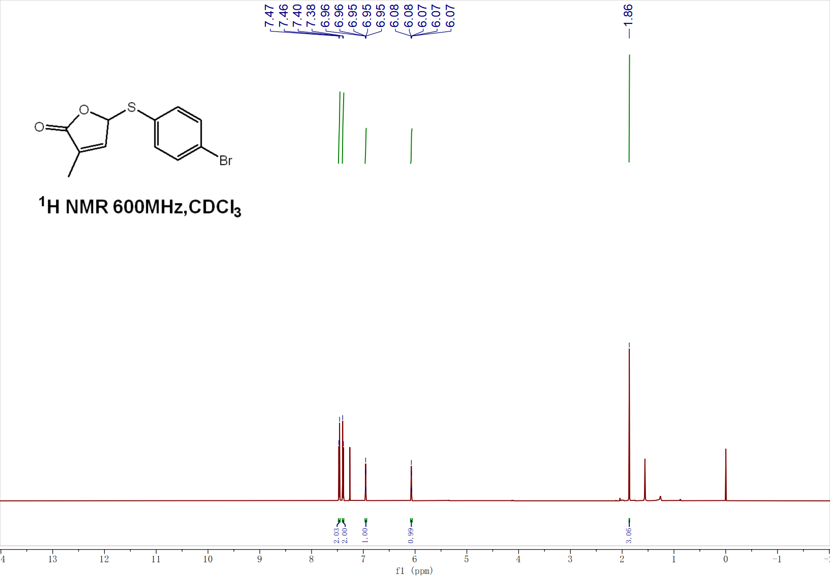
¹³C NMR of 4b
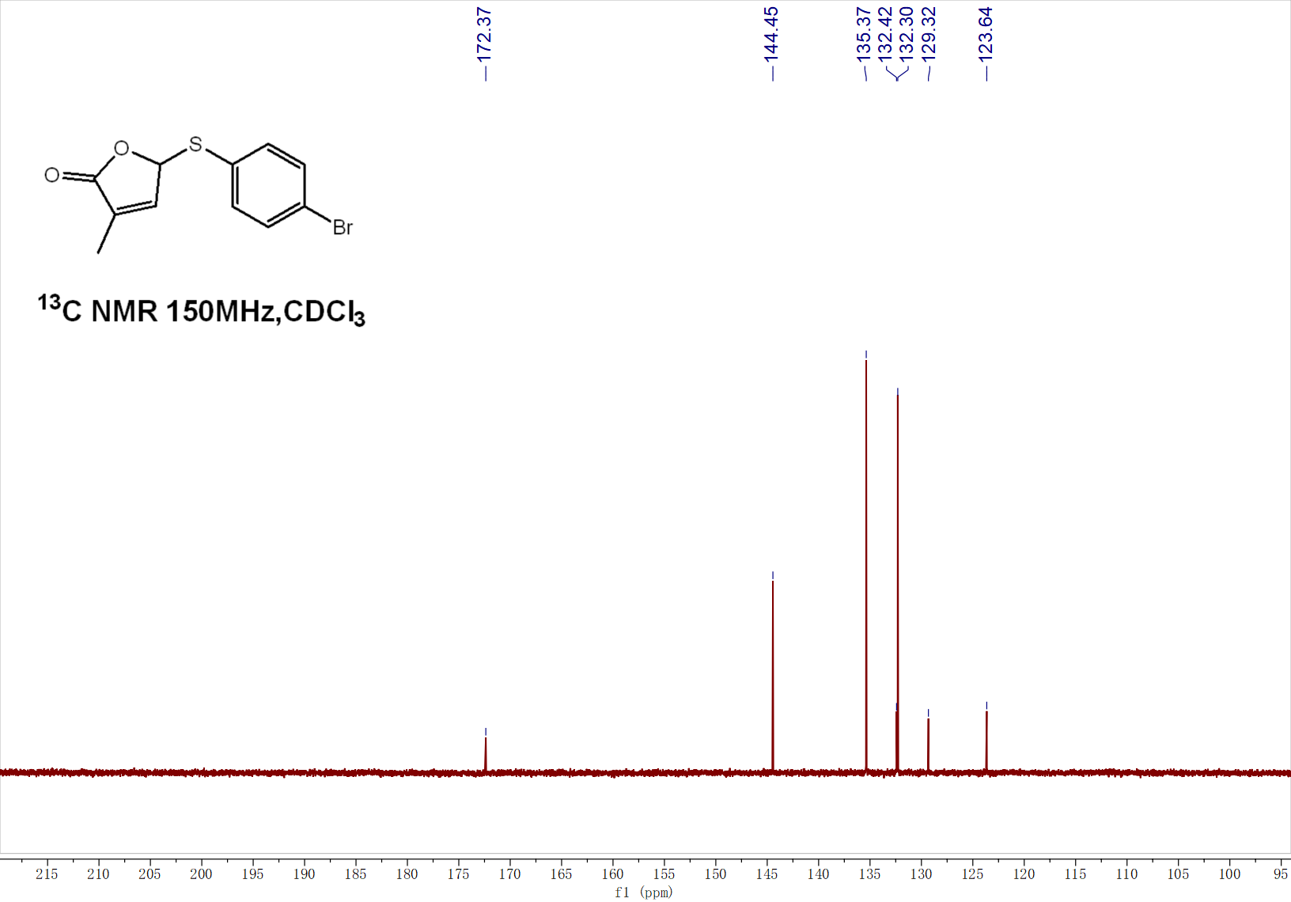

¹H NMR of 4c
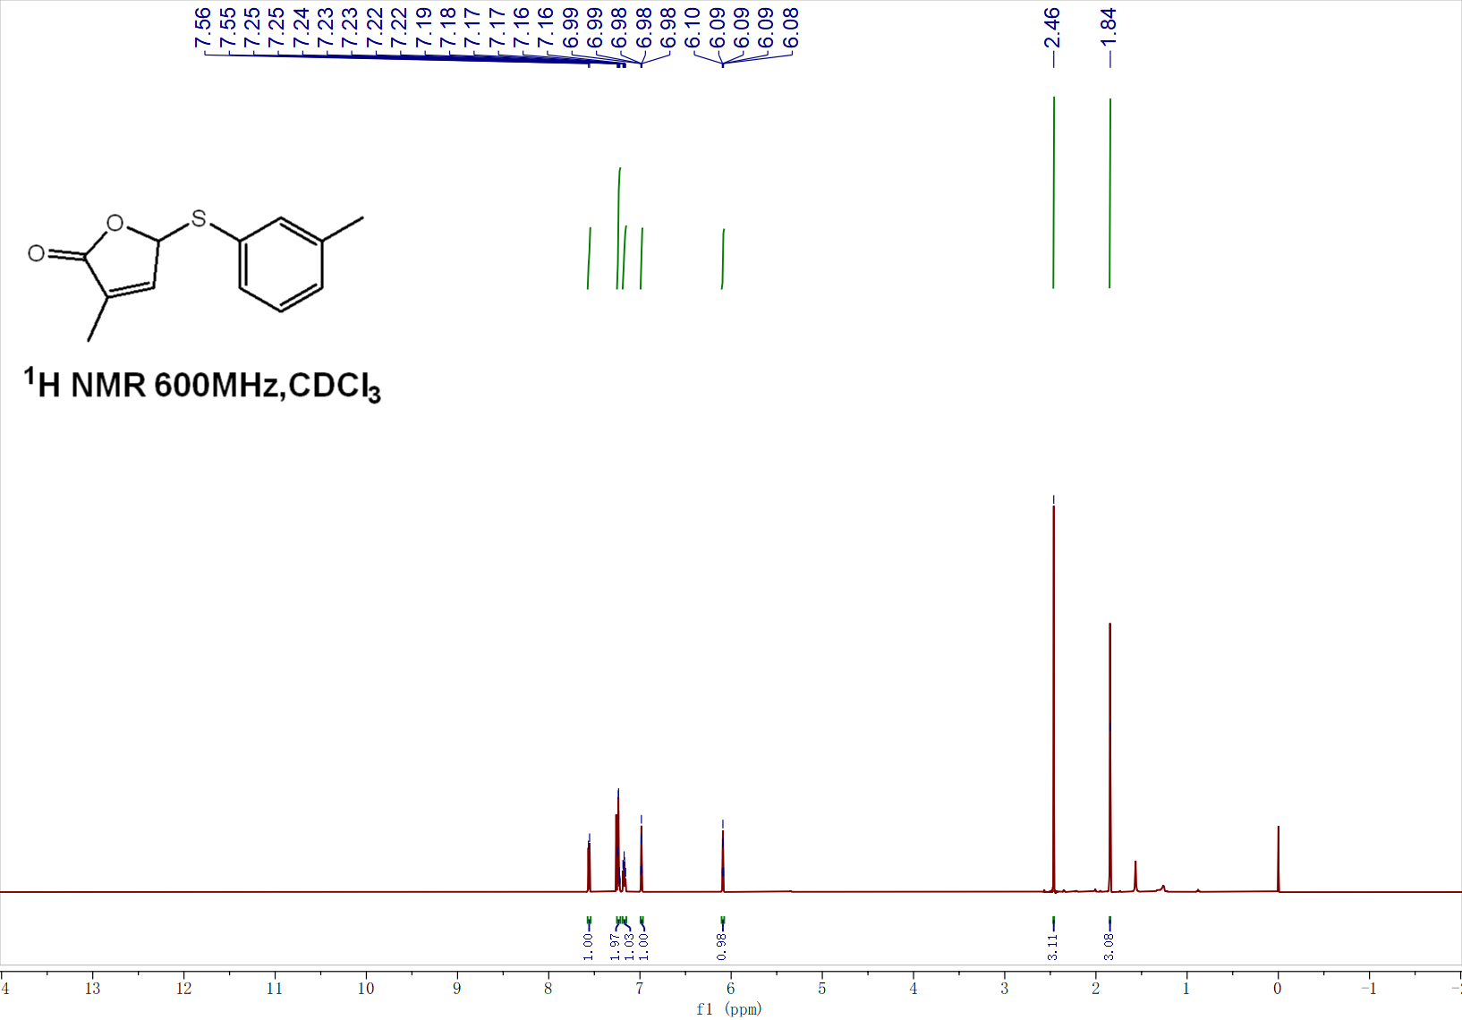
¹³C NMR of 4c
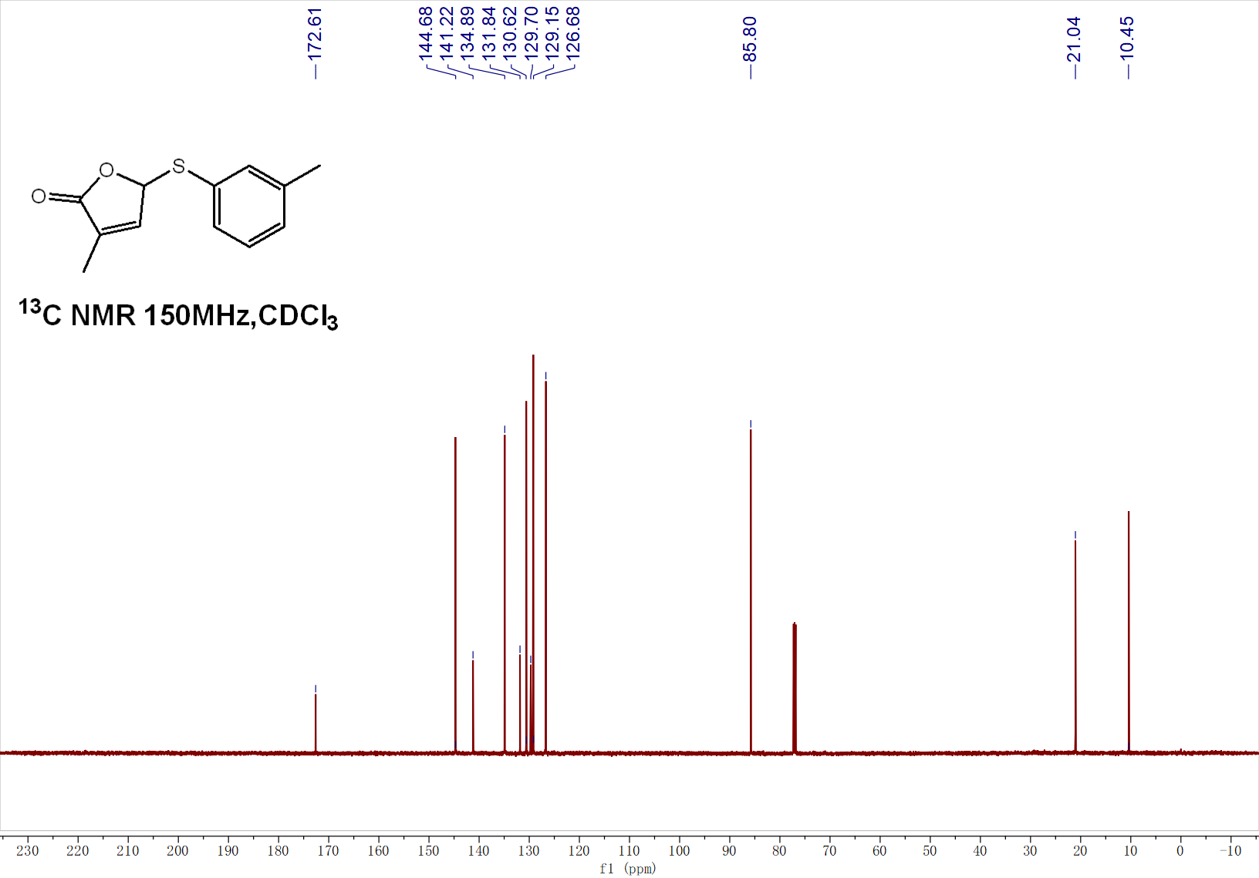

¹H NMR of 4d
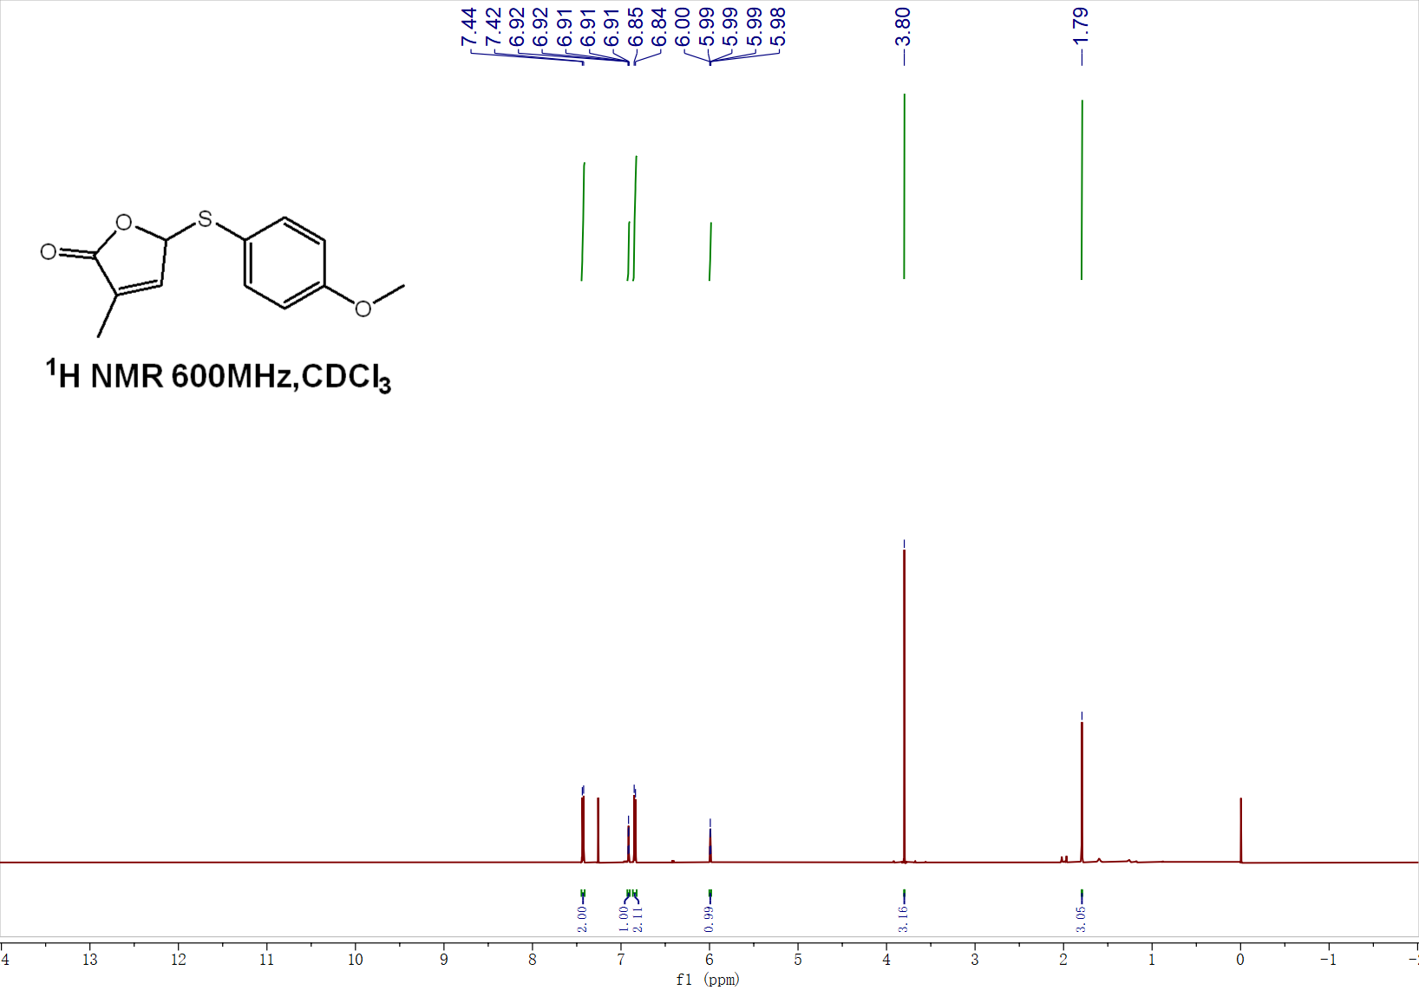
¹³C NMR of 4d
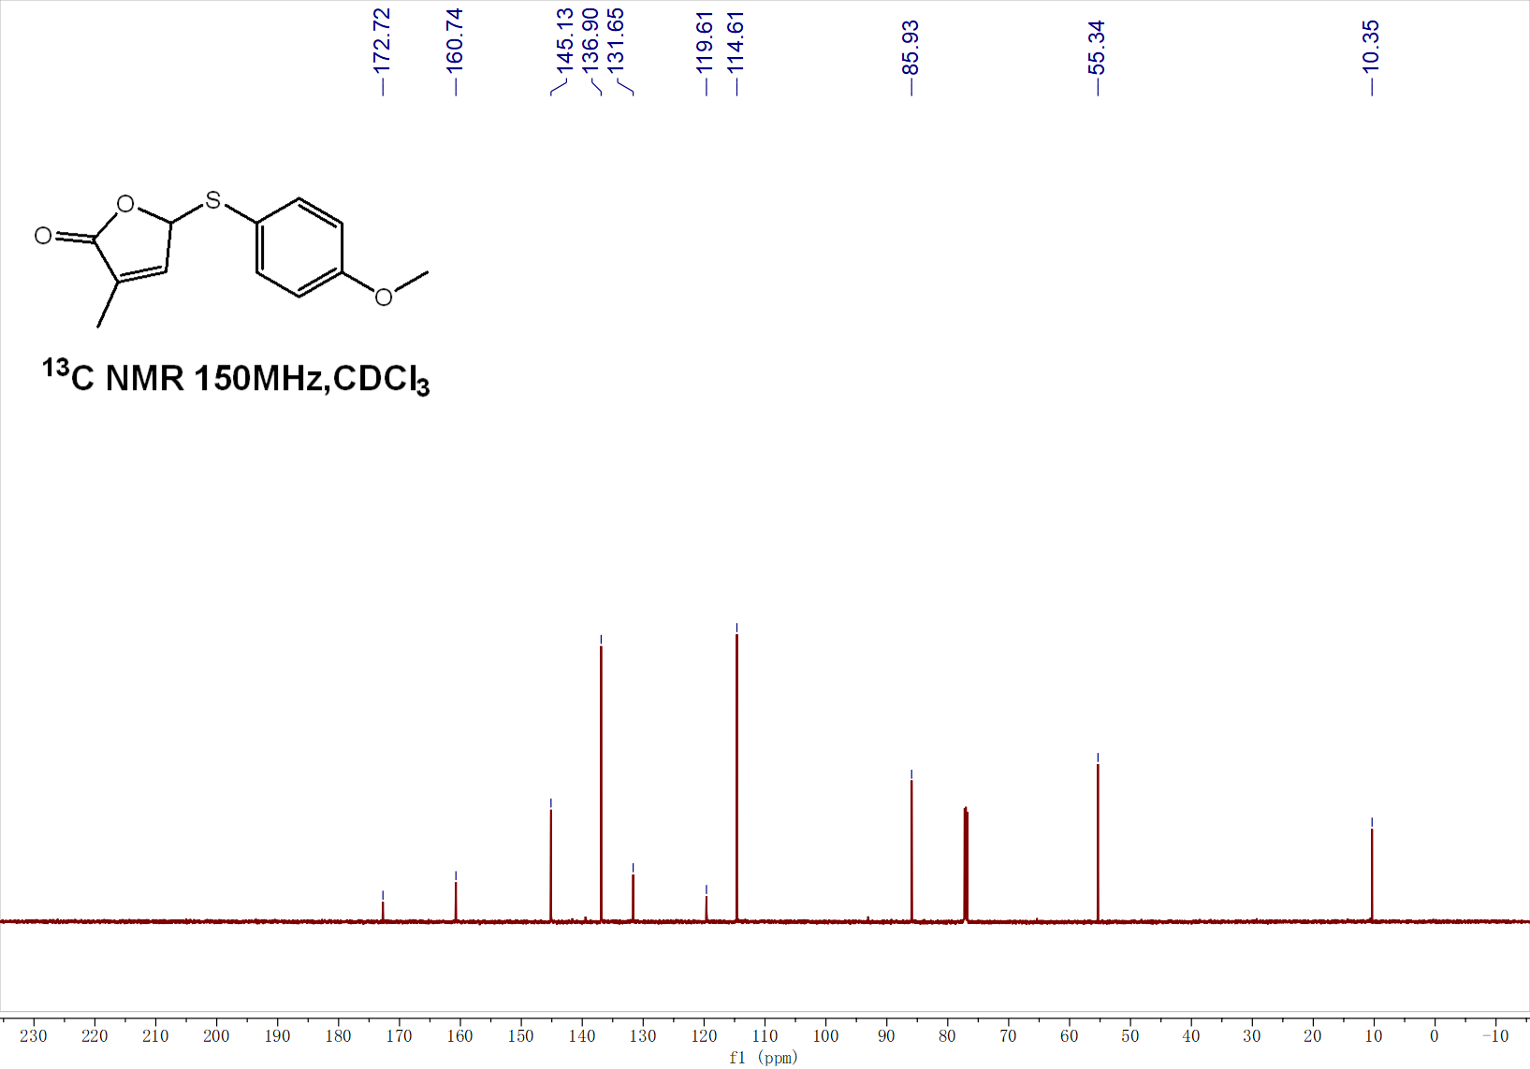

¹H NMR of 4e
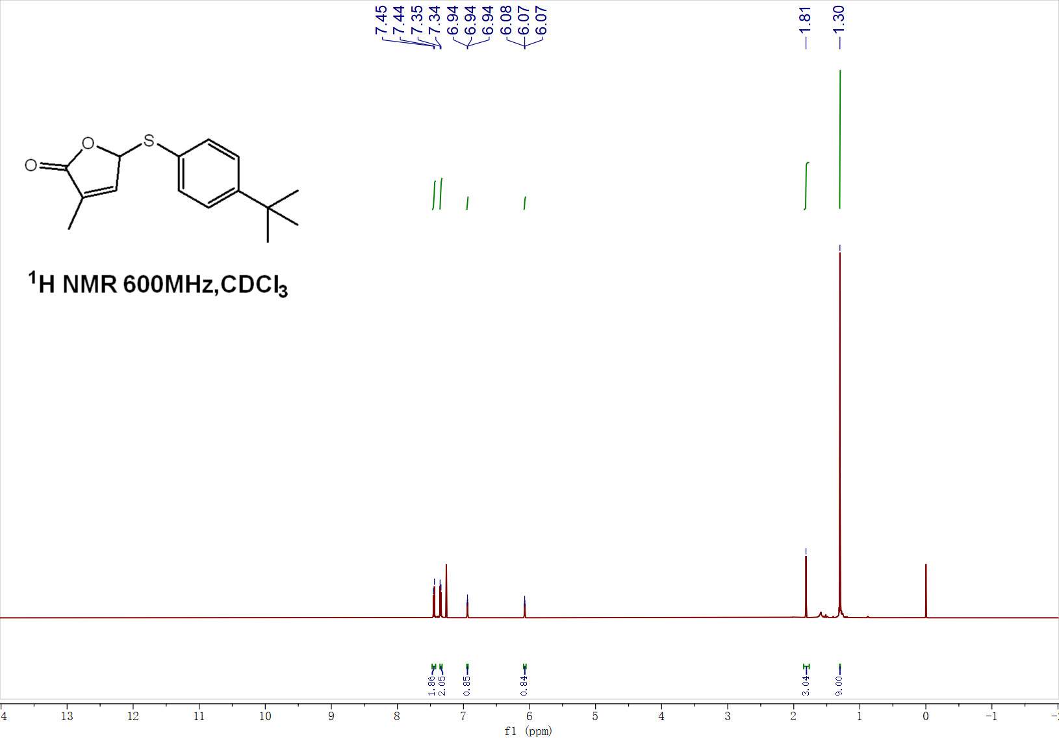
¹³C NMR of 4e
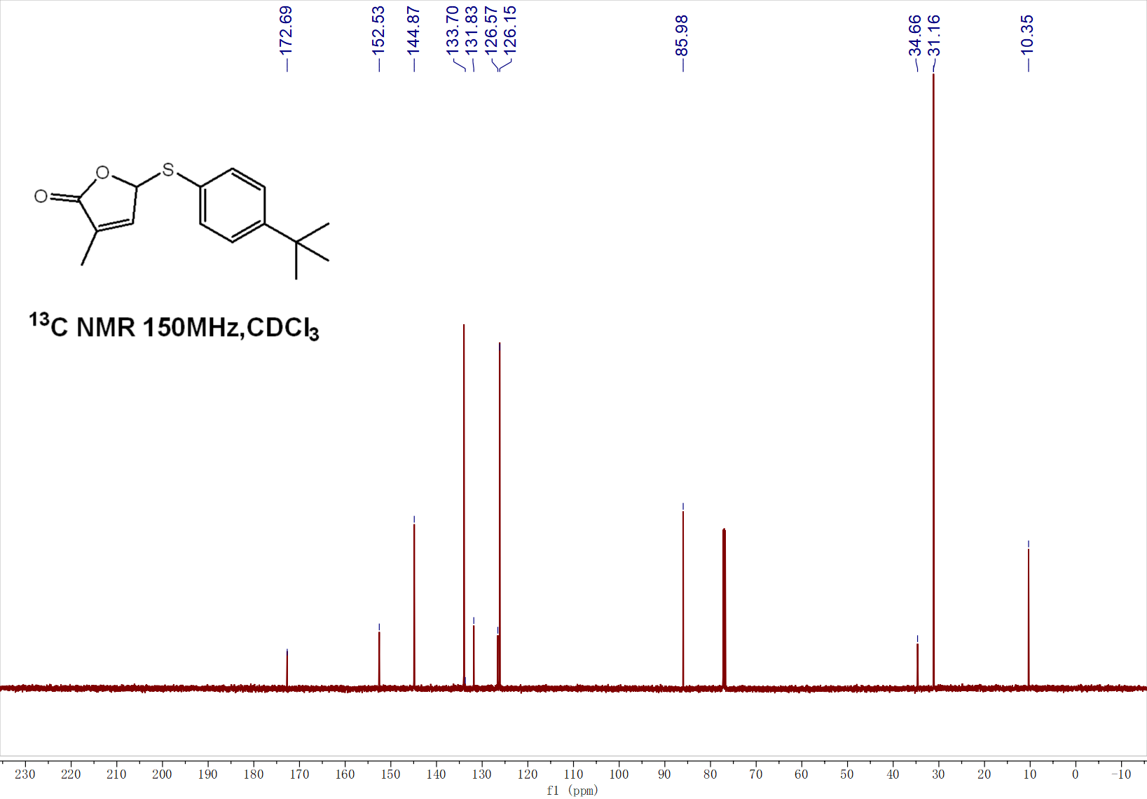

¹H NMR of 4f
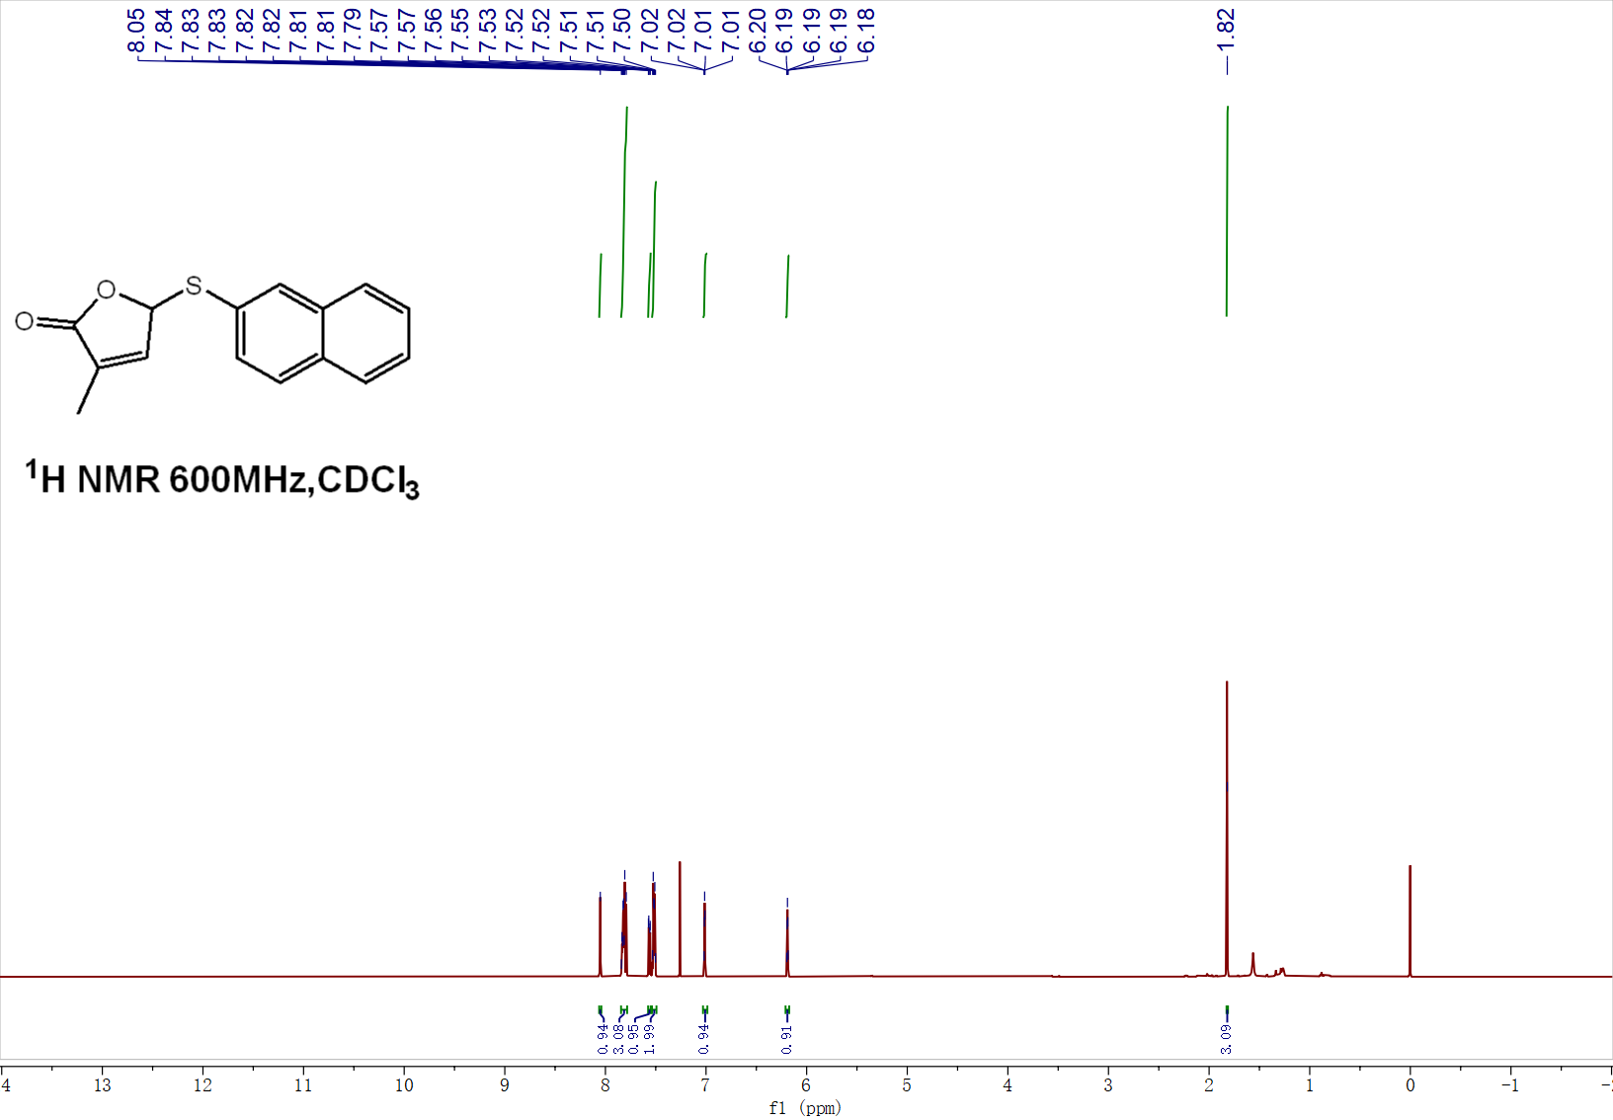
¹³C NMR of 4f
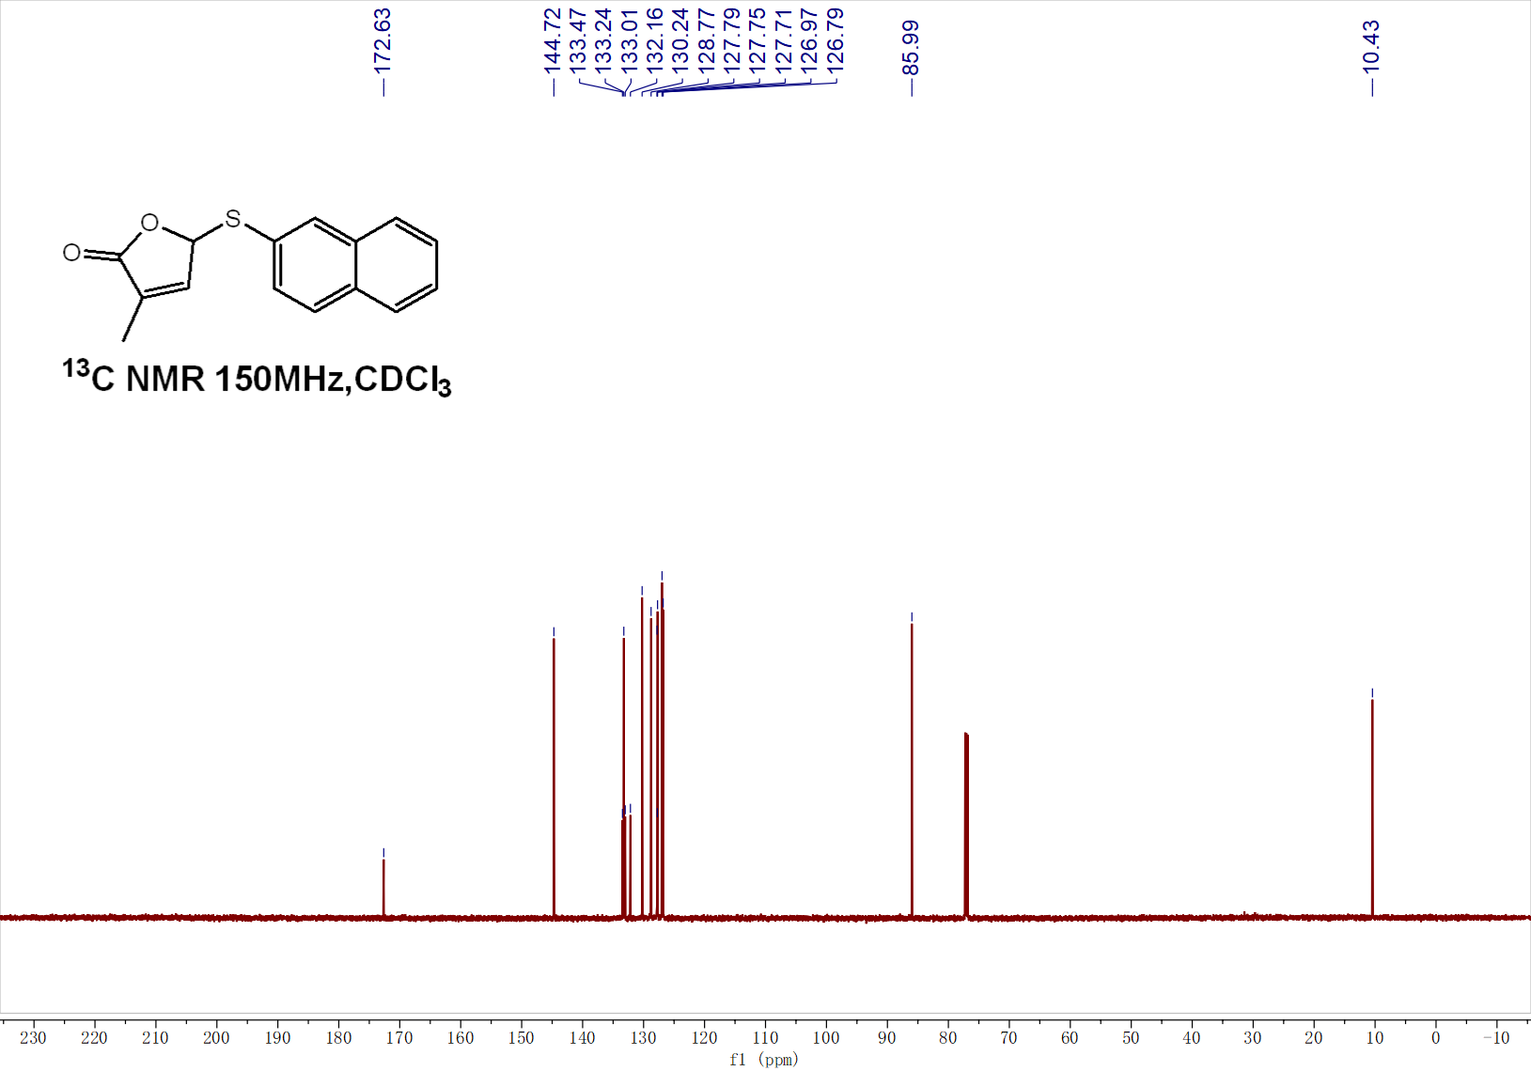

¹H NMR of 4g
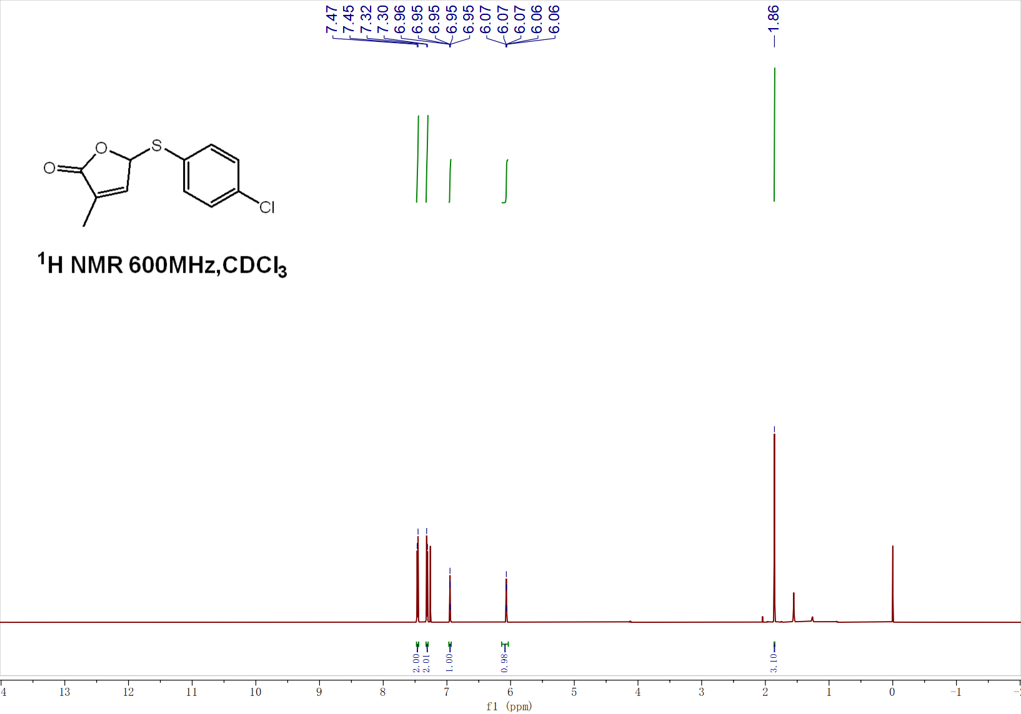
¹³C NMR of 4g
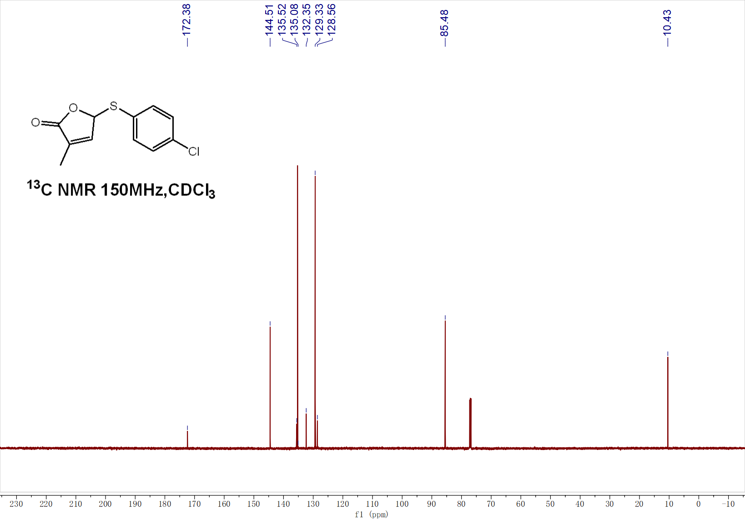

¹H NMR of 4h
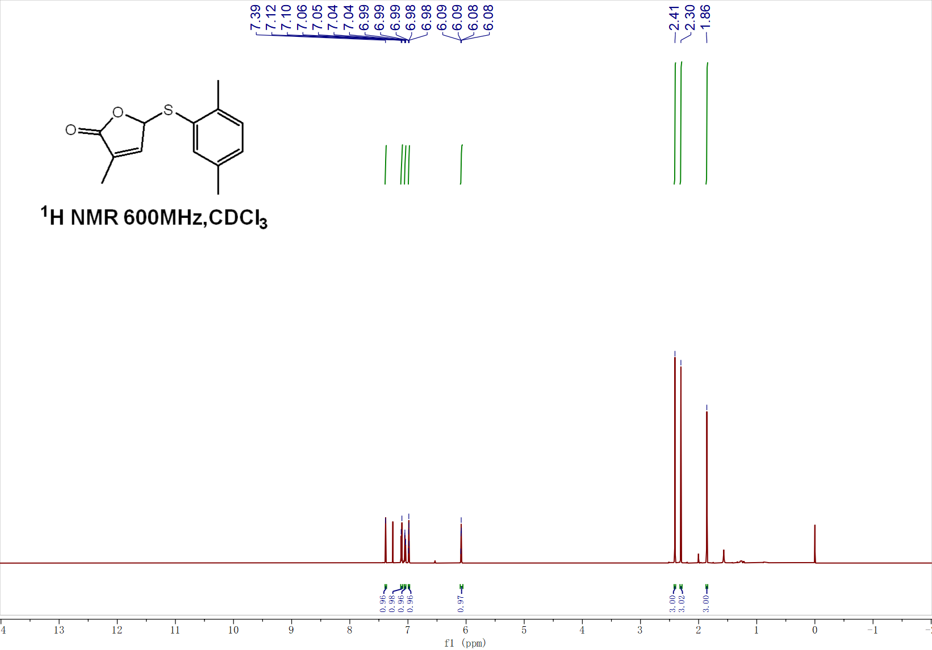
¹³C NMR of 4h
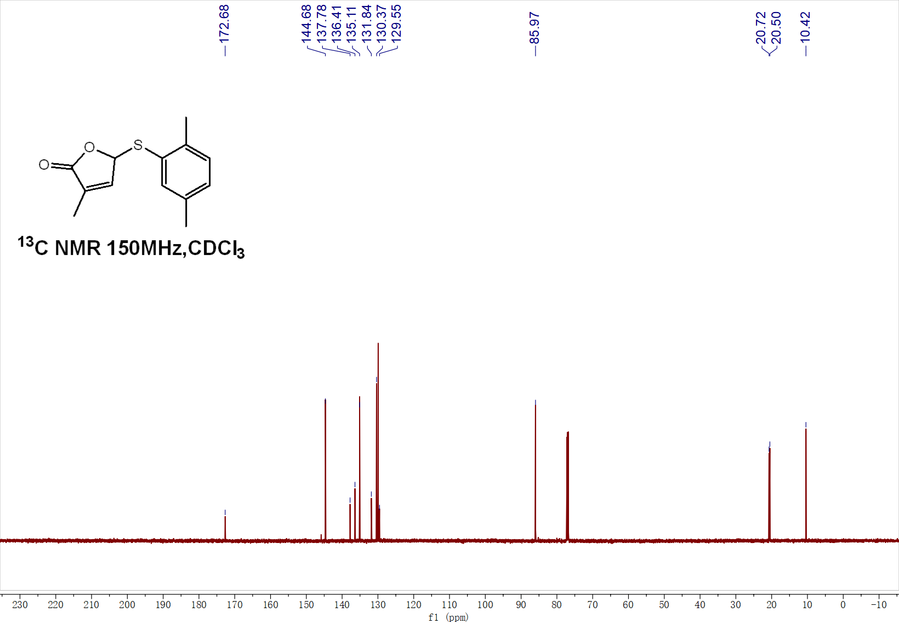

¹H NMR of 4i
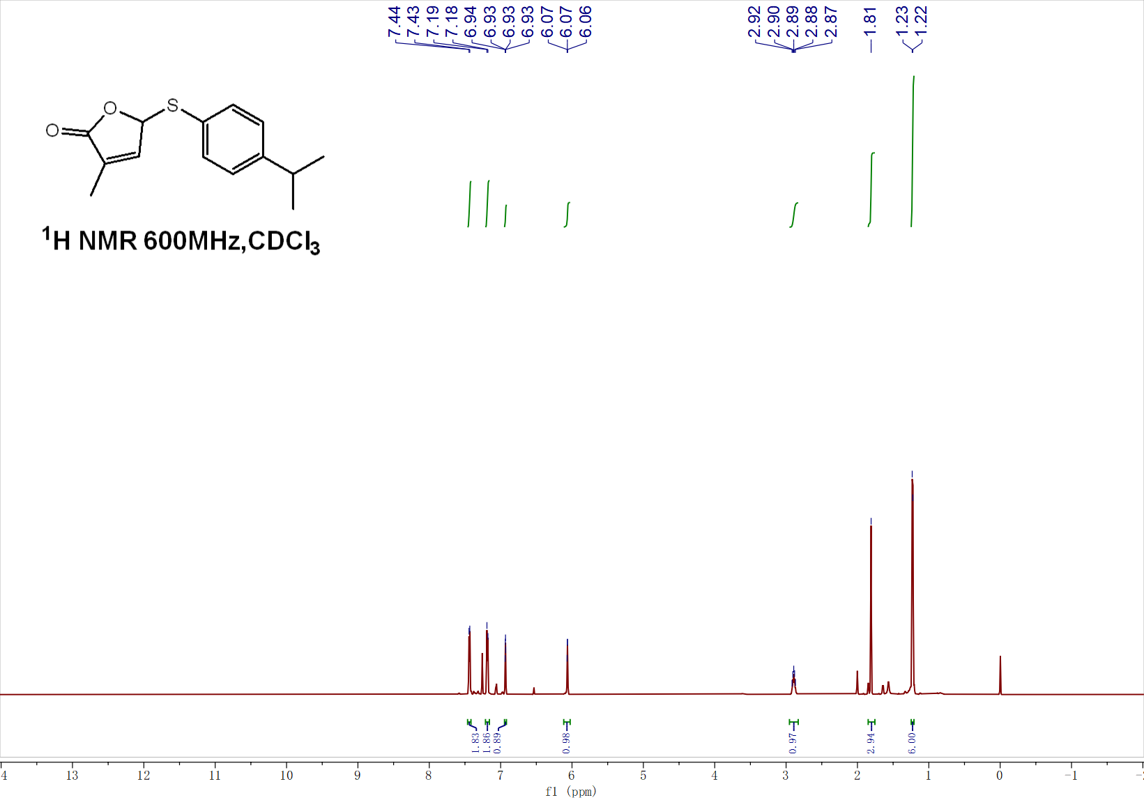
¹³C NMR of 4i
