L 1 2 3 4 5 6 7 8 9 10 11 L 1 2 3 4 5 6 7 8 9 10 11 11
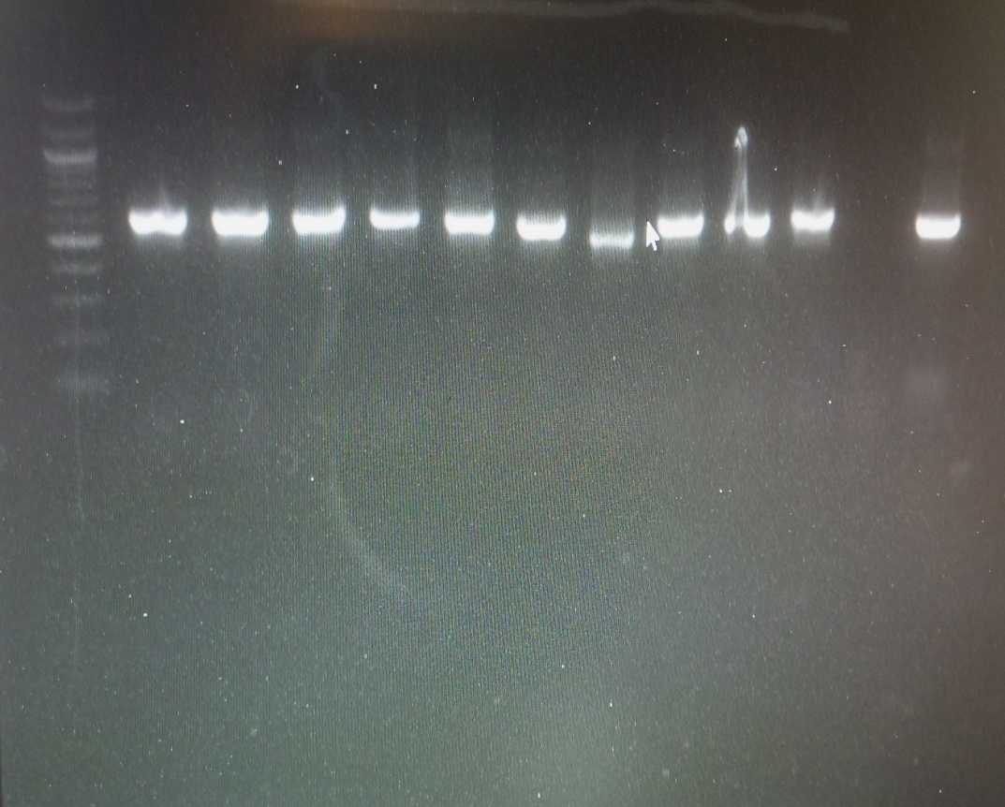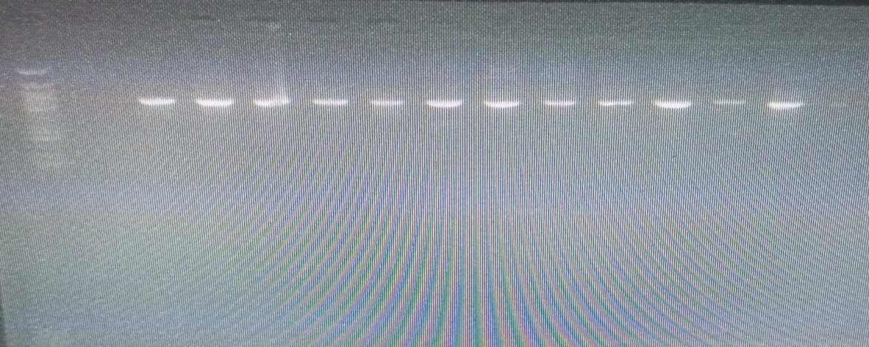
700bp
450bp

L 1 2 3 4 5 6 7 8 9 10 11 L
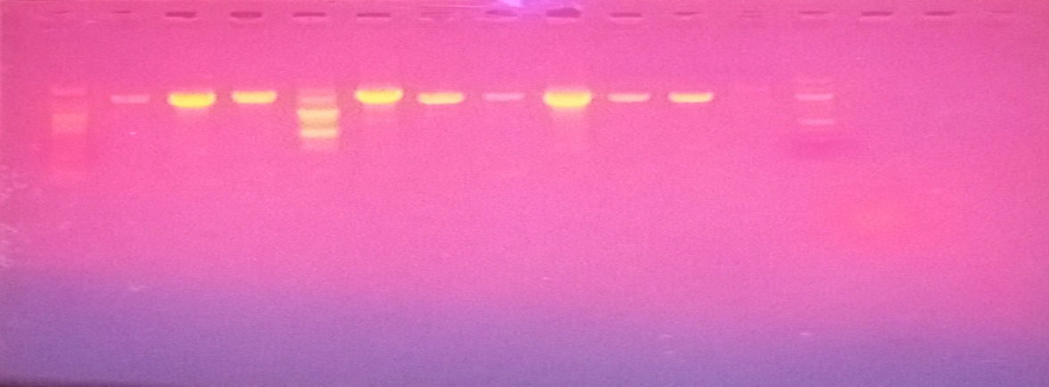
400bp
600bp
700bp
Plate 1. Agarose gel (1%) electrophoresis of the PCR product of the (a) Internal Transcribed Spacer (ITS), (b) D1/D2 domain (NL-1/NL-4) (c) Translational elongation factor 1α (TEF1 α) region of the eleven fungal isolates. L: Molecular ladder,1: E7C, 2: 06C, 3: E7A, 4: M4, 5: M5B1, 6: M6A, 7: M6, 8: A4B, 9: O6A, 10: M1B, 11: E7.

