Carbon nanofiber-assisted molecularly imprinted electrochemical sensors for selective hypoxanthine detection from real samples

Canan Armutcu^{1*}, Sena Pişkin¹, Erdoğan Özgür¹,
Mustafa Karakaya³, M. Emin Çorman², Lokman Uzun¹
¹Hacettepe University, Faculty of Science, Department of Chemistry, Ankara, Türkiye
²University of Health Sciences, Gülhane Faculty of Pharmacy, Department of Biochemistry, Ankara, Türkiye
³Sinop University, Faculty of Engineering & Architecture, Department of Energy System, Sinop, Türkiye

S1. Results and discussion
S1. Quantum calculations for designing of MECs
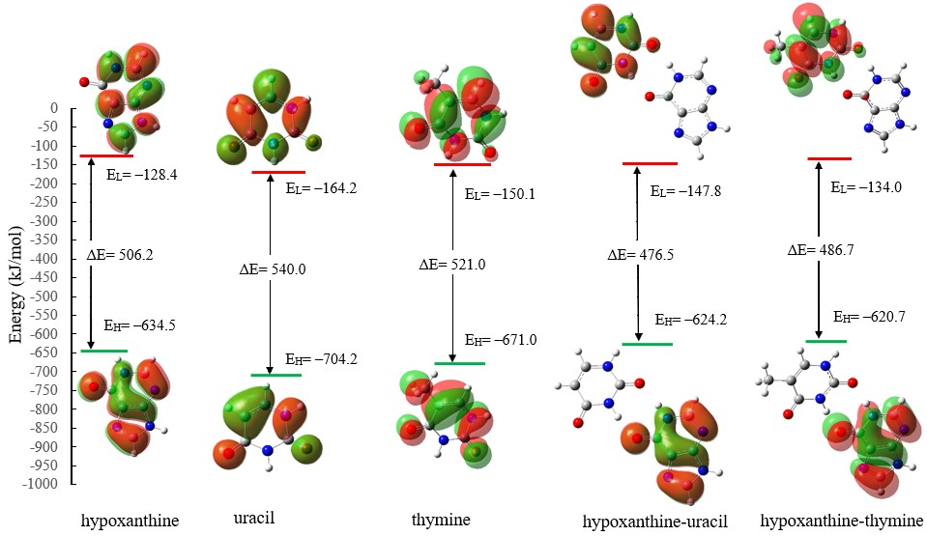

Figure S1. 3D plots and energy levels of the highest occupied and lowest unoccupied molecular orbitals in hypoxanthine-monomer interactions.

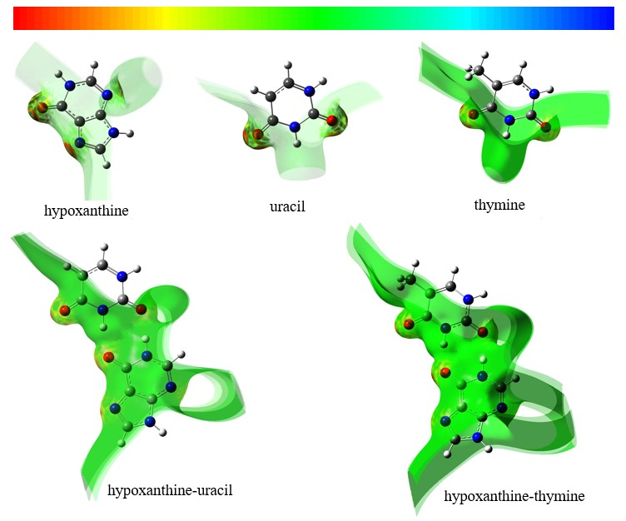

Figure S2. Visuals mapped with ESP of the hypoxanthine-monomer interactions.

