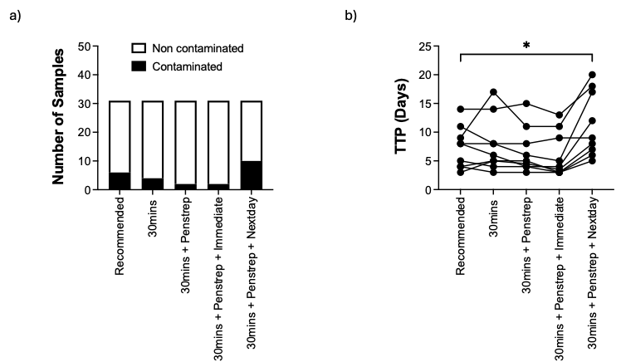

Figure S1. MGIT assay optimization for tissues
b) Number of contaminated vs non-contaminated samples in five conditions. b) Time To Positivity (TTP) for samples that didn’t get contaminated.

