[Nature Geoscience]
Supporting Information for
[Heterogeneous trace element deposition from an effusive volcanic plume.]
Laura Wainmanª, Evgenia Ilyinskayaª, Melissa Anne Pfeffer^{b}, Celine Mandon^{b}, Enikö Bali^{c}, Penny Wieser^{d}, Brock Edwards^{e,f}, Martin Voigt^{c}, Barbara Kleine-Marshall^{g}, Sylvia Gudjonsdottir^{c}, Abigail Symonsª Adam Cotterill^{h}, Sam Hammond^{i}, Barbara Kunz^{i}, Frances Jenner^{i}, Anja Schmidt^{j,k,l}, Andri Stefánsson^{c}, Emma Nicholson^{h,p}, Sæmundur Halldórsson^{c}, Jóhann Gunnarsson^{c}, Alessandro Aiuppa^{m}, Mike Burton^{n}, Tamsin Matherº.

ªSchool of Earth and Environment, University of Leeds, Leeds, UK.
^{b}Icelandic Meteorological Office, Reykjavík, Iceland.
^{c}Institute of Earth Sciences, University of Iceland, Reykjavik, Iceland.
^{d}Earth and Planetary Science, UC Berkeley, Berkeley, USA.
^{e}Centre for Earth Observation Science, Department of Environment and Geography, University of Manitoba, Winnipeg, Canada.
^{f}Geological Survey of Canada, Natural Resources Canada, Ottawa, Canada.
^{g}GeoZentrum Nordbayern, Friedrich-Alexander University Erlangen-Nuremberg, Erlangen, Germany
^{h}Department of Earth Sciences, University College London, London, UK.
^{i}School of Environment, Earth and Ecosystem Sciences, The Open University, Milton Keynes, UK.
^{j}Yusuf Hamied Department of Chemistry, Cambridge, CB2 1EW, UK
^{k}Institute of Atmospheric Physics (IPA), German Aerospace Centre (DLR), 82234 Oberpfaffenhofen, Germany
^{l}Meteorological Institute, Ludwig Maximilian University of Munich, 80333 Munich, Germany
^{m}Università degli Studi di Palermo, Dipartimento di Scienze della Terra e del Mare, Palermo, Italy.
^{n}Department of Earth and Environmental Sciences, University of Manchester, Manchester, UK
ºDepartment of Earth Sciences, University of Oxford, Oxford, UK.
^{p}School of Science, University of Waikato, Hamilton, New Zealand

Corresponding author: Laura Wainman (eelrw@leeds.ac.uk)

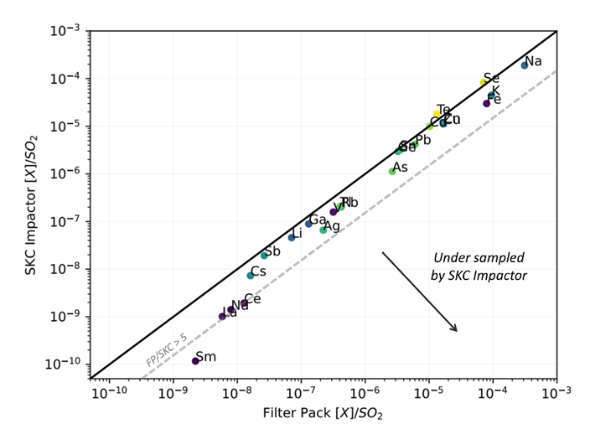
Fig 1. Comparison of SKC and filter pack sampling element distribution. Y-axis shows [X]/[SO2] summed across all stages of a SKC impactor sample GD-SKC1. X-axis shows [X]/[SO2] for FP sample GD-12. Both samples were collected in the main plume above the crater during the 2021 Fagradalsfjall eruption within Phase II of the eruption (~ 6 days apart). Dashed grey line denotes the filter pack [X]/[SO2] being 5 times greater than that of the SKC sample. Elements that lie off the solid black line have a FP/SKC ratio of 1 and are thus sampled equally by both techniques. The SKC impactors are under-sampling PM on the coarsest stages due to increased wall deposition in the coarsest stages, thus leading to elements such as Al (which are predominantly recorded in the coarsest PM fraction) being under-reported see Berlinger et al., 2021).
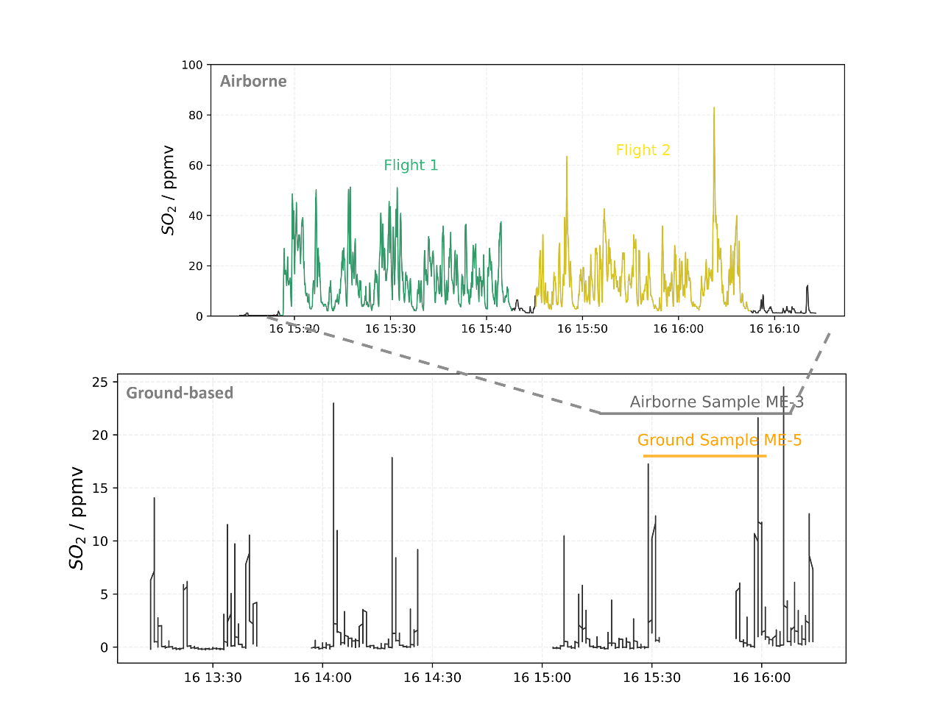

Fig 2. SO₂ timeseries for ground and UAV-based multiGAS during the time window of down-wind sample collection. MultiGAS measurements for airborne sample are from a UAV-mounted MultiGAS unit, whereas a separate MultiGAS was placed next to the ground-based sample throughout sampling duration. The ground-based MultiGAS cut out approximately every 30 mins resulting in periods without gas measurements and so plume concentrations for longer than the duration of the ground-based sample are taken as representative for the sampling duration.
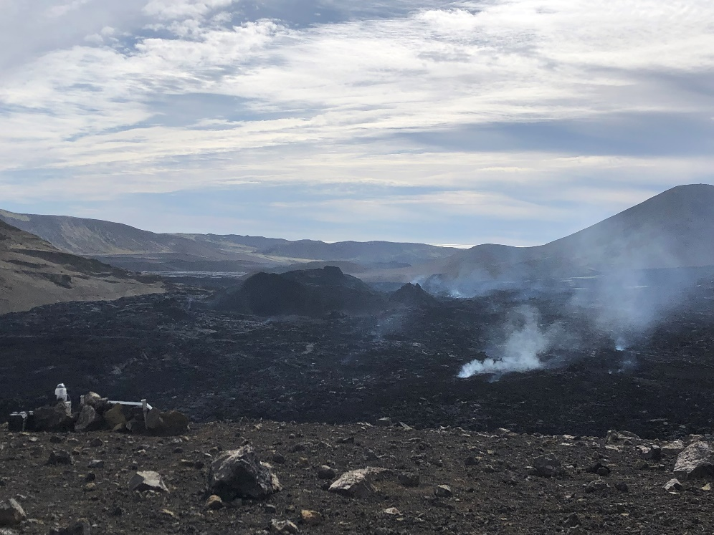

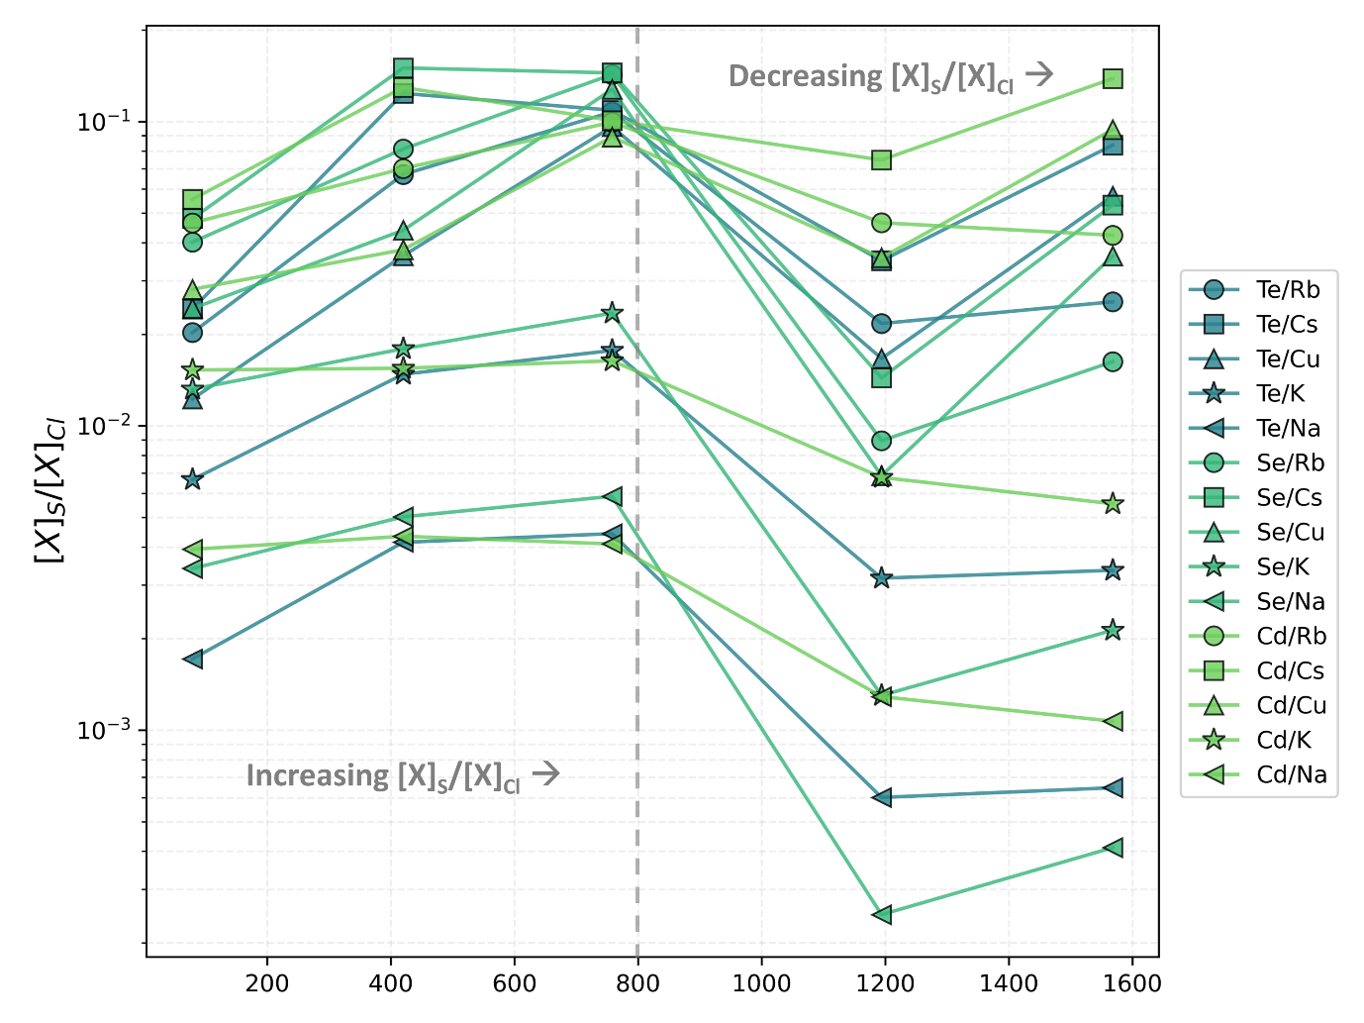
Fig 3. Lava pond with active outgassing vents. Photo (taken by L. Wainman) showing the Meradalir vent during the 2022 Fagradalsfjall eruption, with the surrounding lava pond and outgassing vent in the foreground. This vent was sampled via UAV-mounted FP (sample ME-17).

Fig 4. [X]_{S}/[X]_{Cl} ratios in snow samples downwind. Element concentration ratios were calculated for a range of S and Cl- complexing elements to assess their relative rates of deposition and depletion from the plume. Assuming that the scavenging rate for Cl species, λ_{Cl}, exceeds that of S species, λ_{S}, the ratio of the amount of each species deposited D_{S}/D_{Cl} would be expected to be < 1 but to increase with distance from the vent as the Cl-species are lost more rapidly from the plume. D_{S}/D_{Cl} is < 1 and shows a generally increasing trend across all elements within the first 800 m away from the vent, consistent with preferential wash out of Cl-complexing elements.

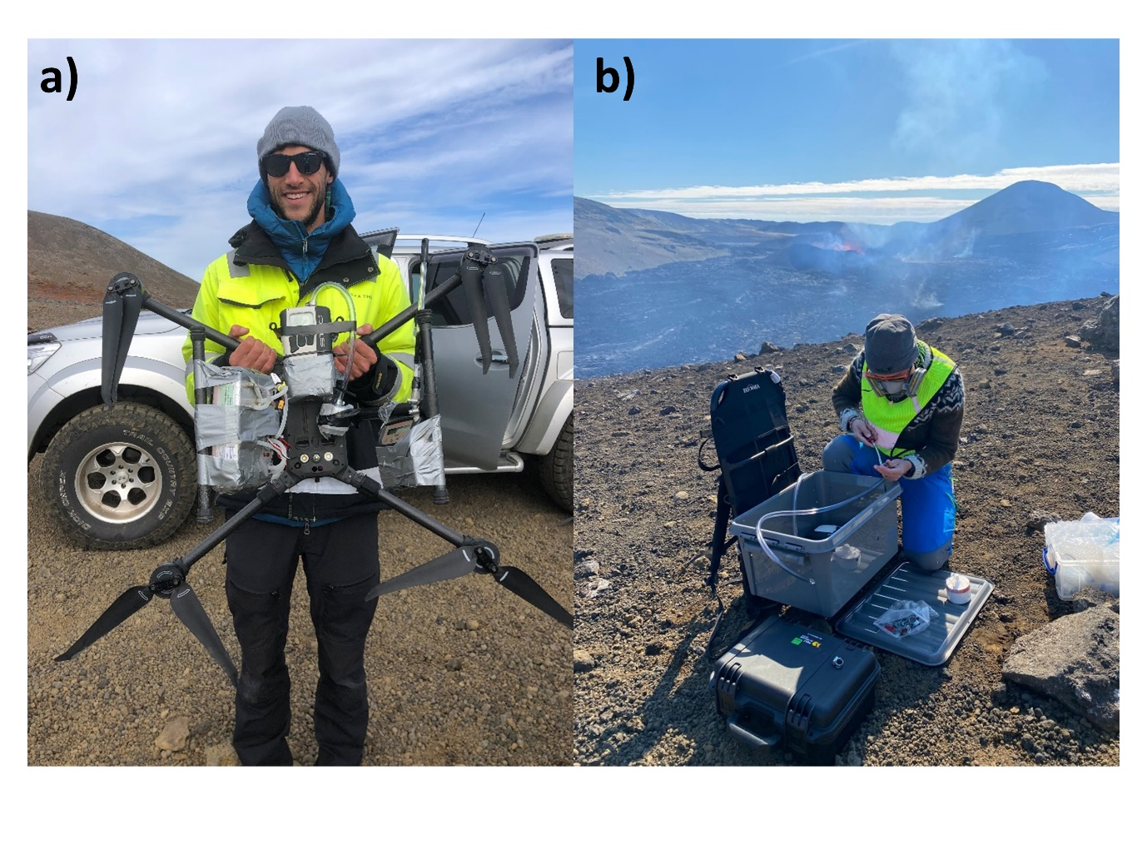

Fig 5. UAV and Ground-based sampling set up at the 2022 Fagradalsfjall eruption. Both set ups consist of a FP or SKC impactor connected via tubing to a Leland Legacy air pump. Simultaneous MultiGAS measurements were collected with both samples.

Sample ID | Sampling Date |  | Sample Set Up | Sampling Location | Distance from vent | Total Volume Pumped (L) | Plume Volume Pumped (L) | Plume Sample Duration (mins) | Flow Rate (L/min) | Number of Flights | % flight above MG SO2 saturation
GD-4 |  | 23rd March 2021 | FP (3G + PM) and MG | At-vent | < 80 m | 117 | 117 | 20 | 6 | 1 | 0
GD-12 |  | 13th April 2021 | FP (PM Only) and MG | At-vent | < 80 m | 621 | 493 | 55 | 9 | 4 | 2
GD-SKC1 |  | 6th April 2021 | SKC Impactor and MG | At-vent | < 80 m | 423 | 310 | 35 | 9 | 3 | 0
ME-1 |  | 16th August 2022 | FP (PM Only) and MG | At-vent | < 80 m | 850 | 830 | 62 | 13.5 | 3 | 9.4
ME-2 |  | 16th August 2022 | FP (PM Only) and MG | At-vent | < 80 m | 202 | 176 | 14 | 13 | 1 | 15
ME-3 |  | 16th August 2022 | FP (PM Only) and MG | Airborne Plume | 500 m | 629 | 582 | 45 | 13 | 2 | 0
Sample ID |  | Sampling Date | Timestamp | Sample Type | Distance from vent | Latitude | Longitude
S-01 |  | 9th April 2021 | 2021-04-09T12:17:05Z | Snow | 350 m | 63.89153201 | 22.26369001
S-02 |  | 9th April 2021 | 2021-04-09T12:31:54Z | Snow | 650 m | 63.88890504 | 22.26180098
S-03 |  | 9th April 2021 | 2021-04-09T13:09:19Z | Snow | 900 m | 63.88591798 | 22.26417096
S-04 |  | 9th April 2021 | 2021-04-09T13:26:57Z | Snow | 1300 m | 63.88216498 | 22.26290798
S-05 |  | 9th April 2021 | 2021-04-09T13:56:31Z | Snow | 1600 m | 63.879019 | 22.26031302

Table 1. Sample Overview. Includes FP, SKC, MultiGAS, and snow sample metadata.#

Particle Diameter, d (µm) | Particle Density, ρ_{p} (kg/m³) | Settling time
100 | 1000 | 88 seconds
100 | 2000 | 44 seconds
10 | 1000 | 2.4 hours
10 | 2000 | 1.2 hours
1 | 1000 | 10 days
1 | 2000 | 5 days
0.1 | 1000 | 2.8 years
0.1 | 2000 | 1.4 years

$Vs= \frac{d^{2}g (ρ_{p}- ρ_{a})}{18η}$ Eq.1

Table 2. Settling times over 30 m in air for particles of varying diameters and densities calculated using Stoke’s Settling Law (eq.1). Density of air, ρa = 1.204 kg/m3. g = 9.81, dynamic viscosity of air, η = 1.6x10⁻⁵

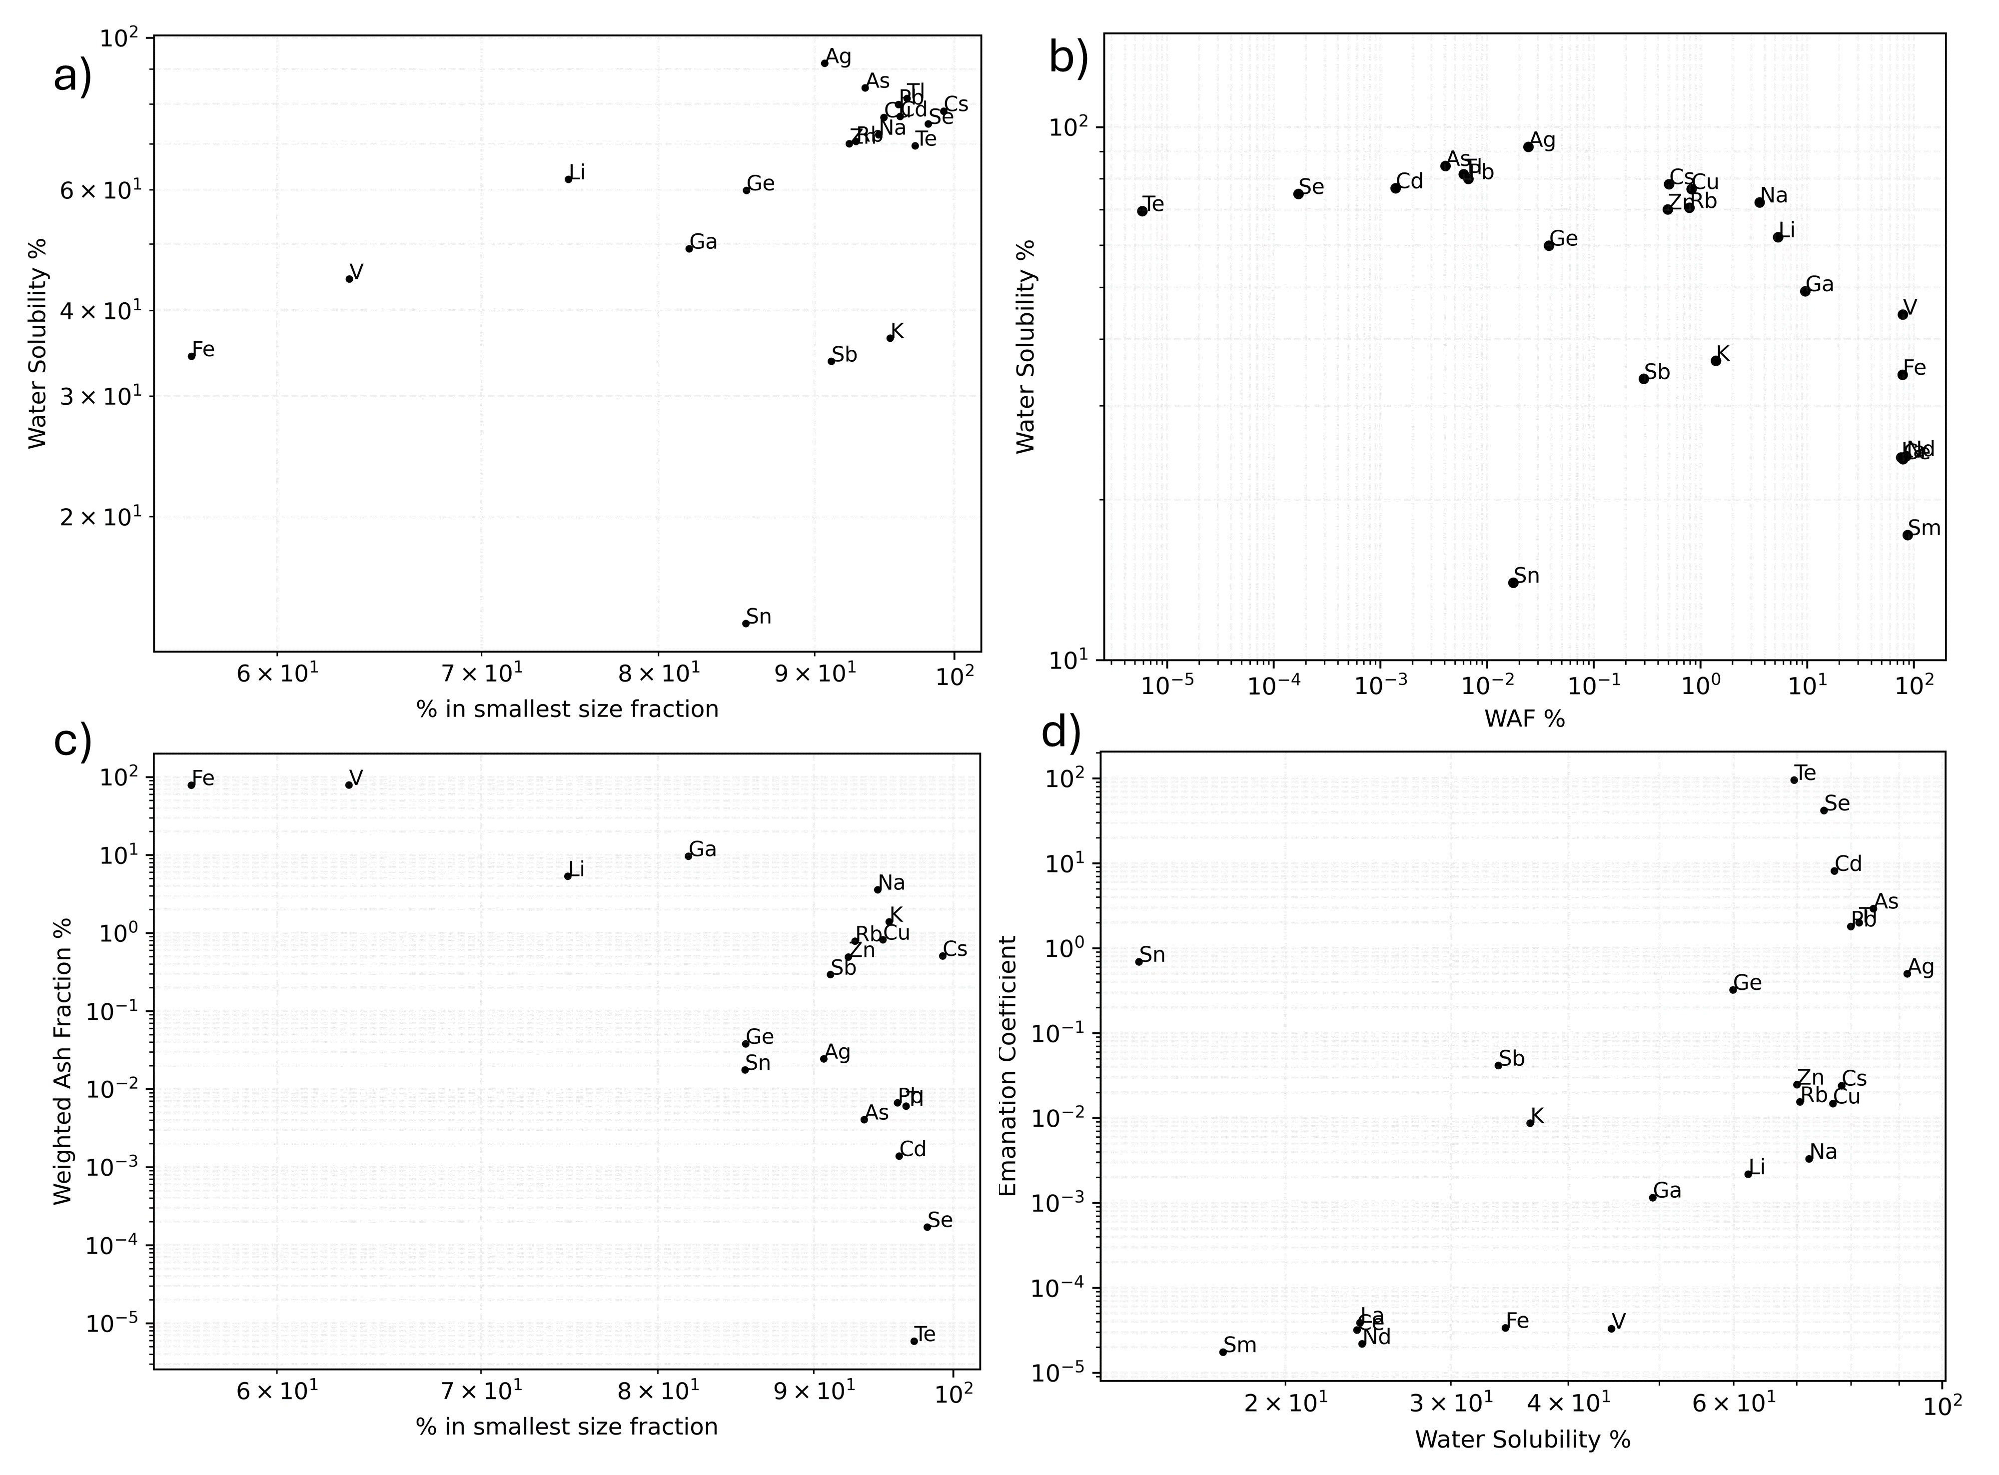

Fig 6. Comparison of element-by-element PM charactersitics. A) water solubility vs mass % of each element in the smallest impactor size bin. Elements which are predominantly hosted in the smallest size fraction generally have relatively higher water solubilities than those which are hosted in the larger size fractions. B) water solubility vs weighted ash fraction (WAF). At WAF > 1 % water solubility begins to decrease. Sn is an exception, having low WAF and also low water solubility. C) WAF vs mass % in the smallest size fraction. Elements hosted in the smallest size fraction generally have the lowest ash contribution (as ash, being formed mechanically, has a larger size distribution that aerosol PM which is formed through gas-particle conversion processes. D) Emanation coefficient (which represents magmatic volatility) vs water solubility. Generally, water solubility increases with increasing magmatic volatility. However, the most volatile elements (Te, Se) are not the most soluble (Ag, Rb, Cs).

