Supplementary: Reversible Ir-based multifunctional electrocatalyst for durable water splitting and fuel cell systems

Woong Hee Lee ª, Young-Jin Ko ^{b}, Jung Hwan Kim ^{c}, Chang Hyuck Choi ^{d},
Keun Hwa Chae ^{e}, Hansung Kim ^{c}, Yun Jeong Hwang ^{a, f}, Byoung Koun Min ^{a, g},
Peter Strasser ^{h} *, and Hyung-Suk Oh ^{a, f, i} *

ª Clean Energy Research Center, Korea Institute of Science and Technology (KIST), Hwarang-ro 14-gil 5, Seongbuk-gu, Seoul 02792, Republic of Korea
^{b} Center for Electronic Materials, Korea Institute of Science and Technology (KIST), Hwarang-ro 14-gil 5, Seongbuk-gu, Seoul 02792, Republic of Korea
^{c} Department of Chemical and Biomolecular Engineering, Yonsei University, 50 Yonsei-ro, Seodaemun-gu, 03722, Seoul, Republic of Korea
^{d} School of Materials Science and Engineering, Gwangju Institute of Science and Technology, 123 Cheomdan-gwangi-ro, Buk-gu, Gwangju 61005, Republic of Korea
^{e} Advanced Analysis Center, Korea Institute of Science and Technology (KIST), Hwarang-ro 14-gil 5, Seongbuk-gu, Seoul 02792, Republic of Korea
^{f} Division of Energy and Environmental Technology, KIST school, Korea University of Science and Technology, Seoul 02792, Republic of Korea
^{g} Green School, Korea University, 145 Anam-ro, Seongbuk-gu, Seoul 02841, Republic of Korea
^{h} The Electrochemical Energy, Catalysis, and Materials Science Laboratory, Department of Chemistry, Chemical Engineering Division, Technical University Berlin, Berlin 10623, Germany
^{i} KHU-KIST Department of Conversing Science and Technology, Kyung Hee University, Seoul 02447, Republic of Korea

* Corresponding author:
(P. Strasser) pstrasser@tu-berlin.de, (H. -S. Oh) hyung-suk.oh@kist.re.kr

Table of Contents
Contents |  |  |  |  | Page
○ Supplementary Note 1 |  | …………………………………………………………… |  |  | S3
 | > Reversal voltage experiment in water electrolyzer
○ Supplementary Note 2 |  | …………………………………………………………… |  |  | S4
 | > Fuel Starvation experiment in PEM fuel cell
○ Supplementary Note 3 |  | …………………………………………………………… |  |  | S5
 | > In situ/operando X-ray absorption spectroscopy (XAS)
○ Supplementary Note 4 |  | …………………………………………………………… |  |  | S6
 | > In situ/operando ICP-MS
○ Supplementary Figures |  | …………………………………………………………… |  |  | S7
 | □ Supplementary Figures 1–20
○ Supplementary Tables |  |  | …………………………………………………………… |  | S27
 | □ Supplementary Tables 1–2

Supplementary Note 1
Voltage reversal test in water electrolyzer
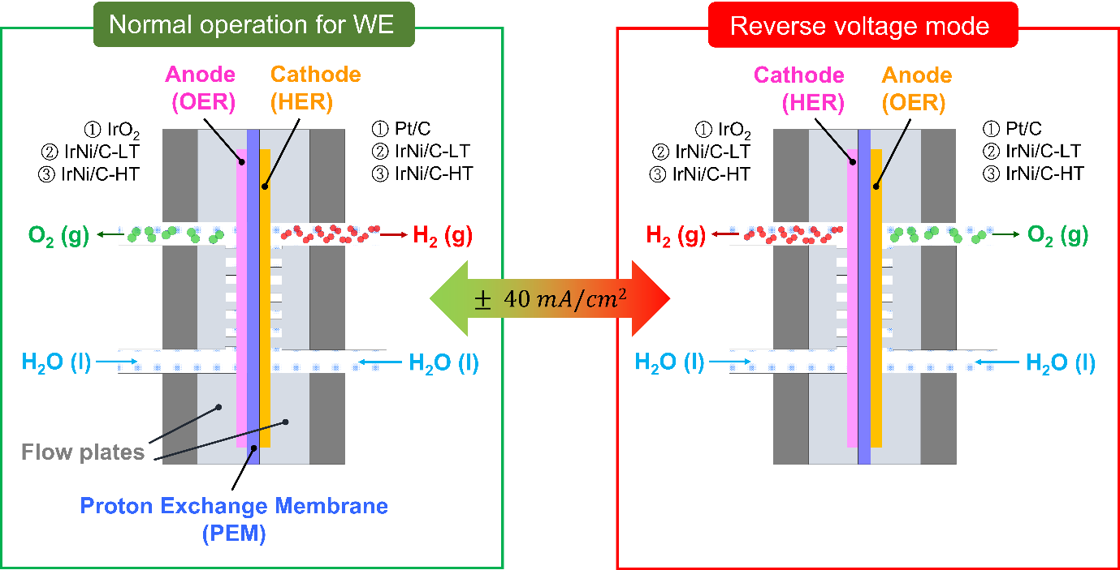

For the voltage reversal test, a round type 10cm² water electrolysis single cell was prepared. The diffusion layer (DL) was prepared by coating Au on Ti foam in order to exclude the influence of carbon corrosion. The synthesized IrNi/C-LT and -HT catalysts were applied to the diffusion layer (DL) and used as the anode and cathode. For comparison, commercial IrO₂ and TKK 46% Pt/C were used to the anode and cathode, respectively. DI water was supplied to both electrodes, and a current density of $±$40 mA cm^{–2} was applied every 20 min to observe the change in cell voltage. The single cell water electrolyzer was operated at room temperature without back pressure.

Supplementary Note 2
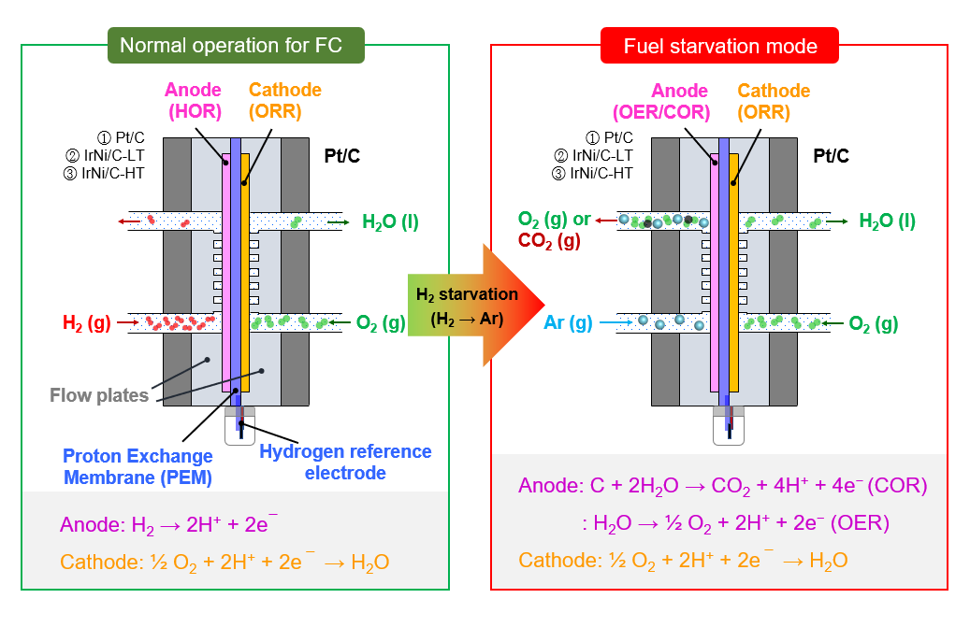
Fuel Starvation experiment in PEM fuel cell
The fuel starvation test was conducted through a chronopotentiometry in which a constant current density of 100 mA cm^{–2} was applied while supplying 150 ccm of gas resource, such as H₂, O₂ and Ar, to the anode and cathode. First, the experiment is conducted under normal operating conditions in which H₂ and O₂ are supplied to the anode and cathode, respectively. And to form fuel starvation conditions, H₂, a source of protons and electrons, is replaced with inert Ar gas. The current density of 100 mA cm^{–2} was maintained for 600 s. During the fuel starvation experiment, the outline of anode was connected to online mass spectrometry to measure the amount of O₂ and CO₂. The cell potential was measured by VSP potentiostat (Bio-Logic). To measure anode potential behavior during fuel starvation phenomenon, a hydrogen reference electrode was connected to edge of MEA. The hydrogen reference electrode was prepared by following method. The Pt catalysts sprayed carbon paper was hot pressed onto end of the 1 cm $×$ 10 cm Nafion 212 membrane at 140 ℃ for 5 min. The Pt wire was connected to carbon paper as a current collector. The manufactured electrode was connected to edge of MEA and the reference electrode was sealed with gas chamber. The gas chamber maintains H₂ condition by flowing H₂ gas and Nafion membrane was covered by moist Kimwipes® to maintain ionic conductivity of Nafion membrane.

Supplementary Note 3
In situ/operando X-ray absorption spectroscopy (XAS)
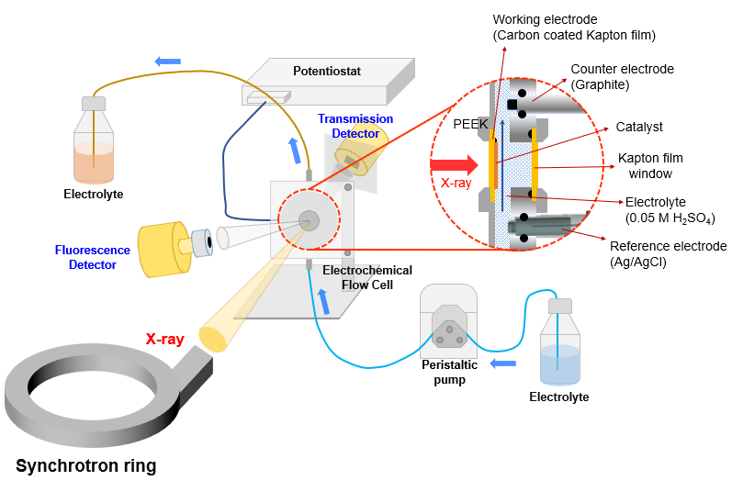

Setup of in situ/operando XAS analysis with the homemade electrochemical flow cell. The Ir-based electrocatalysts were deposited on the surface of the thin carbon film and contacted with 0.05 M H₂SO₄ electrolyte, which is a working electrode. Kapton film was applied on the back side of the working electrode facing the incident X-ray to avoid air entering the flow cell. The electrolyte is supplied below the flow cell by the peristaltic pump. Graphite rod and Ag/AgCl were used as the counter electrode and reference electrode, respectively, and were installed on the back side of the flow cell.

Supplementary Note 4
In situ/operando ICP-MS
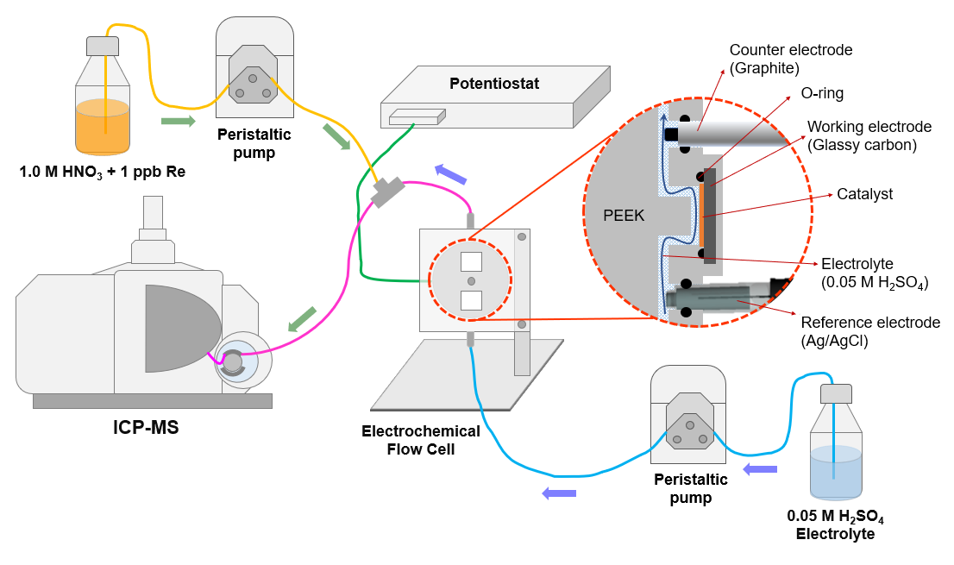

Setup of in situ/operando ICP−MS analysis using the homemade electrochemical flow cell having thin microchannel. The IrNi/C electrocatalysts were loaded on a glassy carbon as a working electrode by drop-casting method. 0.05 M H₂SO₄ as an electrolyte was constantly flowed to the homemade electrochemical flow cell part along the microchannel by the peristaltic pump. The 1 M HNO₃ electrolyte with 1 ppb Re as an internal standard was constantly supplied end of the electrochemical flow cell to calibrate the experiment results. Graphite rod and Ag/AgCl (3 M NaCl) were used as the counter electrode and reference electrode, respectively, and were installed on the flow cell.

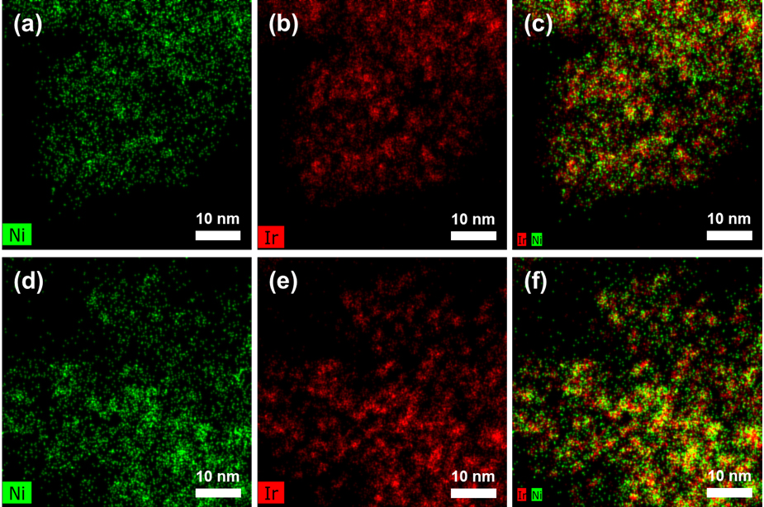
Supplementary Figure 1. STEM-EDX mapping images of Figure 1a and 1d. IrNi nanoparticles supported on carbon with different heat-treatment temperature of 400 ℃ and 1000 ℃, which are denoted to IrNi/C-LT (a ~ c) and IrNi/C-HT (d ~ f), respectively. (a) Ni, (b) Ir, and (c) overall of Ni and Ir of IrNi/C-LT. (d) Ni, (e) Ir, and (f) overall of Ni and Ir of IrNi/C-HT.

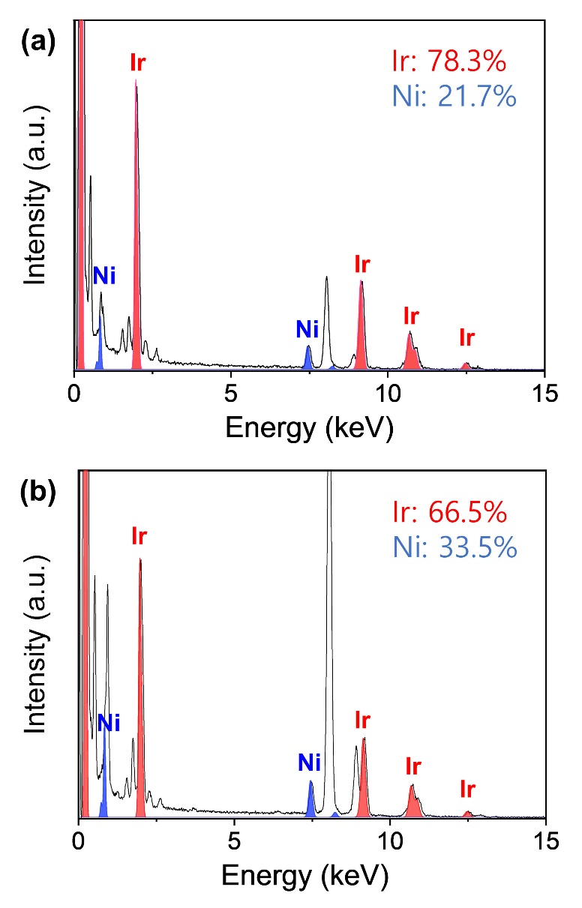
Supplementary Figure 2. EDX profile in TEM measurements of (a) IrNi/C-LT and (b) IrNi/C-HT.

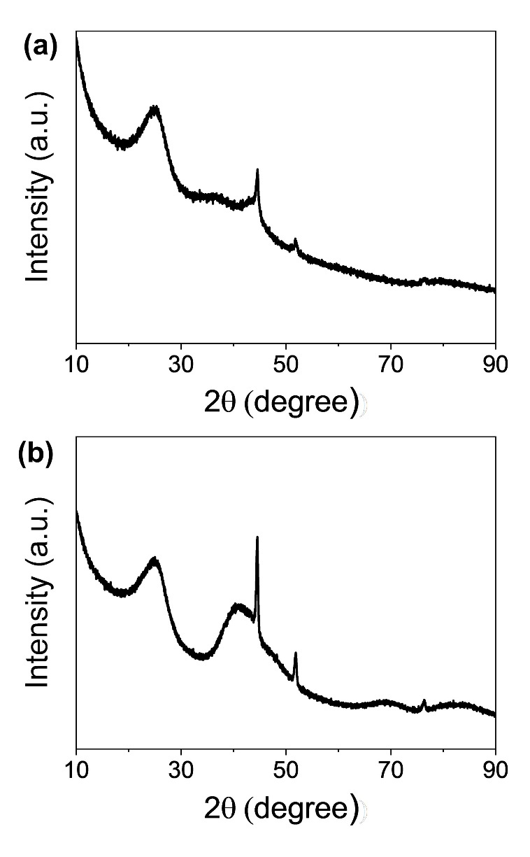
Supplementary Figure 3. Powder XRD patterns of (a) IrNi/C-LT and (b) IrNi/C-HT.

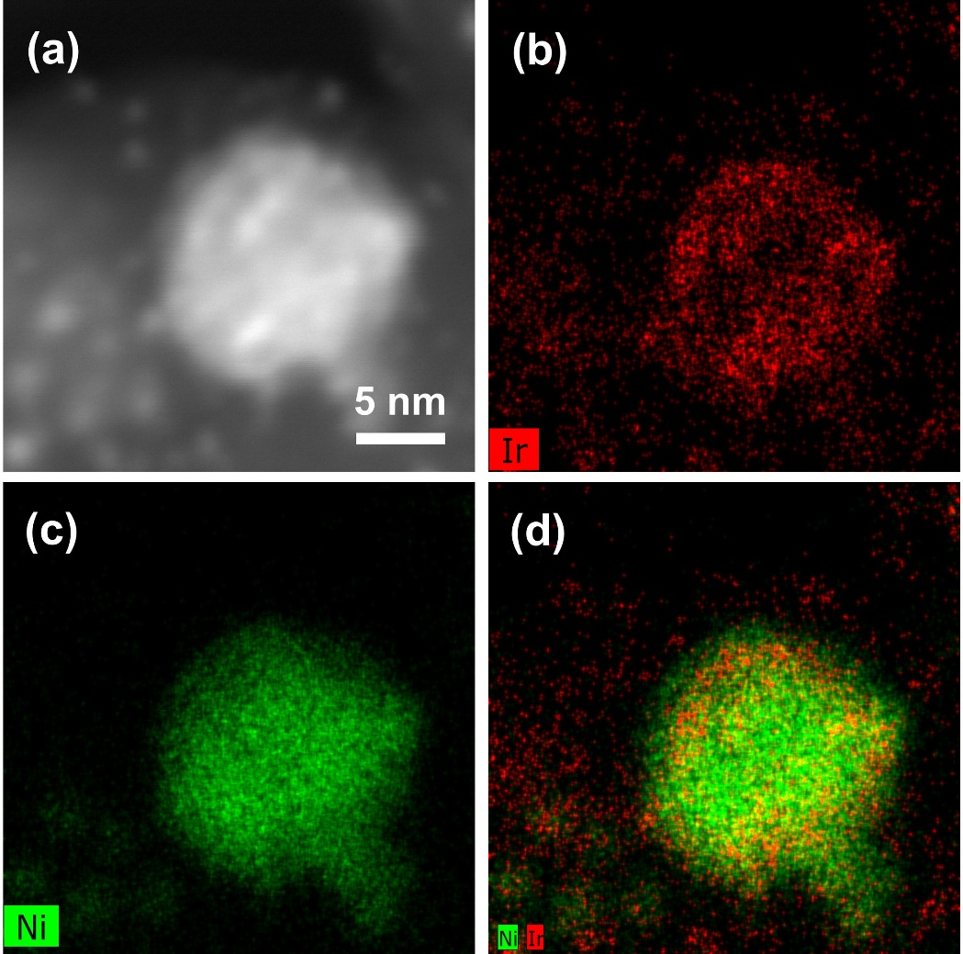
Supplementary Figure 4. (a) HAADF STEM image of IrNi/C-LT. STEM-EDX elemental mapping of large Ni nanoparticle in IrNi/C, showing the distribution of (b) Ir, (c) Ni, and (d) overall of Ir and Ni.

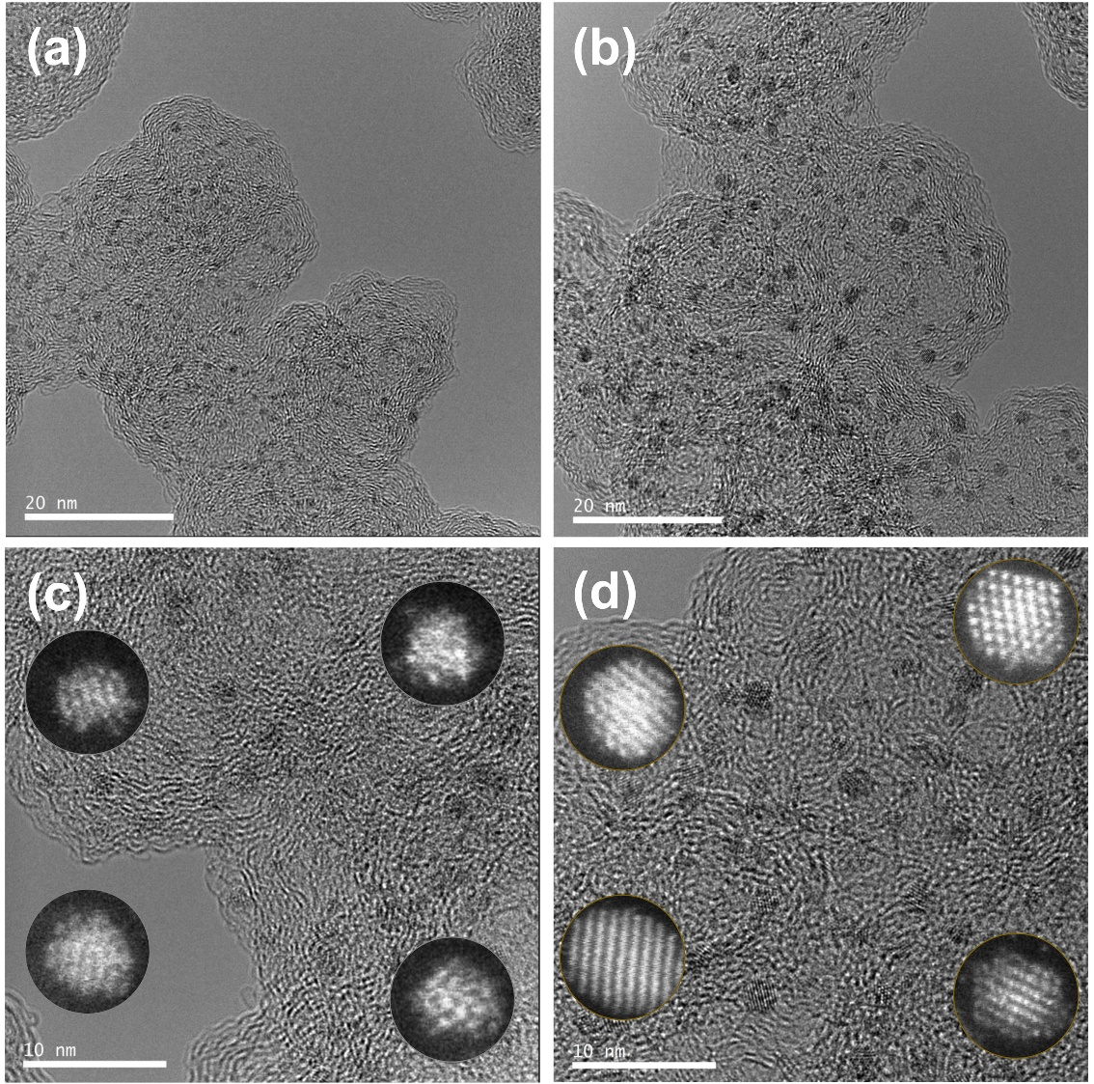
Supplementary Figure 5. HR-TEM images of Ir/C-LT and Ir/C-HT. (a, b) Low- and (c, d) high-magnification

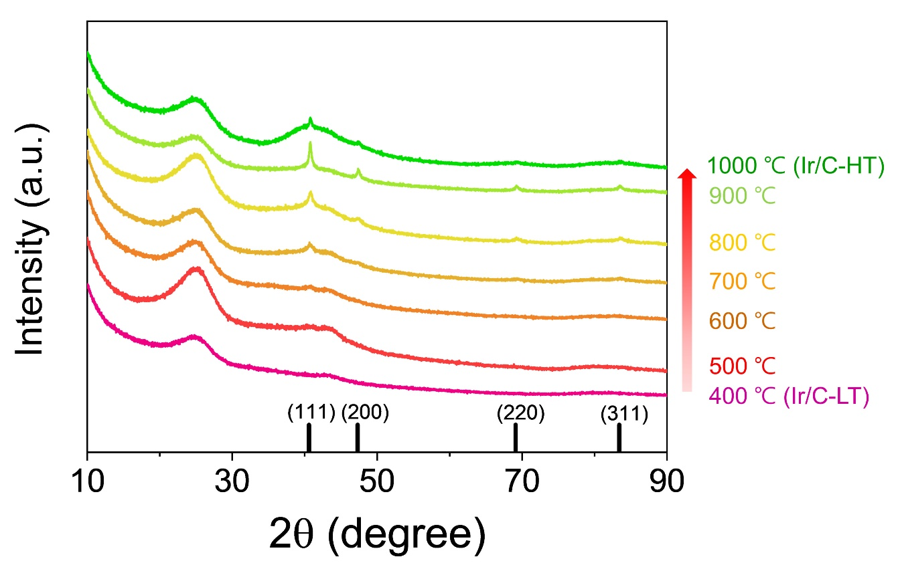
Supplementary Figure 6. XRD patterns of Ir/C with different synthesized temperature from 400 ℃ and 1000 ℃.

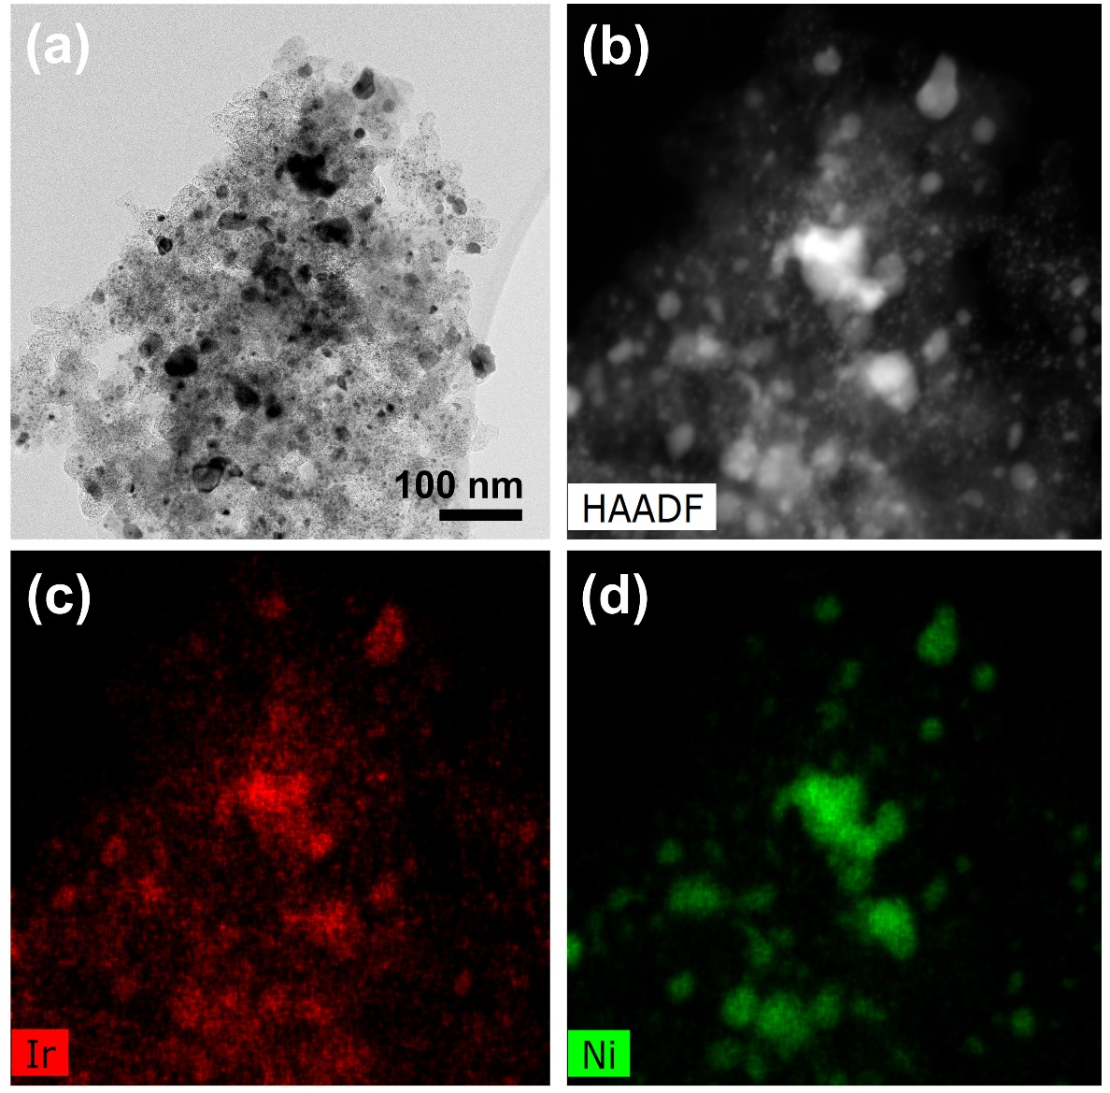
Supplementary Figure 7. (a) HR-TEM image of IrNi/C with heat-treatment at 1000 ℃. The heat-treatment gas condition was 10% H₂ (99.999%) and 90% N₂ (99.999%) from the beginning. (b) HAADF-STEM image and EDX elemental mapping of (c) Ir and (d) Ni in IrNi/C with heat-treatment at 1000 ℃ in 10% H₂ and 90% N₂.

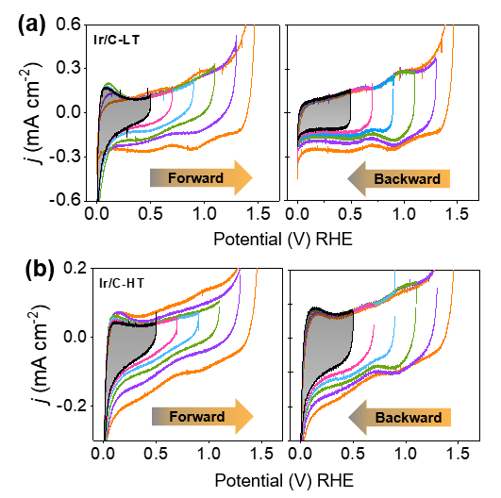
Supplementary Figure 8. Electrochemical property and catalytic reversibility of the Ir-based electrocatalyst. Cyclic voltammetry (CV) of (a) Ir/C-LT and (b) Ir/C-HT catalyst recorded with 50 mV s^{–1} in 0.05 M H₂SO₄ solution. The upper turning potential was increased from 0.5 to 1.5 V and decreased from 1.5 to 0.5 V in 200 mV steps.

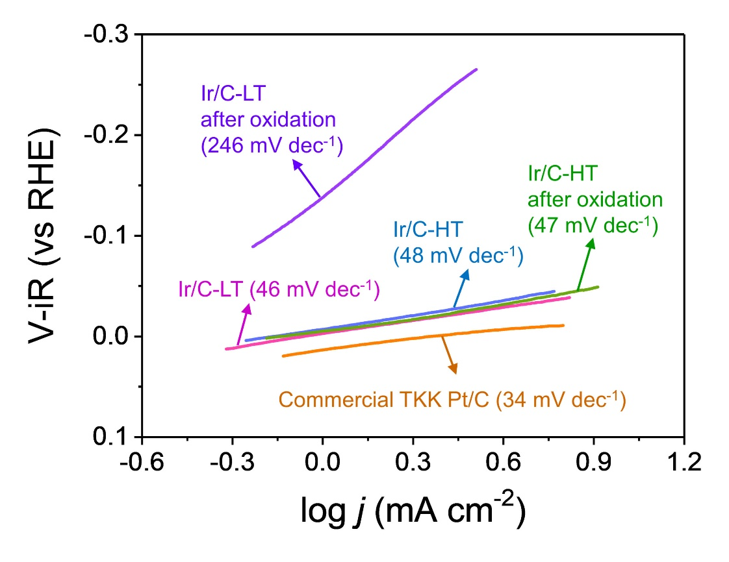
Supplementary Figure 9. Tafel plot of Ir/C-LT and Ir/C-HT for HER and HER after OER measurements. For comparison, the Tafel plot of commercial TKK Pt/C for HER is presented.

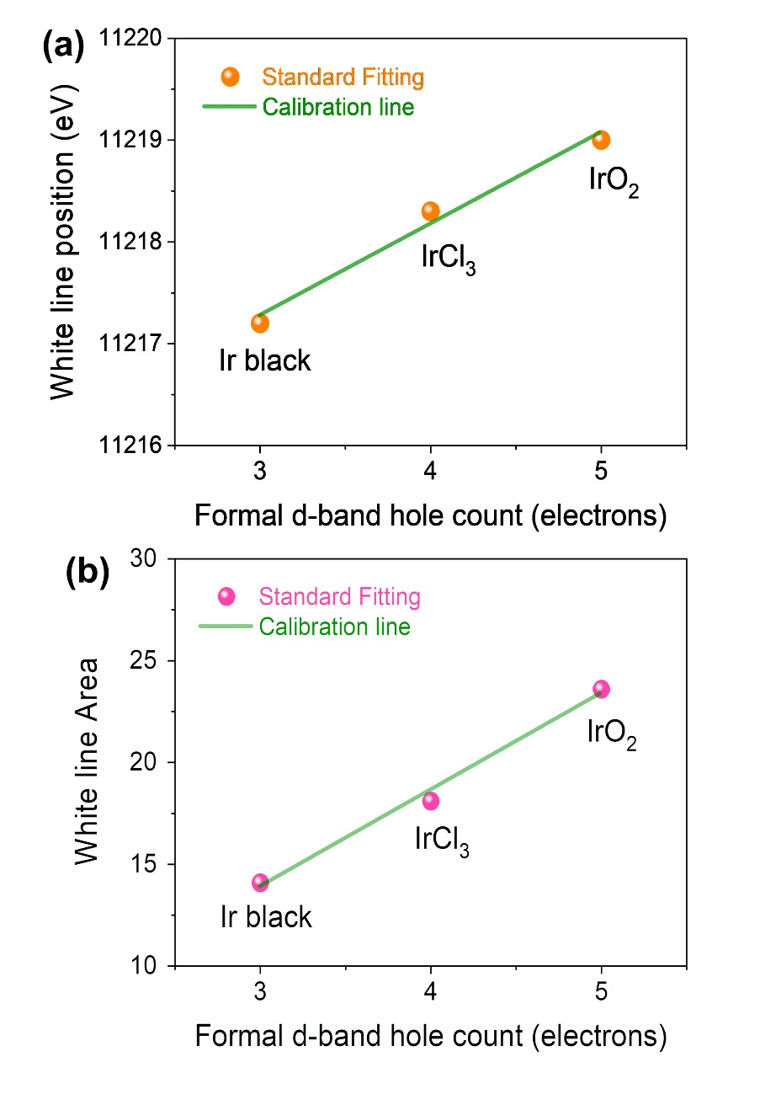
Supplementary Figure 10. (a) White line position and (b) white line area of standard samples, such as metallic-Ir, IrCl₃ and IrO₂, as a function of the formal d-band hole count.

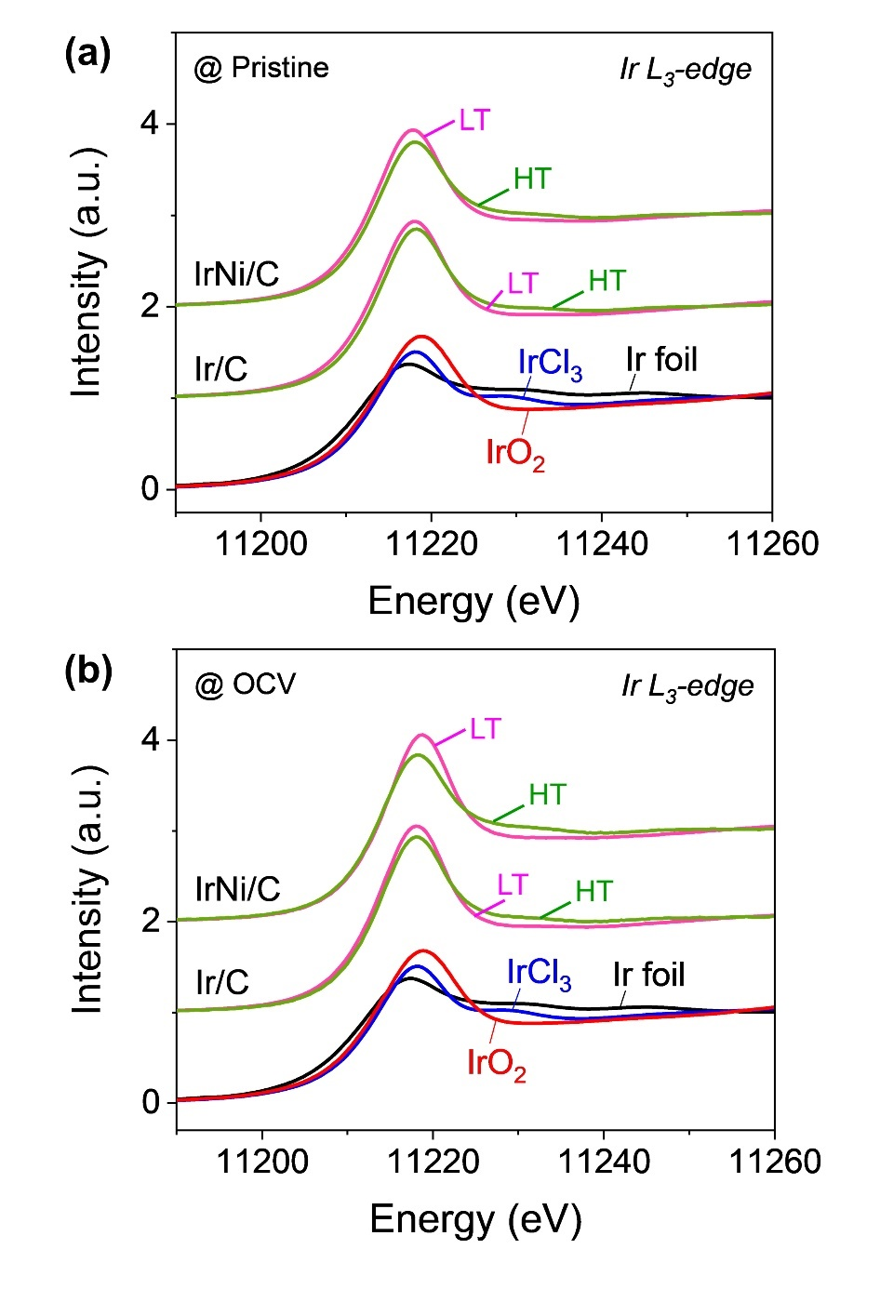
Supplementary Figure 11. Ir L₃-edge XANES spectra of (a) Ir/C-LT, (b) Ir/C-HT, (c) IrNi/C-LT and (d) IrNi/C-HT under pristine, OCV, OER and HER after OER condition. OER and HER were performed under chronoamperometry at 1.5 and ‒0.2 V_{RHE}, respectively.

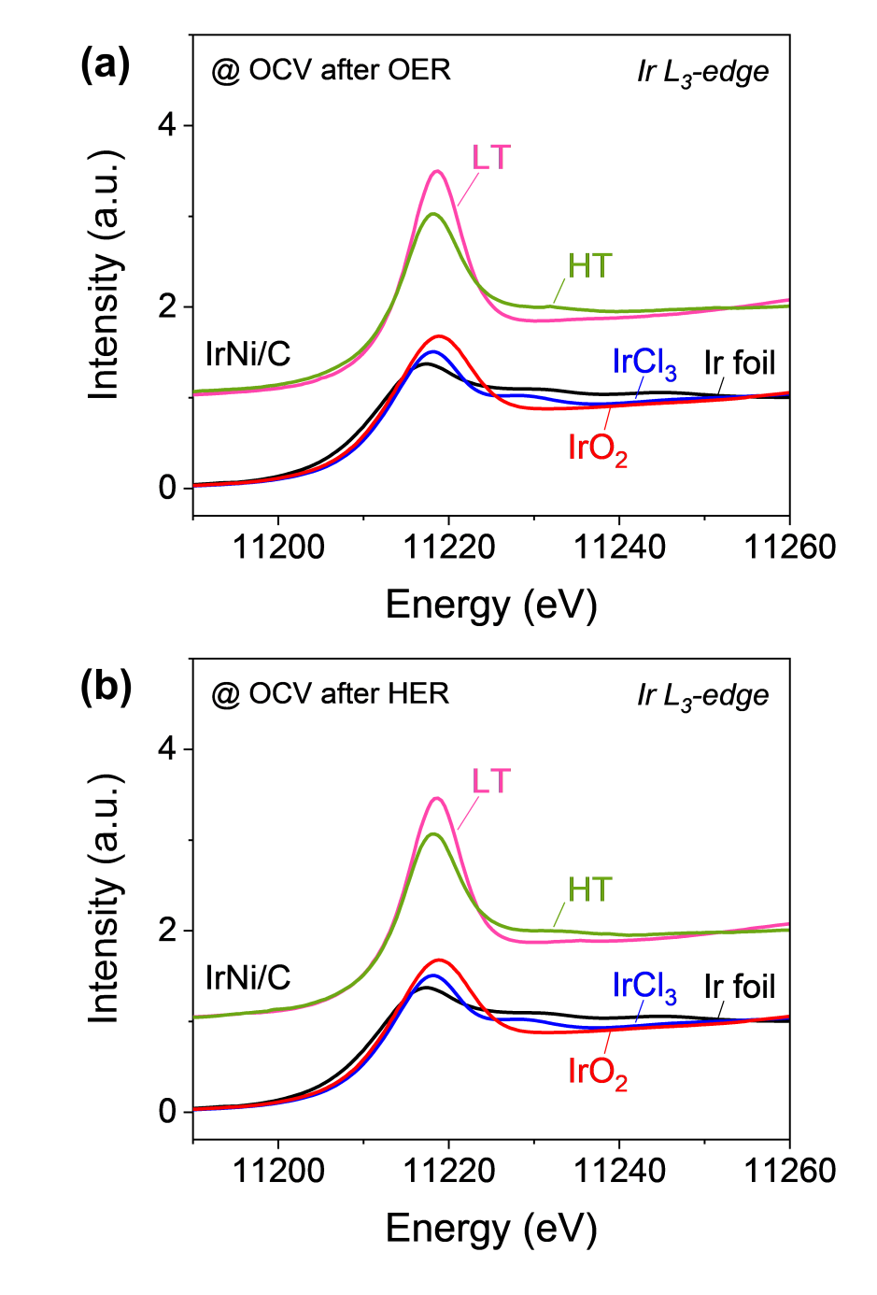
Supplementary Figure 12. Ir L₃-edge XANES spectra of IrNi/C-LT and IrNi/C-HT at (a) OCV after OER and (b) OCV after HER. OER and HER were performed under chronoamperometry at 1.5 and ‒0.2 V_{RHE}, respectively.

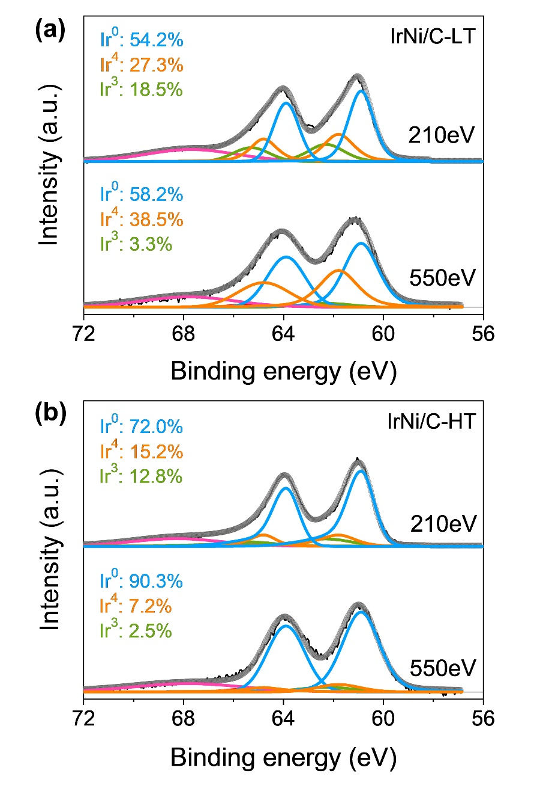
Supplementary Figure 13. Surface electronic structure of Ir in pristine IrNi/C-LT and IrNi/C-HT. Depth-resolved Ir 4f spectrum of (a) IrNi/C-LT and (b) IrNi/C-HT in spray coated electrode condition with photoelectron kinetic energies of 210 and 550 eV. The measured electrodes were prepared by spray coating the IrNi/C-LT and -HT electrocatalysts on carbon paper (Sigracet SGL 39BC). Depth-resolved XPS was measured at the 4D beamline of Pohang Accelerator Laboratory (PAL), Pohang, South Korea.

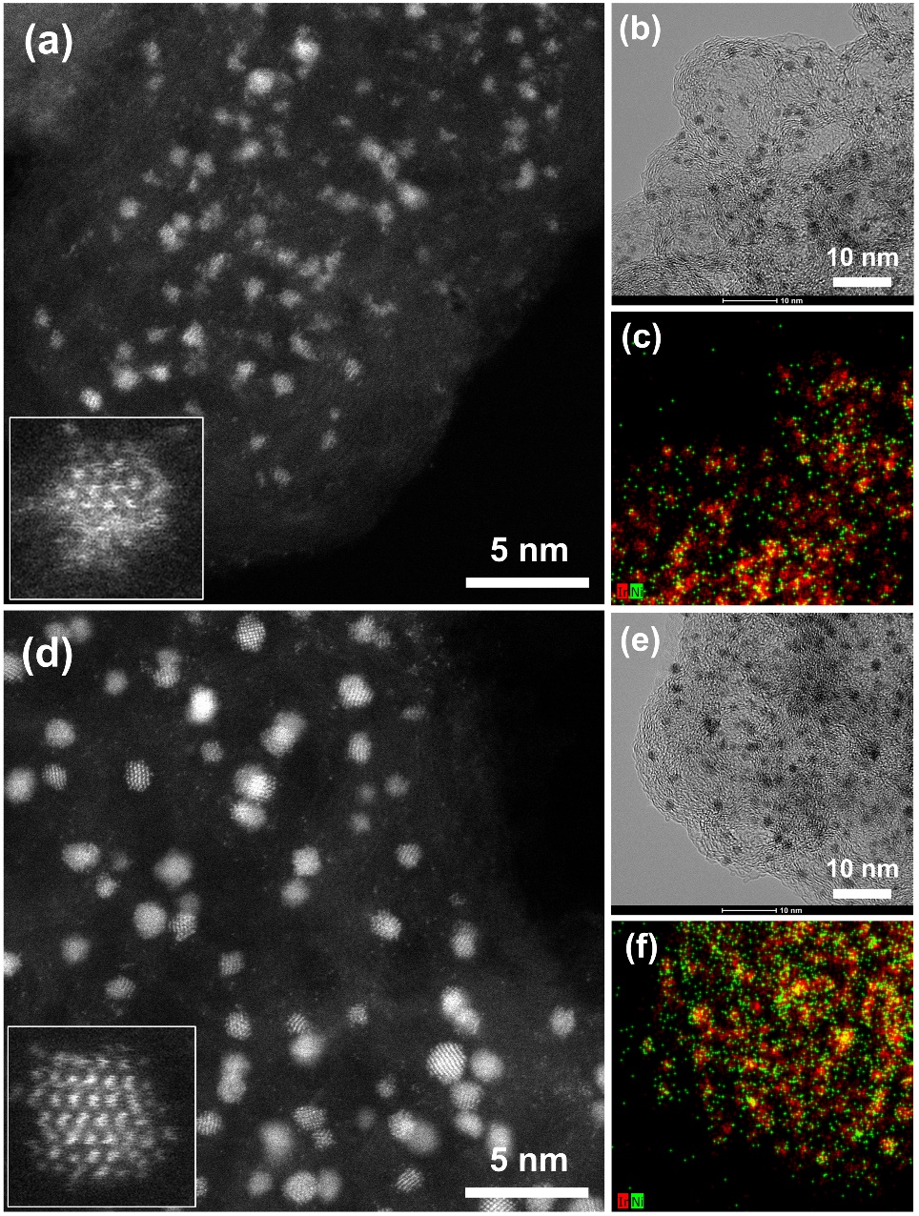
Supplementary Figure 14. Morphological of IrNi/C-LT and IrNi/C-HT after OER. (a) HADDF image, (b) TEM image, (c) STEM-EDX mappings of IrNi/C-LT after OER. (d) HADDF image, (e) TEM image, (f) STEM-EDX mappings of IrNi/C-HT after OER.

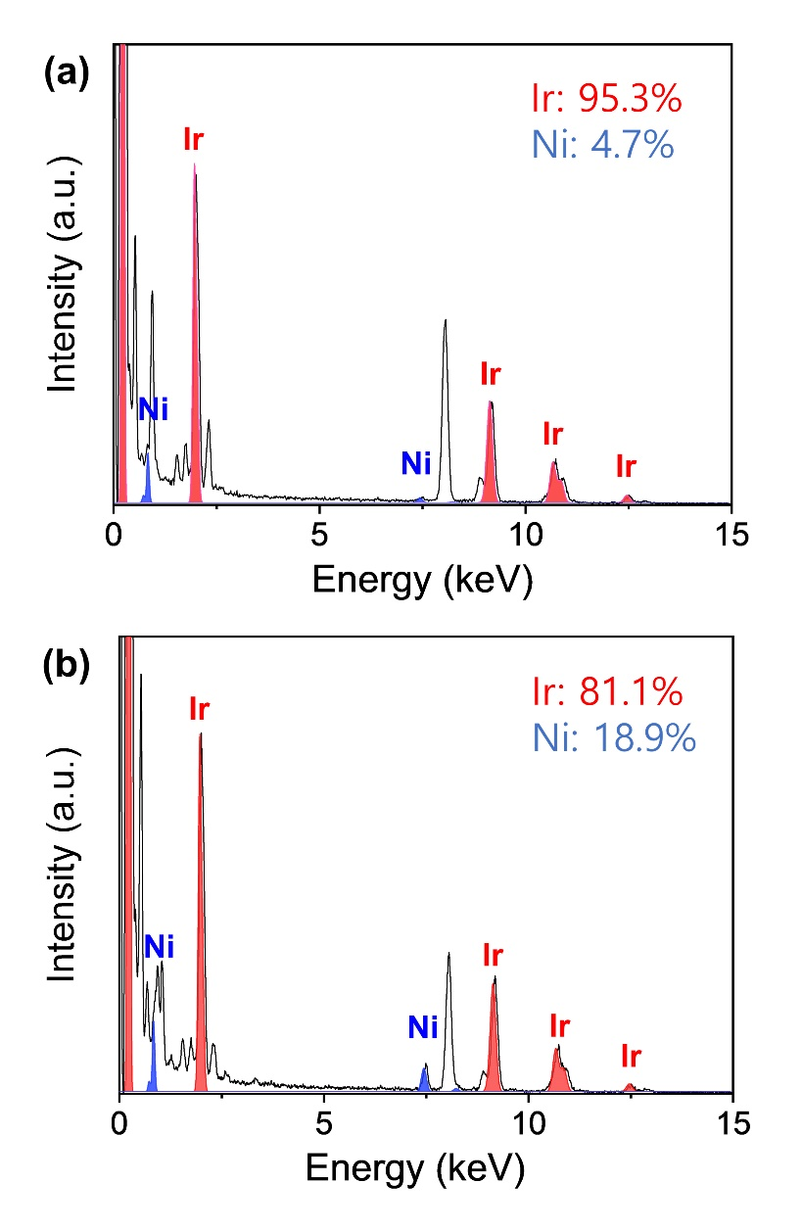
Supplementary Figure 15. EDX profile of IrNi/C-LT and IrNi/C-HT after OER measurement.

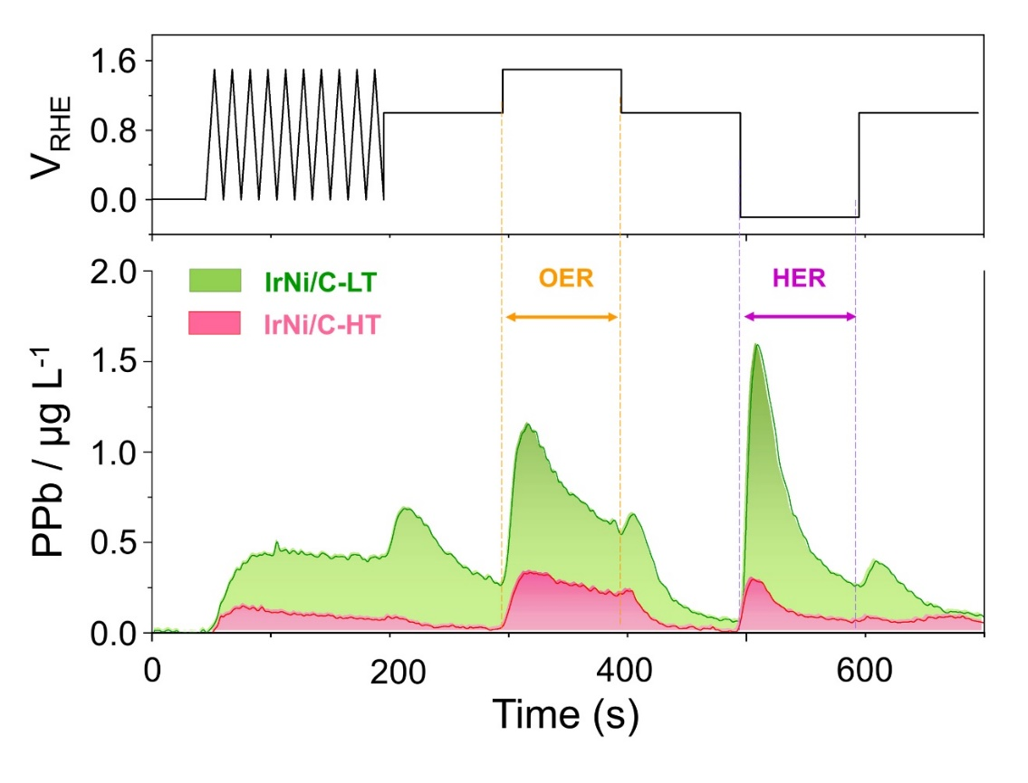
Supplementary Figure 16. Real-time Ir dissolution profile of IrNi/C-LT and IrNi/C-HT under representative experiment sequence. OER and HER were performed under chronoamperometry at 1.5 and ‒0.2 V_{RHE} for 100 s, respectively.

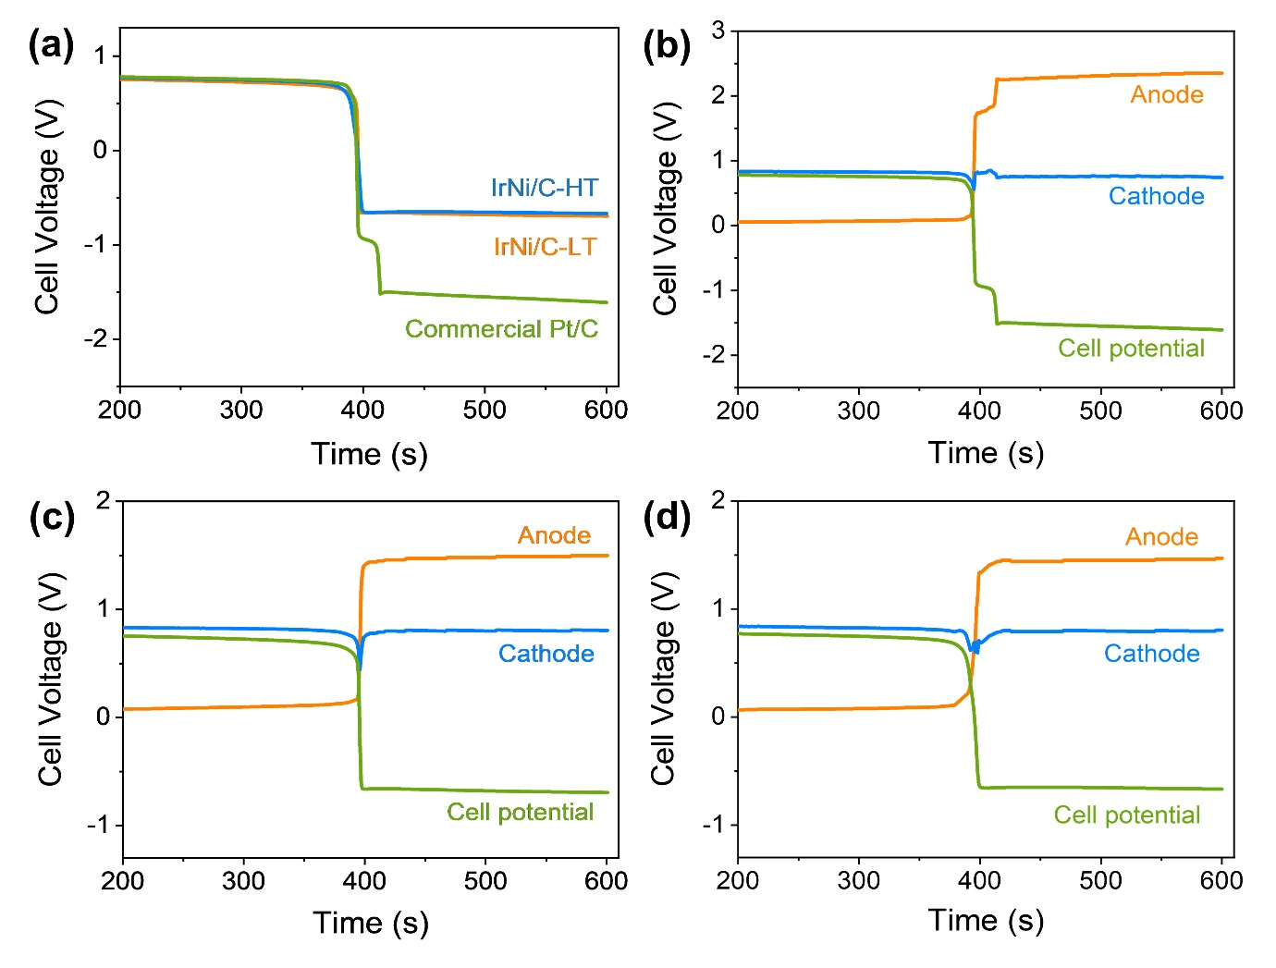
Supplementary Figure 17. Voltage reversal behavior of fuel cells. Cell voltage at fuel starvation as a function of voltage reversal time during the fuel starvation experiment. (a) Fuel cell potential behaviors of the commercial TKK Pt/C, IrNi/C-LT and IrNi/C-HT as the anode catalyst under the fuel starvation condition. The measured cell potentials of (b) commercial TKK Pt/C, (c) IrNi/C-LT and (d) IrNi/C-HT were divided to the anode and cathode potentials. Commercial TKK 46% Pt/C was used as a cathode catalyst for single cell measurement. For the fuel starvation condition, the gas on the anode side was changed from H₂ to Ar while maintaining the current density of 100 mA cm^{‒2} for 600 s.

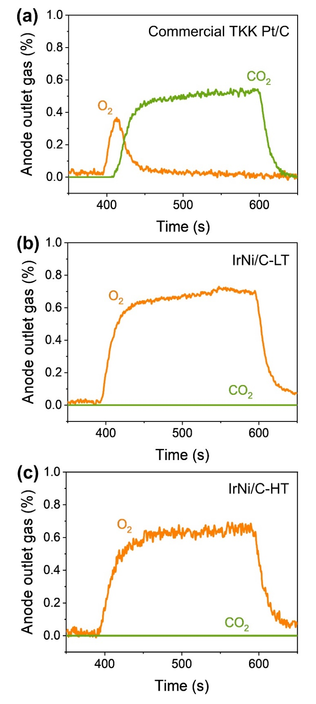
Supplementary Figure 18. In situ/operando gas chromatography-mass spectrometry (GC-MS) analysis on the exhaust gas from the anode of (a) commercial TKK 46% Pt/C, (b) IrNi/C-LT and (c) IrNi/C-HT during the fuel starvation condition. For the fuel starvation condition, the gas on the anode side was changed from H₂ to Ar at 400 s while maintaining the current density of 100 mA cm^{‒2}.

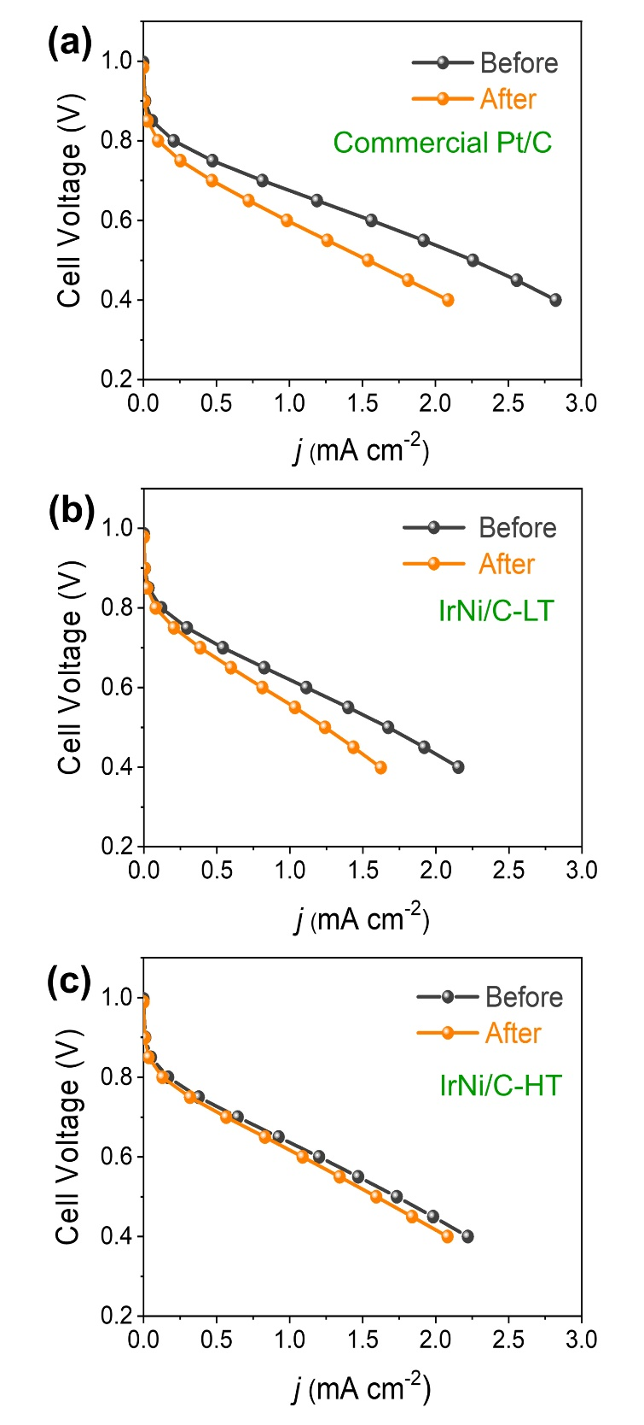
Supplementary Figure 19. Fuel cell polarization curves of (a) commercial TKK 46% Pt/C, (b) IrNi/C-LT and (c) IrNi/C-HT before and after the fuel starvation test.

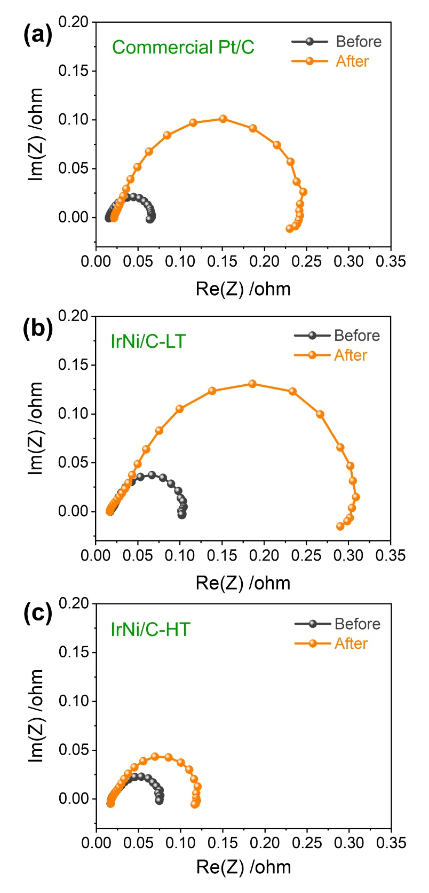
Supplementary Figure 20. Fuel cell impedance of (a) commercial TKK 46% Pt/C, (b) IrNi/C-LT and (c) IrNi/C-HT before and after the fuel starvation test.

Supplementary Table 1. Summary of deconvoluted depth-resolving XPS results.
Condition | IrNi/C-LT |  |  |  |  |  | IrNi/C-HT
Condition | 210 eV |  |  | 550 eV |  |  | 210 eV |  |  | 550 eV
Condition | Ir⁰ | Ir^{Ⅳ} | Ir^{Ⅲ} | Ir⁰ | Ir^{Ⅳ} | Ir^{Ⅲ} | Ir⁰ | Ir^{Ⅳ} | Ir^{Ⅲ} | Ir⁰ | Ir^{Ⅳ} | Ir^{Ⅲ}
Pristine | 54.2 | 27.3 | 18.5 | 58.2 | 38.5 | 3.3 | 72.0 | 15.2 | 12.8 | 90.3 | 7.2 | 2.5
After OER | 0 | 0 | 100 | 0 | 46.8 | 53.2 | 0 | 30.4 | 69.6 | 39.4 | 26.8 | 33.8
After OER  followed by HER | 0 | 0 | 100 | 0 | 67.2 | 32.2 | 38.2 | 46.2 | 15.6 | 57.8 | 31.7 | 10.5

Supplementary Table 2. Summary of changes before and after fuel starvation test.
Condition | MEA performance  at 0.6V  (A cm^{‒2}) |  | Membrane resistance  (Ω) |  | Charge transfer resistance  (Ω) |  | Mass data  O₂ / CO₂  (cm³)
Condition | Before | After | Before | After | Before | After | In situ measure
TKK Pt/C 46% | 1.56 | 0.98 | 0.0155 | 0.0215 | 0.0498 | 0.2191 | 0.53 / 3.98
TKK Pt/C 46% | ‒37.2 % |  | +38.7 % |  | +339 % |  | 0.53 / 3.98
IrNi/C-LT | 1.11 | 0.83 | 0.0174 | 0.0172 | 0.0850 | 0.2944 | 5.15 / 0
IrNi/C-LT | ‒26.9 % |  | ‒1.2 % |  | +246 % |  | 5.15 / 0
IrNi/C-HT | 1.20 | 1.09 | 0.0176 | 0.0176 | 0.0573 | 0.1014 | 5.04 / 0
IrNi/C-HT | ‒9.2 % |  | 0 % |  | +76.9 % |  | 5.04 / 0

