Table 1: First Wave of COVID-19 in India: An account of the impact of the wave in different regions and their respective states and union territories of the country and the testing ratios.
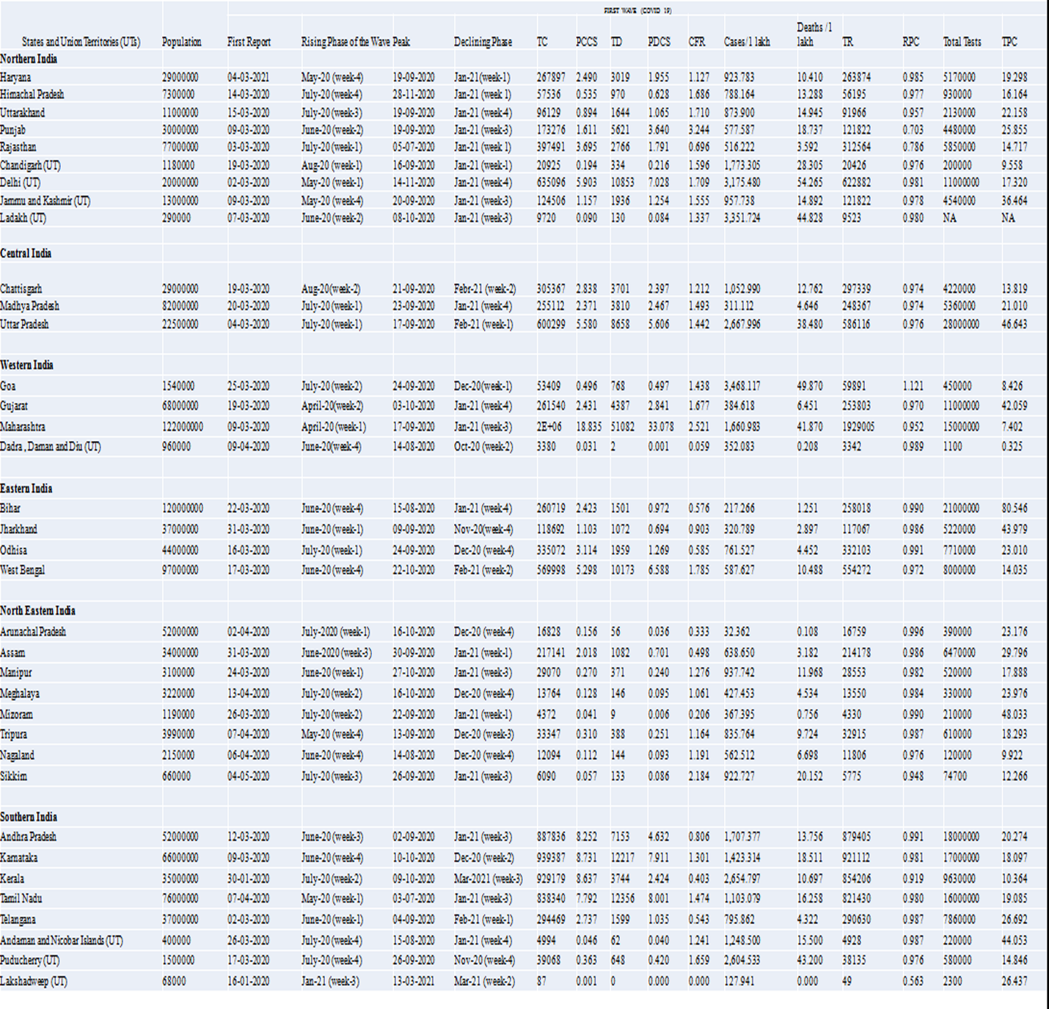
UT:Union Territoty;TC:Total Cases;PCCS:Proportion of case contribution;TD:Total Deaths;PDCS:Proportion of Death contribution;CFR:Case Fatality Ratio;TR:Total recovered;RPC:Recovery Per Case;TPC:Test per case

Table 2: Second Wave of COVID-19 in India: An account of the impact of the 2nd wave in different regions , their respective states and union territories of the country and the testing ratios.

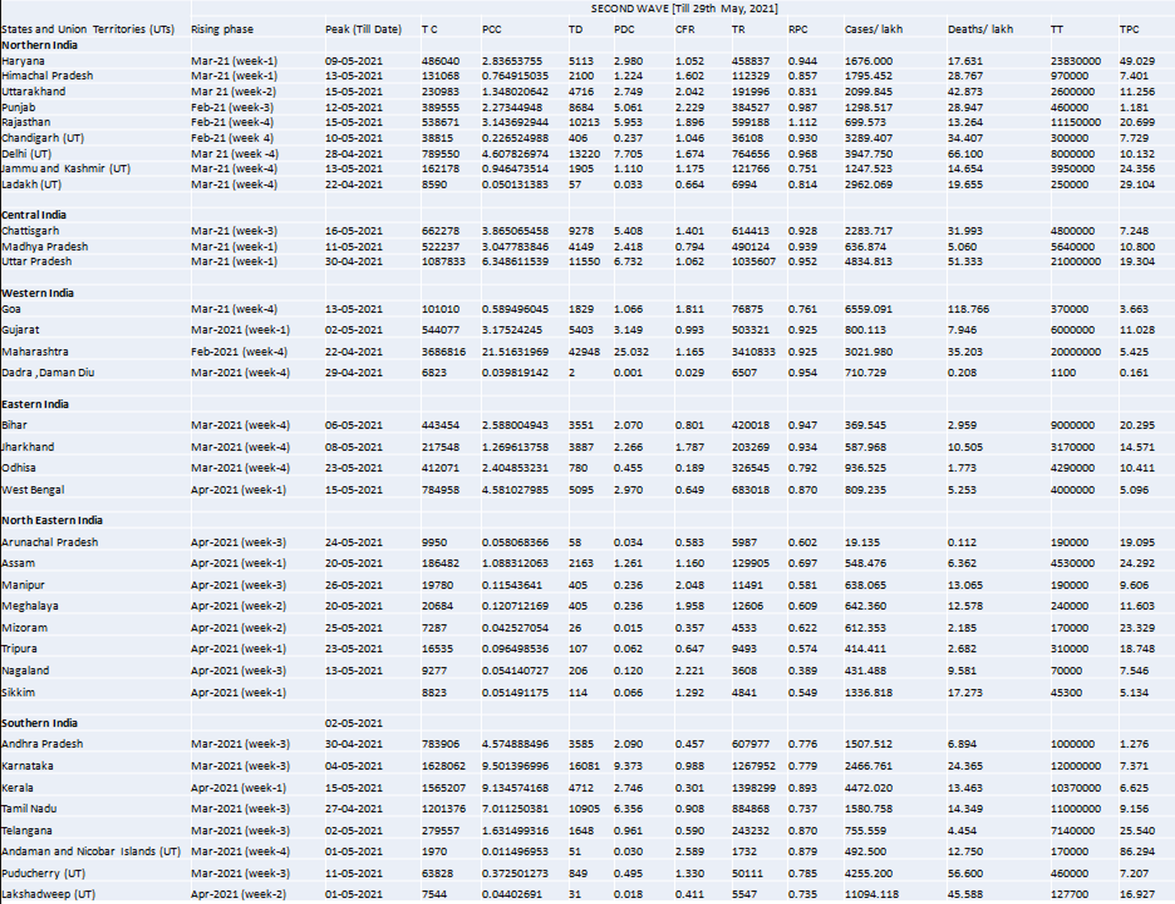
UT:Union Territoty;TC:Total Cases;PCCS:Proportion of case contribution;TD:Total Deaths;PDCS:Proportion of Death contribution;CFR:Case Fatality Ratio;TR:Total recovered;RPC:Recovery Per Case;TPC:Test per case

