Supplemental materials
Figure legends
Figure S1. Bootstrapped test for confidence intervals of EI and bridge EI of NSSI Addiction network model
Figure S2. Bootstrapped difference test for edge weight of NSSI Addiction network model
Figure S3. Bootstrapped difference test for expected influence of NSSI Addiction network model

Table S1. Basic information and network inference of items used to self harm addiction, anxiety and attachment (N=1,169)
Nodes | Label | EI | BEI
OSI-A
self harm addiction | A | 0.36 | 2.44
IPPA
Father trust | Father1 | -1.03 | -1.05
Father communication | Father2 | -0.96 | -0.62
Father alienation | Father3 | -1.00 | 0.18
Mother trust | Mother1 | -0.39 | -0.63
Mother communication | Mother2 | -0.39 | -0.75
Mother alienation | Mother3 | -1.46 | -0.28
Peer trust | Peer1 | -0.45 | -1.25
Peer communication | Peer2 | -0.09 | -0.39
Peer alienation | Peer3 | 0.22 | 1.19
MASC
physical symptoms | MASC1 | 0.94 | 0.94
harm avoidance | MASC2 | 1.87 | 0.62
social anxiety | MASC3 | 1.25 | -0.25
separation anxiety | MASC4 | 1.13 | -0.14

Table S2. Weighted adjacency matrix of the attachment and anxiety with self harm addiction network model
 | A | Father1 | Father2 | Father3 | Mother1 | Mother2 | Mother3 | Peer1 | Peer2 | Peer3 | TMASC1 | TMASC2 | TMASC3 | TMASC4
A | 0.00
Father1 | -0.01 | 0.00
Father2 | 0.00 | 0.72 | 0.00
Father3 | 0.08 | -0.17 | -0.18 | 0.00
Mother1 | 0.00 | 0.26 | -0.13 | 0.03 | 0.00
Mother2 | -0.03 | -0.14 | 0.19 | 0.10 | 0.75 | 0.00
Mother3 | 0.03 | 0.03 | 0.08 | 0.31 | -0.15 | -0.24 | 0.00
Peer1 | -0.01 | 0.03 | 0.00 | 0.01 | 0.04 | 0.00 | 0.00 | 0.00
Peer2 | 0.04 | 0.00 | 0.01 | 0.01 | 0.00 | 0.03 | 0.06 | 0.86 | 0.00
Peer3 | 0.14 | 0.00 | 0.00 | 0.08 | 0.01 | 0.09 | 0.24 | -0.10 | 0.01 | 0.00
TMASC1 | 0.25 | 0.00 | -0.06 | 0.08 | -0.01 | -0.07 | 0.03 | 0.00 | 0.00 | 0.10 | 0.00
TMASC2 | 0.01 | 0.00 | 0.06 | 0.01 | 0.00 | 0.04 | 0.00 | 0.01 | 0.08 | 0.05 | 0.20 | 0.00
TMASC3 | 0.03 | 0.00 | -0.06 | 0.01 | 0.02 | 0.00 | 0.06 | 0.00 | -0.05 | 0.08 | 0.20 | 0.41 | 0.00
TMASC4 | 0.07 | -0.04 | 0.09 | 0.00 | 0.02 | 0.07 | -0.02 | -0.07 | 0.00 | 0.00 | 0.19 | 0.22 | 0.20 | 0.00

Figure S1. Bootstrapped test for confidence intervals of edge,EI and BEI of attachment and anxiety with self harm addiction network model
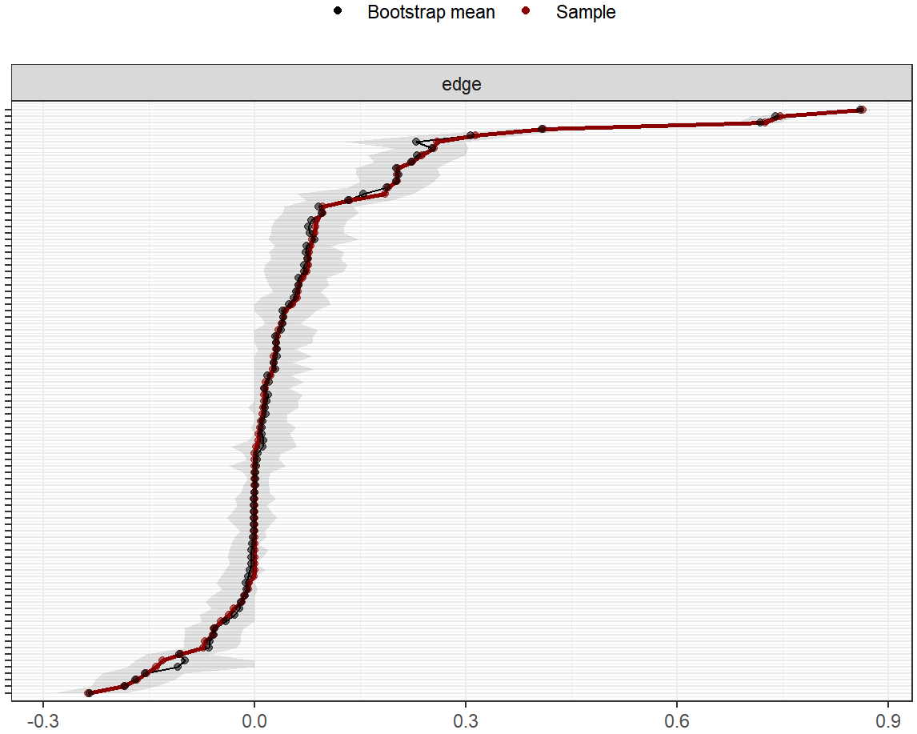

Figure S2. Bootstrapped difference test for edge weight of attachment and anxiety with self harm addiction network model
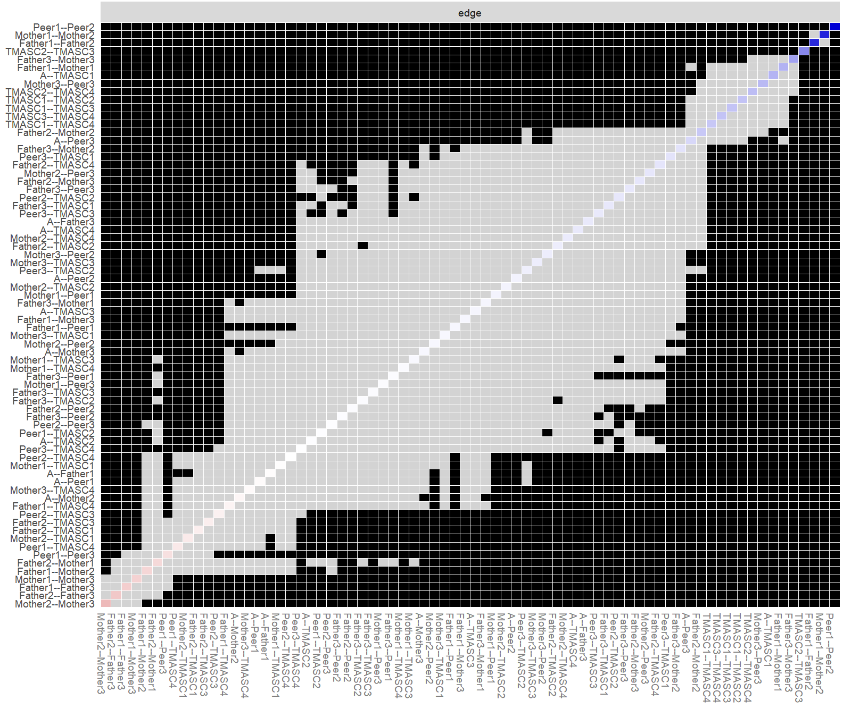

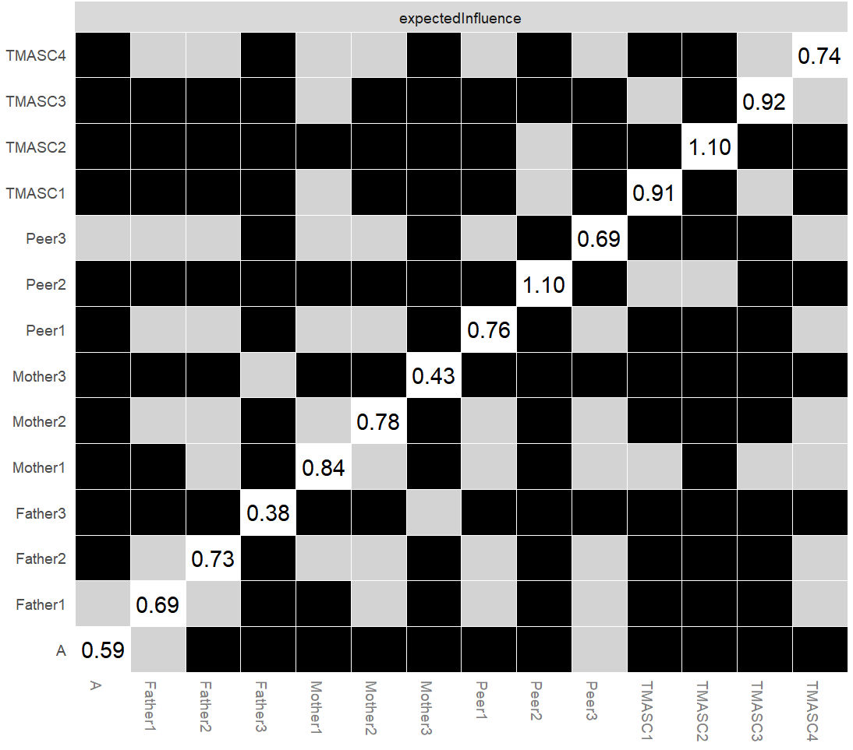
Figure S3. Bootstrapped difference test for expected influence of attachment and anxiety with self harm addiction network model

