Supplementary Figure 1. Frequency instability for each locus in overall cohort (A, n=168 CRC and 348 EC) and in MSI-H patients (B, n= CRC 13 and EC=72) *

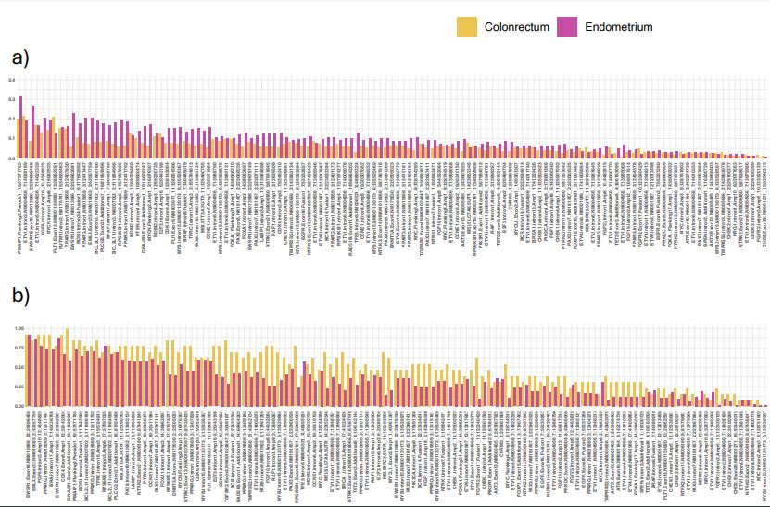
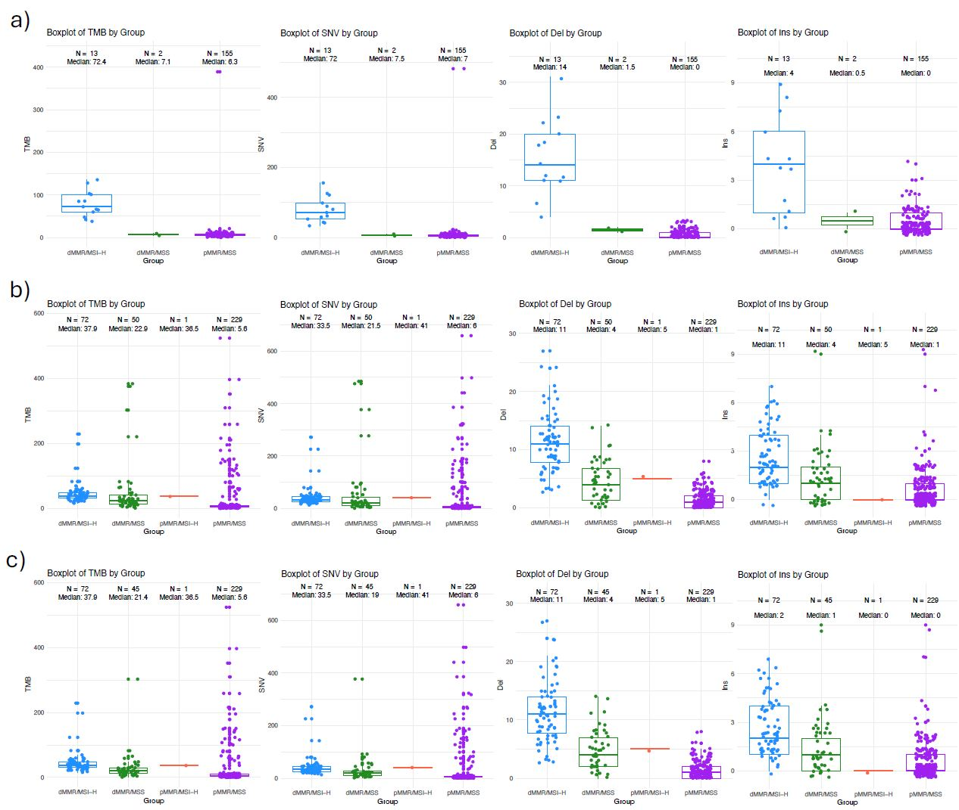
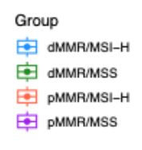
Supplementary Figure 2. TMB values and Variants considered for its calculation (n= 520) for CRC (a), EC (b) and EC without POLEmut discordant cases (c).
Characteristics | EC | CRC
Characteristics | n=352 | n=168
Age at diagnosis, years | 61 ± 11 | 60 ± 12
BMI, kg/m² | 29.7 (23.9-33.7) | 24 (21-26)
Race
White | 336 (95.5) | 164 (97.6)
Asian | 3 (0.9) | 1 (0.6)
American Indian or Alaska Native | 1 (0.3) | 0 (0.0)
Black or African American | 0 (0.0) | 1 (0.6)
Unknown | 12 (3.4) | 2 (1.2)
EC histotype
Endometrioid | 303 (86.1) | -
Serous carcinoma | 19 (5.4) | -
Mixed tumors | 21 (6.0) | -
Carcinosarcoma | 4 (1.1) | -
Others | 5 (1.4) | -
CRC histotype
Adenocarcinoma | - | 137 (81.5)
Mucinous adenocarcinoma | - | 31 (18.5)
Tumor side
Left | - | 86 (51.2)
Right | - | 77 (45.8)
Unknown | - | 5 (3.0)
Grading
1 | 50 (14.2) | 7 (4.2)
2 | 191 (54.3) | 44 (26.2)
3 | 111 (31.5) | 38 (22.6)
Unknown | 0 (0.0) | 79 (47.0)
Stage at first diagnosis
I | 293 (83.2) | 1 (0.6)
II | 33 (9.4) | 13 (7.7)
III | 20 (5.7) | 15 (8.9)
IVB | 6 (1.7) | 109 (64.9)
Unknown | 0 (0.0) | 30 (17.9)
LVSI
Not available | 1 (0.3) | 141 (83.9)
Negative | 234 (66.5) | 13 (7.7)
Positive | 117 (33.2) | 14 (8.3)
Focal | 48/116 (41.4) | -
Substantial | 68/116 (58.6) | -
Molecular risk group
dMMR | 116 (33.0) | -
p53 MT | 32 (9.1) | -
POLE MT | 33 (9.4) | -
NSMP | 166 (47.2) | -
Multiclassifier | 5 (1.4) | -
Mutation status on NGS
Wild type (any gene) | - | 2 (1.2)
Mutated TIER I-II (any gene) | - | 166 (98.8)
KRAS mutated | - | 82/166 (49.4)
NRAS mutated | - | 11/166 (6.6)
BRAS mutated | - | 17/166 (10.2)
MSI NGS status
MSS | 279 (79.3) | 155 (92.3)
MSI-H | 73 (20.7) | 13 (7.7)
MMR IHC status
pMMR | 231 (65.6) | 153 (91.1)
dMMR | 121 (34.4) | 15 (8.9)
TMB
pMMR/MSS | 5.6 (3.3-8.8) | 6.3 (4-8.6)
dMMR/MSI-H | 37.95 (31.37-49.32) | 72.4 (59.9-101.1)
Chemotherapy
No | 284 (80.7) | 14 (8.3)
Yes | 68 (19.3) | 148 (88.1)
Unknown | - | 6 (3.6)
Radiotherapy
No | 231 (65.6) | -
Yes | 121 (34.4) | -
Immunotherapy
No | 350 (99.4) | 124 (73.9)
Yes | 2 (0.6) | 13 (7.7)
Unknown | - | 31 (18.5)
Relapse or progression during treatment | 12 (3.4) | 71 (42.2)
Cancer-specific death | 4 (1.1) | 18 (10.7)
Results are presented as n (%) or mean±standard deviation or median (First quartile-Third quartile) as appropriate. EC: Endometrial Cancer. CRC: ColoRectal Cancer. LVSI: Lymph Vascular Space Invasion. MSI: Micro Satellite Instability. MSS: Micro Satelite Stability. MSI-H: Micro Satellite Instability- High. NGS: Next Generation Sequencing. MMR: MisMatch Repair. pMMR: proficient MisMatch Repair. dMMR: deficient MisMatch Repair. NSMP: No Specific Molecular Profile. POLE MT: POLE mutated. p53: p53 mutated. Multiclassifier: dMMR & POLE MT
Supplemetary Table 1. Clinical and pathological characteristics

Supplementary table 2.
Characteristics | EC | CRC
Characteristics | n=51 | n=2
Age at diagnosis, years | 60 (55-67) | 69 (64-75)
BMI, kg/m² | 27.9 (23.9-30.7) | 27 (27-27)
Race
White | 50 (98.0) | 2 (100.0)
Unknown | 1 (2.0) | 0 (0.0)
EC histotype
Endometrioid | 48 (94.1) | -
Mixed tumors | 3 (5.9) | -
CRC histotype
Adenocarcinoma | - | 1 (50.0)
Mucinous adenocarcinoma | - | 1 (50.0)
Tumor side
Left | - | 2 (1.2)
Grading
1 | 6 (11.8) | 0 (0.0)
2 | 33 (64.7) | 2 (100.0)
3 | 12 (23.5) | 0 (0.0)
Stage at first diagnosis
I | 47 (92.2) | 0 (0.0)
II | 2 (3.9) | 1 (50.0)
III | 2 (3.9) | 1 (50.0)
LVSI
Not available | 1 (2.0) | 2 (100.0)
Negative | 31 (60.8) | 0 (0.0)
Positive | 19 (37.3) | 0 (0.0)
Focal | 9/18 (50.0) | -
Substantial | 9/18 (50.0) | -
Molecular risk group
dMMR | 45 (88.2) | -
p53 MT | 1 (2.0) | -
Multiclassifier | 5 (9.8) | -
Mutation status on NGS
Wild type (any gene) | - | 0 (0.0)
Mutated TIER I-II (any gene) | - | 2 (100.0)
KRAS mutated | - | 1 (50.0)
MSI NGS status
MSS | 50 (98.0) | 2 (100.0)
MSI-H | 1 (2.0) | 0 (0.0)
MMR IHC status
pMMR | 2 (3.9) | 0 (0.0)
dMMR | 49 (96.1) | 2 (100.0)
TMB
dMMR/MSS | 21.35 (13.95-40.32) | 7.2 (NA)
pMMR/MSI-H | 36.6 (NA) | 0 (0.0)
Chemotherapy
No | 46 (90.2) | 0 (0.0)
Yes | 5 (9.8) | 2 (100.0)
Radiotherapy
No | 35 (68.6) | -
Yes | 16 (31.4) | -
Immunotherapy
No | 51 (100.0) | 0 (0.0)
Yes | 0 (0.0) | 2 (100.0)
Relapse or progression during treatment | 1 (2.0) | 1 (50.0)
Cancer-specific death | 0 (0.0) | 0 (0.0)
Results are presented as n (%) or median (First quartile-Third quartile) as appropriate. EC: Endometrial Cancer. CRC: ColoRectal Cancer. LVSI: Lymph Vascular Space Invasion. MSI: Micro Satellite Instability. MSS: Micro Satelite Stability. MSI-H: Micro Satellite Instability- High. NGS: Next Generation Sequencing. MMR: MisMatch Repair. pMMR: proficient MisMatch Repair. dMMR: deficient MisMatch Repair. NSMP: No Specific Molecular Profile. POLE MT: POLE mutated. p53: p53 mutated. Multiclassifier: dMMR & POLE MT
Supplementary table 2. Clinical and pathological characteristics of discordant cases

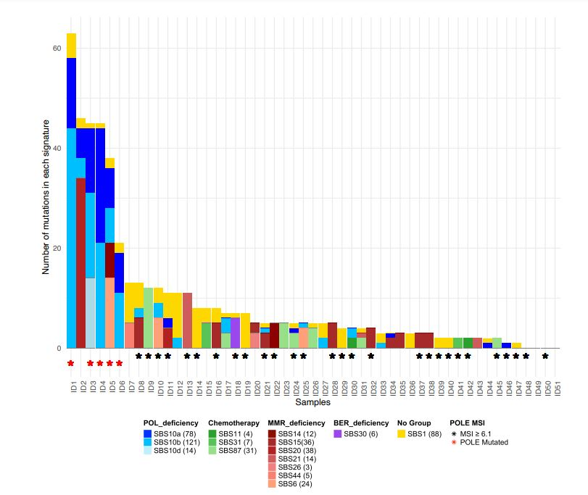
Supplementary Figure 3. Cosmic signatures of discordant cases (n=53)
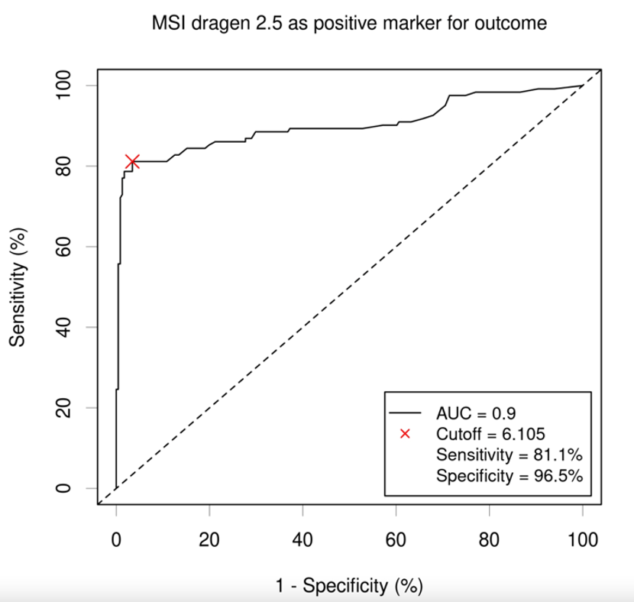
Supplementary Figure 4 . ROC curve for EC

