Supplementary material

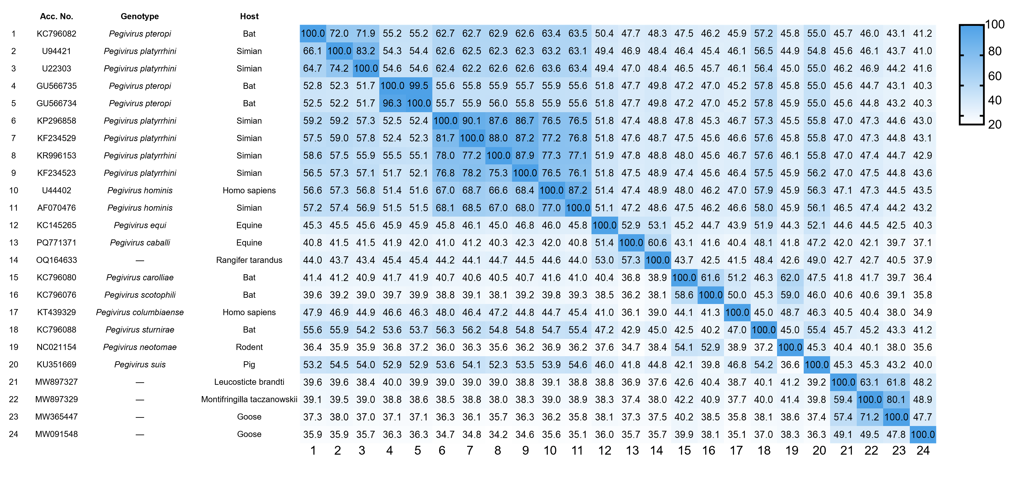
Figure S1. Nucleotide (upper right) and amino acid (lower left) sequence identities of the pegivirus polyprotein gene.

Table S1. The reindeer samples collected in this study
Sample ID | Age (Years) | Sex
1 | ≥3 | Male
2 | 1 | Male
3 | 1 | Male
4 | 2 | Female
5 | 0.5 | Female
6 | ≥3 | Male
7 | 1 | Male
8 | 2 | Male
9 | 2 | Female
10 | ≥3 | Male
11 | ≥3 | Female
12 | 0.5 | Female
13 | 1 | Female
14 | 2 | Male
15 | 2 | Male
16 | 0.5 | Male
17 | ≥3 | Male
18 | 2 | Female
19 | 2 | Female
20 | 1 | Male
21 | 1 | Female

Table S2. The primers used in this study
Primer | Position (bp)* | Sequence (5'→3') | Polarity | Amplicon (bp)
Detection
RPgV F | 1259 | AATGCCCGTCTACCGTGCCTA | + | 282
RPgV R1 | 1589 | GTGCCCCTCAACCATTGCT | - | 282
RPgV R2 | 1541 | ACGGCACAAACCTCGTAACCA | - | 282
Race
5’-GSP | 916 | GATTACGCCAAGCTTCCGTCAGCCGCAAGGGATAGGTTAGG | - | —
5’-NGSP | 237 | GATTACGCCAAGCTTTAGGGATCGTTACGGTCGTGGC | - | —
Genome amplification
1 RPgV F | 1 | AATGCCGTTATCCGGGGCT | + | 665
1 RPgV R1 | 734 | CATGTGAGCGCAAACCTCGT | - | 665
1 RPgV R2 | 666 | GCTTCAGCCCAACAAGTTCCG | - | 665
2 RPgV F1 | 539 | TCCGGCCTCTCCACGAGTGTC | + | 848
2 RPgV F2 | 612 | GTACTGCACCTCGACCGTGT | + | 848
2 RPgV R | 1460 | CCCGCTCGCAGTCAAAGTTGT | - | 848
3 RPgV F | 1435 | CCAGTGTGCCGCCTTCATCG | + | 805
3 RPgV R1 | 2262 | CGCCTGCCTCTGAGTAACACTGA | - | 805
3 RPgV R2 | 2240 | TGATGTTGCCAAACGCTAGCC | - | 805
4 RPgV F | 2092 | TACGTGCCCCAGTTGGATGC | + | 784
4 RPgV R1 | 2922 | ACGTGTCACCGAGCCCGAAC | - | 784
4 RPgV R2 | 2876 | CACCCAGGCCCACCTCGAGT | - | 784
5 RPgV F | 2716 | CGCTCTGTGCTCGGGTATACAGT | + | 850
5 RPgV R1 | 3633 | CCACCACCTAGGGTTCAAGCCA | - | 850
5 RPgV R2 | 3566 | GGTATACATCACAGGCCCCACGA | - | 850
6 RPgV F | 3500 | ACAAAGCGGAGTACAAGGGGAAT | + | 878
6 RPgV R1 | 4452 | CCCCTTCAGATGTTAAAGCAACC | - | 878
6 RPgV R2 | 4378 | GCGTACAACACGAGCCGAACACC | - | 878
7 RPgV F | 4329 | CAGTGTCCTTCTGGGCATT | + | 886
7 RPgV R1 | 5308 | GGCCAGCCCCAACCTCCAA | - | 886
7 RPgV R2 | 5215 | CCGAACCGGCAAATCAGGGG | - | 886
8 RPgV F | 5162 | GGCCTCCTTCGGATGACCCTA | + | 733
8 RPgV R1 | 6127 | GCTTCCCAACCACCGAGGAC | - | 733
8 RPgV R2 | 5895 | CCCAGGCCGCACATATCAGG | - | 733
9 RPgV F | 5821 | AGTCAATCCCCACTAGGAGTTGC | + | 915
9 RPgV R1 | 6771 | CCCCTGGCTGGAACCACGA | - | 915
9 RPgV R2 | 6736 | CCCCACGGATCCAGGACGA | - | 915
10 RPgV F | 6545 | ACTACGCCGTGTCCTTCGTGA | + | 787
10 RPgV R1 | 7432 | GCCCCTCCTTCGTACCCCTG | - | 787
10 RPgV R2 | 7332 | ACCAGACCCGTGACCAATCCG | - | 787
11 RPgV F | 7143 | TTCCGGCGTCCCTAGCACT | + | 762
11 RPgV R1 | 7991 | CCCACCTCAGCAAGCGTCA | - | 762
11 RPgV R2 | 7905 | TGGGCAGAACCACTCTCCGAC | - | 762
12 RPgV F1 | 7839 | CGCAGTGCTTGGTACCGTTT | + | 924
12 RPgV F2 | 7877 | GTCGCTCGCCTCCAAGCTCC | + | 924
12 RPgV R | 8801 | CTTCTCCATCATGTCCGCAACGA | - | 924
13 RPgV F | 8756 | CGGCAATCACGGTCTCGGAT | + | 503
13 RPgV R1 | 9434 | ACCCGTAACCTTTGAGTGCAT | - | 503
13 RPgV R2 | 9259 | GTACACCCCGGATGCACGACA | - | 503
14 RPgV F | 9096 | TGCGTCCGTGTTCGACTCCTC | + | 661
14 RPgV R1 | 9886 | TACCAGCCCAAGCCTCGCAT | - | 661
14 RPgV R2 | 9757 | ACCCAGCGGAAAAGACAACCT | - | 661
15 RPgV F | 9626 | CCGGTGGCTATACCCTACTCT | + | 591
15 RPgV R1 | 10277 | GTCGGTCACCACCCTACAGA | - | 591
15 RPgV R2 | 10217 | CCCAGATGAAGACCCCGACGA | - | 591
16 RPgV F1 | 9763 | TCTTTTCCGCTGGGTTTGCTC | + | 544
16 RPgV F2 | 10062 | GCAGGCACCCTACCAGTCAC | + | 544
16 RPgV R | 10307 | GGTCGCTAGTCCCGTATGATCC | - | 544
*Primer positions are referenced to the complete sequences obtained by RNA-seq in this study.

Table S3. The information about the sequences used in this study
Species | Acc. No. | Strain | Length (nt/aa) | Sampling Country | Sampling date | Host species
— | OQ164633 | GH01 | 10,368/3,249 | China | Jun 2022 | Rangifer tarandus
Pegivirus pteropi | KC796082 | PDB-24 | 9,504/3,010 | Cameroon | 2010 | Chaerephon sp.
Pegivirus pteropi | GU566735 | 93 | 9,536/3,101 | Bangladesh | Dec 2007 | Pteropus giganteus
Pegivirus pteropi | GU566734 | 68 | 9,630/3,106 | Bangladesh | Dec 2007 | Pteropus giganteus
Pegivirus platyrrhini | KP296858 | VGA00020 | 9,146/2,882 | Gambi | 2011 | Chlorocebus sabaeus
Pegivirus platyrrhini | KF234529 | SPgVkrtg_RT11 | 9,276/2,876 | Uganda | May 2010 | Cercopithecus ascanius
Pegivirus platyrrhini | KR996153 | myb_M17 | 8,793/2,883 | Tanzania | 1985 | Papio cynocephalus
Pegivirus platyrrhini | KF234523 | SPgVkrc_RC13 | 9,525/2,898 | Uganda | May 2010 | Piliocolobus tephrosceles
Pegivirus platyrrhini | U94421 | Alab | 9,550/2,967 | — | — | Saguinus labiatus
Pegivirus platyrrhini | U22303 | — | 9,653/2,954 | — | — | —
Pegivirus hominis | U44402 | PNF2161 | 9,392/2,873 | — | — | Homo sapiens
Pegivirus hominis | AF070476 | — | 9,250/2,942 | — | — | —
Pegivirus equi | KC145265 | HorseA1_serum | 10,479/3,189 | USA | Aug 2011 | Equus caballus
Pegivirus caballi | KC410872 | C0035 | 11,197/3,344 | USA | 2011 | Equus sp.
Pegivirus carolliae | KC796080 | PDB-1698 | 10,465/3,325 | Guatemala | 2010 | Carollia perspicillata
Pegivirus scotophili | KC796076 | PDB-620 | 10,767/3,469 | Kenya | 2010 | Scotophilus dinganii
Pegivirus columbiaense | KT439329 | AK-790 | 9,538/3,057 | USA | 2015 | Homo sapiens
Pegivirus sturnirae | KC796088 | PDB-1715 | 9,777/3,036 | Guatemala | 2010 | Sturnira lilium
Pegivirus neotomae | NC021154 | CC61 | 11,279/3,484 | USA | 2008 | Neotoma lepida
Pegivirus suis | KU351669 | PPgV_903/Ger/2013 | 9,760/2,972 | Germany | Aug 2013 | Sus scrofa domestica
— | MW897327 | XZN | 10,719/3,282 | China | Apr 2018 | Leucosticte brandti
— | MW897329 | YSN | 10,419/3,282 | China | Jul 2019 | Onychostruthus taczanowskii
— | MW365447 | FV2 | 11,195/3,406 | China | 2016 | Anser cygnoides
— | MW091548 | — | 11,479/3,430 | China | 2016 | Anser cygnoides

