Supplementary Information

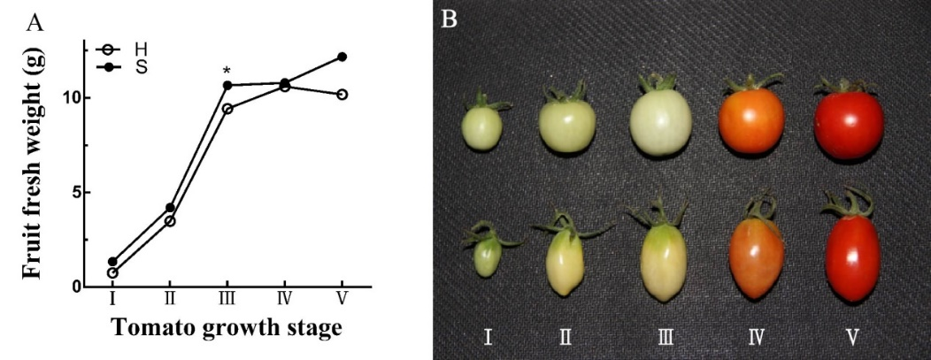
Figure. S1 Standards used to define the developmental stages of tomato fruits.
A, Growth curve of tomato fruit. Student’s t test, *P < 0.05. B, Five developmental stages of fruits of two cherry tomato species based on United States Department of Agriculture (USDA) standards. Abbreviations: I, Immature stage; II, Mature Green stage; III, Breaker stage; IV, Pink stage; Ⅴ, Red Ripe stage.

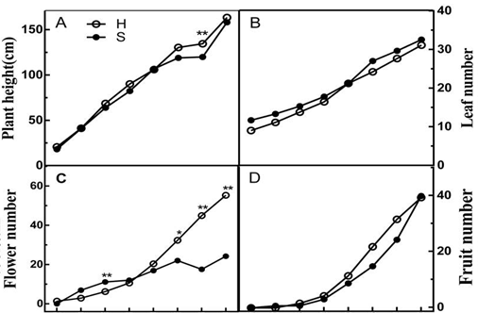

Figure. S2 Comparison of plant height (A), leaf number (B), flower number(C) and fruit number (D) between two kinds of tomato genotypes. Student’s t test, *P < 0.05; **P < 0.01. Abbreviations: H, hexose-accumulating cherry tomato; S, sucrose-accumulating cherry tomato.

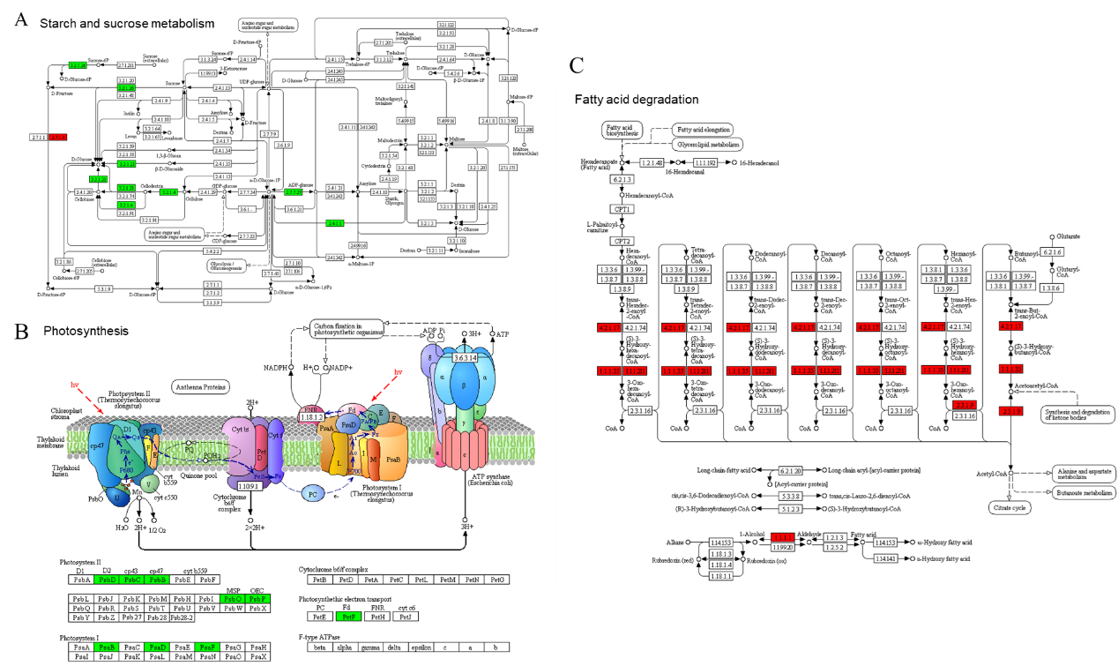
Figure. S3 Kyoto Encyclopedia of Genes and Genomes (KEGG) analysis of differential proteins involved in starch and sucrose metabolism (A), photosynthesis (B) and fatty acid degradation (C). The green box represents downregulated proteins and the red box represents upregulated proteins.

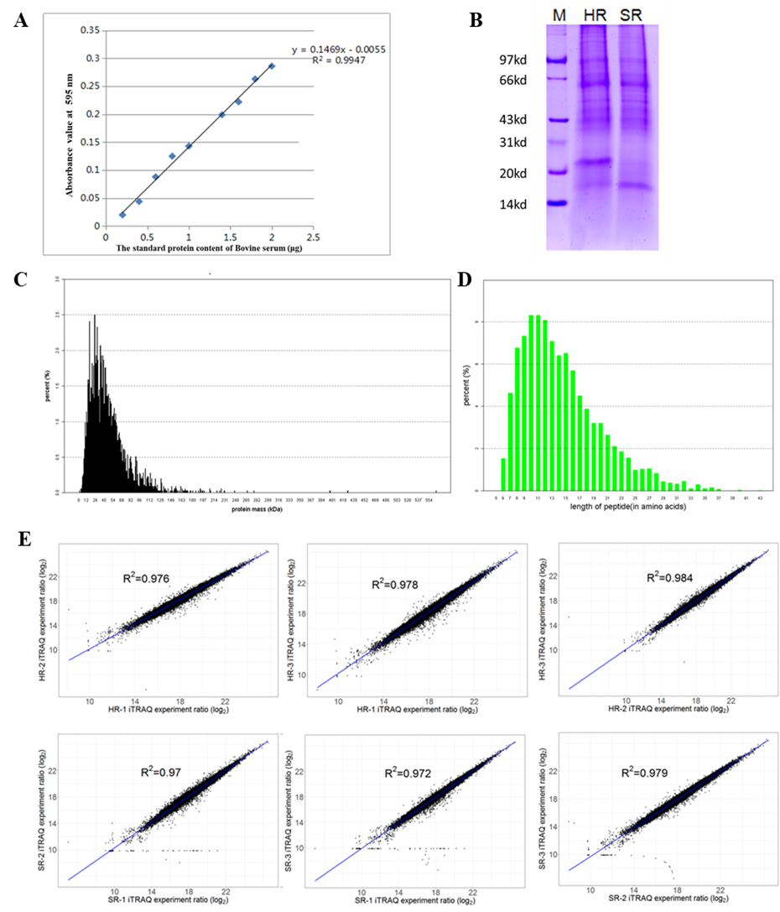
Figure. S4 Protein extraction and quality detection from tomato fruits for iTRAQ proteome sequencing. A, The standard protein content of bovine serum; B, Protein quality detection by SDS-PAGE; C, The distribution of protein mass; D, The distribution of peptide length; E, Parallel analysis between samples.

Table S1. Primers of sucrose transporter (SUT) genes used for qRT-PCR.

Gene | NCBI Reference Sequence | Forward Primer(5’-3’) | Reverse Primer(5’-3’)
SUT1 | NM_001302901.2 | ACCACGAGCGATTGCTGTAT | CAGCCAGTAGTGCTCTGCAT
SUT2 | NM_001247392.2 | AAGGAGAAGCAGATGAAGTAA | CTAACGCCAAGAACAACAG
SUT4 | NM_001247415.2 | CATAGAACAAGGCATAAC | CTCGTAACAATAGTCTCA
Actin-7 | NC_015440.2 | GGAATGGGACAGAAGGAT | CAGTCAGGAGAACAGGGT

Table S2. Plasmodesmal densities (PDDs) between different cells of the phloem during fruit developmental stages I to Ⅴ.
Genotype | Developmental stages | SE/CC | SE/PC | CC/PC | PC/PC
S | I | 0.90 | 0.10 | 0.26 | 0.28
S | II | 0.66 | 0.26 | 0.92 | 0.82
S | III | 0.60 | 0.28 | 0.20 | 0.24
S | IV | 0.75 | 0.20 | 0.12 | 1.05
S | Ⅴ | 0.84 | 0.17 | 0.10 | 1.62
H | I | 0.93 | 0.14 | 0.69 | 0.68
H | II | 0.64 | 0.08 | 0.45 | 0.61
H | III | 0.48 | 0.18 | 0.78 | 0.57
H | IV | 0.95 | 0.03 | 0 | 0.53
H | Ⅴ | 0.78 | 0.03 | 0.04 | 0.51
Units of PDD, number of plasmodesmata μm-1 cell length. Each value is the mean ± standard deviation of 30 replicates for PDD. Abbreviations: SE, sieve element; CC, companion cell; PP, phloem parenchyma cell; PDD, plasmodesmal density; H, hexose-accumulating cherry tomato; S, sucrose-accumulating cherry tomato.

