Supplementary Material for

Detection and Staging of Chronic Obstructive Pulmonary Disease Using a Computed Tomography-based Weakly Supervised Deep Learning Approach

Supplemental Appendix 1
Table S1 Demographic and clinical characteristics of NLST subset.
Demographic Characteristics | NLST (n=620)
Demographic Characteristics | COPD  (n=56) | Non-COPD  (n=564)
Age, Yrs, M (IQR) | 66 (56-74) | 63 (55-74)
Sex, %Male (n) | 48.21 (27) | 51.78 (339)
BMI, mean (SD) | 26.40 (4.27) | 26.61 (4.76)
Former or Current smokers, % (n) | 53.57 (30) | 58.33 (329)
Pack-years, mean (SD) | 66.23 (22.53) | 65.82 (29.26)
Underlying Diseases, % (n)
Cardiovascular Disease | 19.64 (11) | 13.65 (77)
Diabetes Mellitus | 5.36 (3) | 9.57 (54)
Asthma | 25.45 (14) | 3.90 (22)
Bronchiectasis | 3.78 (2) | 1.60 (9)
Pneumonia | 37.0 (20) | 19.21 (108)
Others | 14.29 (8) | 8.16 (46)
Yrs: Years. M (IQR): Median, Inter Quartile Range. SD: Standard Deviation. BMI: Body Mass Index. NLST: National Lung Screening Trail.

Table S2: Detailed information about the data acquisition and scanner protocols of the model development dataset.
Hospital | Group | Participants, n (slices) | Age, Yrs, M (IQR) | Sex, %Male (n) | Manufacturer (slices) | Thickness (slices) | Recon method (slices)
Changsha First Hospital | COPD Patients | 173 (694) | 63, (22-84) | 82.6 (143) | GE (113), SIEMENS (581) | 5.0 (346), 1.5 (291), 1.25 (57) | LUNG (56), STANDAR (57), B70s (286), B30s (162), B20s (131), CHST (1), STND (1)
Changsha First Hospital | Non-COPD Patients | 126 (535) | 56, (18-70) | 44.4 (56) | GE (313), SIEMENS (222) | 5.0 (262), 1.5 (110), 1.25 (163) | LUNG (140), STANDARD (173), B70s (111), B30s (61), B20s (50)
Changsha First Hospital | Healthy Participants | 41(165) | 54, (14-69) | 58.5 (24) | GE (93), SIEMENS (72) | 5.0 (79), 3.75 (1), 1.5 (36), 1.25 (49) | LUNG (42), STANDARD (51), B70s (36), B30s (20), B20s (16)
the Affiliated Hospital of Qingdao University | COPD Patients | 244 (435) | 62, (34-89) | 75.8 (185) | GE (317), UIH (73), Philips (16), SIEMENS (25), Hitachi (2), TOSHIBA (2) | 5.0 (418), 2.0 (1), 1.25 (5), 1.0 (3),0.625 (8) | STANDARD (188), LUNG (123), B_SOFT_B (37), B_VSHARP_C (36), L (5), I30f', '3' (1), 'I70f', '3' (1), 85 (1), 64 (1), 'I31s', '3' (1), B60s (1), B (7), BONE (4), B31f (4), B60f (3), C (1), D (2), B30f (3), B80f (4), FC18 (1), FC56 (1), CHST (2),
the Affiliated Hospital of Qingdao University | Non-COPD Patients | 183 (554) | 58 (33-78) | 45.3 (83) | GE (228), SIEMENS (309), Philips (12), UIH (2), TOSHIBA (3) | 5.0 (340), 2.5 (1), 1.25 (9), 1.0 (22), 8.0 (1), 0.75 (105), 0.625 (74), 0.6 (2) | STANDARD (112), LUNG (111), B31s (111), B70s (124), B41s (7), 'I31s', '3' (26), B60s (8), CHST (1), BONEPLUS (1), 'I31s', '2' (5), 'I50f', '3' (1), 'I31f', '3' (4), L (8), 'I70s', '3' (9), B (4), 'I41s', '3' (5), B_SOFT_B (1), B_VSHARP_C (1), FC18 (2), FC56 (1), B60f (2), B31f (3), SOFT (1), 'I30f', '3' (5), B30f (1)
the Affiliated Hospital of Qingdao University | Healthy Participants | 217 (433) | 43 (15-76) | 50.7 (110) | UIH (100), Hitachi (66), GE (185), SIEMENS (66), Philips (12), TOSHIBA (4) | 10 (2), 5 (431) | B_SOFT_B (50), B_VSHARP_C (50), 85 (33), 64 (33), STANDARD (93), LUNG (85), B41s (18), B70s (18), L (6), B (6), BONEPLUS (3), 'I31s', '3 (14), B60s (14), CHST (4), B31f (1), B80f (1), FC18 (2), FC56 (2)
People’s Liberation Army Joint Logistic Support Force 920th Hospital | COPD Patients | 217 (650) | 68 (26-94) | 77.9 (169) | GE (650) | 10.0 (2), 5.0 (430), 1.25 (216), 0.625 (2) | STANDARD (186), LUNG (203), BONE (248), CHST (1), None (12)
 | Non-COPD Patient | 64 (191) | 58 (14-80) | 39.1 (25) | GE (191) | 5.0 (126), 1.25 (64), 0.625 (1) | STANDARD (46), LUNG (72), BONE (73)
Shandong Provincial Hospital | COPD Patients | 10 (10) | 65 (50-84) | 100 (10) | Philips (5), GE (4), TOSHIBA (1) | 1.25 (4), 1.0 (6) | YB (5), BONE (3), FC55 (1), LUNG (1)
Shandong Provincial Hospital | Healthy Participants | 118 (186) | 35 (4-65) | 50 (59) | GE (120), Philips (60), SIEMENS (2), TOSHIBA (4) | 1.25 (120), 1.0 (66) | STANDARD (85), LUNG (12), B (30), YB (28), BONE (23), 'Br40d', '3' (1), 'Br49d', '3' (1), YC (2), FC55 (2), FC07 (2)
Total |  | 1393 (3853) | 56 (4.0~94.0) | 62.5 (871) | GE (2225), SIEMENS (1277), Philips (105), TOSHIBA (14), Hitachi (68), UIH (175) | 10.0 (4), 8.0 (1), 5.0 (2441), 3.75 (1), 2.5 (1), 2.0 (1), 1.5 (437), 1.25 (689), 1.0 (97), 0.75 (105), 0.625 (85), 0.6 (2),
COPD: Chronic Obstructive Pulmonary Disease. Yrs: Years. M (IQR): Median, Inter Quartile Range.

Supplemental Appendix 2
The Development of COPD Detection Model
a. Data preprocessing
We first developed a ResNet18-based deep learning (DL) model for COPD detection on CT images from a widely distributed dataset. Specifically, original CT images were first adjusted to lung window and resized to a resolution of 512 x 512 pixels using bilinear interpolation method. The whole CT volumes were then performed with data normalization for training the network. Given CT series obtained from different hospitals has thickness ranging from 1.5mm-5mm, we divided the whole CT series into K+2 sub-parts with an equal height. One slice was randomly selected from K sub-part as one instance. These K instances then formed into one bag and was labelled with the label of its patients label in training the network. Note that 2/K+2 of the total height of the original CT sequences was removed from the superior and inferior ends of the sequence due the restricted lung area in these slices. In this way, we made to acquire the effective feature regions with increased volumes of the training data. The details of the preparation of bag and instance were illustrated in Figure S1.
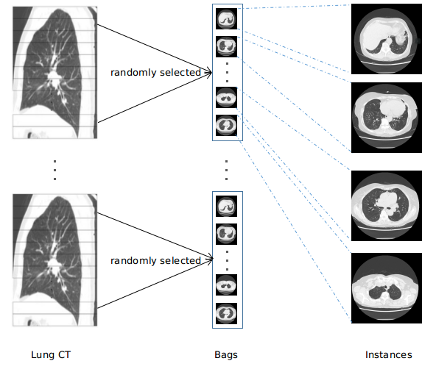
Figure S1 Preparation of the bags and instances.

b. Optimization of the best K sections
To determine the optimal number of K sections in preparation of bags and instance, we tested 12 K values including 4，8，12，16，20，24，28，32，36, 40，44，48 to train the network. As shown in Figure S2, in the validation dataset of 278 samples, the classification accuracy reached to the highest AUC when K was set to 32. It is anticipated that there was not enough instance having lesions to learn when K was too small. Whereas, too many instances could include unnecessary information that could impede the learning efficiency.
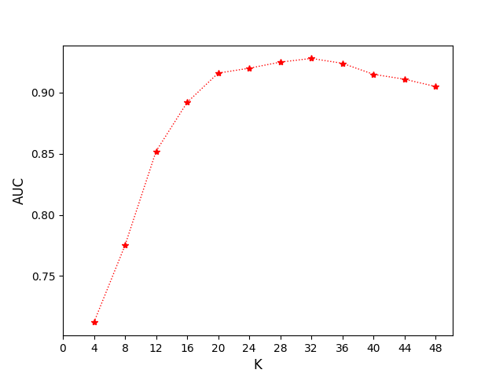
Figure S2 Influence of K sections in model performance.
AUC: Area Under the Receiver Operating Characteristic Curve.

c. Features Extraction
After obtaining bags with multiple instances, each bag was entering into the feature extractor (G_{f}) of ResNet18 architecture to generate feature vectors (FVs). Specifically, for the positive bag (labeled with COPD), each instance was transformed into feature vectors as FVs_COPD (FV1_COPD, FV2_COPD, ..., FVK_COPD); similarly, for the negative bag (labeled with non_COPD), it contains features vectors as FVs_Non (FV1_ Non, FV2_ Non, ..., FVK_ Non). The K indicates the number of instances. A Euclidian-based distance function (FVi_D=D) was applied to calculate the distance between each vector (FV1_ D, FV2_ D, ..., FVK_D). We did the clustering with the K-means function (K=2) to improve the discriminative capacity of the latent vector. Loss function (LOSS-F) was applied to enable the model converge smoothly during the feature extraction steps of multi-instance learning (MIL). This LOSS-F function was implemented using the following equations:
$${LOSS}_{F}=\sum_{i}^{K}{flag({FV}_{i}_D)}$$
$$flag({FV}_{i}_D)=\left\{\begin{aligned}{D(FV}_{i}_COPD,{FV}_{i}_Non),{FV}_{i}_COPD∈{FV}_{s}_COPD_0 \\ 1/{D(FV}_{i}_COPD,{FV}_{i}_Non),{FV}_{i}_COPD∈{FV}_{s}_COPD_1\end{aligned}\right.$$

This loss function is important as it compares the discrepancy between the instances with positive and negative labels, thus to improve the converge speed of feature extractor without increasing the computational load.

d. The attention-based mechanism
We then used the model named attention mechanism to provide a measure of the contribution of each instance to the overall classification and significantly improves the networks detection accuracy (Figure S3). FVs obtained from G_{f} are input to the attention mechanism to z of weighted feature vector. Finally, input z into the fully connected layer and Softmax layer to get the final classification probability. In the prediction stage, we used the cross entropy loss function (LOSS_L) to update the parameters of this part.
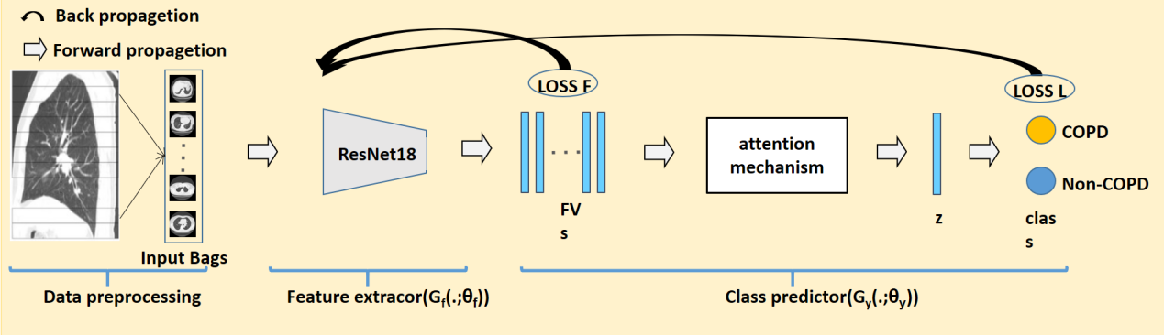
Figure S3 Overall COPD detection pipeline: 1) preparation of CT lung instances and bags; 2) feature extraction using ResNet18 and 3) attention mechanism-based classifier.

Supplemental Appendix 3
a. Development of The GOLD Prediction Model
This process yielded a subset of 644 labelled scans with the determined GOLD stage based on spirometry test. In the preparation of raw CT data, we used the tag information of “spacing” in the DICOM file to reconstruct all the CT scans into the same space to solve the varied image specifications, and used bilinear interpolation to obtain the input channel of the 3D whole CT volumes with the size of 180×150×180. To exclude the regions outside the lung, we used previously established in-house lung segmentation algorithms by Infervision (infervision, Beijing China). This algorithm was trained with over 3045 CT images collected from China regions using Mxnet (version 1.6.0) and CUDA (version 10.0). All images were reviewed and annotated by experienced radiologists to create the parenchymal masks. The segmented lung parenchyma was therefore obtained with the size of 180×150×180, which were used as the second channel. Lastly, we applied -950 Hounsfield (HU<-950) as the threshold to extract Images features associated with the COPD structural alterations (Figure S4). Previous reports had demonstrated that this CT range represents the regions responsible for COPD exacerbation and can be used as the predictor for COPD identification. Thus, stacked channels comprising of these three 3D images as model inputs, and outputs were four categories representing each stage.
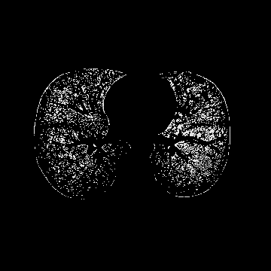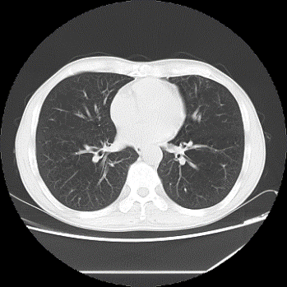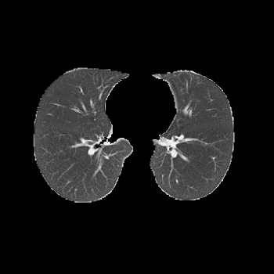
Figure S4 Representative CT slices from three input channels into the 3D network

In this study, we chose to use 3D ResNet50 architecture as the backbone (Figure S5). This structure has been previously used to achieve a robust and fast network with higher specificity. The model architecture contains one 7×7×7 convolutional layer, one max pooling layer, 5 ‘Conv block’ and 12 ‘Identity block’. Each block contains one 1×1×1 convolutional layer, one ‘ReLU’ layer, one 3×3×3 convolutional layer, one ‘ReLU’ layer and one 1×1×1 convolutional layer. The residual connection is from the beginning of the block to the end of the block. The output of the last block was connected to an avg.pool layer with Softmax function to give the prediction.

Figure S5 Illustration of the architecture of 3D ResNet50

b. Optimization of model variant on GOLD Prediction
Using the cross-validation of 644 samples, the AUC of different model depth was computed and compared in Table S3. Considering measurements like Kappa, F1-score, recall and specificity (using the macro definition), we highlighted the best-performing model when 50 layers were chosen.

Table S3 GOLD prediction performance of different model depth.
Model depth | AUC | Kappa | F1-macro | Recall-macro | Specificity-macro
18 layers | 0.856 | 0.510 | 0.602 | 0.621 | 0.879
34 layers | 0.887 | 0.551 | 0.630 | 0.716 | 0.888
50 layers | 0.901 | 0.618 | 0.715 | 0.676 | 0.901
101 layers | 0.973 | 0.518 | 0.623 | 0.643 | 0.879
152 layers | 0.753 | 0.517 | 0.615 | 0.626 | 0.879

Supplemental Appendix 4
a. Training details
The proposed DL models were implemented using the popular open-source framework PyTorch library with 4 NVIDIA GPUs (GeForce GTX 1080). All the competitive networks were optimized by adam optimizer with the batch size of 16. The initialization learning rate was set to 0.001, the momentum and weight decay coefficients were set to 0.9 and 1×10⁻⁶, respectively. The attention-based MIL network was trained for approximately 300 epochs, and the learning rate decreased to 0.0001 after 50 epochs. The overall loss function is defined as LOSS = LOSS_F + LOSS_L.
For the modified ResNet50 network, it was trained for approximately 200 epochs. We used adam as the optimizer with the initial learning rate of 0.01 and the batch size of 16. The learning rate decreased to 0.001 after 25 epochs, and 0.0001 after another 50 epochs. We used the ‘multi-label loss’ as the loss function instead of the standard ‘softmax single-label’ to make multi-categories predictions.

