Genome-Wide Association Study Identifies Protective Genetic Factors in Active Blood Donors Against Multiple Diseases

SUPPLEMENTARY INFORMATION

Jonna Clancy*^{1,2}, Jarkko Toivonen², Jouni Lauronen², Satu Koskela¹, Jukka Partanen², FinnGen³, Mikko Arvas², Jarmo Ritari²

¹ Finnish Red Cross Blood Service, Blood Service Biobank, Vantaa, Finland
² Research & Development, Finnish Red Cross Blood Service, Helsinki, Finland
³ List of FinnGen members is available as a supplementary file

*Corresponding author:
Jonna Clancy, PhD
Finnish Red Cross Blood Service
Biobank/Research & Development
Härkälenkki 13
01730 Vantaa
Finland
+358 50 553 2373
jonna.clancy@bloodservice.fi
Contents
Supplementary Figure 1 2
Supplementary Table 1 3
General work flow 4
Results of blood group antigen association analysis 5
Supplementary File 1 8
GWAS summary statistics 8
Chr6 summary statistics 8
Fine-mapping Susie 99 8
Supplementary File 2 9
Genetic correlation 9
Red cell antigen association analysis 9
HLA association analysis 10
Protein quantative trait loci 11
Supplementary File 3 12
Results of protein quantative trait loci 12
String enrichment all 12
String enrichment ABO 12
Supplementary File 4 13
Significant labQTL 13
Mediation analysis 13
Putative bias caused by red cell antigen enrichment in research setting 14
Supplementary Methods 15
FinnGen ethics statement 16
Data acquisition 17
Association analysis and fine-mapping 18
Genetic correlation 19
HLA and blood group imputation 20
QTL analysis 20
Supplementary Table 4 22

Supplementary Figure 1

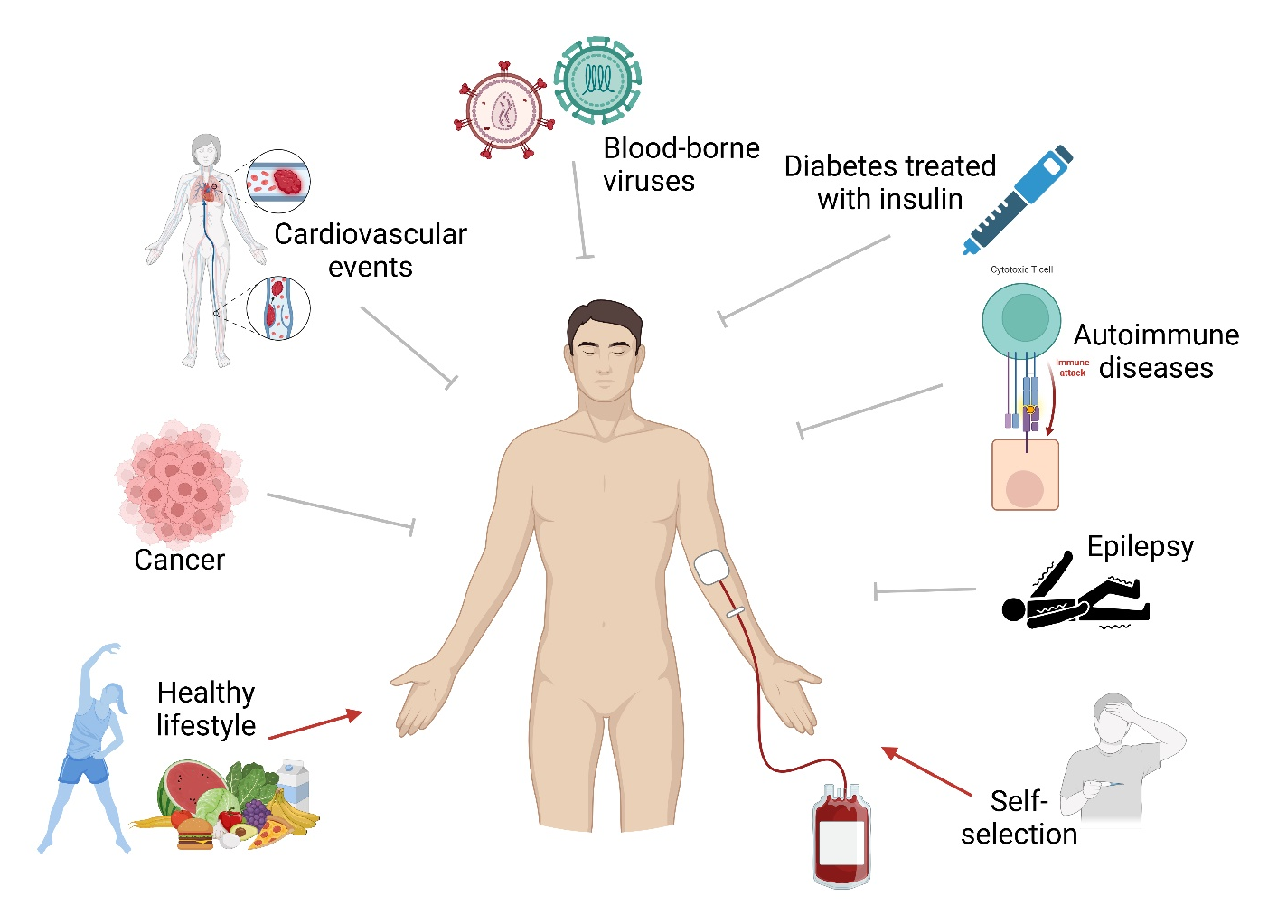
Supplementary Figure 1. The Healthy Donor Effect (HDE). Blood donation criteria restrict individuals with certain diseases, such as severe cardiovascular diseases, cancer or certain autoimmune diseases from blood donation. This leads into healthy donor effect and into lower morbidity and mortality rates among blood donors. Figure created with BioRender.

Supplementary Table 1

Cohort | N
ARCTIC-BIOBANK-NFBC1966¹ | 1,693
ARCTIC-BIOBANK-NFBC1986¹ | 1,998
ARCTIC-BIOBANK-OULU1935¹ | 415
ARCTIC-BIOBANK-OULU1945¹ | 602
AURIA-BIOBANK² | 38,691
BIOBANK-OF-CENTRAL-FINLAND² | 4,084
BIOBANK-OF-EASTERN-FINLAND² | 11,598
BLOOD-SERVICE-BIOBANK³ | 53,688
BOREALIS-BIOBANK² | 13,862
HELSINKI-BIOBANK² | 57,257
TAMPERE-BIOBANK² | 24,927
TERVEYSTALO-BIOBANK (mainly occupational health) | 17,719
THL-BIOBANK-ATBC⁴ | 15,891
THL-BIOBANK-BOTNIA⁴ | 5,050
THL-BIOBANK-COROGENE⁴ | 2,076
THL-BIOBANK-FINHEALTH-2017⁴ | 5,661
THL-BIOBANK-FINHIT⁴ | 4,755
THL-BIOBANK-FinIPF⁴ | 260
THL-BIOBANK-FINRISK-2012⁴ | 1,954
THL-BIOBANK-FUSION⁴ | 10,048
THL-BIOBANK-HHS⁴ | 2,977
THL-BIOBANK-KUUSAMO⁴ | 231
THL-BIOBANK-T1D⁴ | 933
THL-BIOBANK-TWINS⁴ | 5,378

Supplementary Table 1. Cohorts used for the control population in the GWAS study.
¹ https://www.oulu.fi/en/university/faculties-and-units/faculty-medicine/northern-finland-birth- cohorts-and-arctic-biobank/northern-finland-birth-cohorts
² https://site.fingenious.fi/en/all-partner-biobanks
³ Clancy J, Ritari J, Vaittinen E, Arvas M, Tammi S; FinnGen; Koskela S, Partanen J. Blood donor biobank as a resource in personalised biomedical genetic research. Eur J Hum Genet. 2024 Jan 12. doi: 10.1038/s41431-023-01528-0. Epub ahead of print. PMID: 38212662.
⁴ https://thl.fi/en/research-and-development/thl-biobank/for-researchers/sample-collections

General work flow

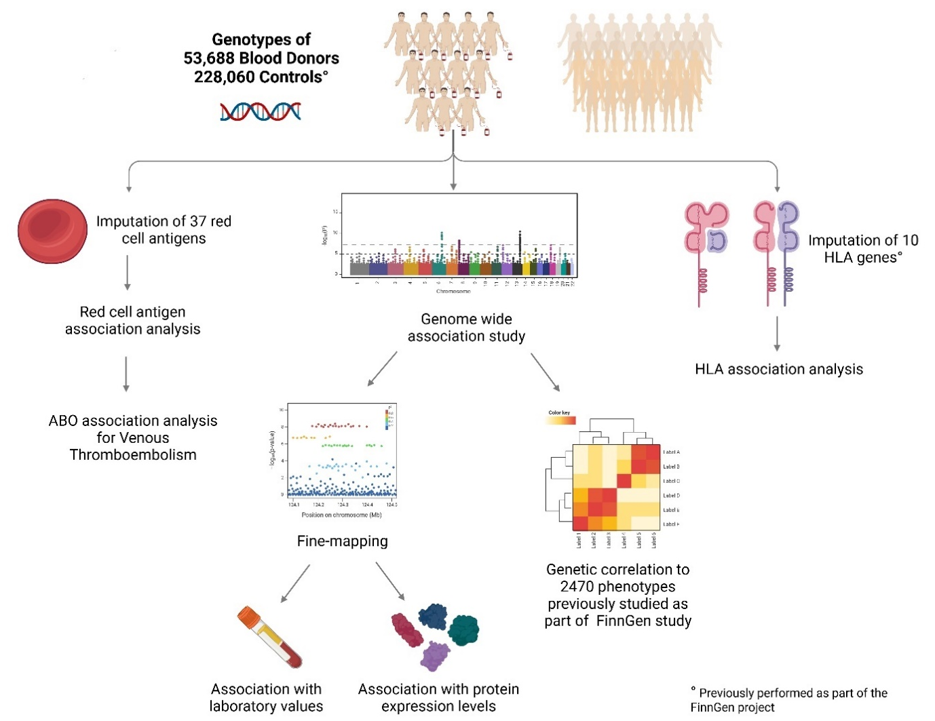
Supplementary Figure 2. We conducted a GWAS on 53,688 blood donors and 228,060 controls (FinnGen). Genome-wide significant associations were fine-mapped and used for downstream analyses. Genetic correlations between 2,470 FinnGen phenotypes and blood donorship were calculated based on the GWAS summary statistics. Additionally, we imputed red cell antigens and tested their association with blood donorship. Previously imputed HLA-alleles in FinnGen were similarly used for association analysis. We further used quantitative trait loci analysis to examine the association of fine-mapped and MHC lead variants with blood protein levels and clinical laboratory measurements. Figure created with BioRender.

Results of blood group antigen association analysis
We analyzed the blood group related significant fine-mapped GWAS variants in chromosomes 1, 7 and 9 with linear regression models. The lead variant in chromosome 1, rs55794721-A, was associated with the Rh blood group system (previously shown to be associated with height¹⁸). Rh antigens E, C and D were negatively associated with rs55794721-A, whereas e and c antigens of the most common Rh negative haplotype in the Caucasoid population, dce⁸, were positively associated with rs55794721-A (Figure 4b). 91% of individuals positive for Rh c and e alleles and had no Rh D, C or E alleles, were homozygotes (dosage value > 1.5) for rs55794721-A. rs55794721-A is in LD¹⁹ (R² = 0.39) with variant rs586178-C tagging certain RhCE blood group alleles²⁰. Lead variant in chromosome 7, rs8176058-A, a known tag SNP for Kell blood group antigen²⁰ was positively associated with K antigen (Figure 4c). The lead variant in chromosome 9, rs687621-A¹⁹, is in strong LD, R² = 1 with blood group O tagging SNP rs687289-G²¹. We saw a strong positive association of rs687621-A with blood group antigen O, a positive association with blood group antigen B and a negative association with blood group antigen AB (Figure 4d).
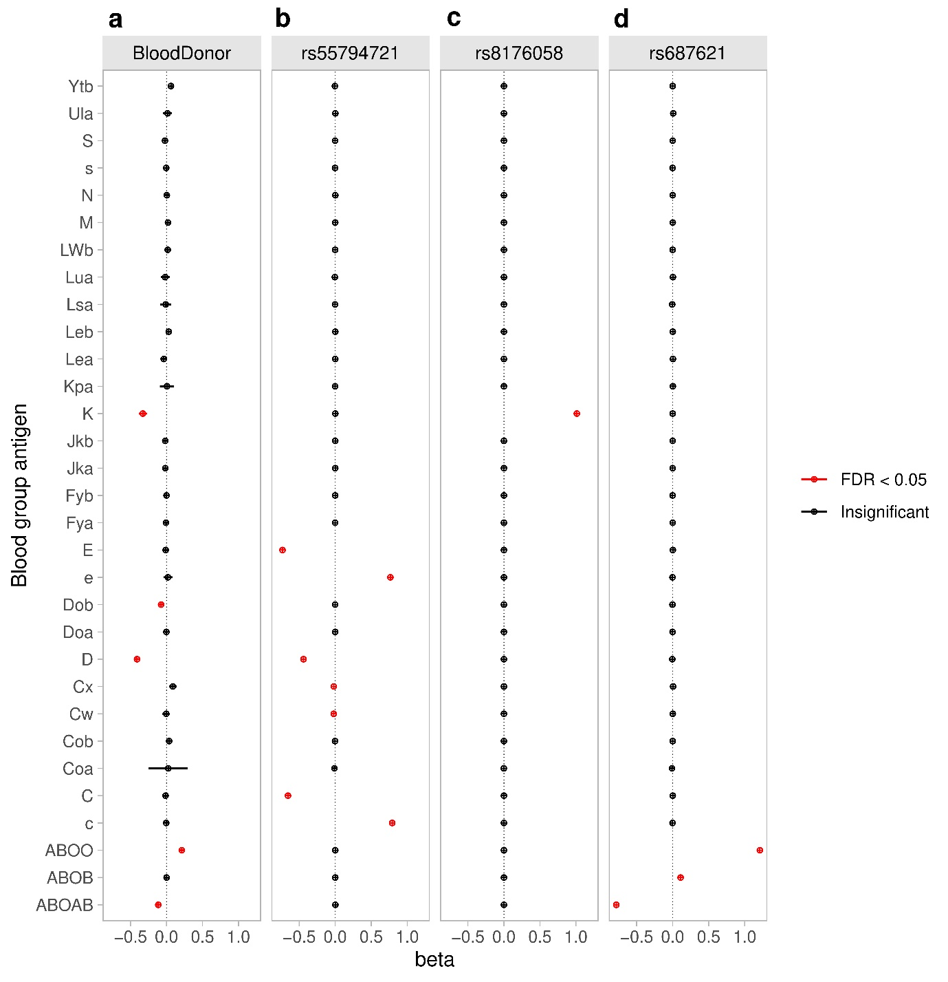
Supplementary Figure 3. Association of blood group antigens with a) blood donorship and the fine-mapped lead variants b) rs55794721-A, c) rs8176058-A, and d) rs687621-A on chromosomes 1, 7, and 9, respectively. The magnitude of the association is represented on the x-axis as log odds ratios for the logistic regression of blood donorship and regression coefficients for the linear regression of the variant dosage.

Supplementary File 1

The file contains three different sheets in one excel file.

GWAS summary statistics
Summary statistics of genome-wide association study
Analysis was performed with FinnGen pipeline with Regenie v2.2.4
53,688 cases (blood donors) and 228,060 controls (other FinnGen participants)
Covariates used in GWAS: sex, age, BMI, PC1-10, birth region, and FinnGen genotyping array version
Variants with p-value ≤ 9.9 x 10⁻⁷ are shown

Chr6 summary statistics
Summary statistics of T1D adjusted association analysis
Analysis was performed with FinnGen pipeline with Regenie v2.2.4
53,688 cases (blood donors) and 228,060 controls (other FinnGen participants)
Covariates used in GWAS: sex, age, BMI, PC1-10, birth region, FinnGen genotyping array version, and FinnGen T1D endpoint
Variants with p-value ≤ 9.9 x 10⁻⁷ are shown

Fine-mapping Susie 99
Summary statistics of fine-mapping
Summary statistics of fine-mapping analysis. For each fine-mapped locus the credible set as an independent hit was accepted if the strongest primary p-value was p < 5 x 10⁻⁸. In case of multiple credible sets within a single locus, to accept the secondary hit, genome-wide significance and log₁₀(Bayes factor) > 2 was required.

Supplementary File 2

The file contains three different sheets in one excel file.

Genetic correlation
Genetic correlation between blood donorship and 595 FinnGen phenotypes with FDR<0.05.

Red cell antigen association analysis
Association analysis for 31 red cell antigens and following end points:

Blood donor: logistic regression analysis, binary endpoint
BloodDonor ~ BMI + regionofbirthname + SEX_IMPUTED + AGE_AT_DEATH_OR_END_OF_FOLLOWUP + PC1 + PC2 + PC3 + PC4 + PC5 + PC6 + PC7 + PC8 + PC9 + PC10 + IS_FINNGEN2_CHIP + ABO + Ytb + Coa + Cob + Doa + Dob + Fya + Fyb + Lsa + K + Kpa + Ula + Jka + Jkb + LWb + Lea + Leb + Lua + M + N + S + s + C + c + D + E + e + Cw + Cx

rs55794721: linear regression analysis, continuous independent variable: dosage value of the variant
chr1_25235176_G_A ~ BMI + regionofbirthname + SEX_IMPUTED + AGE_AT_DEATH_OR_END_OF_FOLLOWUP + PC1 + PC2 + PC3 + PC4 + PC5 + PC6 + PC7 + PC8 + PC9 + PC10 + IS_FINNGEN2_CHIP + ABO + Ytb + Coa + Cob + Doa + Dob + Fya + Fyb + Lsa + K + Kpa + Ula + Jka + Jkb + LWb + Lea + Leb + Lua + M + N + S + s + C + c + D + E + e + Cw + Cx

rs8176058: linear regression analysis, continuous independent variable: dosage value of the variant

chr7_142957921_G_A ~ BMI + regionofbirthname + SEX_IMPUTED + AGE_AT_DEATH_OR_END_OF_FOLLOWUP + PC1 + PC2 + PC3 + PC4 + PC5 + PC6 + PC7 + PC8 + PC9 + PC10 + IS_FINNGEN2_CHIP + ABO + Ytb + Coa + Cob + Doa + Dob + Fya + Fyb + Lsa + K + Kpa + Ula + Jka + Jkb + LWb + Lea + Leb + Lua + M + N + S + s + C + c + D + E + e + Cw + Cx

rs687621: linear regression analysis, continuous independent variable: dosage value of the variant

chr9_133261662_G_A ~ BMI + regionofbirthname + SEX_IMPUTED + AGE_AT_DEATH_OR_END_OF_FOLLOWUP + PC1 + PC2 + PC3 + PC4 + PC5 + PC6 + PC7 + PC8 + PC9 + PC10 + IS_FINNGEN2_CHIP + ABO + Ytb + Coa + Cob + Doa + Dob + Fya + Fyb + Lsa + K + Kpa + Ula + Jka + Jkb + LWb + Lea + Leb + Lua + M + N + S + s + C + c + D + E + e + Cw + Cx

HLA association analysis
Results of association analysis for 10 HLA antigens with blood donor as an end point.

Unadjusted HLA analysis
covariates used: BMI + regionofbirthname + SEX_IMPUTED + AGE_AT_DEATH_OR_END_OF_FOLLOWUP + PC1 + PC2 + PC3 + PC4 + PC5 + PC6 + PC7 + PC8 + PC9 + PC10 + IS_FINNGEN2_CHIP

Conditioned HLA analysis with rs32636375
covariates used: BMI + regionofbirthname + SEX_IMPUTED + AGE_AT_DEATH_OR_END_OF_FOLLOWUP + PC1 + PC2 + PC3 + PC4 + PC5 + PC6 + PC7 + PC8 + PC9 + PC10 + IS_FINNGEN2_CHIP + 6_32636375_A_G

Conditioned analysis with HLA-DRB1*04:01
covariates used: BMI + regionofbirthname + SEX_IMPUTED + AGE_AT_DEATH_OR_END_OF_FOLLOWUP + PC1 + PC2 + PC3 + PC4 + PC5 + PC6 + PC7 + PC8 + PC9 + PC10 + IS_FINNGEN2_CHIP + HLA-DRB1*04:01

Protein quantative trait loci

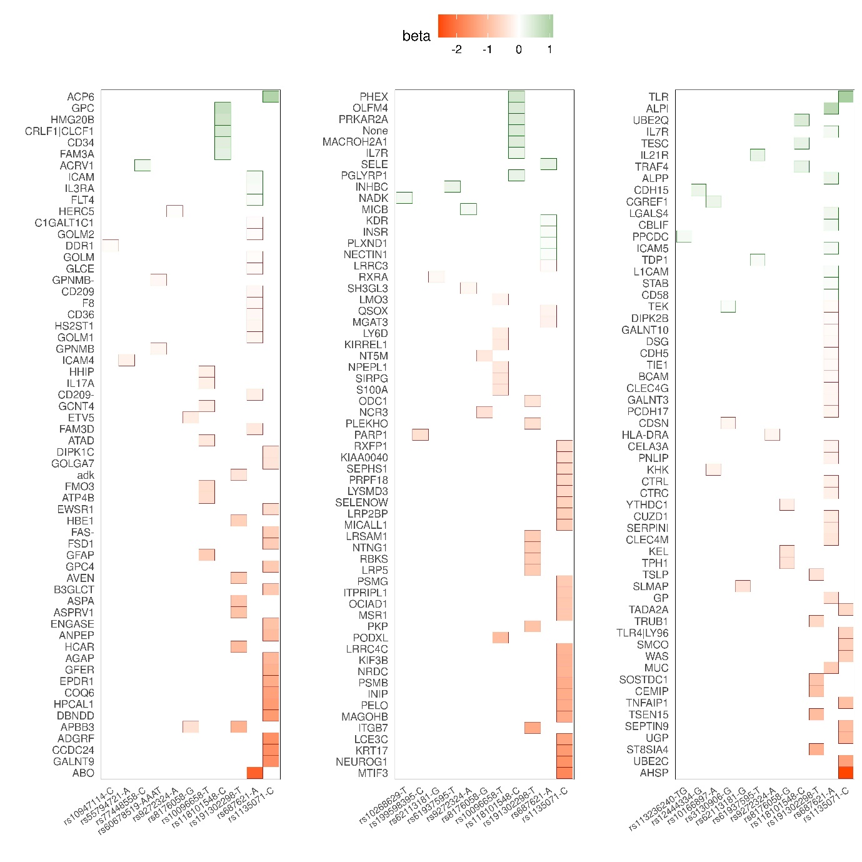
Supplementary Figure 4. Fine-mapped GWAS variants and MHC lead variants (x-axis) significantly associated (FDR<0.05) with 181 protein expression levels in blood donors (y-axis). QTL direction is shown according to the allele enriched in blood donors. All the variants affecting protein levels can be found in more detail in Supplementary file 3.

Supplementary File 3

The file contains three different sheets in one excel file.

Results of protein quantative trait loci
pQTL_sig FDR < 0.05:
Results of significant (FDR < 0.05) protein quantative trait loci of the 41 fine-mapped and 5 MHC lead GWAS variants

String enrichment all
Summary statistics of significant functional enrichments

String enrichment ABO
Summary statistics of significant functional enrichments associated with rs687621-G

Supplementary File 4

The file contains two sheets in one excel file.

Significant labQTL
Significant results (FDR < 0.05)

Mediation analysis
Results of the mediation analysis of the laboratory values in blood donors.

Putative bias caused by red cell antigen enrichment in research setting
Protective association of red cell antigen O to venous thromboembolism (VTE) has been shown previously by multiple studies (see main text for references). To investigate the putative bias an ABO enrichment could cause to a VTE association study, we conducted an association analysis with VTE as an endpoint using chromosome 9 variants by adjusting for imputed ABO antigens. Our results showed that after the adjustment, the p-value of the lead variant failed to reach the genome-wide significance level of 5 x 10⁻⁸ (rs582118 unadjusted p=3.28x10⁻¹¹⁵, ABO adjusted p=1.16x10⁻⁶). The signal was not completely lost as other genome-wide significant variants remained in the region (Supplementary Figure 4A-B). The adjustment not only removed associations of some SNPs but also made visible other variants not detected in the basic analysis (Supplementary Figure 4C).

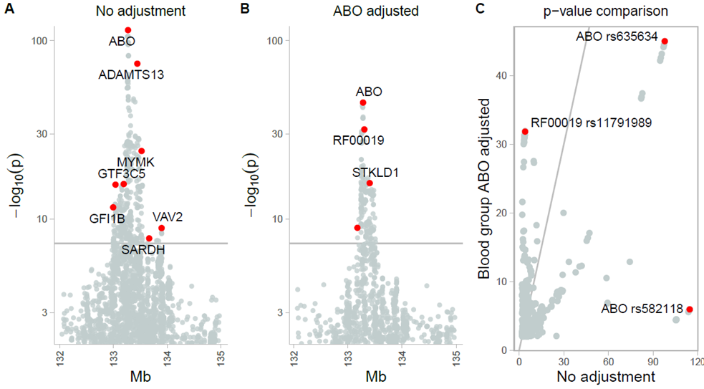

Supplementary Figure 4. Association analysis of venous thromboembolism, VTE. A) VTE association analysis without adjustment. The lead variant is rs582118 in ABO gene. B) VTE association analysis adjusted with ABO red cell antigens. The lead variant is rs635634 in ABO gene. C) P-value comparison of the two VTE association analyses. Covariates: Sex, age, PC1-10, FinnGen genotyping array version, and FinnGen batch information. Number of cases was 19,957 and controls 344,672. The primary analysis was conditioned with imputed ABO red cell antigens. Due to the low PP values of imputed ABO antigens, the number of individuals in the conditioned analysis was following; cases 19,956, controls 344,653.

Supplementary Methods

FinnGen ethics statement
Recruitment protocols followed the biobank protocols approved by Fimea. The Coordinating Ethics Committee of the Hospital District of Helsinki and Uusimaa (HUS) statement number for the FinnGen study is Nr HUS/990/2017. Full list of permits numbers are listed in Supplementary information.The use of the data in the present study is in accordance with the biobank consent and meets the requirements of the Finnish Biobank Act 688/2012. A formal biobank decision 004-2022 for the research project has been granted by the Finnish Red Cross Blood Service Biobank. The use of the FinnGen data has been accepted with FinnGen proposal F_2022_086.
The FinnGen study is approved by Finnish Institute for Health and Welfare (permit numbers: THL/2031/6.02.00/2017, THL/1101/5.05.00/2017, THL/341/6.02.00/2018, THL/2222/6.02.00/2018, THL/283/6.02.00/2019, THL/1721/5.05.00/2019 and THL/1524/5.05.00/2020), Digital and population data service agency (permit numbers: VRK43431/2017-3, VRK/6909/2018-3, VRK/4415/2019-3), the Social Insurance Institution (permit numbers: KELA 58/522/2017, KELA 131/522/2018, KELA 70/522/2019, KELA 98/522/2019, KELA 134/522/2019, KELA 138/522/2019, KELA 2/522/2020, KELA 16/522/2020), Findata permit numbers THL/2364/14.02/2020, THL/4055/14.06.00/2020, THL/3433/14.06.00/2020, THL/4432/14.06/2020, THL/5189/14.06/2020, THL/5894/14.06.00/2020, THL/6619/14.06.00/2020, THL/209/14.06.00/2021, THL/688/14.06.00/2021, THL/1284/14.06.00/2021, THL/1965/14.06.00/2021, THL/5546/14.02.00/2020, THL/2658/14.06.00/2021, THL/4235/14.06.00/2021, Statistics Finland (permit numbers: TK-53-1041-17 and TK/143/07.03.00/2020 (earlier TK-53-90-20) TK/1735/07.03.00/2021, TK/3112/07.03.00/2021) and Finnish Registry for Kidney Diseases permission/extract from the meeting minutes on 4th July 2019.
The Biobank Access Decisions for FinnGen samples and data utilized in FinnGen Data Freeze 12 include: THL Biobank BB2017_55, BB2017_111, BB2018_19, BB_2018_34, BB_2018_67, BB2018_71, BB2019_7, BB2019_8, BB2019_26, BB2020_1, BB2021_65, Finnish Red Cross Blood Service Biobank 7.12.2017, Helsinki Biobank HUS/359/2017, HUS/248/2020, HUS/430/2021 §28, §29, HUS/150/2022 §12, §13, §14, §15, §16, §17, §18, §23, §58, §59, HUS/128/2023 §18, Auria Biobank AB17-5154 and amendment #1 (August 17 2020) and amendments BB_2021-0140, BB_2021-0156 (August 26 2021, Feb 2 2022), BB_2021-0169, BB_2021-0179, BB_2021-0161, AB20-5926 and amendment #1 (April 23 2020) and it´s modifications (Sep 22 2021), BB_2022-0262, BB_2022-0256, Biobank Borealis of Northern Finland_2017_1013, 2021_5010, 2021_5010 Amendment, 2021_5018, 2021_5018 Amendment, 2021_5015, 2021_5015 Amendment, 2021_5015 Amendment_2, 2021_5023, 2021_5023 Amendment, 2021_5023 Amendment_2, 2021_5017, 2021_5017 Amendment, 2022_6001, 2022_6001 Amendment, 2022_6006 Amendment, 2022_6006 Amendment, 2022_6006 Amendment_2, BB22-0067, 2022_0262, 2022_0262 Amendment, Biobank of Eastern Finland 1186/2018 and amendment 22§/2020, 53§/2021, 13§/2022, 14§/2022, 15§/2022, 27§/2022, 28§/2022, 29§/2022, 33§/2022, 35§/2022, 36§/2022, 37§/2022, 39§/2022, 7§/2023, 32§/2023, 33§/2023, 34§/2023, 35§/2023, 36§/2023, 37§/2023, 38§/2023, 39§/2023, 40§/2023, 41§/2023, Finnish Clinical Biobank Tampere MH0004 and amendments (21.02.2020 & 06.10.2020), BB2021-0140 8§/2021, 9§/2021, §9/2022, §10/2022, §12/2022, 13§/2022, §20/2022, §21/2022, §22/2022, §23/2022, 28§/2022, 29§/2022, 30§/2022, 31§/2022, 32§/2022, 38§/2022, 40§/2022, 42§/2022, 1§/2023, Central Finland Biobank 1-2017, BB_2021-0161, BB_2021-0169, BB_2021-0179, BB_2021-0170, BB_2022-0256, BB_2022-0262, BB22-0067, Decision allowing to continue data processing until 31st Aug 2024 for projects: BB_2021-0179, BB22-0067,BB_2022-0262, BB_2021-0170, BB_2021-0164, BB_2021-0161, and BB_2021-0169, and Terveystalo Biobank STB 2018001 and amendment 25th Aug 2020, Finnish Hematological Registry and Clinical Biobank decision 18th June 2021, Arctic biobank P0844: ARC_2021_1001.

Data acquisition
Genotyping, quality control, and genome imputation protocols are described in detail in FinnGen Gitbook (https://finngen.gitbook.io/documentation/). In short, genotype calling was performed with GenCall or zCall algorithm for Illumina and AxiomGT1 algorithm for Affymetrix arrays. Prior the imputation, genotyped samples were pre-phased with Eagle 2.3.5 with the default parameters, except the number of conditioning haplotypes was set to 20,000. Genotype imputation was performed using the population-specific imputation reference panel SISu v4.2 with Beagle 4.1 (version 27Jan18.7e1).
In addition to genome and phenotype data, the following electronic health register data and supplementing data were utilized: KANTA clinical laboratory values, ICD (ICD9 and 10) code for type 1 diabetes, occurrence of venous thromboembolism, age, BMI, sex, region of birth and genetic principal components (PC) 1-10.
Since BMI is a criterium of blood donation, individuals lacking BMI data were excluded. Furthermore, as 18 is the minimum age of blood donation, individuals under this age were excluded. Individuals born in regions in Finland that were ceded to Soviet Union were excluded due to small number of individuals, age structure of the region, and the maximum blood donation age of 70 years.

Association analysis and fine-mapping
For each fine-mapped locus we accepted the credible set as an independent hit if the strongest primary p-value was p < 5 x 10⁻⁸. In case multiple credible sets within a single locus were found, we required genome-wide significance and log₁₀(Bayes factor) > 2. As the MHC region is excluded from the fine-mapping pipeline due to its strong LD, four MHC lead variants from the T1D adjusted association analysis were selected for downstream analyses: rs9968910, rs10947114, rs3130906 and rs4713637.
Association analyses with the blood donor endpoint for all the covariates used in GWAS and the imputed blood groups were performed with logistic regression in R. We further analyzed the associations of all the covariates used in GWAS and the imputed blood group antigens with the lead variants in chromosomes 1 (rs55794721), 7 (rs8176058) and 9 (rs687621) by using linear regression.
Association testing of each classical HLA-allele HLA-A, -B, -C, -DRB1, -DQA1, -DQB1, DPB1 and HLA-DRB3-5 with the blood donor endpoint was performed using Regenie v3.0.1. First, a sparse genotype data set for fitting Regenie null models (https://rgcgithub.github.io/regenie/options/) was generated with Plink2 v2.00a4LM using FinnGen DF12 HapMap3 variants as a basis, and randomly thinning the variants to approximately 500,000 with further filtering for minor allele frequency at least 0.1, Hardy-Weinberg equilibrium p-value > 1 x 10⁻¹⁵ and minimum allele count at least 100. Second, the Regenie null models were fitted on the filtered genotype data and used in the following association step. To dissect the HLA signal further, two additional association tests were performed: i) conditioning for the GWAS chromosome 6 lead variant rs9272324 and ii) conditioning for the HLA-allele with the strongest association, HLA-DRB1*04:01, in the primary HLA association analysis.
Since both the GWAS lead variant rs687621 in chromosome 9 and the red cell antigen ABO have previously been reported to be strongly associated with venous thromboembolism⁴⁵(VTE), we studied whether ABO enrichment in the blood donor pool and the lead variant associate independently with VTE. To this end, we conducted an association analysis of chromosome 9 in FinnGen pipeline using Regenie (https://github.com/FINNGEN/regenie-pipelines) v2.2.4 with FinnGen venous thromboembolism as the binary endpoint. Sex, age, PC1-10, FinnGen genotyping array version, and FinnGen batch information were used as covariates, as well as imputed ABO red cell antigens. After filtering out 20 individuals based on low posterior probability of the imputed ABO antigens, 19,956 cases and 344,653 controls remained in the conditional analysis.

Genetic correlation
All pair-wise genetic correlations between blood donorship and all the 2470 phenotypes previously studied as part of FinnGen study were computed using LD Score Regression v1.0.1 using Finnish LD panel in FinnGen pipeline (https://github.com/FINNGEN/)⁴⁸. The computation was based on the GWAS summary statistics previously obtained using Regenie for each phenotype. We used the Benjamini-Yekutieli method to control FDR of genetic correlation at the level of 0.05. Genetic correlation between groups of phenotypes was approximated as the average of all the pair-wise genetic correlations between the groups.

HLA and blood group imputation
The alleles of the classical HLA genes, HLA-A, -C, -B, -DRB1, DRB3-5, -DQA1, -DQB1, and -DPB1, were previously imputed at four-field resolution (defining protein sequence variation) in FinnGen using HIBAG⁴⁹ algorithm with population-specific reference panel, as reported earlier⁵⁰. The dosage value of each HLA-allele was used in downstream analyses.
Altogether 37 red blood cell antigens in 14 different blood group systems were imputed using population-specific random forest models as described by Hyvärinen et al⁵¹. P1, A1 and A2 antigens were excluded from downstream analyses due to uncertain frequency at the population level. In addition, blood group antigens HrS and HrB, occurring mainly in African population, are in high correlation with the blood group antigen e and have low clinical significance (consultation with an expert at the Finnish Red Cross Blood Service), hence they were excluded from further analyses. After imputation, the samples were categorized based on the posterior probability, PP, value; samples with PP < 0.5 were considered as antigen negative and samples with PP ≥ 0.5 were considered as antigen positive. Altogether 13 individuals were excluded from downstream blood group related analyses due to all PP values in ABO being < 0.5.

QTL analysis
Proteomics data were previously generated in FinnGen on blood donors using multiplex antibody-based immunoassay (Olink) and multiplex aptamer-based immunoassay (SomaScan)⁵². We analyzed protein QTLs by performing an association analysis between 46 GWAS lead variants and protein expression data using glm function of Plink2 v2.00a4LM. Age, sex, sampling year and PC1-10 were used as covariates in the association analysis, and first-degree relatives were removed. To evaluate the enrichment of the associated proteins in functional processes, we used STRING interaction network and functional enrichment analysis tool²⁵.
We also analyzed metabolite level data produced by Nightingale NMR platform (https://research.nightingalehealth.com/) in FinnGen. The data were preprocessed by selecting variables that were common between all available data files, removing duplicated sample IDs, and removing variables with >500 missing entries. The association analysis between cleaned NMR data and lead GWAS variants was performed as described above for proteomics.
The KANTA clinical laboratory test data in FinnGen spans from 2014 to 2023, as detailed in the FinnGen documentation (https://finngen.gitbook.io/finngen-handbook). Laboratory values were extracted for each individual in this study, comprising 53,688 blood donors and 228,060 controls. Missing values were excluded, retaining measurements with n > 100,000. The data were then cleaned by removing measurements > 5 standard deviations from the population mean. To obtain a single value per variable for each individual, we computed the geometric mean over time. To account for temporal changes in lab values, we also calculated the slope for each variable and individual. Finally, each variable was transformed into a standard normal distribution using quantile normalization.
We tested the associations of the 46 GWAS lead variants with the laboratory values using continuous regression analysis, adjusting for age, sex, sampling year, and PC1-10 as covariates using the glm function in Plink2. Laboratory values with a significant QTL (FDR < 0.05) were included in follow-up analyses. For mediation analysis⁵³, we selected significant labQTLs limiting to the smallest p-value per each KANTA lab value, and included both the SNP and the corresponding KANTA lab value as independent variables in a logistic regression model of blood donorship. We accepted lab value associations reaching FDR < 0.05, indicating that these values associate with blood donorship when adjusted for their QTL SNPs. To further validate the causal effect of each GWAS lead variant on KANTA laboratory values, we employed the Sobel mediation test⁵⁴ using the R package bda v18.3.2, accepting FDR < 0.05.

Supplementary Table 4

List of FinnGen Consortium members

