Extended Data Fig. 1

Extended Data Fig. 1
P-wave velocity model from seismic refraction survey.
a, Bathymetric map of the study area. The solid red line is the seismic refraction survey line and the orange circles represent the OBSs. b, P-wave velocity model along the survey line determined using first-arrival tomography. The contour interval is 0.5 km/s and is annotated every 1.0 km/s. Area deeper than the ray path coverage were masked. c, All ray paths used in first-arrival tomography. d, Travel time misfit (difference between observed and synthetic travel times) for each pick data from OBSs in the final first-arrival tomography model. The vertical axis represents the OBS number and the horizontal axis represents the distance along the survey line.

Extended Data Fig. 2

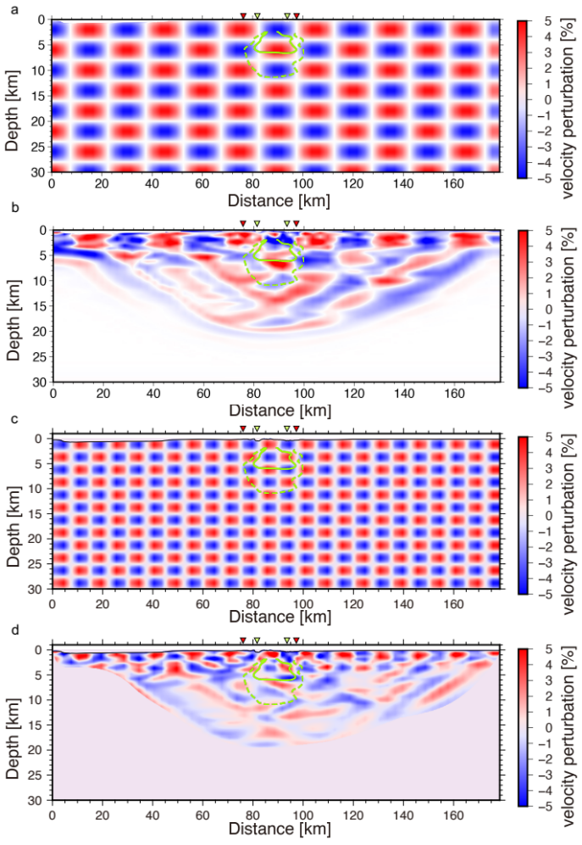

Extended Data Fig. 2
Chequerboard resolution test (CRT).
The horizontal axis represents the distance along the survey line from the westernmost shot point, and the vertical axis represents the depth. The upper figure shows the synthetic chequerboard patterns (±5% velocity perturbation pattern) given to the final model of the first-arrival tomography and the lower figure shows the recovery of the chequerboard patterns after the CRT. The pattern sizes were as follows: a, 15 km (horizontal) and 4 km (vertical), b, 7.5 km (horizontal) and 2.5 km (vertical). The green solid line shows the area of the magma reservoir identified in this study and the green dashed line shows the melt zone. The positions of the outer caldera and the two ends of the central lava dome are indicated by red and yellow-green inverted triangles, respectively.

Extended Data Fig. 3

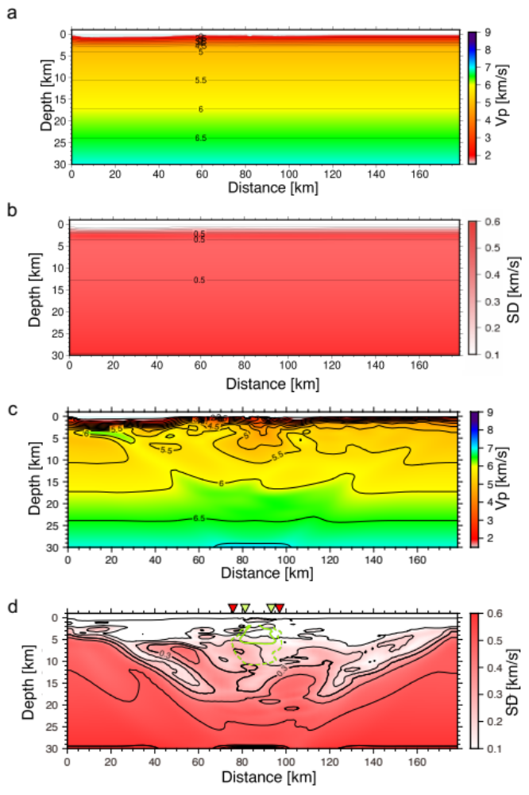

Extended Data Fig. 3
Monte Carlo type uncertainty analysis.
This analysis was performed to evaluate how the tomographic Vp model depends on the initial models. The following procedure was used. First, 500 starting models were randomly generated. Second, each starting model was used for first-arrival tomography to obtain the final Vp model. Then, the average and standard deviation of the 500 final Vp models were calculated. a, Average of 500 starting Vp models. b, Standard deviation of the 500 starting Vp models. c, Average of the 500 final Vp models, which shows the same characteristics, such as a low Vp below the caldera, as the final Vp model of Fig. 1b. d, Standard deviation of the 500 final Vp models. The contour interval is 0.1 km/s and the contour line of 0.3 km/s is highlighted as a thick line. The green solid line shows the area of the magma reservoir identified in this study and the green dashed line shows the melt zone. The positions of the outer caldera and the two ends of the central lava dome are indicated by red and yellow-green inverted triangles, respectively.

Extended Data Fig. 4

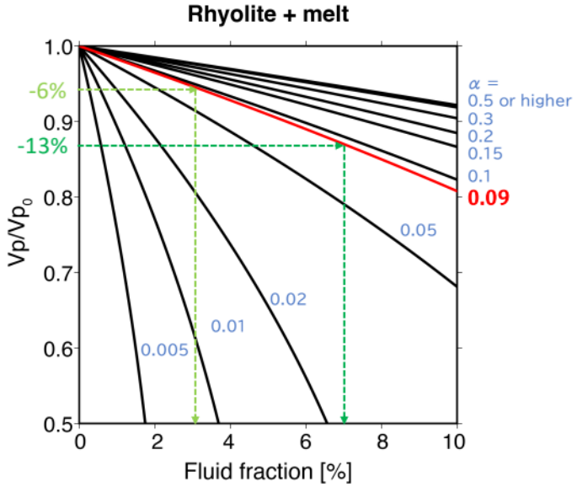

Extended Data Fig. 4
Normalised P-wave velocity (Vp/Vp₀) and melt volume fraction for different aspect ratios.
This plot represents for a composite of rhyolite and its melt is based on the formula derived by Takei (2002). Bulk and shear moduli and density are taken to be K = 39.8 GPa, G = 30.2 GPa, ρ= 2371 kg/m³ for rhyolite ²³ and k_{f} = 13 GPa, g_{f} = 0 GPa, ρ_{f} = 2290 kg/m³ for rhyolite melt ²⁴. This plot allows us to estimate the melt fraction from the velocity reduction rate at a melt aspect ratio of 0.09 (red line), for example the melt fractions corresponding to 6% and 13% velocity reduction were estimated to be 3% (light green dashed lines with arrows) and 7% (dark green dashed lines with arrows) respectively.

Extended Data Table 1

Extended Data Table 1
Parameters for temperature estimation.

$${\left.\frac{d\ln{v_{p}}}{dT}\right|}_{anharmonic}$$ | -8.1$×{10}^{-5} K^{-1}$ | Temperature derivative of P-wave velocity
$$H_{Q}^{*}$$ | 276 | Activation energy
$$R$$ | 8.31 | Gas constant
$$Q$$ | 100 | Attenuation coefficient
$$\frac{dT}{dz}$$ | 30 $K$/km, 40 $K$/km, 50 $K$/km | Background geothermal gradient

These parameters were used to estimate temperatures from low-velocity anomalies beneath the Kikai Caldera Volcano. These values were based on temperature estimates from the low-velocity anomaly beneath Santorini Volcano ⁶. As the background geothermal gradient was expected to vary significantly from region to region, a general gradient of 30 K/km to a higher gradient of 50 K/km was used, but no significant differences were found.

