Supplemental Materials for
Carbonate-Capped Seamount Subduction Accelerates CO₂-Rich Arc Magma Ascent: Insights from Pagan Volcano, Mariana Arc
X.H. Huang^{1,2}, A.Y. Yang^{1*}, M.D. Sun¹, W. Tan¹, Y. Tamura³, S.Y. Zhao^{1,4} and T.P. Zhao¹
¹State Key Laboratory of Deep Earth Processes and Resources, Guangzhou Institute of Geochemistry, Chinese Academy of Sciences, Guangzhou 510640, Guangdong, China
²College of Earth and Planetary Sciences, University of Chinese Academy of Sciences, Beijing 100049, China
³Research Institute for Marine Geodynamics, Japan Agency for Marine-Earth Science and Technology, Yokosuka 237-0061, Japan
⁴Department of Earth and Planetary Sciences, Harvard University, Cambridge, MA 02138, USA
*Corresponding author. Email: yangyang@gig.ac.cn (A.Y.Y.)
This PDF file includes:
Fig. S1 to S15
Captions for Table S1-8
Supplemental materials reference list

Supplemental figure
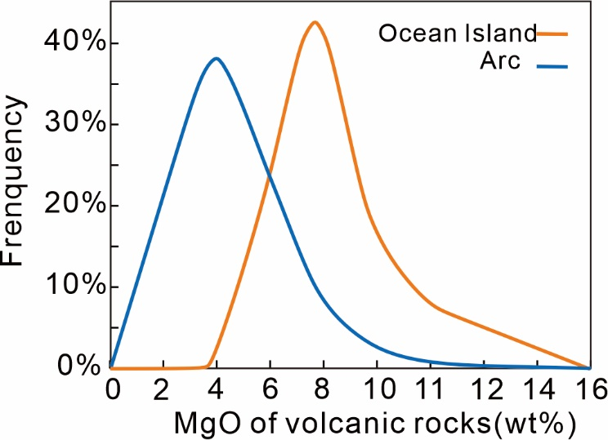
Fig. S1 Frequency distribution of MgO (wt.%) in ocean island volcanic rocks (orange) and arc volcanic rocks (blue). Approximately 80% of ocean island volcanic rocks have MgO > 6 wt.%, while only about 16% of arc volcanic rocks have MgO > 6 wt.%. The whole-rock data for arc volcanic rocks are compiled from ref.¹, and the data for ocean island volcanic rocks are sourced from ref.².
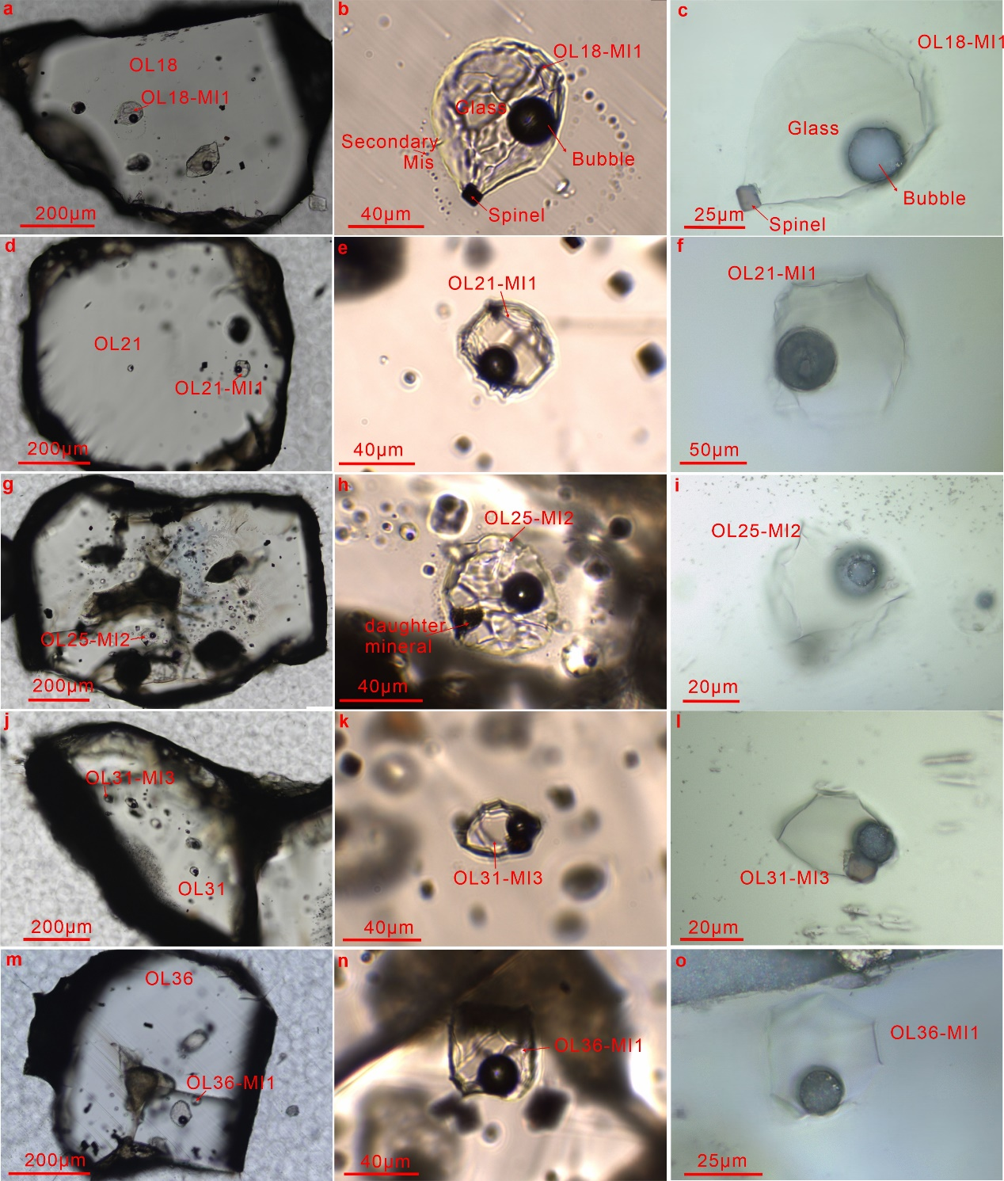
Fig. S2 Photomicrographs of reheated olivine crystals (OL18, OL21, OL25, OL31, OL36) containing only one melt inclusions (MIs) with detectable CO₂ in bubbles. a, d, g, j, m Glassy, bubble-bearing MIs hosted in olivine crystals from basalt erupted by Pagan volcano, shown under transmitted light. b, e, h, k, n These MIs commonly exhibit a "wrinkled" texture, with daughter minerals and spinel inclusions frequently observed in larger inclusions (~80 µm or more). c, f, i, l, o The corresponding polished mis viewed under reflected light. Note the presence of melt inclusions OL18-MI1 and OL25-MI2 surrounded by secondary inclusions in panels b and h. However, their compositions do not show abnormal volatile loss.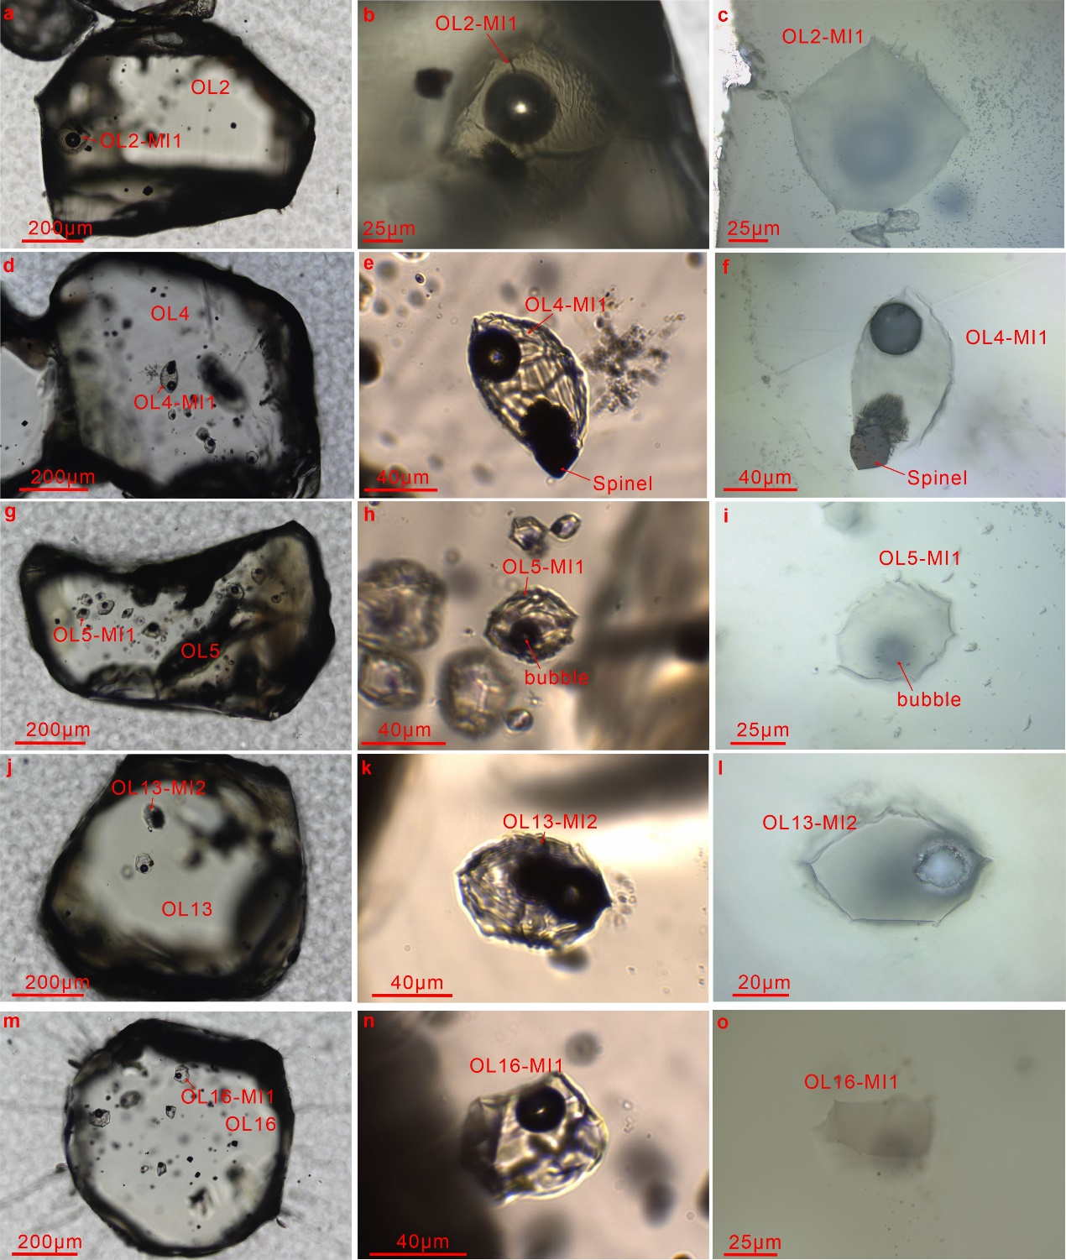
Fig. S3 Photomicrographs of reheated olivine crystals (OL2, OL4, OL5, OL13, OL16). a, d, g, j, m, b, e, h, k, n Glassy, bubble-bearing MIs hosted in olivine crystals from basalt erupted by Pagan volcano, shown under transmitted light. c, f, i, l, o Corresponding MIs viewed under reflected light.
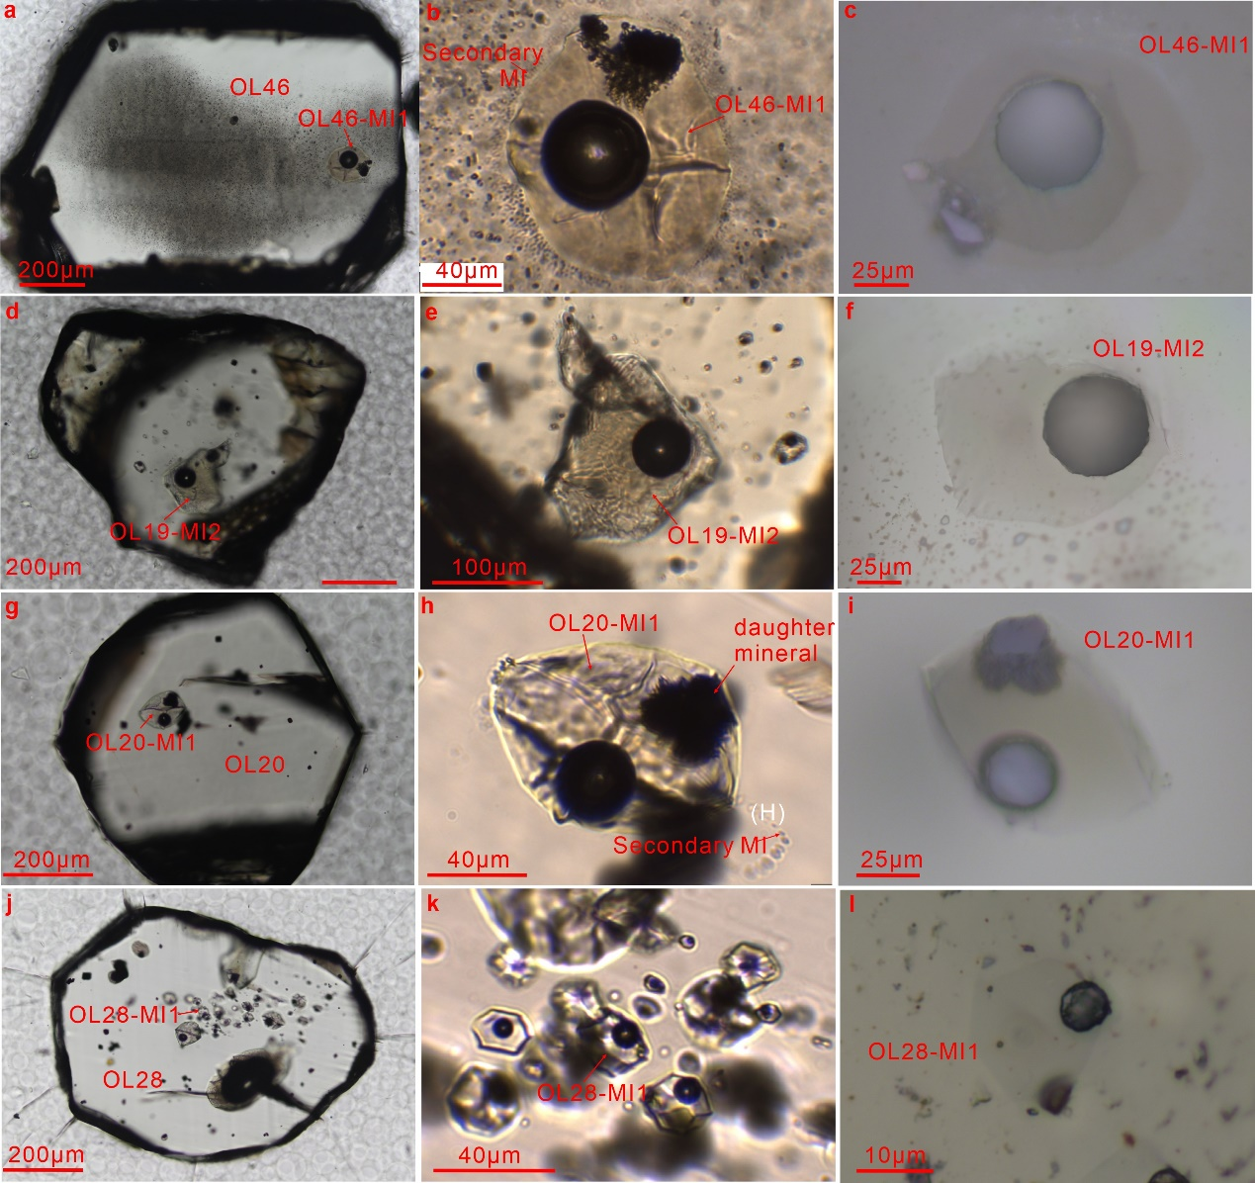
Fig. S4 Photomicrographs of reheated olivine crystals (OL46, OL19, OL20, OL28). a, b, d, e, g, h, j, k Glassy, bubble-bearing MIs hosted in olivine crystals from basalt erupted by Pagan volcano, shown under transmitted light. c, f, i, l Corresponding MIs viewed under reflected light.
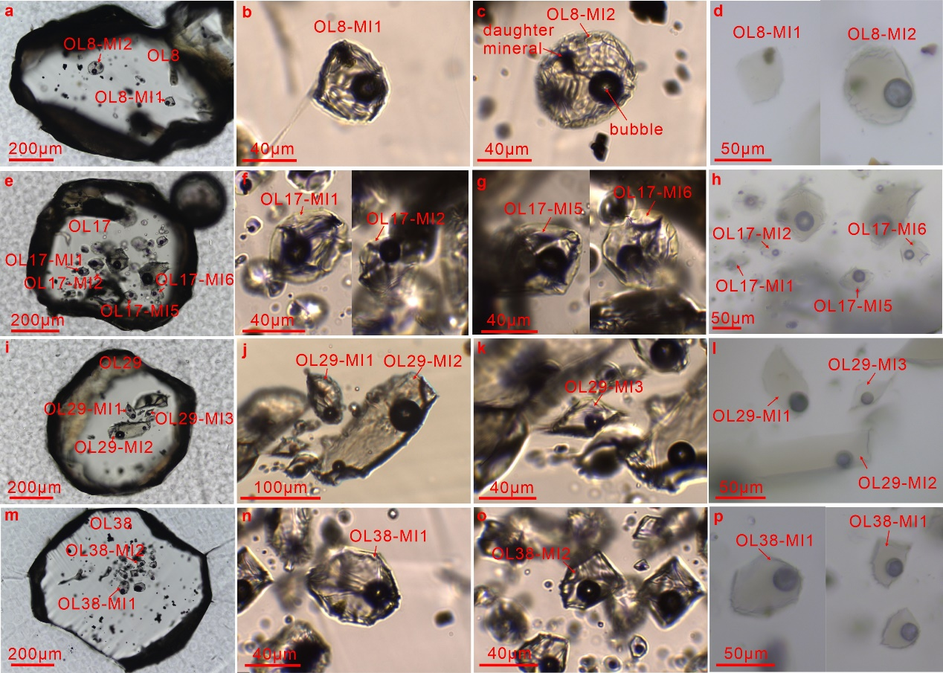
Fig. S5 Photomicrographs of olivine crystals (OL8, OL17, OL29, OL38) containing multiple melt inclusions (MIs) with detectable CO₂ in bubbles. a, b, c, e, f, g, I, j, k, m, n, o Glassy, bubble-bearing MIs hosted in olivine crystals from basalt erupted by Pagan volcano, shown under transmitted light. d, h, l, p Corresponding polished mis viewed under reflected light.

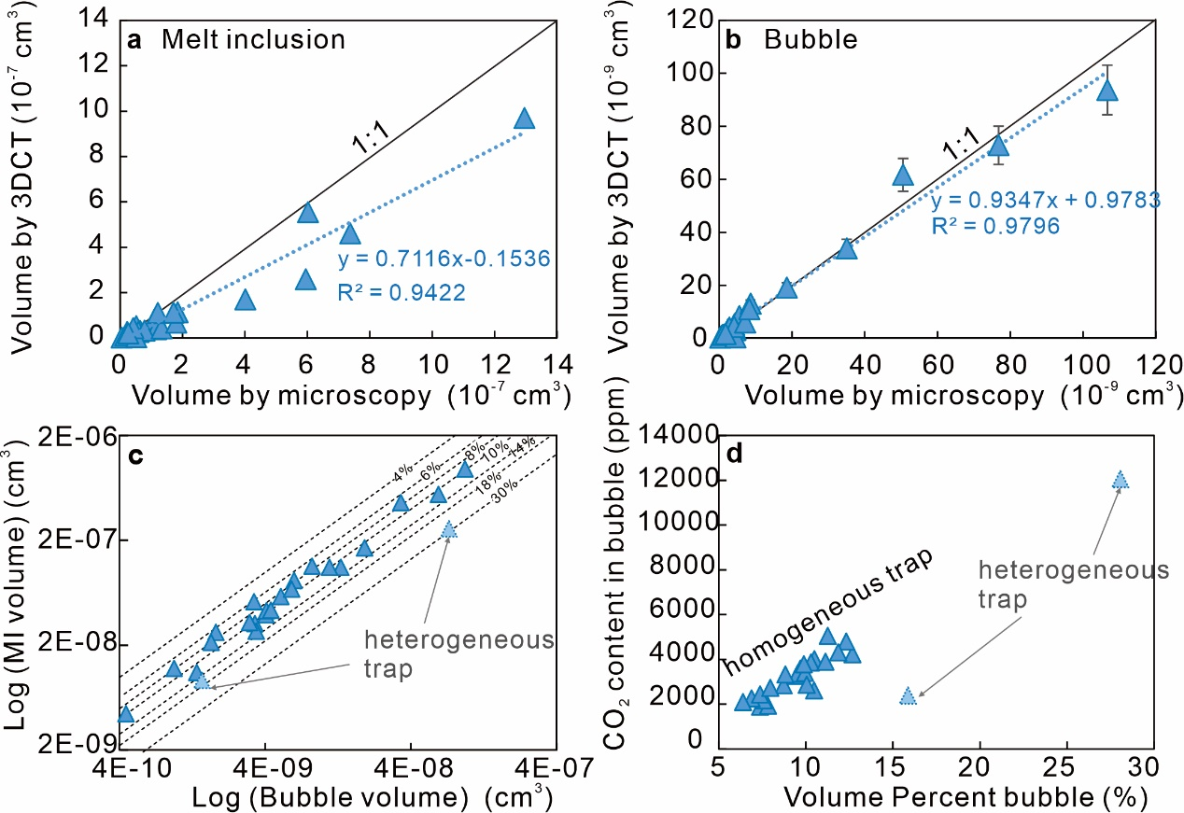
Fig. S6 Volume of melt inclusions and shrinkage bubbles determined by 3D X-ray micro-computed tomography (3DCT) and optical measurement under a microscope. a Volume determined by microscope versus volume determined by 3DCT of melt inclusions (glass plus bubbles). b Volume determined by microscope versus volume determined by 3DCT of bubbles. Note that the error bars for volume determined by 3DCT of melt inclusions are smaller than the symbol size in panel a. c MI volume vs. vapor bubble volume. d the CO₂ contents in bubbles of MI vs. the volume proportion of bubble in MI. Dashed lines are bubble volume percent.
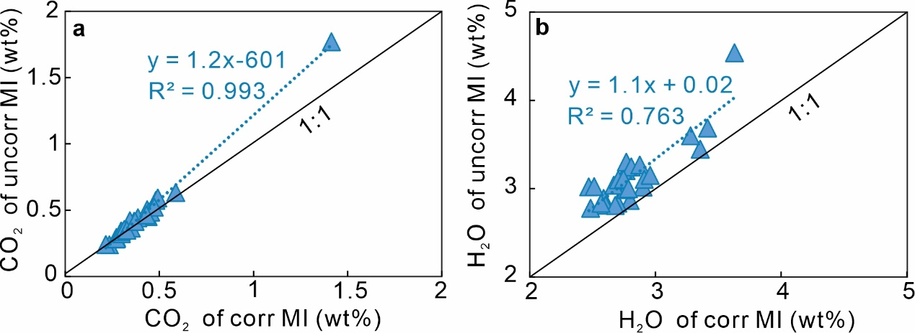
Fig. S7 Comparison of volatile contents in melt inclusions after PEC and Fe loss correction versus uncorrected inclusions. a CO₂ contents. b H₂O contents. Formula and R-squared value suggest the corrected H₂O and CO₂ contents are slightly lower than uncorrected values.
Fig. S8 Variation of geochemical data in melt inclusions and hosting olivines from Pagan. a H₂O in melt inclusions versus MI volume. b H₂O versus K₂O in melt inclusions. c H₂O in melt inclusions versus Fo content of hosting olivine. d NiO versus Fo content variation of host olivine. Previous studies of melt inclusions at Pagan (Grey squares) are from ref.^{3, 4}. All data are corrected for PEC and Fe loss by MIMiC from ref.⁵. The degassing and crystal fractionation model in (b) was from ref.⁶. Crystallization trend in c is from ref.⁷.
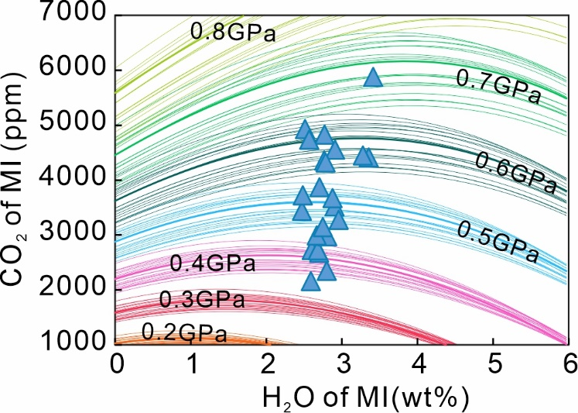
Fig. S9 Isobars for representative of the full major element compositional diversity of the melt inclusion suite at Pagan in this study. The heavy lines represent the isobars shown in Table 3. Temperature calculated from the melt inclusion MgO content using the thermometer of eq. 4 from ref.⁸, shown in Table S2.
Fig. S10 Data and model fits for Lines 2-5. a, d, g, j Backscattered electron (BSE) image of the analyzed olivine crystals with the locations of the EPMA profiles (red line). b, e, h, k EPMA profile of Fo (red dots). c, f, i, l EPMA profile of Ni (yellow dots) and Mn (blue dots). Inset is an equal area pole figure of the crystal showing the orientation of the main crystallographic axes (black diamonds) relative to the profile (black dot). The timescale shown is the median crystal residence time obtained from DIPRA⁹. Initial conditions are shown in Supplemental Table S8.
Fig. S11 Data and model fits for Line 6-10. Caption the same as Fig. S11.
Fig. S12 Data and model fits for Line 11-15. Caption the same as Fig. S11.
Fig. S13 Data and model fits for Line 16-20. Caption the same as Fig. S11.
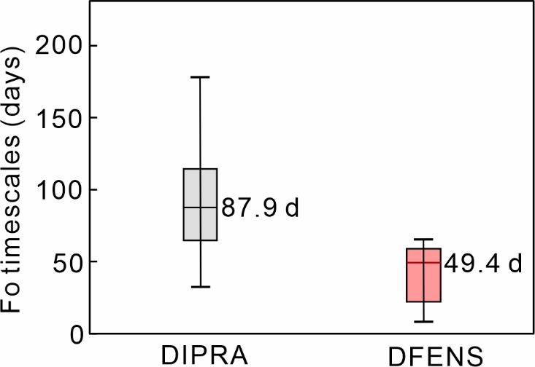
Fig. S14 Comparison of Fo timescale distributions obtained from DIPRA and DFENS. The median timescale is lower in DFENS (49.37 days, with an uncertainty range of -15.68 to +23.93 days) compared to DIPRA (87.96 days, with an uncertainty range of -37.75 to +49.79 days). The interquartile range (IQR) is also smaller in DFENS (36.64 days vs. 49.19 days), indicating a more concentrated distribution. DIPRA exhibits a greater spread, as reflected by a higher standard deviation (50.74 days for DIPRA vs. 40.81 days for DFENS).
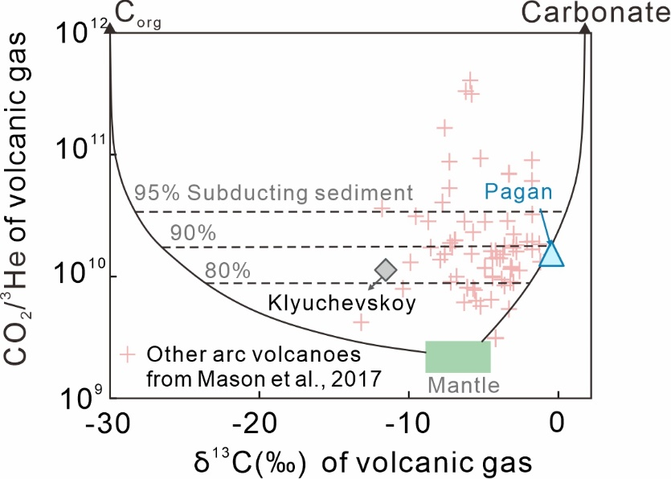
Fig. S15 C–He mixing relationships of volcanic-arc gases for Pagan and other arc volcanoes. Modified from ref.¹⁰. Model end members of the upper mantle, organic carbon and carbonate are from ref.¹¹. Black curves show mixing among the end members, while dashed lines indicate the percentage contribution of carbon released from the subducted slab in the sub-arc mantle source. Gas data of Pagan volcano from ref.¹², and Klyuchevskoy volcano from ref.¹³. Pink crosses represent gas data with minimal crustal contributions at arc volcanoes from compilation of ref.¹⁴. The volcanic gas data of Pagan and Klyuchevskoy volcanoes indicate that 90% and 86% of the carbon in the gas, respectively, is derived from subducted components.

Data Sets S1-S7. (in Separate Excel files)
Supplementary Table S1. Chemical compositions and volumes of melt inclusions and their host olivines from Pagan volcano.
Supplementary Table S2. Melt compositions corrected for PEC/PEM and Fe–Mg diffusion using MIMiC.
Supplementary Table S3. Results of pressure estimates based on volatile contents in melt inclusions, calculated using MagmaSat in VESIcal and MafiCH.
Supplementary Table S4. Chemical compositions of standard samples.
Supplementary Table S5. Pressure calculated from published volatile data in melt inclusions (glass+bubble) of Klyuchevskoy by Magamsat in VESIcal, after PEC corrections.
Supplementary Table S6. Compilation of experimental partial melts from CO₂-poor and CO₂-bearing peridotites.
Supplementary Table S7. Complete electron microprobe dataset for all olivine traverses from Pagan volcano, along with model conditions and results from DIPRA and DFENS simulations.
Supplementary Table S8. Estimates of carbon influx and outflux in the Mariana subduction zone system.
References
1. Zhao S-Y, Yang AY, Langmuir CH, Zhao T-P. Oxidized primary arc magmas: Constraints from Cu/Zr systematics in global arc volcanics. Science Advances 8, eabk0718 (2022).
2. Arevalo R, McDonough WF, Luong M. The K/U ratio of the silicate Earth: Insights into mantle composition, structure and thermal evolution. Earth and Planetary Science Letters 278, 361-369 (2009).
3. Kelley KA, et al. Mantle Melting as a Function of Water Content beneath the Mariana Arc. Journal of Petrology 51, 1711-1738 (2010).
4. Brounce MN, Kelley KA, Cottrell E. Variations in Fe3+/∑Fe of Mariana Arc Basalts and Mantle Wedge fO2. Journal of Petrology 55, 2513-2536 (2014).
5. Rasmussen DJ, Plank TA, Wallace PJ, Newcombe ME, Lowenstern JB. Vapor-bubble growth in olivine-hosted melt inclusions. American Mineralogist 105, 1898-1919 (2020).
6. Lloyd AS, Plank T, Ruprecht P, Hauri EH, Rose W. Volatile loss from melt inclusions in pyroclasts of differing sizes. Contributions to Mineralogy and Petrology 165, 129-153 (2013).
7. Tamura Y, et al. Mission Immiscible: Distinct Subduction Components Generate Two Primary Magmas at Pagan Volcano, Mariana Arc. Journal of Petrology 55, 63-101 (2014).
8. Putirka KD. Thermometers and Barometers for Volcanic Systems. Reviews in Mineralogy and Geochemistry 69, 61-120 (2008).
9. Girona T, Costa F. DIPRA: A user-friendly program to model multi-element diffusion in olivine with applications to timescales of magmatic processes. Geochemistry, Geophysics, Geosystems 14, 422-431 (2013).
10. Kagoshima T, Sano Y, Takahata N, Maruoka T, Fischer TP, Hattori K. Sulphur geodynamic cycle. Scientific Reports 5, 8330 (2015).
11. Sano Y, Marty B. Origin of carbon in fumarolic gas from island arcs. Chemical Geology 119, 265-274 (1995).
12. Hilton D, Fischer T, Hauri E, Shaw A. Controls on the He C systematics of the Izu-Bonin-Marianas (IBM) subduction zone. Geochimica Et Cosmochimica Acta - GEOCHIM COSMOCHIM ACTA 70, (2006).
13. Taran YA, Rozhkov AM, Serafimova EK, Esikov AD. Chemical and isotopic composition of magmatic gases from the 1988 eruption of Klyuchevskoy volcano, Kamchatka. Journal of Volcanology and Geothermal Research 46, 255-263 (1991).
14. Mason E, Edmonds M, Turchyn AV. Remobilization of crustal carbon may dominate volcanic arc emissions. Science 357, 290-294 (2017).

