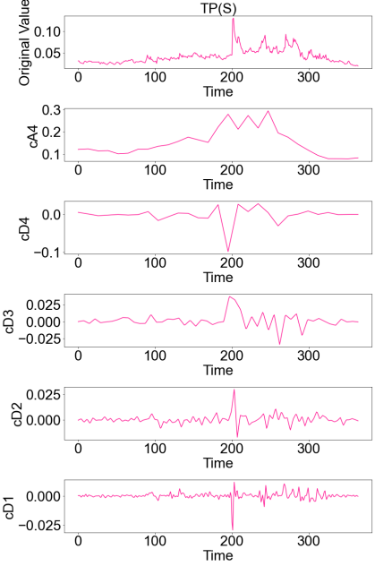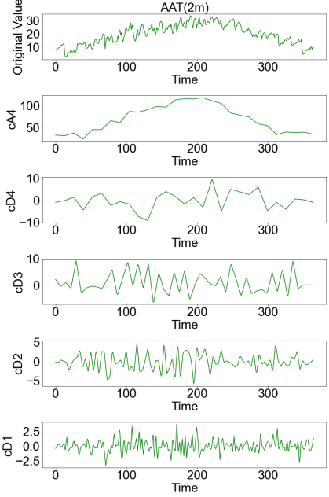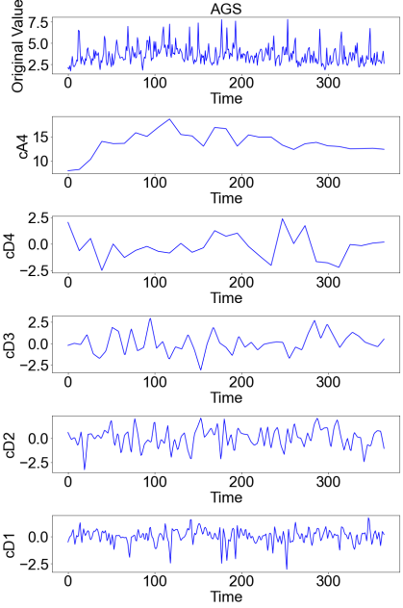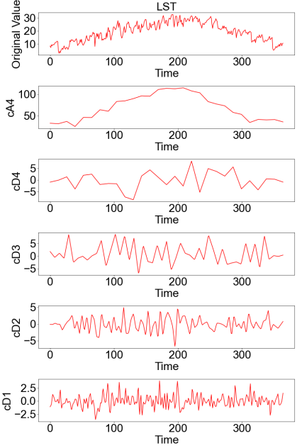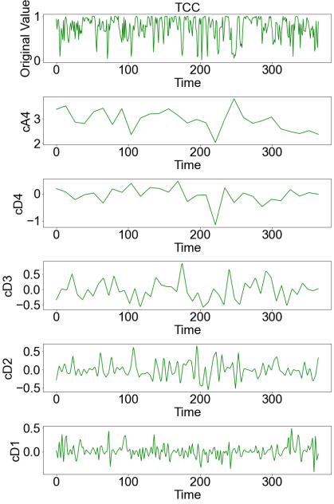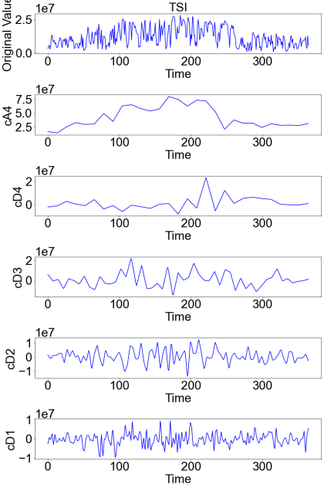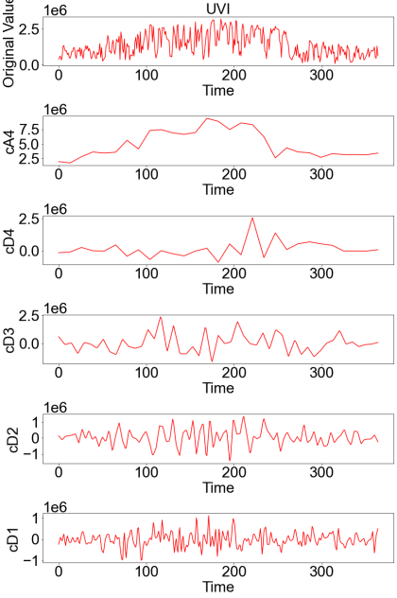
Fig.S1 Wavelet component plot of TP(S), AAT(2m), AGS, LST, TCC, TSI, UVI
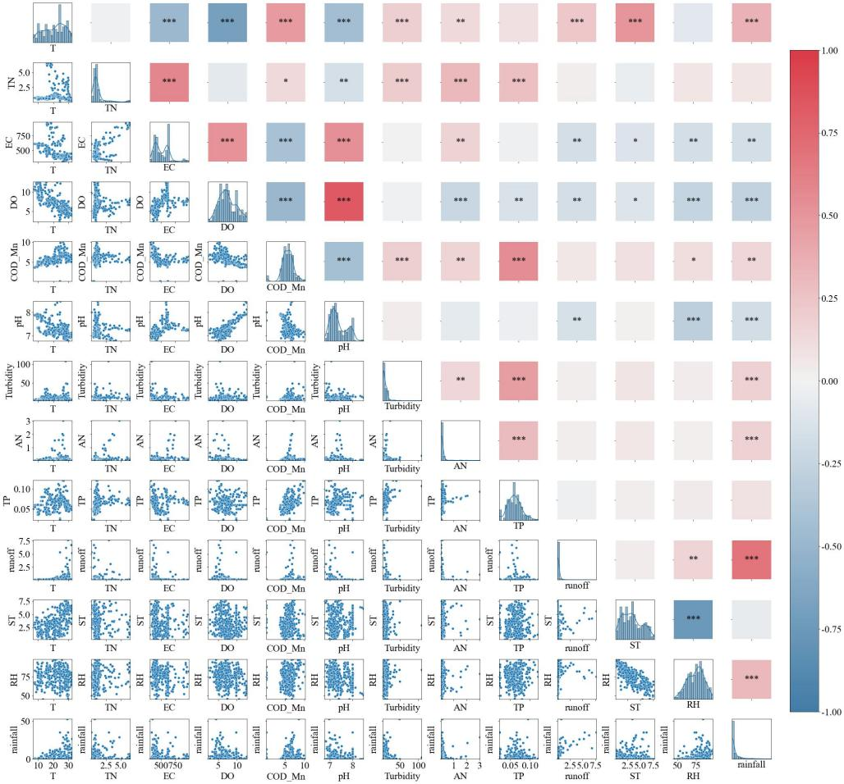
Fig.S2 Pearson correlation results for the raw data of Wandang
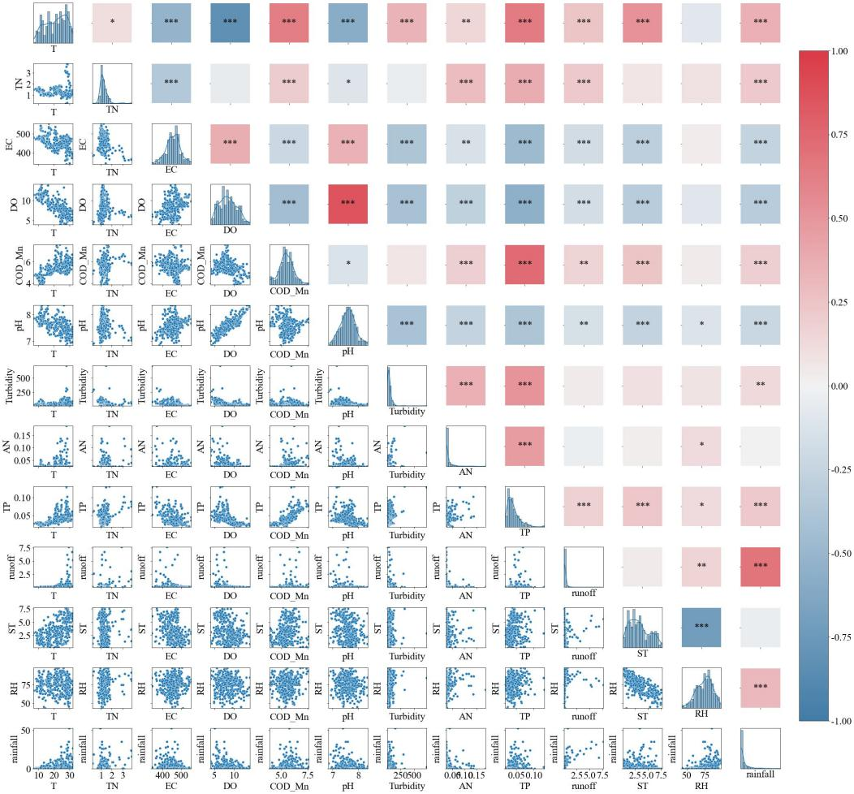
Fig.S3 Pearson correlation results for the raw data of Siming
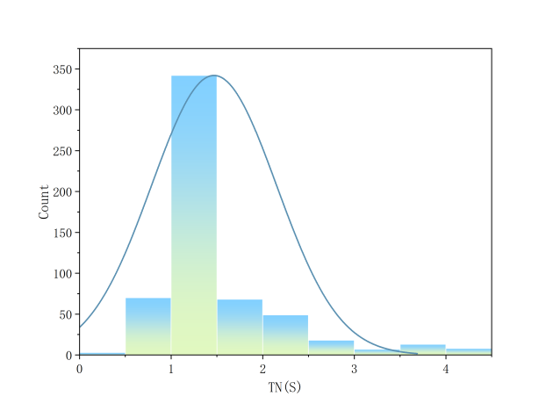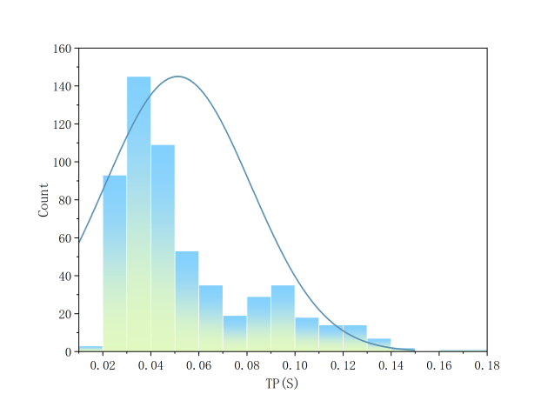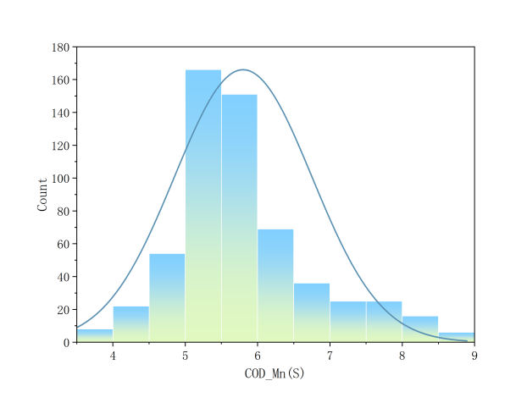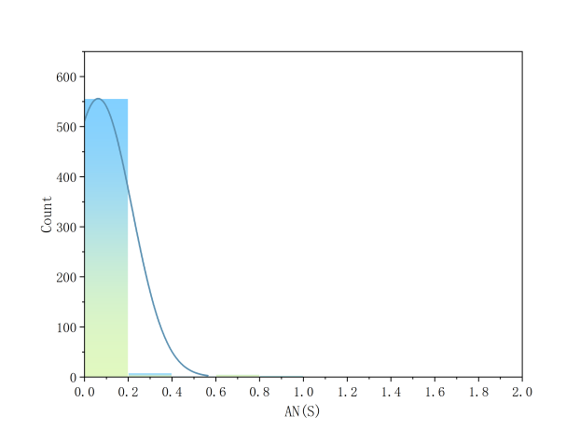
Fig.S4 Frequency histogram of TN(S)、TP(S)、COD_{Mn}(S)、AN(S)

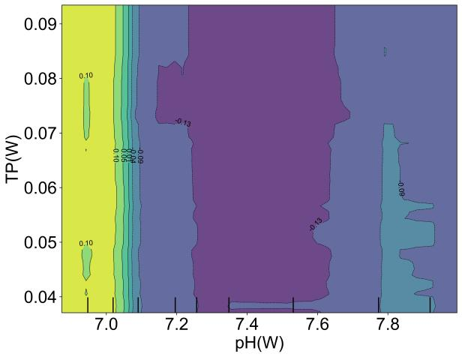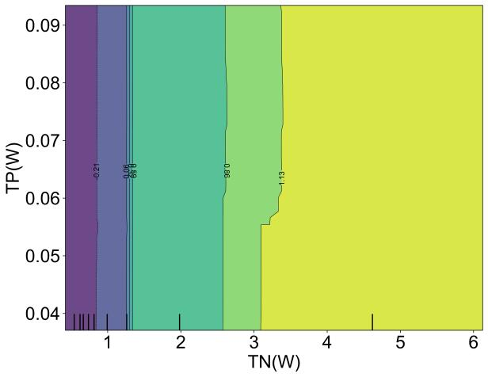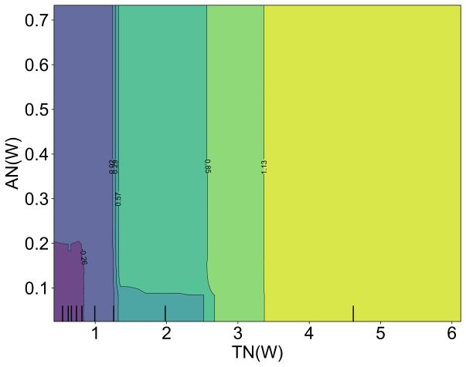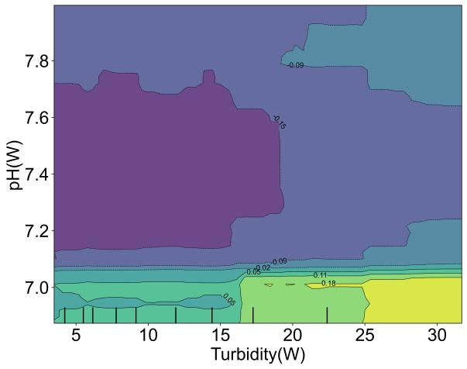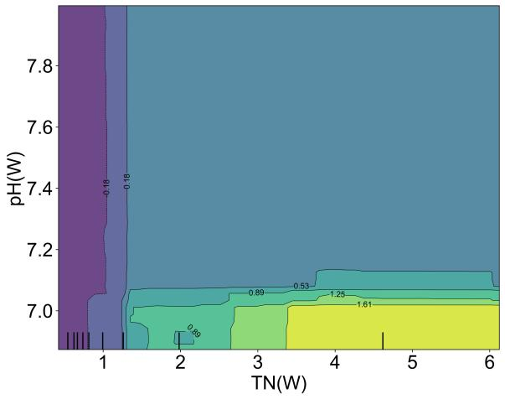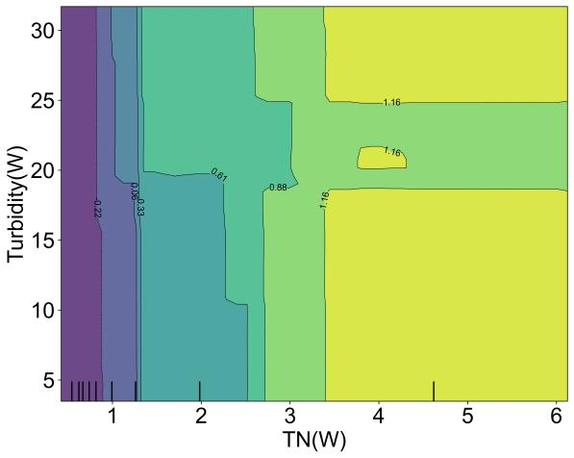
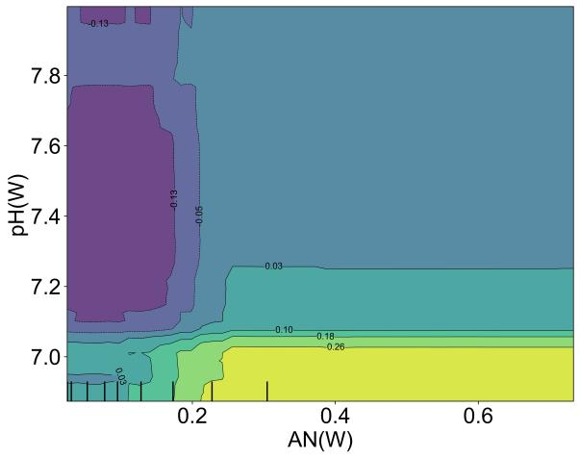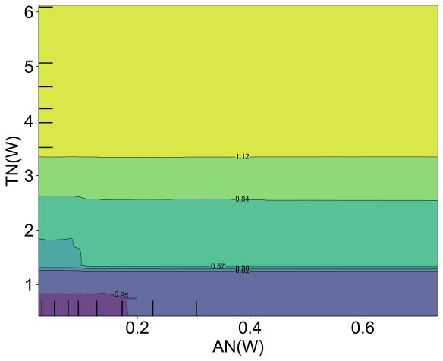
Fig.S5 PDP charts for different combinations

Table S1 Statistical table of data from the Wandang site of the training set
Factor categories | Specific indicator | Unit | Average | Median | Mode | Standard deviation | Variance | Min | Max
Water quality factors | T(W) | ℃ | 20.58 | 21.62 | 24.26 | 6.83 | 46.61 | 6.93 | 32.46
Water quality factors | pH(W) | / | 7.35 | 7.26 | 8.00 | 0.38 | 0.15 | 6.75 | 8.47
Water quality factors | DO(W) | mg/L | 7.63 | 7.03 | 9.73 | 2.82 | 7.97 | 2.22 | 15.85
Water quality factors | EC(W) | μS/cm | 509.90 | 494.74 | 616.27 | 133.82 | 17907.28 | 218.24 | 986.12
Water quality factors | Turbidity(W) | NTU | 12.84 | 8.24 | 14.41 | 15.44 | 238.44 | 0.41 | 217.90
Water quality factors | COD_{Mn}(W) | mg/L | 5.72 | 5.64 | 6.18 | 1.47 | 2.17 | 0.25 | 10.14
Water quality factors | AN(W) | mg/L | 0.26 | 0.09 | 0.03 | 0.68 | 0.46 | 0.03 | 5.29
Water quality factors | TP(W) | mg/L | 0.06 | 0.06 | 0.06 | 0.02 | 0.00 | 0.02 | 0.18
Water quality factors | TN(W) | mg/L | 1.35 | 0.79 | 0.05 | 1.37 | 1.89 | 0.05 | 7.44
Meteorological factors | Rainfall | mm | 3.41 | 0.69 | 0.00 | 6.87 | 47.23 | 0.00 | 67.93
Meteorological factors | RH | % | 75.52 | 76.27 | 67.41a | 10.78 | 116.21 | 43.64 | 97.93
Meteorological factors | ST | h | 3.39 | 3.12 | 1.18 | 1.91 | 3.65 | 0.20 | 7.77
Hydrological factors | Runoff | mm | 0.35 | 0.11 | 0.07 | 1.78 | 3.17 | 0.03 | 31.86
‘a’Indicates the presence of multiple plurals. The smallest value is shown;The Runoff in the text is essentially the value of the Runoff depth, so the unit is mm, not m³/s.
Table S2 Statistical table of data from the Siming site of the training set
Factor categories | Specific indicator | Unit | Average | Median | Mode | Standard deviation | Variance | Min | Max
Water quality factors | T(S) | ℃ | 20.86 | 21.55 | 8.80 | 6.61 | 43.64 | 6.83 | 32.20
Water quality factors | pH(S) | / | 7.62 | 7.64 | 7.66a | 0.29 | 0.08 | 6.84 | 8.36
Water quality factors | DO(S) | mg/L | 8.43 | 8.18 | 11.61 | 2.17 | 4.69 | 3.99 | 14.27
Water quality factors | EC(S) | μS/cm | 446.29 | 453.68 | 475.90 | 53.47 | 2858.80 | 291.18 | 551.90
Water quality factors | Turbidity(S) | NTU | 46.75 | 35.84 | 32.80 | 46.51 | 2162.74 | 8.88 | 720.54
Water quality factors | COD_{Mn}(S) | mg/L | 5.80 | 5.58 | 4.77a | 0.95 | 0.91 | 3.85 | 8.85
Water quality factors | AN(S) | mg/L | 0.06 | 0.03 | 0.03 | 0.15 | 0.02 | 0.03 | 1.92
Water quality factors | TP(S) | mg/L | 0.05 | 0.04 | 0.03 | 0.03 | 0.00 | 0.02 | 0.17
Water quality factors | TN(S) | mg/L | 1.47 | 1.21 | 0.99 | 0.68 | 0.47 | 0.22 | 4.29
Meteorological factors | Rainfall | mm | 3.41 | 0.69 | 0.00 | 6.87 | 47.23 | 0.00 | 67.93
Meteorological factors | RH | % | 75.52 | 76.27 | 67.41a | 10.78 | 116.21 | 43.64 | 97.93
Meteorological factors | ST | h | 3.39 | 3.12 | 1.18 | 1.91 | 3.65 | 0.20 | 7.77
Hydrological factors | Runoff | mm | 0.35 | 0.11 | 0.07 | 1.78 | 3.17 | 0.03 | 31.86

Table S3 12 meteorological factor abbreviations and units
Meteorological factors | Acronyms | Unit
atmosphere | ATM | hPa
average annual temperature(2m) | AAT(2m) | ℃
rainfall | Rainfall | mm
land surface temperature | LST | ℃
relative humidity | RH | %
average gustiness | AGS | m/s
total cloud cover | TCC | %
total solar irradiance | TSI | J/m²
sunshine time | ST | h
ultraviolet intensity | UVI | J/m²
runoff | Runoff | mm
thunderstorms | TT | K

Table S4 Pearson results for wavelet coefficients of different factors
 |  | Runoff |  |  |  |  |  | Rainfall
 |  | cA4 | cD4 | cD3 |  | cD2 | cD1 | cA4 | cD4 | cD3 | cD2 | cD1
TN(S) | cA4 | 0.61** | 0.09 | 0.19 |  | 0.07 | -0.04 | 0.47* | -0.12 | 0.39* | 0.19 | -0.13
TN(S) | cD4 | -0.39* | -0.22 | -0.19 |  | -0.07 | 0.01 | -0.29 | 0.32 | -0.42* | -0.12 | 0.07
TN(S) | cD3 | 0.06 | -0.03 | -0.13 |  | -0.11 | 0.22 | 0.13 | 0.02 | 0.05 | -.31* | 0.20
TN(S) | cD2 | -0.04 | -0.09 | 0.01 |  | -0.05 | -0.02 | -0.03 | -0.20 | 0.15 | -0.03 | 0.04
TN(S) | cD1 | 0.25 | 0.19 | -0.04 |  | 0.06 | -0.03 | 0.17 | 0.05 | 0.00 | -0.04 | -0.08
TP(S) | cA4 | 0.55** | -0.25 | 0.11 |  | -0.08 | -0.001 | 0.79** | -0.24 | 0.22 | 0.02 | 0.05
TP(S) | cD4 | -0.61** | -0.20 | -0.18 |  | -0.10 | 0.05 | -0.43* | 0.23 | -0.40* | -0.18 | 0.10
TP(S) | cD3 | -0.04 | -0.05 | 0.11 |  | -0.19 | 0.13 | -0.15 | -0.06 | -0.20 | -0.23 | 0.14
TP(S) | cD2 | -0.04 | -0.03 | 0.00 |  | -0.29** | -0.05 | 0.08 | -0.05 | 0.14 | -.48** | -0.05
TP(S) | cD1 | -0.19 | -0.13 | -0.01 |  | 0.06 | -0.11 | -0.24 | 0.31 | -0.08 | 0.04 | -0.10
AN(S) | cA4 | 0.37* | 0.09 | 0.19 |  | 0.24 | -0.15 | 0.54** | 0.01 | 0.34 | 0.28 | -0.12
AN(S) | cD4 | -0.56** | -0.08 | -0.14 |  | -0.06 | 0.02 | -0.52** | 0.21 | -0.31 | -0.14 | -0.05
AN(S) | cD3 | -0.10 | -0.09 | -0.11 |  | -0.11 | -0.20 | -0.18 | -0.07 | -0.20 | -0.19 | -0.18
AN(S) | cD2 | 0.04 | -0.01 | 0.24 |  | -0.45** | -0.03 | 0.14 | -0.02 | 0.24 | -0.44** | -0.01
AN(S) | cD1 | 0.00 | 0.00 | 0.06 |  | -0.08 | 0.16* | 0.00 | 0.00 | 0.14 | -0.05 | 0.07
 |  | RH |  |  |  |  |  | ST
 |  | cA4 | cD4 |  | cD3 | cD2 | cD1 | cA4 | cD4 | cD3 | cD2 | cD1
COD_{Mn}(S) | cA4 | -0.15 | -0.29 |  | 0.08 | 0.00 | 0.16 | 0.40* | 0.32 | -0.04 | -0.10 | -0.10
COD_{Mn}(S) | cD4 | -0.01 | -0.16 |  | -0.12 | 0.09 | 0.15 | 0.01 | 0.32 | 0.17 | 0.18 | -0.14
COD_{Mn}(S) | cD3 | -0.14 | 0.11 |  | -0.35* | 0.06 | -0.13 | 0.07 | -0.39* | 0.46** | -0.10 | 0.12
COD_{Mn}(S) | cD2 | -0.01 | -0.25 |  | -0.02 | -0.38** | 0.11 | 0.06 | 0.05 | -0.21 | 0.37** | -0.19
COD_{Mn}(S) | cD1 | -0.21 | -0.01 |  | 0.04 | 0.03 | 0.06 | 0.17 | 0.10 | 0.00 | -0.01 | -0.14

Table S5 Different combinations of input variables and results for TN(S)
Combined serial number | Specific indicators | Training R² | Test  R²
Combine in order of relevance
1 | TN(W) | 0.739 | 0.505
2 | TN(W)、AN(W) | 0.894 | 0.490
3 | TN(W)、AN(W)、Turbidity(W) | 0.944 | 0.736
4 | TN(W)、AN(W)、Turbidity(W)、COD_{Mn}(W) | 0.975 | 0.820
5 | TN(W)、AN(W)、Turbidity(W)、COD_{Mn}(W)、pH(W) | 0.986 | 0.876
6 | TN(W)、AN(W)、Turbidity(W)、COD_{Mn}(W)、pH(W)、TP(W) | 0.991 | 0.873
7 | TN(W)、AN(W)、Turbidity(W)、COD_{Mn}(W)、pH(W)、TP(W)、DO(W) | 1.000 | 0.880
8 | TN(W)、AN(W)、Turbidity(W)、COD_{Mn}(W)、pH(W)、TP(W)、DO(W)、EC(W) | 1.000 | 0.886
9 | TN(W)、AN(W)、Turbidity(W)、COD_{Mn}(W)、pH(W)、TP(W)、DO(W)、EC(W)、T(W) | 1.000 | 0.904
10 | TN(W)、AN(W)、Turbidity(W)、COD_{Mn}(W)、pH(W)、TP(W)、DO(W)、EC(W)、T(W)、Rainfall | 1.000 | 0.897
11 | TN(W)、AN(W)、Turbidity(W)、COD_{Mn}(W)、pH(W)、TP(W)、DO(W)、EC(W)、T(W)、Rainfall、runoff | 1.000 | 0.901
12 | TN(W)、AN(W)、Turbidity(W)、COD_{Mn}(W)、pH(W)、TP(W)、DO(W)、EC(W)、T(W)、Rainfall、Runoff、RH | 0.999 | 0.899
13 | TN(W)、AN(W)、Turbidity(W)、COD_{Mn}(W)、pH(W)、TP(W)、DO(W)、EC(W)、T(W)Rainfall、Runoff、RH、ST | 0.999 | 0.891

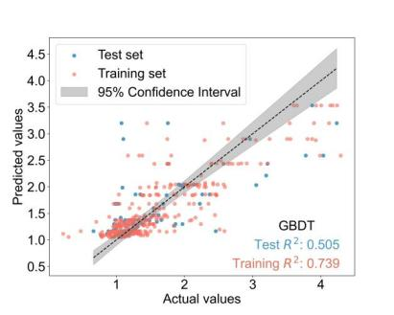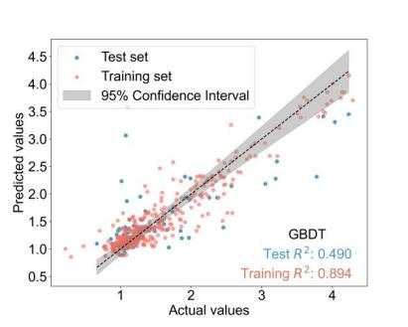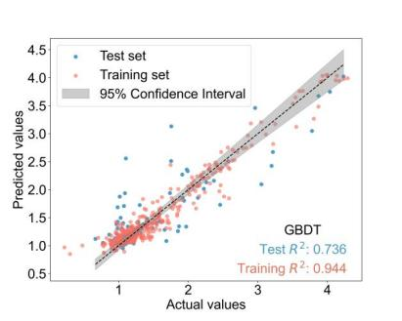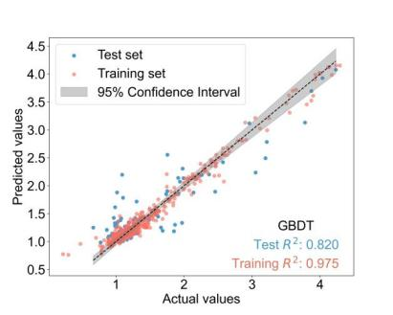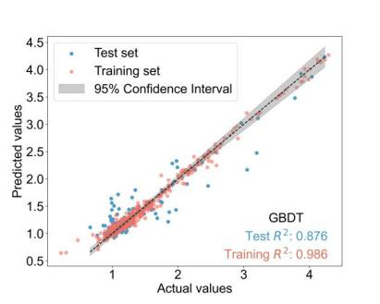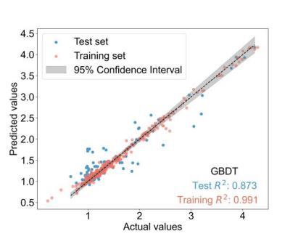
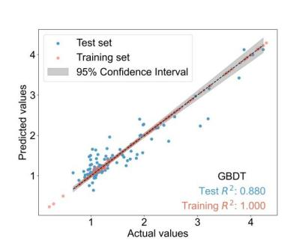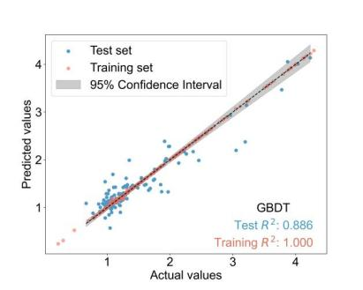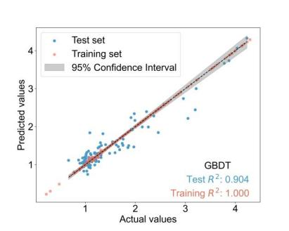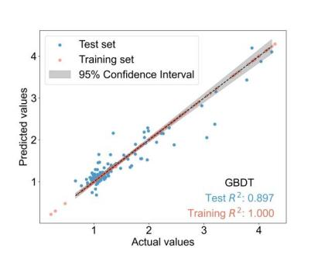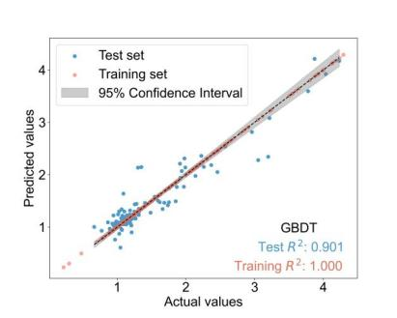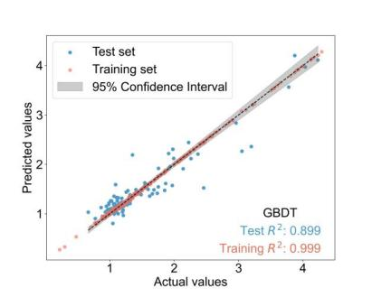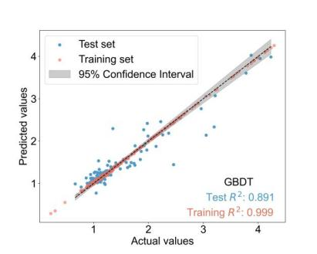
Fig.S6 Prediction results for different combinations of input variables for TN(S)

Table S6 Different combinations of input variables and results for COD_{Mn}(S)
Combined serial number | Specific indicators | Training R² | Test  R²
1 | COD_{Mn}(W) | 0.507 | 0.298
2 | COD_{Mn}(W)、AN(W) | 0.803 | 0.380
3 | COD_{Mn}(W)、AN(W)、T(W) | 0.870 | 0.586
4 | COD_{Mn}(W)、AN(W)、T(W)、DO(W) | 0.995 | 0.657
5 | COD_{Mn}(W)、AN(W)、T(W)、DO(W)、EC(W) | 0.994 | 0.885
6 | COD_{Mn}(W)、AN(W)、T(W)、DO(W)、EC(W)、Turbidity(W) | 0.986 | 0.658
7 | COD_{Mn}(W)、AN(W)、T(W)、DO(W)、EC(W)、Turbidity(W)、pH(W) | 0.986 | 0.720
8 | COD_{Mn}(W)、AN(W)、T(W)、DO(W)、EC(W)、Turbidity(W)、pH(W)、TN(W) | 0.997 | 0.702
9 | COD_{Mn}(W)、AN(W)、T(W)、DO(W)、EC(W)、Turbidity(W)、pH(W)、TN(W)、ST | 0.999 | 0.694
10 | COD_{Mn}(W)、AN(W)、T(W)、DO(W)、EC(W)、Turbidity(W)、pH(W)、TN(W)、ST、TP(W) | 0.999 | 0.715
11 | COD_{Mn}(W)、AN(W)、T(W)、DO(W)、EC(W)、Turbidity(W)、pH(W)、TN(W)、ST、TP(W)、rainfall | 0.996 | 0.753
12 | COD_{Mn}(W)、AN(W)、T(W)、DO(W)、EC(W)、Turbidity(W)、pH(W)、TN(W)、ST、TP(W)、rainfall、runoff | 0.996 | 0.747
13 | COD_{Mn}(W)、AN(W)、T(W)、DO(W)、EC(W)、Turbidity(W)、pH(W)、TN(W)、ST、TP(W)、rainfall、runoff、RH | 0.997 | 0.717

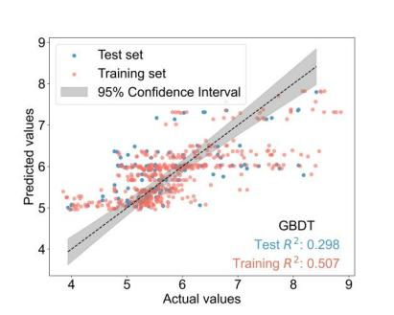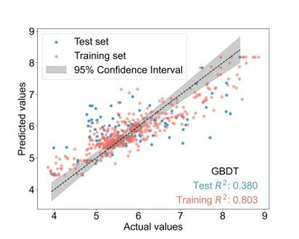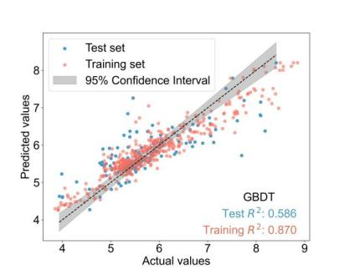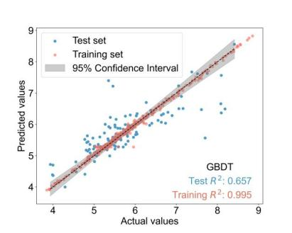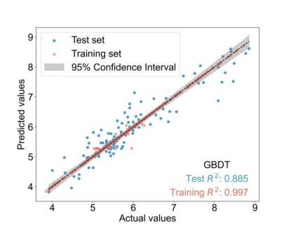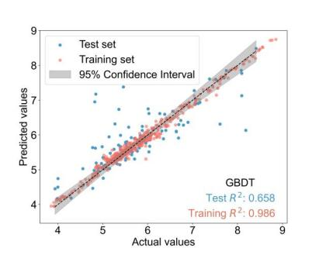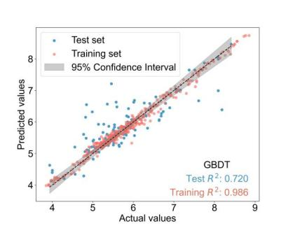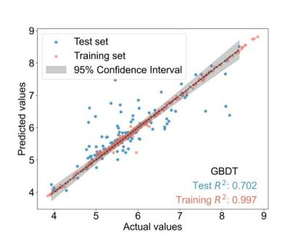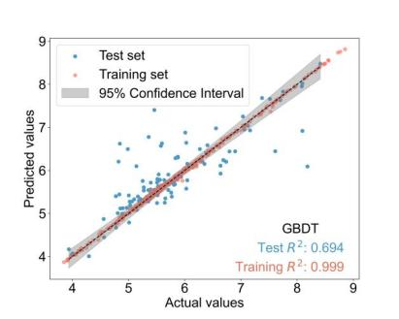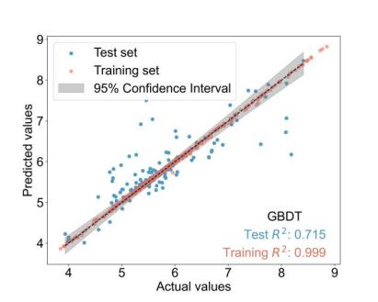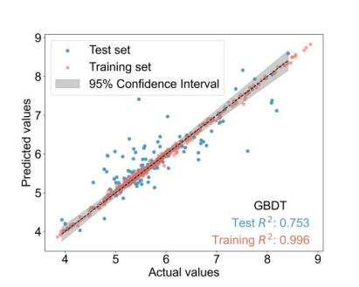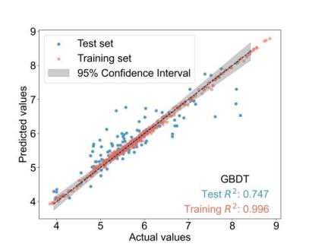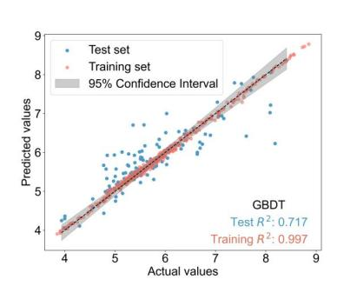
Fig.S7 Prediction results for different combinations of input variables for COD_{Mn}(S)

Table S7 Different combinations of input variables and results for AN(S)
Combined serial number | Specific indicators | Training R² | Test  R²
1 | AN(W) | 0.660 | 0.236
2 | AN(W)、Turbidity(W) | 0.955 | 0.858
3 | AN(W)、Turbidity(W)、TN(W) | 0.999 | 0.874
4 | AN(W)、Turbidity(W)、TN(W)、COD_{Mn}(W) | 1.000 | 0.746
5 | AN(W)、Turbidity(W)、TN(W)、COD_{Mn}(W)、TP(W) | 0.939 | 0.512
6 | AN(W)、Turbidity(W)、TN(W)、COD_{Mn}(W)、TP(W)、DO(W) | 1.000 | 0.514
7 | AN(W)、Turbidity(W)、TN(W)、COD_{Mn}(W)、TP(W)、DO(W)、pH(W) | 1.000 | 0.818
8 | AN(W)、Turbidity(W)、TN(W)、COD_{Mn}(W)、TP(W)、DO(W)、pH(W)、EC(W) | 0.999 | 0.748
9 | AN(W)、Turbidity(W)、TN(W)、COD_{Mn}(W)、TP(W)、DO(W)、pH(W)、EC(W)、Rainfall | 0.998 | 0.878
10 | AN(W)、Turbidity(W)、TN(W)、COD_{Mn}(W)、TP(W)、DO(W)、pH(W)、EC(W)、Rainfall、ST | 0.999 | 0.749

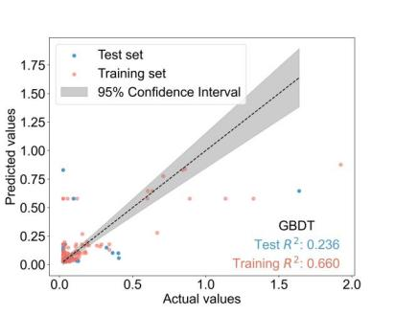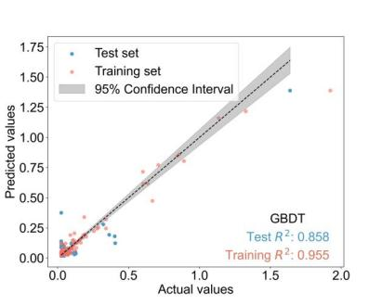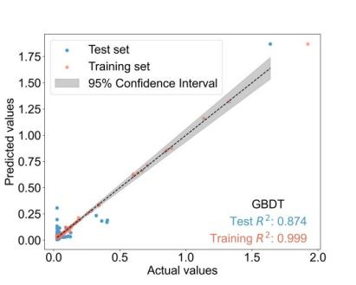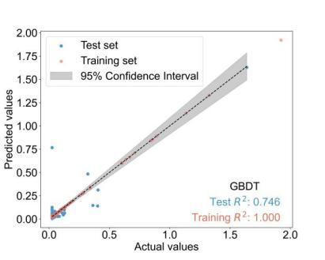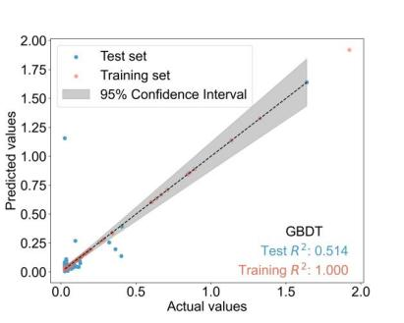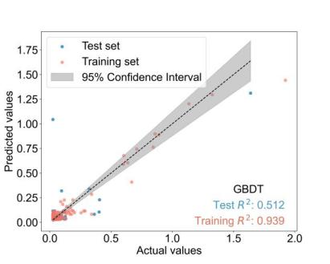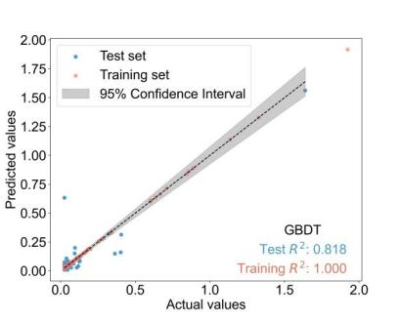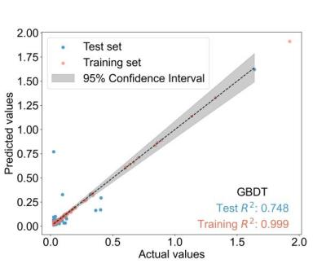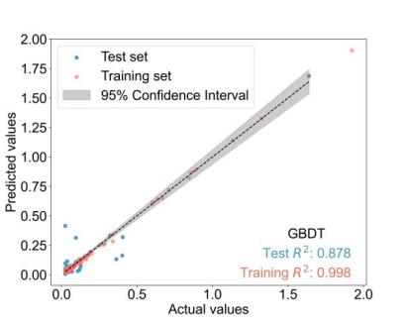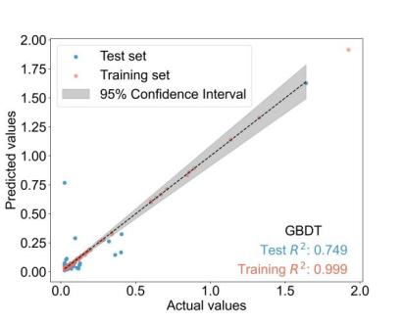
Fig.S8 Prediction results for different combinations of input variables for AN(S)

Table S8 Different combinations of input variables and results for TP(S)
Combined serial number | Specific indicators | Training R² | Test  R²
1 | T(W) | 0.579 | 0.347
2 | T(W)、Turbidity(W) | 0.873 | 0.747
3 | T(W)、Turbidity(W)、DO(W) | 0.947 | 0.772
4 | T(W)、Turbidity(W)、DO(W)、EC(W) | 0.999 | 0.718
5 | T(W)、Turbidity(W)、DO(W)、EC(W)、pH(W) | 0.981 | 0.756
6 | T(W)、Turbidity(W)、DO(W)、EC(W)、pH(W)、COD_{Mn}(W) | 0.990 | 0.818
7 | T(W)、Turbidity(W)、DO(W)、EC(W)、pH(W)、COD_{Mn}(W)、TP(W) | 0.997 | 0.860
8 | T(W)、Turbidity(W)、DO(W)、EC(W)、pH(W)、COD_{Mn}(W)、TP(W)、ST | 0.987 | 0.829
9 | T(W)、Turbidity(W)、DO(W)、EC(W)、pH(W)、COD_{Mn}(W)、TP(W)、ST、TN(W) | 0.999 | 0.830
10 | T(W)、Turbidity(W)、DO(W)、EC(W)、pH(W)、COD_{Mn}(W)、TP(W)、ST、TN(W)、AN(W) | 0.994 | 0.849
11 | T(W)、Turbidity(W)、DO(W)、EC(W)、pH(W)、COD_{Mn}(W)、TP(W)、ST、TN(W)、AN(W)、rainfall | 0.997 | 0.855
12 | T(W)、Turbidity(W)、DO(W)、EC(W)、pH(W)、COD_{Mn}(W)、TP(W)、ST、TN(W)、AN(W)、rainfall、RH | 0.996 | 0.856
13 | T(W)、Turbidity(W)、DO(W)、EC(W)、pH(W)、COD_{Mn}(W)、TP(W)、ST、TN(W)、AN(W)、rainfall、RH、runoff | 0.995 | 0.888

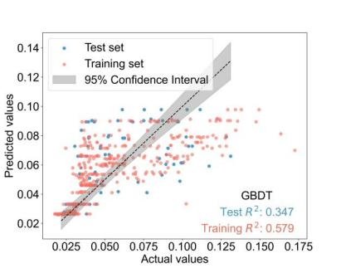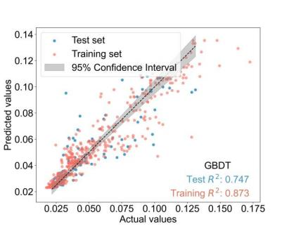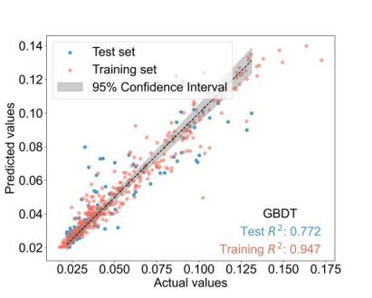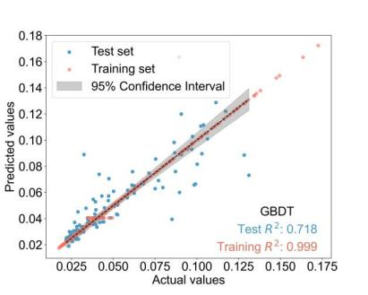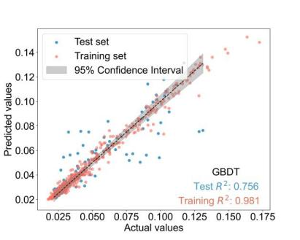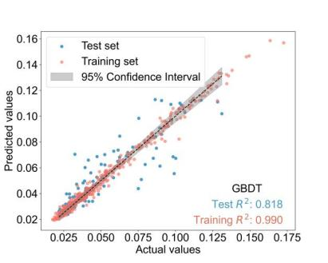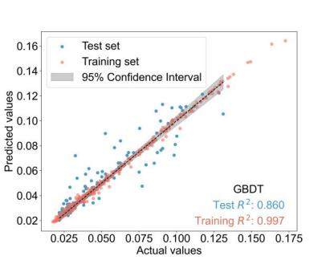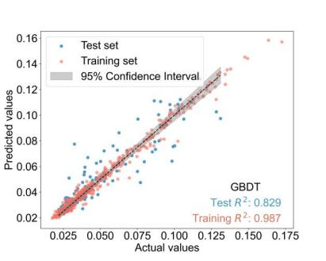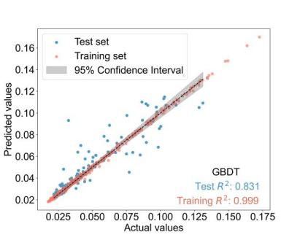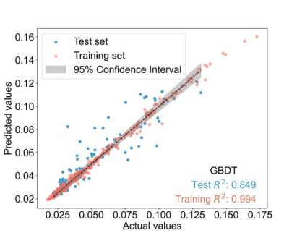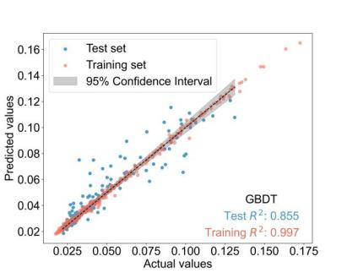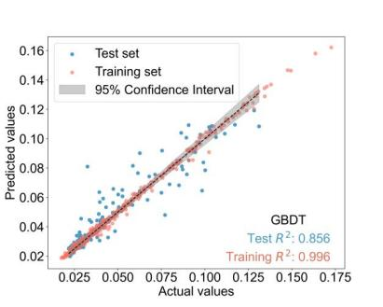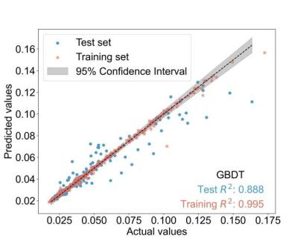
Fig.S9 Prediction results for different combinations of input variables for TP(S)

Table S9 Best fit results of six models for COD_{Mn}(S),AN(S), and TP(S)
 | Models | Training R² | Test R² | RMSE | MAE
COD_{Mn}(S) | GBDT | 1.00 | 0.90 | 0.31 | 0.22
COD_{Mn}(S) | RF | 0.97 | 0.88 | 0.37 | 0.28
COD_{Mn}(S) | DT | 0.87 | 0.84 | 0.43 | 0.31
COD_{Mn}(S) | ELM | 0.81 | 0.73 | 0.51 | 0.41
COD_{Mn}(S) | SVR | 0.48 | 0.58 | 0.66 | 0.50
COD_{Mn}(S) | BP | 0.36 | 0.56 | 0.67 | 0.52
AN(S) | GBDT | 1.00 | 0.94 | 0.05 | 0.02
AN(S) | RF | 0.95 | 0.91 | 0.05 | 0.02
AN(S) | DT | 0.89 | 0.94 | 0.04 | 0.02
AN(S) | ELM | 0.95 | 0.77 | 0.12 | 0.06
AN(S) | SVR | 0.31 | 0.38 | 0.16 | 0.06
AN(S) | BP | 0.33 | 0.45 | 0.15 | 0.06
TP(S) | GBDT | 1.00 | 0.93 | 0.01 | 0.01
TP(S) | RF | 0.96 | 0.92 | 0.01 | 0.01
TP(S) | DT | 0.95 | 0.87 | 0.01 | 0.01
TP(S) | ELM | 0.87 | 0.84 | 0.01 | 0.01
TP(S) | SVR | 0.75 | 0.78 | 0.01 | 0.01
TP(S) | BP | 0.09 | 0.41 | 0.02 | 0.02

