Supplementary Data

Figure S1 & S2: Self-Reported Energy Intake Compared to Estimated Energy Requirements

S1
S2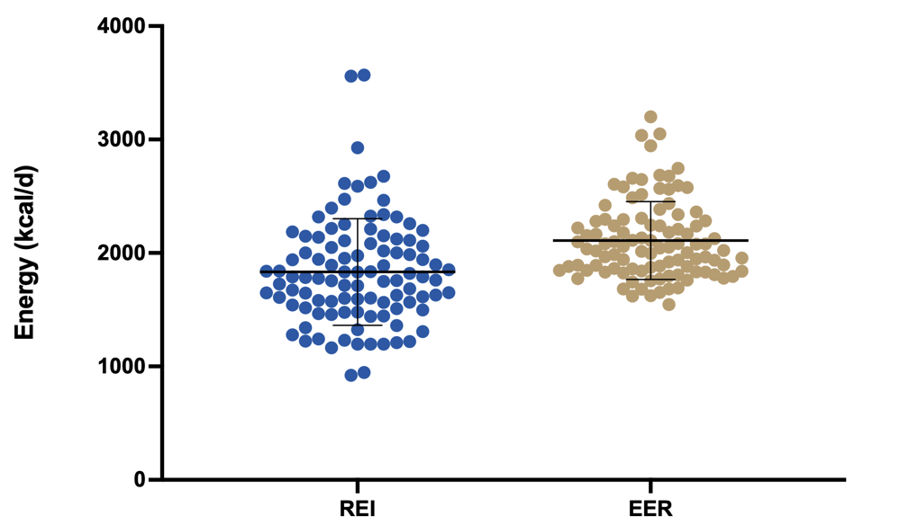

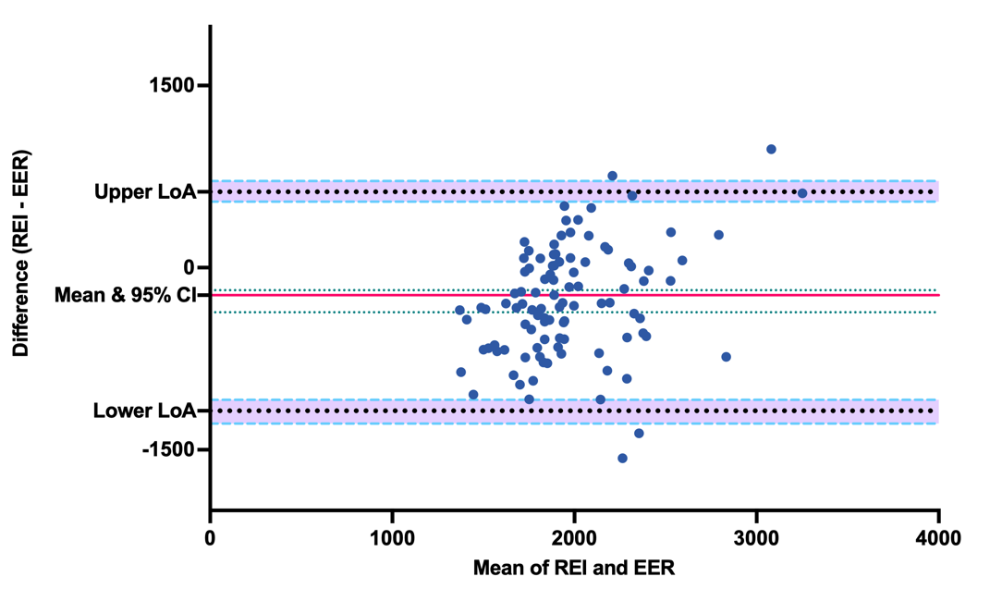
Figure: S1) Mean, standard deviation, and plotted individual values for reported energy intake compared to estimated energy requirements, and S2) Bland-Altman plot of TEF values calculated above the baseline fasting RMR measure and above the pre-meal RMR measure for paired measurements of meals. Left y-axis represents the difference of self-reported energy intake [REI] minus estimated energy requirements [EER]. The x-axis represents the mean of the paired values. Data are presented as the mean of the difference (red solid line) and 95% confidence intervals of the mean difference (green dashed lines), and Limits of Agreement (LoA; black dashed lines) with 95% confidence intervals of the upper and lower LoA (dashed sky-blue lines) shaded in purple. p < 0.001 for the difference between measures (paired one-sample t-test). Lower LoA = -1179 (95% CI, -1296 to -1098); Upper LoA = 624 (95% CI, 543 to 713).

Table S1: Bland-Altman Comparison of Self-Reported vs. Estimated Energy Intake

 | Mean | SD | SE | Min | Max | Lower 95% CI | Upper 95% CI
REI | 1833 | 470.1 | 46.78 | 922.4 | 3569 | 1740 | 1926
EER | 2110 | 343.3 | 34.17 | 1546 | 3200 | 2043 | 2178
REI-EER | -277 | 460.1 | 45.79 | -975 | 1570 | -368 | -186

Note: Values for energy intake are presented as kilocalories [kcal]. REI = reported energy intake; EER = estimated energy requirements (estimated resting metabolic rate [RMR] from height, weight, and reported physical activity levels multiplied by physical activity levels [PAL]).

Figure S3 & S4: Distribution of Social Jetlag & Chronotype

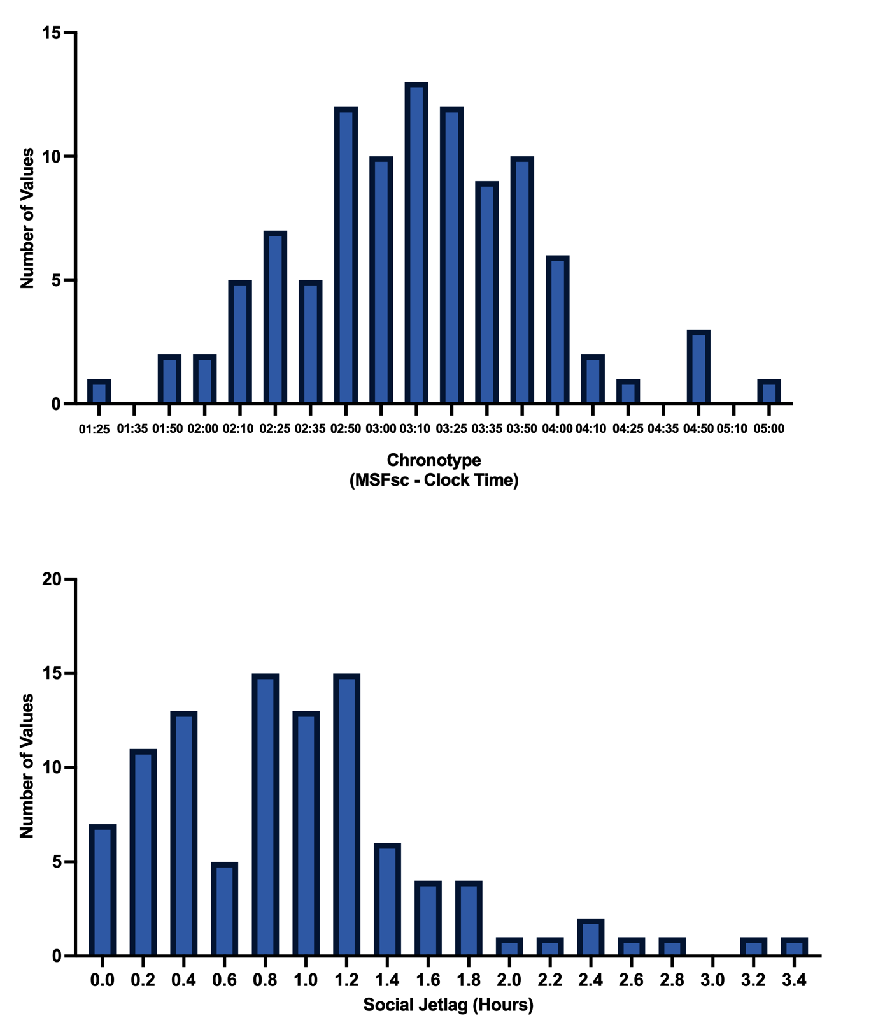
Figure: Histograms of distribution of S3) chronotype and S4) social jetlag in the study cohort.

Table S2: Parameter Estimates from Linear Mixed Model Analysis of Social Jetlag Categorised in Tertile Ranges (Model 3)
Tertile Model Weekdays |  |  | Tertile Model Weekends
Predictors | Estimates | CI | p | Estimates | CI | p
(Intercept) | 89.60 | 9.87 – 169.33 | 0.028 | 57.07 | -46.21 – 160.36 | 0.279
Age Centred | -0.54 | -4.17 – 3.10 | 0.772 | 0.48 | -3.43 – 4.38 | 0.811
Sex [M] | 23.96 | -90.88 – 138.80 | 0.683 | 136.55 | -28.14 – 301.24 | 0.104
BMI Centred | 0.01 | -5.54 – 5.56 | 0.997 | 4.93 | -1.03 – 10.89 | 0.105
Workplace [Mixed] | -51.61 | -106.99 – 3.77 | 0.068 | 0.07 | -59.41 – 59.54 | 0.998
Workplace [WFH] | -42.02 | -83.19 – -0.86 | 0.045 | -1.91 | -46.12 – 42.30 | 0.933
SJL Quartile [Moderate] | 72.07 | 0.62 – 143.51 | 0.048 | -4.72 | -107.93 – 98.49 | 0.928
SJL Quartile [High] | -2.87 | -88.72 – 82.97 | 0.948 | 25.67 | -97.50 – 148.83 | 0.683
Chronotype [Intermediate] | -9.03 | -49.25 – 31.20 | 0.660 | -11.53 | -54.74 – 31.67 | 0.601
Chronotype [Late] | 12.41 | -48.92 – 73.74 | 0.692 | 25.65 | -40.22 – 91.52 | 0.445
Time [b] | 291.68 | 223.97 – 359.40 | <0.001 | 346.59 | 229.85 – 463.32 | <0.001
Time [c] | 465.44 | 397.72 – 533.15 | <0.001 | 465.36 | 348.62 – 582.09 | <0.001
Time [d] | 423.59 | 355.87 – 491.30 | <0.001 | 554.00 | 437.26 – 670.74 | <0.001
Time [e] | 200.82 | 133.11 – 268.54 | <0.001 | 254.43 | 137.70 – 371.17 | <0.001
Parent [Yes] | -17.68 | -73.72 – 38.37 | 0.536 | -44.10 | -104.29 – 16.08 | 0.151
Smoking [Never] | 10.10 | -47.93 – 68.14 | 0.733 | -3.12 | -65.44 – 59.21 | 0.922
Alcohol Centred | 4.96 | 0.21 – 9.72 | 0.041 | 8.58 | 3.47 – 13.69 | 0.001
SJL Quartile [Moderate] ×  Time [b] | -83.13 | -164.06 – -2.19 | 0.044 | 23.86 | -115.67 – 163.38 | 0.737
SJL Quartile [High] ×  Time [b] | -63.13 | -158.90 – 32.63 | 0.196 | -124.30 | -289.39 – 40.79 | 0.140
SJL Quartile [Moderate] ×  Time [c] | -119.21 | -200.14 – -38.27 | 0.004 | -54.57 | -194.10 – 84.95 | 0.443
SJL Quartile [High] ×  Time [c] | -41.40 | -137.17 – 54.36 | 0.397 | 18.07 | -147.02 – 183.16 | 0.830
SJL Quartile [Moderate] ×  Time [d] | -79.60 | -160.54 – 1.34 | 0.054 | -9.93 | -149.46 – 129.60 | 0.889
SJL Quartile [High] ×  Time [d] | -30.87 | -126.63 – 64.90 | 0.527 | -13.47 | -178.56 – 151.62 | 0.873
SJL Quartile [Moderate] ×  Time [e] | -82.15 | -163.09 – -1.22 | 0.047 | -31.17 | -170.69 – 108.36 | 0.661
SJL Quartile [High] ×  Time [e] | 103.82 | 8.06 – 199.59 | 0.034 | -12.92 | -178.01 – 152.17 | 0.878
Sex [M] × SJL Quartile  [Moderate] | 52.06 | -96.98 – 201.11 | 0.493 | -103.21 | -318.78 – 112.35 | 0.348
Sex [M] × SJL Quartile  [High] | 13.79 | -144.35 – 171.93 | 0.864 | -155.19 | -382.34 – 71.96 | 0.180
Sex [M] × Time [b] | 19.23 | -108.75 – 147.20 | 0.768 | -12.67 | -233.28 – 207.93 | 0.910
Sex [M] × Time [c] | 49.52 | -78.45 – 177.49 | 0.448 | 5.31 | -215.30 – 225.92 | 0.962
Sex [M] × Time [d] | 262.50 | 134.53 – 390.47 | <0.001 | 172.89 | -47.72 – 393.50 | 0.124
Sex [M] × Time [e] | -18.37 | -146.34 – 109.60 | 0.778 | -169.58 | -390.19 – 51.02 | 0.132
(Sex [M] × SJL Quartile  [Moderate]) × Time [b] | -136.61 | -305.90 – 32.68 | 0.114 | 73.64 | -218.20 – 365.48 | 0.621
(Sex [M] × SJL Quartile  [High]) × Time [b] | 186.77 | 9.91 – 363.63 | 0.038 | 200.62 | -104.27 – 505.51 | 0.197
(Sex [M] × SJL Quartile  [Moderate]) × Time [c] | -4.82 | -174.11 – 164.47 | 0.955 | 144.04 | -147.80 – 435.88 | 0.333
(Sex [M] × SJL Quartile  [High]) × Time [c] | -95.57 | -272.43 – 81.29 | 0.289 | -112.67 | -417.55 – 192.22 | 0.469
(Sex [M] × SJL Quartile  [Moderate]) × Time [d] | -180.90 | -350.19 – -11.60 | 0.036 | -44.42 | -336.25 – 247.42 | 0.765
(Sex [M] × SJL Quartile  [High]) × Time [d] | 59.52 | -117.34 – 236.38 | 0.509 | 6.34 | -298.55 – 311.23 | 0.967
(Sex [M] × SJL Quartile  [Moderate]) × Time [e] | 122.10 | -47.19 – 291.39 | 0.157 | 410.04 | 118.20 – 701.87 | 0.006
(Sex [M] × SJL Quartile  [High]) × Time [e] | -21.87 | -198.73 – 154.99 | 0.808 | 292.95 | -11.94 – 597.83 | 0.060
Random Effects
σ² | 107379.53 |  |  | 127549.79
τ₀₀ | 5618.14 _{Participant} |  |  | 2572.70 _{Participant}
ICC | 0.05 |  |  | 0.02
N | 101 _{Participant} |  |  | 101 _{Participant}
Observations | 5050 |  |  | 2020
Marginal R² / Conditional R² | 0.207 / 0.246 |  |  | 0.257 / 0.272

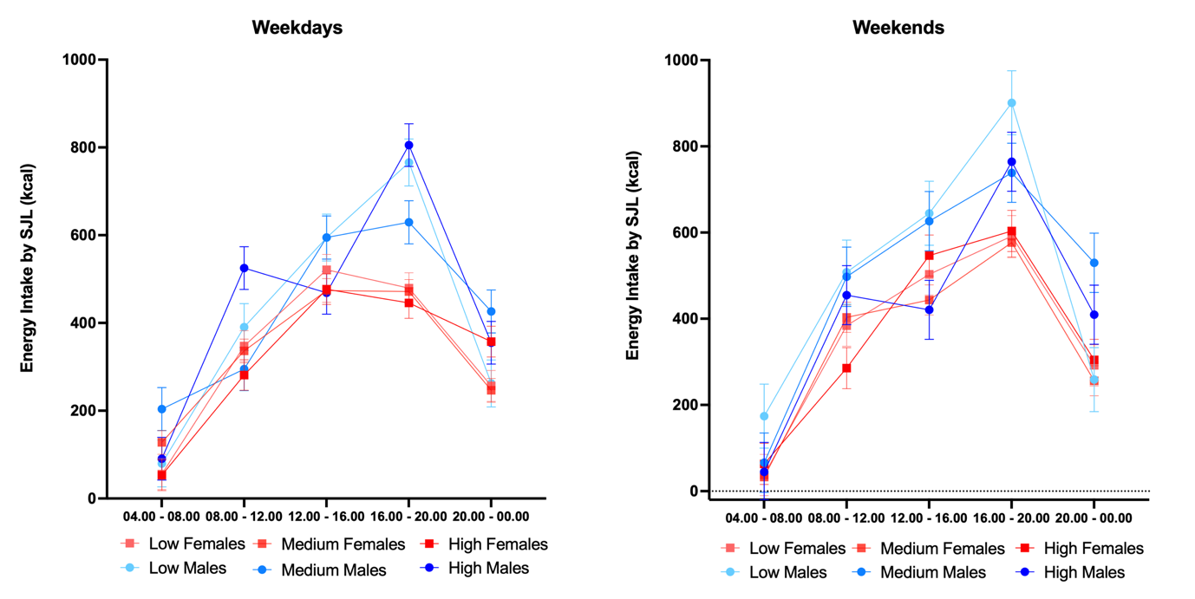
Figure S5: Model 3 estimated marginal means for energy intake (Kilocalories [kcal]) per low (< 27 min), moderate (27–75 mins), and high (> 75 mins) social jetlag (SJL) in male (blue) and female (red) participants on weekdays and weekends. Marginal means were calculated for females and males with average sample age and BMI; see Methods for further reference values.

Table S3: Sensitivity Analysis Omitting Chronotype from Linear Mixed Model Analysis Predicting Energy Intake Based on <1 h vs. >1 h Social Jetlag (Model 1)

Sensitivity – Chronotype Omitted Weekdays |  |  | Chronotype Omitted Weekends
Predictors | Estimates | CI | p | Estimates | CI | p
(Intercept) | 174.42 | 124.74 – 224.11 | <0.001 | 62.45 | -3.50 – 128.40 | 0.063
Age Centred | -0.96 | -4.55 – 2.63 | 0.601 | 0.17 | -3.74 – 4.07 | 0.933
Sex [M] | 21.43 | -60.89 – 103.75 | 0.610 | 101.45 | -16.70 – 219.59 | 0.092
BMI Centred | 0.49 | -4.78 – 5.77 | 0.855 | 4.82 | -0.92 – 10.55 | 0.100
Workplace [Mixed] | -46.33 | -100.16 – 7.51 | 0.092 | 2.92 | -55.61 – 61.45 | 0.922
Workplace [WFH] | -43.04 | -81.90 – -4.18 | 0.030 | -2.01 | -44.26 – 40.23 | 0.926
SJL [> 1 h] | -81.30 | -140.01 – -22.58 | 0.007 | -10.97 | -95.20 – 73.25 | 0.798
Time [b] | 209.01 | 163.98 – 254.04 | <0.001 | 373.25 | 295.94 – 450.56 | <0.001
Time [c] | 361.53 | 316.50 – 406.56 | <0.001 | 464.88 | 387.57 – 542.19 | <0.001
Time [d] | 368.27 | 323.24 – 413.30 | <0.001 | 549.81 | 472.50 – 627.12 | <0.001
Time [e] | 94.09 | 49.06 – 139.12 | <0.001 | 193.20 | 115.89 – 270.51 | <0.001
Parent [Yes] | -20.74 | -76.68 – 35.20 | 0.467 | -56.55 | -117.35 – 4.26 | 0.068
Smoking [Ex] | -2.97 | -59.42 – 53.49 | 0.918 | 11.17 | -50.21 – 72.54 | 0.721
Alcohol Centred | 5.23 | 0.66 – 9.80 | 0.025 | 7.85 | 2.88 – 12.82 | 0.002
Sex [M] × Time [b] | 27.02 | -64.75 – 118.79 | 0.564 | -21.10 | -178.67 – 136.47 | 0.793
Sex [M] × Time [c] | 70.17 | -21.61 – 161.94 | 0.134 | 61.30 | -96.27 – 218.86 | 0.446
Sex [M] × Time [d] | 196.27 | 104.50 – 288.04 | <0.001 | 87.92 | -69.64 – 245.49 | 0.274
Sex [M] × Time [e] | 99.07 | 7.30 – 190.84 | 0.034 | 43.77 | -113.79 – 201.34 | 0.586
Sex [M] × SJL [> 1 h] | 16.27 | -104.75 – 137.28 | 0.792 | -113.95 | -289.20 – 61.31 | 0.202
SJL [> 1 h] × Time [b] | 49.20 | -16.17 – 114.58 | 0.140 | -89.59 | -201.84 – 22.66 | 0.118
SJL [> 1 h] × Time [c] | 63.59 | -1.79 – 128.97 | 0.057 | -52.15 | -164.40 – 60.10 | 0.362
SJL [> 1 h] × Time [d] | 11.25 | -54.13 – 76.62 | 0.736 | -8.99 | -121.24 – 103.26 | 0.875
SJL [> 1 h] × Time [e] | 182.26 | 116.88 – 247.64 | <0.001 | 87.42 | -24.83 – 199.67 | 0.127
(Sex [M] × SJL [> 1 h]) ×  Time [b] | 46.13 | -91.64 – 183.91 | 0.512 | 186.70 | -49.85 – 423.25 | 0.122
(Sex [M] × SJL [> 1 h]) ×  Time [c] | -80.89 | -218.67 – 56.89 | 0.250 | -79.62 | -316.16 – 156.93 | 0.509
(Sex [M] × SJL [> 1 h]) ×  Time [d] | 82.84 | -54.93 – 220.62 | 0.239 | 164.87 | -71.68 – 401.42 | 0.172
(Sex [M] × SJL [> 1 h]) ×  Time [e] | -109.37 | -247.15 – 28.40 | 0.120 | 89.80 | -146.75 – 326.35 | 0.457
Random Effects
σ² | 108150.53 |  |  | 127428.86
τ₀₀ | 5254.84 _{Participant} |  |  | 2387.83 _{Participant}
ICC | 0.05 |  |  | 0.02
N | 101 _{Participant} |  |  | 101 _{Participant}
Observations | 5050 |  |  | 2020
Marginal R² / Conditional R² | 0.201 / 0.238 |  |  | 0.255 / 0.269

