Supplemental Figures
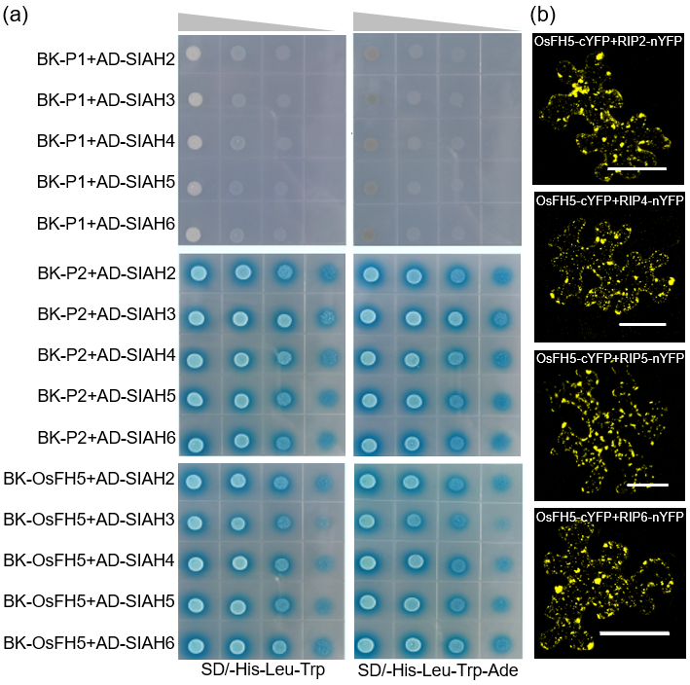
Figure S1. RIP1 has five rice homologs that all interact with OsFH5.
(a) Yeast 2 hybrid experiment, combining OsFH5 full-length and truncated proteins expressed from the BK bait vector (pGBKT7), and SIAH domains from RIP2–RIP6 proteins expressed from the AD prey vector (pGADT7). Yeast cells co-transformed with each bait–prey pair were grown on selective medium, revealing that the P3 section of OsFH5 is essential for interaction with RIP SIAH domains.
(b) Bimolecular fluorescence complementation in tobacco leaves reveals that OsFH5 interacts with RIP2, RIP4, RIP5, and RIP6 proteins. Bar = 50µm.
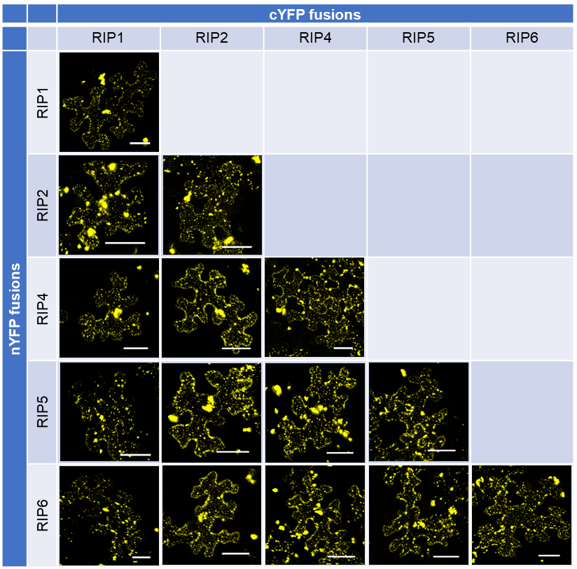
Figure S2. Other RIP proteins form homo- and hetero-dimers.
RIP2, RIP4, RIP5, and RIP6 were each fused with cYFP and nYFP domains, and introduced into tobacco leaves in different combinations. Bar = 50µM.

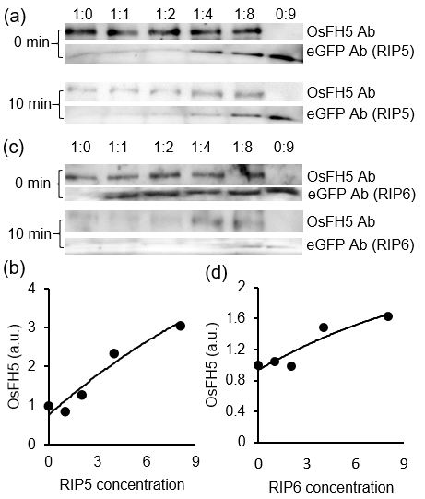
Figure S3. RIP5 and RIP6 slow down degradation rate of OsFH5.
OsFH5 protein extract was mixed with different ratios (0, 1, 2, 4, or 8× vol) of (a) RIP5-eGFP extract or (c) RIP6-eGFP extract. The sixth lane contains a 9×vol of RIP1 extract with no OsFH5 extract. Anti-OsFH5 antibody (Ab) was used to detect osFH5; anti-eGFP antibody was used to detect tagged RIP1. For (a) and (b), the upper panel shows protein amounts immediately after mixing (0 min); the lower panel, protein amounts 10 min after mixing. (c, d) Data statistic of OsFH5 10 min from (a and c). a.u., arbitrary unit.

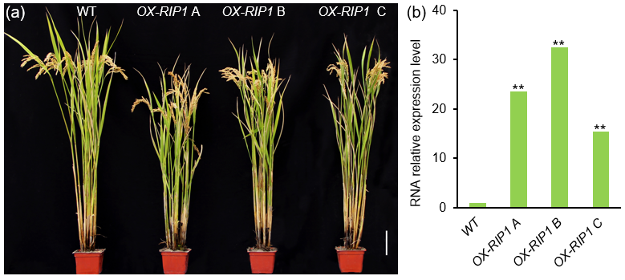
Figure S4. RIP1 overexpression (a) lines have no obvious phenotype. The overexpression level of RIP1 relative to WT was detected by RT-PCR (b).

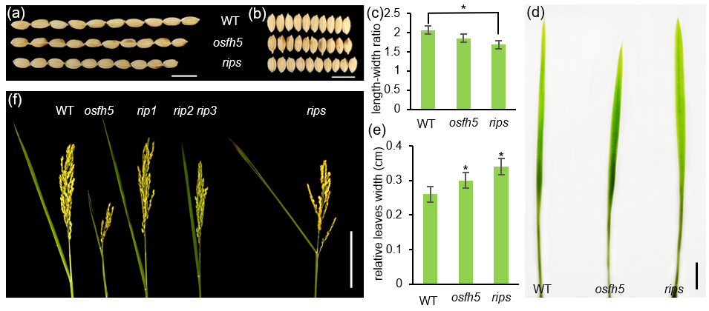
Figure S5. Other phenotypes of rips.
(a) Length and (b) width of wild type (WT), osfh5, and rips seeds. Bar = 1cm.
(c) Length:width ratio of WT, osfh5, and rips seeds. n = 50, * P<0.05 (stats test).
(d) Phenotype of wider rips flag leaves (mean value 0.34 cm) compared with WT (mean value 0.26 cm) and osfh5 (mean value 0.3cm). Bar = 1cm.
(e) Flag Leaf width of WT, osfh5, and rips. n = 20, * P<0.05 (stats test).
(f) The angle of the flag leaf to the spike branch increased in rips compared with WT, osfh5, rip1, and rip2 rip3 mutants. Bar = 10cm.

