Supplementary Material for
Cyclometalating Ligand Affords NIR Absorption in Ruthenium Enantiomers for Type-I Photodynamic Therapy

Zongwei Zhangª, Xiaolong Zeng^{a,b}, Xiao Zhouª, Zhiyuan Maª, Maomao Heª, Danhong Zhouª, Saran Longª, Jiangli Fan^{a,c,d}, Xiaojun Peng^{a,d} and Wen Sun*^{a,c,d}

ª State Key Laboratory of Fine Chemicals, Frontiers Science Center for Smart Materials Oriented Chemical Engineering, Dalian University of Technology, Dalian 116024, China
^{b} DWI-Leibniz Institute for Interactive Materials & Institute of Technical and Macromolecular Chemistry, RWTH Aachen University, 52074 Aachen, Germany
^{c} Ningbo Institute of Dalian University of Technology, Ningbo 315016, China
^{d} Liaoning Binhai Laboratory, Dalian 116023, China
Corresponding author email: sunwen@dlut.edu.cn

Instruments and materials
All manipulations with organic compounds were degassed performed under a dry argon atmosphere by using standard Schlenk techniques. The general chemical reagents were purchased from Energy Chemical Co. (China). All solvents were of analytic grade. 3-(4,5-dimethyl-2-thiazolyl)-2,5-diphenyl-2-H-tetrazolium bromide (MTT) were purchased from Energy Chemical Co. DMEM and PBS were purchased from KeyGEN BioTECH Ltd. DCFH, DHE and HPF detection kit were purchased from Beyotime Biotechnology. ¹H-NMR and ¹³C-NMR were measured by Bruker Avance Ⅲ 400 spectrometers. Mass spectrometry (MS) was carried out using Q-TOF Micro (Micromass UK Limied, UK) and MALDI-TOF (Bruker, Germany). Absorption spectra were measured on a CARY 60 UV-Vis spectrophotometer (Agilent, USA). Fluorescence spectra were obtained with an Agilent Cary Eclipse fluorescence spectrophotometer (Agilent, USA). Confocal laser scanning microscope (CLSM) images were performed on an Olympus FV3000 CLSM (Olympus, Japan). Small animals’ fluorescence imaging was carried out by the NightOWL II LB983 living imaging system. The size distribution was determined using dynamic light scattering (DLS) measurement (Zetasizer Nano ZS90, Malvern Instrument, UK). The morphology was examined using transmission electron microscope TEM (JEM-1400Flash, Japan).

Preparation of TPABP and Λ/Δ-Ru-TPABP
Synthesis of 4-bromo-7-(2-pyridinyl)-2,1,3-benzothiadiazole (1)
A 250 mL three-necked round-bottomed flask was charged with 4,7-dibromo-2,1,3-benzothiadiazole (4.8 g, 16.3 mmol) and Pd(PPh₃)₄ (0.95 g, 0.82 mmol) under argon, then a toluene solution (120 mL) of 2-(tributylstannyl)pyridine (6 g, 16.25 mmol) was added. The reaction mixture was heated to reflux at 117 ℃ and stirred for 12 h. After cooling to room temperature, the mixture was washed with saturated aqueous NaCl (100 mL) and the organic layer was separated and dried over anhydrous MgSO₄. The solvent was removed, and the residue was purified by column chromatography to afford a yellow solid (1.28 g, 27%). ¹H NMR (600 MHz, DMSO-d6) δ 8.83 – 8.75 (m, 1H), 8.69 (d, J = 8.0 Hz, 1H), 8.40 (d, J = 7.7 Hz, 1H), 8.21 (d, J = 7.7 Hz, 1H), 8.02 (td, J = 7.8, 1.9 Hz, 1H), 7.49 (ddd, J = 7.6, 4.7, 1.1 Hz, 1H). Calcd for C₁₁H₆BrN₃S (M_{r} = 290.94), ESI-MS: m/z 291.95 ([M+H]⁺).
Synthesis of compound TPABP
Toluene (20 mL) was injected under argon to a flask containing 4- (diphenylamino) phenylboronic acid (0.5 g, 1.3 mmol), 1 (400 mg, 1.37 mmol) and Pd(PPh₃)₄ (20 mg, 0.017 mmol) and saturated aqueous K₂CO₃ (1 mL). The mixture was heated to reflux for 48 h. After cooling to room temperature, the mixture was washed with water (40 mL) and extracted with CH₂Cl₂ (100 mL). The organic layer was separated and dried over anhydrous MgSO₄. The solvent was removed, and the residue was purified by recrystallization in methanol to afford a red solid (449 mg, 73%). ¹H NMR (500 MHz, CDCl₃, ppm) d 8.79 (d, 1H, J = 4.5 Hz), 8.69 (d, 1H,7.5Hz), 8.52 (d, 1H, 7.5Hz), 7.87 (m, 3H), 7.83 (d, 1H, J = 7.5Hz), 7.33 (m, 1H), 7.28 (m, 4H), 7.19 (m, 6H), 7.06 (t, 2H, J = 7.5 Hz). Calcd for C₂₉H₂₀N₄S (M_{r} = 456.14), ESI-MS: m/z 457.14 ([M+H]⁺).
Synthesis of compound Ru(dqpy)Cl₃
RuCl₃·H₂O (1 mmol, 262 mg), dqpy (1 mmol, 333 mg), and excess LiCl (100 mg) were dissolved in absolute DMF (30 mL). The mixture was heated at reflux for 12 h with vigorous magnetic stirring. After cooling, Ru(dqpy)Cl₃ appeared and was filtered from the solution as a fine green powder, which was washed with diethyl ether, and air-dried (200 mg, 40%).
Synthesis of Λ/Δ-Ru-TPABP
Ru(dqpy)Cl₃ (0.5 mmol, 272 mg), TPABP (1.5 mmol, 650 mg) and NaHCO₃ (300 mg) were mixed in ethanol (20 mL) and the solution was bubbled with N₂ for 15 min. The mixture was heated at reflux (75℃) overnight under N₂ atmosphere in the dark. The product was purified by column chromatography (CH₃OH/CH₂Cl₂ = 1/50). The solvent was evaporated, and the product was obtained as black solid (100 mg). Ru-TPABP was subjected to chiral column chromatography to isolate its enantiomers (PE/DCM = 8:2). The separation was performed under optimized conditions, and the resulting enantiomers were collected individually. The purity of each fraction were confirmed using analytical techniques such as circular dichroism (CD) spectroscopy and high-performance liquid chromatography (HPLC) with a chiral stationary phase. Calcd for C₅₂H₃₄N₇RuSCl (M_{r} = 925.13), ESI MS: m/z: 926.14 ([M+H]⁺).

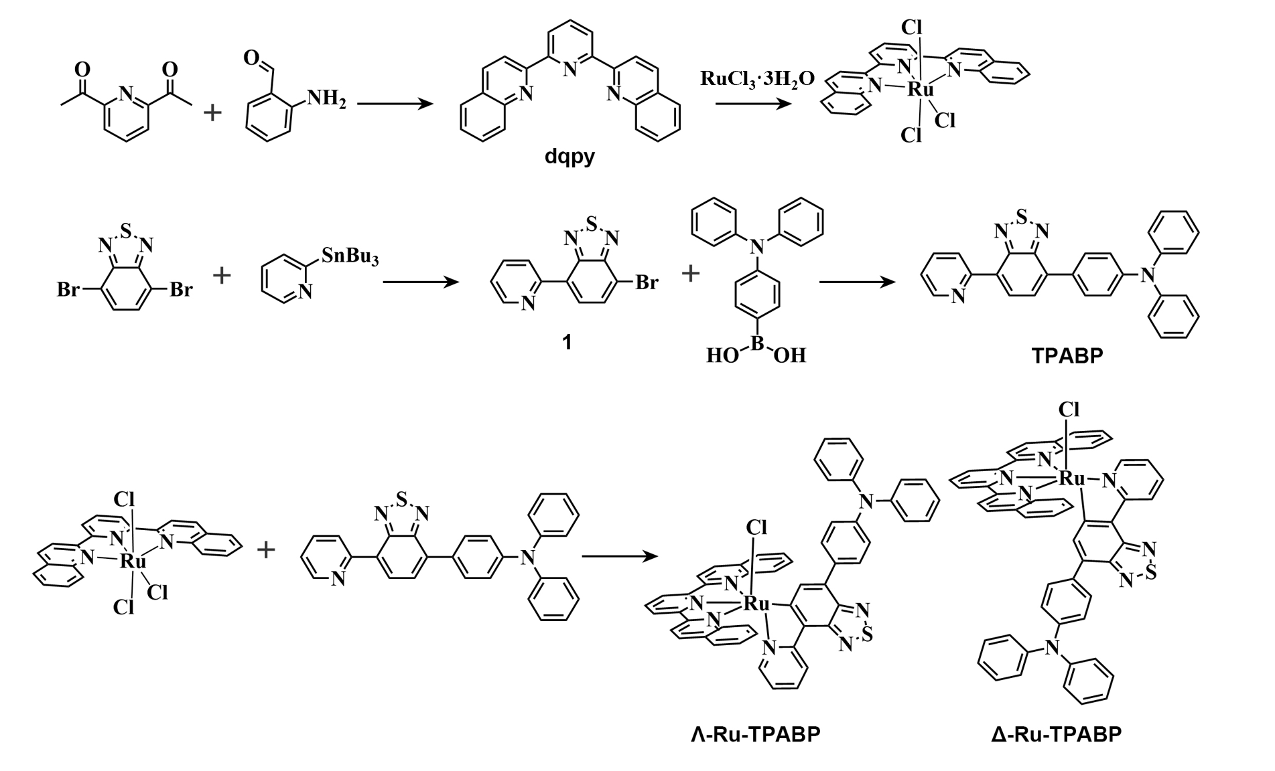
Scheme S1. The synthesis route for Λ/Δ-Ru-TPABP.

Reactive oxygen species detection in solution
The generation of total ROS was quantified by monitoring the fluorescence increase of the 2’,7’-dichlorodihydrofluorescein (DCFH) compound at 525 nm. The concentrations of DCFH were maintained a 5 μM. Superoxide radical (O₂^{−•}) generation was measured by the increase in fluorescence of dihydroethidium (DHE) at 610 nm in the presence of ct-DNA. The concentration of DHE, and ct-DNA was 10 μM, and 500 μg/mL, respectively. The generation of hydroxyl radicals (•OH) was quantified by monitoring the fluorescence increase of hydroxyphenyl fluorescein (HPF) at 515 nm. The concentration of HPF used was 5 μM.

Detection of • OH production with EPR spectroscopy
Electron paramagnetic resonance (EPR) spectroscopy was employed to confirm the generation of •OH. 5,5-dimethyl-1-pyrroline-N-oxide (DMPO) was used as a spin-trap agent for •OH. EPR spectroscopy was employed to detect the EPR signals of the following different conditions: Control: 50 mM DMPO in water solution with light irradiation (700 nm, 50 mW cm⁻²); Λ/Δ-Ru-TPABP-Dark: 100 µM Λ/Δ-Ru-TPABP and 50 mM DMPO in water solution without irradiation; Λ/Δ-Ru-TPABP-Light: 100 µM Λ/Δ-Ru-TPABP and 50 mM DMPO in water solution with light irradiation (700 nm, 50 mW cm⁻²).

Detection of O₂^{−•} production with EPR spectroscopy
Electron paramagnetic resonance (EPR) spectroscopy was employed to confirm the generation of O₂^{−•}. 5,5-dimethyl-1-pyrroline-N-oxide (DMPO) was used as a spin-trap agent for O₂^{−•}. EPR spectroscopy was employed to detect the EPR signals of the following different conditions: Control: 50 mM DMPO in methanol solution with light irradiation (700 nm, 50 mW cm⁻²); Λ/Δ-Ru-TPABP-Dark: 100 µM Λ/Δ-Ru-TPABP and 50 mM DMPO in methanol solution without irradiation; Λ/Δ-Ru-TPABP-Light: 100 µM Λ/Δ-Ru-TPABP and 50 mM DMPO in methanol solution with light irradiation (700 nm, 50 mW cm⁻²).

Preparation of Λ/Δ-Ru-TPABP NPs and fluorescent dye loaded Λ/Δ-Ru-TPABP NPs
Λ/Δ-Ru-TPABP NPs were prepared by adding water to the polymer solution. In brief, the Λ/Δ-Ru-TPABP were dissolved in THF (1 mg, 1 mL), which was added into Milli-Q water containing DSPE-PEG2000 (5 mg, 5 mL) under sonication (180 W). The resulted dispersion was further kept in sonication (180 W) for 40 min. After that, the colloidal dispersion was dialyzed against Milli-Q water for three days to remove the organic solvents using a dialysis tube (MW cutoff, 3.5 kDa). In the dialysis process, Milli-Q water was replaced approximately every 6 h. The dispersion was finally dialyzed against saline, and the nanoparticle solution in the dialysis tube was collected.
To prepare dye-loaded Λ/Δ-Ru-TPABP NPs, 0.1 mg Cy7 was added to the THF containing Λ/Δ-Ru-TPABP (1 mg, 1mL), which was stirred for 4 h before use. The mixture was added into Milli-Q water containing DSPE-PEG2000 (5 mg, 5 mL) under sonication (180 W). The resulted dispersion was further kept in sonication (180 W) for 40 min. After that, the colloidal dispersion was dialyzed against Milli-Q water for three days to remove the organic solvents and free Cy7 using a dialysis tube (M_{W} cutoff, 3.5 kDa). In the dialysis process, Milli-Q water was replaced approximately every 6 h. The dispersion was finally dialyzed against saline, and then the nanoparticle solution in the dialysis tube was collected.

Electrochemistry
The cyclic voltammogram (CV) experiments were carried out by using a CHI620E Electrochemical Analyzer/Workstation (Shanghai Huachen ENERGY Co., Ltd.), with a scan rate of 100 mVs⁻¹ for 3 cycles. The three-electrode system was used in the experiment: a glassy carbon electrode, an Ag/AgCl electrode in saturated KCl solution, and platinum wire were used as the working electrode, reference electrode, and counter electrode, respectively. Compounds (100 μM) were dissolved in degassed CH₃CN containing tetrabutylammonium hexafluorophosphate (0.1 M) as the supporting electrolyte. Ferrocene was used as an internal reference, and solutions were degassed by N₂.

Theoretical calculation
All calculations were performed with the Gaussian 16 package employing density functional theory (DFT) and time-dependent DFT (TD-DFT) theory. The ground state geometries of Λ/Δ-Ru-TPABP and [Ru(dqpy)(bpy)]⁺Cl (Ru-bpy) were optimized using PBE0 functional¹ with the Stuttgart pseudopotential and basis set (SDD) for ruthenium atom while the 6-31g(d) basis set for H, C, N, S, and Cl atoms. The vertical excitations for singlet and triplet states were calculated based on the ground state geometries by using B3LYP hybrid functional. The SDD was used for the ruthenium atom and the TZVP basis set for the remaining elements. All calculations were carried out in dichloromethane (DCM) using the polarizable continuum model (PCM). The Hole-Electron analysis was carried out using Multiwfn 3.84^{2, 3}. Visual Molecular Dynamics (VMD) were used to visualize the frontier molecular orbitals and the electron-hole distribution⁴.

Femtosecond transient absorption spectra
A detailed description of the femtosecond time-resolved transient absorption setup can be found elsewhere. In summary, a regenerative amplifier (Astrella, Coherent Inc.) is seeded by a Ti:Sapphire oscillator (Viatra, Coherent Inc.). This configuration enables the amplifier to generate a 7 mJ train of 90 femtosecond (fs) pulses at a center wavelength, with a repetition rate of 1 kHz. The output is divided into pump and probe paths using a beam splitter. Specifically, one of the outputs is allocated to pump an optical parametric amplifier (OPerA Solo, Coherent Inc.). The OPerA is tuned to generate light with a specific wavelength, which serves as the pump pulse. Meanwhile, the remaining output is employed for the generation of white light continuum (WLC) after passing through an optical delay line and interacting with a rotating CaF₂ crystal, which acts as the probe pulse. A chopper is utilized to intermittently block every other pump pulse, enabling the collection of spectra both with and without pump excitation. Rotational effects are mitigated by setting the polarization between the pump and the probe to a magic angle (54.7°). The pump beam is overlapped with the probe beam within a 2 mm fused silica cell. The instrumentation features a measurement time window of 8 ns, and the instrumental response time is estimated from the two-photon absorption of pure water to be 120 ± 10 fs. To ensure homogeneity of the solutions during laser experiments, a magnetic stir bar was used. Freshly prepared solutions were employed if the absorbance of the sample at its lowest energy absorption maximum decreased by more than 5%, as determined by steady-state absorption spectroscopy.

Triplet lifetime measurements
The triplet life of Λ/Δ-Ru-TPABP was measured by LP920 laser flash photolysis spectrometer (Edinburgh Instruments Ltd.) in combination with a Nd:YAG laser (Surelite I-10, Continuum Electro-Optics, Inc.). The oxygen in the sample was removed by aerating nitrogen for 30 min. The samples (5 μM) were excited by a 532 nm laser pulse (1 Hz, 100 mJ per pulse, fwhm ≈ 7 ns) at 300 K.

Cell lines
The 4T1 (mouse breast cancer cells) MCF-7 (MichiganCancerFoundation-7) and HepG2 (human hepatocellular carcinomas) were purchased from Institute of Basic Medical Sciences (IBMS) of the Chinese Academy of Medical Sciences. The cells were cultured in complete Dulbecco’s modified Eagle’s medium (DMEM, Gibco, Invitrogen) with 10% fetal bovine serum (FBS), and 1 % antibiotics (penicillin/streptomycin, 100 U mL⁻¹).

MTT cytotoxicity assay
The cells were seeded in 100 mm cell culture dish (1 × 10⁶ cells/mL) and incubated with complete medium in cell incubator for 24 h. All cells were digested and divided into different groups in 1.5 mL tube. The medium was replaced with varying concentration in1mL DMEM medium. After two hours of incubation in a cell incubator, the cells underwent three PBS washes. Cells were then incubated in the 1mL fresh DMEM and treated with laser (700 nm, 30 mW cm⁻², 10 min). Each well received 500 μL of 1×MTT after 24 h of culture, followed by an additional 4 h incubation. After removing the medium, 500 μL of DMSO was added to each well and the absorbance (OD) at 570 nm and 630 nm in each well was acquired on a microplate reader. The relative cell viability was calculated as follows:

Cell viability (%) = $\frac{{OD}_{dye570}-{OD}_{dye630}}{{OD}_{control570}-{OD}_{control630}}$×100%

Confocal fluorescence imaging
4T1 cells were seeded on confocal dishes (5 × 10⁴ cells/dish) and allowed to adhere overnight, then Λ/Δ-Ru-TPABP NPs was added (5 μM). The confocal fluorescence imaging was carried out and images were recorded ($λ_{ex}$= 488 nm, $λ_{em}$= 500-550 nm). In the suborganelle localization experiments, the cells were incubated with 5 μM Λ/Δ-Ru-TPABP for 3h and then stained with LysoTracker Red and MitoTracker Red, Nile Red, Hoechst 33342 respectively. After fluorescence imaging, colocalization coefficient was analyzed and recorded.

Necrosis assessment with Annexin V-FITC & PI
4T1 cells were seeded at 6-well plates at a density of 1 × 10⁵ cells/mL and incubated 24 h for attachment. Then cells were treated with different conditions: PBS, PBS-Light, Λ/Δ-Ru-TPABP NPs (Λ/Δ-NPs), and Λ/Δ-Ru-TPABP NPs-Light (Λ/Δ-NPs-Light) and either left in the dark or exposed to 700 nm light for 10 min. After that, cells were washed with PBS three times, stained with Annexin V-FITC Apoptosis Detection Kit in 1 × binding buffer and detected by Flow cytometer.

Calcein-AM/PI cytotoxicity assay
As for Calcein-AM/PI staining, 4T1 cells were seeded into glass bottom dishes and cultured with different conditions: PBS, PBS-Light, Λ/Δ-Ru-TPABP NPs (Λ/Δ-NPs), and Λ/Δ-Ru-TPABP NPs-Light (Λ/Δ-NPs-Light). After that, 2 mL of PBS was directly stained with 5 μL each of Calcein-AM and PI. Following 30 min incubation at 37 ºC, the cells were imaged under Olympus FV-3000. The green channel was excited at 488 nm and collected at 500-550 nm. The red channel was excited at 561 nm and collected at 590-640 nm.

Lysosome disruption assay
4T1 cells were seeded at 6-well plates at a density of 1 × 10⁵ cells/mL and incubated for 24 h. Then cells were treated with different conditions: (PBS, PBS-Light, Λ/Δ-Ru-TPABP NPs (Λ/Δ-NPs), Λ/Δ-Ru-TPABP NPs-Light (Λ/Δ-NPs-Light) and treated with 700 nm light for 10 min or remain in the dark for same time. After treatment, cells were incubated with acridine orange (AO) at a concentration of 10 μM for 20 min. All cells were then washed with PBS three times and subjected to a laser fluorescent confocal microscope.

Animals
BALB/c mice (7–8 weeks old, 18–20 g) were purchased from the Liaoning Changsheng biotechnology Co. All animals were bred in the isolation of pathogens facility and supplied adequate food and water. The mouse model construction and imaging experiments involved in this work were carried out under Guide for the Care and Use of Laboratory Animals (8th edition) published by the US National Institutes of Health in 2011, all manipulations were followed by USA National Research Council regulation. The animal protocol was approved by the local research ethics review board of the Animal Ethics Committee of Dalian University of Technology (20220516).

In vivo fluorescence
To study the enrichment of nanoparticles in tumors, the 4T1 tumor-bearing mice were
injected with fluorescent dye-loaded Λ-Ru-TPABP NPs in the tail vein, and then observed the in vivo fluorescence signals at the different post-injection time (1, 2, 4, 6, 9, 12, 24, 36 h) by using the small animals imaging system (NightOWL II LB983 live imaging system, $λ_{ex}$ = 740 ± 10 nm, $λ_{em}$ = 810 ± 10 nm).

In vivo phototherapy
To explore the anticancer efficiency of Λ/Δ-Ru-TPABP NPs in vivo, the mice were divided into 6 groups, and each group contained 5 mice when the tumor volume reached ~ 80 mm³: 1) the PBS group of mice administrated with PBS alone; 2) the PBS-Light group of mice administrated with PBS and irradiated with 700 nm (50 mW cm⁻²) for 10 min; 3-4) the Λ/Δ-NPs group of mice administrated with Λ/Δ-Ru-TPABP NPs (50 μM /100 uL) and without irradiation; 5-6) the Λ/Δ-NPs-Light group of mice administrated with Λ/Δ-Ru-TPABP NPs (50 μM, 100 uL) and irradiated with 700 nm (50 mW cm⁻²) for 10 min. The Λ/Δ-Ru-TPABP NPs or PBS was injected via the tail vein. In the process of illumination, by adjusting the spot size, irradiation distance and output power to ensure that the light intensity is precisely controlled at 50 mW cm⁻². The light irradiation was performed after 12 h injection after the injection of Λ/Δ-Ru-TPABP NPs or PBS. The volume of tumors and the weight of the mice were measured every two days. The tumor volume = (width × width × length)/2.

Orthotopic mice metastatic tumor model of breast cancer
The female BALB/c nude mice, 6-8 weeks of age, were purchased from Liaoning Changsheng Biotechnology Co., Ltd. Then, 5 × 10⁵ 4T1 cells were injected in situ into the breasts of mice to establish the solid tumor model of mice. Tumors were allowed to grow to about 80 mm³ in volume.

Orthotopic mouse metastatic tumor in vivo phototherapy evaluation
To evaluate the in vivo anti-metastatic tumor efficacy of Λ/Δ-Ru-TPABP NPs, all mice were divided into 6 groups: 1) the PBS group of mice administrated with PBS alone; 2) the PBS-Light group of mice administrated with PBS and irradiated with 700 nm (50 mW cm⁻²) for 10 min; 3-4) the Λ/Δ-NPs group of mice administrated with Λ/Δ-Ru-TPABP NPs (50 μM, 100 uL) and without irradiation; 5-6) the Λ/Δ-NPs-Light group of mice administrated with Λ/Δ-Ru-TPABP NPs (50 μM, 100 uL) and irradiated with 700 nm (50 mW cm⁻²) for 10 min. The Λ/Δ-Ru-TPABP NPs was injected via the tail vein. The irradiation was performed after 12 h injection after the injection of PBS or Λ/Δ-Ru-TPABP NPs. The treatment with Λ/Δ-Ru-TPABP NPs was repeated on 0, and 12 days. Moreover, on the 24th day after treatment, the mice were euthanized, and the lungs were harvested for histological analysis using H&E staining. For the quantification of lung metastasis, the number of tumor nodules in each lung was recorded. Furthermore, the expression of tumor metastasis-related proteins on tumor sections including platelet endothelial cell adhesion molecule-1 (PECAM-1), vascular cell adhesion molecule-1 (VCAM-1), hepatocyte growth factor (HGF), and metastasis-associated protein 2 (MTA2) were determined by immunofluorescent staining.

Statistical analysis
Quantitative data are expressed as mean ± standard deviation. One-way analysis of variance and Tukey’s test were performed for significant differences among test groups using Excel (Microsoft Software). Differences of P values were significantly different from the control. The data was obtained from representative experiments executed at least three times with similar results. N represents the number of independent samples for each group.

Figure S1. ESI-MS spectrum of Compound 1.

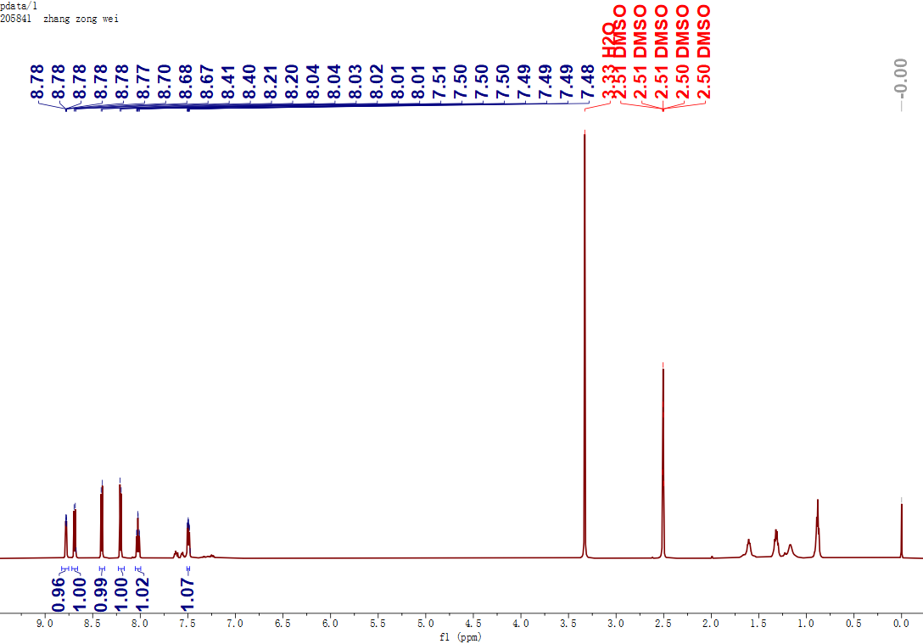
Figure S2. ¹H NMR spectrum of Compound 1 in DMSO-d₆.

Figure S3. ESI-MS spectrum of TPABP.

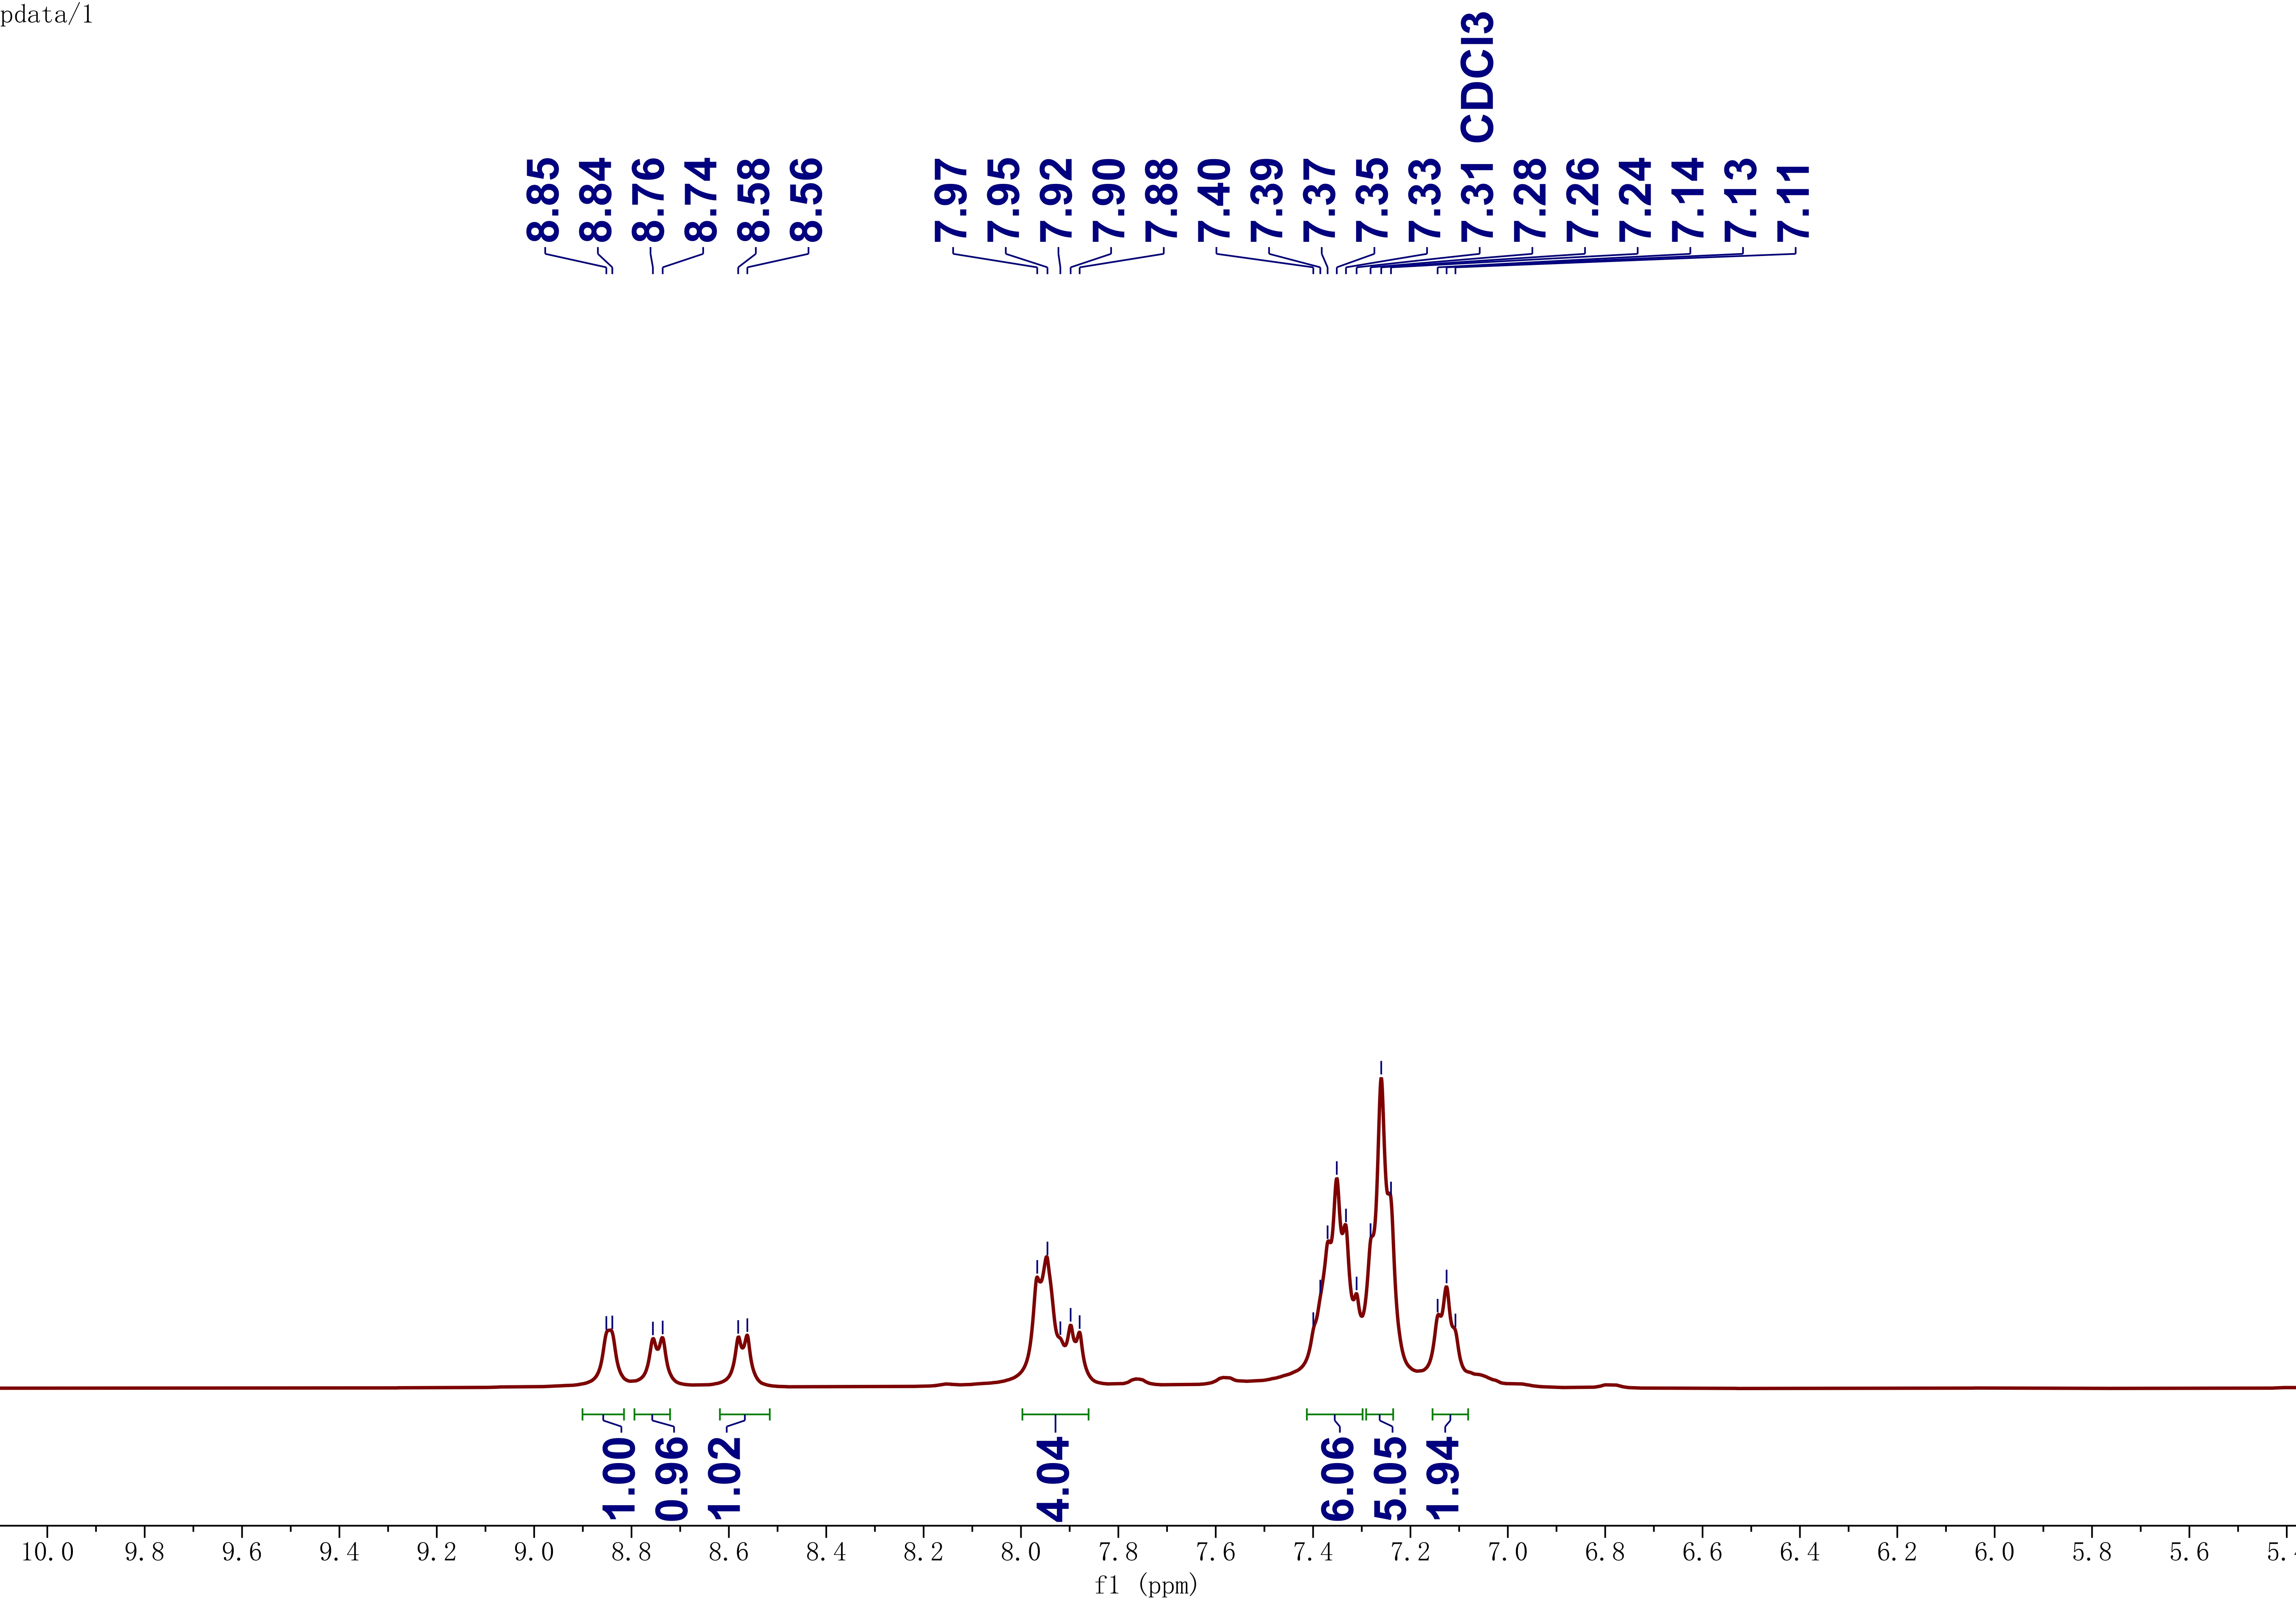
Figure S4. ¹H NMR spectrum of TPABP in CDCl₃.

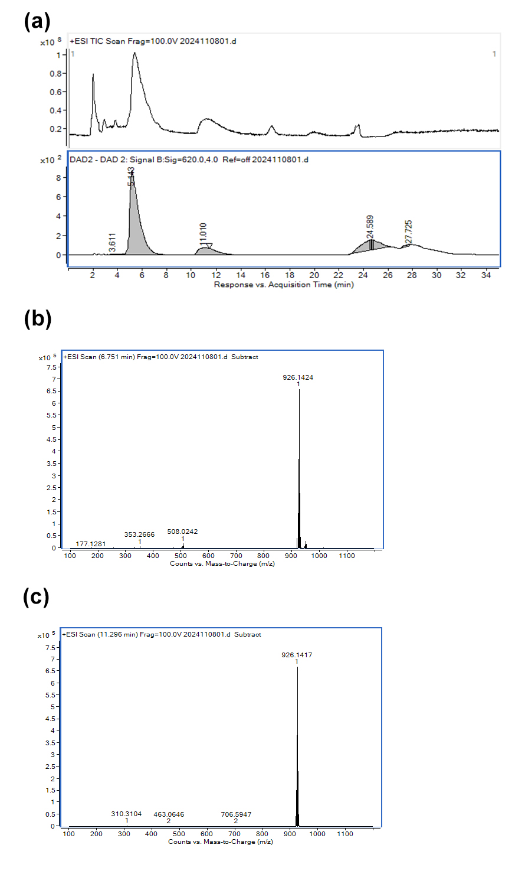
Figure S5. (a) The ESI TIC Scan and HPLC signal of Λ/Δ-Ru-TPABP; (b) and (c) ESI-MS spectrum of Ru-TPABP ([M+H] ⁺) at different times.

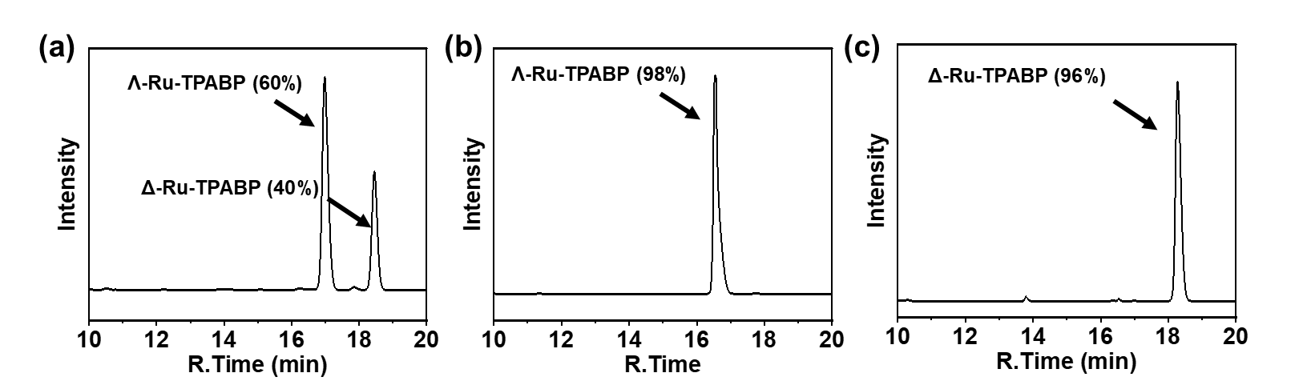
Figure S6. (a) HPLC chromatogram of Λ/Δ-Ru-TPABP before separation; (b, c) HPLC chromatograms of Λ/Δ-Ru-TPABP after chiral separation, confirming the successful isolation of the enantiomers.

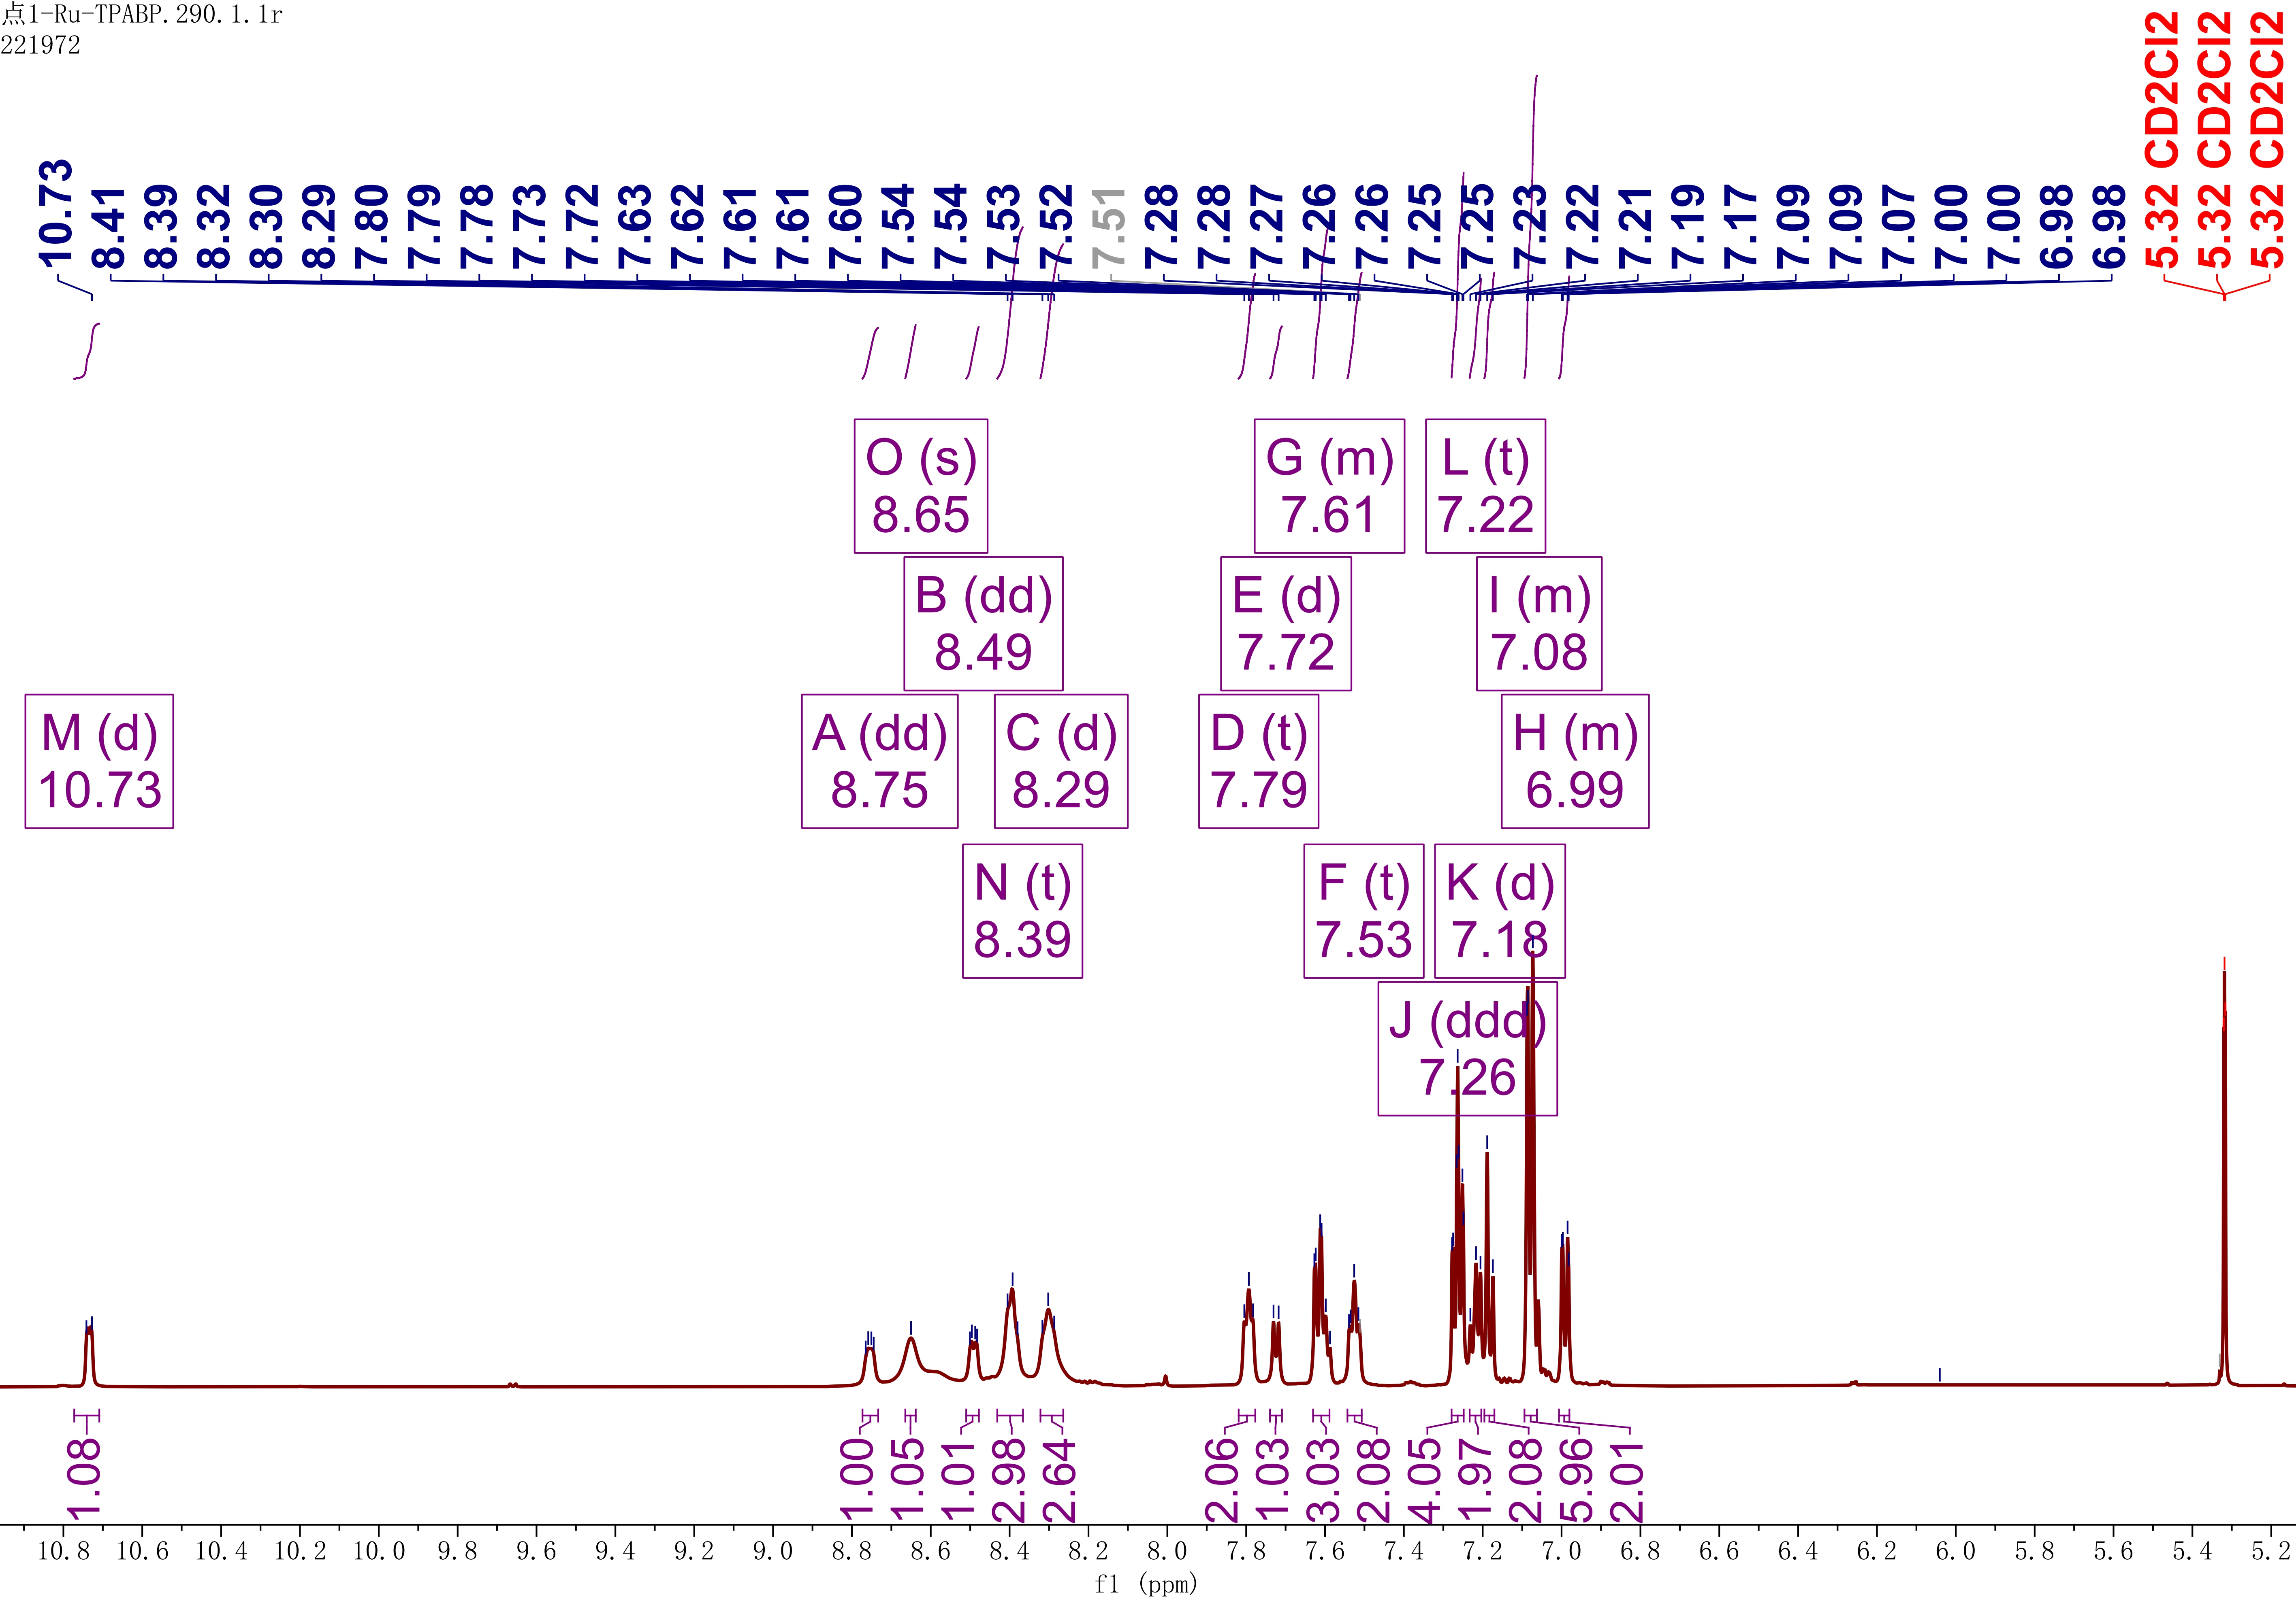
Figure S7. ¹H NMR spectrum of Λ-Ru-TPABP in CD₂Cl₂.
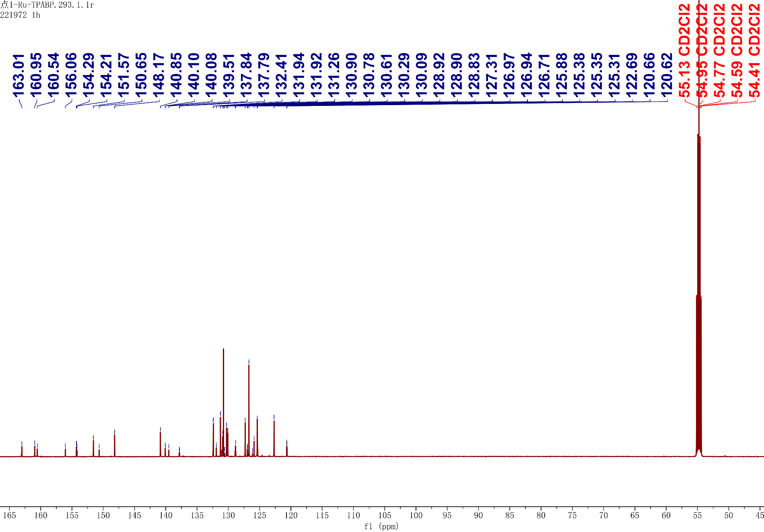
Figure S8. ¹³C NMR spectrum of Λ-Ru-TPABP in CD₂Cl₂.

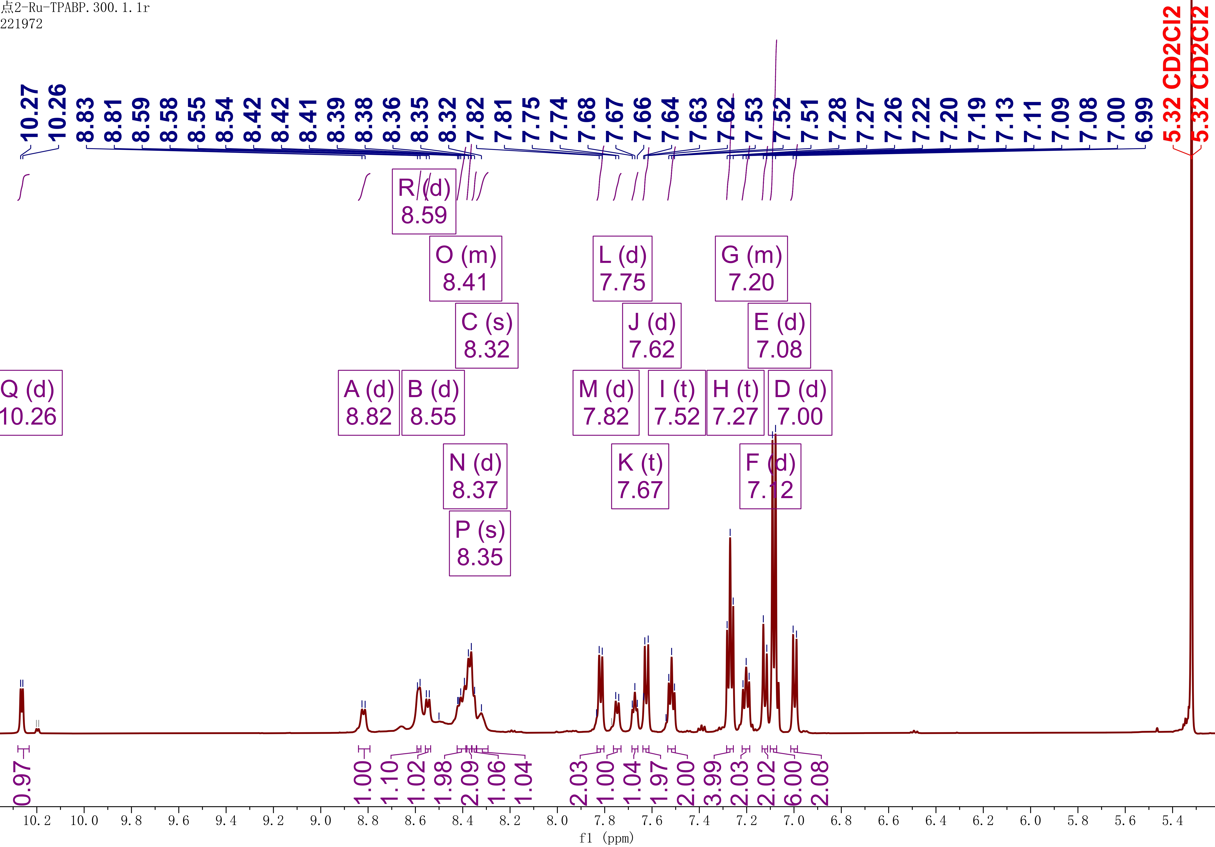
Figure S9. ¹H NMR spectrum of Δ-Ru-TPABP in CD₂Cl₂.

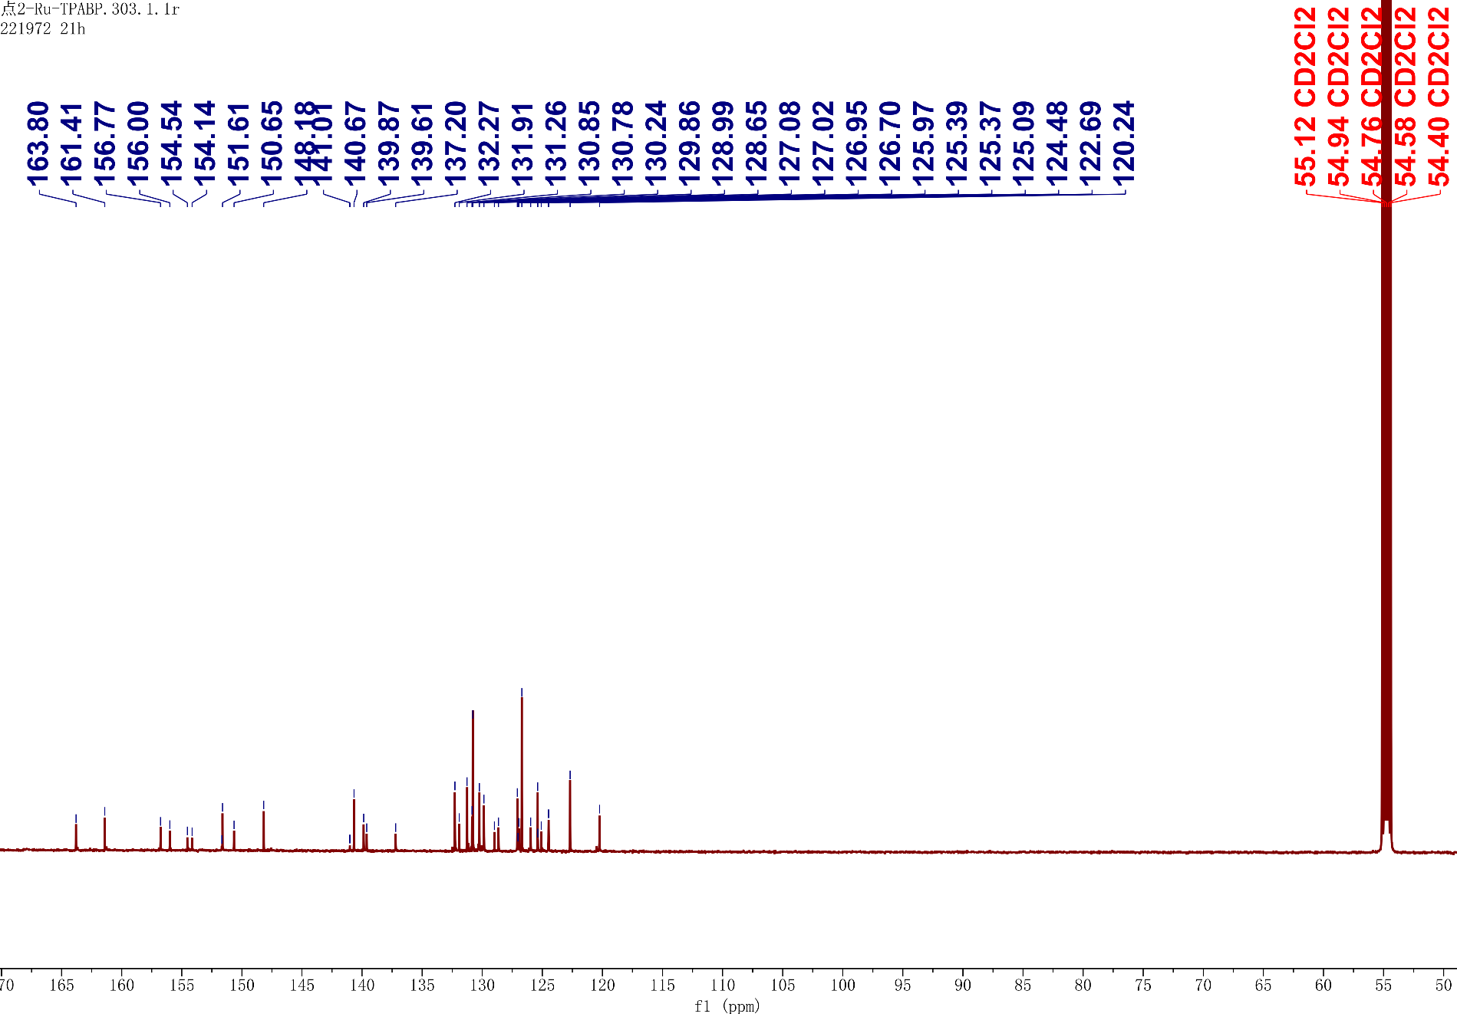
Figure S10. ¹³C NMR spectrum of Δ-Ru-TPABP in CD₂Cl₂.

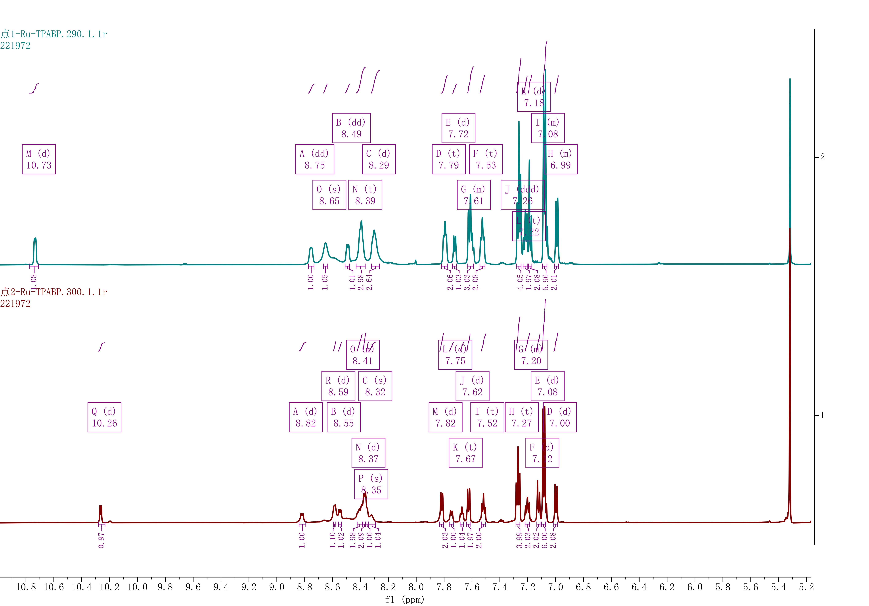
Figure S11. ¹H NMR spectrum of Λ-Ru-TPABP and Δ-Ru-TPABP in CD₂Cl₂.
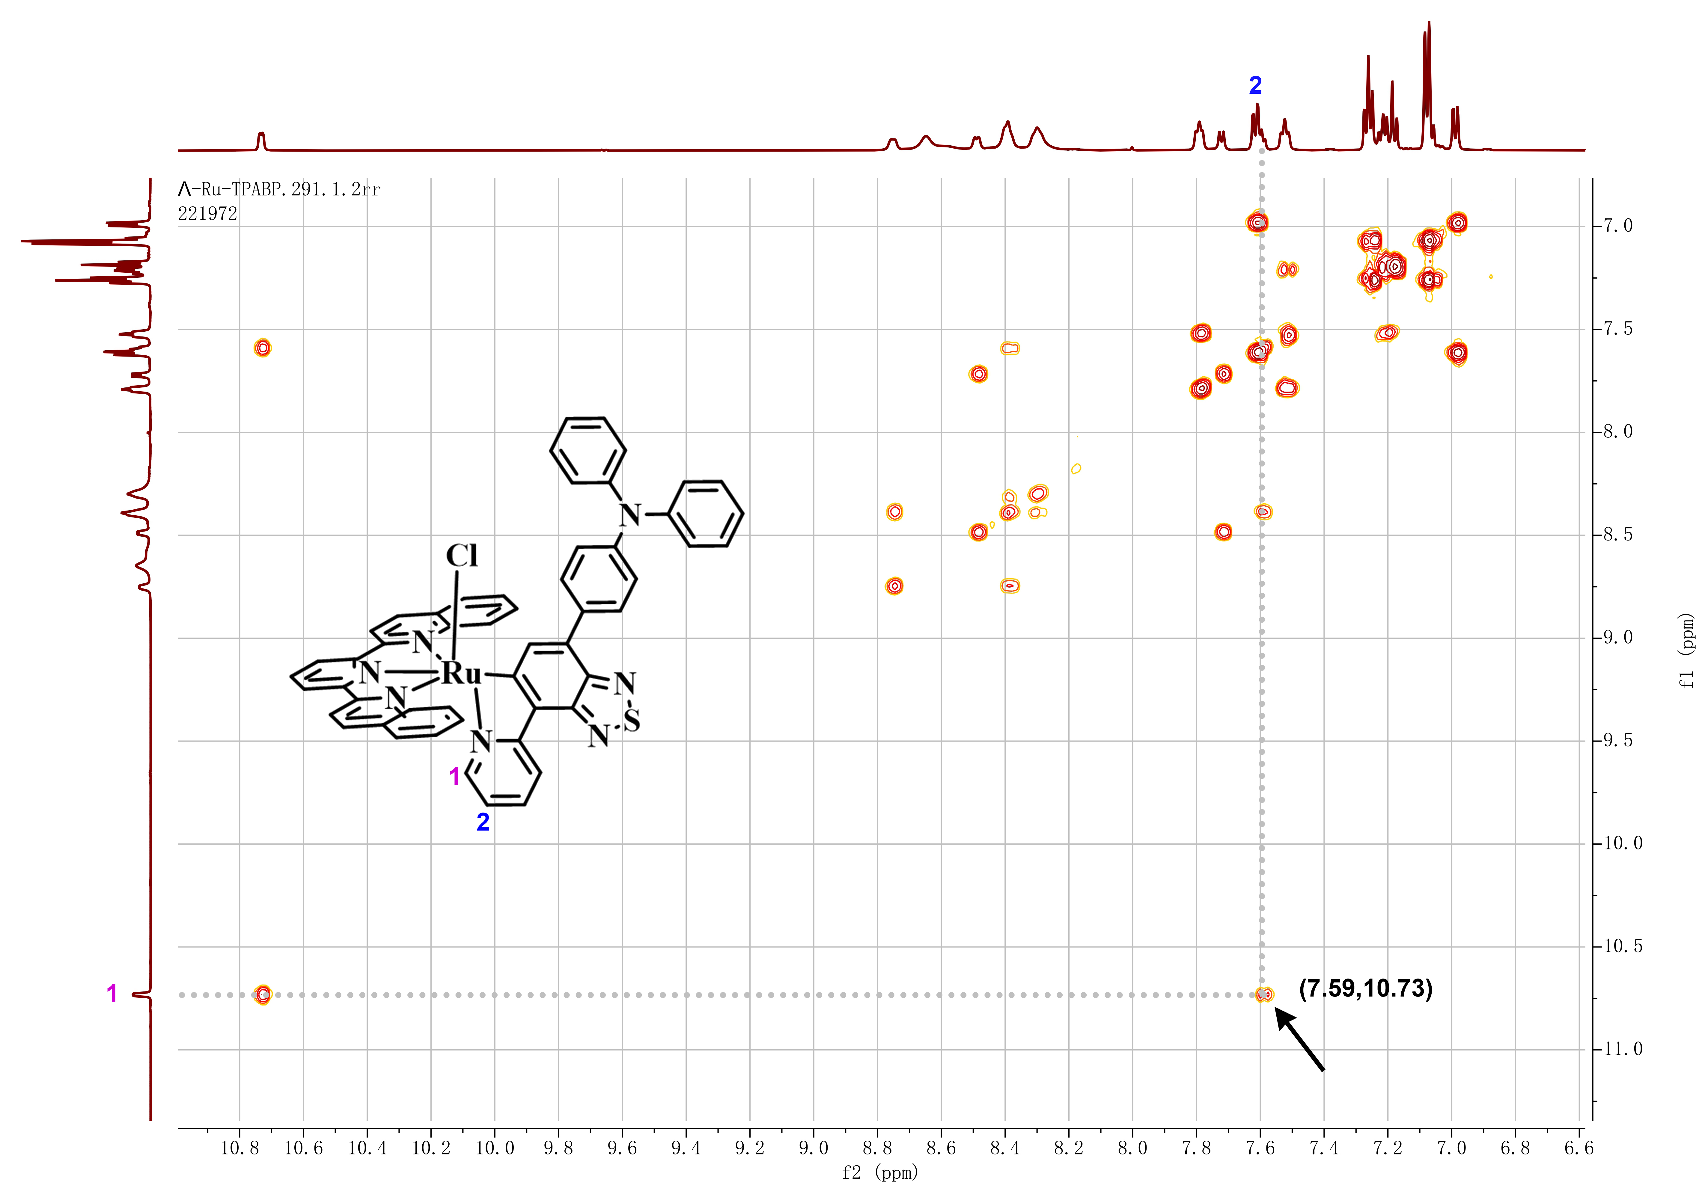
Figure S12. ¹H-¹H COSY spectrum of Λ-Ru-TPABP in CD₂Cl₂. Coordination of the pyridinic nitrogen to ruthenium (II) generates a deshielding effect that characteristically induces downfield shifts in the chemical shifts of H atom on adjacent carbons. For the dqpy ligand, the absence of H atom on the adjacent carbons to the coordinating pyridinic nitrogen precludes this possibility. Consequently, we unambiguously assign the downfield-shifted H1 (δ 10.73 ppm) to the ortho-position of TPABP's pyridine, which is further corroborated by its exclusive scalar coupling with a single upfield proton in the COSY spectrum.

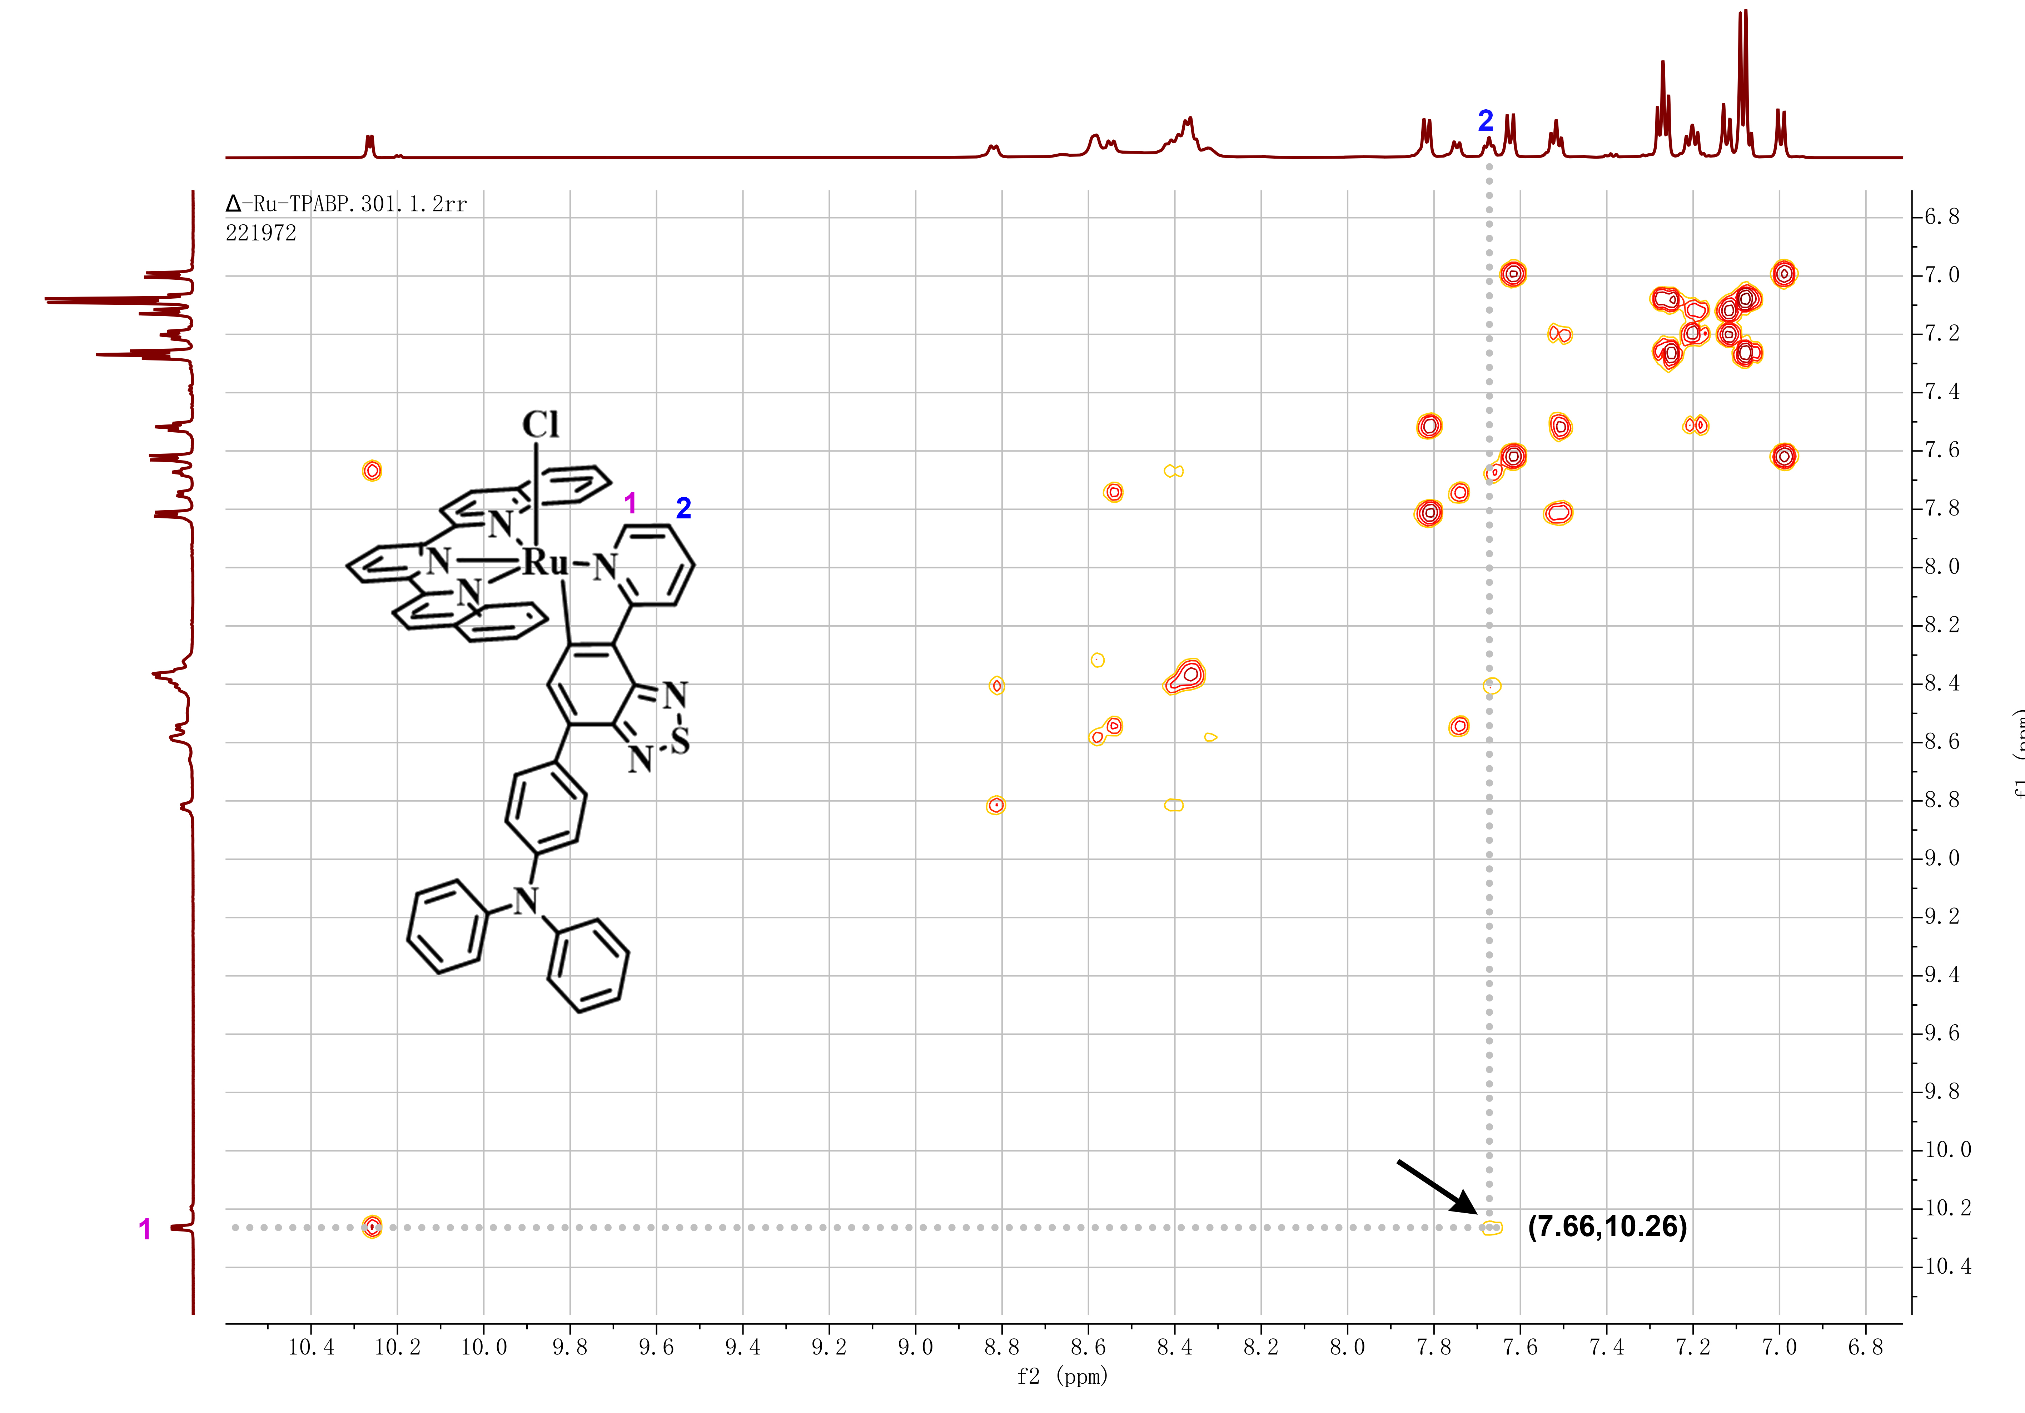
Figure S13. ¹H-¹H COSY spectrum of Δ-Ru-TPABP in CD₂Cl₂. Λ/Δ-Ru-TPABP exhibits distinct (f₂,f₁) between H1 and H2, confirming successful separation of the two configurations. However, COSY analysis alone cannot determine their absolute configurations, which were ultimately assigned by CD spectroscopy.

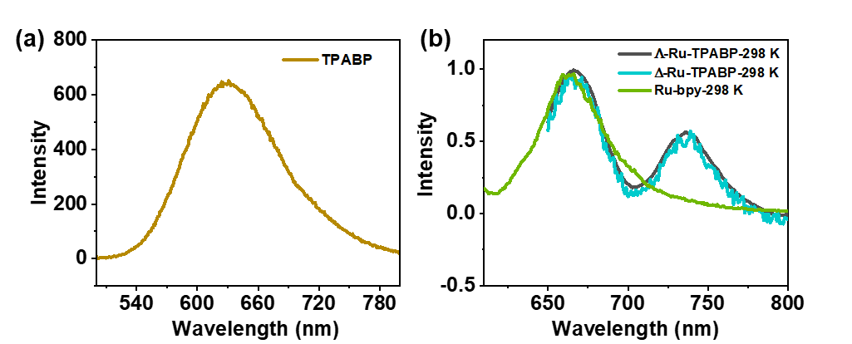
Figure S14. (a) Fluorescence emission spectrum of TPABP in dichloromethane at 298K; (b) Phosphorescence emission spectra of Λ/Δ-Ru-TPABP and Ru-bpy in dichloromethane at 298K.

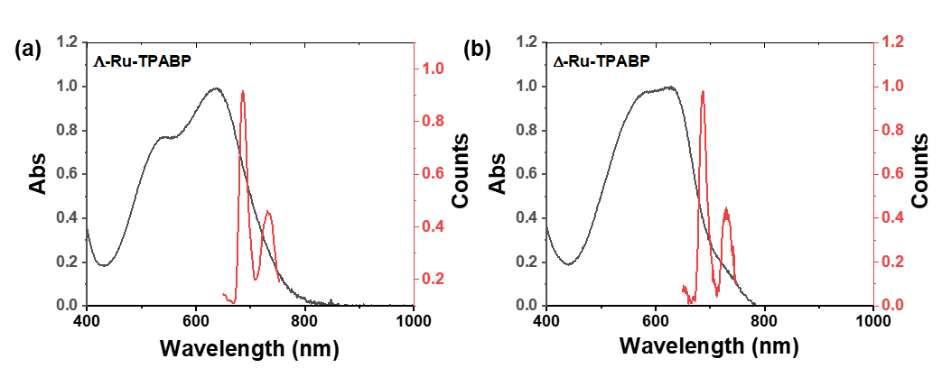
Figure S15. The absorption spectrum (298 K) and phosphorescence emission spectrum (77K) of Λ-Ru-TPABP(a) and Δ-Ru-TPABP(b) in dichloromethane:methanol (1:1 v/v).

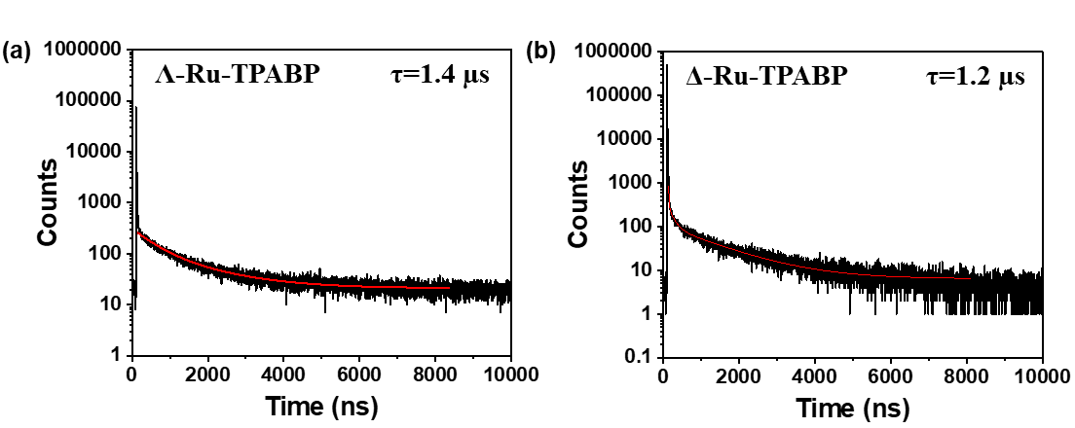
Figure S16. Phosphorescence lifetime of Λ-Ru-TPABP (a) and Δ-Ru-TPABP (b) in dichloromethane:methanol (1:1 v/v) at 77 K.

Table S1. Summary of the spectroscopic (λ_{max}>500 nm) and photophysical data of Λ/∆-Ru-TPABP and reported structure in nitrogen-sparged solvent at room temperature.⁵⁻⁹ According to the energy gap law, the triplet-state lifetime of cyclometalated Ru complexes decreases with reduced emission energy.¹⁰ Λ/∆-Ru-TPABP’s minimal Stokes shift (E_{max}-λ_{abs}) with long-wavelength absorption potentially promotes a longer lifetime than cyclometalated Ru complexes with larger Stokes shifts.
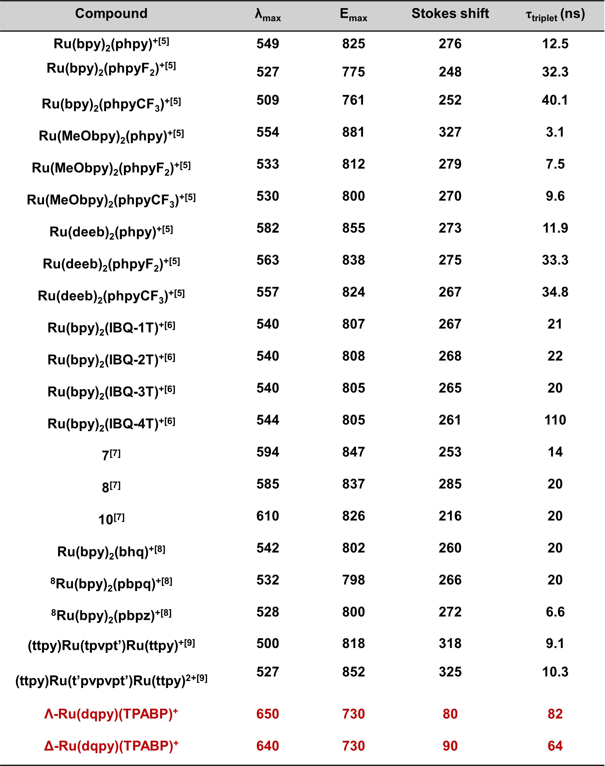

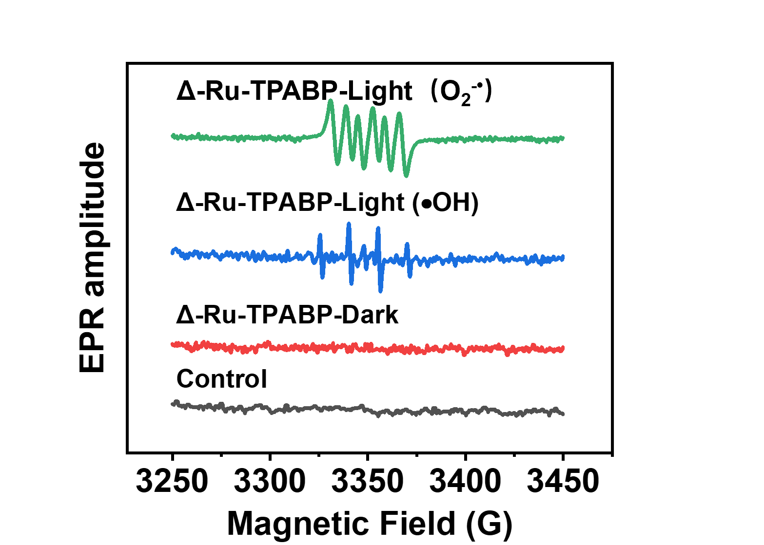
Figure S17. EPR signals of O₂^{−•} and •OH induced by Λ-Ru-TPABP under 700 nm irradiation (50 mW cm⁻², 10 min) in MeOH and H₂O, respectively.

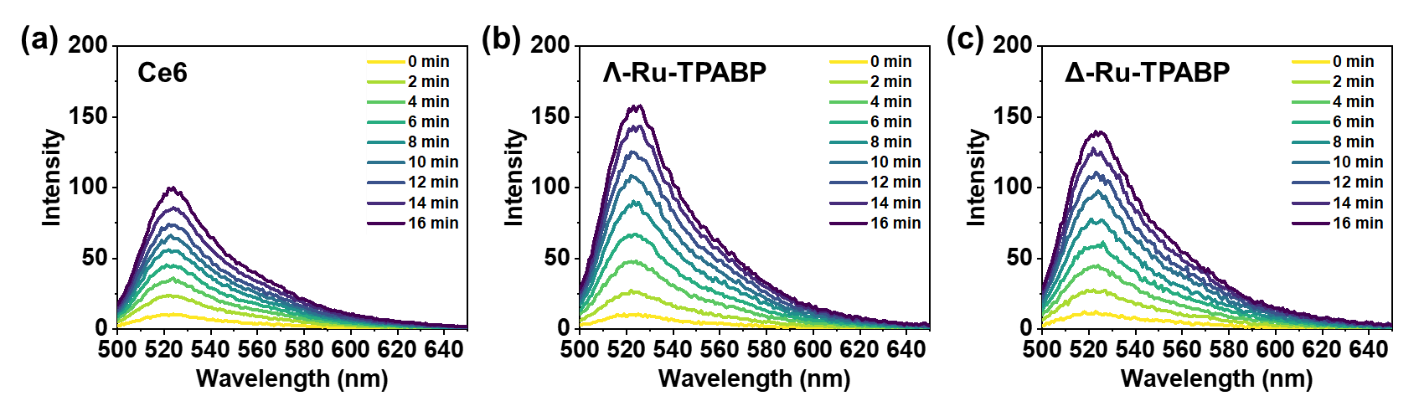
Figure S18. (a) The intensity of DCFH at 525 nm versus irradiation time in the presence of Ce6 (10 μM); (b, c) The intensity of DCFH at 525 nm versus irradiation time in the presence of Λ/Δ-Ru-TPABP (10 μM).

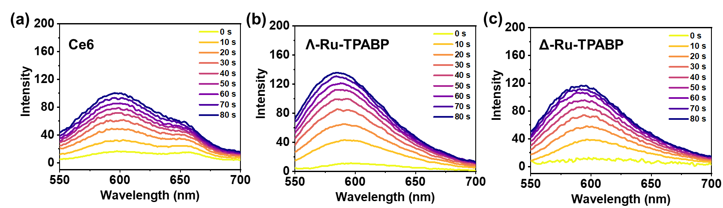
Figure S19. (a) The intensity of DHE at 610 nm versus irradiation time in the presence of Ce6 (10 μM) in water; (b) The intensity of DHE at 610 nm versus irradiation time in the presence of Λ/Δ-Ru-TPABP (10 μM) in water.

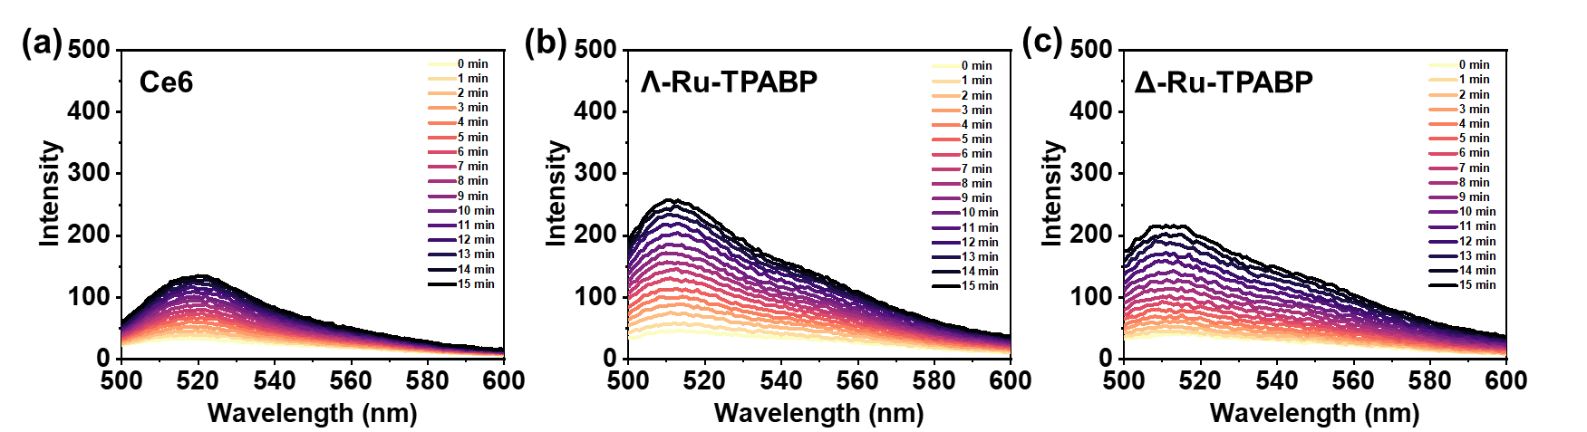
Figure S20. (a) The intensity of HPF at 510 nm versus irradiation time in the presence of Ce6 (10 μM) in water; (b, c) The intensity of HPF at 510 nm versus irradiation time in the presence of Λ/Δ-Ru-TPABP (10 μM) in water.

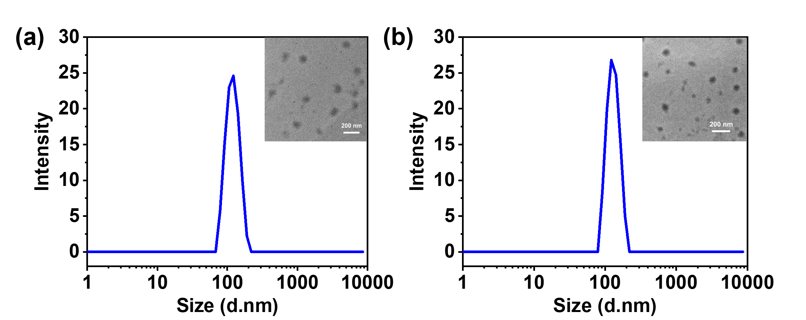
Figure S21. (a/b) The DLS and TEM image of the Λ/Δ-Ru-TPABP NPs.

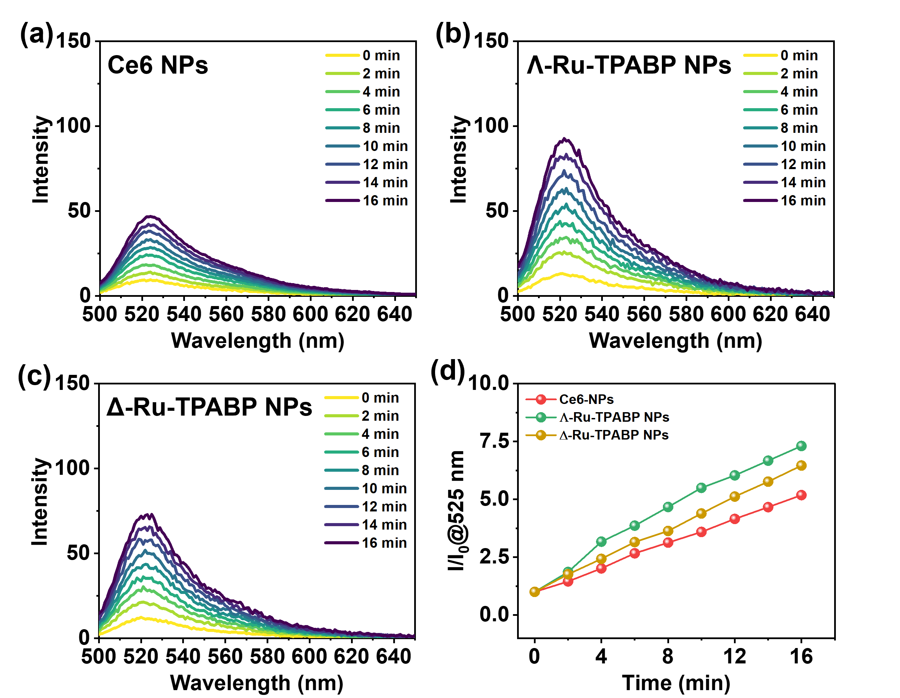
Figure S22. (a) The intensity of DCFH at 525 nm versus irradiation time in the presence of Ce6 NPs (10 μM). (b, c) The intensity of DCFH at 525 nm versus irradiation time in the presence of Λ/Δ-Ru-TPABP NPs (10 μM). (d) DCFH fluorescence activation rates by Ce6 NPs (660 nm, 20 mW cm⁻²), and Λ/∆-Ru-TPABP NPs (660 nm, 20 mW cm⁻²).

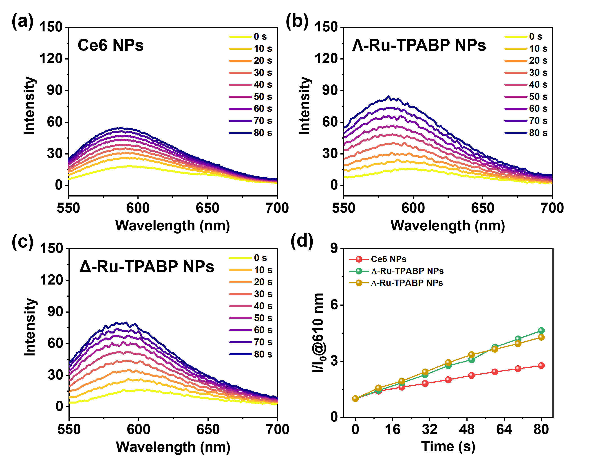
Figure S23. (a) The intensity of DHE at 525 nm versus irradiation time in the presence of Ce6 NPs (10 μM). (b, c) The intensity of DHE at 525 nm versus irradiation time in the presence of Λ/Δ-Ru-TPABP NPs (10 μM). (d) DHE fluorescence activation rates by Ce6 NPs (660 nm, 20 mW cm⁻²), and Λ/∆-Ru-TPABP NPs (660 nm, 20 mW cm⁻²).

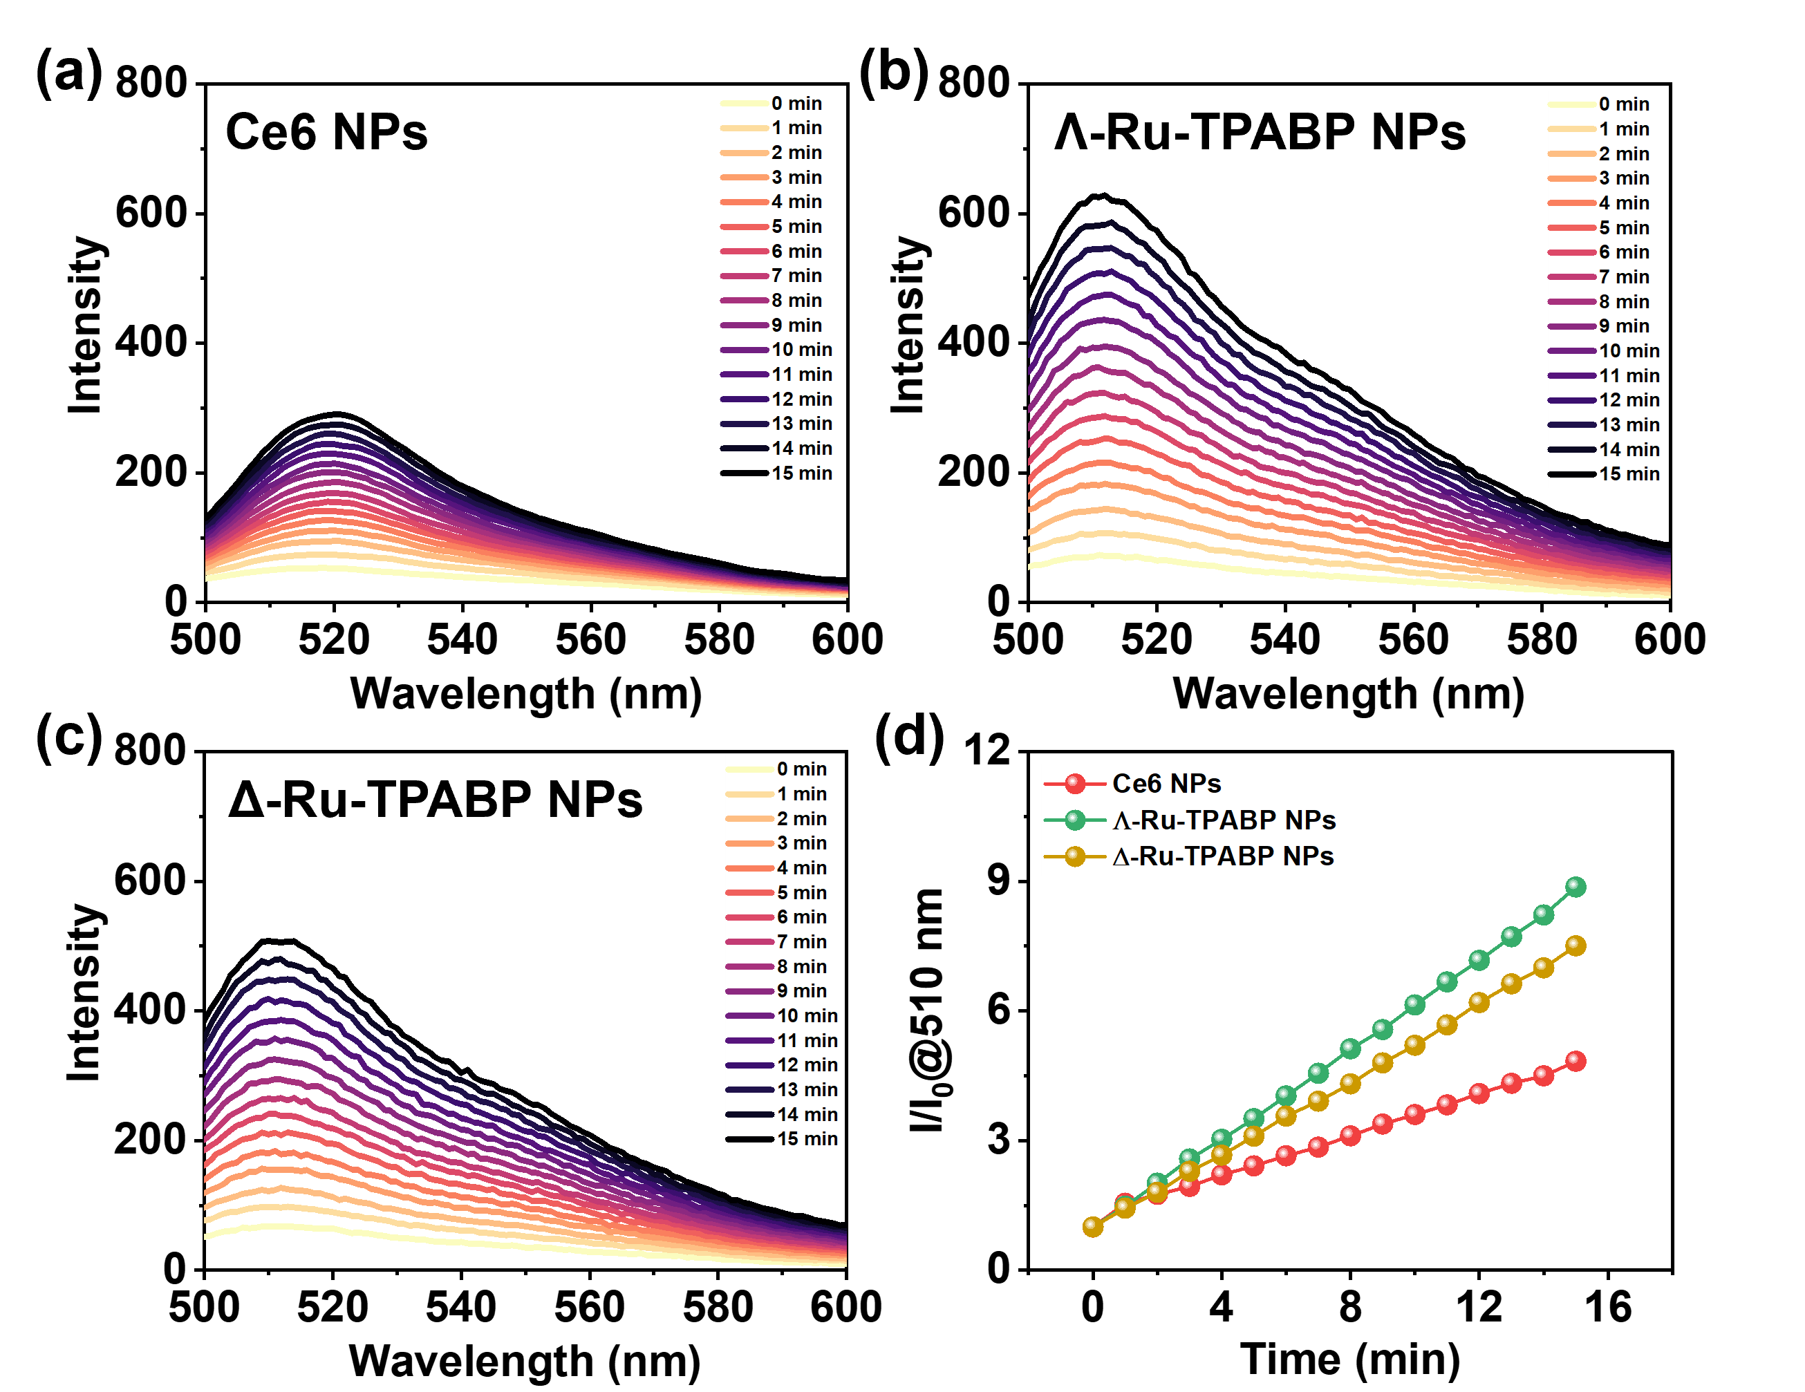
Figure S24. (a) The intensity of HPF at 510 nm versus irradiation time in the presence of Ce6 NPs (10 μM) in water; (b, c) The intensity of HPF at 510 nm versus irradiation time in the presence of Λ/Δ-Ru-TPABP NPs (10 μM) in water; (d) HPF fluorescence activation rates by Ce6 (660 nm, 20 mW cm⁻²), and Λ/∆-Ru-TPABP (660 nm, 20 mW cm⁻²).

Figure S25. Cyclic voltammetric curve of TPABP and Λ/Δ-Ru-TPABP.

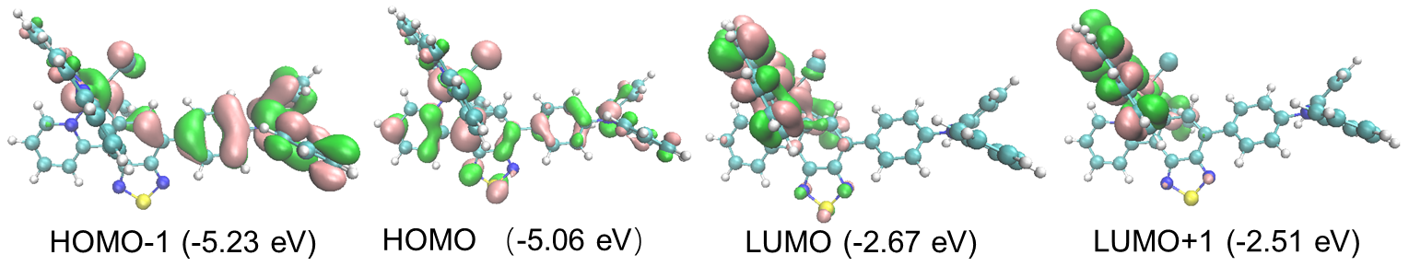
Figure S26. Frontier molecular orbitals from DFT calculations of Λ-Ru-TPABP in the ground state.

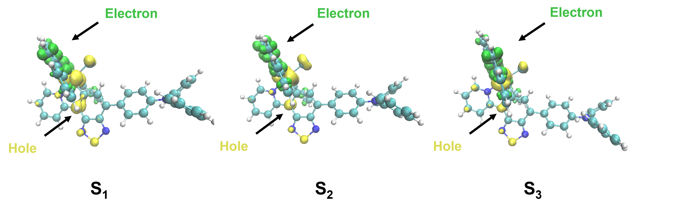
Figure S27. The hole (yellow) and electron (green) distribution of Λ-Ru-TPABP at S₁ S₂ and S₃.

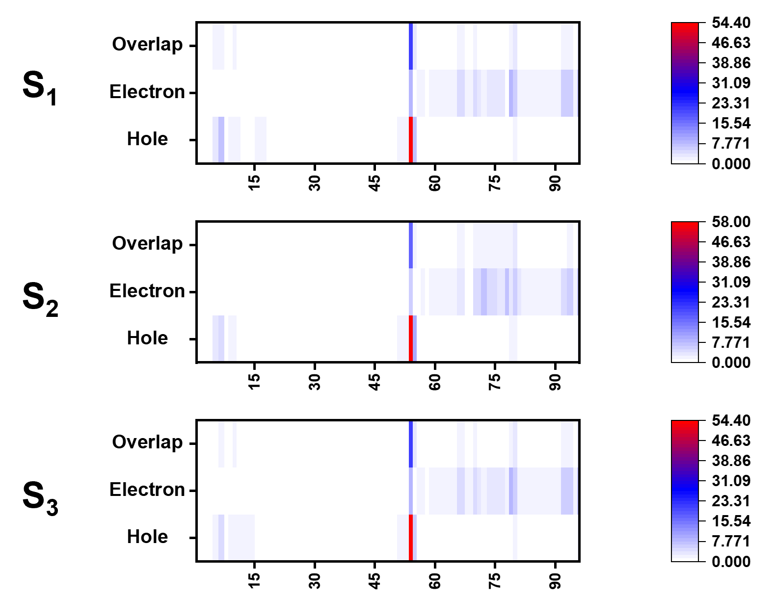
Figure S28. The heat map of Λ-Ru-TPABP hole-electron distribution at S₁ S₂ and S₃.
Table S2. The hole (yellow) and electron (green) distribution of Λ-Ru-TPABP at S₁ S₂ and S₃.
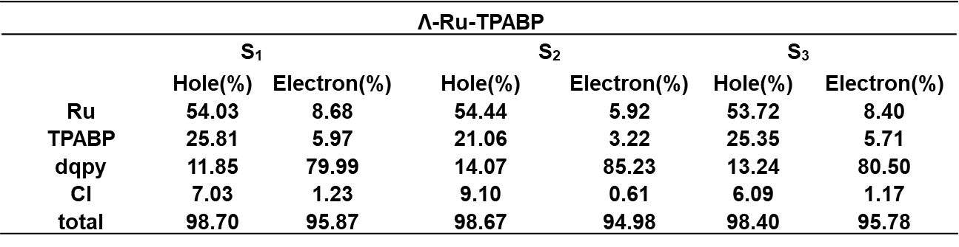

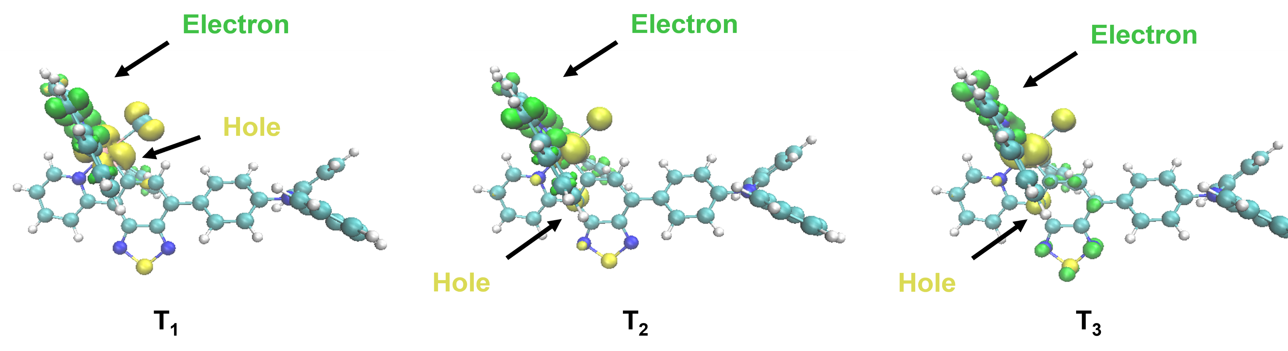
Figure S29. The hole (yellow) and electron (green) distribution of Λ-Ru-TPABP at T₁ T₂ and T₃.

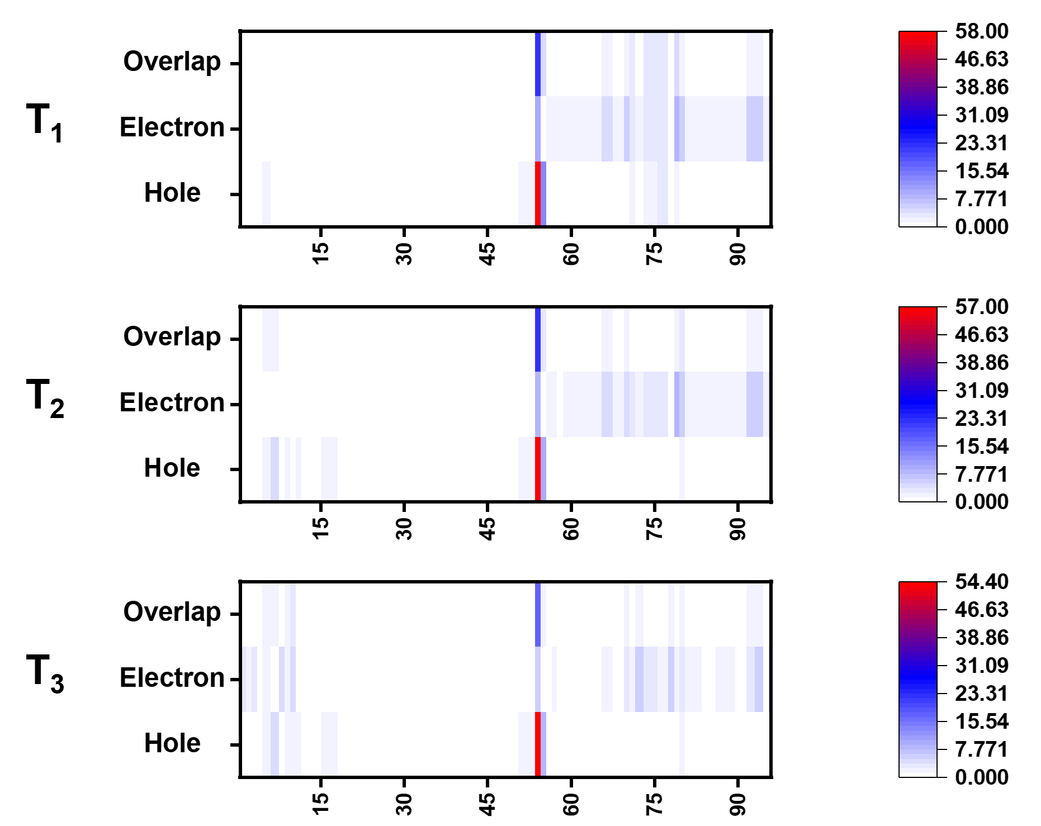
Figure S30. The heat map of Λ-Ru-TPABP hole-electron distribution at T₁ T₂ and T₃.
Table S3. The hole (yellow) and electron (green) distribution of Λ-Ru-TPABP at T₁ T₂ and T₃.
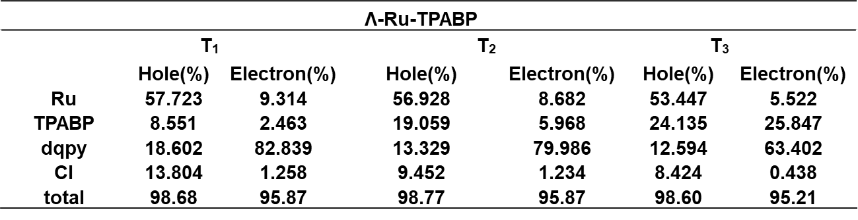

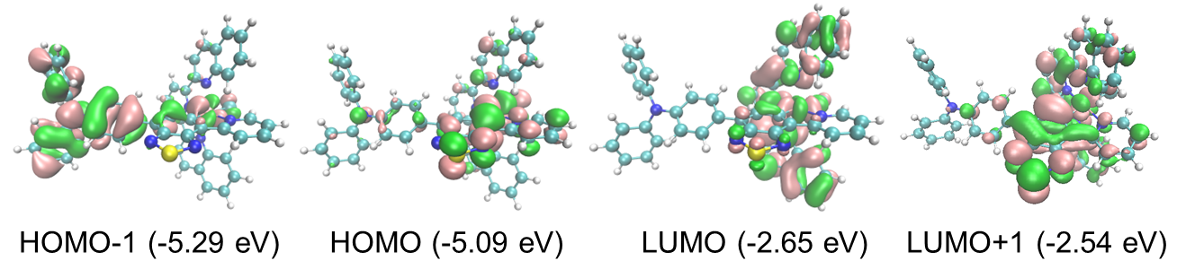
Figure S31. Frontier molecular orbitals from DFT calculations of Δ-Ru-TPABP in the ground state.

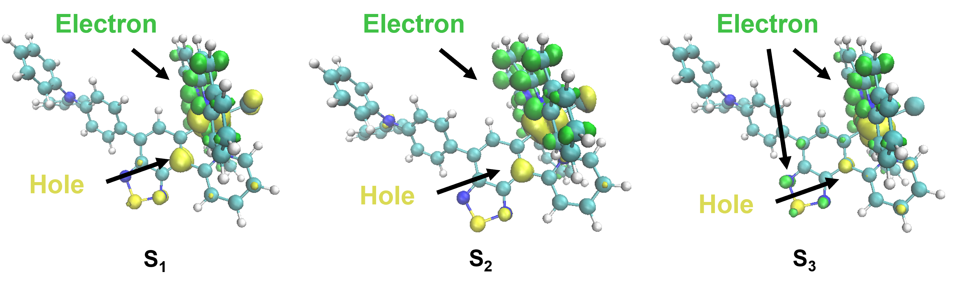
Figure S32. The hole (yellow) and electron (green) distribution of Δ-Ru-TPABP at S₁ S₂ and S₃.

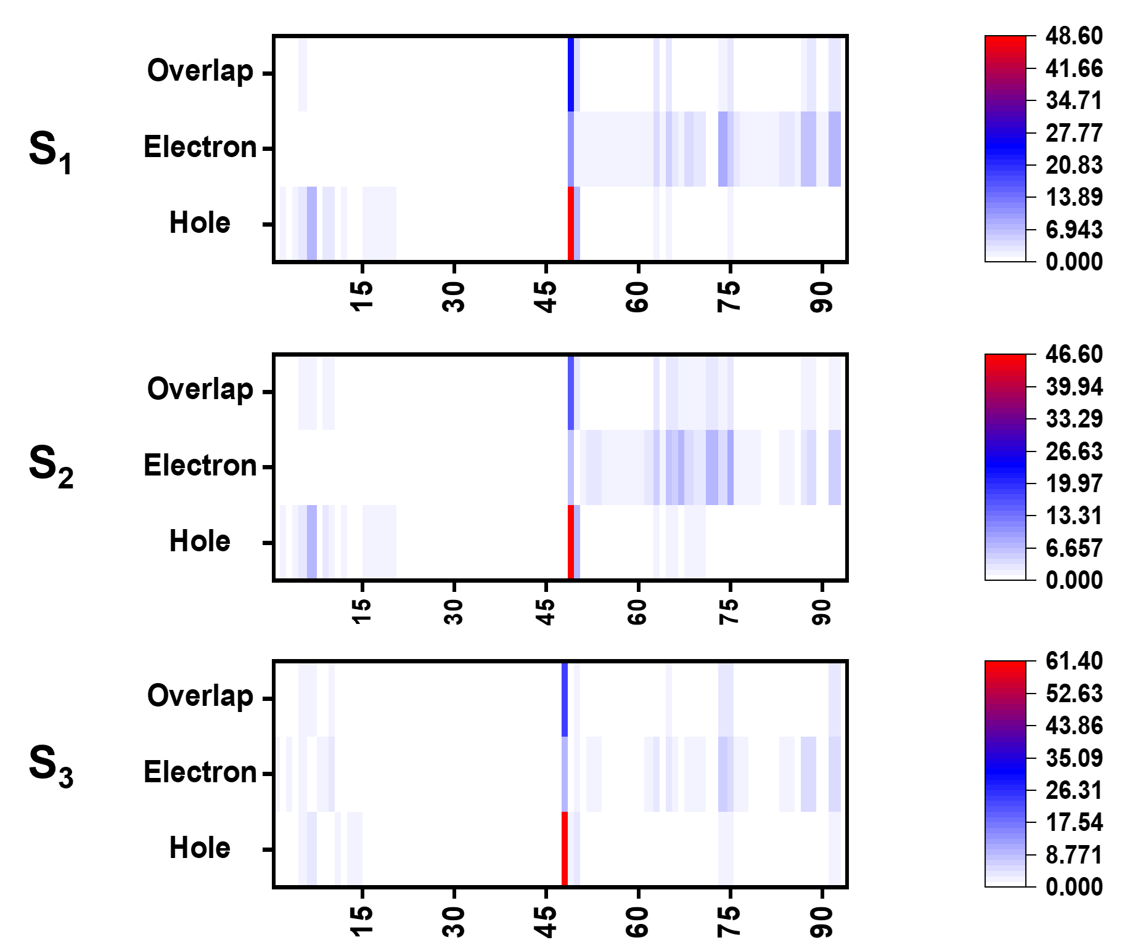
Figure S33. The heat map of Δ-Ru-TPABP hole-electron distribution at S₁ S₂ and S₃.
Table S4. The hole (yellow) and electron (green) distribution of Δ-Ru-TPABP at S₁ S₂ and S₃.
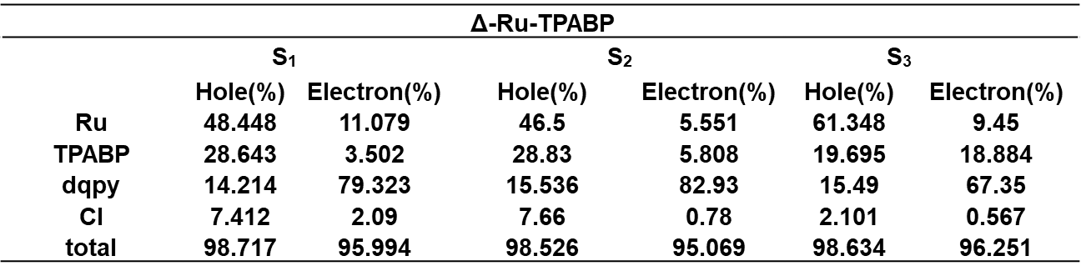

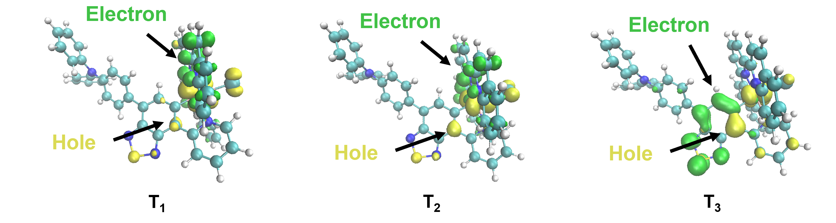
Figure S34. The hole (yellow) and electron (green) distribution of Δ-Ru-TPABP at T₁ T₂ and T₃.

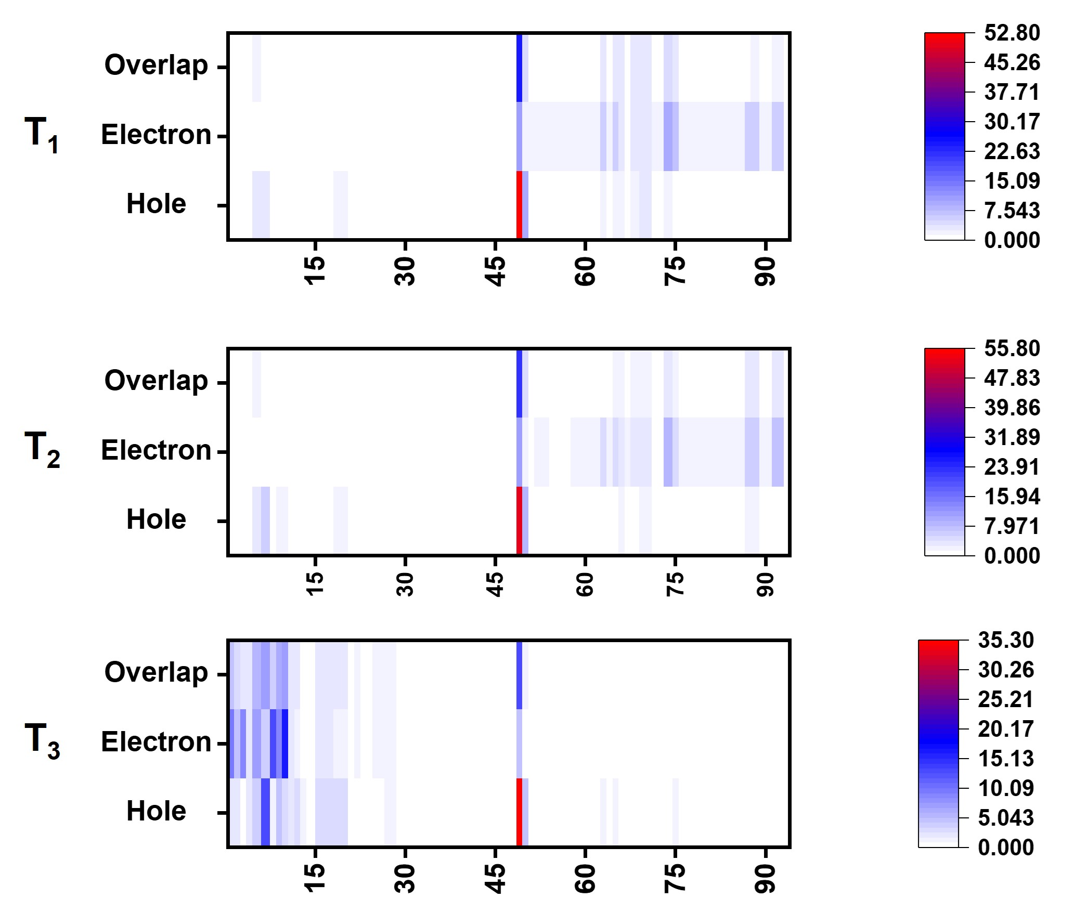
Figure S35. The heat map of Δ-Ru-TPABP hole-electron distribution at T₁ T₂ and T₃.

Table S5. The hole and electron distribution of Δ-Ru-TPABP at T₁ T₂ and T₃.
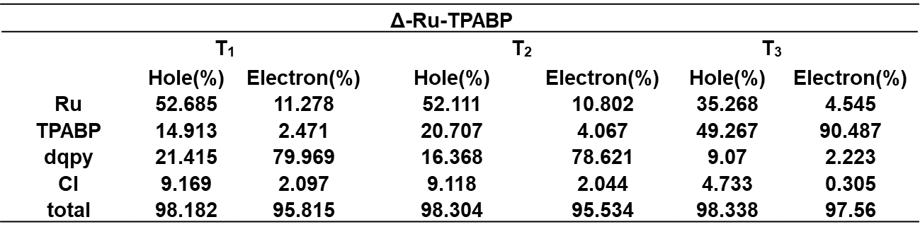

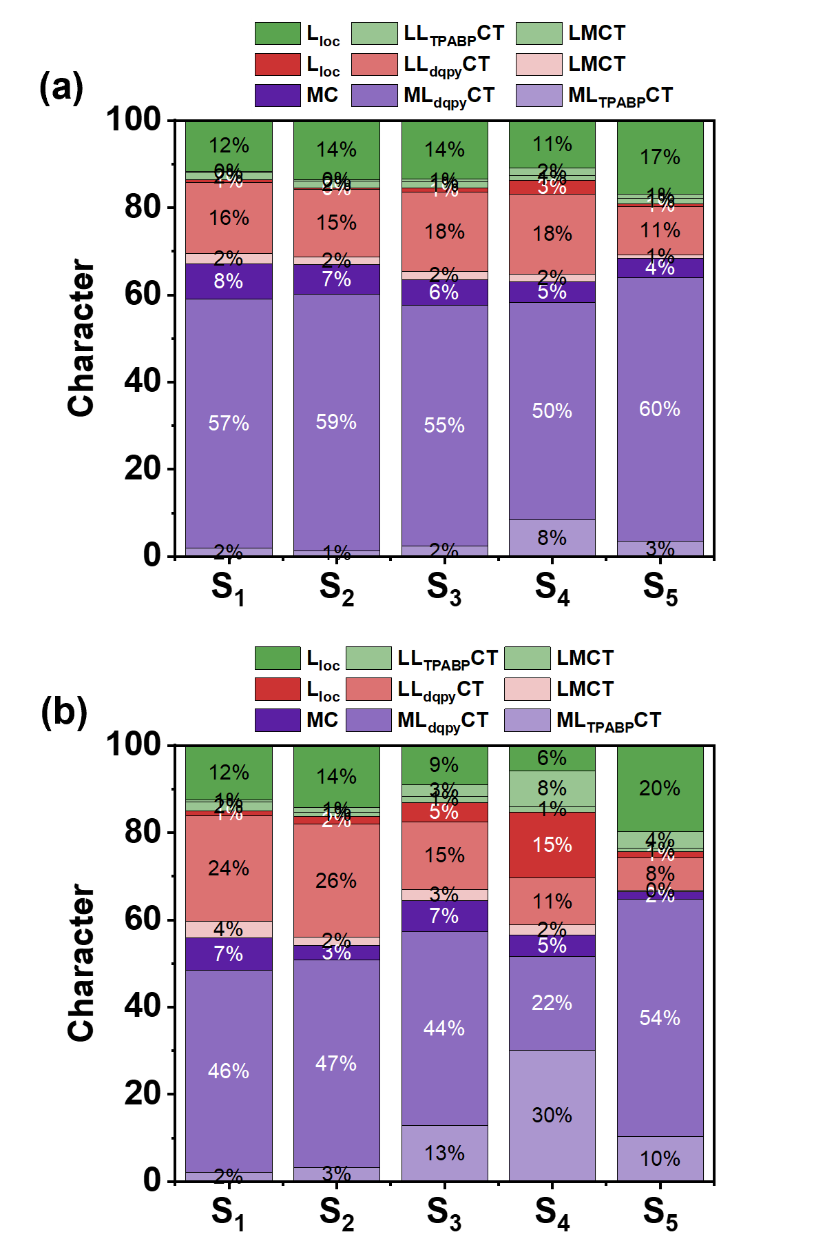
Figure S36. Decomposition analysis made with Multiwfn for the first five singlet excited states of Λ/Δ-Ru-TPABP (a and b) decomposed into contributions.

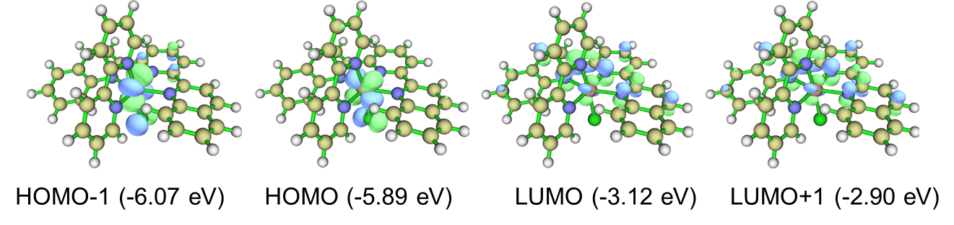
Figure S37. Frontier molecular orbitals from DFT calculations of Ru-bpy in the ground state.

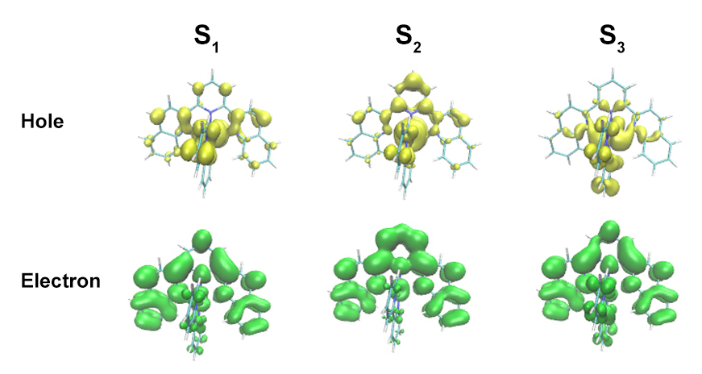
Figure S38. The hole (yellow) and electron (green) distribution of Ru-bpy at S₁ S₂ S₃.

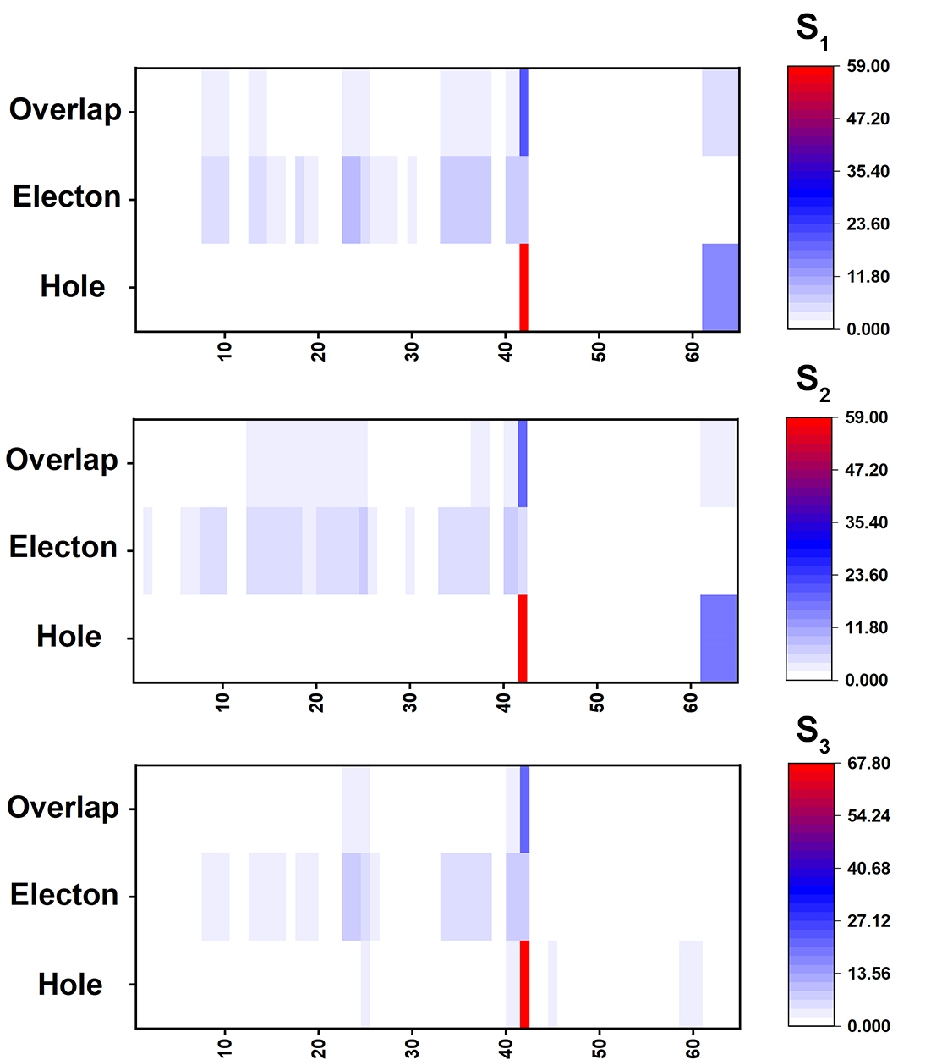
Figure S39. Heat maps of the hole−electron distributions of Ru-bpy at S₁ S₂ and S₃.

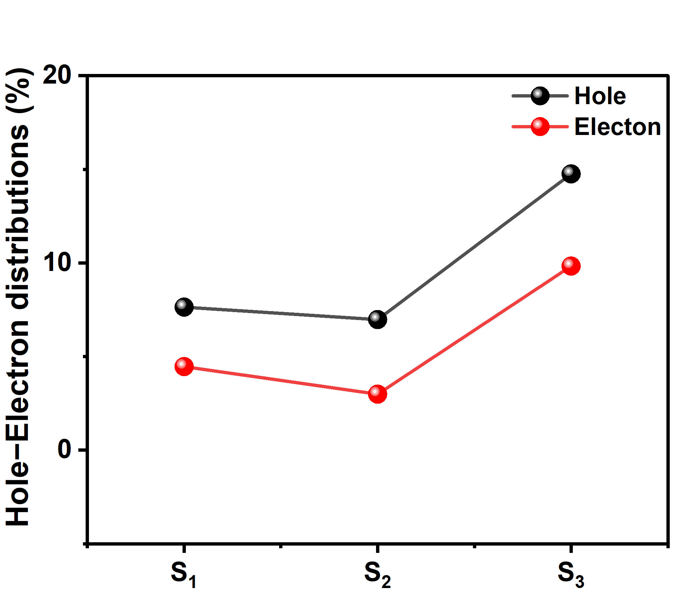
Figure S40. The hole−electron distributions of bpy in different excited states of Ru-bpy.

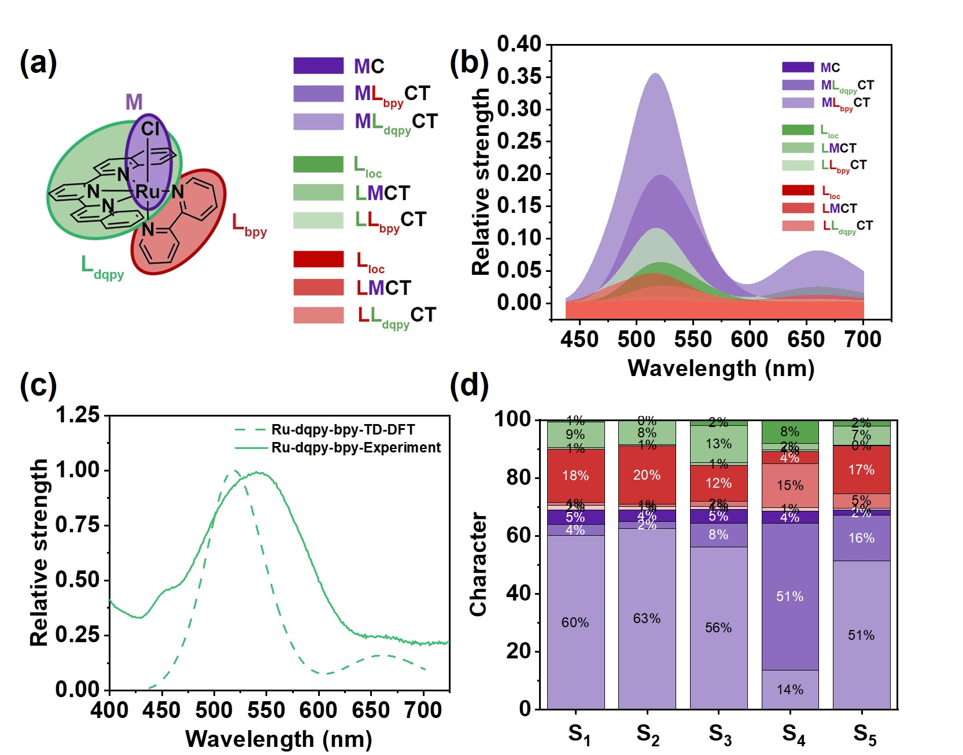
Figure S41．(a) Fragmentation of the complex used in the transition-density matrix analysis; (b) Electronic character of states contributing to the spectrum; (c) Comparison of experimental absorption spectrum and calculated absorption spectrum of Ru-bpy in DCM. (d) Decomposition analysis made with Multiwfn for the first five singlet excited states of Ru-bpy decomposed into contributions.

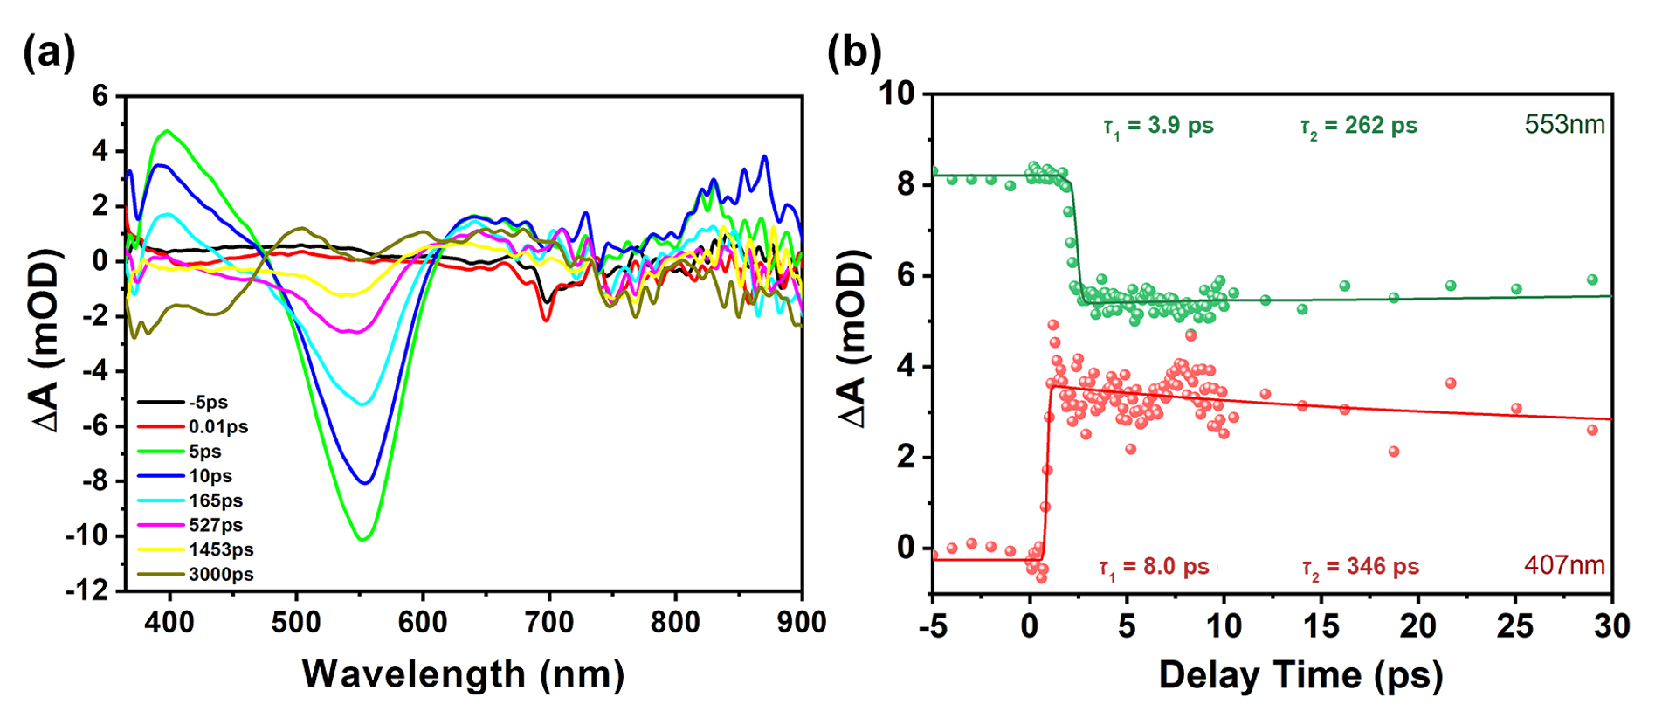
Figure S42. (a) Femtosecond transient absorption spectroscopy (fs-TA) analysis for Ru-bpy at different pump-probe delay times. Different color lines represent spectra at different times, λ_{ex} = 350 nm; (b) Kinetic traces and fitting lines of Ru-bpy at 407 nm and 533 nm. The construction was similar to the reported method.¹¹

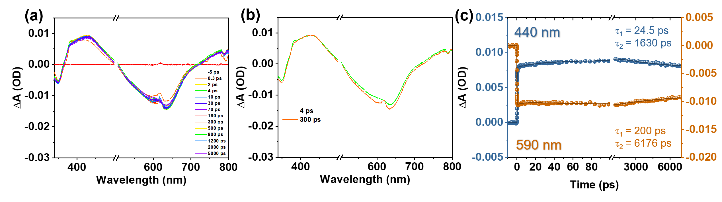
Figure S43. (a) Femtosecond time-resolved transient-absorption spectra of Λ-Ru-TPABP; (b) representative transient-absorption spectra of Λ-Ru-TPABP; (c) representative kinetic traces under N₂ in DCM upon excitation by 620 nm.

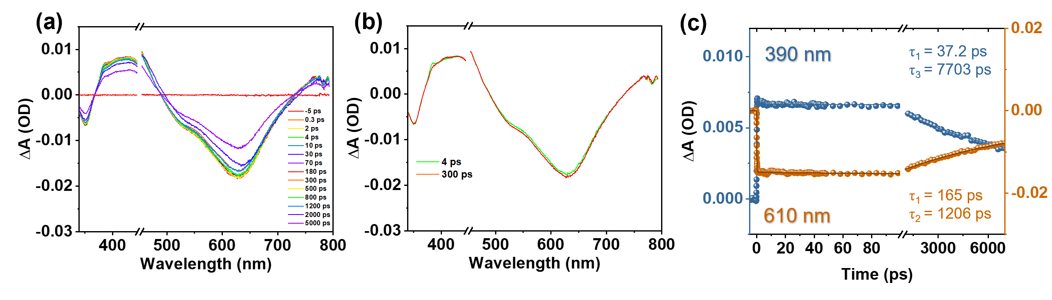
Figure S44. (a) Femtosecond time-resolved transient-absorption spectra of Δ-Ru-TPABP; (b) representative transient-absorption spectra of Δ-Ru-TPABP; (c) representative kinetic traces under N₂ in DCM upon excitation by 620 nm.

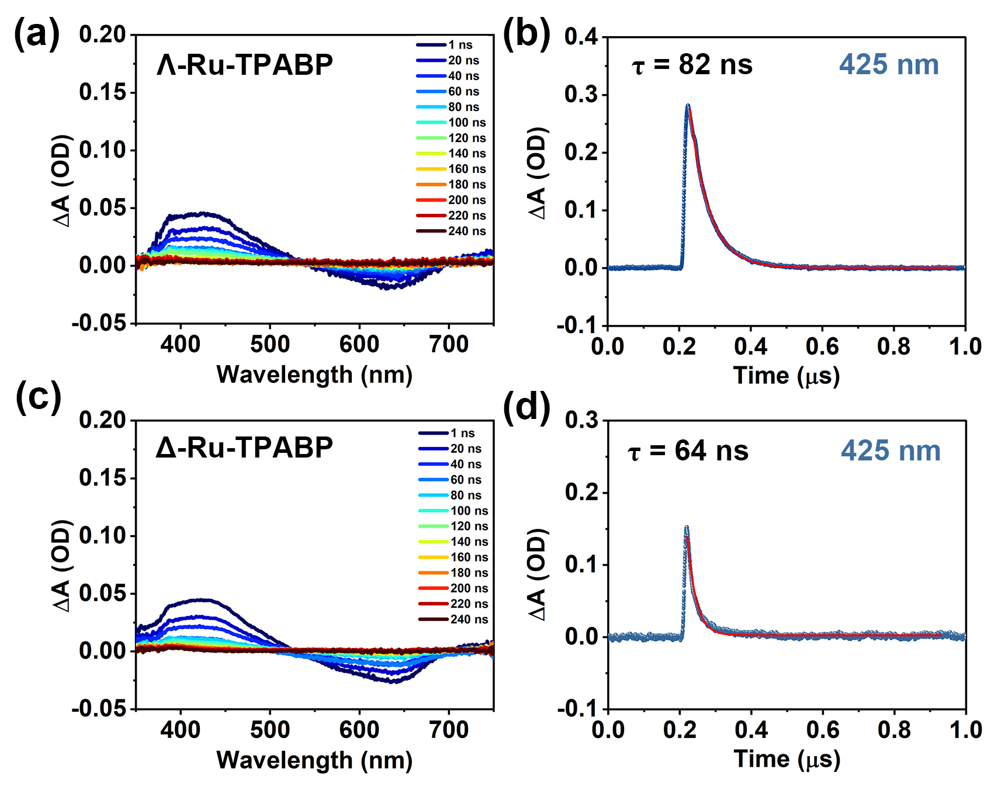
Figure S45. Nanosecond time-resolved transient-absorption (TA) spectra of Λ/Δ-Ru-TPABP (a, c), and representative kinetic traces (b, d) under N₂ in DCM excited by 532 nm.

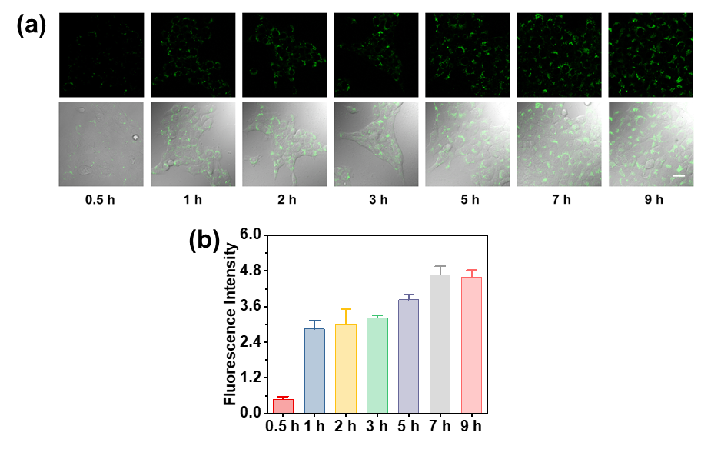
Figure S46. (a) Confocal fluorescence imaging of 4T1 cells incubated Λ-Ru-TPABP NPs for different time ($λ_{ex}$= 488 nm, $λ_{em}$= 530-560 nm). Scale bar : 30 μm; (b) Intracellular fluorescence intensity changes with incubation time.

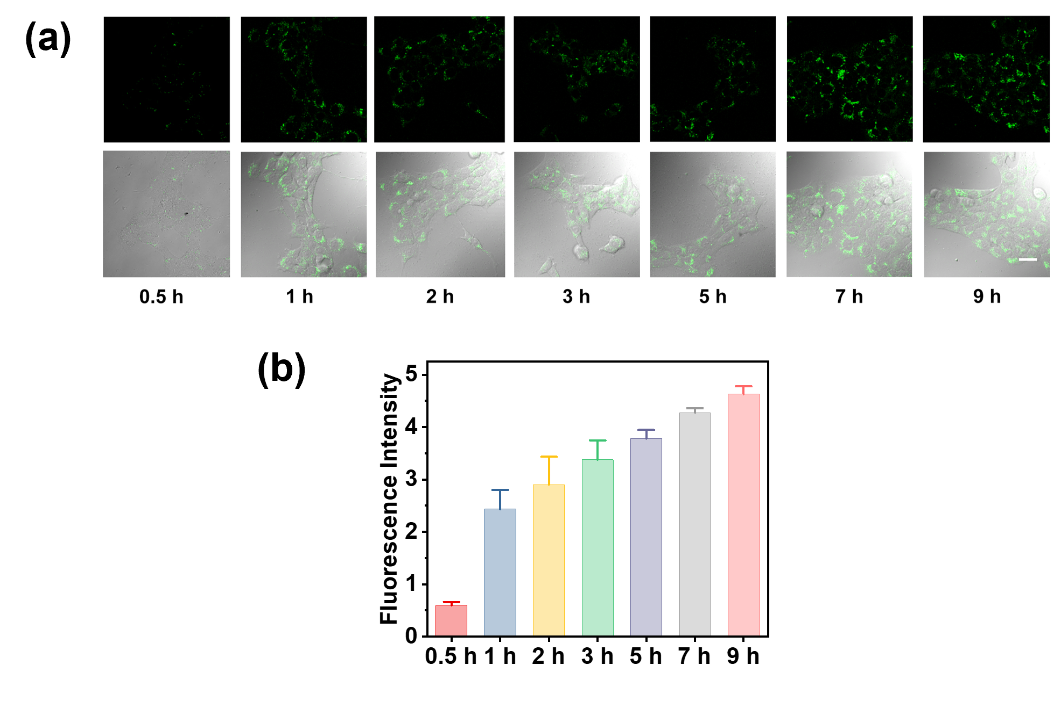
Figure S47. (a) Confocal fluorescence imaging of 4T1 cells incubated Δ-Ru-TPABP NPs for different time ($λ_{ex}$= 488 nm, $λ_{em}$= 530-560 nm). Scale bar : 30 μm; (b) Intracellular fluorescence intensity changes with incubation time.

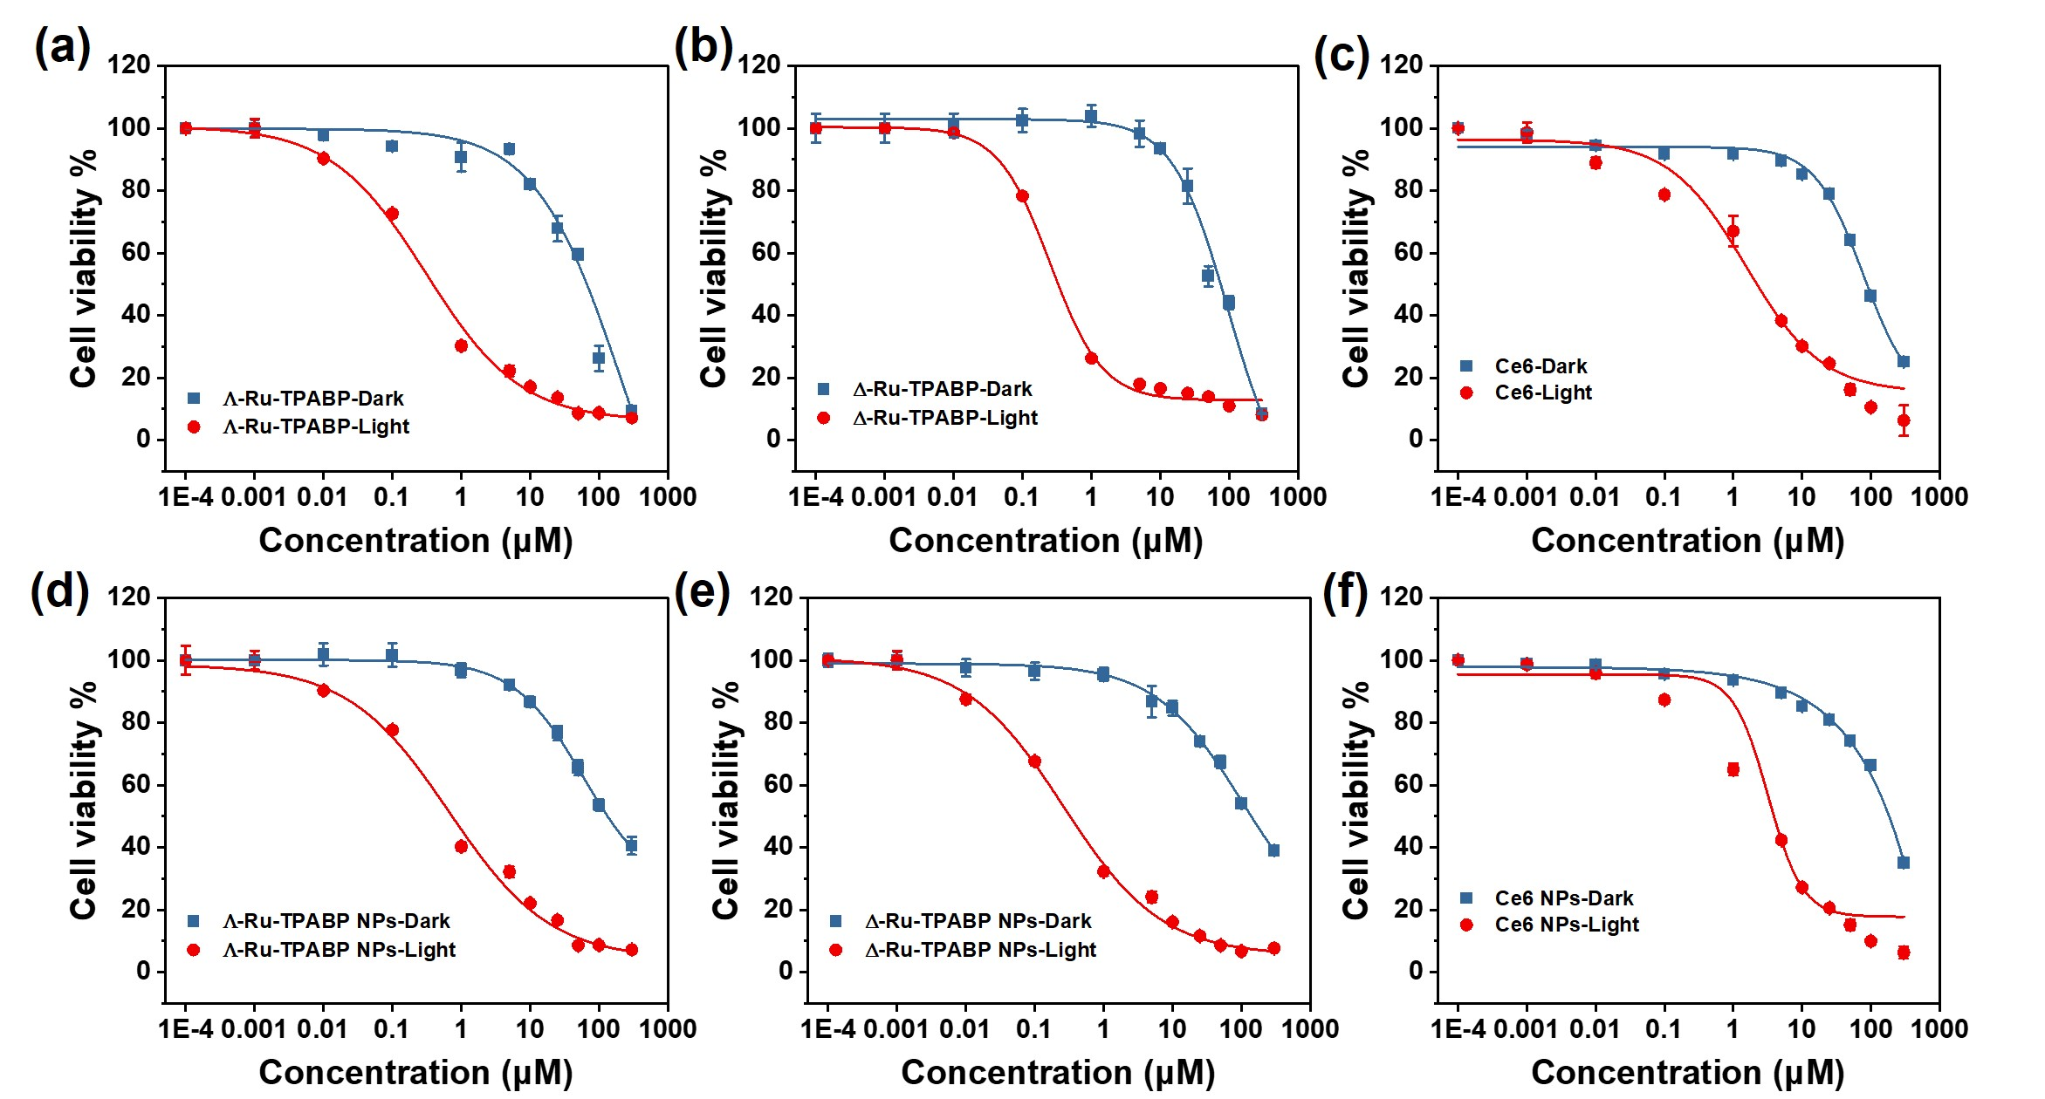
Figure S48. Dose-response curves for chromatic (photo)cytotoxicity screening of Λ-Ru-TPABP and Λ-Ru-TPABP NPs (a, d), Δ-Ru-TPABP and Δ-Ru-TPABP NPs (b, e), and Ce6 and Ce6 NPs (c, f) in 4T1 cells under normoxic conditions (21% O₂).

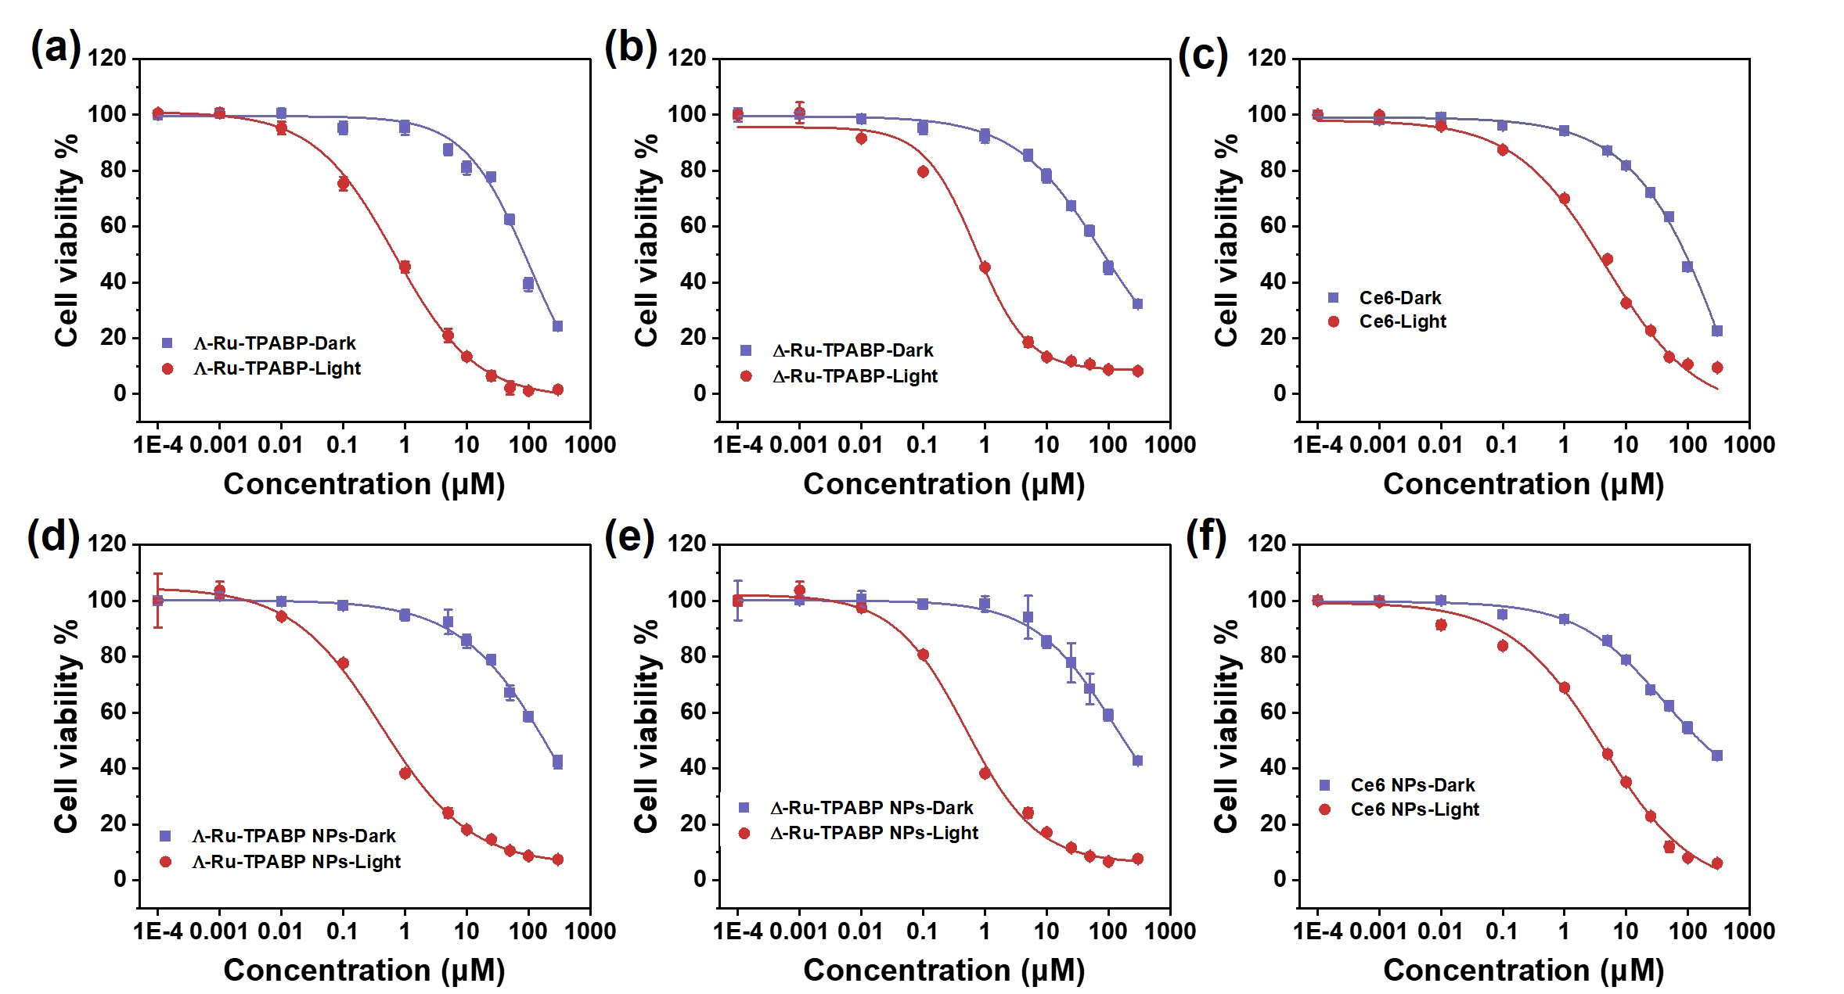
Figure S49. Dose-response curves for chromatic (photo)cytotoxicity screening of Λ-Ru-TPABP and Λ-Ru-TPABP NPs (a, d), Δ-Ru-TPABP and Δ-Ru-TPABP NPs (b, e), and Ce6 and Ce6 NPs (c, f) in MCF-7 cells under normoxic conditions (21% O₂).

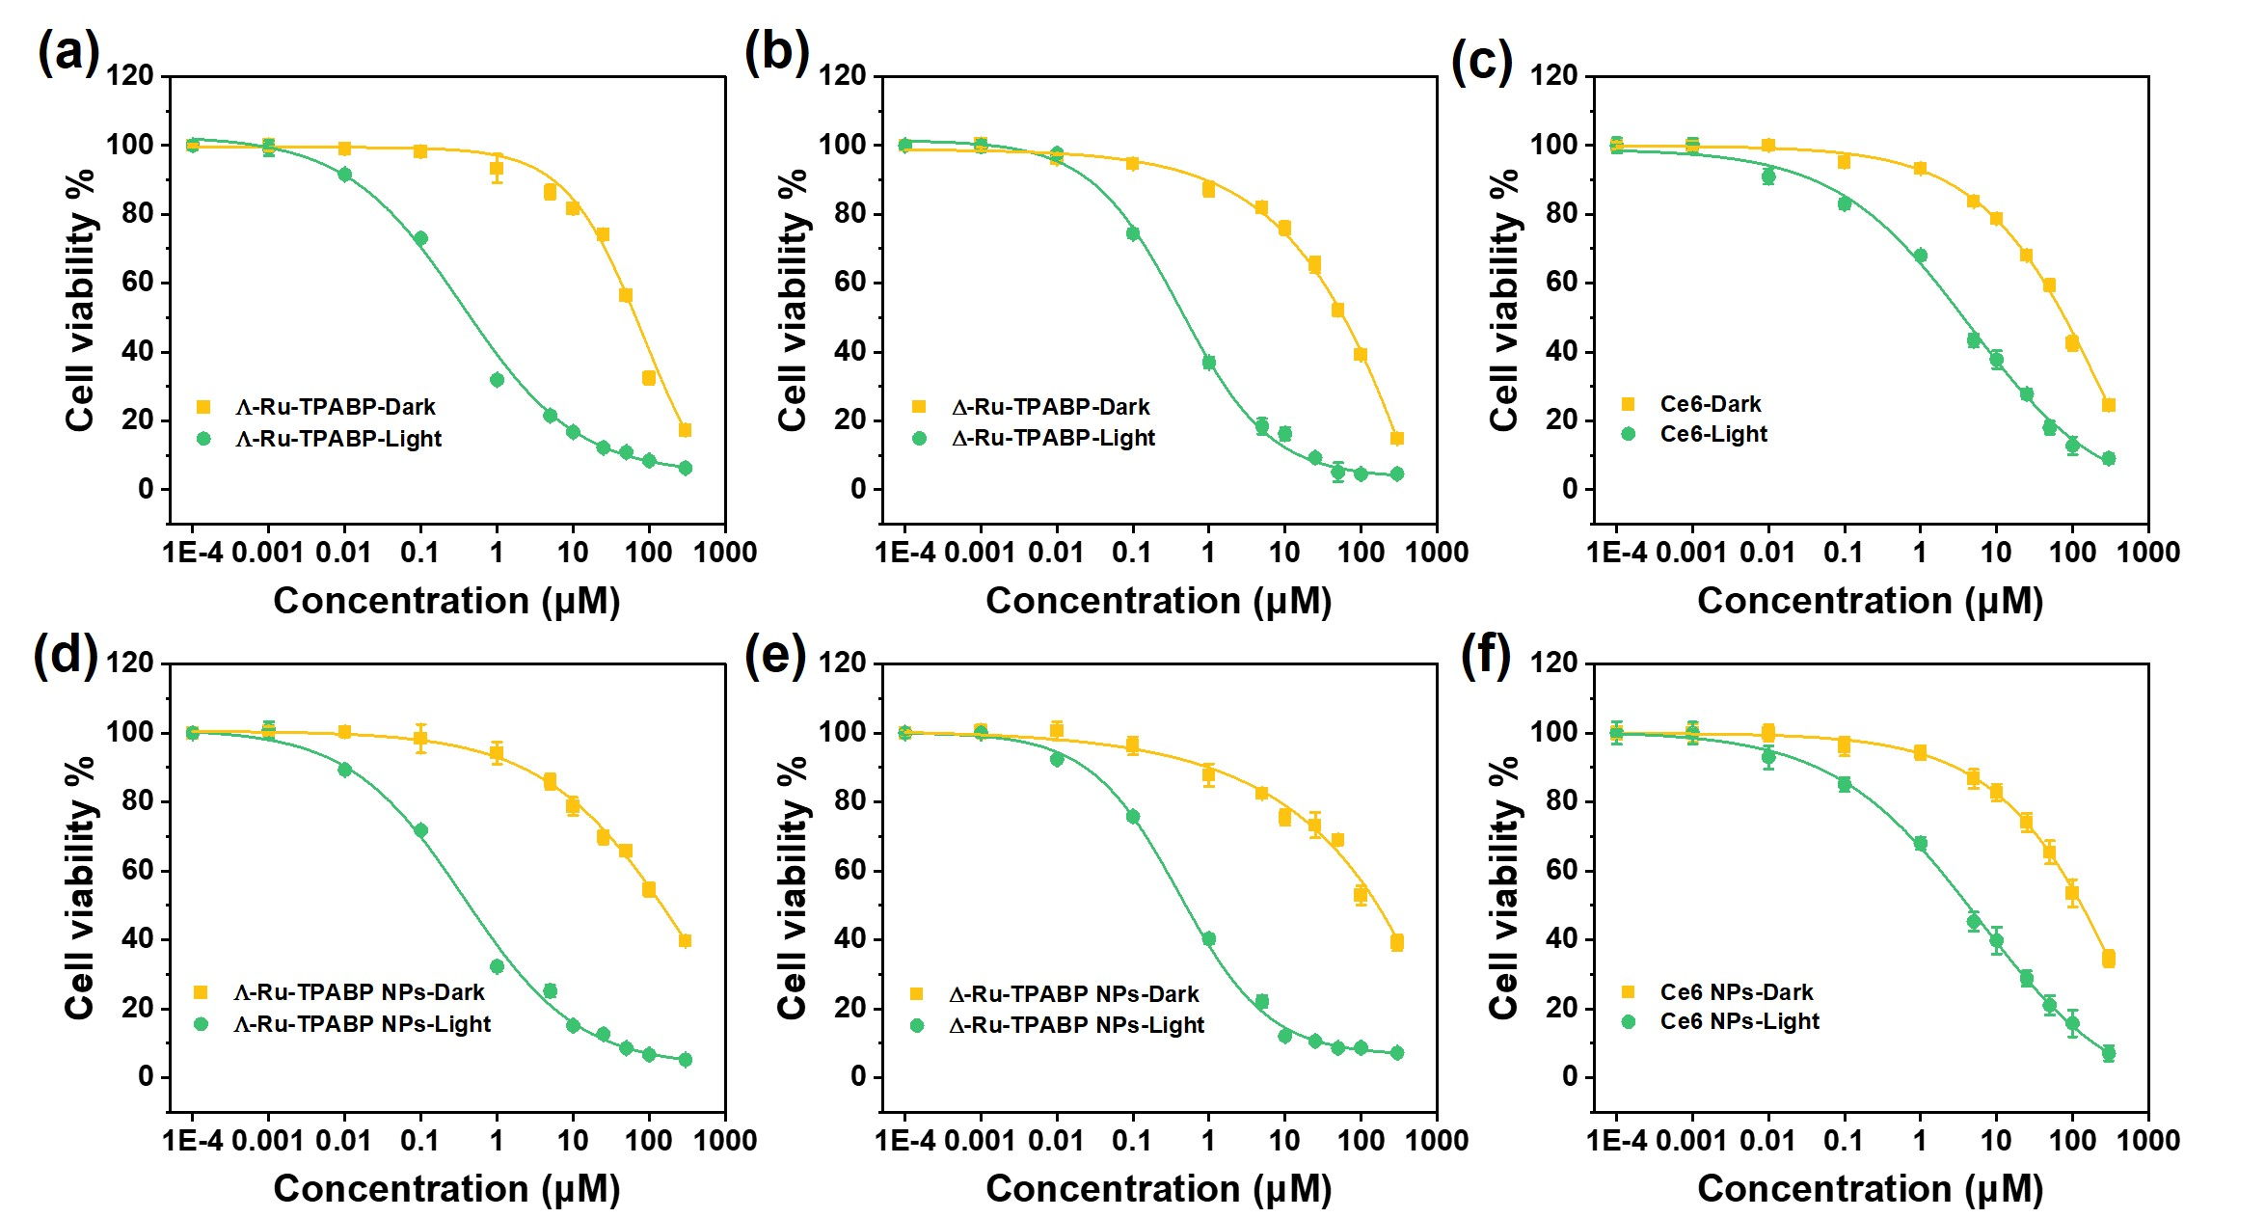
Figure S50. Dose-response curves for chromatic (photo)cytotoxicity screening of Λ-Ru-TPABP and Λ-Ru-TPABP NPs (a, d), Δ-Ru-TPABP and Δ-Ru-TPABP NPs (b, e), and Ce6 and Ce6 NPs (c, f) in A549 cells under normoxic conditions (21% O₂).

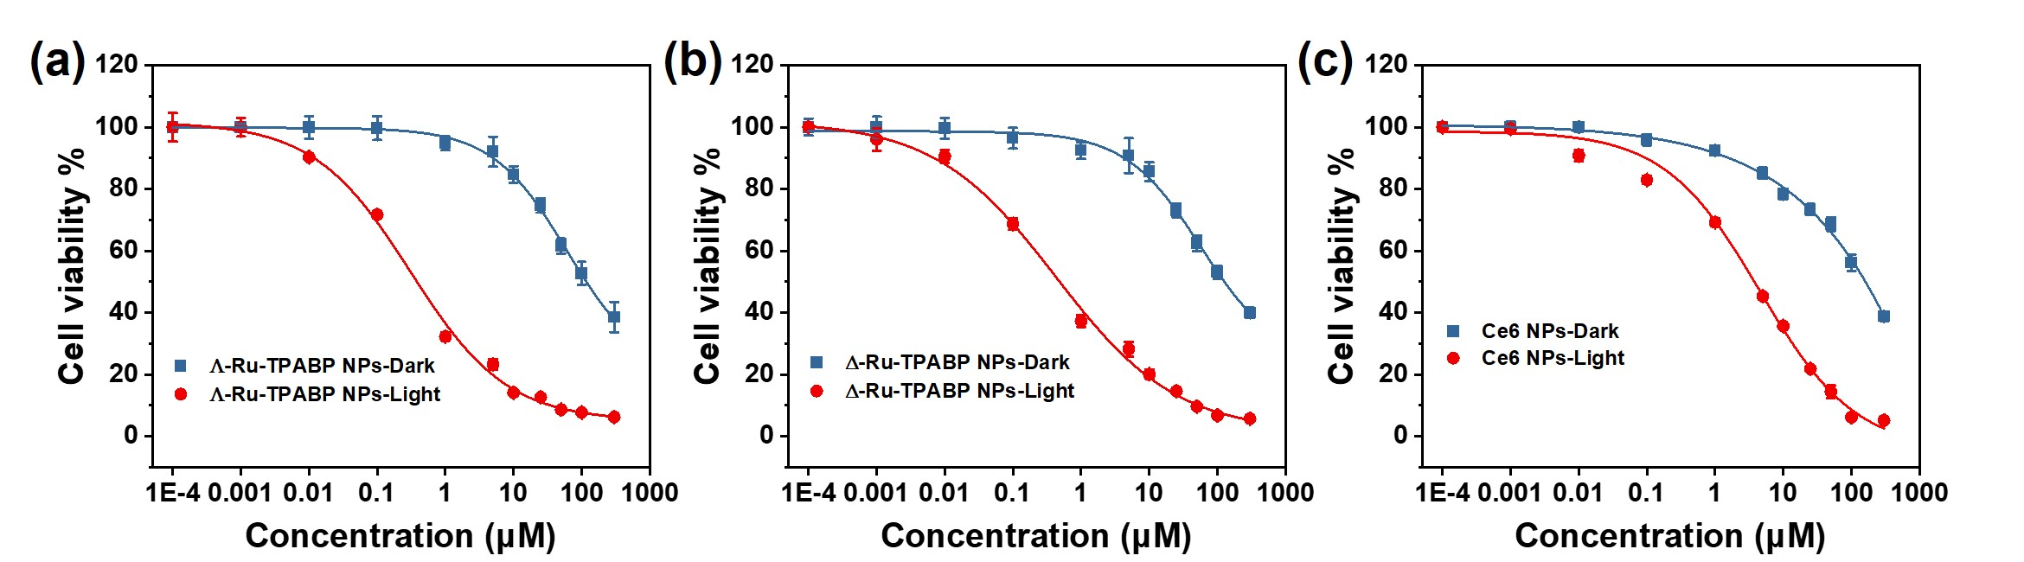
Figure S51. Dose-response curves for chromatic (photo)cytotoxicity screening of Λ-Ru-TPABP NPs (a), Δ-Ru-TPABP NPs (b), and Ce6 NPs (c) in 4T1 cells under hypoxia conditions (2% O₂).

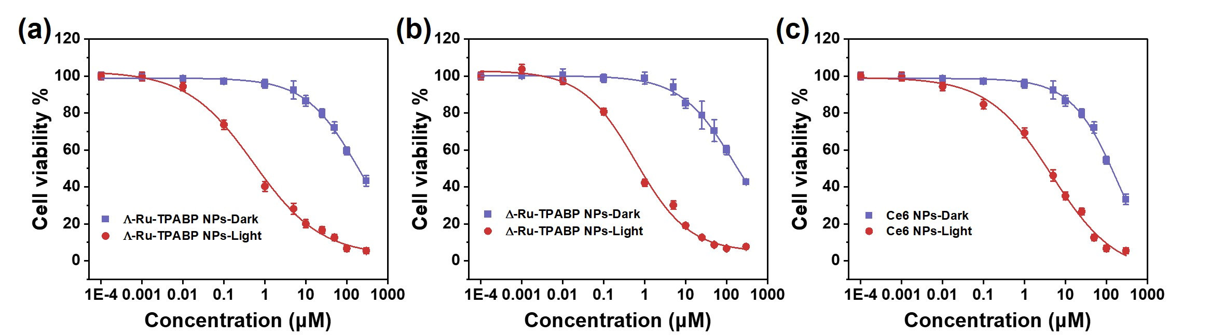
Figure S52. Dose-response curves for chromatic (photo)cytotoxicity screening of Λ-Ru-TPABP NPs (a),Δ-Ru-TPABP NPs (b), and Ce6 NPs (c) in MCF-7 cells under hypoxia conditions (2% O₂).

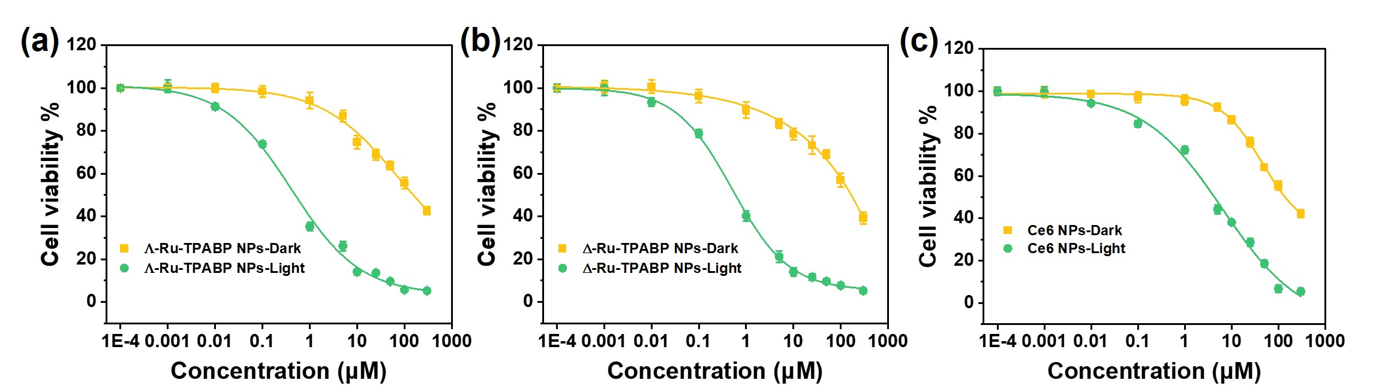
Figure S53. Dose-response curves for chromatic (photo)cytotoxicity screening of Λ-Ru-TPABP NPs (a), Δ-Ru-TPABP NPs (b), and Ce6 NPs (c) in A549 cells under hypoxia conditions (2% O₂).
Table S6. Photo and dark cytotoxicity of PSs in 4T1, MCF-7, and A549 tumor cell lines under normoxic conditions (21% O₂).

 | 4T1 |  |  | MCF-7 |  |  | A549
IC₅₀ (µM) | Light | Dark | PI | Light | Dark | PI | Light | Dark | PI
Λ-Ru-TPABP | 0.29 | 66 | 227 | 0.45 | 88 | 196 | 0.46 | 78 | 170
Δ-Ru-TPABP | 0.32 | 76 | 238 | 0.51 | 83 | 163 | 0.47 | 73 | 155
Ce6 | 2.63 | 86 | 33 | 3.45 | 92 | 27 | 3.61 | 84 | 24

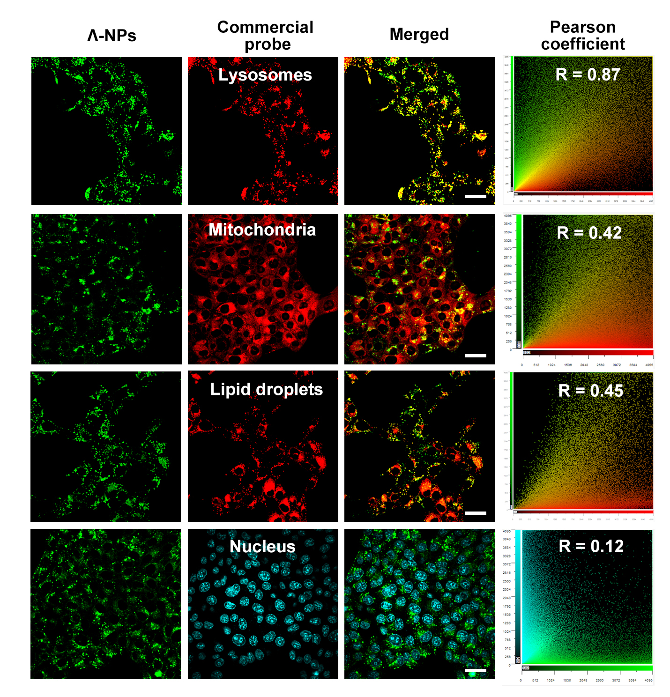
Figure S54. Confocal fluorescence images of 4T1 cells co-stained with Λ-Ru-TPABP NPs (5 μM, λ_{ex} = 488 nm, λ_{em} = 500-550 nm) and commercial dyes for organelles, including lysosome tracker red (λ_{ex} = 561 nm, λ_{em} = 600–650 nm), nile red for lipid droplets (λ_{ex} = 561 nm, λ_{em} = 600–650 nm), mitotracker red for mitochondria (0.5 μM, λ_{ex} = 561 nm, λ_{em} = 600–650 nm) , and hoechst 33342 for nuclear, (0.5 μM, λ_{ex} = 405 nm, λ_{em} = 430–470 nm). Scale bar: 30 μm.

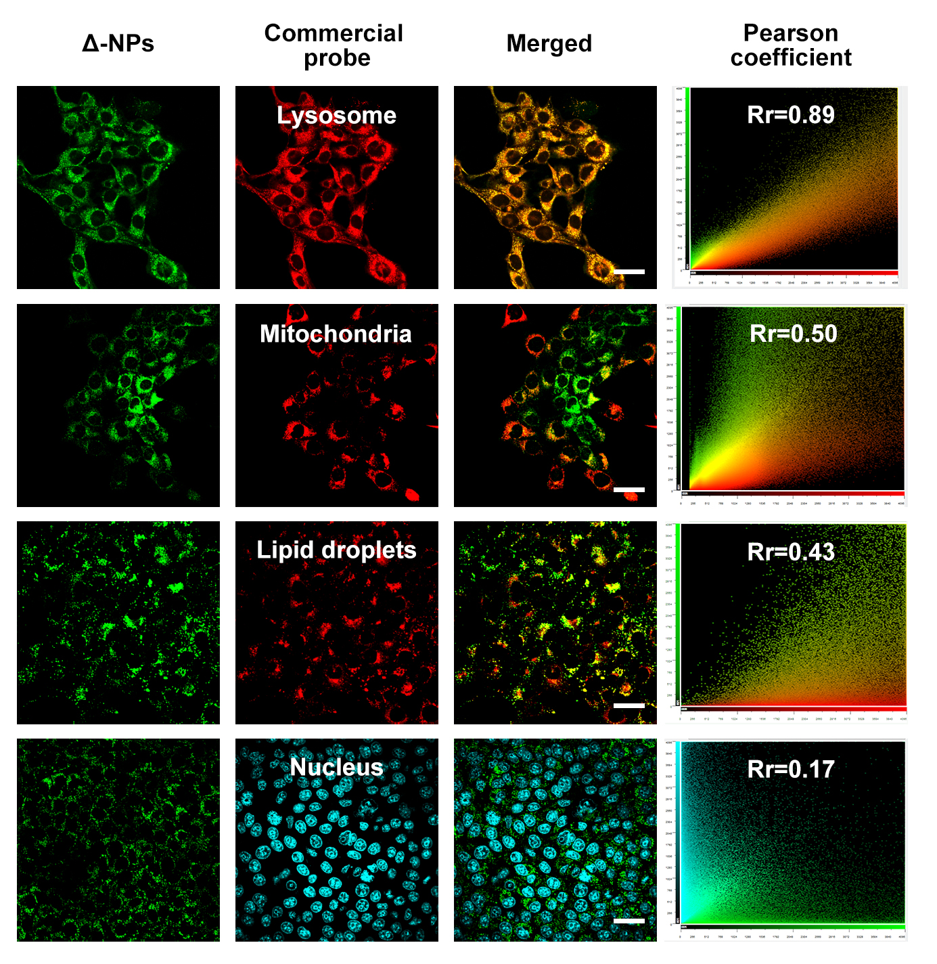
Figure S55. Confocal fluorescence images of 4T1 cells co-stained with Δ-Ru-TPABP NPs (5 μM, λ_{ex} = 488 nm, λ_{em} = 500-550 nm) and commercial dyes for organelles, including lysosome tracker red (λ_{ex} = 561 nm, λ_{em} = 600–650 nm), nile red for lipid droplets (λ_{ex} = 561 nm, λ_{em} = 600–650 nm), mitotracker red for mitochondria (0.5 μM, λ_{ex} = 561 nm, λ_{em} = 600–650 nm) , and hoechst 33342 for nuclear, (0.5 μM, λ_{ex} = 405 nm, λ_{em} = 430–470 nm). Scale bar: 30 μm.

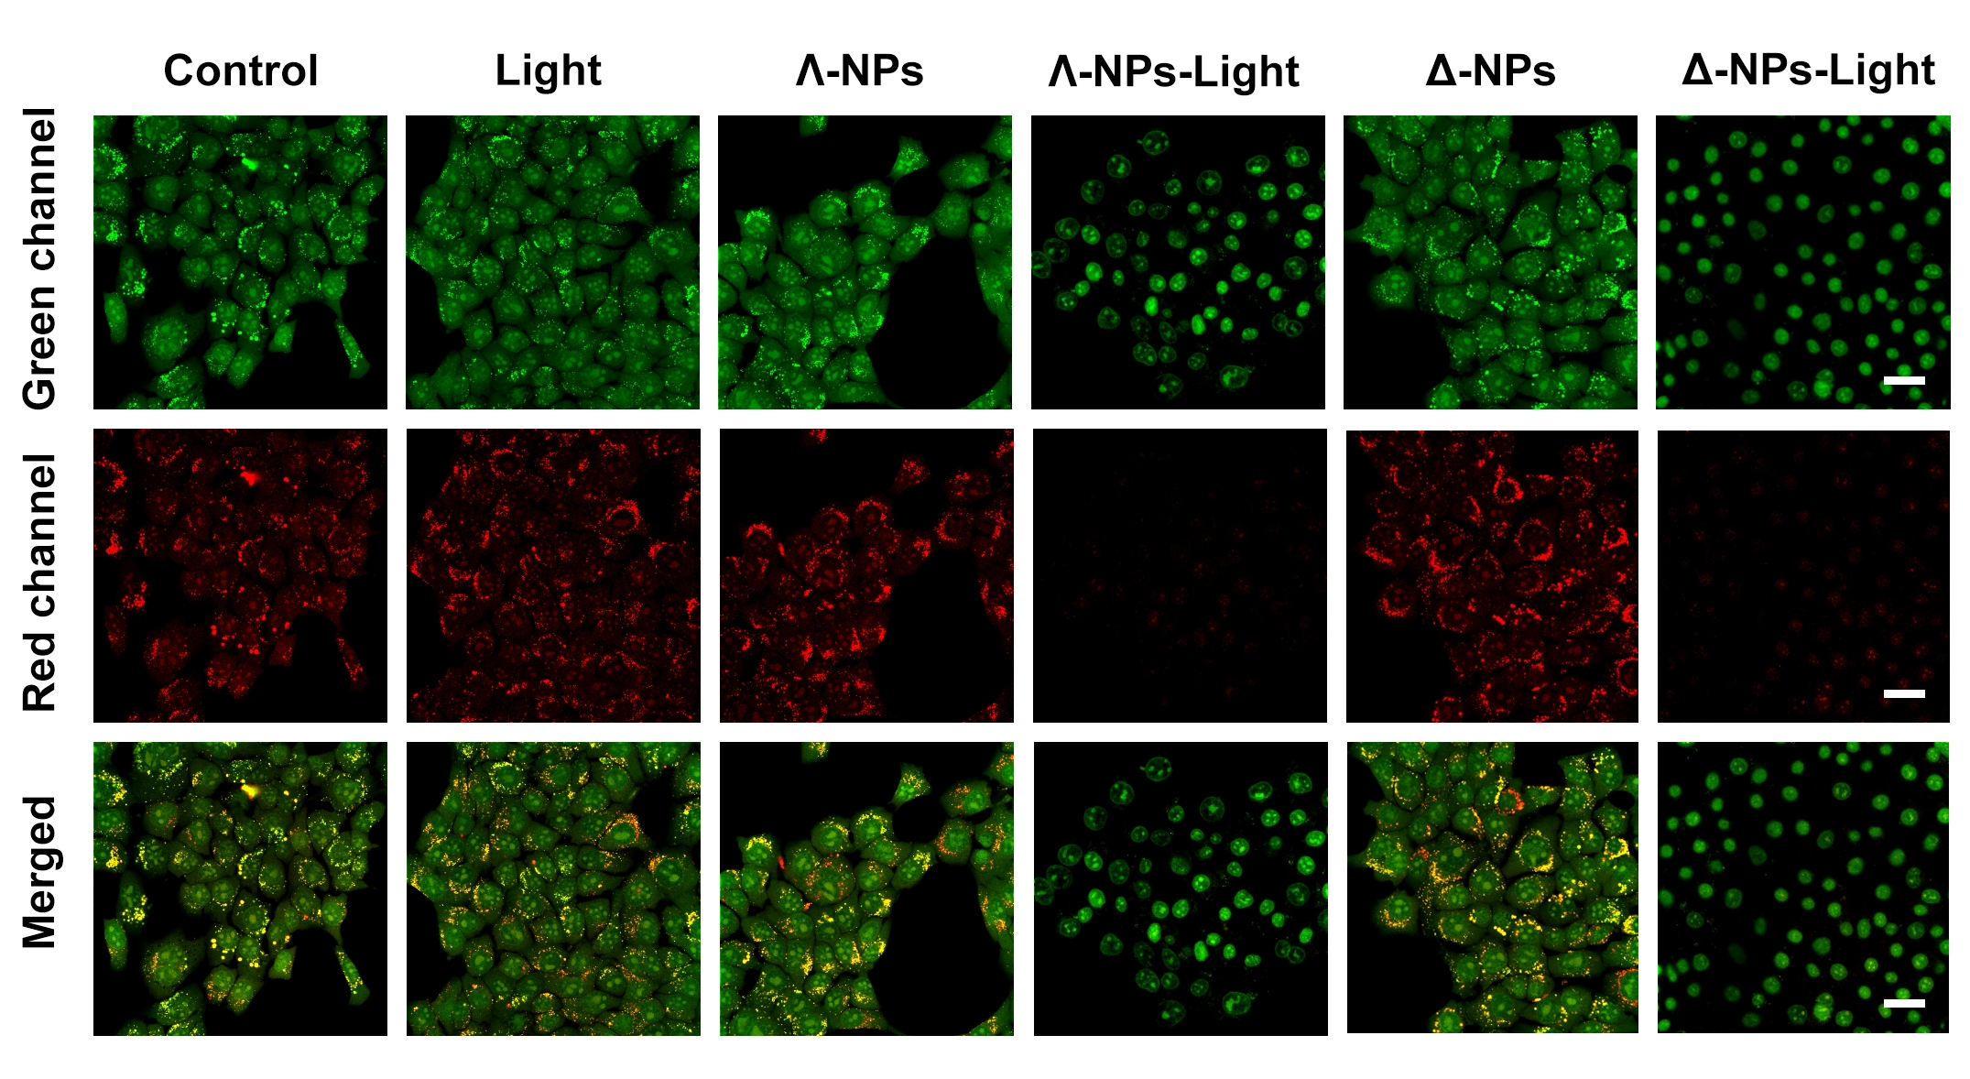
Figure S56. CLSM images of AO staining for lysosomal integrity in 4T1 cells. Red-light irradiation (700 nm, 30 mWcm⁻², 10 min) was conducted after cells were incubated with Λ/Δ-Ru-TPABP NPs for 6h. Scale bar: 30 µm.

Figure S57. Histograms of the mean fluorescence intensity analysis of multicellular structures studied with AO green/red channel iodide staining.
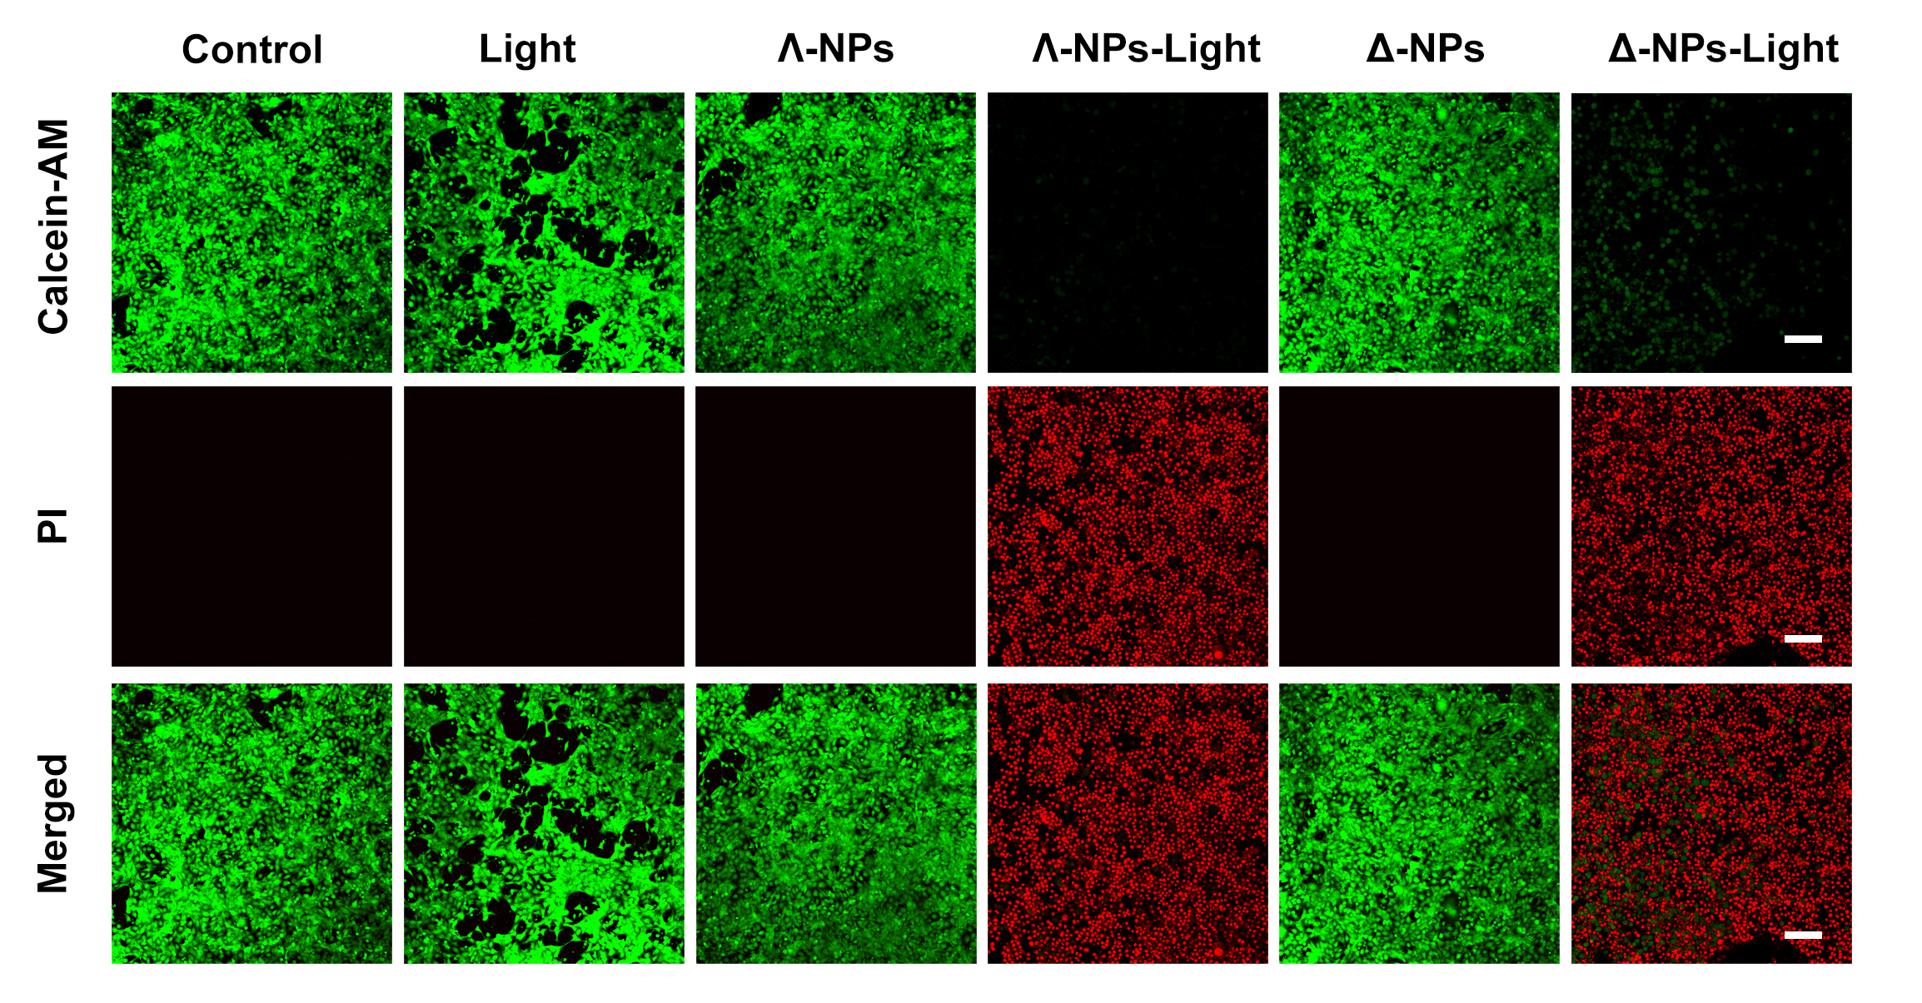
Figure S58. CLSM images of Calcein-AM/PI staining for lysosomal integrity in 4T1 cells. Red-light irradiation (700 nm, 30 mW cm⁻², 10 min) was conducted after cells were incubated with Λ/Δ-Ru-TPABP NPs for 6h. Scale bar: 180 µm.

Figure S59. Histograms of the mean fluorescence intensity analysis of multicellular structures were studied with Calcein-AM/PI channel iodide staining.
Figure S60. The normalized mean fluorescence intensity distribution of Λ-Ru-TPABP NPs in the tumor sites at different time point.

Figure S61. Body weight changes of mice during different treatments in 14 days.
Figure S62. Body weight changes of breast tumors and pulmonary metastases mice during different treatments in 24 days.

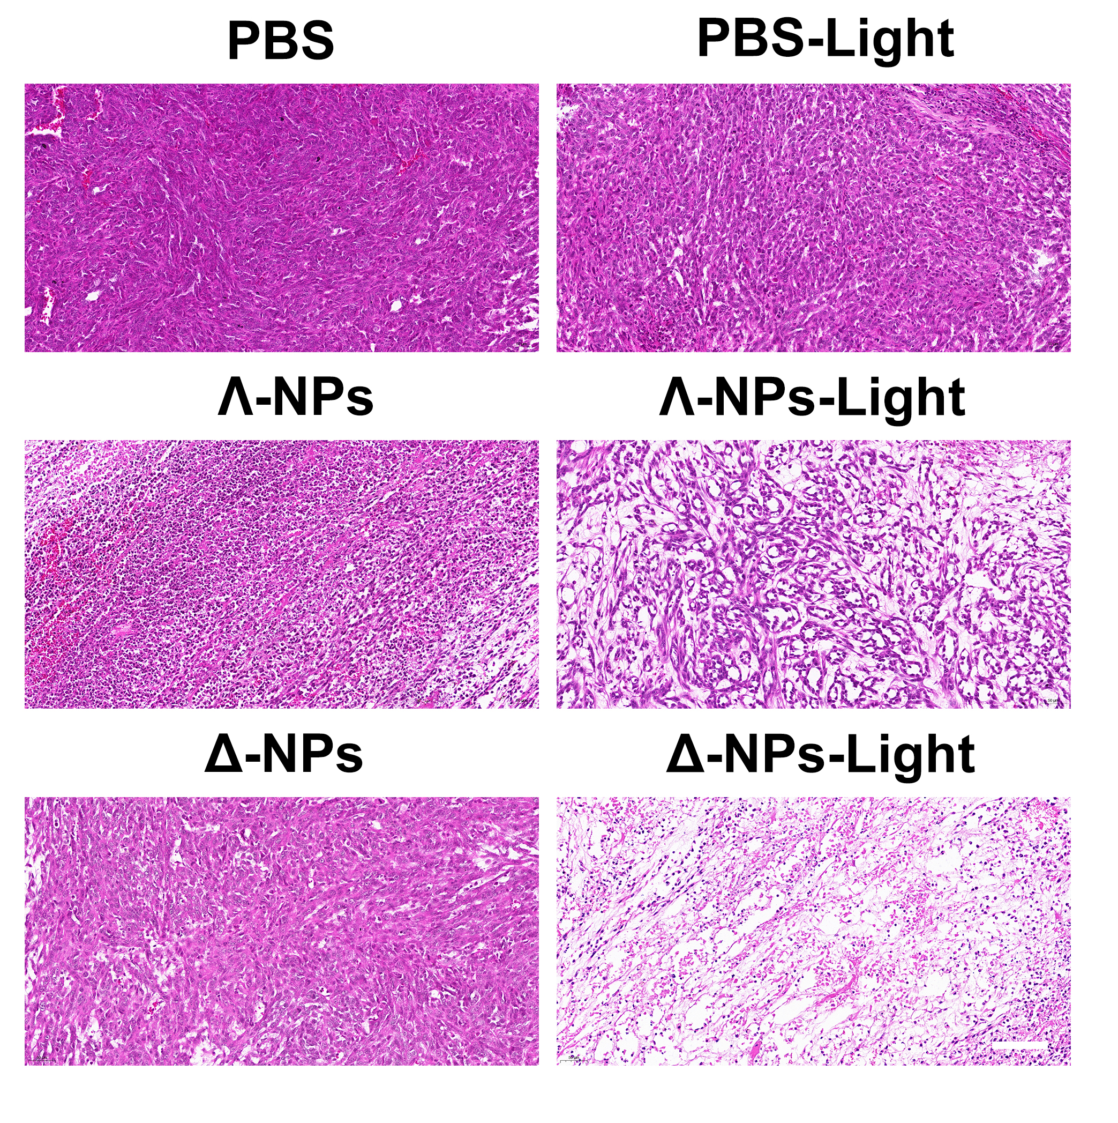
Figure S63. H&E staining of tumor slices collected from breast tumors and pulmonary metastases mice models. Scale bar: 100 µm.
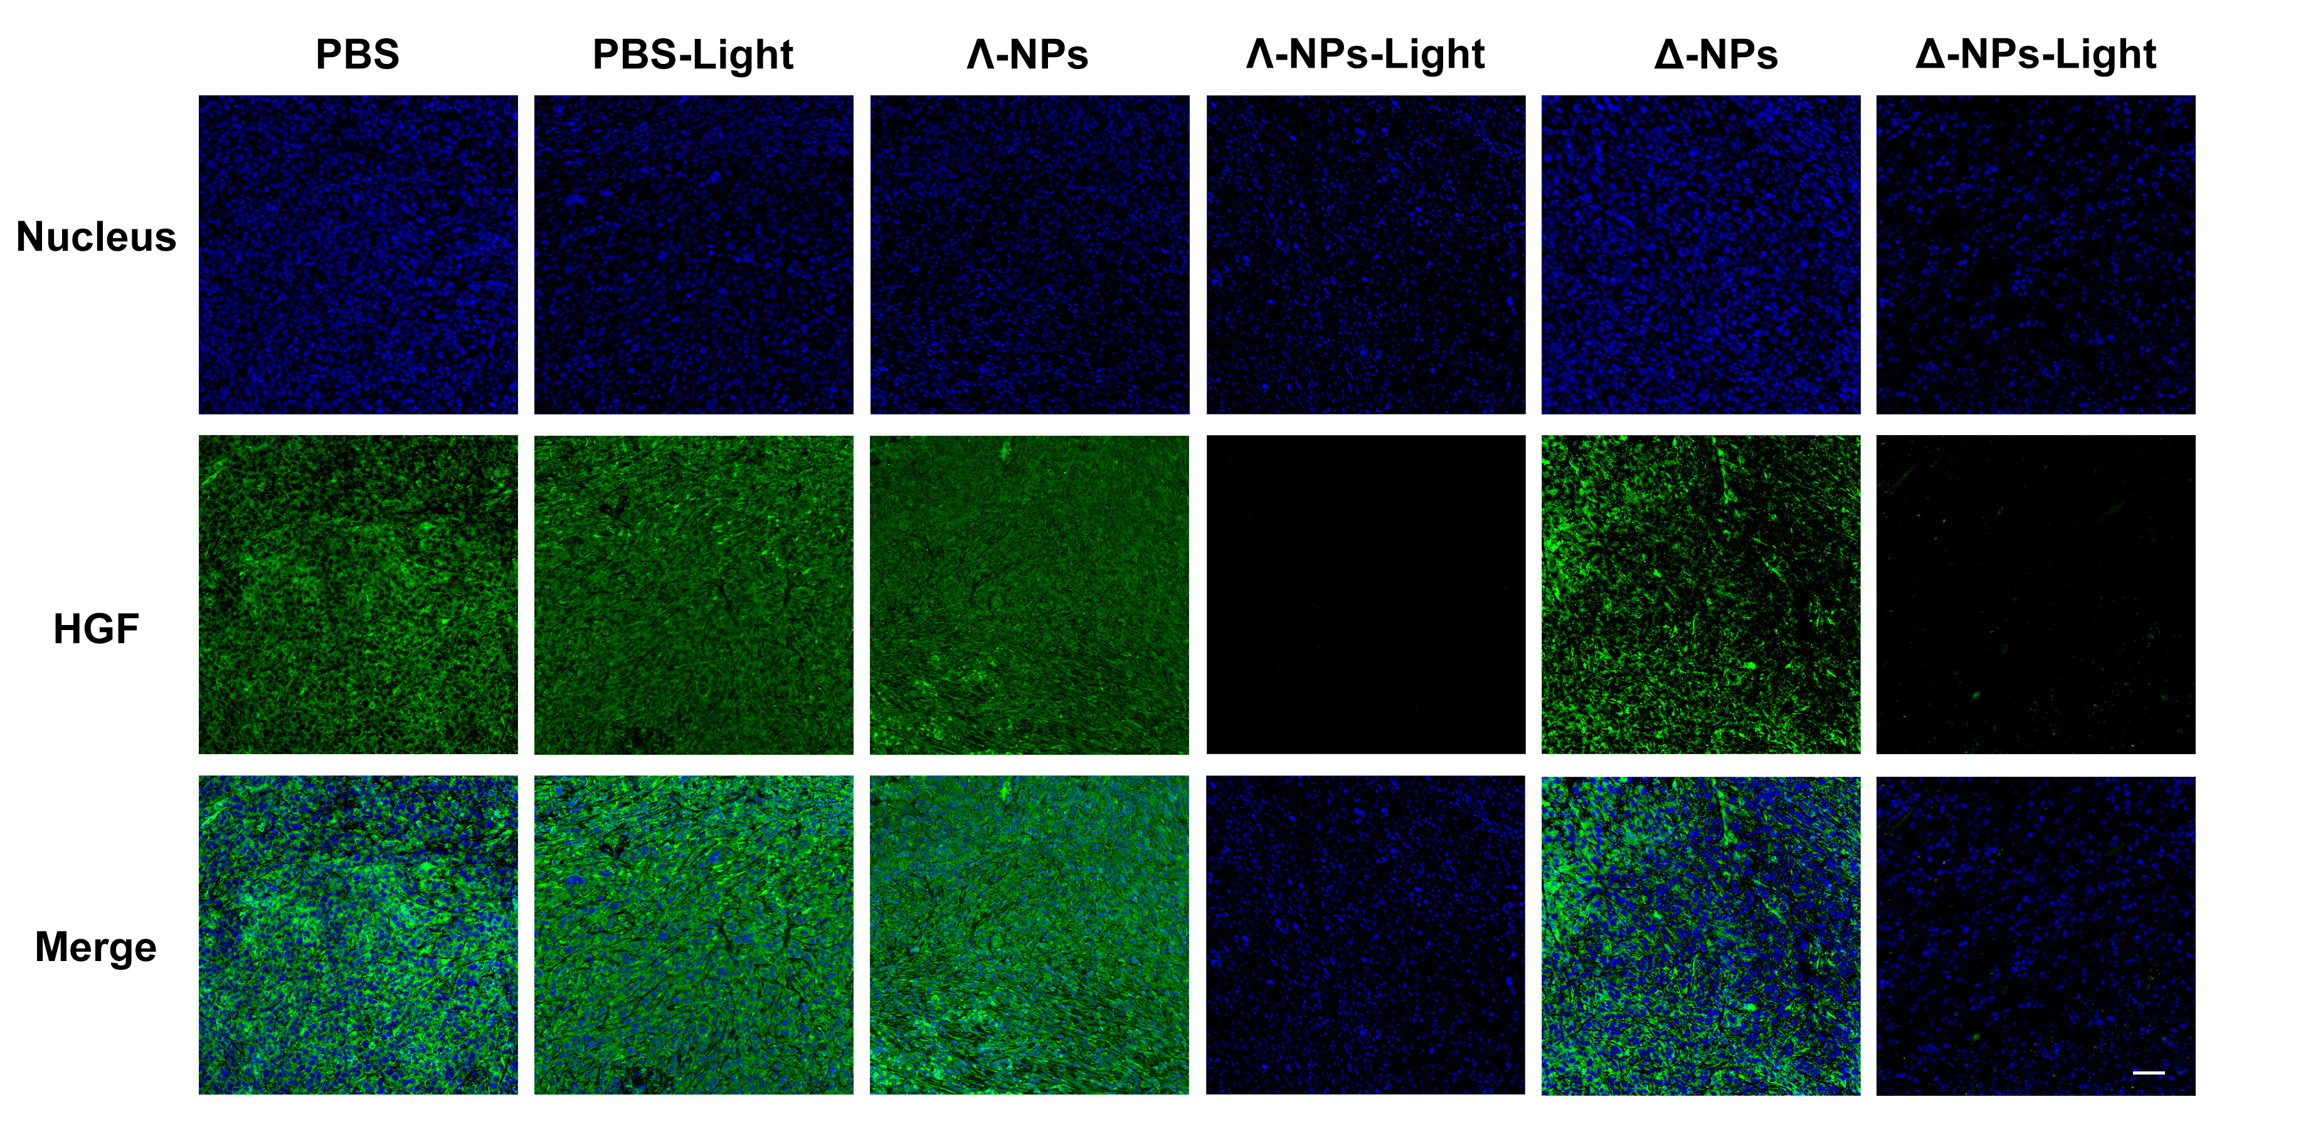
Figure S64. Immunofluorescent staining of hepatocyte growth factor (HGF) after different treatments. Scale bar: 50 µm.

Figure S65. Relative protein expression level of HGF analysis of tumor slices collected from breast tumors and pulmonary metastases mice models.
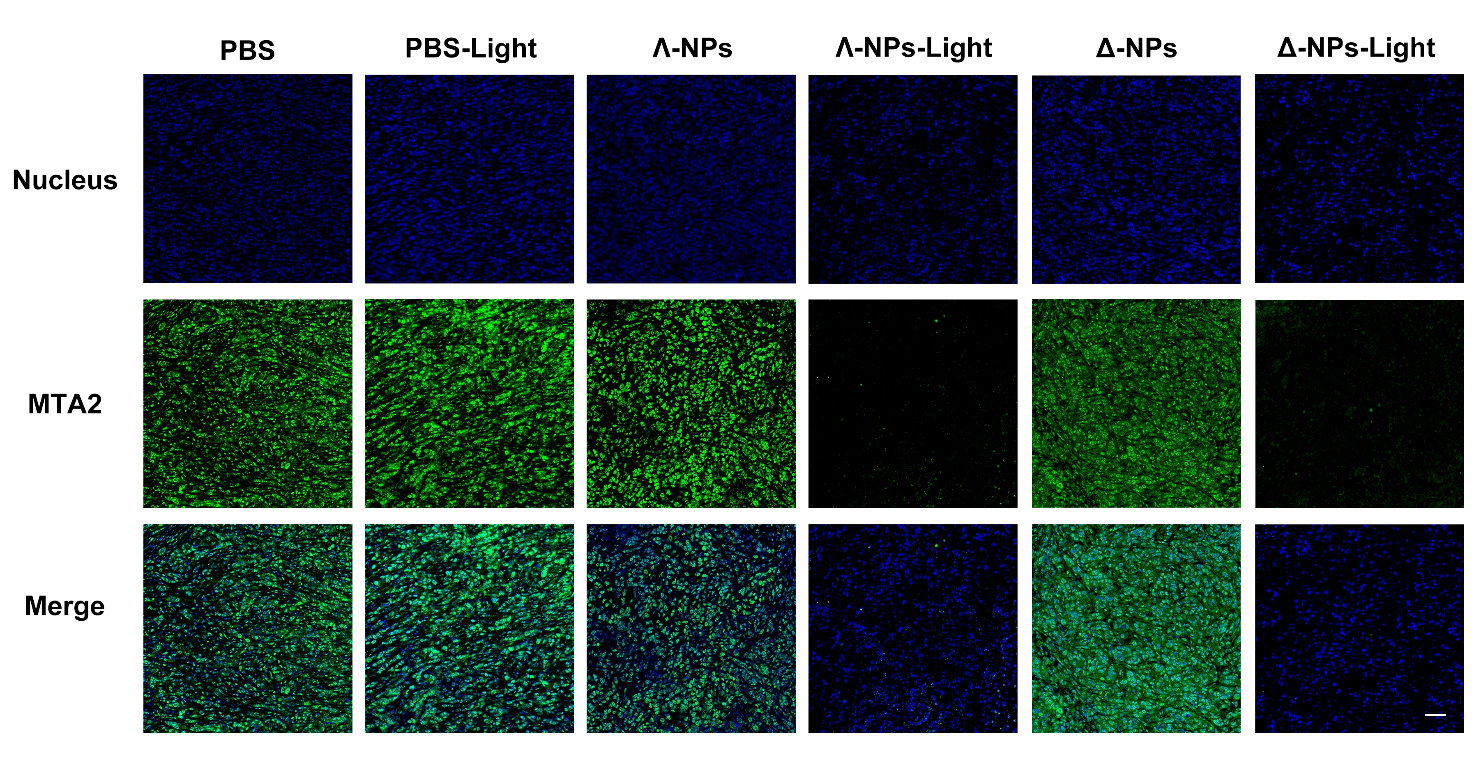
Figure S66. Immunofluorescent staining of metastasis-associated protein 2 (MTA2) after different treatments. Scale bar: 50 µm.

Figure S67. Relative protein expression level of MTA2 analysis of tumor slices collected from breast tumors and pulmonary metastases mice models.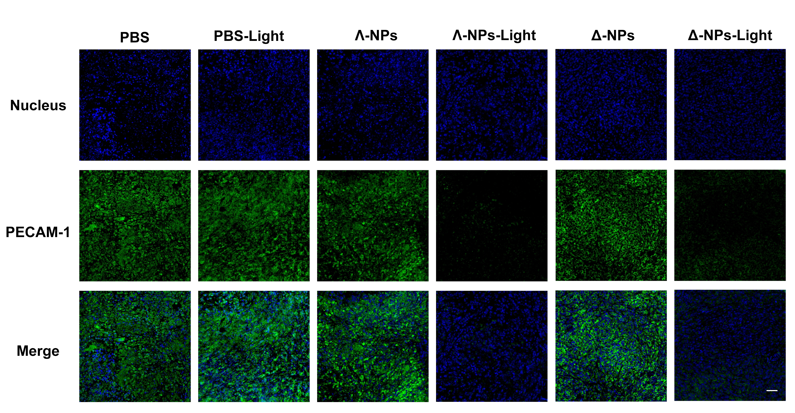
Figure S68. Immunofluorescent staining of platelet endothelial cell adhesion molecule-1 (PECAM-1) after different treatments. Scale bar: 50 µm.

Figure S69. Relative protein expression level of PECAM-1 analysis of tumor slices collected from breast tumors and pulmonary metastases mice models.
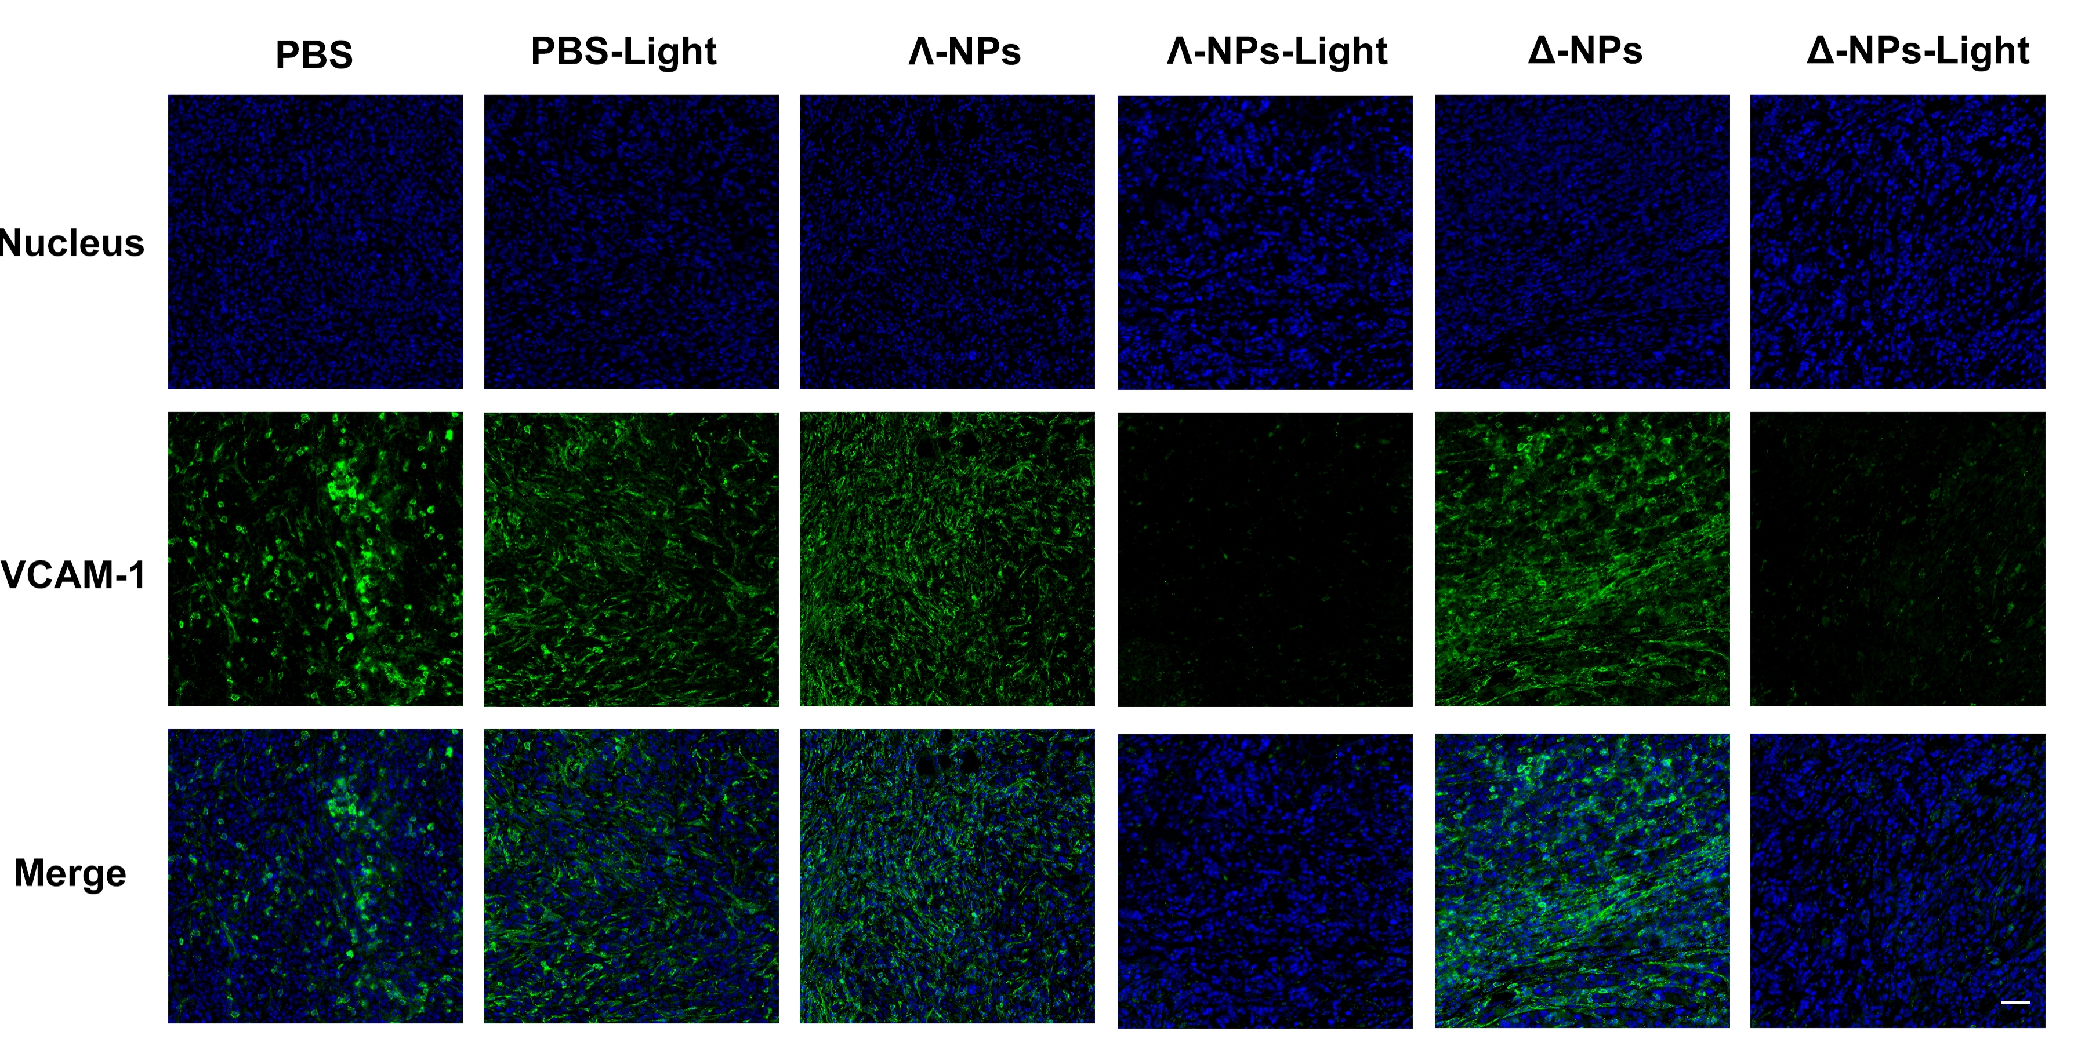
Figure S70. Immunofluorescent staining of vascular cell adhesion molecule-1 (VCAM-1) after different treatments. Scale bar: 50 µm.

Figure S71. Relative protein expression level of VCAM-1 analysis of tumor slices collected from breast tumors and pulmonary metastases mice models.
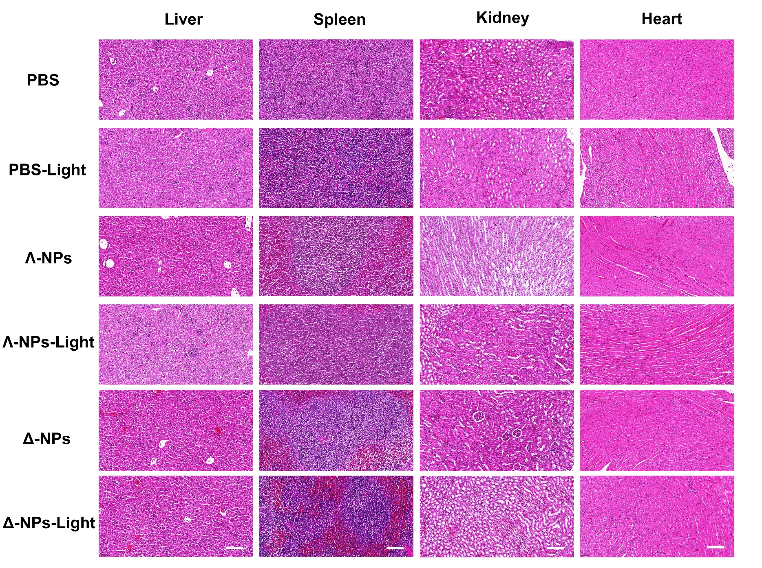
Figure S72. Images of H&E staining liver, spleen, kidney, heart, slides from mice after different treatments. Scale bars: 100 μm.
References
1. Adamo C, Barone V. Toward reliable density functional methods without adjustable parameters: The PBE0 model. J. Chem. Phys. 110, 6158-6170 (1999).
2. Lu T, Chen F. Multiwfn: A multifunctional wavefunction analyzer. J. Comput. Chem. 33, 580-592 (2012).
3. Liu Z, Lu T, Chen Q. An sp-hybridized all-carboatomic ring, cyclo[18]carbon: Electronic structure, electronic spectrum, and optical nonlinearity. Carbon 165, 461-467 (2020).
4. Humphrey W, Dalke A, Schulten K. VMD: Visual molecular dynamics. J. Mol. Graph. 14, 33-38 (1996).
5. Motley TC, Troian-Gautier L, Brennaman MK, Meyer GJ. Excited-state decay pathways of tris(bidentate) cyclometalated ruthenium(II) compounds. Inorg. Chem. 56, 13579-13592 (2017).
6. Ghosh G, et al. Cyclometalated ruthenium(II) complexes derived from α-oligothiophenes as highly selective cytotoxic or photocytotoxic agents. Inorg. Chem. 57, 7694-7712 (2018).
7. Schlotthauer T, Parada GA, Görls H, Ott S, Jäger M, Schubert US. Asymmetric cyclometalated RuII polypyridyl-type complexes with π-extended carbanionic donor sets. Inorg. Chem. 56, 7720-7730 (2017).
8. Sainuddin T, et al. Organometallic Ru(II) photosensitizers derived from π-expansive cyclometalating ligands: surprising theranostic PDT effects. Inorg. Chem. 55, 83-95 (2016).
9. Das S, Pal P, Biswas R, Baitalik S. Design of near-infrared emissive molecular switches based on stilbene-appended cyclometalated bimetallic Ru(II)-terpyridine complexes. Inorg. Chem. 63, 23725-23741 (2024).
10. Bomben PG, Robson KCD, Koivisto BD, Berlinguette CP. Cyclometalated ruthenium chromophores for the dye-sensitized solar cell. Coord. Chem. Rev. 256, 1438-1450 (2012).
11. Steinke SJ, Piechota EJ, Loftus LM, Turro C. Acetonitrile ligand photosubstitution in Ru(II) complexes directly from the ³MLCT state. J. Am. Chem. Soc. 144, 20177-20182 (2022).

