Supplementary Information
Liquid-liquid phase-separated commensal membrane gates mass transport in inorganic nanocells

Yong Lu^{#,1}, Zhexuan Song^{#,2}, Zetan Cao¹, Linfeng Xu¹, Haoran Liu¹, Jing Xie ^{*,2}, Bin Chen ^{*,1}

¹Center for Ultrafast Science and Technology, School of Chemistry and Chemical Engineering, Shanghai Jiao Tong University, Shanghai 200240, China
²Key Laboratory of Cluster Science of Ministry of Education, Beijing Key Laboratory of Photoelectronic/Electrophotonic Conversion Materials, School of Chemistry and Chemical Engineering, Beijing Institute of Technology, Beijing 100081, China

E-mail: jingxie@bit.edu.cn, cbcce@sjtu.edu.cn

# These authors contributed equally to this work

This PDF includes:
Supplementary Figs. 1-31
Supplementary Tables 1-7
Supplementary Note
Supplementary Movie Captions
References

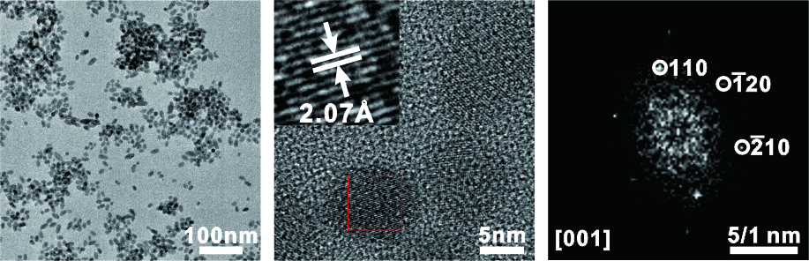
Supplementary Fig. 1 Low-magnification TEM image (left), high-resolution TEM (HRTEM) image (middle) and corresponding fast Fourier transform (FFT) pattern (right) of the as-synthesized HgS seeds. The d-spacing of 2.07 Å (inset) corresponds to the (110) lattice plane of HgS.

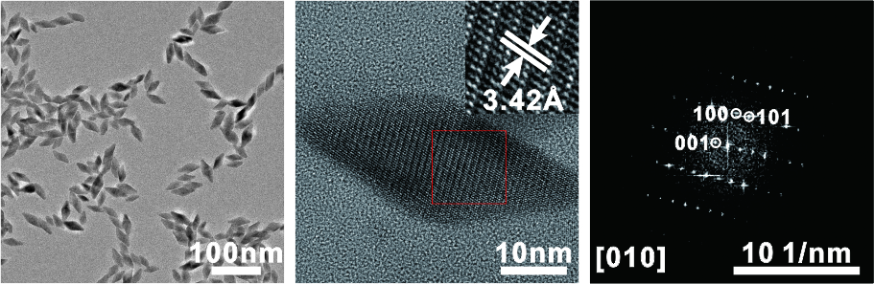
Supplementary Fig. 2 Low-magnification TEM (left), HRTEM image (middle) and associated FFT pattern (right) of the HgS nanobipyramids. The interplanar spacing of 3.42 Å (inset) corresponds to the (101) lattice plane of HgS.

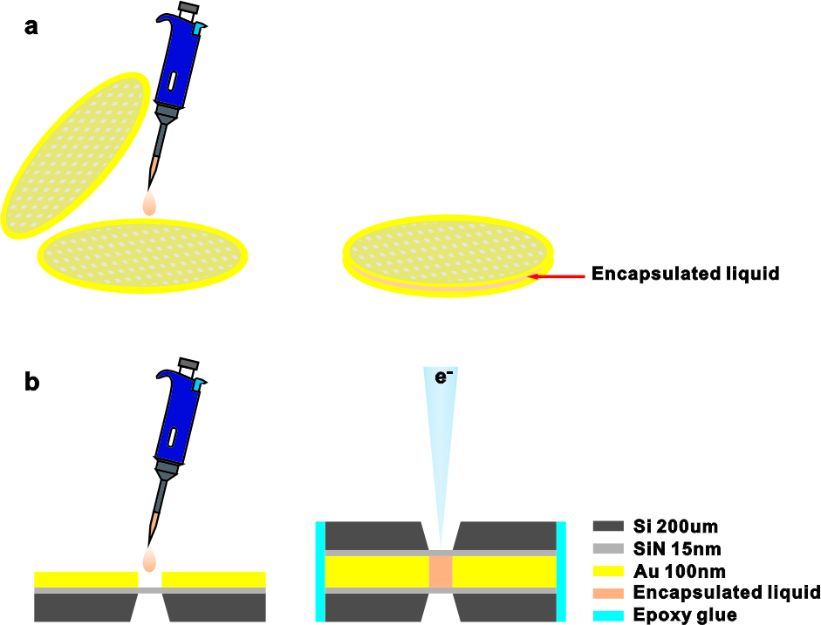
Supplementary Fig. 3 Illustration of the preparation of typical LCs. a, Fabrication of carbon LCs. About 2 μL of the solution containing the HgS NPs was encapsulated between two ultrathin carbon-film Au grids. b, Preparation of SiN_{x} LCs. The solution was sandwiched between two SiN_{x} chips follow by sealing with epoxy glue. The observation window of SiN_{x} layer was ~15 nm thick. A 100-nm-thick spacer of gold film was used to separate the two chips. Detailed procedures were referred to the experimental sections.

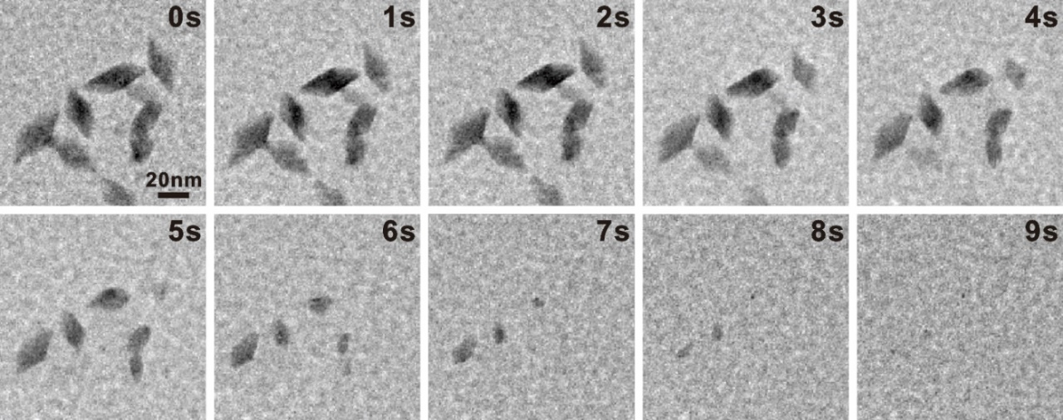
Supplementary Fig. 4 The etching process of HgS nanobipyramids in a ~100-nm-thick liquid layer sandwiched between two SiN_{x} films under the e-beam illumination. The nanobipyramids were fully etched off in a very short time (~9 s).

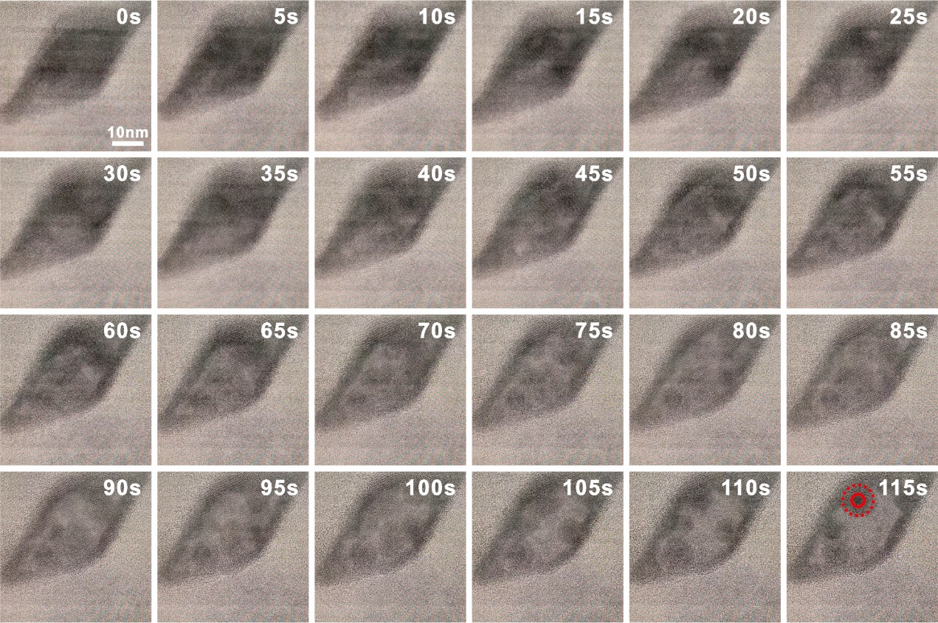
Supplementary Fig. 5 The typical evolution of a HgS nanobipyramid in the carbon LC at the early stage (0-115 s). The nanobipyramid was gradually evolved into a nanocell upon the e-beam excitation. The nanocomplexes moved randomly inside the nanocell and were condensed into a nanodroplet with an outer membrane at 115 s (marked by the solid and dotted circles, respectively). These images were extracted from movie S1.

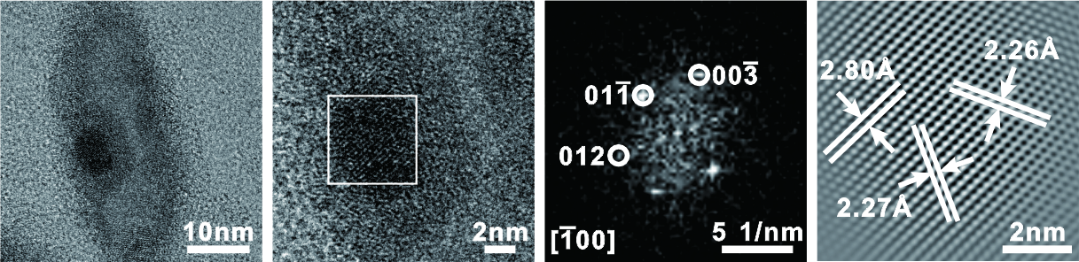
Supplementary Fig. 6 Cryo-EM images of Hg taken at -100 ℃ and the associated FFT pattern. The d-spacings of 2.27, 2.80 and 2.26 Å in HRTEM correspond to the ($012$), ($01\overline{1}$), ($00\overline{3}$) planes of Hg, which match the X-ray diffraction (XRD) pattern values in the COD database (ID# 1523182). The interplanar spacings and angles for various crystal planes of Hg are listed in Supplementary Table 1.

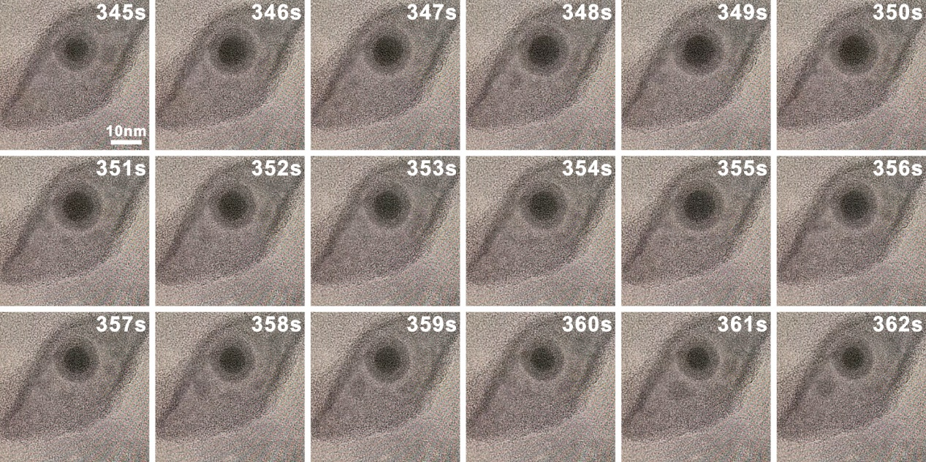
Supplementary Fig. 7 The evolution of Hg nanodroplet when the e-beam dose rate was increased to ~2390 e⁻ Å² s⁻¹ (see also Figure 2 in the main text).

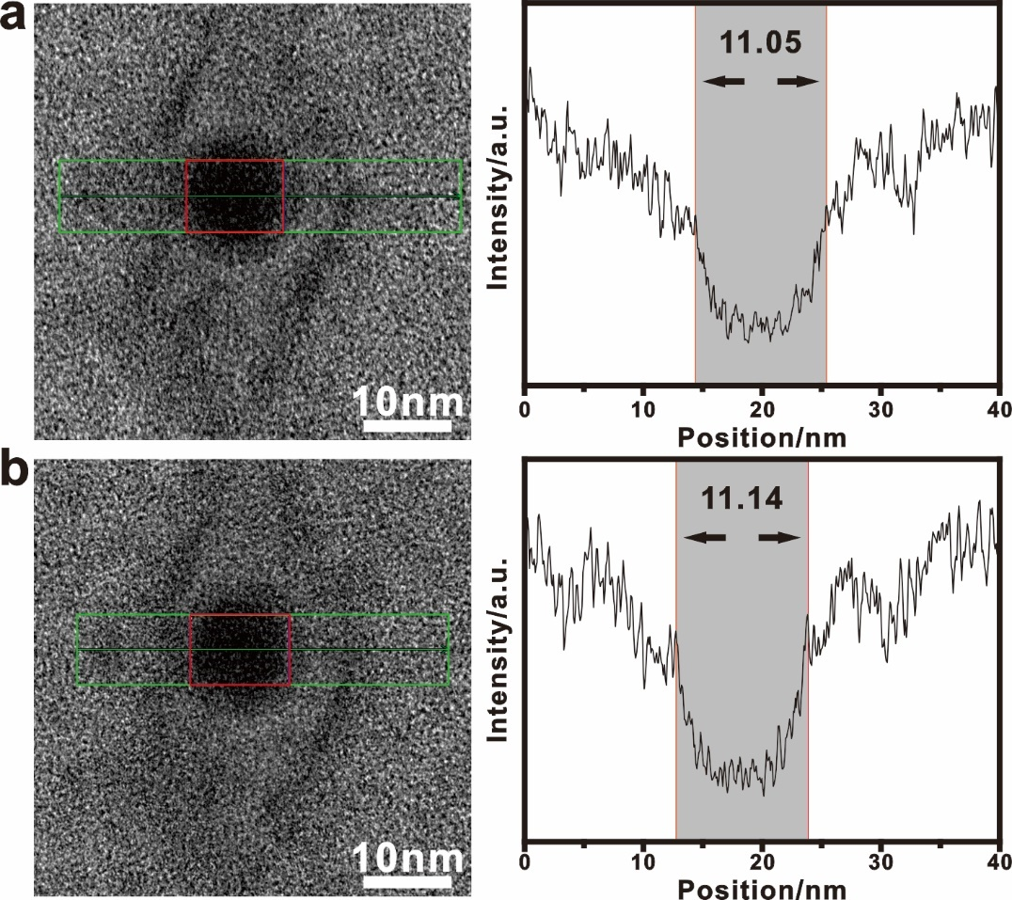
Supplementary Fig. 8 TEM images and intensity profiles showing the effect of the e-beam irradiation on the evolution of Hg nanodroplet. a, A nanodroplet was formed upon the e-beam excitation. b, The state after blanking of the e-beam for 5 min. No obvious change was observed for the diameter of the nanodroplet (marked by the red box) before (11.05 nm) and after (11.14 nm) the e-beam blanking.

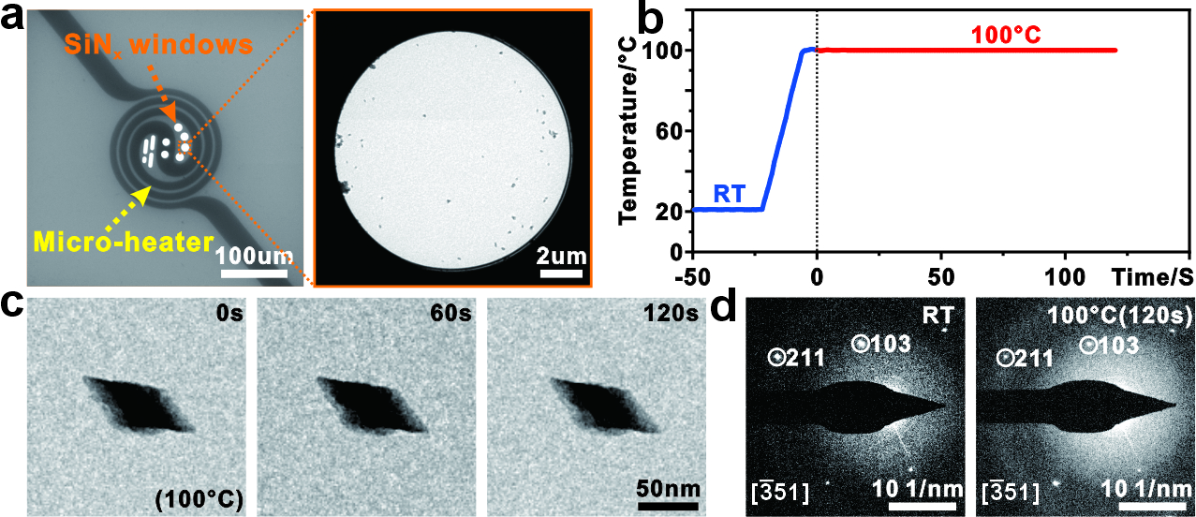
Supplementary Fig. 9 In-situ heating experiment of HgS nanobipyramids. a, Low-magnification TEM images of the heating chip and one of the SiN_{x} observation windows with HgS nanobipyramids. b, Heating procedure from room temperature (RT) and 100 ℃. c, Morphology evolution of a single HgS nanobipyramid at 100 ℃. d, Diffraction patterns of the HgS nanobipyramid at RT and 100 ℃, respectively. No obvious changes were observed in the morphology and diffraction pattern of the nanobipyramid.

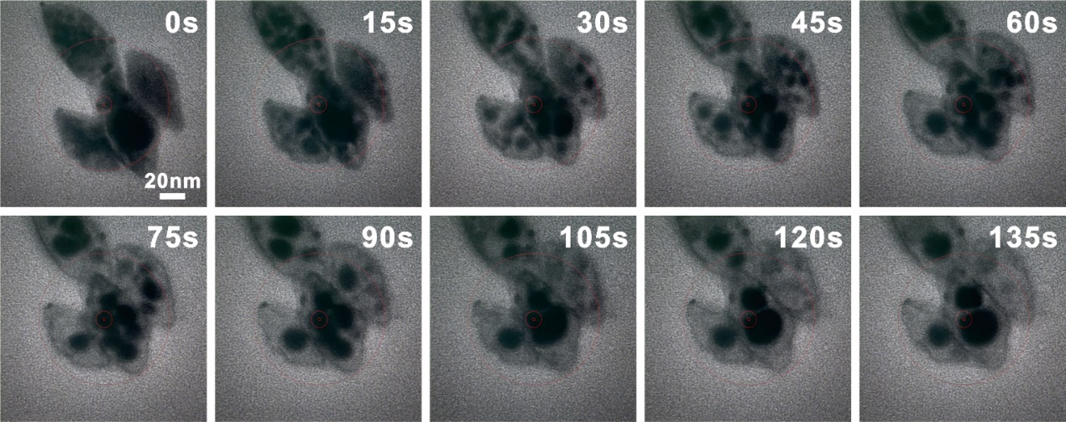
Supplementary Fig. 10 The evolution of the HgS nanobipyramids encapsulated in the graphene LC with the Tris·HCl buffer solution (10 mM). Similar phenomena as that in the carbon LC (shown in the main text) were observed.

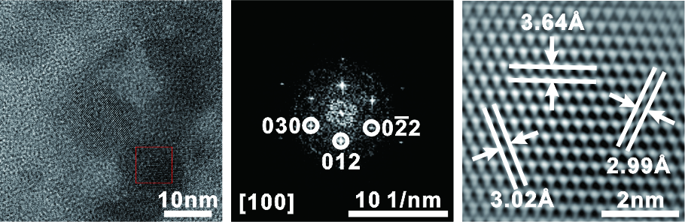
Supplementary Fig. 11 TEM image and FFT pattern of the crystallized HgSO₄·H₂O. The interplanar spacings of 2.99, 3.02 and 3.64 Å in HTREM correspond to the ($02\overline{2}$), ($030$) and ($012$) planes of HgSO₄·H₂O in the COD database (ID# 2310684). Detailed d-spacings and angles for various crystal planes are listed in Supplementary Table 2.

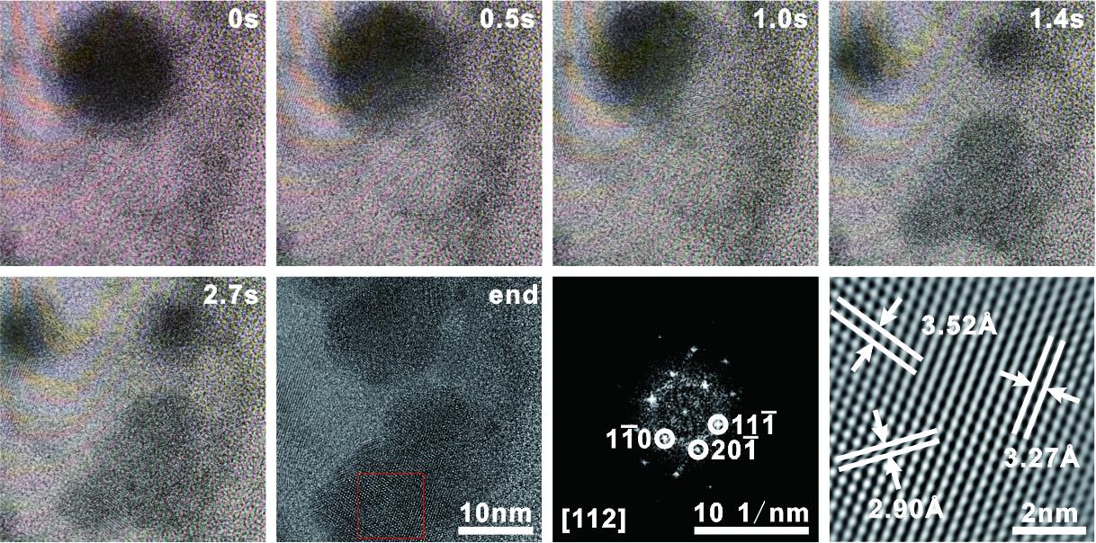
Supplementary Fig. 12 The rupture process of the Hg nanodroplet and the subsequent crystallization. The HRTEM and FFT analyses identified that the crystalized NP was Hg₂SO₄, with the interplanar spacings of 3.52, 2.90 and 3.27 Å corresponding to the ($1\overline{1}0$), ($20\overline{1}$) and (11$\overline{1}$) planes of Hg₂SO₄ in the COD database (ID# 1527303). The detailed analyses are given in Supplementary Table 3.

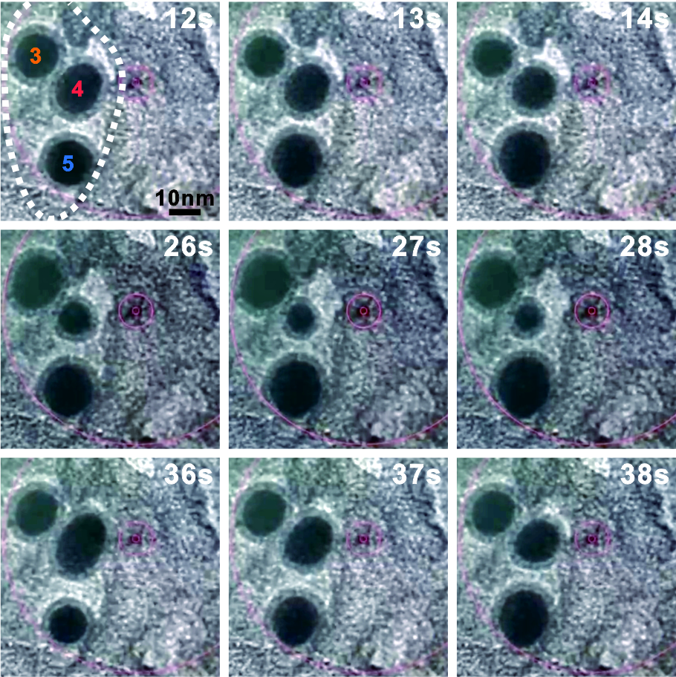
Supplementary Fig. 13 TEM images showing the mass transport behavior among three different Hg nanodroplets. Two nanodroplets (D3 and D4) underwent the shrinkage process, whereas another nanodroplet (D5) grew larger. These images correspond to the three stages (i.e., 10~15s, 25~30s, 35~40s) in Fig. 3d (indicated with the dotted arrows) of the main text.

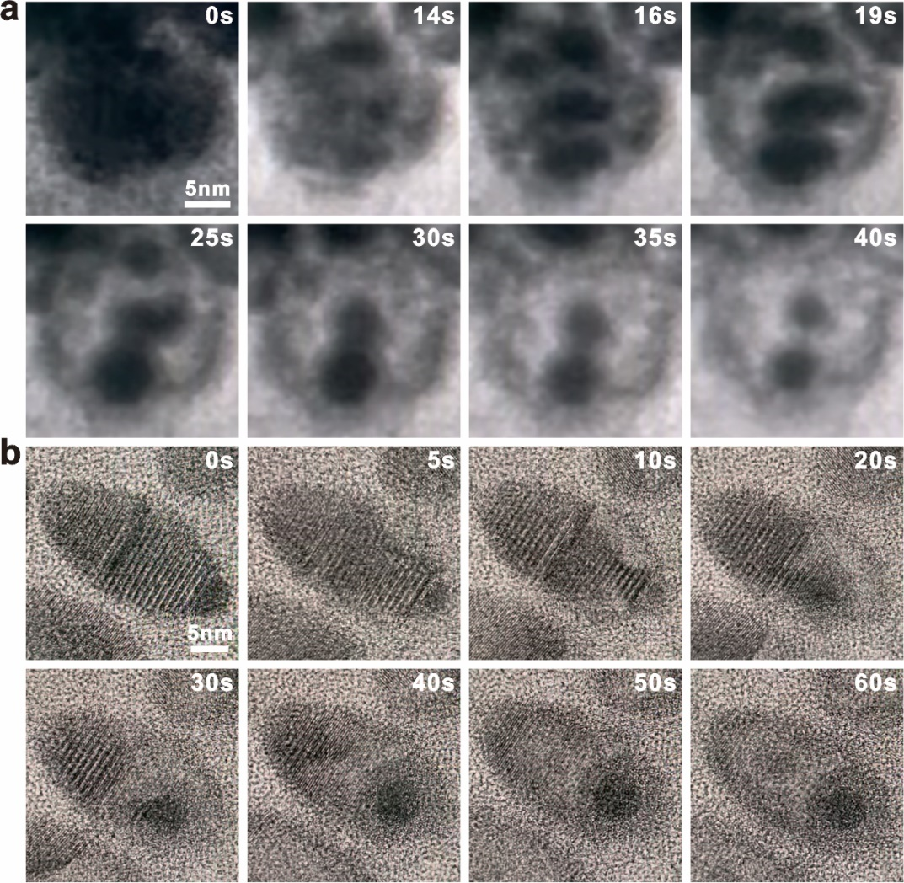
Supplementary Fig. 14 The evolution of single HgS NP with different shapes. a, Polyhedron. b, Ellipsoidal shape. These NPs were encapsulated in the carbon LC with the Tris·HCl buffer solution (10 mM).

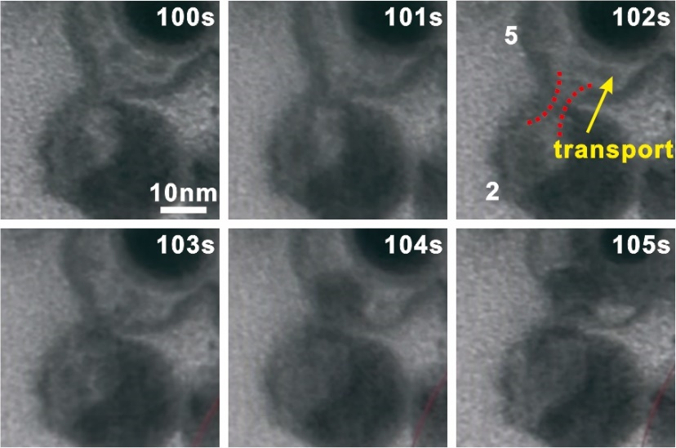
Supplementary Fig. 15 The enlarged TEM images showing the mass transport proceeded by the nanochannel (marked by the dotted lines) between the nanocells 2 and 5 (see also Fig. 3e in the main text).

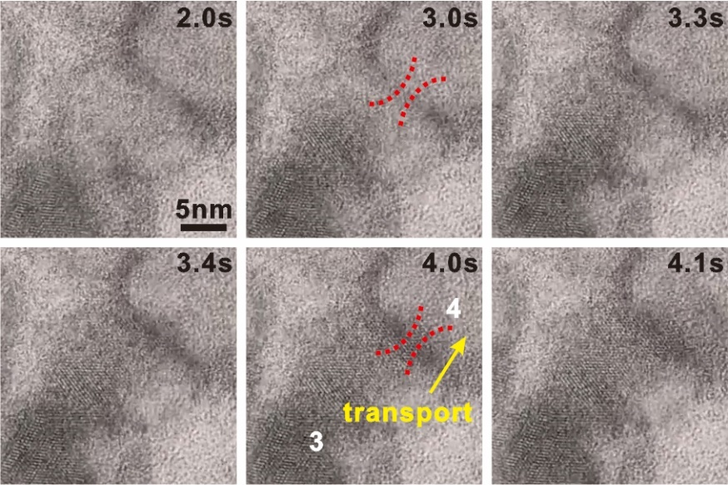
Supplementary Fig. 16 The TEM images showing the magnified view of the mass transport behavior through the nanochannel (marked by the dotted lines) between the nanocells 3 and 4 (see also Fig. 3f in the main text).

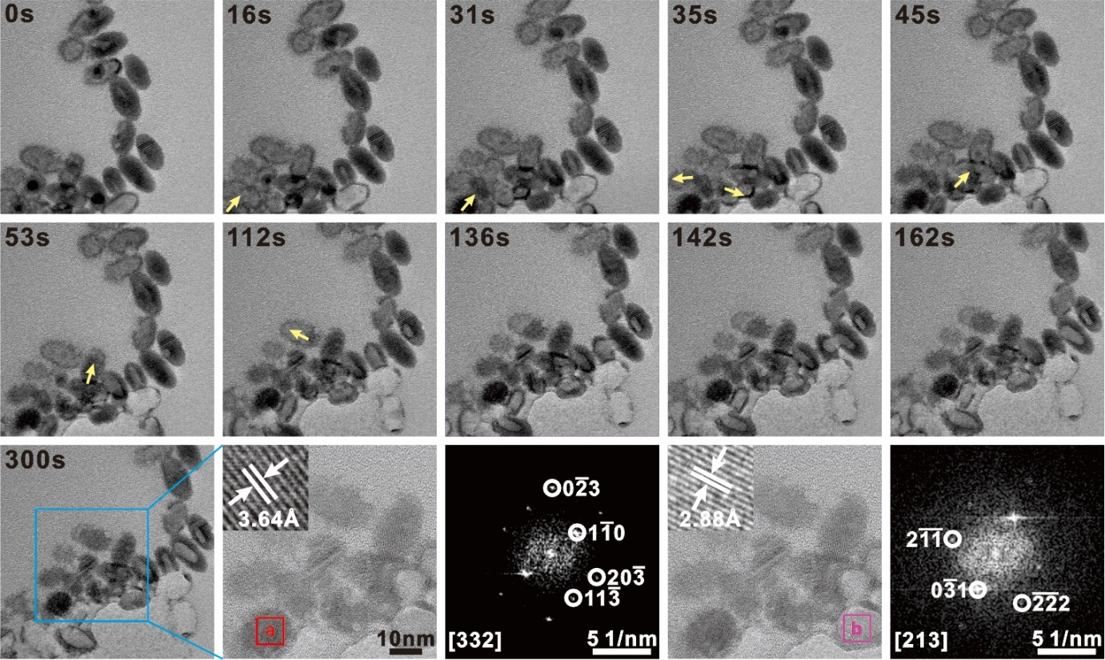
Supplementary Fig. 17 TEM images showing the crystalized products during the mass transfer in the HgS ellipsoidal sample. The arrows indicate the transport direction among different nanocells. The HRTEM and FFT analyses were used to identify the crystalized products. The crystal in the region a is Hg₂SO₄ (COD database ID# 1527303), whereas that in the region b is HgSO₄·H₂O (COD database ID# 2310684). The detailed analyses are listed in Supplementary Tables 4 and 5, respectively.

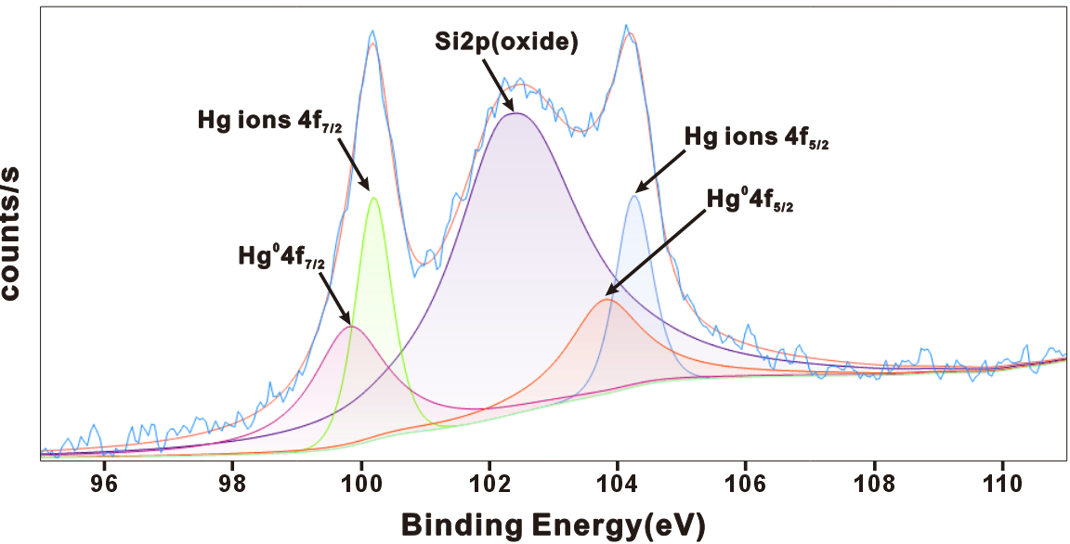
Supplementary Fig. 18 XPS characterization of the LC sample with Hg droplets embedded in the 10 mM tris-HCl aqueous solution. The binding energies of 99.70 eV and 103.73 eV are attributed to Hg 4f_{7/2} and 4f_{5/2} electron spectra from the Hg⁰ species ¹. The corresponding peaks with higher energies at 100.17 eV and 104.23 eV are related to the Hg⁺/Hg²⁺ ions ¹. The additional peak with binding energy of 102.39 eV corresponds to Si 2p ², which comes from the supporting copper grid used for the LC preparation.

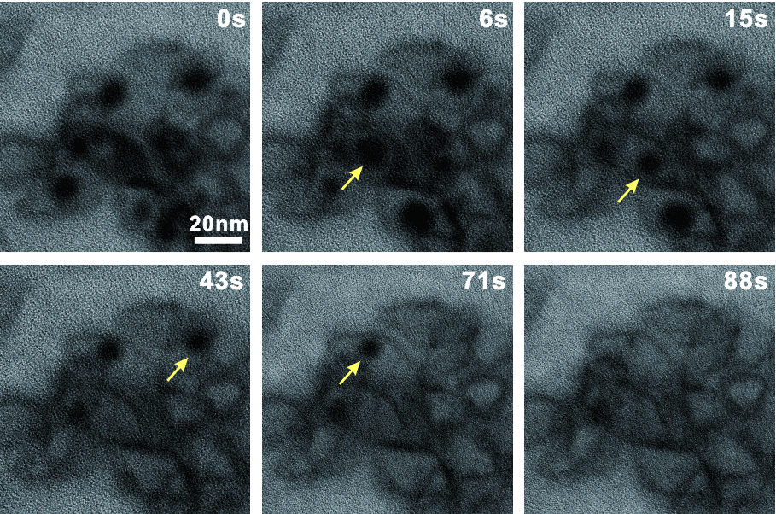
Supplementary Fig. 19 The evolution of the HgS nanobipyramids encapsulated into the LC with the 20 mM Tris·HCl aqueous solution. Similar processes (e.g., the one marked by the arrows) were observed as that of the samples with the concentration of 10 mM shown in the main text.

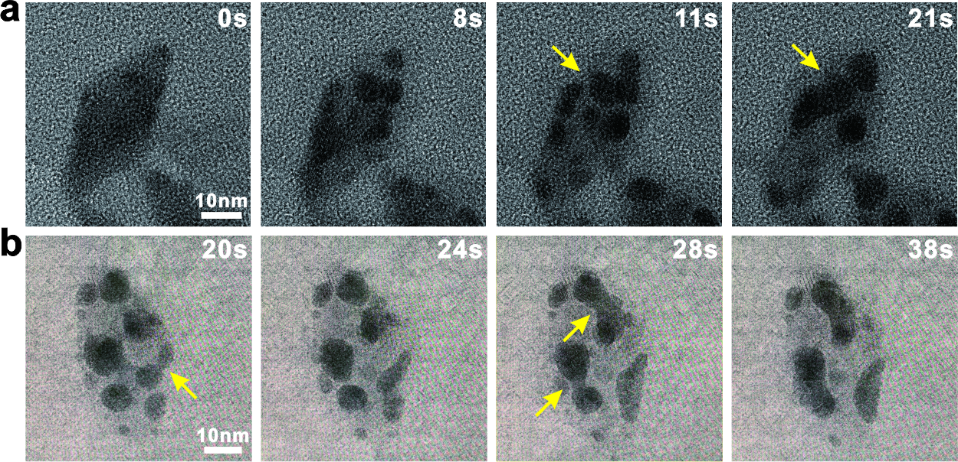
Supplementary Fig. 20 TEM images showing two examples a and b of the Ostwald ripening behavior (marked by the arrows) observed when no membrane existed on the Hg droplets. The HgS nanobipyramids were encapsulated in the LC with the 10 mM NaCl solution.

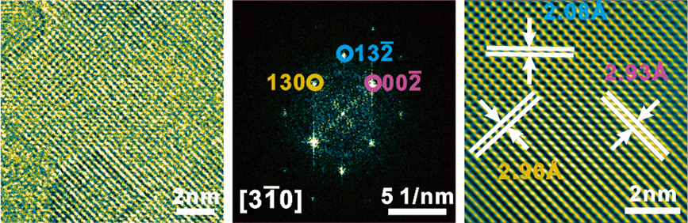
Supplementary Fig. 21 HRTEM images and associated FFT pattern of HgCl₂ crystalized in the LC with the NaCl aqueous solution. The interplanar spacings of 2.98, 2.09 and 2.93 Å correspond to the ($130$), (132), (002) planes of HgCl₂, respectively (COD database ID# 9009212). Detailed analyses are listed in Supplementary Table 6.

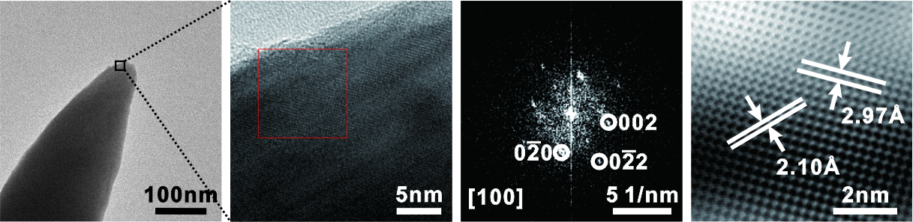
Supplementary Fig. 22 TEM images and corresponding FFT pattern of β-HgS section in the Hg-HgS heterostructure (see also Figure 4C). The interplanar spacings of 2.97 and 2.10 Å correspond to the (020), (022) and (002) planes of β-HgS, respectively (COD database ID# 9008848). The parameters of various spacings and angles are detailed in Supplementary Table 7.

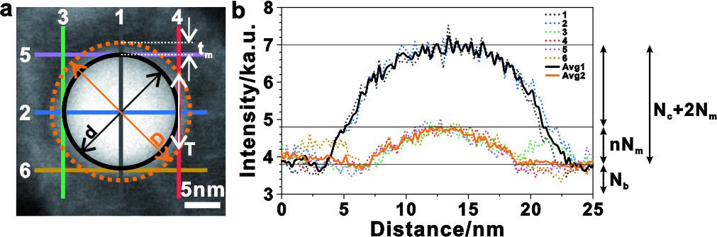
Supplementary Fig. 23 Estimation of the H₂O: Hg in the membrane. a, HAADF image of a typical nanodroplet with the membrane. The core and membrane are indicated by the solid line and dash line, respectively. and there are 6 lines with different colors across the center of core and the thickest of membrane, respectively. b, The intensity profiles across the six lines in (a). The solid lines represent the average intensity (Avg1 and Avg2). The notations for each parameter are shown in the following section of Supplementary Note.

Supplementary Note
This section is the estimation of the H₂O:Hg ratio in the membrane. The following analysis method is similar to that reported in the previous papers ^{3,4}. According to the HAADF image in Fig. S23A, the diameter ($D$) of the nanodroplet with membrane is ~20 nm and the thickness ($t_{m}$) of the membrane is ~2.4 nm. Therefore, the diameter ($d$) of the core is,
$$d=D-2t_{m}=20-2.4×2=15.2 nm$$
The thickness ($T$) at the position of the maximum HAADF intensity of the membrane is,
$$T=2\sqrt{{(\frac{D}{2})}^{2}-{(\frac{d}{2})}^{2}}=2\sqrt{{(\frac{20}{2})}^{2}-{(\frac{15.2}{2})}^{2}}=13.0 nm$$
The ratio $n$ for of $T/t_{m}$ is thereby,
$$n=\frac{nN_{m}}{N_{m}}=\frac{T}{t_{m}}=\frac{13.0}{2.4}=5.42$$
Based on the HAADF intensity values shown Fig. S23B, we obtain the following equations,
$$N_{c}+2N_{m}+N_{b}=7000$$
$$5.42N_{m}+N_{b}=4800, N_{b}=3800$$
So,
$$N_{m}=\frac{4800-3800}{5.42}=184.5$$
$$N_{c}=7000-3800-2×184.5=2831$$
where $N_{b}$,$N_{m}$ and $N_{c}$ are the intensity of the background, membrane and the core caused by elastically scattered electrons in STEM-HAADF, respectively. Specifically, $N$ can be calculated as,
$$N=\frac{N_{0}t}{λ}$$
where $t$ and $λ$ are the thickness for each kind of structure and the mean free path for elastic scattering, $N_{0}$ and $N$ are the intensity from the total and specific elastically scattered electrons, respectively.
As such, the thicknesses of the Hg species $t_{Hg}$ and water $t_{water}$ in the membrane are estimated,
$$t_{Hg}=\frac{N_{m}λ_{Hg}}{N_{0}}=\frac{N_{m}λ_{Hg}}{\frac{N_{c}λ_{Hg}}{D}}=\frac{N_{m}D}{N_{c}}=\frac{184.5×20}{2831}=0.99 nm$$
$$t_{water}=t_{m}-t_{Hg}=2.4-0.99=1.41 nm$$
Therefore, the ratio of H₂O: Hg in the membrane is,
$$H_{2}O:Hg=\frac{\frac{t_{water}×ρ_{water}}{A_{water}}}{\frac{t_{m}×ρ_{Hg}}{A_{Hg}}}=\frac{\frac{1.41×1}{18}}{\frac{0.99×13.6}{200.6}}≈1.17$$
The above ratio is used for the ab initio molecular dynamics simulations.

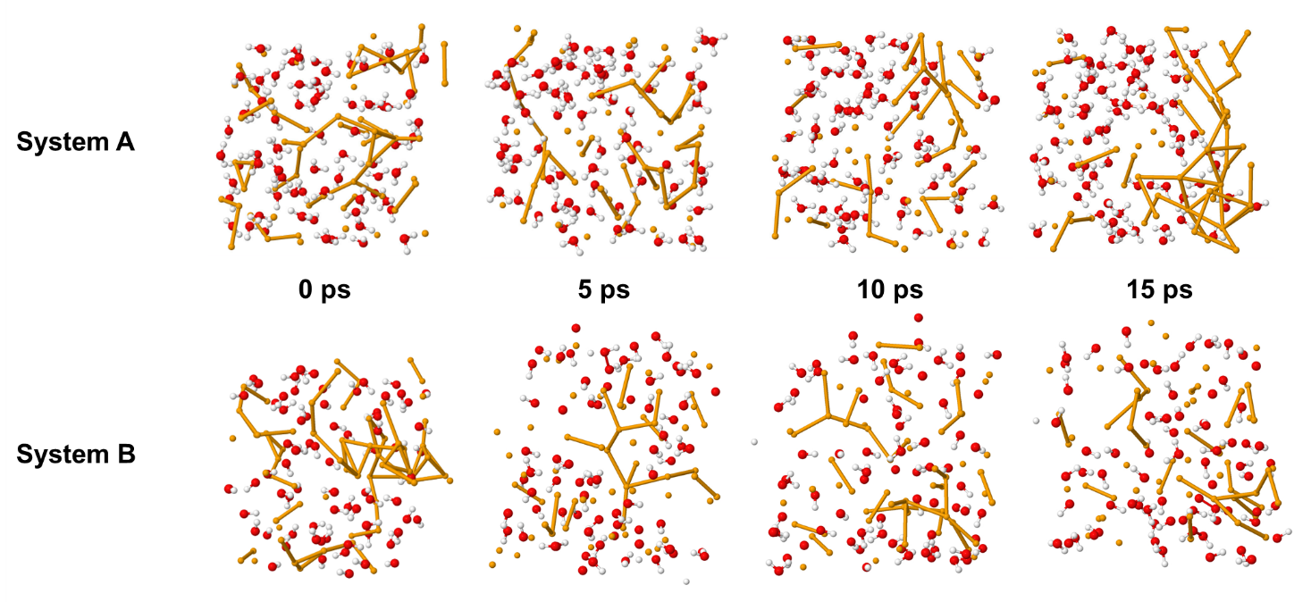
Supplementary Fig. 24 Snapshots of selected trajectory of system A and B for simulating the membrane stability. System A contains 72 H₂O molecules and 60 neutral Hg atoms , which are initially uniformly placed in a cubic box with a side length of 16.5 Å. System B contains 72 OH⁻ ions and 60 positively charged Hg ions, which together maintain the system's neutrality. The orange line connects the Hg-associated species with a distance less than 3.3 Å, which is used to measure the aggregation degree in the system. The neutral Hg-atoms system A shows the strong tendency of aggregating into the clusters, while the Hg-ions system B tends to disperse in the solution rather than aggregate. Color mode: orange, Hg; red, O; white, H.

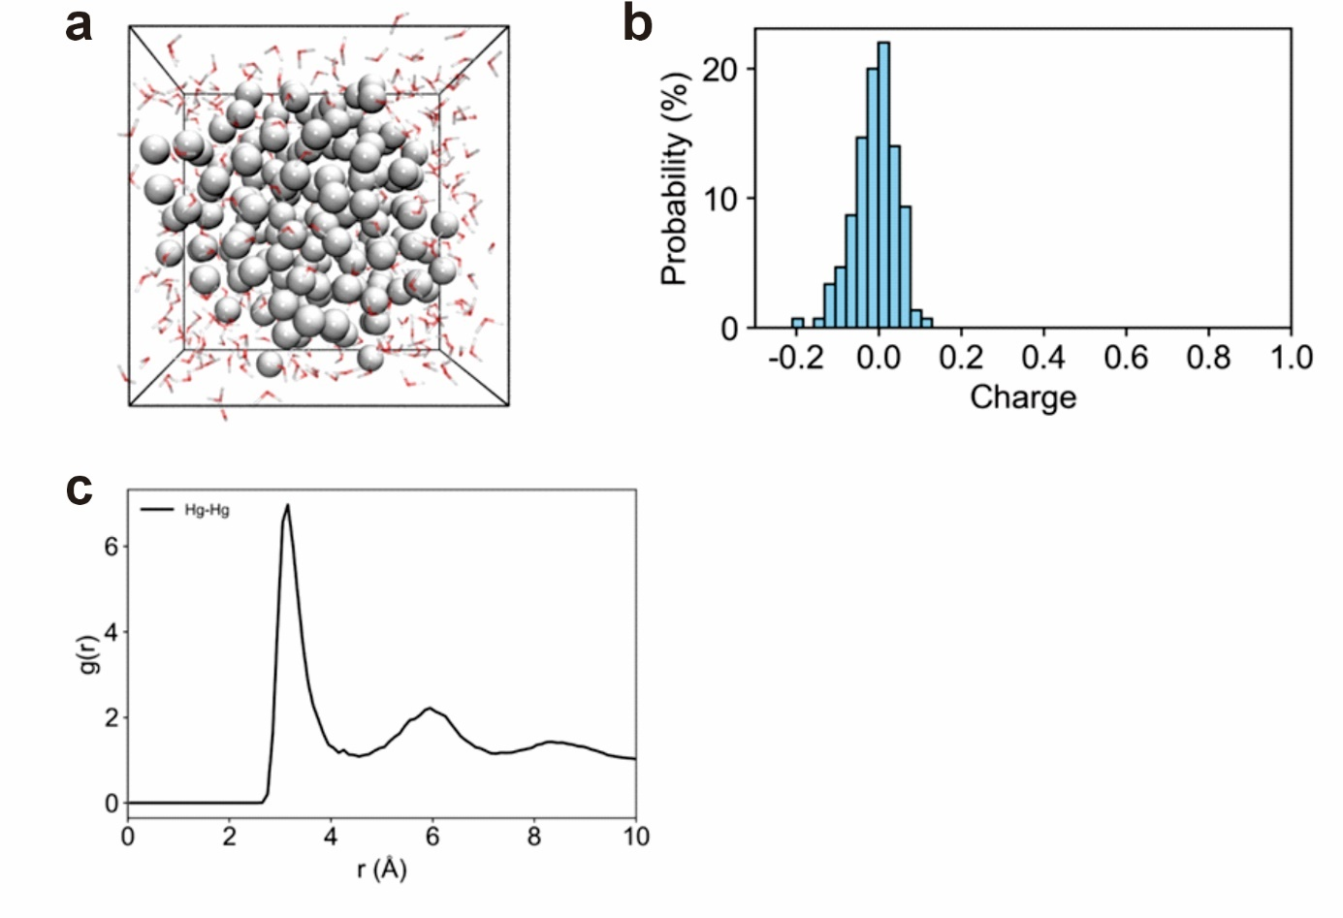
Supplementary Fig. 25 Charge distribution and radial distribution function for the Hg-atoms system. a, Representative structural snapshot of a simulated system that contains 150 Hg atoms and 300 H₂O molecules in a cubic box with a side length of 22.5 Å. The system of pure Hg atoms tends to aggregate to form a cluster structure. b, Charge distribution of Hg atoms in the system. The charge distribution of this system sets the basis to use 0.1 |e| as the threshold for dividing Hg atoms (Hg_{a}) and Hg ions (Hg_{i}). c, Radial distribution function (RDF) of Hg atoms in the system. The RDF of the system provides the information of the Hg-Hg coordination shell, which allows the peak position of 3.3 Å corresponding to the first coordination layer to be used as the basis for analyzing the degree of Hg aggregation. Color mode: grey, Hg_{a}; red, O; white, H.

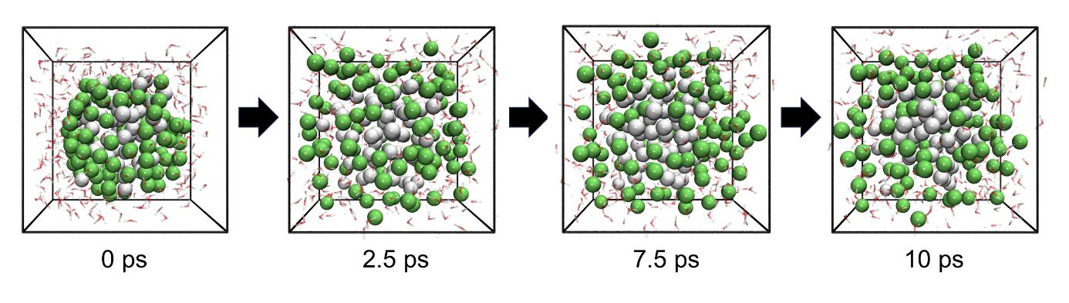
Supplementary Fig. 26 Time-dependent snapshots of the trajectory of systems C that contains 150 Hg species (either Hg atoms or cations), 200 H₂O, and 100 OH⁻ in a cubic box with a length of 22.5 Å. The core-membrane structure is clearly observed, i.e., the neutral Hg atoms form the core and the Hg ions occupy the membrane region, respectively. Color mode: grey, Hg_{a}; green, Hg_{i}; red, O; white, H.

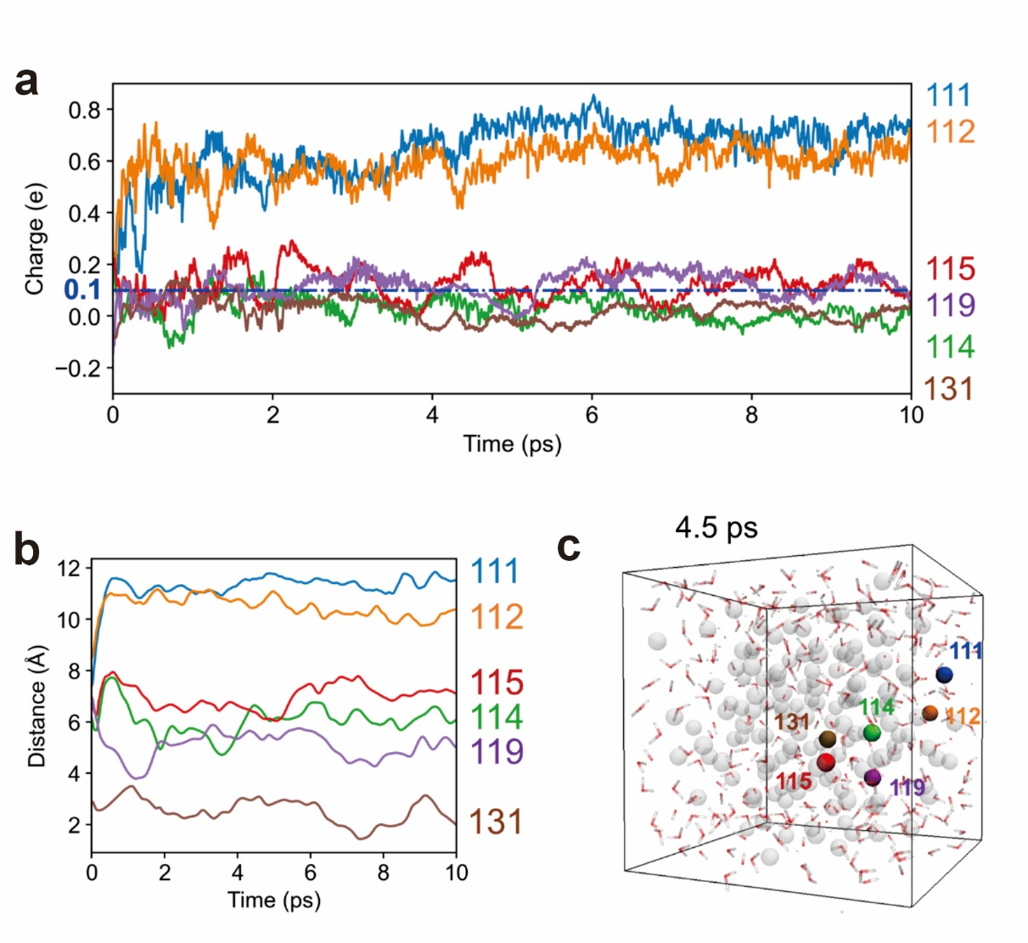
Supplementary Fig. 27 Spatial and charge distribution characteristics in system C. a, The charge evolution of selected Hg-associated species. The selected Hg species are distributed in different charge intervals and show different charge evolution processes. The Hg species in the core remain in an atomic state (labeled 131), while those at the membrane predominantly exhibit a positively charged ionic state (labeled 111 and 112). It is noteworthy that the species at the core-membrane interfacial region undergo a dynamic transition between atomic and ionic states (labeled 114, 115, and 119). b, The distance between selected Hg species and the center-of-mass of the Hg-droplet as a function of time. It shows that the Hg species locate at three different positions: the core region (labeled 131), the membrane region (labeled 111 and 112), and the core–membrane interfacial region (labeled 114, 115, and 119). c, Snapshot of the trajectory at 4.5 ps of system C with highlighted Hg species (labeled from 111 to 131), consistent with those analyzed in (b).

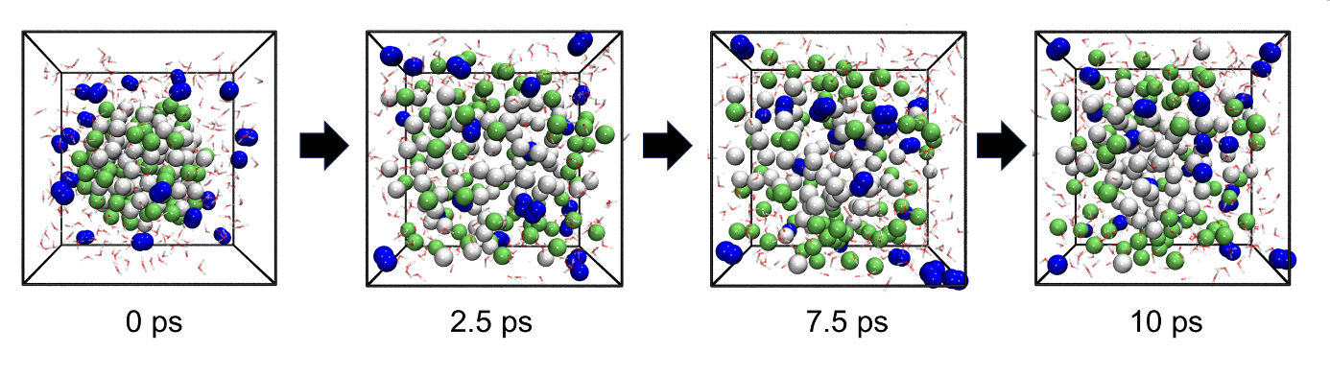
Supplementary Fig. 28 Snapshots of the trajectory of system D that contains 150 Hg species (either Hg atoms or cations), 200 H₂O, 100 OH⁻, and 20 H₂ molecules. It is seen that H₂ gradually destroys the Hg core-membrane structure. Color mode: grey, Hg_{a}; green, Hg_{i}; red, O; white, H; blue, H₂.

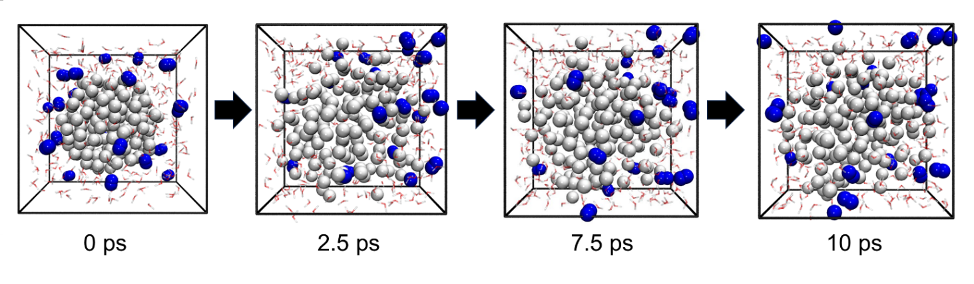
Supplementary Fig. 29 Snapshots of the trajectory of system E that contains 300 H₂O molecules, 150 neutral Hg atoms, and 20 H₂ molecules. No obvious destruction of the Hg nanodroplet by H₂ is observed. Color mode: grey, Hg_{a}; red, O; white, H of H₂O molecules; blue, H₂ molecules.

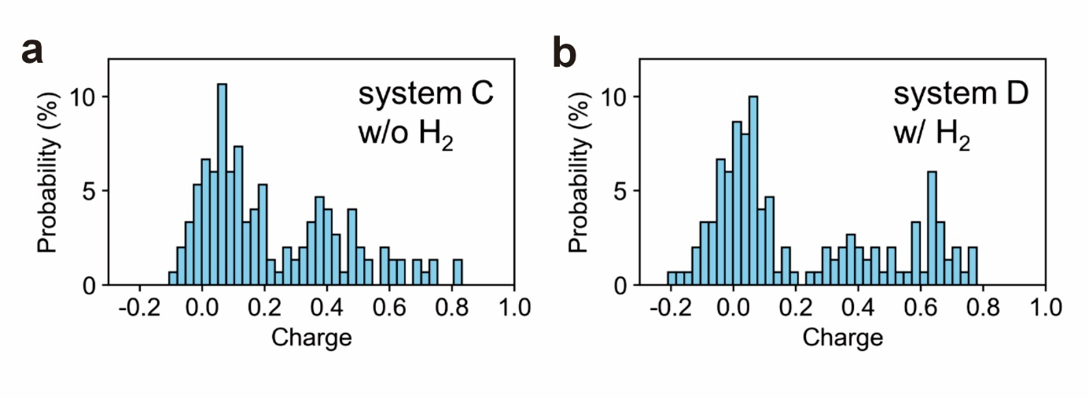
Supplementary Fig. 30 Charge distribution of the Hg-related species at the end of 10 ps simulation. a, System C. b, System D. It suggests that H₂ slightly affects the charge distribution of the Hg-associated species, dynamically impacting the stability of the nanodroplet's core-membrane structure.

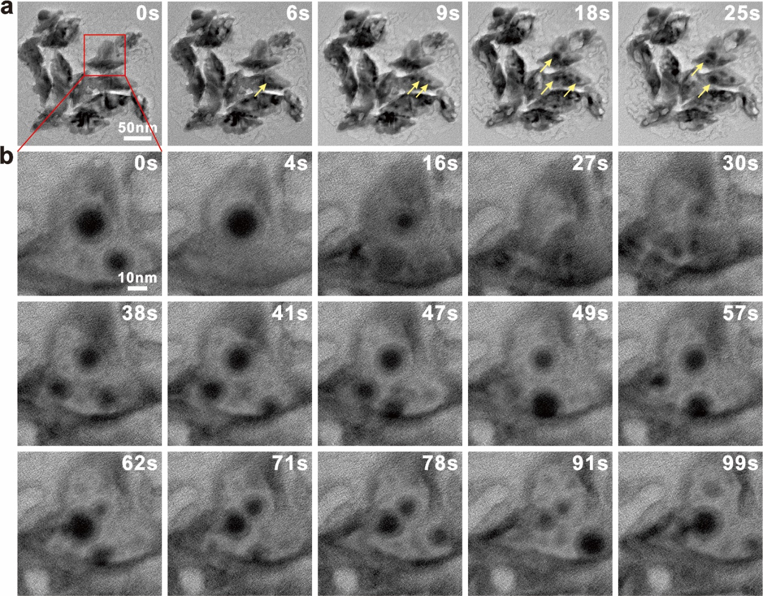
Supplementary Fig. 31 Evolution of the HgS nanobipyramids encapsulated into the LC with the glycine-HCl buffer solution. a, TEM images showing the large-area view of the evolution of several HgS nanobipyramids. The arrows indicate the examples of the generated Hg nanodroplets. b, A typical example illustrating the evolution process of the Hg nanodroplets, which is similar to that of the LC with the tris·HCl solution shown in the main text.

Supplementary Table 1 Comparison between reference and measurement values of interplanar spacings and angles for Hg. The reference values are from the XRD pattern of Hg in the COD database (ID# 1523182, see also Fig. S6).

Plane | Reference/Å | Measurement/ Å | $\left|Δ\right|$/%
($012$) | 2.230 | 2.27 | 1.794
($021$) | 1.461 | 1.50 | 2.669
($01\overline{1}$) | 2.733 | 2.80 | 2.452
($00\overline{3}$) | 2.228 | 2.26 | 1.436

Angle | Reference/° | Measurement/° | $$\left|Δ\right|$$
($012$)/($021$) | 29.236 | 29.29 | 0.054
($021$)/($01\overline{1}$) | 36.761 | 36.15 | 0.611
($01\overline{1}$)/($00\overline{3}$) | 65.866 | 65.88 | 0.014
($00\overline{3}$)/($012$) | 131.863 | 132.32 | 0.457

Supplementary Table 2 The reference and measurement values of interplanar spacings and angles for HgSO₄·H₂O. The values are referred from the XRD pattern in the COD database (ID# 2310684, see also Fig. S11).

Plane | Reference/Å | Measurement/ Å | $\left|Δ\right|$/%
($030$) | 2.988 | 3.02 | 1.071
($042$) | 1.948 | 1.97 | 1.129
($012$) | 3.605 | 3.64 | 0.971
($0\overline{2}2$) | 2.958 | 2.99 | 1.082

Angle | Reference/° | Measurement/° | $$\left|Δ\right|$$
($030$)/($042$) | 29.649 | 29.66 | 0.011
($042$)/($012$) | 36.640 | 36.68 | 0.040
($012$)/($0\overline{2}2$) | 65.007 | 65.00 | 0.007
($0\overline{2}2$)/($030$) | 131.296 | 131.34 | 0.044

Supplementary Table 3 Comparison between reference and measurement values of d-spacings and angles for Hg₂SO₄. The reference values are from the XRD pattern of Hg₂SO₄ in the COD database (ID# 1527303, see also Fig. S12).

Plane | Reference/Å | Measurement/ Å | $\left|Δ\right|$/%
(11$\overline{1}$) | 3.342 | 3.27 | 2.154
($20\overline{1}$) | 2.969 | 2.90 | 2.324
($1\overline{1}0$) | 3.618 | 3.52 | 2.709
($0\overline{2}1$) | 2.140 | 2.09 | 2.336

Angle | Reference/° | Measurement/° | $$\left|Δ\right|$$
(11$\overline{1}$)/($20\overline{1}$) | 51.094 | 51.49 | 0.396
($20\overline{1}$)/($1\overline{1}0$) | 57.394 | 57.15 | 0.244
($1\overline{1}0$)/($0\overline{2}1$) | 37.390 | 37.14 | 0.250
($0\overline{2}1$)/(11$\overline{1}$) | 145.878 | 145.78 | 0.098

Supplementary Table 4 The measurement and reference values of interplanar spacings and angles for Hg₂SO₄. (refer to the COD database ID# 1527303; the measurement is related to Fig. S17).

Plane | Reference/Å | Measurement/ Å | $\left|Δ\right|$/%
($11\overline{3}$) | 2.227 | 2.29 | 2.829
(20$\overline{3}$) | 2.117 | 2.18 | 2.976
(1$\overline{1}0$) | 3.618 | 3.64 | 0.608
($0\overline{2}3$) | 1.734 | 1.76 | 1.499

Angle | Reference/° | Measurement/° | $$\left|Δ\right|$$
($11\overline{3}$)/(20$\overline{3}$) | 34.780 | 35.60 | 0.820
(20$\overline{3}$)/(1$\overline{1}0$) | 67.960 | 67.81 | 0.150
(1$\overline{1}0$)/($0\overline{2}3$) | 49.385 | 48.50 | 0.885
($0\overline{2}3$)/($11\overline{3}$) | 152.139 | 151.91 | 0.229

Supplementary Table 5 Identification of HgSO₄·H₂O from the reference and measurement values of interplanar spacings and angles (the reference is from the COD database ID# 2310684; see also Fig. S17).

Plane | Reference/Å | Measurement/ Å | $\left|Δ\right|$/%
(2$\overline{11}$) | 2.462 | 2.52 | 2.356
(2$\overline{4}0$) | 1.726 | 1.77 | 2.549
(0$\overline{3}1$) | 2.794 | 2.88 | 3.078
($\overline{22}2$) | 1.997 | 2.06 | 3.155

Angle | Reference/° | Measurement/° | $$\left|Δ\right|$$
(2$\overline{11}$)/(2$\overline{4}0$) | 37.691 | 37.48 | 0.211
(2$\overline{4}0$)/(0$\overline{3}1$) | 43.922 | 43.90 | 0.022
(0$\overline{3}1$)/($\overline{22}2$) | 53.370 | 53.65 | 0.280
($\overline{22}2$)/(2$\overline{11}$) | 134.982 | 135.03 | 0.048

Supplementary Table 6 Comparison between reference and measurement values of interplanar spacings and angles for HgCl₂ (refer to the COD database ID# 9009212; see also Fig. S21).

Plane | Reference/Å | Measurement/ Å | $\left|Δ\right|$/%
(00$\overline{2}$) | 2.981 | 2.93 | 1.711
($13\overline{2}$) | 2.125 | 2.08 | 2.118
($130$) | 3.030 | 2.96 | 2.310
($132$) | 2.125 | 2.09 | 1.647

Angle | Reference/° | Measurement/° | $$\left|Δ\right|$$
(00$\overline{2}$)/($13\overline{2}$) | 44.542 | 44.63 | 0.088
($13\overline{2}$)/($130$) | 45.458 | 45.18 | 0.278
($130$)/($132$) | 45.458 | 45.37 | 0.088
($132$)/(00$\overline{2}$) | 135.458 | 135.18 | 0.278

Supplementary Table 7 The reference and measurement values of interplanar spacings and angles for β-HgS (refer to the COD database ID# 9008848; see also Fig. S22).

Plane | Reference/Å | Measurement/ Å | $\left|Δ\right|$/%
(002) | 2.926 | 2.97 | 1.504
(0$\overline{2}2$) | 2.069 | 2.10 | 1.498
($0\overline{2}$0) | 2.926 | 2.97 | 1.504
($0\overline{2}\overline{2}$) | 2.069 | 2.10 | 1.498

Angle | Reference/° | Measurement/° | $$\left|Δ\right|$$
(002)/(0$\overline{2}2$) | 45.000 | 45.00 | 0
(0$\overline{2}2$)/($0\overline{2}$0) | 45.000 | 45.00 | 0
($0\overline{2}$0)/($0\overline{2}\overline{2}$) | 45.000 | 44.00 | 0
($0\overline{2}\overline{2}$)/(002) | 135.000 | 135.00 | 0

Supplementary Movie Captions
Supplementary Movie 1: The evolution of a single HgS nanobipyramid encapsulated into 10 mM tris•HCl buffer solution under e-beam illumination. Movie at 43 × speed.
Supplementary Movie 2: The formation of the nanoscale confined cell from the HgS matrix visualized under high resolution. Movie at 23 × speed.
Supplementary Movie 3: The dynamical evolution of Hg nanodroplets confined within the single nanocell. Movie at 4 × speed.
Supplementary Movie 4: The crystallization process after the rupture of a Hg nanodroplet inside the nanocell. Movie at 4 × speed.
Supplementary Movie 5: The mass transfer between two Hg nanodroplets in the single nanocell. Movie at 10 × speed.
Supplementary Movie 6: The mass transfer among three Hg nanodroplets within the single nanocell. Movie at 10 × speed.
Supplementary Movie 7: The mass transfer process across multiple nanocells with the polyhedral morphology. Movie at 15 × speed.
Supplementary Movie 8: The mass transfer process across multiple nanocells with the ellipsoidal morphology. Movie at 17.5 × speed.
Supplementary Movie 9: The evolution of a single HgS nanobipyramid encapsulated into 10 mM NaCl solution under e-beam illumination. Movie at 16 × speed.
Supplementary Movie 10: The rupture process of the Hg nanodroplet caused by the nanobubbles. Movie at 2 × speed.
Supplementary Movie 11: The evolution of Hg-HgS heterostructure without the outer membrane. Movie at 10 × speed.
Supplementary Movie 12: The evolution of Hg nanodroplet with the formation of the core-membrane structure (system C).
Supplementary Movie 13: The evolution of selected Hg species from different locations of the core-membrane structure (system C).
Supplementary Movie 14: Effect of H₂ on the evolution of Hg nanodroplet with the core-membrane structure (system D).
Supplementary Movie 15: The evolution of Hg nanodroplet without the membrane under the influence of H₂ (system E).
Supplementary References
1 Wu, G.-W. et al. Citrate-Capped Platinum Nanoparticle as a Smart Probe for Ultrasensitive Mercury Sensing. Anal. Chem. 86, 10955-10960 (2014).
2 Anwar, M., Hogarth, C. A. & Bulpett, R. An XPS study of amorphous MoO3/SiO films deposited by co-evaporation. J. Mater. Sci. 25, 1784-1788 (1990).
3 Loh, N. D. et al. Multistep nucleation of nanocrystals in aqueous solution. Nat. Chem. 9, 77-82 (2016).
4 Peng, X. et al. Identification of a quasi-liquid phase at solid–liquid interface. Nat. Commun. 13, 3601 (2022).

