Theoretical investigation
In this section, we present reconstruction results under various conditions using simulated data.
Impact of total variation regularization
Due to the increased number of unknown variables, minimizing only the fidelity term can result in significant reconstruction artifacts. This is similar to conventional tomography cases where the dataset is incomplete due to sparse views or limited angular coverage. In Fig. S1, we present results obtained without total variation (TV) regularization. As shown, although the stochastic sampling scheme produces the best outcome with the fewest artifacts, the result remains unsatisfactory. This highlights the important role of TV in suppressing background fluctuations, eliminating crosstalk, and enhancing contrast. In Fig. S2, we illustrate the progressive improvement of the reconstruction over iterations. The algorithm converges rapidly, with most of the improvement occurring within the first 10 iterations. Therefore, stochastic energy sampling, joint reconstruction, and TV regularization constitute the three fundamental pillars of the proposed method.
Impact of hyperparameters in ADMM
The ADMM algorithm involves two tuning hyperparameters, µ₁ and µ₂. The first, µ₁, controls the weight of the regularization term. For datasets with a high signal-to-noise ratio, a smaller value is recommended, while noisier datasets require a larger one. The second hyperparameter, µ₂, influences the convergence speed of the algorithm. Similarly, a smaller value is preferable for high-quality data. In Fig. S3, we present several examples illustrating the impact of these parameters. Proper tuning is essential for achieving optimal results, especially when the data is noisy.
Impact of noise
Experimental data inherently contains noise, making it essential to evaluate its impact on reconstruction quality. In Fig. S4, we simulate two cases with Poisson noise. The corresponding photon statistics for the sinogram used in the reconstruction are shown on the right. As expected, reconstruction quality degrades noticeably with increasing noise. Spectroscopic analysis generally requires a high signal-to-noise ratio for accurate spectral fitting, and the same holds true for spectro-tomography. In fact, the photon count requirements for spectro-tomography are higher than those for conventional tomography. To achieve reliable reconstruction, we recommend collecting at least a few hundred photons per pixel.
Impact of spectral randomness
We randomize the matrix $W$ by performing stochastic sampling over the energy domain. For theoretical investigation, we generate a simulated dataset using two hypothetical spectra composed of random values in the range of (0,1), ensuring minimal correlation between them. A reconstruction comparison is shown in Fig. S5, where both hypothetical random spectra and real Fe spectra were used to generate the sinogram. The results clearly show that the random spectra yield better reconstruction quality. This also points to a potential direction for further improving the technique.
Impact of initial guess
The previous test case involved two spatially separated species. Here, we evaluate the algorithm under a more challenging condition, where two complex patterns exhibit significant spatial overlap. The "Pepper" and "Barbara" images (128×128 pixels) were used to represent two Fe species (Fe⁰ and Fe³⁺), and 121 projections over 180° were generated for tomographic reconstruction. In Fig. S6, we present the reconstructed distributions of the two species. Three different initial guesses were tested—constant, random, and near ground truth. For stochastic sampling, all initializations led to similar results, successfully separating the two species. However, for interlaced and segmented sampling, only the initialization near the ground truth produced good reconstructions, free from strong artifacts and crosstalk. This suggests that interlaced and segmented sampling schemes are more susceptible to local minima; they converge to the correct solution only when the initial guess is reasonably close to the ground truth.

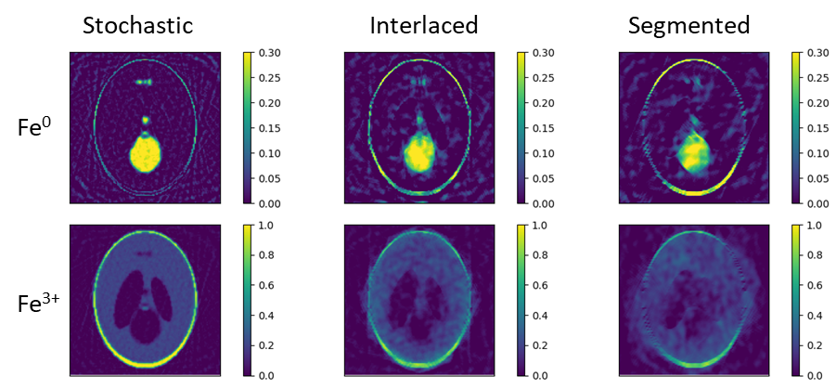
Fig. S1 Results of solving Eq. (2) without TV regularization term using different sampling schemes. Although stochastic sampling produces the best outcome, it still exhibits background fluctuations, crosstalk between the two states, and blurring. The simulation conditions are identical to those in Fig. 2a.

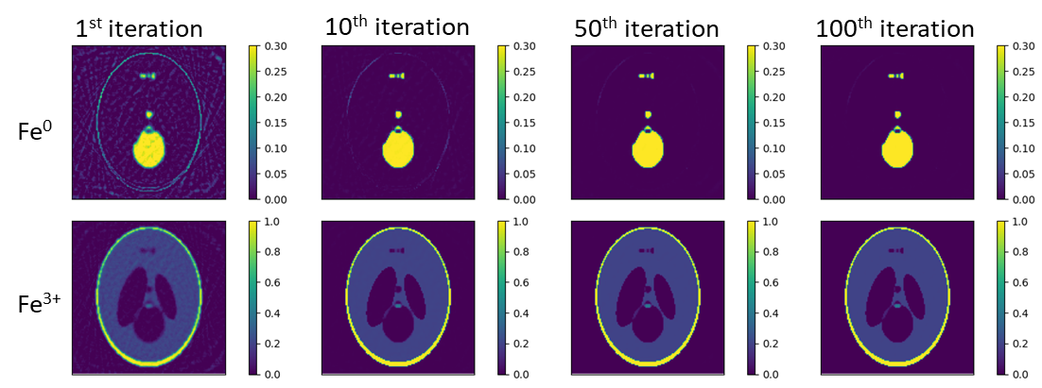
Fig. S2. Progressive improvement over iterations with TV regularization. Background fluctuations are significantly suppressed, and blurring is effectively eliminated.

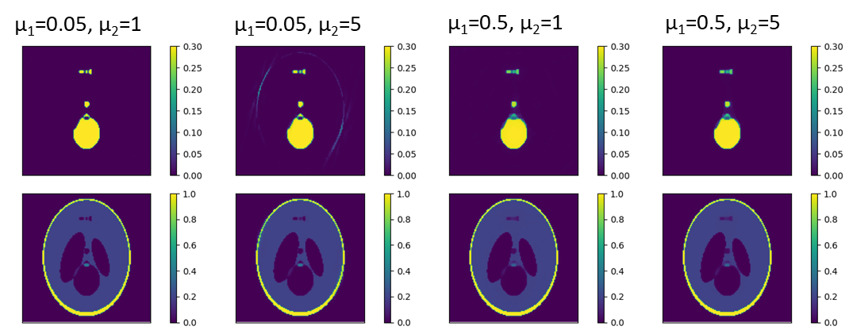
Fig. S3. Impact of µ1 and µ2 on reconstruction. The conditions are the same with those in Fig. 2a. Subtle difference in reconstruction quality can be observed.

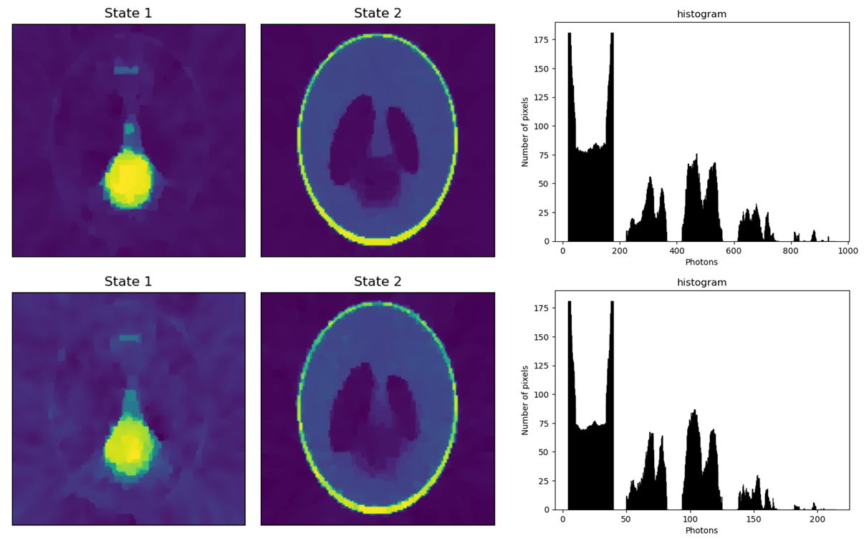
Fig. S4. Impact of noise. We reconstruct the two oxidation states of the phantom with simulated data that contains Poisson noise. The right figure shows the intensity histogram of the used sinogram.

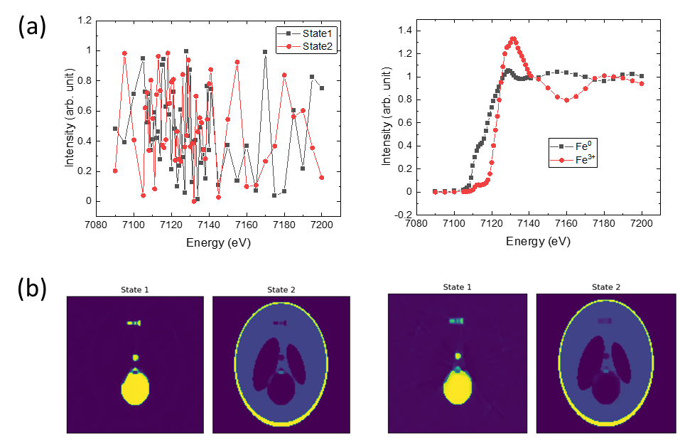
Fig. S5. Impact of spectral randomness. (a) Spectra used to generate the simulated data. (b) Spectro-tomographic reconstruction of the two states. The reconstruction using hypothetical random spectra yields better results.
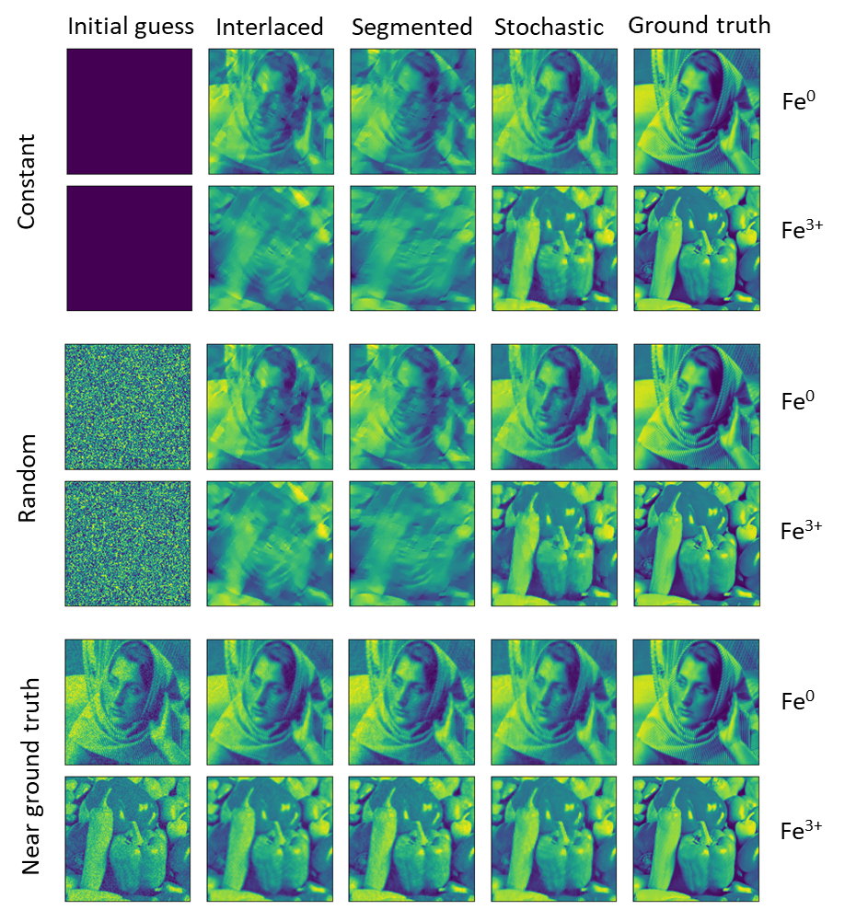
Fig. S6. Simulated experiment with two Fe species (Fe⁰ and Fe³⁺) strongly overlapping with each other. Results from top to bottom correspond to three different initial guesses of the solution - constant, random, and near ground truth.

Sample preparation and SEM characterization
In this section we present more details about sample preparation and SEM characterizations as well.
FIB and EDS measurements
Both the stainless steel/hematite nanoparticle mixture and NMC811 particles were prepared using FIB to mount them to a sharp pin for spectro-tomography measurement. In Fig. S7-S11 we show their morphologies in SEM and compositions in EDS analysis.

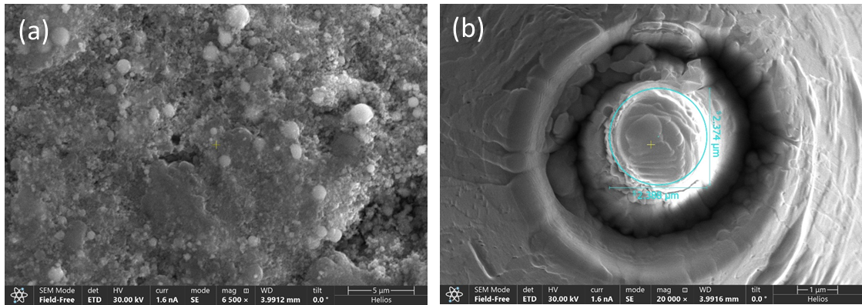
Fig. S7. SEM of stainless steel-Hematite Silicate. a) SEM micrograph of the silica encased iron nanoparticle matrix, at 30KeV steel particles stand in stark relief to the silica and hematite composite. b) Top-down view of cylindrical section of Steel/Hematite silicate with annotation showing 2.4 µm diameter.

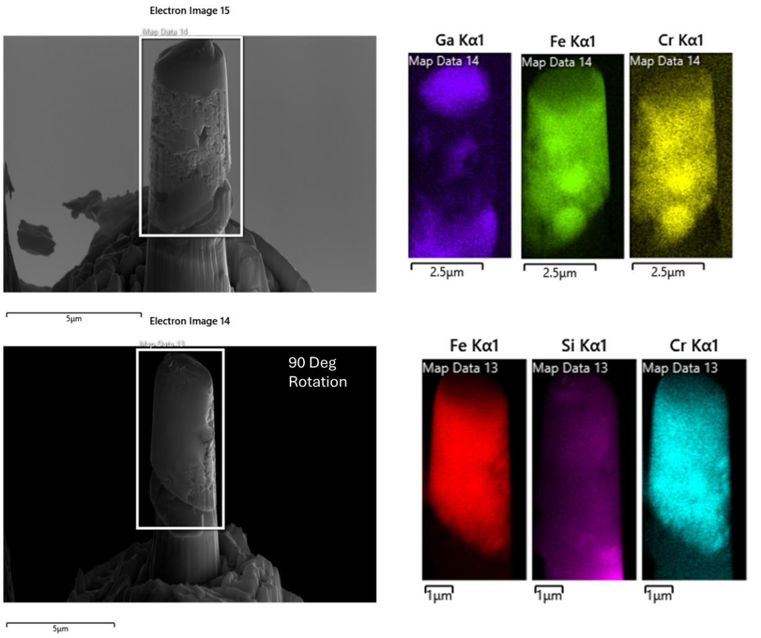
Fig. S8. FIB/SEM Prepared Cylindrical Sample of stainless steel/hematite nanoparticle mixture. A sample of 2.4 µm is shown at two angles with respect to the electron beam (0 and 90degrees relative). Zero degrees angle (Top) with EDS map which shows the carbon cap represented by Gallium, Iron, Chromium and silicon for the 90º setting (Bottom) shown.

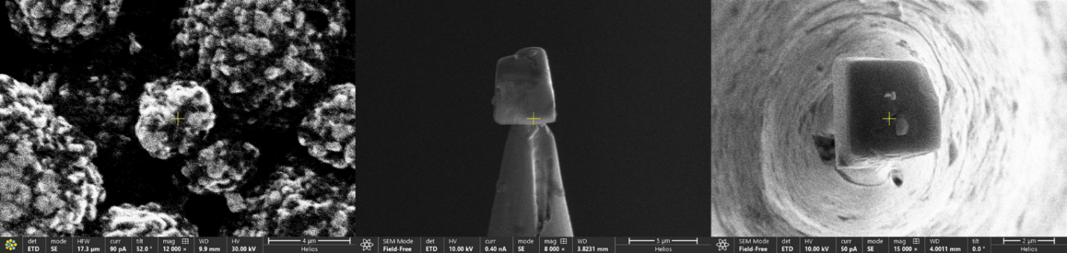
Fig. S9. Cycled NMC Sample. Left) Cycled NMC particle selected for size (<5um). The Sample is capped with carbon to protect the sample during mounting, the sample is then shown mounted to the tungsten needle from the side (Center) and top view (Right)

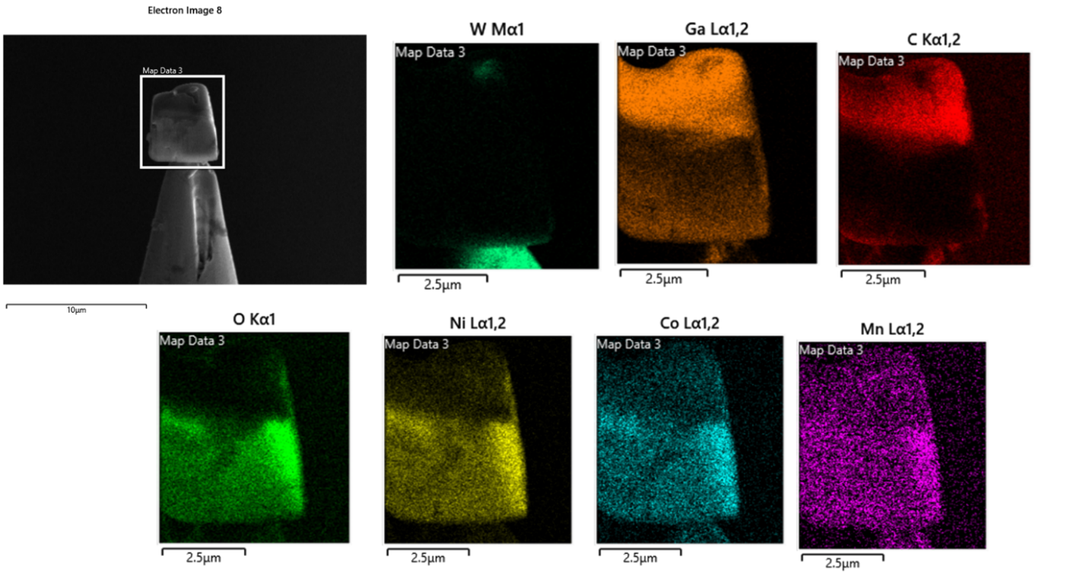
Fig. S10. Cycled NMC SEM-EDS. SEM EDS of the Cycled NMC sample from the side view, showing the carbon cap protecting the sample along with the dominant species, Ni, Manganese and Cobalt oxides.

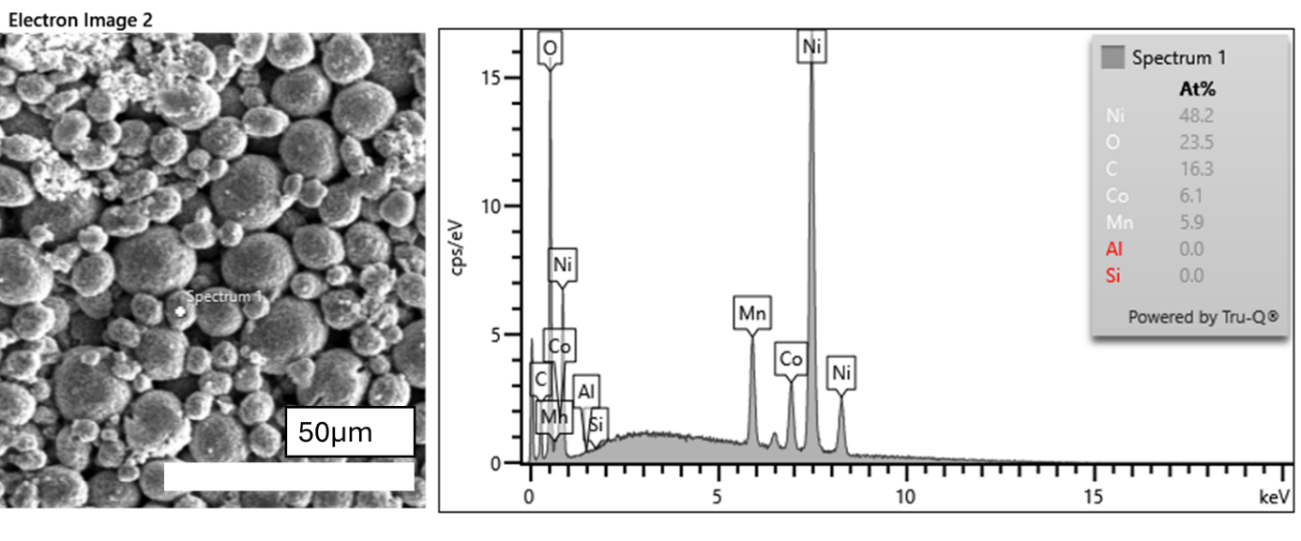
Fig. S11. Pristine NMC SEM-EDS. Left) SEM Image and spectrum spot marker Right) EDS spectrum with At% table with dominant species nickel, manganese, and cobalt identified. Ni:Mn:Co ratio agrees well with 8:1:1.

Additional experimental data
In this section, we present additional experimental data that supports the claims in the main text.
Spectro-tomography measurement on the second stainless steel/hematite nanoparticle mixture
A measurement on another test sample was performed to verify the observation of excessive Fe⁰ on the boundary. Results are shown in Fig. S12. Like the case presented in Fig. 3, distributions of Fe⁰ and Cr are highly correlated, but there is an excessive amount of Fe⁰ on the boundary. This provides another verification of the observation.
2D nano-XANES of the pristine NMC811 particle
A 2D nano-XANES measurement on the pristine NMC811 sample was conducted to determine the chemical state of Co before cycling. From Fig. S13, it is evident that only Co³⁺ exists in the pristine particle.
Ni distribution of the cycled NMC811 particle
Since the Co K-edge lies below that of Ni, Ni’s distribution could not be captured during the spectro-tomography measurement. Therefore, a separate tomography scan was performed at 10 keV to reveal the Ni distribution. In Fig. S14, we present 3D renderings of the reconstructions, with cutaway views to highlight internal variations. Corresponding cross-sectional slices and a composite map are shown at the bottom. The Ni distribution appears largely uniform, with no noticeable change in concentration at the surface phase.

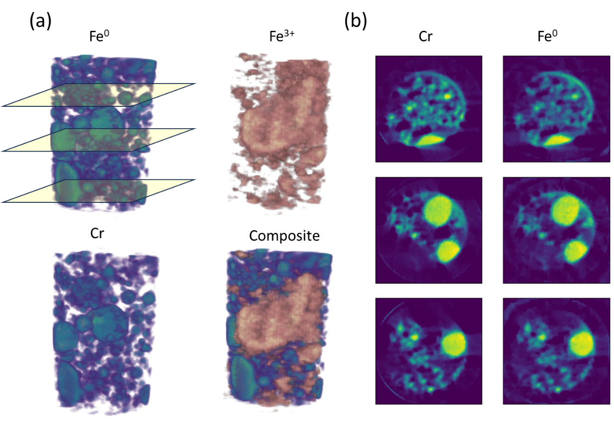
Fig. S12. Spectro-tomography reconstruction of the second test sample. (a) 3D renderings showing distributions of Fe⁰, Fe³⁺, Cr, and the composite of two iron oxidation states. (b) cross-sectional views of Cr and Fe⁰ distributions at three heights shown in (a).

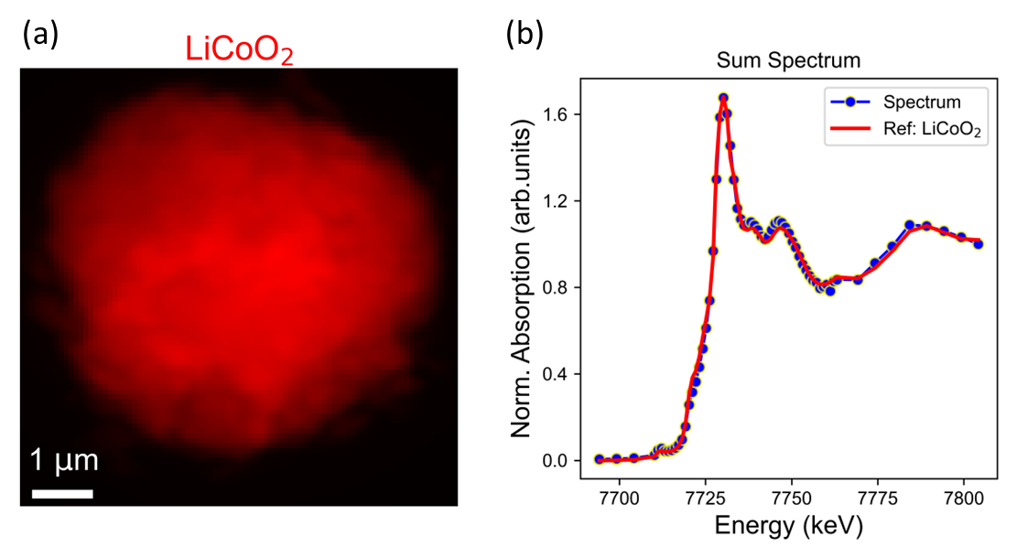
Fig. S13. nano-XANES measurement of the pristine NMC811 cathode particle. (a) Chemical state map of Co based on single-pixel spectrum fitting. Only Co³⁺ was detected throughout the entire particle. (b) summed spectrum from all pixels and the fitting. The experimental data can be well-fitted with the reference spectrum of LiCoO₂.

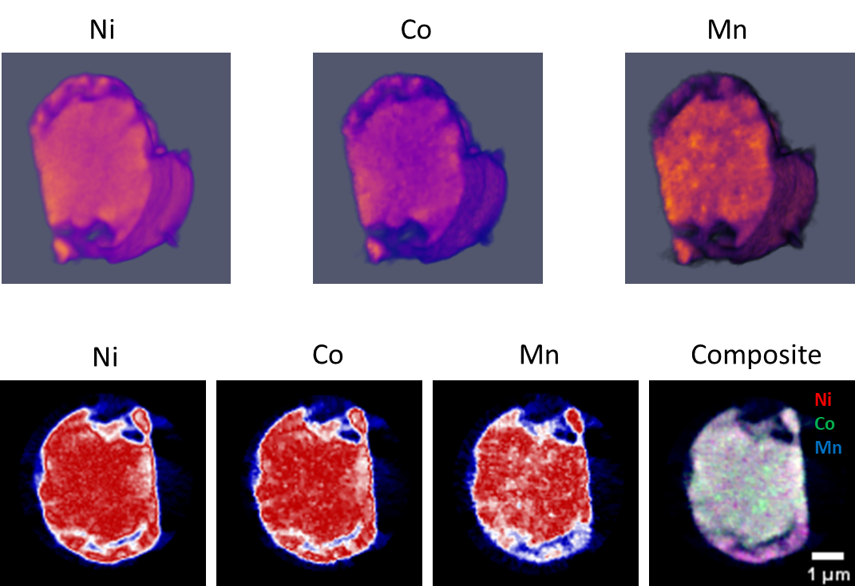
Fig. S14 Tomography performed at 10 keV. 3D renderings showing Ni, Co and Mn concentrations based on fluorescence data taken at 10 keV are presented. The particle is clipped to show the internal variations. Cross-sectional views correspond to the clipped plane are shown at the bottom.

Movie S1.
3D rendering showing volume destructions of Fe, Cr, and two Fe oxidation states of the test sample.

Movie S2.
3D rendering showing the volume distribution of the Co, Mn and two Co oxidation states of a cycled NMC811 battery particle.

