A

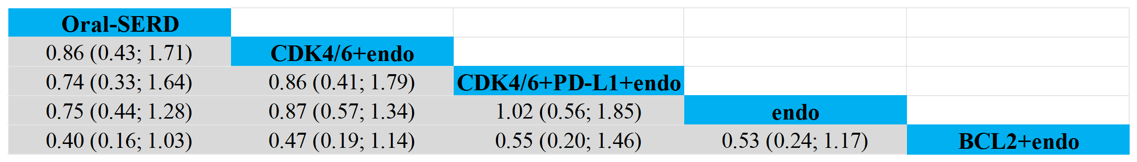

B

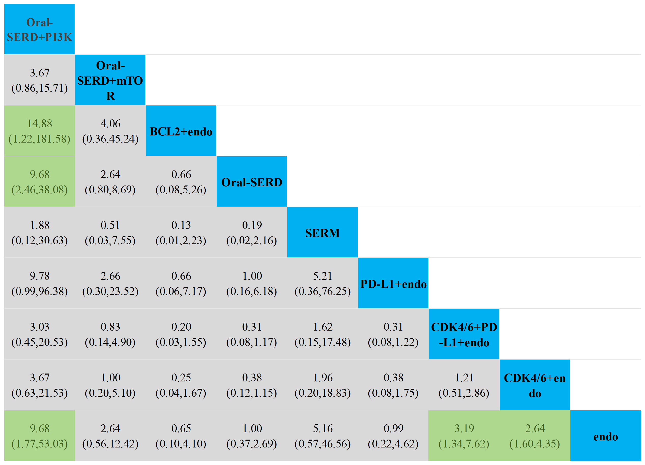

C

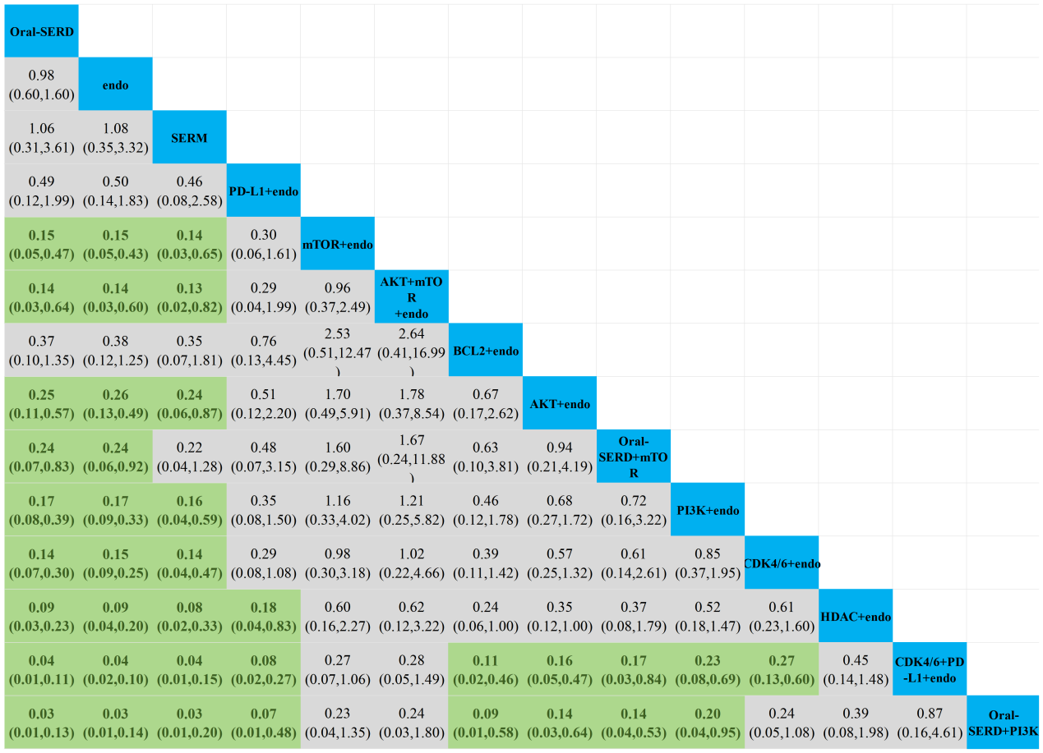

D

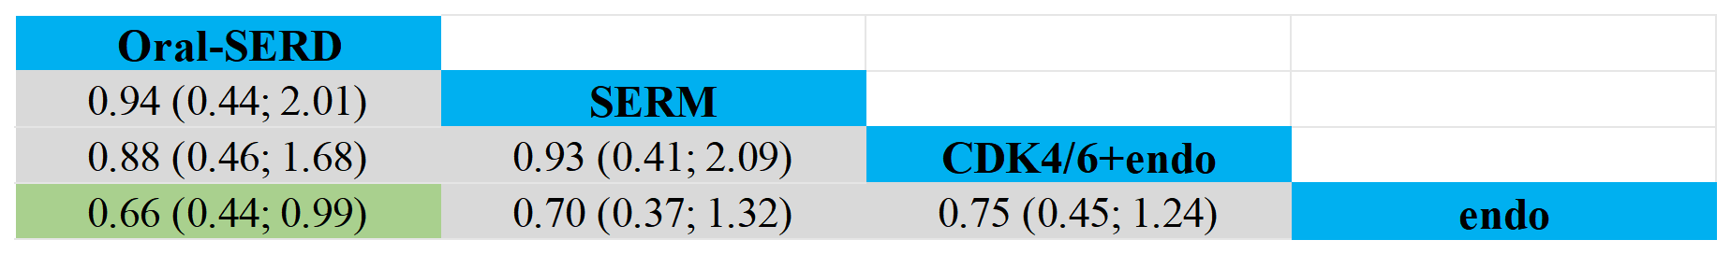

E

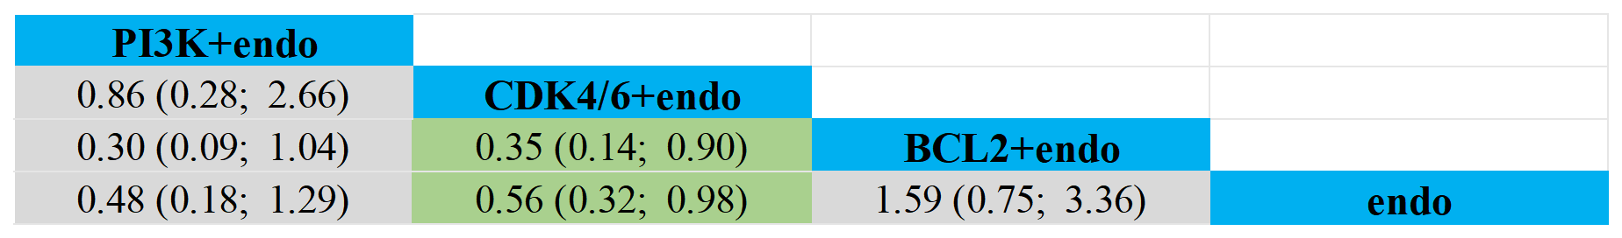

Supplemental File C: Cross-comparison of each endpoints. A. OS of overall populations. The results after making comparisons of the treatment regimens in each row and column are shown as HR and 95% CI results, and results with p < 0.05 are highlighted in light green. B. ORR of overall populations. The results after making comparisons of the treatment regimens in each row and column are shown as OR and 95% CI results, and results with p < 0.05 are highlighted in light green. C. ≥3 AEs of overall populations. The results after making comparisons of the treatment regimens in each row and column are shown as OR and 95% CI results, and results with p < 0.05 are highlighted in light green. D. PFS of ESR1-Mutant populations. The results after making comparisons of the treatment regimens in each row and column are shown as HR and 95% CI results, and results with p < 0.05 are highlighted in light green. E. PFS of PIK3CA-Mutant populations. The results after making comparisons of the treatment regimens in each row and column are shown as HR and 95% CI results, and results with p < 0.05 are highlighted in light green.

