Mechanistic Insights into Cannabidiol-Mediated TrkB Activation via FRS2 Interaction in Attenuating Alzheimer's Disease Pathology and Cognitive Impairment
Jiantao Liu^{1,5 #}, Feiyuan Peng^{1 #}, Chuangyu Yao¹, Sha Jin^{2,3}, Guoli Wu¹, Tianshu Zhang^{2,3}, Xiaohui Wang^{2,3,4*}, Xiubo Du1*

¹College of Life Sciences and Oceanography, Shenzhen University, Shenzhen, Guangdong, 518055, China
²Laboratory of Chemical Biology, Changchun Institute of Applied Chemistry, Chinese Academy of Sciences, Changchun, 130022, China
³School of Applied Chemistry and Engineering, University of Science and Technology of China, Hefei, 230026, China
⁴State Key Laboratory of Brain Machine Intelligence, Zhejiang University, Hangzhou, 310027, China
⁴Sino-German Joint Research Lab for Space Biomaterials and Translational Technology, Synergetic innovation Center of Biological Optoelectronics and Healthcare Engineering, School of Life Sciences, Northwestern Polytechnical University, Xi’an, Shaanxi 710072, China
* Corresponding authors: Xiaohui Wang (xiaohui.wang@ciac.ac.cn), Xiubo Du (duxiubo@szu.edu.cn)
# These authors contributed to this paper equally.
Original data for Western Blot
Lanes order of mouse brain samples, from left to right: Marker, WT-1, WT-2, WT-3, AD-1, AD-2, AD-3, AD+L-CBD-1, AD+L-CBD-2, AD+L-CBD-3, AD+H-CBD-1, AD+H-CBD-2, AD+H-CBD-3, Marker, Marker. Markers are sometimes not visible.
(WT: Wild-type, AD: Transgene, L-CBD: 20μM CBD, H-CBD: 40μM)

Fig 2F Original data for Western blot
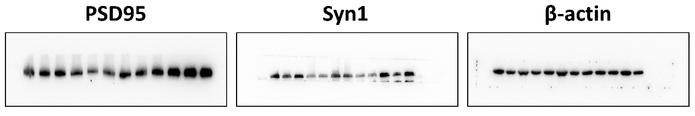

Lanes order of mouse brain samples, from left to right: Marker, WT-1, WT-2, WT-3, AD-1, AD-2, AD-3, AD+L-CBD-1, AD+L-CBD-2, AD+L-CBD-3, AD+H-CBD-1, AD+H-CBD-2, AD+H-CBD-3, Marker, Marker. Markers are sometimes not visible.
(WT: Wild-type, AD: Transgene, L-CBD: 20μM CBD, H-CBD: 40μM)

Fig 3B&D Original data for Western blot
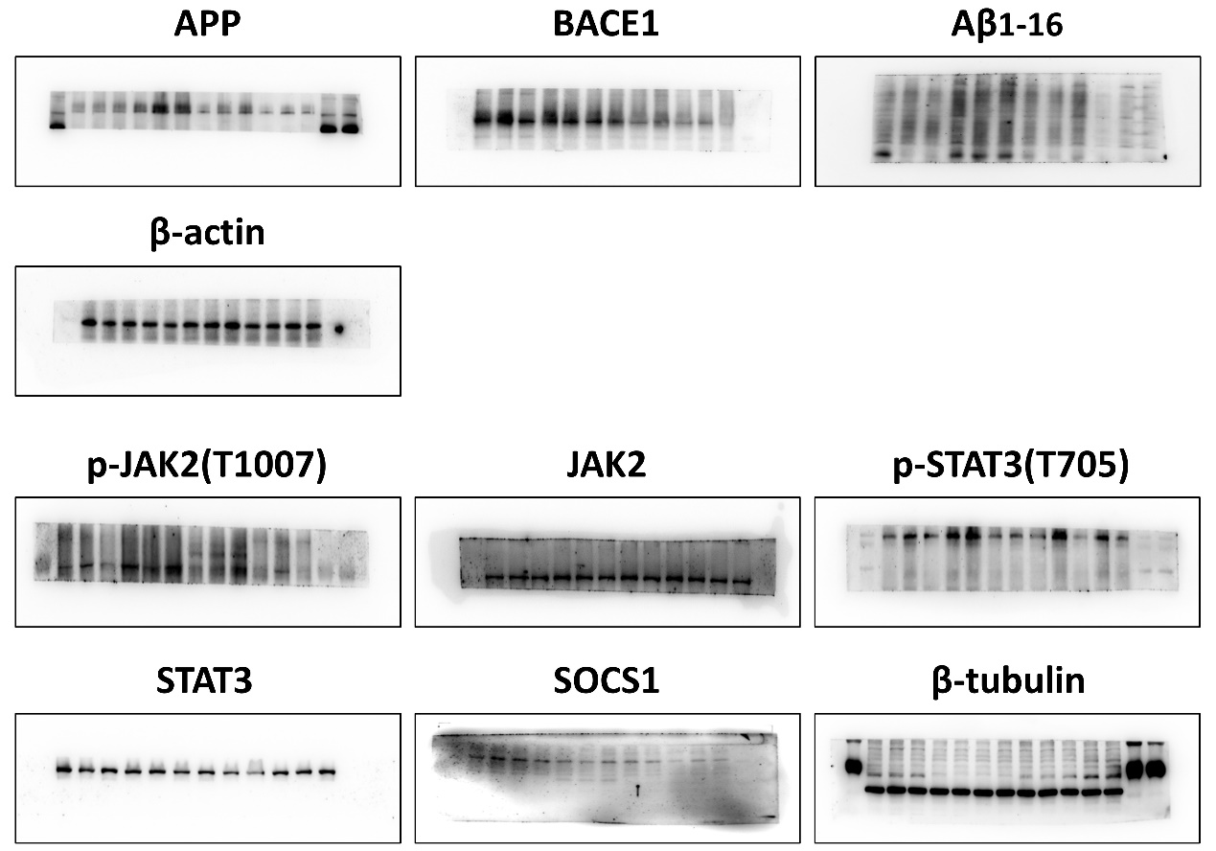

Lanes order of mouse brain samples, from left to right: Marker, WT-1, WT-2, WT-3, AD-1, AD-2, AD-3, AD+L-CBD-1, AD+L-CBD-2, AD+L-CBD-3, AD+H-CBD-1, AD+H-CBD-2, AD+H-CBD-3, Marker, Marker. Markers are sometimes not visible.
(WT: Wild-type, AD: Transgene, L-CBD: 20μM CBD, H-CBD: 40μM. The red-framed area is the selected region.)

Fig 3J Original data for Western blot
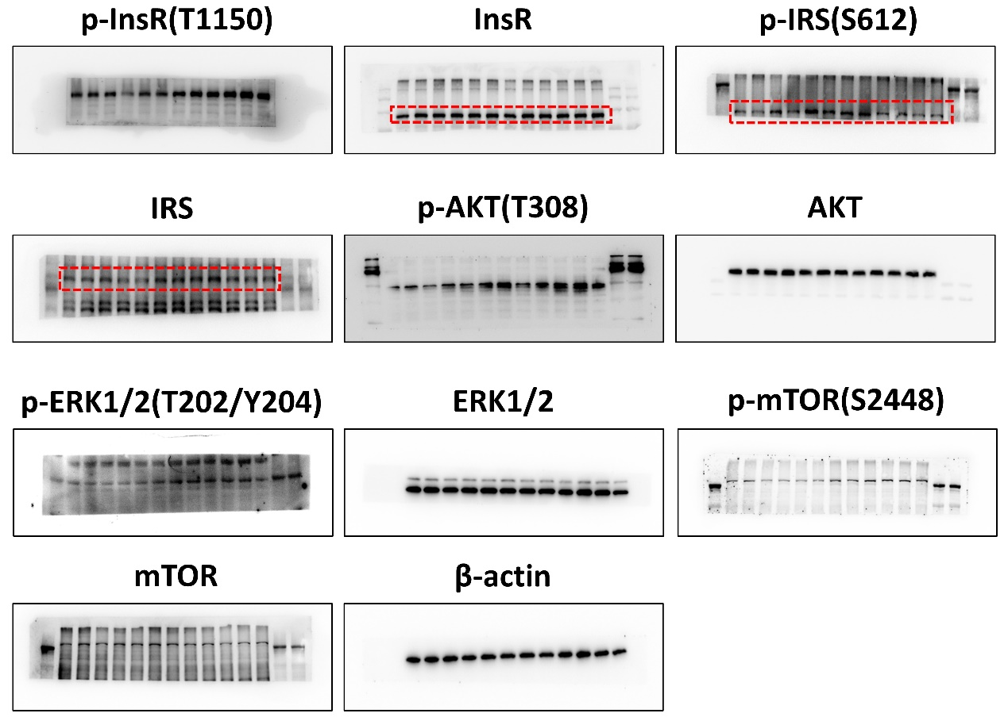

Lanes order of mouse brain samples, from left to right: Marker, WT-1, WT-2, WT-3, AD-1, AD-2, AD-3, AD+L-CBD-1, AD+L-CBD-2, AD+L-CBD-3, AD+H-CBD-1, AD+H-CBD-2, AD+H-CBD-3, Marker, Marker. Markers are sometimes not visible.
(WT: Wild-type, AD: Transgene, L-CBD: 20μM CBD, H-CBD: 40μM. The red-framed area is the selected region.)

Fig 4E&G Original data for Western blot
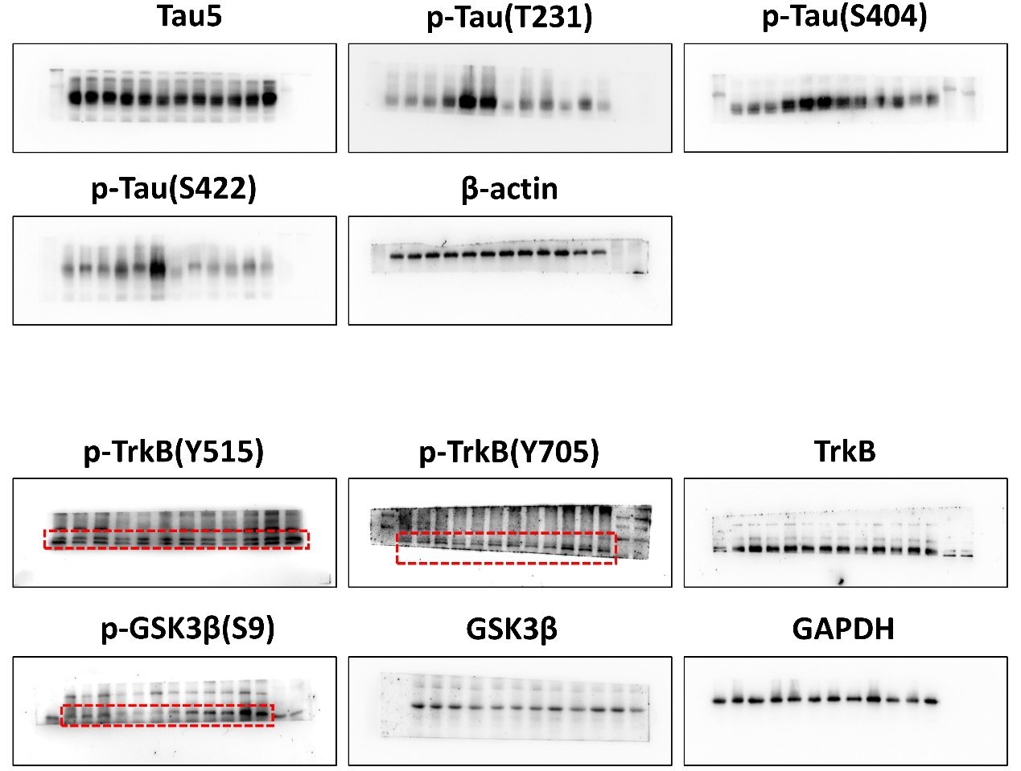

Lanes order of Hek293 cell samples, from left to right: Marker, CBD0-1, CBD0.1-1, CBD1-1, CBD3-1, CBD5-1, CBD7-1, CBD10-1, CBD0-2, CBD0.1-2, CBD1-2, CBD3-2, CBD5-2, CBD7-2, CBD10-2, Marker. Markers are sometimes not visible. (0-10 represent the concentrations of CBD treatment (μM). The red-framed area is the selected region.)

Fig S4A Original data for Western blot
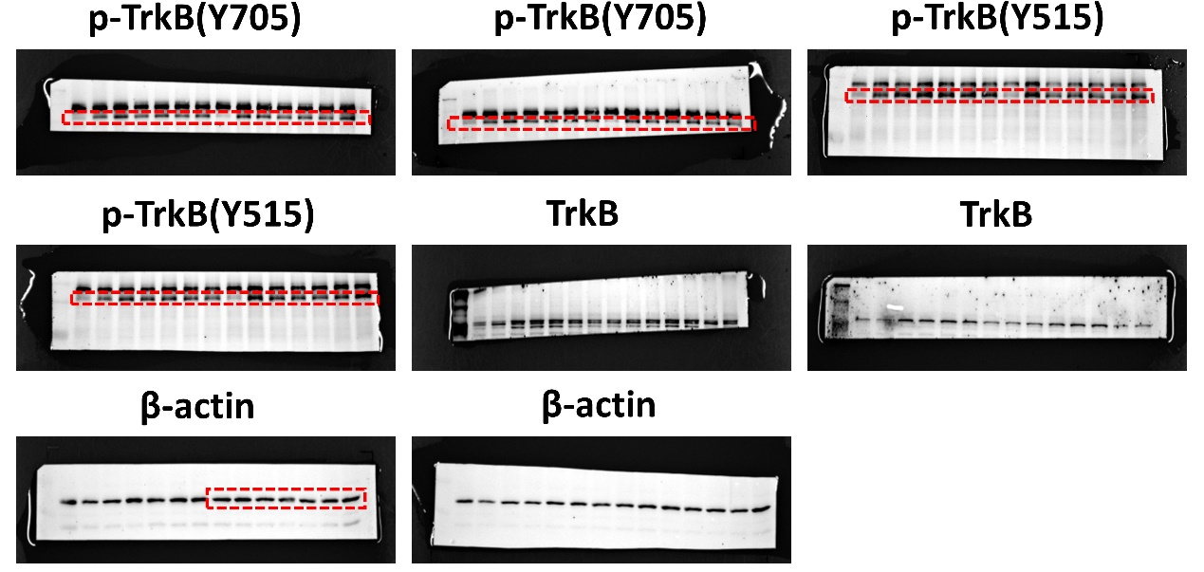
Lanes order of Hek293 cell samples, from left to right: Marker, CBD0-1, CBD10-1, CBD30-1, CBD180-1, CBD360-1, CBD720-1, CBD1440-1, CBD0-2, CBD10-2, CBD30-2, CBD180-2, CBD360-2, CBD720-2, CBD1440-2, Marker. Markers are sometimes not visible. (0-1440 represent the time points of CBD treatment (min). The red-framed area is the selected region.)

Fig S4D Original data for Western blot
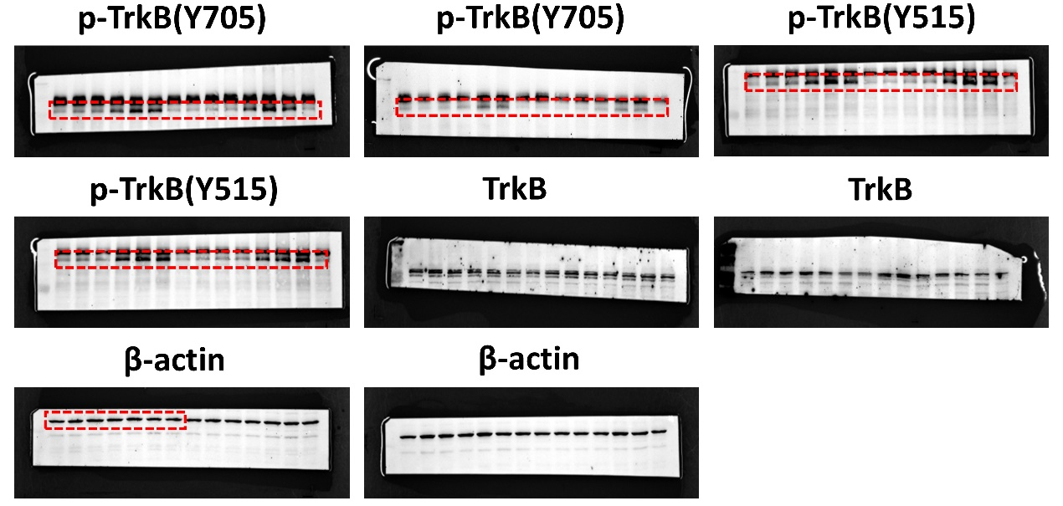

Lanes order of Hek293 cell samples and mouse brain samples. The red-boxed areas for the three samples are in the following order: DMSO, CBD, CBD+shFRS2. The corresponding red-boxed areas for the nine samples are in the order of DMSO-1, DMSO-2, DMSO-3, CBD-1, CBD-2, CBD-3, CBD+shFRS2-1, CBD+shFRS2-2, and CBD+shFRS2-3, which are used for statistical analysis. Additionally, the order of the WB (Western Blot) images for AKT and ERK is DMSO-1, DMSO-2, DMSO-3, CBD-1, CBD-2, and CBD-3.
The WB images for FRS2 and BDNF use mouse brain tissue samples. For the FRS2 image, the loading order within the red box is WT-1, WT-2, WT-3, WT+shFRS2-1, WT+shFRS2-2, and WT+shFRS2-3. For the BDNF image, the loading order within the red box is AD-1, AD-2, AD-3, AD+CBD-1, AD+CBD-2, and AD+CBD-3.

Fig S4G&K&N&P Original data for Western blot
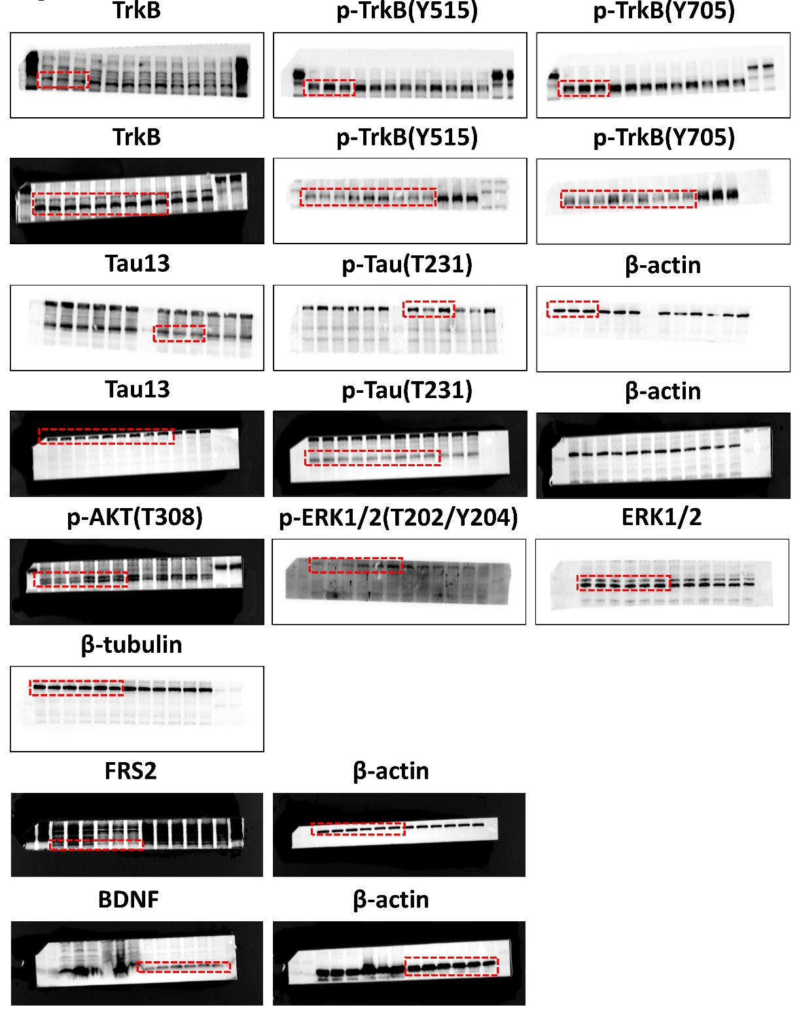
Lanes order of Hek293 cell samples, from left to right: Marker, 41-CBD, 41-DMSO, 44-CBD, 44-DMSO, 47-CBD, 47-DMSO, 50-CBD, 50-DMSO, 53-CBD, 53-DMSO, 56-CBD, 56-DMSO, 59-CBD, 59-DMSO. Markers are sometimes not visible. 41-59 represent the treatment temperatures (℃).

Fig 5E Original data for Western blot
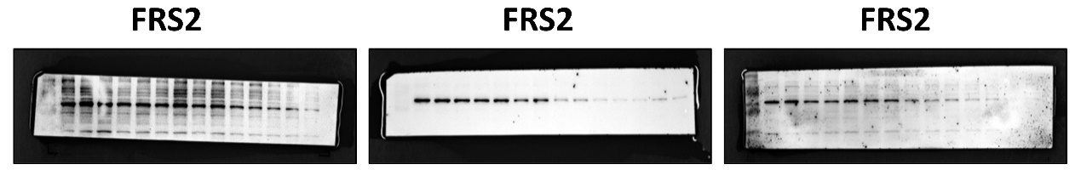

The order of the red-boxed areas in the four lanes is: WT, AD, AD+CBD, AD+CBD+shFRS2, which are used for the figures in the main text. (The samples were derived from either wild-type mice or triple-transgenic AD model mice.)

Fig 6G&I Original data for Western blot
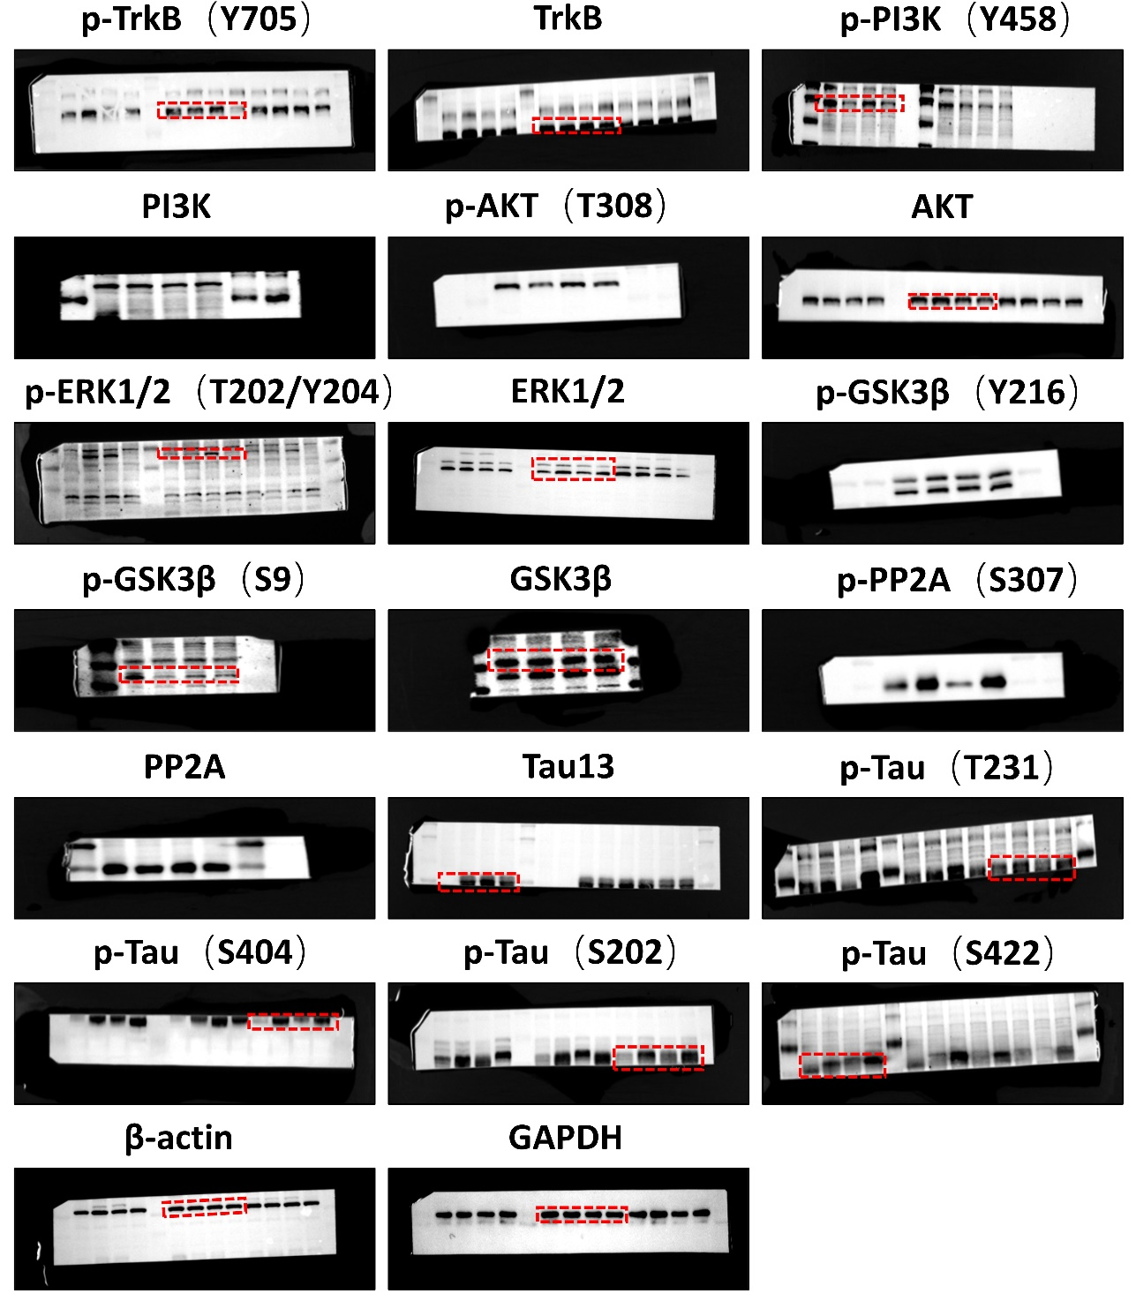

The order of the 12 lanes is: WT-1, WT-2, WT-3, AD-1, AD-2, AD-3, AD+CBD-1, AD+CBD-2, AD+CBD-3, AD+CBD+shFRS2-1, AD+CBD+shFRS2-2, AD+CBD+shFRS2-3. This part is used as the display figure, and the corresponding statistical data are obtained accordingly. The special red-boxed areas follow the loading order of the display figure. (The samples were derived from either wild-type mice or triple-transgenic AD model mice.)

Fig 6K Original data for Western blot
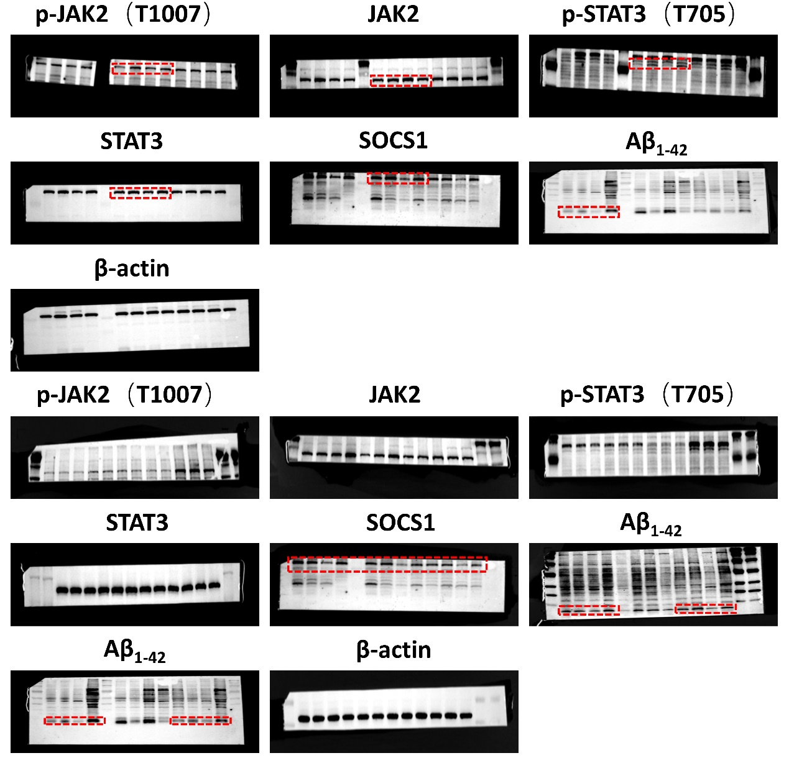

The order of the 12 lanes is: WT-1, WT-2, WT-3, AD-1, AD-2, AD-3, AD+CBD-1, AD+CBD-2, AD+CBD-3, AD+CBD+shFRS2-1, AD+CBD+shFRS2-2, AD+CBD+shFRS2-3. This part is used as the display figure, and the corresponding statistical data are obtained accordingly. The special red-boxed areas follow the loading order of the display figure. (The samples were derived from either wild-type mice or triple-transgenic AD model mice.)

Fig 6H&J Original data for Western blot
