Mechanistic Insights into Cannabidiol-Mediated TrkB Activation via FRS2 Interaction in Attenuating Alzheimer's Disease Pathology and Cognitive Impairment
Jiantao Liu^{1,5 #}, Feiyuan Peng^{1 #}, Chuangyu Yao¹, Sha Jin^{2,3}, Guoli Wu¹, Tianshu Zhang^{2,3}, Xiaohui Wang^{2,3,4*}, Xiubo Du1*

¹College of Life Sciences and Oceanography, Shenzhen University, Shenzhen, Guangdong, 518055, China
²Laboratory of Chemical Biology, Changchun Institute of Applied Chemistry, Chinese Academy of Sciences, Changchun, 130022, China
³School of Applied Chemistry and Engineering, University of Science and Technology of China, Hefei, 230026, China
⁴State Key Laboratory of Brain Machine Intelligence, Zhejiang University, Hangzhou, 310027, China
⁴Sino-German Joint Research Lab for Space Biomaterials and Translational Technology, Synergetic innovation Center of Biological Optoelectronics and Healthcare Engineering, School of Life Sciences, Northwestern Polytechnical University, Xi’an, Shaanxi 710072, China
* Corresponding authors: Xiaohui Wang (xiaohui.wang@ciac.ac.cn), Xiubo Du (duxiubo@szu.edu.cn)
# These authors contributed to this paper equally.

Materials and methods
UPLC-MS/MS
Quantifying cannabidiol (CBD) in mouse brain tissue involves homogenizing the tissue in methanol/water, centrifuging, and filtering the supernatant for analysis. A series of CBD standards are prepared in methanol and analyzed alongside samples using UPLC-MS/MS with a BEH C18 column and negative ion mode detection. Data are processed using a calibration curve to determine CBD concentrations in the samples.

Results
Figure S1. Detection of CBD blood-brain barrier penetration and physiological and biochemical toxicity testing. (A) Detection of CBD accumulation in the mouse brain after intraperitoneal injection. (B) Statistical analysis of CBD accumulation levels in the brain (n=3). (C-F) Statistical analysis of biochemical parameters in mouse serum, including ALT, AST, UA, Cre-P, UREA, and AMY. (n≥9, *represent comparisons with the Transgene group. *p<0.05, **p<0.01).

Figure S2. CBD preserves neuronal activity and synaptic structure of AD mice. (A) Observation of Nissl vesicles in CA1 and DG regions. (B) Statistical analysis of Nissl vesicle staining results. (C) Immunofluorescence assessment of MAP2 and PSD95 proteins in the CA3 region. (D) Quantification of MAP2 and PSD95 through immunofluorescence. (n=3, *represent comparisons with the Transgene group. *p<0.05, **p<0.01).

Figure S3. Effects of CBD on neuroinflammation, Aβ pathology and insulin resistance of AD mice. (A) Assessment of inflammatory factors in mouse serum. (B) Assessment of soluble Aβ₁₋₄₂ in the hippocampus. (C&D) Assessment of insulin in mouse serum and cortex (n=5). (E-G) Detection of anti-inflammatory factors in the cortex by ELISA (n=6). (H-J) Detection of anti-inflammatory factors in the cortex by qRT-PCR (n=4). (* represent comparisons with the Transgene group. *p<0.05, **p<0.01, ***p<0.001).

Figure S4. CBD suppresses Tau pathology through TrkB pathway in AD model cells. (A-F) Representative immunoblot analysis of TrkB and p-TrkB in cells upon CBD treatment with different concentrations or time. The quantitative results were normalized to β-actin (n=3). (G-J) Representative immunoblot analysis of TrkB, Tau and p-Tau in the cells upon CBD and shFRS2 treatment and the quantitative results were normalized to β-actin (n=3). (K-M) Representative immunoblot analysis of AKT, ERK and p-ERK in the cells upon CBD treatment and the quantitative results were normalized to β-tubulin (n=3). (N&O) Detection of FRS2 knockdown in the mouse hippocampus and the quantitative results were normalized to β-actin (n=3). (P&Q) Detection of BDNF in the mouse hippocampus and the quantitative results were normalized to β-actin. (n=3, *p<0.05, **p<0.01, ***p<0.001).

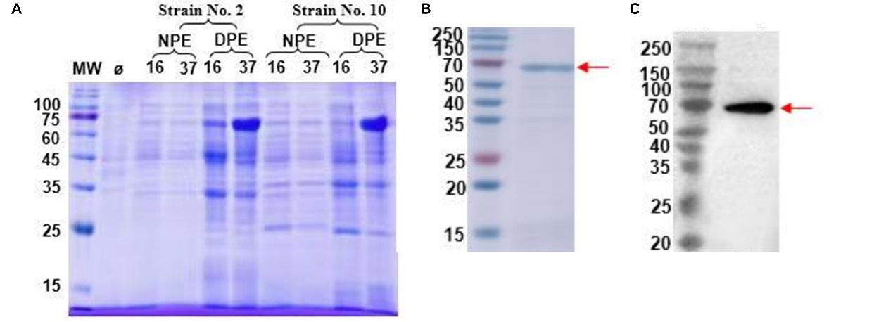
Figure S5. Expression and purification of FRS2 from E.coli. (A) The expression of FRS2 in E.coli. (B) Coomassie blue staining showing the purified FRS2 protein by Ni²⁺-affinity column. (C) Verification of the purified FRS2 protein by Western blot.
Figure S6. CBD preserves neuronal activity and synaptic structure of AD mice via FRS2. (A) Observation of the neuronal dendritic spines. (B) Statistical analysis of the number of neuronal dendritic spines (n=25, ***p＜0.001). (C) Visualization of synaptic structure in hippocampal neurons. (D) Statistical analysis of the number of synapses (n=12, ***p<0.001).

