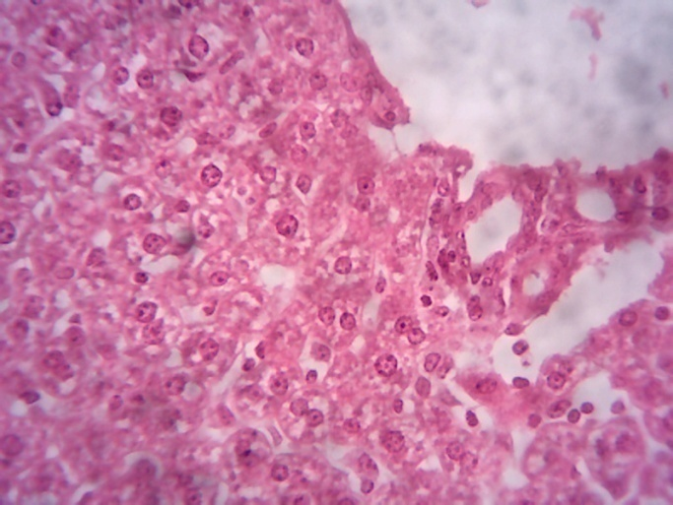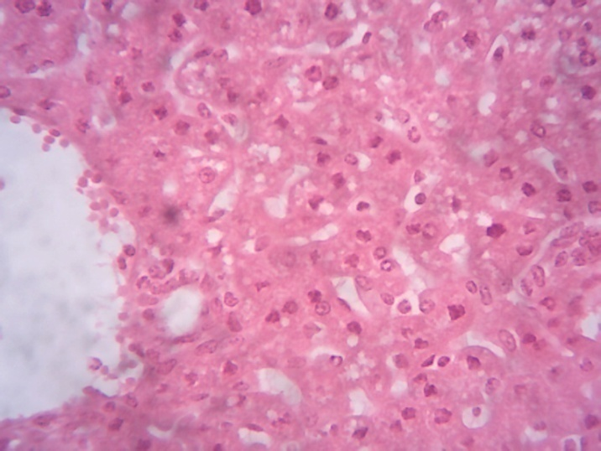
A2
A1
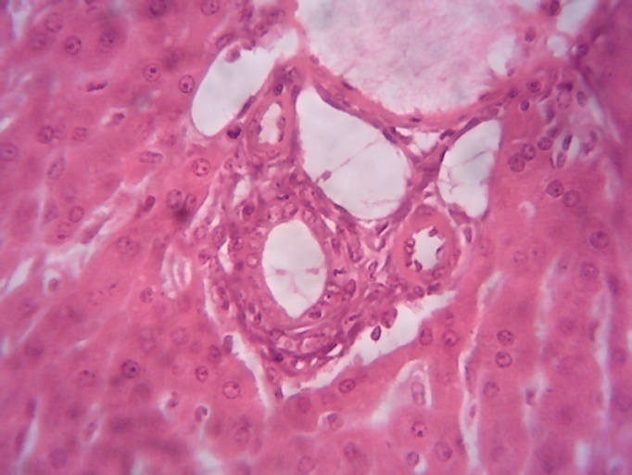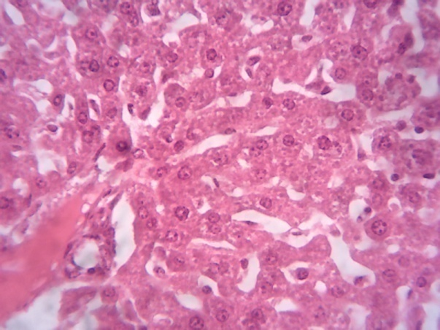
PT
F
PT
A3
Plate 1: Photomicrograph of liver sections from the experimental groups A1(infected with malaria parasite + treatment with 500 mg/kg Morinda lucida) and A2 (infected with malaria parasite + treatment with 1000 mg/kg Morinda lucida) showing moderate degeneration of hepatocytes (arrows) while A3 (infected with malaria parasite + treatment with 1500 mg/kg Morinda lucida) shows normal hepatocytes (white arrows) and portal tracts (PT) and F (uninfected control) shows normal hepatocytes (white arrows) and portal tracts (PT). H and E stain × 400.

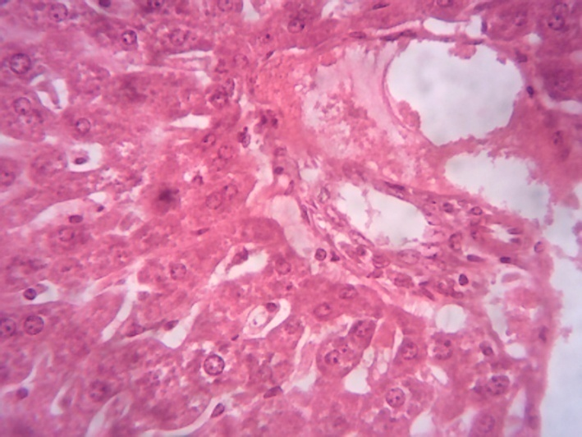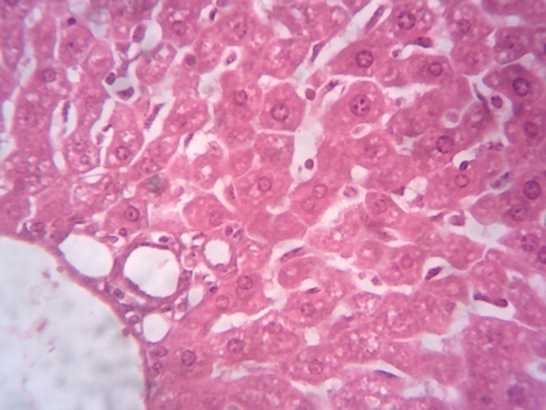
B2
B1
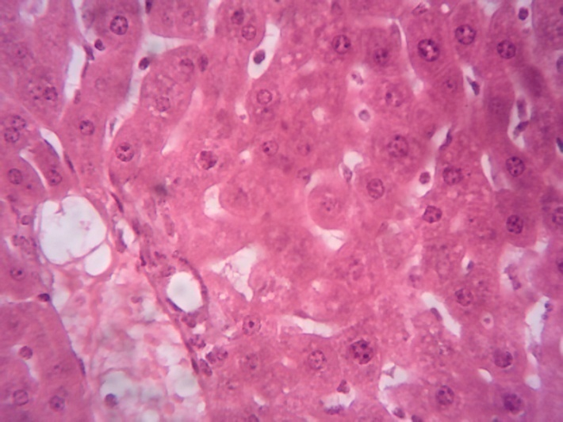
F
PT
PT
B3
Plate 2: Photomicrograph of liver sections from the experimental groups B1 (infected with malaria parasite + treatment with 500 mg/kg Ficus exasperata) and B2 (infected with malaria parasite + treatment with 1000 mg/kg Ficus exasperata) showing moderate degeneration of hepatocytes (black arrows) while B3 (infected with malaria parasite + treatment with 1500 mg/kg Ficus exasperata) shows normal hepatocytes (white arrows) and portal tracts (PT) and F (uninfected control) shows normal hepatocytes (white arrows) and portal tracts (PT). H and E stain × 400.

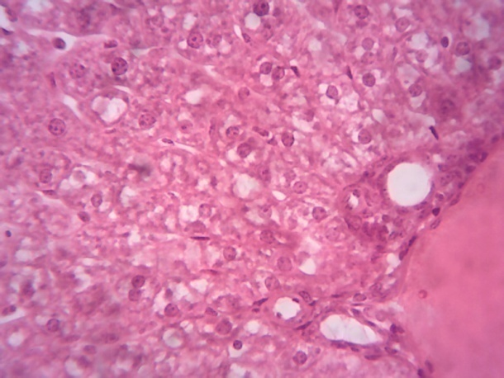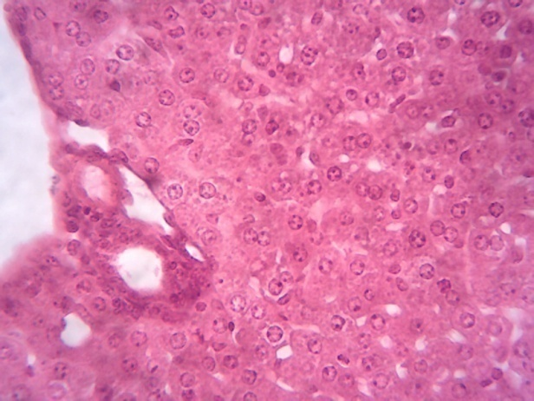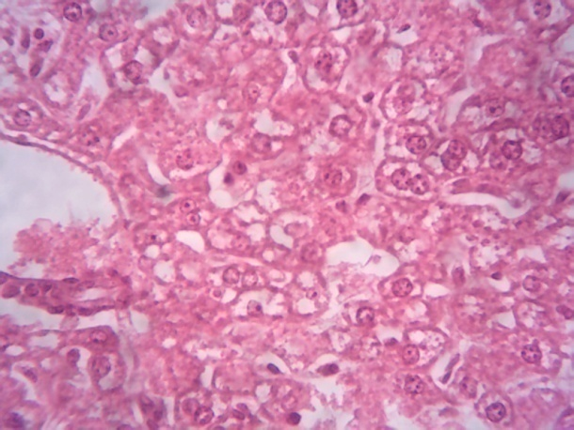
F
PT
PT
E
D
C
Plate 3: Photomicrograph of liver sections from the experimental groups C (infected with malaria parasite + treatment with combination of 1500mg/kg Morinda lucida and Ficus exasperata) and E (infected untreated group) showing diffuse degeneration of hepatocytes (arrows) while D (infected with malaria parasite + treatment with 20mg/kg ACT) and F (uninfected control) shows normal hepatocytes (white arrows) and portal tracts (PT). H and E stain × 400.

