Supplementary Information for

Three-dimensional wide-bandwidth quantum energy truncation terahertz coherence tomography

Pengfei Zhu¹, Hai Zhang^{1*}, Stefano Sfarra², Fabrizio Sarasini³, Xavier Maldague¹, Andreas Mandelis^{4,5*}
¹Department of Electrical and Computer Engineering, Computer Vision and Systems Laboratory (CVSL), Laval University, Quebec G1V 0A6, Canada.
²Department of Industrial and Information Engineering and Economics (DIIIE), University of L’Aquila, L’Aquila, I-67100, Italy
³Department of Chemical Engineering Materials Environment & UDR INSTM, Sapienza University of Rome, Rome, I-00184, Italy
⁴Center for Advanced Diffusion-Wave and Photoacoustic Technologies (CADIPT), Department of Mechanical and Industrial Engineering, University of Toronto, Toronto, M5S 3G8, Canada
⁵Institute for Advanced Non-Destructive and Non-Invasive Diagnostic Technologies (IANDIT), Faculty of Applied Science and Engineering, University of Toronto, Toronto, M5S 1A4, Canada.
*Corresponding authors: hai.zhang.1@ulaval.ca (H.Z.), mandelis@mie.utoronto.ca (A.M.)

Quantitative evaluation of three-dimensional reconstruction based on QET-THCT
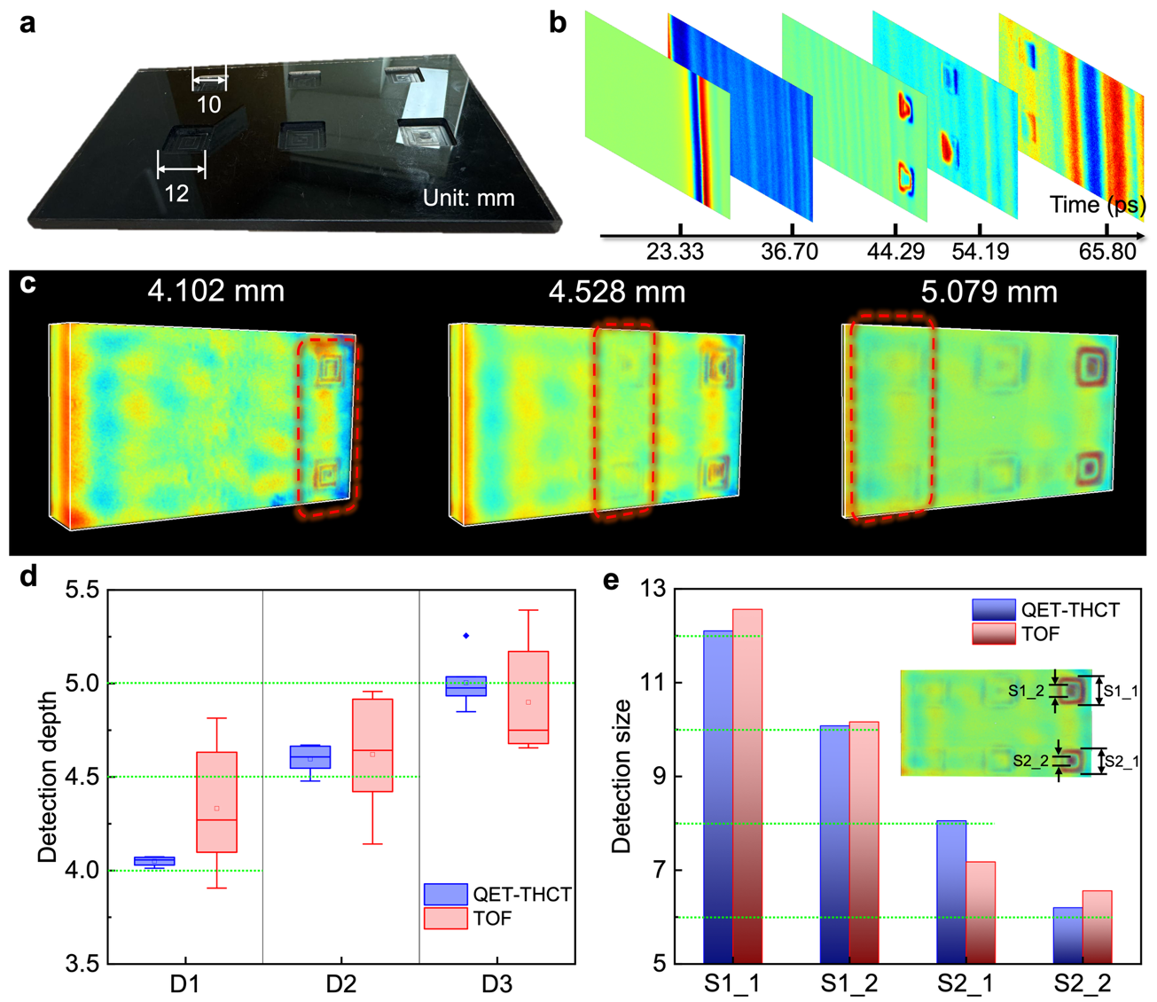
Fig. S1. Experimental validation based on a GFRP plate with six regular-shape defects. a Photograph of GFRP plate. b Time-of-flight images. c 3D reconstruction using QET-THCT. d Quantitative evaluation for the defect depth where D1, D2, D3 denote 4 mm, 4.5 mm, 5.0 mm depths of defects, respectively. e Quantitative evaluation for the defect size. The green dotted lines denote real depth and size where S1_1, S1_2, S2_1, S2_2 denote the outside profile size and inner profile size of the square defects.

In the previous content, experimental results are mainly focused on the sample with complex-shape defects. However, it is difficult to quantitative evaluate the detection accuracy based on the proposed QET-THCT technique. Here, a GFRP plate with six defects was employed to evaluate the detection accuracy of the QET-THCT comparing with time-of-flight method (Fig. S1a). The top three square-shape defects have a length of 10 mm, and the bottom three square-shape defects have a length of 12 mm. The defect depths from left to right are 4.0, 4.5, 5.0 mm, respectively. Due to imperfect focus there are strong fringes in original time-of-flight images, which interferes us to observe the defect information (Fig. S1b). From the results of QET-THCT, it is obvious that the fringes are eliminated. The defects emerge at 4.102, 4.528, and 5.079 mm, respectively, which is near to the prefabricated depth (Fig. S1c). To quantitatively characterize the defect depth, ten pixels from each defect area are selected and calculated using QET-THCT and TOF methods. The results are shown in Fig. S1d and Fig. S1e. It is possible to find that the QET-THCT has higher accuracy in characterizing defect depths and sizes.

FDTD simulation for validating the feasibility of QET-THCT
Finite-difference time-domain (FDTD) was employed to validate the feasibility and accuracy of proposed QET-THCT technique (Fig. S2a). The shape of incident source in time-domain is shown in Fig. S2b. To simulate the sample in the previous section, the Drude-Lorentz model was used to fit the material properties including refractive index and extinction coefficient (Fig. S2c). Then the cross-correlation amplitude (Fig. S2d) was calculated according to the program in Fig. 2b. By repeating this program for each pixel, the entire 3D tomogram can be obtained. Quantitative analysis was performed between the profile of the reconstructed semicircular hole and the profile of the real hole (Fig. S2e). It is possible to find that the accuracy of reconstructed profile is high at the top of the semicircular hole. However, the reconstructed profile begins to deviate from the real true below 4 mm. The reasons can be concluded as follows. Firstly, the THz signal will be significantly affected by the absorption and scattering when THz wave propagates into the media. With the increase of the propagation distance the THz beam naturally spreads out due to the diffraction effects. This results in a larger area of signal coverage and lower energy density at depth. In addition, QET-THCT algorithm only considers the absorption varying with frequency. In this simulation, the refractive index of a material varies significantly with frequency (Fig. S2c). The cross-sectional tomogram is shown in Fig. S2f. To better present the profile of semicircular holes, we performed image segmentation for the entire 3D tomogram (Fig. S2g). The location and area variation of defects is presented in Fig. S2h.
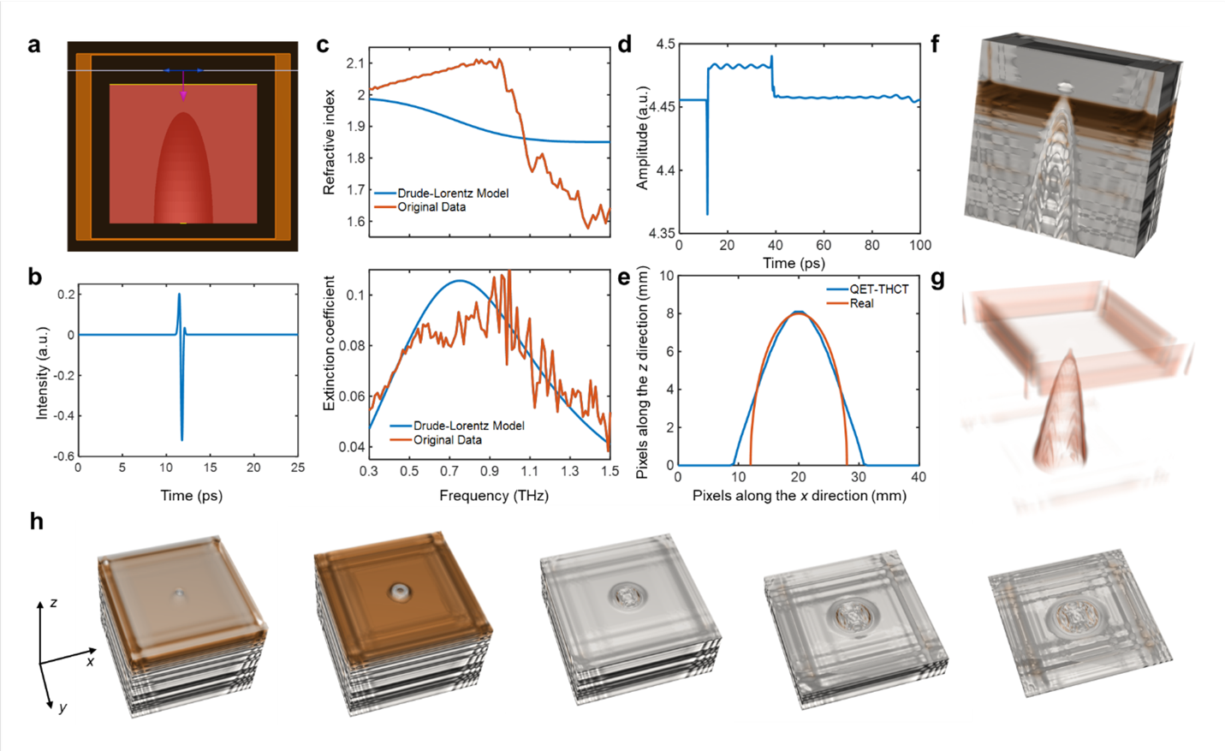
Fig. 5. FDTD modeling for validating the 3D tomographic effect of QET-THCT techniques. a Simulation setup for a GFRP plate with semicircular hole (16 mm diameter). b incident THz source. c Refractive index and extinction coefficient. d The cross-correlation amplitude. e Profile of the reconstructed semicircular hole. f Cross-sectional tomogram of the GFRP plate. g Tomogram with transparency and threshold optimized for semicircular hole profile inspection. h Sectional views of QET-THCT results.

