Social vulnerability and the risk of respiratory virus infection in households: a case-ascertained study: Supplemental tables and figures
Supplement

Supplemental Table 1: Adjusted Incident Rate Ratios (aIRRs)¹ of SARS-CoV-2 among exposed household contacts by National Social Vulnerability Index overall and by domain percentiles, adjusted for age, study site, and race/ethnicity, cluster adjusted within census tract in a case ascertained household transmission study, United States, September 2021-May 2023

 | Overall |  |  | Theme 1: Socioeconomic Status |  |  | Theme 2: Household Characteristics |  |  | Theme 3: Racial/ethnic minorities |  |  | Theme 4: Household type-transportation-crowding
Characteristic | IRR¹ | 95% CI¹ | p-value | IRR¹ | 95% CI¹ | p-value | IRR¹ | 95% CI¹ | p-value | IRR¹ | 95% CI¹ | p-value | IRR¹ | 95% CI¹ | p-value
SVI | 1.24 | 1.00, 1.52 | 0.045 | 1.24 | 1.02, 1.51 | 0.032 | 1.08 | 0.88, 1.33 | 0.5 | 1.34 | 0.98, 1.82 | 0.064 | 1.11 | 0.92, 1.35 | 0.3
Age | 1.00 | 1.00, 1.00 | 0.3 | 1.00 | 1.00, 1.00 | 0.3 | 1.00 | 1.00, 1.00 | 0.3 | 1.00 | 1.00, 1.00 | 0.3 | 1.00 | 1.00, 1.00 | 0.3
Sex
Female | — | — |  | — | — |  | — | — |  | — | — |  | — | —
Male | 0.96 | 0.89, 1.03 | 0.3 | 0.96 | 0.89, 1.03 | 0.3 | 0.95 | 0.89, 1.03 | 0.2 | 0.95 | 0.89, 1.03 | 0.2 | 0.96 | 0.89, 1.03 | 0.2
Unknown | 1.14 | 0.74, 1.75 | 0.5 | 1.14 | 0.75, 1.73 | 0.5 | 1.13 | 0.74, 1.73 | 0.6 | 1.13 | 0.74, 1.73 | 0.6 | 1.14 | 0.74, 1.76 | 0.6
missing | 2.13 | 1.45, 3.12 | <0.001 | 2.12 | 1.45, 3.11 | <0.001 | 2.11 | 1.43, 3.12 | <0.001 | 2.10 | 1.43, 3.10 | <0.001 | 2.08 | 1.41, 3.05 | <0.001
Enrollment site
Arizona (AZ) | — | — |  | — | — |  | — | — |  | — | — |  | — | —
Colorado (CO) | 1.27 | 0.97, 1.67 | 0.082 | 1.25 | 0.95, 1.63 | 0.11 | 1.24 | 0.94, 1.64 | 0.12 | 1.24 | 0.94, 1.62 | 0.12 | 1.26 | 0.95, 1.65 | 0.10
Columbia (NY) | 1.14 | 0.90, 1.43 | 0.3 | 1.14 | 0.90, 1.43 | 0.3 | 1.19 | 0.94, 1.50 | 0.2 | 1.11 | 0.88, 1.41 | 0.4 | 1.16 | 0.92, 1.48 | 0.2
Marshfield (WI) | 1.09 | 0.82, 1.44 | 0.6 | 1.09 | 0.82, 1.44 | 0.5 | 1.08 | 0.81, 1.43 | 0.6 | 1.18 | 0.87, 1.61 | 0.3 | 1.05 | 0.80, 1.39 | 0.7
Nashville (TN) | 1.28 | 1.03, 1.59 | 0.024 | 1.25 | 1.02, 1.54 | 0.033 | 1.24 | 1.00, 1.54 | 0.051 | 1.28 | 1.03, 1.60 | 0.024 | 1.24 | 1.01, 1.54 | 0.043
North Carolina (NC) | 1.38 | 1.09, 1.75 | 0.008 | 1.36 | 1.07, 1.71 | 0.011 | 1.36 | 1.07, 1.73 | 0.012 | 1.35 | 1.07, 1.70 | 0.011 | 1.35 | 1.07, 1.72 | 0.012
Stanford (CA) | 1.20 | 0.94, 1.53 | 0.15 | 1.22 | 0.95, 1.56 | 0.12 | 1.18 | 0.92, 1.51 | 0.2 | 1.13 | 0.89, 1.44 | 0.3 | 1.16 | 0.91, 1.48 | 0.2
SARS-CoV-2 Vaccine receipt
0-1 dose | — | — |  | — | — |  | — | — |  | — | — |  | — | —
2 or more doses | 0.96 | 0.87, 1.07 | 0.5 | 0.96 | 0.87, 1.07 | 0.5 | 0.96 | 0.86, 1.06 | 0.4 | 0.95 | 0.86, 1.06 | 0.4 | 0.96 | 0.86, 1.06 | 0.4
Race/ethnicity
White, Non-Hispanic | — | — |  | — | — |  | — | — |  | — | — |  | — | —
Asian, Non-Hispanic | 0.95 | 0.70, 1.28 | 0.7 | 0.95 | 0.70, 1.28 | 0.7 | 0.95 | 0.70, 1.29 | 0.7 | 0.93 | 0.69, 1.27 | 0.7 | 0.95 | 0.70, 1.29 | 0.7
Black, Non-Hispanic | 0.96 | 0.80, 1.15 | 0.7 | 0.96 | 0.80, 1.15 | 0.7 | 1.00 | 0.84, 1.19 | >0.9 | 0.95 | 0.78, 1.14 | 0.6 | 1.00 | 0.83, 1.19 | >0.9
Hispanic/Latino | 1.04 | 0.90, 1.20 | 0.6 | 1.04 | 0.90, 1.19 | 0.6 | 1.08 | 0.94, 1.23 | 0.3 | 1.04 | 0.90, 1.20 | 0.6 | 1.07 | 0.93, 1.22 | 0.3
Multiple race, Non-Hispanic | 0.96 | 0.74, 1.24 | 0.7 | 0.95 | 0.74, 1.23 | 0.7 | 0.96 | 0.74, 1.25 | 0.8 | 0.96 | 0.74, 1.24 | 0.8 | 0.96 | 0.74, 1.25 | 0.8
NH/OPI, Non-Hispanic | 1.52 | 1.21, 1.92 | <0.001 | 1.54 | 1.25, 1.89 | <0.001 | 1.54 | 1.25, 1.89 | <0.001 | 1.59 | 1.29, 1.96 | <0.001 | 1.51 | 1.19, 1.92 | <0.001
Unknown/Refused | 1.20 | 0.96, 1.51 | 0.11 | 1.20 | 0.96, 1.50 | 0.12 | 1.24 | 0.99, 1.56 | 0.060 | 1.20 | 0.96, 1.51 | 0.11 | 1.24 | 0.99, 1.55 | 0.066
missing | 0.85 | 0.62, 1.16 | 0.3 | 0.84 | 0.61, 1.16 | 0.3 | 0.86 | 0.62, 1.18 | 0.3 | 0.85 | 0.61, 1.17 | 0.3 | 0.86 | 0.62, 1.18 | 0.3

- Adjusted models included age, sex, study site, vaccine receipt, and clustering by census tract. SARS-CoV-2 vaccine receipt defined as unvaccinated if received 1 or fewer COVID-19 vaccine doses and vaccinated if received 2 or more COVID-19 vaccine doses. Influenza vaccine receipt defined as unvaccinated if did not receive annual Influenza vaccine and vaccinated if participant did receive the seasonal Influenza vaccine.
Supplemental Table 2: Adjusted Incident Rate Ratios (aIRRs)¹ of influenza among exposed household contacts by National Social Vulnerability Index overall and by domain percentiles, adjusted for age, study site, and race/ethnicity, cluster adjusted within census tract in a case ascertained household transmission study, United States, September 2021-May 2023,
 | Overall |  |  | Theme 1: Socioeconomic Status |  |  | Theme 2: Household Characteristics |  |  | Theme 3: Racial/ethnic minorities |  |  | Theme 4: Household type-transportation-crowding
Characteristic | IRR¹ | 95% CI¹ | p-value | IRR¹ | 95% CI¹ | p-value | IRR¹ | 95% CI¹ | p-value | IRR¹ | 95% CI¹ | p-value | IRR¹ | 95% CI¹ | p-value
SVI | 1.45 | 0.88, 2.39 | 0.14 | 1.26 | 0.74, 2.12 | 0.4 | 1.52 | 0.98, 2.35 | 0.063 | 1.90 | 0.95, 3.80 | 0.069 | 1.31 | 0.81, 2.12 | 0.3
Age | 1.00 | 0.99, 1.00 | 0.071 | 1.00 | 0.99, 1.00 | 0.060 | 1.00 | 0.99, 1.00 | 0.062 | 1.00 | 0.99, 1.00 | 0.079 | 1.00 | 0.99, 1.00 | 0.063
Sex
Female | — | — |  | — | — |  | — | — |  | — | — |  | — | —
Male | 1.04 | 0.88, 1.22 | 0.7 | 1.03 | 0.87, 1.20 | 0.8 | 1.04 | 0.88, 1.22 | 0.6 | 1.03 | 0.88, 1.21 | 0.7 | 1.03 | 0.87, 1.21 | 0.7
Enrollment site
Arizona (AZ) | — | — |  | — | — |  | — | — |  | — | — |  | — | —
Colorado (CO) | 1.40 | 1.17, 1.67 | <0.001 | 1.40 | 1.10, 1.78 | 0.006 | 1.51 | 1.14, 2.00 | 0.004 | 1.17 | 0.98, 1.39 | 0.081 | 1.29 | 1.10, 1.52 | 0.002
Columbia (NY) | 0.46 | 0.31, 0.67 | <0.001 | 0.48 | 0.33, 0.72 | <0.001 | 0.49 | 0.33, 0.73 | <0.001 | 0.39 | 0.25, 0.61 | <0.001 | 0.46 | 0.31, 0.68 | <0.001
Marshfield (WI) | 0.23 | 0.04, 1.24 | 0.088 | 0.23 | 0.04, 1.24 | 0.087 | 0.24 | 0.04, 1.35 | 0.11 | 0.26 | 0.05, 1.39 | 0.12 | 0.21 | 0.04, 1.14 | 0.071
Nashville (TN) | 0.66 | 0.52, 0.84 | <0.001 | 0.64 | 0.49, 0.83 | <0.001 | 0.67 | 0.49, 0.91 | 0.010 | 0.63 | 0.50, 0.78 | <0.001 | 0.64 | 0.50, 0.81 | <0.001
North Carolina (NC) | 0.69 | 0.43, 1.09 | 0.11 | 0.67 | 0.42, 1.09 | 0.10 | 0.68 | 0.41, 1.12 | 0.13 | 0.62 | 0.40, 0.98 | 0.039 | 0.65 | 0.41, 1.04 | 0.072
Stanford (CA) | 0.85 | 0.53, 1.35 | 0.5 | 0.88 | 0.55, 1.42 | 0.6 | 0.93 | 0.56, 1.54 | 0.8 | 0.69 | 0.42, 1.13 | 0.14 | 0.81 | 0.50, 1.31 | 0.4
Influenza Vaccine receipt
Unvaccinated for Influenza | — | — |  | — | — |  | — | — |  | — | — |  | — | —
Vaccinated for Influenza | 0.88 | 0.72, 1.07 | 0.2 | 0.88 | 0.72, 1.07 | 0.2 | 0.86 | 0.71, 1.06 | 0.2 | 0.88 | 0.72, 1.07 | 0.2 | 0.88 | 0.72, 1.07 | 0.2
Race/ethnicity
White, Non-Hispanic | — | — |  | — | — |  | — | — |  | — | — |  | — | —
AI/AN, Non-Hispanic | 1.02 | 0.90, 1.15 | 0.8 | 1.00 | 0.89, 1.13 | >0.9 | 1.01 | 0.90, 1.14 | 0.8 | 1.15 | 0.95, 1.38 | 0.15 | 0.99 | 0.87, 1.11 | 0.8
Asian, Non-Hispanic | 0.81 | 0.26, 2.52 | 0.7 | 0.80 | 0.25, 2.51 | 0.7 | 0.79 | 0.26, 2.37 | 0.7 | 0.76 | 0.27, 2.14 | 0.6 | 0.81 | 0.26, 2.54 | 0.7
Black, Non-Hispanic | 0.97 | 0.63, 1.49 | 0.9 | 1.02 | 0.66, 1.55 | >0.9 | 1.00 | 0.67, 1.51 | >0.9 | 0.96 | 0.63, 1.47 | 0.9 | 1.01 | 0.66, 1.54 | >0.9
Hispanic/Latino | 1.23 | 0.86, 1.76 | 0.3 | 1.27 | 0.90, 1.81 | 0.2 | 1.27 | 0.90, 1.78 | 0.2 | 1.24 | 0.87, 1.78 | 0.2 | 1.29 | 0.91, 1.83 | 0.15
Multiple race, Non-Hispanic | 1.42 | 0.74, 2.70 | 0.3 | 1.44 | 0.74, 2.79 | 0.3 | 1.33 | 0.69, 2.58 | 0.4 | 1.31 | 0.68, 2.50 | 0.4 | 1.51 | 0.77, 2.98 | 0.2
NH/OPI, Non-Hispanic | 1.58 | 1.01, 2.45 | 0.043 | 1.81 | 1.19, 2.76 | 0.006 | 1.59 | 1.08, 2.33 | 0.018 | 1.75 | 1.30, 2.36 | <0.001 | 1.74 | 1.15, 2.62 | 0.008
Unknown/Refused | 0.94 | 0.40, 2.18 | 0.9 | 0.97 | 0.43, 2.20 | >0.9 | 0.95 | 0.41, 2.21 | >0.9 | 0.96 | 0.41, 2.22 | >0.9 | 0.98 | 0.43, 2.26 | >0.9
missing | 0.00 | 0.00, 0.00 | <0.001 | 0.00 | 0.00, 0.00 | <0.001 | 0.00 | 0.00, 0.00 | <0.001 | 0.00 | 0.00, 0.00 | <0.001 | 0.00 | 0.00, 0.00 | <0.001

Supplemental Table 3: Mediation analysis using the Baron-Kenny method for SARS-CoV-2 households
SARS-CoV-2
Regressing Household infection on SVI (Y on X)
Characteristic | IRR¹ | 95% CI¹ | p-value
SVI: overall | 1.20 | 1.04, 1.38 | 0.01
SVI: Socioeconomic status | 1.24 | 1.08, 1.43 | 0.00
SVI: Household characteristics | 1.11 | 0.95, 1.30 | 0.20
SVI: Racial/ethnic minorities | 1.25 | 1.05, 1.48 | 0.01
SVI: Household type, transportation, crowding | 1.12 | 0.97, 1.30 | 0.13
¹ IRR = Incidence Rate Ratio, CI = Confidence Interval
Regressing vaccination receipt (yes/no) on SVI (X on M)
Characteristic | IRR¹ | 95% CI¹ | p-value
SVI: overall | 0.88 | 0.83, 0.92 | <0.001
SVI: Socioeconomic status | 0.87 | 0.83, 0.92 | <0.001
SVI: Household characteristics | 0.87 | 0.83, 0.92 | <0.001
SVI: Racial/ethnic minorities | 0.93 | 0.88, 0.99 | 0.03
SVI: Household type, transportation, crowding | 0.89 | 0.85, 0.93 | <0.001
¹ IRR = Incidence Rate Ratio, CI = Confidence Interval
Regressing household infection on SVI + vaccine receipt (Y on X+M)
Characteristic | IRR¹ | 95% CI¹ | p-value
SVI: overall | 1.18 | 1.02, 1.36 | 0.02
Vaccine receipt
No | Reference
Yes | 0.93 | 0.84, 1.02 | 0.12
SVI: Socioeconomic status | 1.22 | 1.06, 1.41 | 0.01
Vaccine receipt
No | Reference
Yes | 0.93 | 0.85, 1.03 | 0.20
SVI: Household characteristics | 1.09 | 0.93, 1.27 | 0.30
Vaccine receipt
No | Reference
Yes | 0.91 | 0.83, 1.01 | 0.07
SVI: Racial/ethnic minorities | 1.23 | 1.04, 1.46 | 0.02
Vaccine receipt
No | Reference
Yes | 0.92 | 0.83, 1.01 | 0.07
SVI: Household type, transportation, crowding | 1.1 | 0.95, 1.28 | 0.20
Vaccine receipt
No | Reference
Yes | 0.92 | 0.83, 1.01 | 0.07
¹ IRR = Incidence Rate Ratio, CI = Confidence Interval

Supplemental Table 4: Mediation analysis using the Baron-Kenny method for Influenza households

Regressing Household infection on SVI (Y on X)
Characteristic | IRR¹ | 95% CI¹ | p-value
SVI: Overall | 1.17 | 0.88, 1.56 | 0.30
SVI: Socioeconomic status | 1.14 | 0.84, 1.54 | 0.40
SVI: Household Characteristics | 1.27 | 0.92, 1.77 | 0.15
SVI: Racial/ethnic minorities | 1.25 | 0.87, 1.79 | 0.20
SVI: Household type, transportation, crowding | 1.15 | 0.85, 1.56 | 0.40
¹ IRR = Incidence Rate Ratio, CI = Confidence Interval
Regressing Influenza vaccination receipt (yes/no) on SVI (X on M)
Characteristic | IRR¹ | 95% CI¹ | p-value
SVI: Overall | 0.90 | 0.81, 1.00 | 0.05
SVI: Socioeconomic status | 0.89 | 0.79, 1.00 | 0.04
SVI: Household Characteristics | 0.97 | 0.86, 1.10 | 0.60
SVI: Racial/ethnic minorities | 0.86 | 0.76, 0.98 | 0.03
SVI: Household type, transportation, crowding | 0.88 | 0.78, 0.98 | 0.02
¹ IRR = Incidence Rate Ratio, CI = Confidence Interval
Regressing household infection on SVI + Influenza vaccine receipt (Y on X+M)
Characteristic | IRR¹ | 95% CI¹ | p-value
SVI: Overall | 1.14 | 0.85, 1.53 | 0.40
Vaccine receipt | Reference
No
Yes | 0.87 | 0.70, 1.06 | 0.20
SVI: Socioeconomic status | 1.11 | 0.82, 1.51 | 0.50
Vaccine receipt
No | Reference
Yes | 0.86 | 0.70, 1.06 | 0.20
SVI: Household Characteristics | 1.27 | 0.91, 1.76 | 0.20
Vaccine receipt
No | Reference
Yes | 0.86 | 0.70, 1.05 | 0.15
SVI: Racial/ethnic minorities | 1.21 | 0.84, 1.75 | 0.30
Vaccine receipt
No | Reference
Yes | 0.87 | 0.71, 1.07 | 0.20
SVI: Household type, transportation, crowding | 1.12 | 0.82, 1.52 | 0.50
Vaccine receipt
No | Reference
Yes | 0.86 | 0.70, 1.06 | 0.20
¹ IRR = Incidence Rate Ratio, CI = Confidence Interval

Effect modification by pathogen analysis
Supplemental Table 5:Effect modification analysis of SVI domain percentile by pathogen among SARS-CoV-2 and influenza household contacts in a case ascertained household transmission study using an interaction term: United Staates, September 2021-May 2023¹
 | Estimate | Exponentiated | Standard error | Wald | Pr(>|Wald|)
Model 1
(Intercept) | 0.33 | 1.39 | 0.02 | 275.24 | <0.001
SVI: Overall | -0.09 | 0.91 | 0.04 | 6.44 | 0.01
SARS-CoV-2 | Reference
Influenza | 0.09 | 1.09 | 0.04 | 4.43 | 0.04
SVI: Overall*Influenza | 0.04 | 1.04 | 0.06 | 0.33 | 0.57
Model 2
(Intercept) | 0.34 | 1.40 | 0.02 | 293.48 | <0.001
SVI: Socioeconomic | -0.11 | 0.90 | 0.04 | 8.90 | <0.001
SARS-CoV-2 | Reference
Influenza | 0.07 | 1.08 | 0.04 | 3.18 | 0.07
SVI: Socioeconomic*Influenza | 0.06 | 1.06 | 0.07 | 0.90 | 0.34
Model 3
(Intercept) | 0.31 | 1.37 | 0.02 | 212.41 | <0.001
SVI: Household Characteristics | -0.05 | 0.95 | 0.04 | 1.72 | 0.19
SARS-CoV-2 | Reference
Influenza | 0.12 | 1.13 | 0.04 | 7.65 | 0.01
SVI: Household Characteristics*Influenza | -0.04 | 0.97 | 0.07 | 0.24 | 0.63
Model 4
(Intercept) | 0.35 | 1.42 | 0.03 | 188.62 | <0.001
SVI: Racial/Ethnic Minorities | -0.11 | 0.90 | 0.04 | 6.71 | 0.01
SARS-CoV-2 | Reference
Influenza | 0.09 | 1.09 | 0.05 | 2.93 | 0.09
SVI: Racial/Ethnic Minorities*Influenza | 0.03 | 1.03 | 0.08 | 0.17 | 0.68
Model 5
(Intercept) | 0.32 | 1.38 | 0.02 | 208.09 | <0.001
SVI: Household type, transportation, crowding | -0.06 | 0.95 | 0.04 | 2.32 | 0.13
SARS-CoV-2 | Reference
Influenza | 0.09 | 1.10 | 0.04 | 4.52 | 0.03
SVI: Household type, transportation, crowding*Influenza | 0.01 | 1.01 | 0.07 | 0.01 | 0.91

Footnote: ¹ We combined both cohorts and created a binary variable if a household contact was infected with either Influenza or SARS-CoV-2. We then created a binary variable by pathogen to evaluate differences between cohorts and to see if the household infection regressed on SVI differed by pathogen using an interaction term with SARS-CoV-2 as the reference group. We used these regressions to calculate Wald scores to evaluate statistical significance. We did not find any statistical significance with the interaction terms in the model.

Supplemental Figures

Box and whisker plots
Supplemental Figure 1: Box and Whisker plots of SVI domain percentile at the census tract level by vaccine receipt¹ among SARS-CoV-2 household contacts.
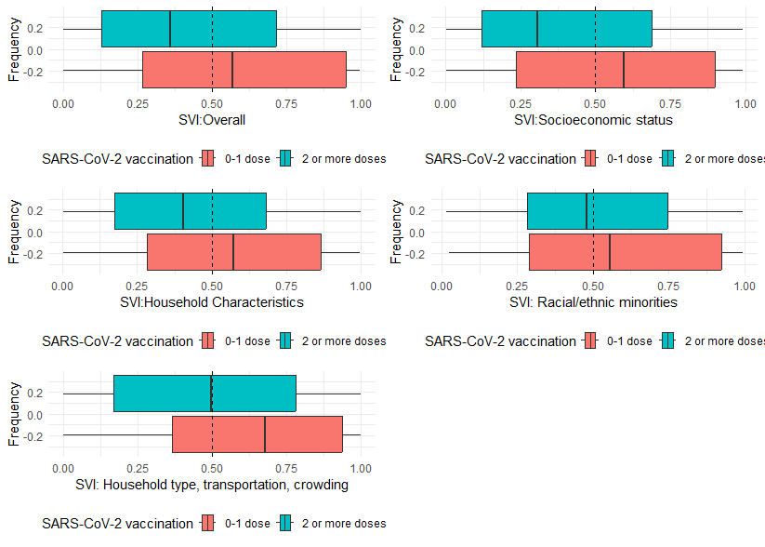 Footnote:
¹ SARS-CoV-2 vaccine receipt defined as unvaccinated if received 1 or fewer COVID-19 vaccine doses and vaccinated if received 2 or more COVID-19 vaccine doses. Supplemental

Figure 2: Box and Whisker plots of SVI domain percentile at the census tract level by vaccine receipt¹ among the Influenza household contacts.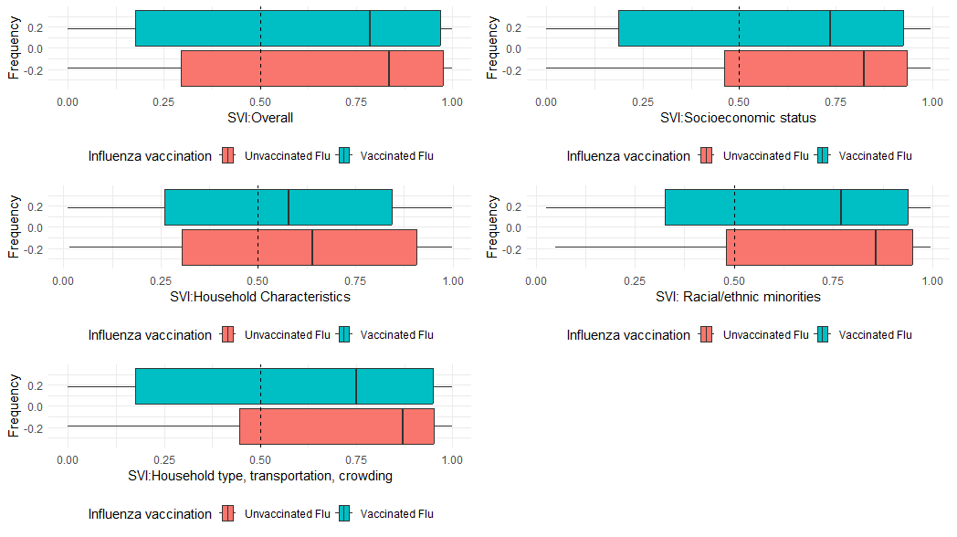
Footnote:
¹ Influenza vaccine receipt defined as unvaccinated if did not receive annual Influenza vaccine and vaccinated if participant did receive the seasonal Influenza vaccine.

Forest plots
Supplemental Figure 3: Forest plots of Crude (cIRR) and adjusted Incident Rate Ratios (aIRRs)¹ of SARS-CoV-2 or Influenza among exposed household contacts by National or State Social Vulnerability Index overall and by domain percentiles, adjusted for age, sex, study site, race/ethnicity, and vaccine receipt. cluster adjusted within census tract in a case ascertained household transmission study, United States, September 2021-May 2023

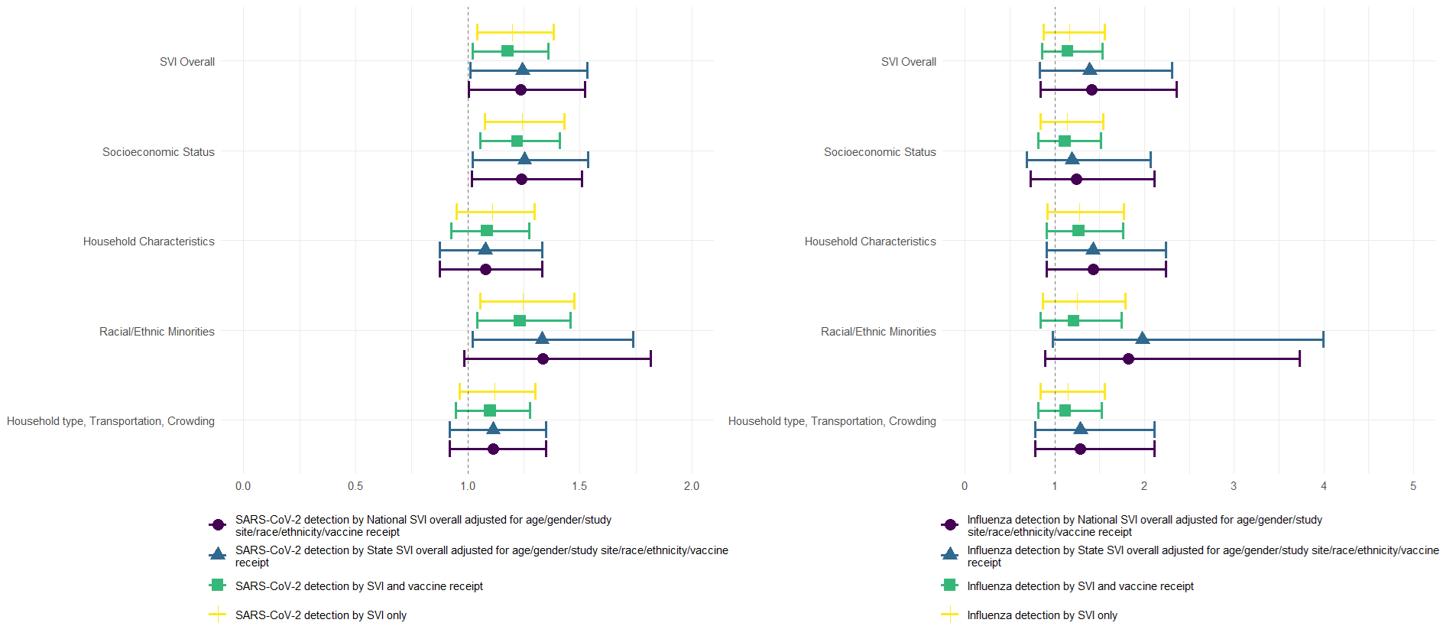
¹ Adjusted models included age, sex, study site, vaccine receipt, and clustering by census tract. SARS-CoV-2 vaccine receipt defined as unvaccinated if received 1 or fewer COVID-19 vaccine doses and vaccinated if received 2 or more COVID-19 vaccine doses. Influenza vaccine receipt defined as unvaccinated if did not receive annual Influenza vaccine and vaccinated if participant did receive the seasonal Influenza vaccine.

