Supplementary Information.
Protein engineering and expression. To express Fc-SPINK1, DNA encoding the amino acid sequence in Figure 1 was designed with codon optimization for Pichia pastoris and inserted into the pPICZalpha expression vector (Invitrogen/Life Technologies) such that the EPK . . . coding sequence followed the . . . EKREAEA coding sequence in the vector, which corresponds to the cleavage site that removes the alpha-factor leader peptide that promotes secretion from yeast.
Competent cells of P. pastoris strain NRRL-Y-11430 were transformed using the Pichia EasyComp™ Transformation Kit (Thermo Fisher Scientific, K173001) according to manufacturer’s instructions. For secreted protein expression, 50 ml of BMGY were inoculated with the desired P. pastoris strain. The culture was incubated over night at 30°C, 250 rpm. The next morning, the culture was diluted to 250 ml with BMGY and incubated at 30°C, 250 rpm until they reached an OD₆₀₀ of ~ 5. Afterward, cells were diluted to a starting OD₆₀₀ of 1.0 in BMMY.
The required culture volume was transferred to 50 ml conical tubes or centrifuge flasks and centrifuged at 3.000 x g for 5 minutes before resuspending in 1000 ml BMMY and transferring to a 4 l shaking flask. The culture was incubated at 30°C, 250 rpm for
48 – 96 h. Afterward, the suspension was transferred in 400 ml centrifuge bottles to separate the cells from the protein-containing supernatant by centrifuging at 3.000 x g for 15 min. The supernatant was sterile-filtered, flash-frozen and stored at -80°C or directly used for concentration.
Protein concentration for purification. Supernatants from protein expression were concentrated before to purification by ultrafiltration using membranes with 10 kDa molecular weight cut-off at 4°C. Therefore, Centricon Plus-70 spin concentrators (Merck, UFC701008) were used according to manufacturer’s instructions to reduce the liquid volume by factor 50 - 100. The concentrates were supplemented with Halt Protease Inhibitor Cocktail (Thermo Fischer Scientific, 78429) and stored at 4°C for up to 3 days. Concentrates were flash-frozen and stored at -80°C for longer storage periods.
Protein A affinity chromatography. IgG Fc fragment containing proteins were purified using Pierce Protein A Plus Agarose (Thermo Fisher Scientific, 22812) according to manufacturer’s instructions. Before purification, concentrated supernatants from were adjusted to pH 7.5 using concentrated solutions of NaOH or NH₄OH. Precipitates during neutralization were removed by centrifugation at 3.000 x g for 3 min.
The clarified sample was diluted 1:1 IgG1 Binding Buffer (Thermo Fischer Scientific, 21011) before adding 1 ml Protein A Plus Agarose per 20 mg IgG Fc fragment containing protein. After incubation for 1 hour at 4°C shaking overhead, the agarose resin was collected by centrifugation for 3 min at 800 x g and loaded into a column. Alternatively, the diluted sample was directly applied to a pre-packed and equilibrated column. The column was washed with 15 column volumes Binding Buffer before eluting the target protein with IgG1 Elution Buffer (Thermo Fischer Scientific, 21004) in 1 – 4 ml fractions. The collection tubes were prefilled with 100 µl 1 M TRIS pH 8.0 per 1 ml of eluate to adjust eluted fractions to physiologic pH immediately. Elution was monitored by measuring the absorbance at 280 nm. Samples from all purification steps were subsequently analyzed by SDS-PAGE and Coomassie staining. Protein containing fractions were pooled after SDS-PAGE analysis and stored at 4°C for further use or flash-frozen and stored -80°C.
Dialysis. Slide-A-Lyzer G2 Dialysis Cassettes (Thermo Fisher Scientific, A52972) were used for buffer exchange after protein purification according to manufacturer’s instructions. Before dialysis, large volume samples were concentrated to fit the dialysis device using spin concentrators (Centricon Plus-70, Merck, UFC701008) with a 10 kDa molecular weight cut-off. Dialysis was performed at 4°C against the desired buffer for 2 h before replacing the dialysis buffer for a second dialysis step overnight. Dialysis buffer was used at a total of at least 300 times the sample volume throughout the dialysis procedure.
Measurement of protein concentration. Protein concentration was quantified either by BCA assay or photometric determination. The NanoDrop 2000c (Thermo Fisher Scientific, ND2000CLAPTOP) was used to analyze the absorption at 280 nm. Protein concentration was calculated according to Lambert-Beer law with the instrument’s software. The protein’s extinction coefficient required for calculation was obtained from ExPASy webtool (Swiss institute for bioinformatics). Alternatively, protein concentration was measured using the Pierce BCA Protein Assay Kit (Thermo Fisher Scientific, 23225) according to the manufacturer’s instructions in a 96-well plate.
Endotoxin assay. Prior to in vivo application of purified proteins, the endotoxin concentration was measured using the Pierce LAL Chromogenic Endotoxin Quantitation Kit (Thermo Fisher Scientific, A39553) according to manufacturer’s instructions. The maximum acceptable endotoxin concentration for mouse studies was 0.1 endotoxin units (EU) per drug dose.
SDS-PAGE. SDS-PAGE was used to separate proteins by molecular weight for analysis by Coomassie staining and Western Blotting. In brief, samples were diluted to an appropriate concentration and mixed with Novex Tris-Glycine SDS Sample Buffer (2x) (Thermo Fischer Scientific, LC2676) and NuPAGE Sample Reducing Agent (10x) (Thermo Fischer Scientific, NP0004) before boiling at 95°C for 3 min. Boiled samples were stored at -20°C or directly loaded into a Novex 4-20% Tris-Glycine Mini Gel (Thermo Fischer Scientific, XP04200BOX). Electrophoresis was performed at 225 V for 40-50 min in 1x Novex Tris-Glycine SDS Running Buffer (Thermo Fischer Scientific, LC2675).
Coomassie staining. After separation of proteins by SDS-PAGE, gels were stained with Coomassie blue to visualize the protein bands. Therefore, gels were stained with SimplyBlue SafeStain (Thermo Fischer Scientific, LC6065) according to the manufacturer’s provided microwave protocol. In brief, after electrophoresis, gels were placed in 100 ml of ultrapure water and microwaved for 1 min or until the solution almost boiled. Gels were agitated on an orbital shaker for 1 min and the water discarded. This procedure was repeated 2 additional times. After the last wash, 20 ml SimplyBlue SafeStain were added, and the gel was microwaved for 45 s to 1 min or until the solution almost boiled. Gels were agitated on an orbital shaker for 5 min before discarding the stain. 100 ml ultrapure water was added to wash the gel for 10 min on a shaker. Afterward, water was replaced by 20% NaCl and the gel incubated for at least 5 min before imaging.

ELISAs. Fusion proteins in a subset of samples were checked for overall integrity by SDS-PAGE and Western blots using antibodies targeting either Myc-tag or the respective protease inhibitor. In this enzyme-linked immunosorbent assay (ELISA) protocol designed for the detection of SPINK1, the process unfolds systematically for optimal results.
To initiate the procedure, the capture antibody (anti-SPINK1; abcam, ab207302) is diluted at a ratio of 1:1000 in coating buffer (8.4 g/l NaHCO₃, 3.56 g/l Na₂CO₃ in H₂O). Subsequently, 100 µl of the diluted antibody is added to each well, followed by an overnight incubation at 4°C.
Moving on to the blocking phase, the plate is brought to room temperature, and each well undergoes five washes with wash buffer (0.5 ml/L Tween-20 in PBS).
200 µL of blocking buffer (5% BSA in PBS) is then added to each well and incubated for 1 hour at room temperature. Another round of five washes with wash buffer follows.
Standards and samples are diluted in sample buffer (1% BSA in PBS). Then 100 µl of each diluted standard or sample is added to the appropriate wells and the plate is incubated for 2 hours at room temperature. This is followed by another five washes with wash buffer.
For the detection antibody step, biotin-labeled detection antibody (goat anti-human IgG Fc (biotin); abcam, ab97223) is diluted to 200 ng/mL in sample buffer. 100 µl of the diluted antibody is added to each well and the plate is incubated for 1 hour at room temperature. This step is followed by five washes with wash buffer.
Streptavidin-Horseradish Peroxidase (SA-HRP) is added by diluting the conjugate 1:15,000 in sample buffer. 100 µl of the diluted conjugate is added to each well and the plate is incubated for 30 minutes at room temperature. Simultaneously, the TMB substrate is prepared by placing the required amount in a conical tube, wrapping it in aluminum foil, and allowing it to reach room temperature in the dark for 30 minutes. The plate is then washed 5-8 times with PBS/Tween.
To add the substrate (TMB), 100 µl of equilibrated TMB is added to each well using a multichannel pipette. After waiting 1-5 minutes or until the desired dynamic range is reached, 100 µl of 1 M sulfuric acid is added to stop the reaction.
The final step is to read the optical density (OD) for each well using a microplate reader set at 450 nm.
Image analysis

Code availability:

DOI: https://doi.org/10.5281/zenodo.14894990

GitHub: https://github.com/HMS-IAC/image_analysis_pancreatitis

Edema tutorial:

https://github.com/HMS-IAC/quantify_edema

Explanation of batch identifiers
Three imaging experiments were performed
Experiment 1: Identifiers 11571 and 11564 refer to a batch referenced in Figure 2.
Experiment 2: Identifiers 14628 and 14550 refer to the dose response experiments.
Experiment 3: The identifier 25868 refers to a batch of mice of strain C57Bl6J.

Segmentation
Segmentation is the process of assigning pixels to a class, such as endocrine tissue, exocrine tissue, necrosis, and edema. Segmentation was performed using the histopathology software QuPath: Tissue examples are annotated manually. These annotations were used as ground truth to train a machine-learning based pixel classifier. For reproducibility, pixel classifier settings are saved as a .json file and applied in .groovy scripts, which can be run from QuPath (see code availability). Such obtained segments were manually corrected where specified.

Segmentation of exocrine and endocrine tissue
Unless specified otherwise, pixel classifiers were trained on a composite image from samples of batches 11571, 14550, and 25868. The pixel classifier endo_exo_bin_20240521.json was trained using QuPath and used to segment endocrine and exocrine tissue using the script fine_grained_segmentation.groovy.
For exocrine tissue, minor manual corrections were made by removing wrongly segmented (false positive) areas. Endocrine tissue was manually corrected by both removing false positive segmentations and correcting false negative segmentations.
Next, the segmentation was processed to achieve a smoother outline to accelerate downstream computations: The polygon representing the segmentation was simplified by removing vertices (corners), it was expanded by 15 microns to fill holes, then shrunk by 15 microns. If exocrine and endocrine tissue overlapped after these operations, the overlapping area was assigned to endocrine. (coarse_grained_segmentation.groovy).

Segmentation of Edema
Edema is brighter (higher grayvalue) than surrounding tissue. Hence, bright background may mistakenly be segmented as edema. Hence, bright background pixels were segmented based on the thresholder background.json and subtracted from the class exocrine. Exocrine tissue is shrunk by 1 um to remove additional background. A pixel classifier edema_20241006.json was trained on a composite image of a randomly selected 200 x 200 um region from each image using training_annotation.groovy and used to segment edema within exocrine tissue using refine_exocrine.groovy.

Segmentation of Necrosis
For 14550 and 25868, exocrine tissue segmentation from the previous step (Edema) was used. The pixel classifier necrosis_ignorebackground.json was trained on a composite image of 200 x 200 um regions selected from every other image, including images from batch 11571. These training regions were randomly selected and, if necessary, manually shifted to a region containing necrotic cells. The pixel classifier necrosis_ignorebackground.json was applied to the bounding box of exocrine using segment_necrosis.groovy. Necrosis segmentation that overlapped with endocrine was assigned to endocrine instead using mergenecrosis.groovy. False positive segmentations were manually removed. The area (um²) of exocrine tissue and necrotic tissue is exported to CSV using export_necrosis.groovy.

Segmentation of Necrosis in 11571
To achieve a more precise segmentation of necrotic tissue in 11571, pixel classifiers were trained on 11571 specifically. The previous exocrine annotation was removed and endocrine tissue was subtracted from the exocrine boundingbox. Within the exocrine bounding box, two 500 x 500 um regions were randomly selected for each image in 11571 and shifted to a region with necrotic cells, where necessary. These regions were combined into a training image (training_annotation.groovy) to train the pixel classifier exocrine11571.json. Within the exocrine boundingbox, new exocrine tissue was classified using pixel classifier exocrine11571.json. Background from pixel classifier background.json was subtracted (new_exocrine.groovy). Next, pixelclassifier necrosis2.json was specifically trained on 11571 and applied to segment necrosis within the exocrine region (segment_necrosis.groovy). False positive segmentations were manually removed. The area (um²) of exocrine tissue and necrotic tissue is exported to CSV using export_necrosis.groovy.

Segmentation of CD11B
14628: The pixel classifier tissue_ignorebg.json was trained to segment tissue areas in batch 14628, immune_cells_ignorebg.json was trained to segment immune cells within the segmented tissue of 14628. (segment_exocrine.groovy). The relative area of immune cells to tissue was computed.

11564: The pixel classifier exocrine.json was trained to segment tissue areas in batch 11564, immune_cells.json was trained to segment immune cells within the segmented tissue of 14628 (segmentation11564.groovy). The relative area of immune cells to tissue was computed.

Exporting Edema
The edema mask and exocrine mask were exported as .png files. Batch 14550 and 25868 were exported at full resolution. Batch 11571 was exported at 1.5x downsampling (export_edema_experimental.groovy) due to computational limitations (i.e. the pixelsize increased from 0.252 µm/px to 0.378 µm/px). Images were split into tiles (tile_image.py) to enable further processing. For each tile, the edema mask was skeletonized, and the branch points of the resulting skeleton were counted. The ratio of branchpoints to exocrine area, based on the exocrine mask, was computed (edema_to_graph_downsampled.py).

Exporting and quantifying necrosis
Per image, the ratio of the necrotic area to exocrine area was calculated (analyse_necrosis.py).
(A)
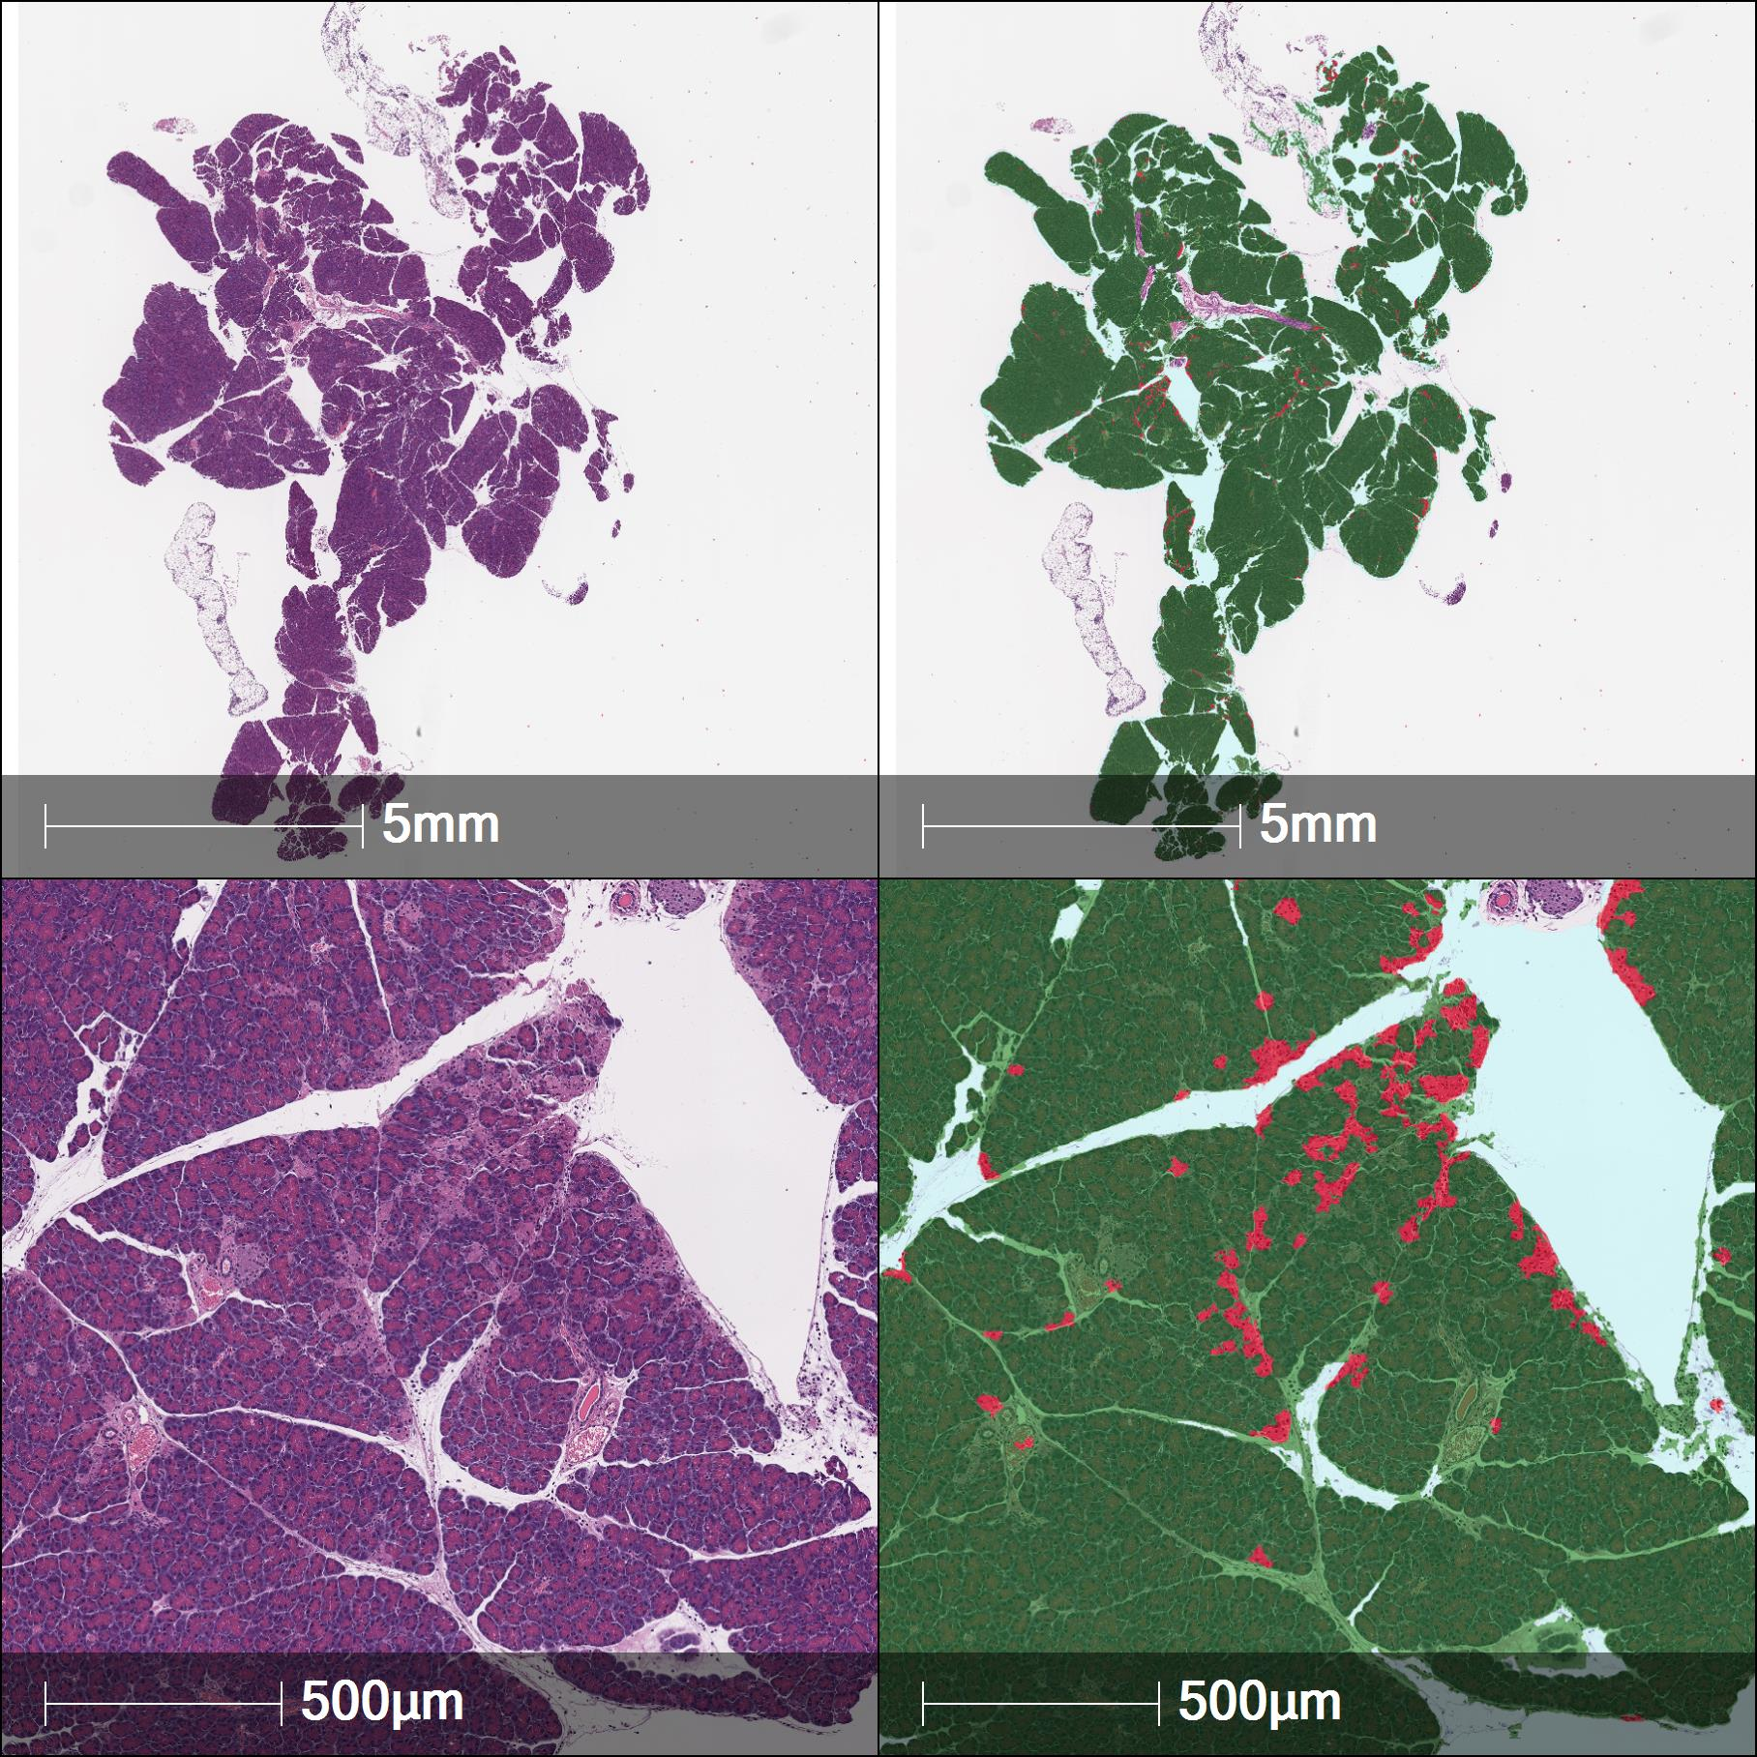
(B)
Supplementary Figure 1. (A) Quantification of necrotic cells in hematoxylin/eosin-stained pancreas sections from mice using an alternative automated image analysis method. These images were generated by Histowiz, a commercial histology provider, using their proprietary image analysis pipeline. (B) The same data as analyzed for Figure 2N by our image analysis software was also analyzed by Histowiz (n.s. – not significant; * p<0.05; ** p<0.01: one-tailed Student‘s T-test). Results from the Histowiz analysis are consistent with those generated by the image analysis approaches described above, supporting the validity of our open-source approach.

A B
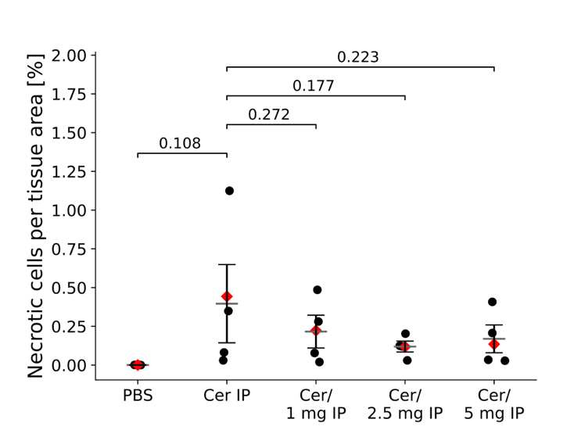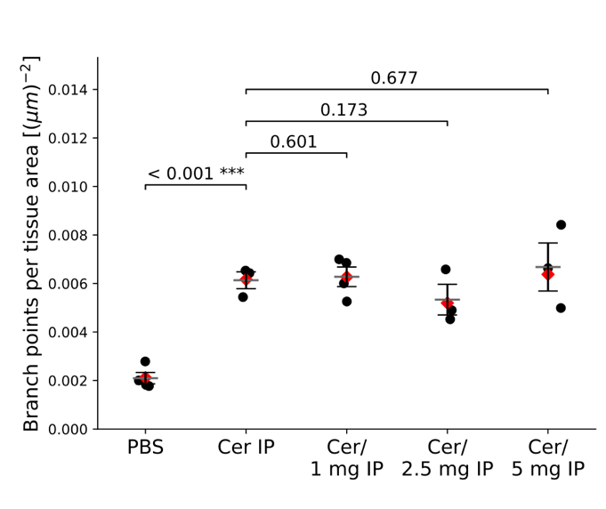
C
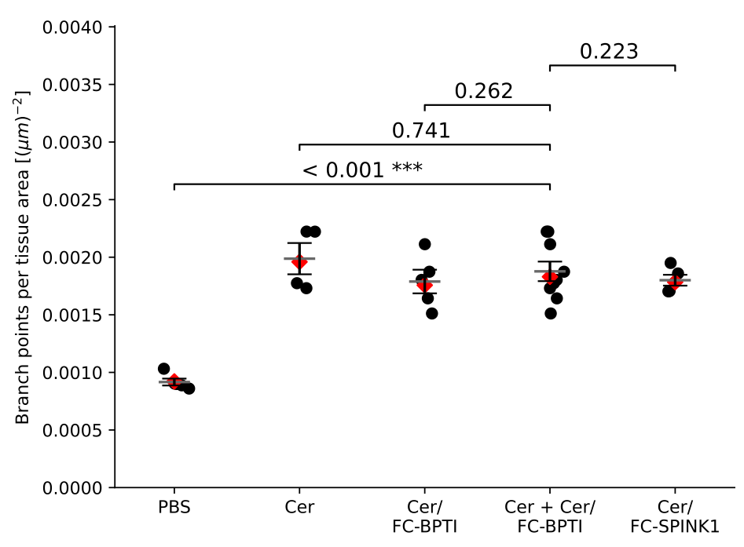
Supplementary figure 2. Necrotic cells and branchpoints, IP dosing in dose escalation; and branchpoint analysis of IP dosing with Fc-BPTI and Fc-SPINK1. A and B: Horizontal bars indicate mean ± standard error of mean (SEM). Red diamonds indicate mean weighted by tissue-area. P-values: single-tailed Welch’s t-test. (A) Results of semi-automated necrotic cell staining. Pancreases of PBS-treated mice show no necrotic cells, while pancreases of cerulein treated mice showed an increased level of cell necrosis. (B) Analysis of tissue integrity by branchpoint quantitation. A comparison of this panel with Figure 3(B) suggests that IV dosing results in a higher level of drug delivery, such that the IV doses have a statistically significant impact while corresponding IP doses do not. (C) Analysis of branchpoints for the same images as in Figure 2N. This panel, when compared with Figure 4(B), suggests that prophylactic dosing has a stronger effect than therapeutic dosing on reduction of branchpoint scores.

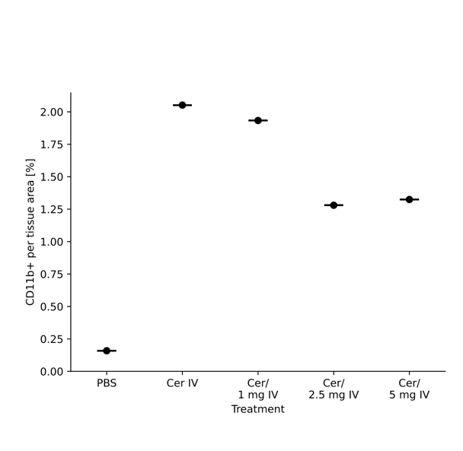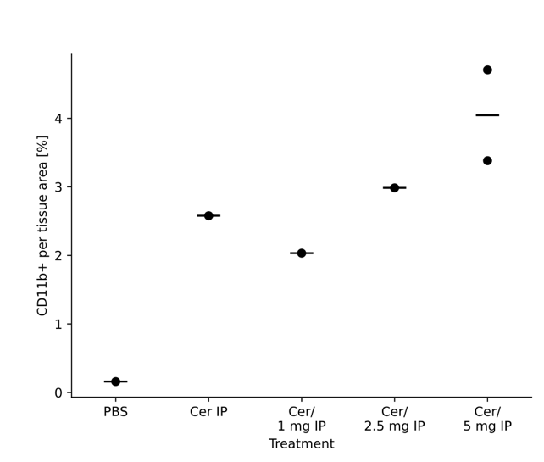

Supplementary Figure 3: Image analysis of CD11b+ leukocyte infiltration in the dose response experiment. A subset of cross-sections from the experiments in Figure 3 and Supplementary Figure 2, respectively were stained with anti-CD11b+ antibodies imaged using HRP immunohistochemistry, and analyzed using the automated image analysis methods described above.

Note on the pattern of Fc-SPINK1 inhibition of trypsin
We tested every batch of Fc-SPINK1 for trypsin inhibition and generally found a step-function increase in inhibition, without signs of partial inhibition at molar ratios around 0.5:1 of SPINK1:trypsin. This is observed in Figure 1F. Buchholz et al. found that there are actually two binding sites for SPINK1 on trypsin. It may be that since Fc-SPINK1 is dimeric for SPINK1, it can form a higher-order complex with a high Hill coefficient of binding.

Reference: Buchholz, I., et al. The impact of physiological stress conditions on protein structure and trypsin inhibition of serine protease inhibitor Kazal type 1 (SPINK1) and its N34S variant. BBA – Proteins and Proteomics. 1868,1-8 (2020).

Supplementary Figure 4.

Supplementary Figure 4. Pharmacokinetics of Fc-SPINK1, analyzed by a three-parameter fit. Garzone and Atkinson^{[1]} have argued that the pharmacokinetics of protein drugs that do not bind to or penetrate cells should be modeled with a three-parameter fit, corresponding to the plasma compartment, a ‘fast’ equilibrating compartment corresponding to splanchic tissues such as the liver, which have fenestrated capillaries, and a ‘slow’ compartment, corresponding to the rest of the tissues. Here we take the 48-hour timepoint to represent the point at which distribution into the fast compartment is complete. The last three timepoints suggest a terminal plasma half-life of about four days, since the relative protein amount decreases from about 14% to about 9.8% in two days.

- Garzone, P.D. & Atkinson A.J. In search of physiologically based distribution volume estimates for macromolecules. Clin. Pharmacol. Therapeutics 92,419-421 (2012).

