Social Network Mechanisms of Behavior Change in Alcohol Use Disorder Recovery:
A Longitudinal Observational Cohort Study

Supplemental Materials

Sample Details and Retention

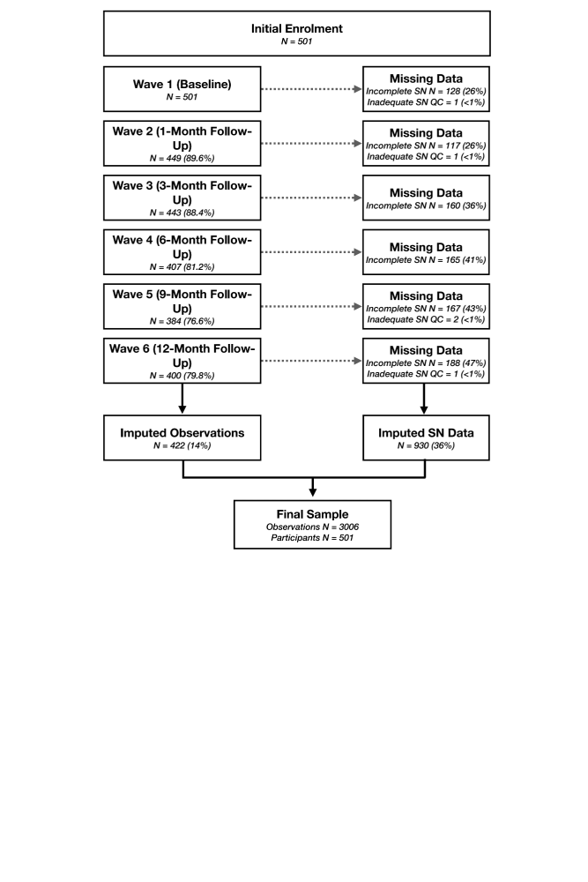
Supplemental Figure 1: CONSORT Diagram Demonstrating Attrition and item nonresponse in social network ties
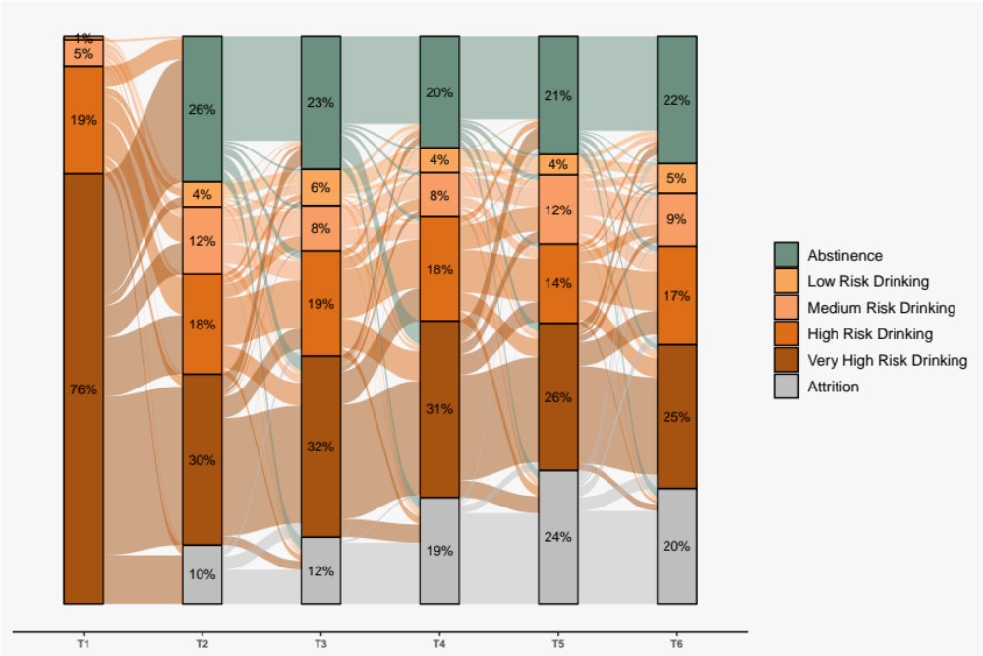
Supplemental Figure 2: Alluvial plot demonstrating transition of drinking behaviours over the course of the study

Missing Data
Appropriate missing data handling was a key component to this study. Attrition or loss to follow-up is a prevalent issue in cohort studies and is particularly important to consider in samples of individuals with substance use disorders, as attrition may be more likely for those struggling with treatment (Claus et al., 2002; Hallgren et al., 2016). Methods that delete missing cases or employ techniques that rely heavily on simple assumptions (e.g., single imputation, last observation carried forward) are demonstrated to produce biased results (Hallgren et al., 2016; Hallgren & Witkiewitz, 2013; Streiner, 2008). Item non-response (i.e., missing predictor data) adds an addition layer of complexity, and may also lead to bias estimates if not appropriately handled (Knol et al., 2010; White & Carlin, 2010). Not unlike many cohort studies, the present study had attrition (14% missing observations) and item non-response (36% missing SN data). The approach used in this study to handle the missingness present was a Bayesian joint imputation and analysis framework through the JointAI R package (Erler et al., 2021). Like traditional multiple imputation, this approach operates under the missing at random assumption but has several additional advantages, including convenience of joint framework and reduced risk of model misspecification (Erler et al., 2021).

In order to make use of all available information while still ensuring comparability of findings, incomplete SN data (e.g., reporting some but <190 tie values) was leveraged as auxiliary information which informed the imputation procedure. Additionally, the 5-person SN battery was used as auxiliary information which informed the imputation instead of using the 5-person averages directly; this was done to maintain between-person validity such that all SN predictors were based on a 20-person denominator. Several additional auxiliary variables were also leveraged to better inform the imputation of SN predictors as well the alcohol use outcomes; a list and associated definitions of these are provided in the Supplemental Table 1 below.

Supplemental Table 1: Auxiliary Variables Used for Imputation Procedures
Incomplete SN Variables | Incomplete social network (SN) data derived from either failure to complete the 20-person battery in full, or from those who completed only the 5-person brief version of the battery for all SN variables in analyses (see Section 1.2.3 of main manuscript for full list of SN variables)
ADASES Score | The Alcohol and Drug Abstinence Self-Efficacy Scale is a 20-item instrument which evaluates an individual’s self-efficacy to achieve abstinence (range 20-100) (DiClemente et al., 1994).
SIP Score | The Short Inventory of Problems (SIP) is a 15-item instrument which measures consequences of alcohol use (range 0-45) (Blanchard et al., 2003; Miller et al., 1995).
BARC-10 Score | The Brief Assessment of Recovery Capital (BARC) is shortened from the original 50-item scale and is an indicator of an individual resources which may facilitate more successful recovery (i.e., a person’s “recovery capital”); range 10 to 50 (Vilsaint et al., 2017).
PHQ-9 Score | The Patient Health Questionnaire 9-item depression module (PHQ-9) is a 9-item scale used to asses clinically relevant symptoms of depression (range 0-27) (Kroenke et al., 2001).
GAD-7 Score | The Generalized Anxiety Disorder 7-item scale (GAD-7) is used to assess clinically relevant symptoms of anxiety (range 0-21) (Spitzer et al., 2006).
NIH Emotional Support Score | The NIH emotional support score is a component of the National Institutes of Health (NIH) Toolbox of Social Relationships which gauges the availability of supports persons to empathetically listen to one’s problems (range 8-40) (Cyranowski et al., 2013).
NIH Friendship Score | The NIH Friendship score is a component of the NIH Toolbox of Social Relationships which gauges the availability of friends to provide support (range 8-40) (Cyranowski et al., 2013).
EUROHIS-QOL Score | The EUROHIS-QOL is an 8-item instrument which assess physical, psychological, social, and environmental wellbeing (range 8-40) (Schmidt et al., 2006).

Social Network Diagrams

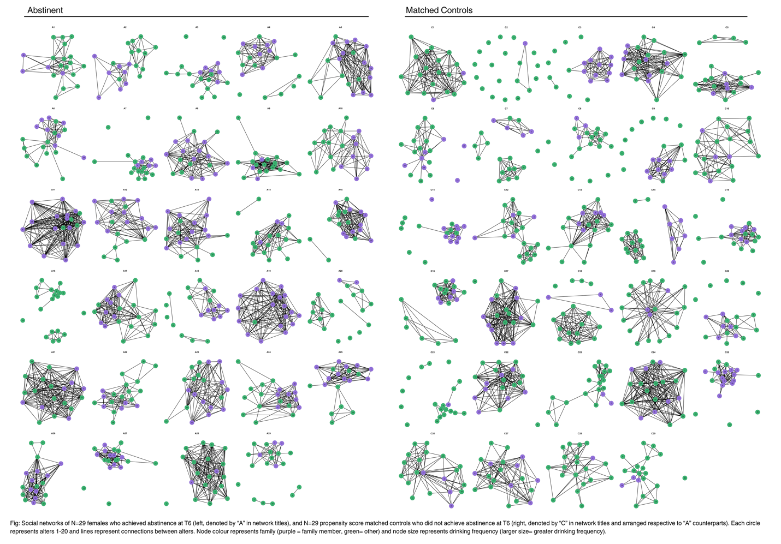
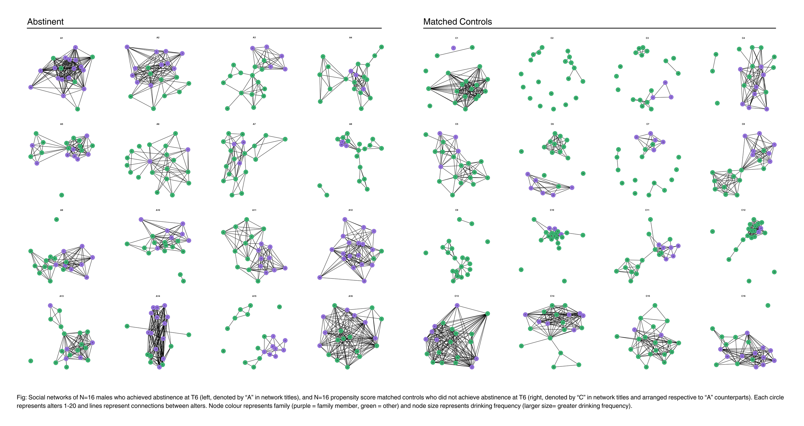
Supplemental Figure 3: Social networks of N=29 females (top) and N=16 males (males) who achieved abstinence at 1-year (left, denoted by “A” in network titles), and their respective propensity score matched controls who did not achieve abstinence at 1-year (right, denoted by “C” in network titles and arranged respective to “A” counterparts). Each circle represents alters 1-20 and lines represent connections between alters. Node colour represents family (purple = family member, green= other).
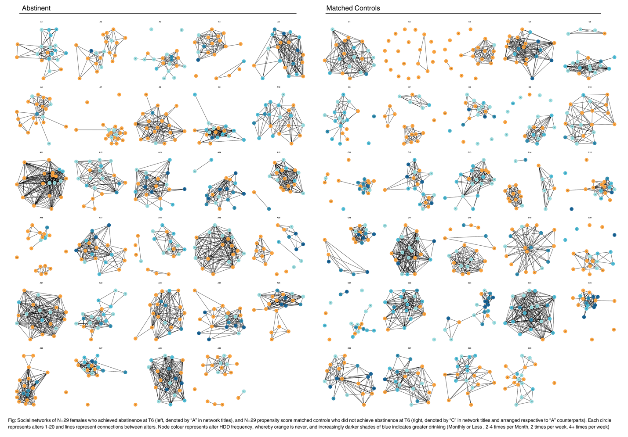
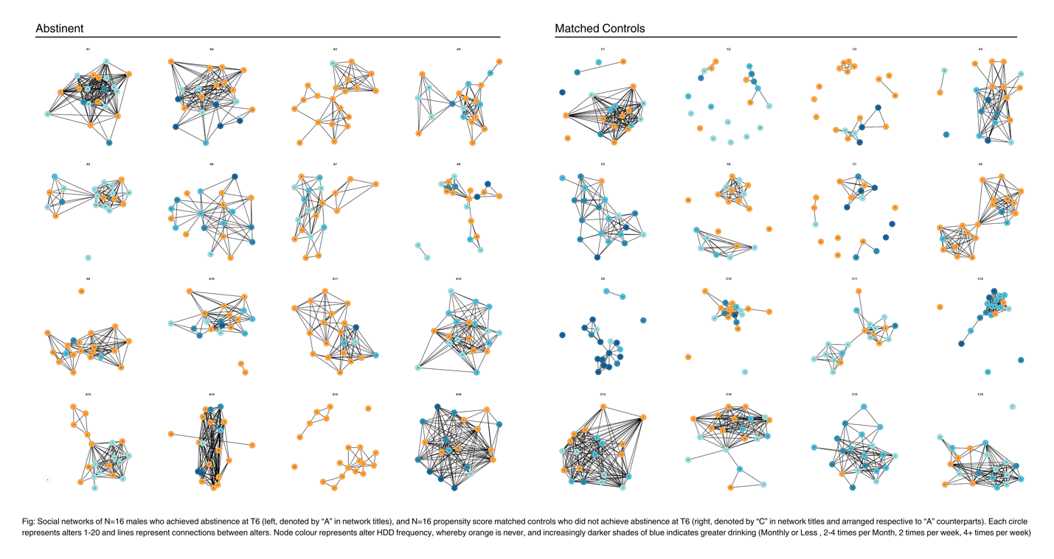
Supplemental Figure 4: Social networks of N=29 females (top) and N=16 males (males) who achieved abstinence at 1-year (left, denoted by “A” in network titles), and their respective propensity score matched controls who did not achieve abstinence at 1-year (right, denoted by “C” in network titles and arranged respective to “A” counterparts). Each circle represents alters 1-20 and lines represent connections between alters. Node colour represents alter heavy drinking days (HDD) frequency, whereby orange is never, and increasingly darker shades of blue indicates greater HDD (Monthly or Less , 2-4 times per Month, 2 times per week, 4+ times per week)

Supplemental References

Blanchard, K. A., Morgenstern, J., Morgan, T. J., Labouvie, E. W., & Bux, D. A. (2003). Assessing Consequences of Substance Use: Psychometric Properties of the Inventory of Drug Use Consequences. Psychology of Addictive Behaviors, 17(4), 328–331. https://doi.org/10.1037/0893-164X.17.4.328
Claus, R. E., Kindleberger, L. R., & Dugan, M. C. (2002). Predictors of attrition in a longitudinal study of substance abusers. Journal of Psychoactive Drugs, 34(1), 69–74. https://doi.org/10.1080/02791072.2002.10399938
Cyranowski, J. M., Zill, N., Bode, R., Butt, Z., Kelly, M. A. R., Pilkonis, P. A., Salsman, J. M., & Cella, D. (2013). Assessing social support, Companionship, And distress: National institute of health (NIH) toolbox adult social relationship scales. Health Psychology, 32(3), 293–301. https://doi.org/10.1037/a0028586
DiClemente, C. C., Carbonari, J. P., Montgomery, R. P., & Hughes, S. O. (1994). The Alcohol Abstinence Self-Efficacy scale. Journal of Studies on Alcohol, 55(2), 141–148. https://doi.org/10.15288/jsa.1994.55.141
Erler, N. S., Rizopoulos, D., & Lesaffre, E. M. E. H. (2021). JointAI: Joint Analysis and Imputation of Incomplete Data in R. Journal of Statistical Software, 100(20), 1–56. https://doi.org/10.18637/JSS.V100.I20
Hallgren, K. A., & Witkiewitz, K. (2013). Missing Data in Alcohol Clinical Trials: A Comparison of Methods. Alcoholism: Clinical and Experimental Research, 37(12), 2152–2160. https://doi.org/10.1111/acer.12205
Hallgren, K. A., Witkiewitz, K., Kranzler, H. R., Falk, D. E., Litten, R. Z., O’Malley, S. S., & Anton, R. F. (2016). Missing Data in Alcohol Clinical Trials with Binary Outcomes. Alcoholism: Clinical and Experimental Research, 40(7), 1548–1557. https://doi.org/10.1111/acer.13106
Knol, M. J., Janssen, K. J. M., Donders, A. R. T., Egberts, A. C. G., Heerdink, E. R., Grobbee, D. E., Moons, K. G. M., & Geerlings, M. I. (2010). Unpredictable bias when using the missing indicator method or complete case analysis for missing confounder values: an empirical example. Journal of Clinical Epidemiology, 63(7), 728–736. https://doi.org/10.1016/j.jclinepi.2009.08.028
Kroenke, K., Spitzer, R. L., & Williams, J. B. W. (2001). The PHQ-9: validity of a brief depression severity measure. Journal of General Internal Medicine, 16(9), 606–613. https://doi.org/10.1046/j.1525-1497.2001.016009606.x
Miller, W. R., Scott Tonigan, J., Longabaugh, R., Mattson, M. E., Lisa Marshall, E. A., & Editor, A. (1995). National Institute on Alcohol Abuse and Alcoholism Project MATCH Monograph Series Volume 4 THE DRINKER INVENTORY OF CONSEQUENCES (DrInC) An Instrument for Assessing Adverse Consequences of Alcohol Abuse Test Manual.
Schmidt, S., Mühlan, H., & Power, M. (2006). The EUROHIS-QOL 8-item index: Psychometric results of a cross-cultural field study. In European Journal of Public Health (Vol. 16, Issue 4, pp. 420–428). https://doi.org/10.1093/eurpub/cki155
Spitzer, R. L., Kroenke, K., Williams, J. B. W., & Löwe, B. (2006). A brief measure for assessing generalized anxiety disorder: The GAD-7. Archives of Internal Medicine, 166(10), 1092–1097. https://doi.org/10.1001/archinte.166.10.1092
Streiner, D. L. (2008). Missing data and the trouble with LOCF. Evidence-Based Mental Health, 11(1), 3–5. https://doi.org/10.1136/ebmh.11.1.3-a
Vilsaint, C. L., Kelly, J. F., Bergman, B. G., Groshkova, T., Best, D., & White, W. (2017). Development and validation of a Brief Assessment of Recovery Capital (BARC-10) for alcohol and drug use disorder. Drug and Alcohol Dependence, 177, 71–76. https://doi.org/10.1016/j.drugalcdep.2017.03.022
White, I. R., & Carlin, J. B. (2010). Bias and efficiency of multiple imputation compared with complete-case analysis for missing covariate values. Statistics in Medicine, 29(28), 2920–2931. https://doi.org/10.1002/sim.3944

