SUPPLEMENTAL DATA
Figure 1. Graph of Kaplan Meier survival analysis on immune checkpoint inhibitor (ICI) therapy in patients with pre-existing psoriasis who experienced worsening disease on ICIs versus those with unaffected disease.
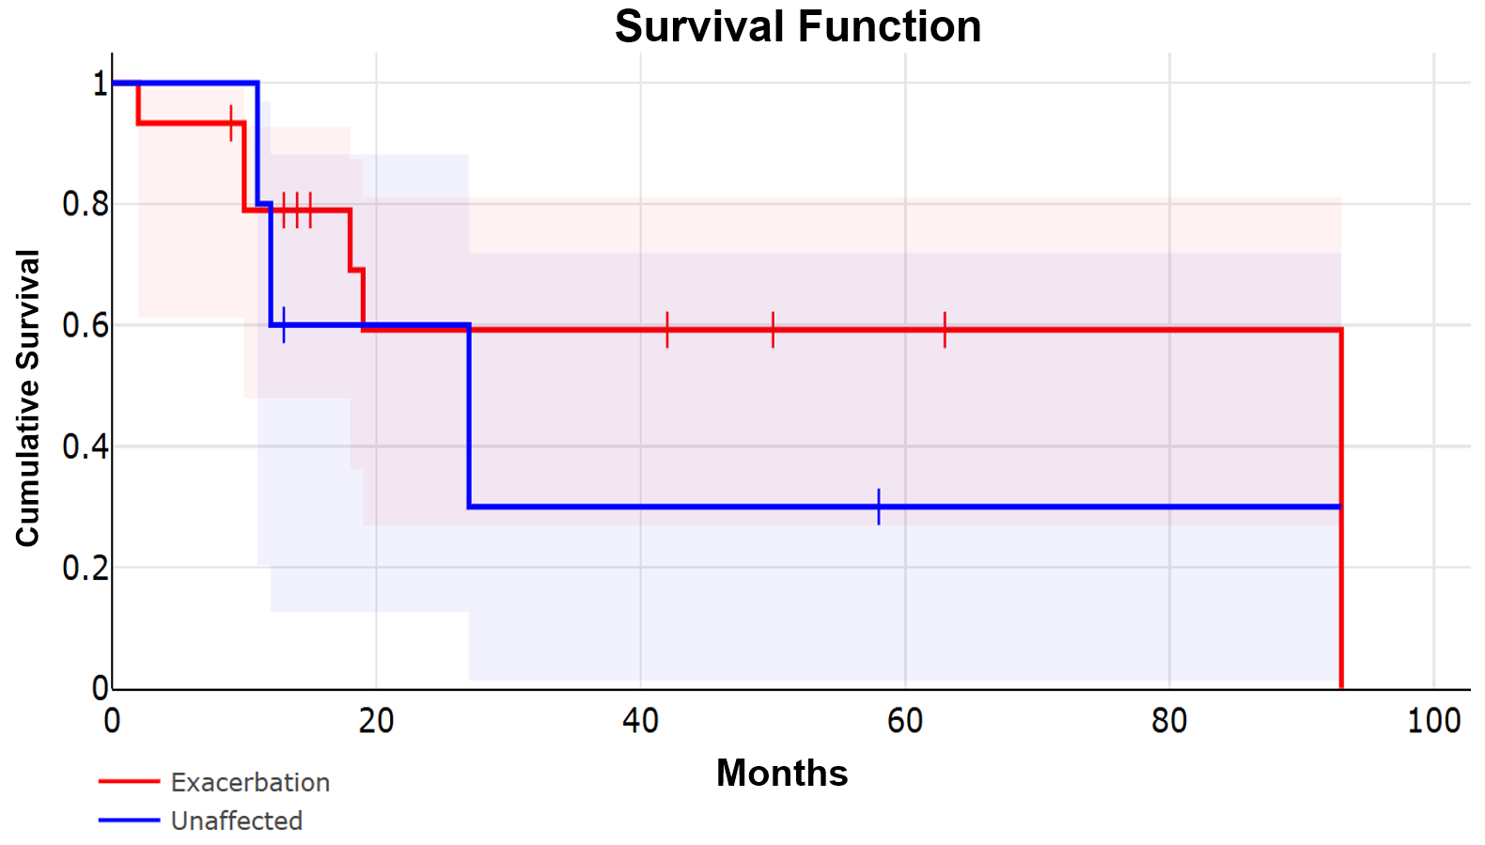
Figure 2. Graph of Kaplan Meier cancer progression free survival on immune checkpoint inhibitor (ICI) therapy in patients with pre-existing psoriasis who experienced worsening disease on ICIs versus those with unaffected disease.
