Supplementary Information
Using Folded Proteins as Mechanically Well-Defined Units to Understand Fatigue Fracture in Hydrogels: Bridging Single-Molecule and Bulk Studies

Liang Dong^{1, 2, 7}, Puyu Cao^{3, 7}, Huiyan Chen², Yu Zhang², Ying Li⁴, Bin Chen^{3*}, Hai Lei^{1*}, Yi Cao^{2, 5, 6*}
¹School of Physics, Institute for Advanced Study in Physics, Zhejiang University, Hangzhou 310027, China
²National Laboratory of Solid State Microstructure, School of Chemistry and Chemical Engineering, Nanjing University, Nanjing 210093, China
³Department of Engineering Mechanics, Zhejiang University, Hangzhou 310027, China
⁴Institute of Advanced Materials and Flexible Electronics (IAMFE), School of Chemistry and Materials Science, Nanjing University of Information Science & Technology, Nanjing, 210044, China.
⁵Chemistry and Biomedicine Innovation Center (ChemBIC), Nanjing University, Nanjing 210093, China
⁶MOE Key Laboratory of High Performance Polymer Materials & Technology, Nanjing University, Nanjing 210093, China
⁷These authors contributed equally.
*E-mail: caoyi@nju.edu.cn; leihai@zju.edu.cn; chenb6@zju.edu.cn

Amino Acid Sequence of Protein Domains

GB1: 6.3kDa
MDTYKLILNGKTLKGETTTEAVDAATAEKVFKQYANDNGVDGEWTYDDATKTFTVTE

SdrGB1: 13.6kDa
APEKTYKIGDYVWEDVDKDGIQNTNDNEKPLSNVLVTLTYPDGTSKSVRTDEEGKYQFDGLKNGLTYKITFETPEGYTPTLKHSGTNPALDSEGNSVWVTINGQDDMTIDSGFYQTPGS

NuG2: 6.1kDa
TYKLVIVLNGTTFTYTTEAVDAATAEKVFKQYANDNGVDGEWTYDDATKTFTVTE

SNAP: 19.3kDa
MDKDCEMKRTTLDSPLGKLELSGCEQGLHEIKLLGKGTSAADAVEVPAPAAVLGGPEPLMQATAWLNAYFHQPEAIEEFPVPALHHPVFQQESFTRQVLWKLLKVVKFGEVISYQQLAALAGNPAATAAVKTALSGNPVPILIPCHRVVSSSGAVGGYEGGLAVKEWLLAHEGHRLGKPGLG

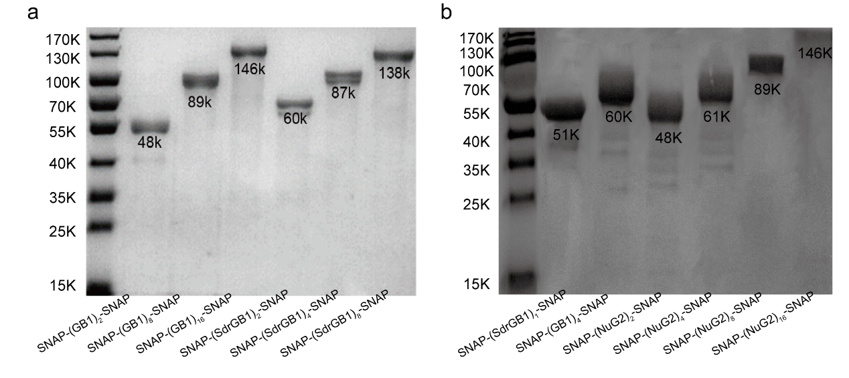
Supplementary Figure 1. SDS-PAGE of all 12 polyproteins for gelation.

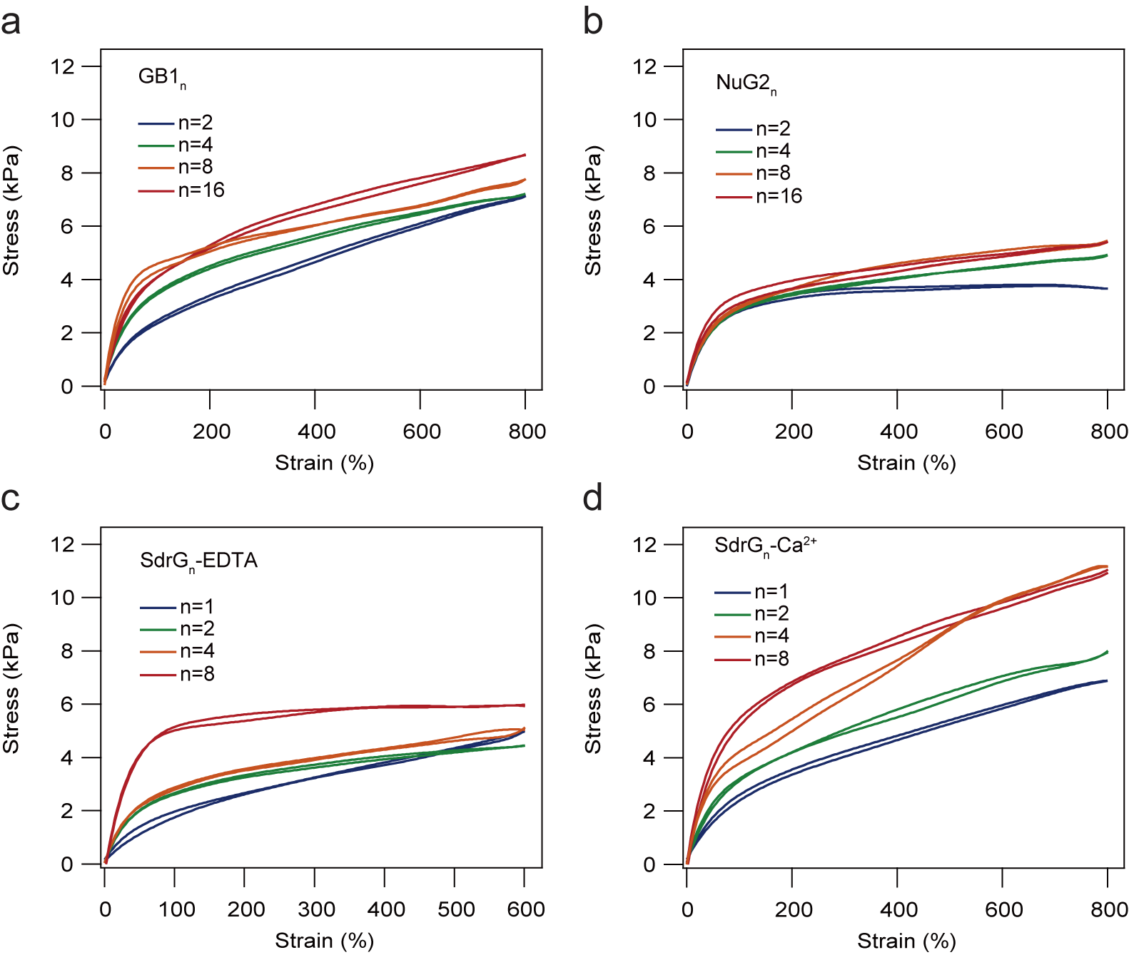
Supplementary Figure 2. Uniaxial single cycle tensile 800% strain test. For GB1 (a); NuG2 (b) and Ca²⁺-treated SdrGB1(d) single cyclic tensile experiments showed that the hysteresis was all less than 2%. Due to the difficulty of maintaining all the mechanical properties of EDTA-treated SdrGB1 protein gels at 800% deformation without breaking. Therefore, 600% deformation was chosen for testing(c).

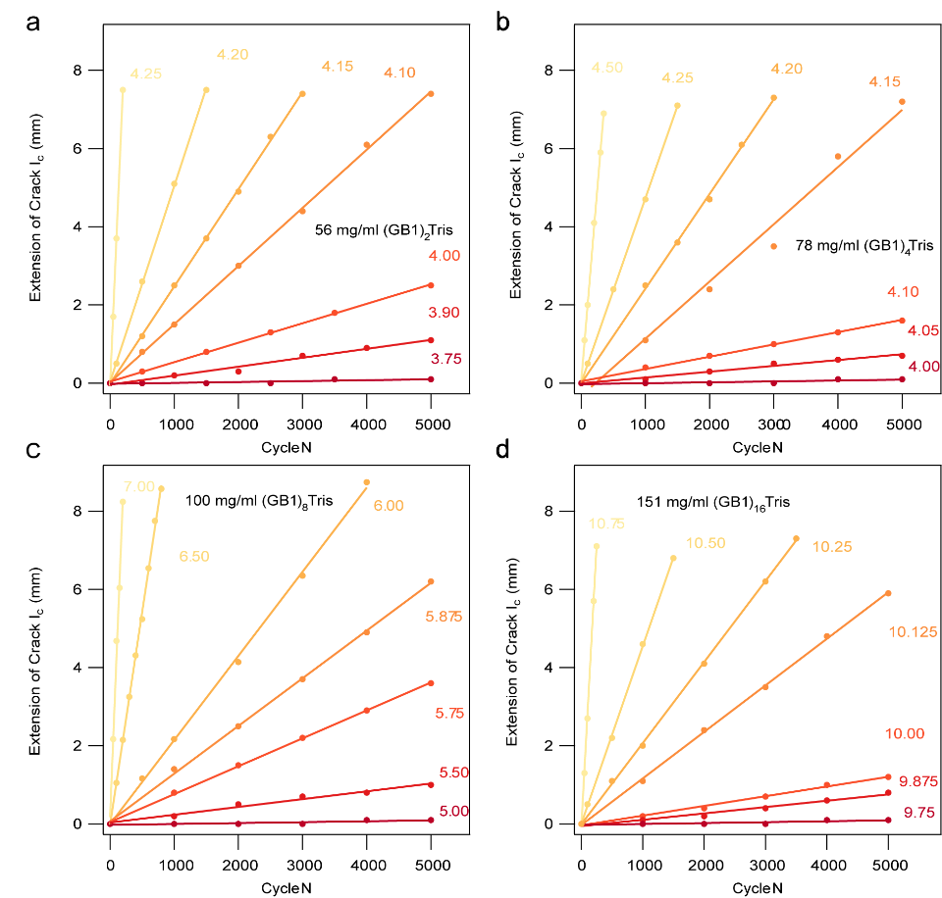
Supplementary Figure 3. Crack diffusion rate calculation for GB1 polyprotein hydrogels. Crack extension as a function of the number of cycles with different applied strain for dimerization hydrogel (a), tetrameric hydrogel (b), octamer hydrogel (c), and hexadecamer hydrogel (d), respectively.

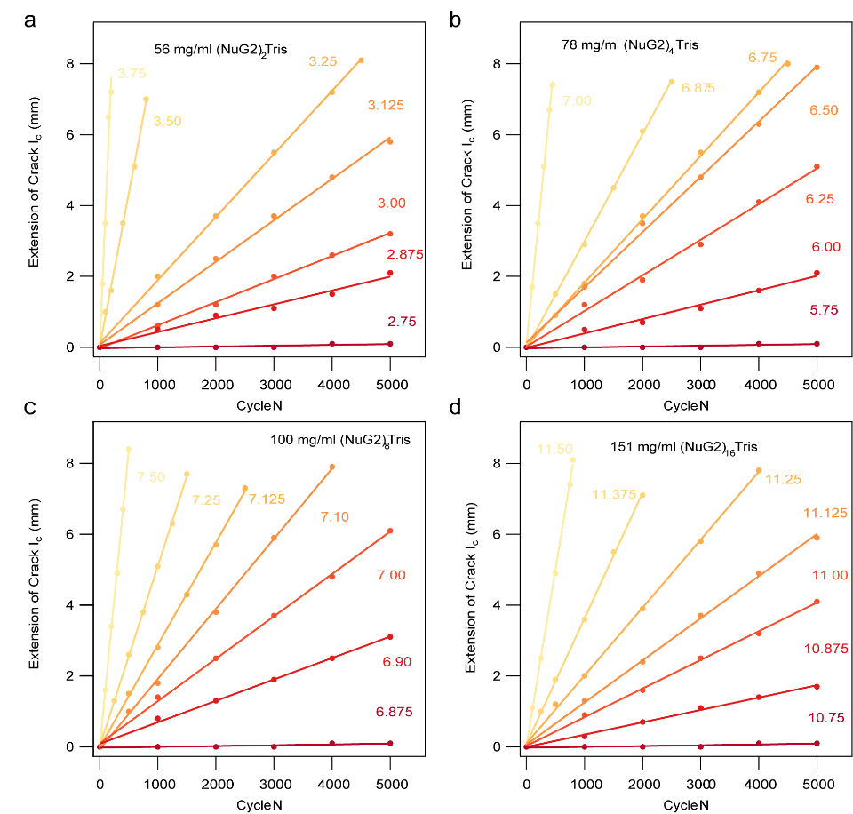
Supplementary Figure 4. Crack diffusion rate calculation for NuG2 polyprotein hydrogels. Crack extension as a function of the number of cycles with different applied strain for dimerization hydrogel (a), tetrameric hydrogel (b), octamer hydrogel (c), and hexadecamer hydrogel (d), respectively.

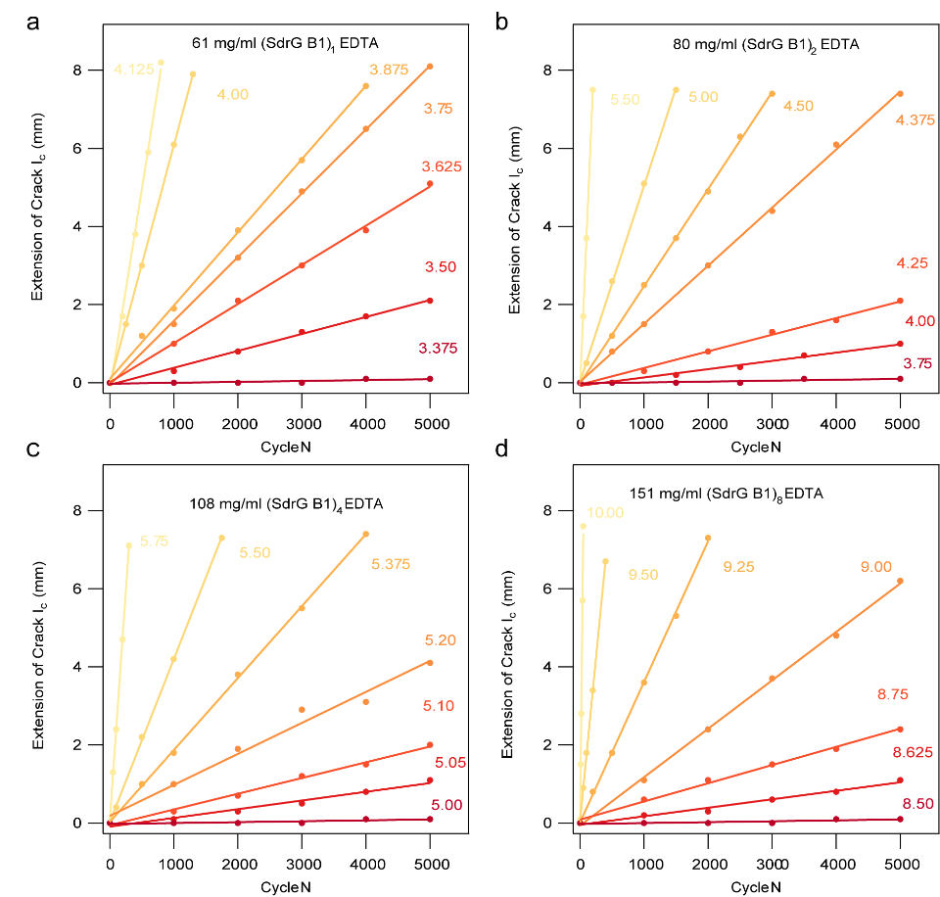
Supplementary Figure 5. Fatigue threshold calculation for EDTA-treated SdrGB1 polyprotein hydrogels. Crack extension as a function of the number of cycles with different applied strain for monomer hydrogel (a), dimerization hydrogel (b), tetrameric hydrogel (c), and octamer hydrogel, respectively.

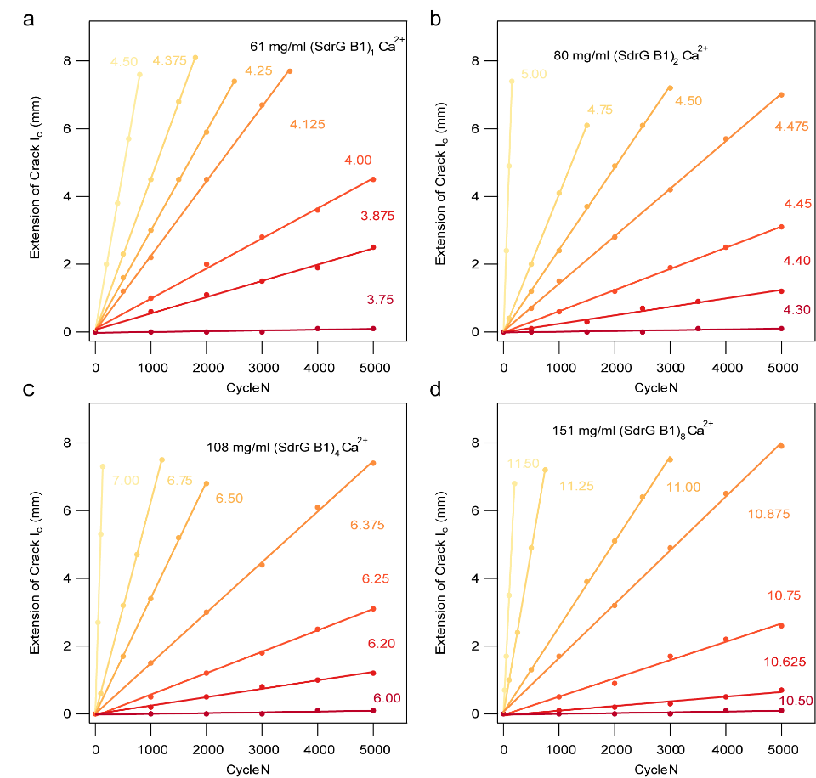
Supplementary Figure 6. Fatigue threshold calculation for Ca²⁺-treated SdrGB1 polyprotein hydrogels. Crack extension as a function of the number of cycles with different applied strain for monomer hydrogel (a), dimerization hydrogel (b), tetrameric hydrogel (c), and octamer hydrogel, respectively.

Supplementary Table 1. The kinetic parameters of the protein unfolding
 | Contour length increment  ΔL_{c} (nm) | Unfolding rate  α₀ (s⁻¹) | Unfolding  Force  F (pN) | With of transition states  Δx_{u} (nm)
GB1 | 18 | 0.037 | 193.3±64.8 |  | 0.17
NuG2 | 18 | 0.0018 | 112.6±47.2 |  | 0.32
SdrGB1-Ca²⁺ | 35 | 5×10⁻¹⁷ | 1492.7±130.5 |  | 0.083
SdrGB1-EDTA | 36 | 0.009 | 474.6±131.6 |  | 0.071

Theoretical Model
In the model, it is assumed that polymer chains close to the crack tip form a hierarchical Cayley tree structure with multiple layers upon fatigue loading, as illustrated in Fig. 5a. The total number of these layers is denoted as H and their numbering sequence, denoted as i, is displayed in Fig. 5a. Chains within the tree exhibit constitutive uniformity and consist of folded protein domains. These domains are mechanosensitive, capable of force-dependent unfolding or refolding. Our model is thus termed as the force-response model. When the single chain in the first layer at the crack tip is broken, the energy consumed within the whole tree would contribute to the fatigue threshold of materials, as assumed in the previous tree model (Lin et al., 2021; Lin and Zhao, 2020).
In the model, the effective chain force is assumed to rapidly decay across layers (Lin et al., 2021; Lin and Zhao, 2020). Due to the stress singularity existing near the crack tip, as rooted in the classical fracture theory (Irwin, 1957; Williams, 1957) and also suggested from polymer chain network analysis (Cao et al., 2025), the effective chain force in the i^{th} layer, denoted as $F_{i}$, is assumed to follow the similar singular decay in the force-response model, which is given by as $F_{i}=F_{1}i^{s}$, where $F_{1}$ is the effective chain force in the 1st layer, and 𝑠 is the singular exponent, which is of a negative value. The effective number of chains in the i^{th} layer, denoted as $m_{i}$, is derived from force equilibrium across layers, given by $m_{i}=i^{-s}$.
With the assumption of the self-similar crack propagation, chains in the i^{th} layer of the current tree would migrate to the (i+1)^{th} layer of the next tree, as the single chain at the current crack tip breaks and the crack tip moves a step ahead. The associated change in chain force within the same layer in two trees is then approximately given by $∆F= s⋅F_{1}i^{s-1}$. $\left|∆F/F_{1}\right|$ decreases as i increases. When $\left|∆F/F_{1}\right|$ is very small, the energy stored within the chains in that layer would not be released. In the analysis, we set $\left|∆F/F_{1}\right|$ to be 0.005 to determine the total number of layers in the tree, H.
The force-extension relationship of chains in each layer within the model is described by the worm-like chain theory (Marko and Siggia, 1995), given by $F_{i}=\frac{kT}{L_{p}}\left(\frac{1}{4}{\left(1-\frac{x_{i}}{L_{c,i}}\right)}^{-2}-\frac{1}{4}+\frac{x_{i}}{L_{c,i}}\right)$, where k is the Boltzmann constant, T is the absolute temperature, $L_{p}$ is the persistence length, $L_{c,i}$ is the current contour length of the polymer chain in the $i^{th}$ layer, and $x_{i}$ represents the current extension of the polymer chain in the $i^{th}$ layer. Upon loading, $F_{i}$ increases, and the folded domains can be gradually unfolded, which leads to an increase in $L_{c,i}$, given by $L_{c,i}=L_{c}^{0}+R_{i}⋅n⋅∆L_{c}$, where $L_{c}^{0}$ is the initial contour length of each chain, $R_{i}$ denotes the fraction of unfolded domains of each chain within the $i^{th}$ layer, $n$ stands for the number of the folded domains within a single polymer chain, and $∆L_{c}$ is the increase in the contour length due to the unfolding of an individual domain. The rate of $R_{i}$ is given by $dR_{i}/dt=k_{uf,i}\left(1-R_{i}\right)-k_{f,i}R_{i}$, where $k_{uf,i}$ and $k_{f,i}$ are the unfolding rate and refolding rate of protein domains in the $i^{th}$ layer, respectively (Fan et al., 2019), given by the Bell’s law in Eq. (2) (Bell, 1978).
The simulation was conducted by imposing a constant stretching velocity to the outmost layer of the force-response model and also ensuring that $F_{1}$ reaches $F_{C}$ within half a second to mimic experimental loading conditions with a loading frequency of 1 Hz. The initial fraction of unfolded domains in each chain before loading is set to zero by default and all unfolded domains are assumed to be refolded upon the completion of a loading cycle. An explicit scheme was employed in the simulations of fatigue thresholds of hydrogels and physical quantities, including $R_{i}, x_{i}, L_{c,i}$, etc., are updated iteratively. The parameters used in the simulation are provided in Supplementary Tables 2–6. Predicted fatigue thresholds of fabricated hydrogels of our tree model are displayed in Figs. 5b. The farthest unfolded layer upon loading and the energy stored within each layer, $U_{i}$, right before the breaking of the chain in the first layer are also simulated, which are displayed in Supplementary Figure 7 and 8, respectively.
For comparison, we also simulate the fatigue thresholds of hydrogels based on the previous tree model developed in literature (Lin and Zhao, 2020; Lin et al., 2021), displayed in Fig. 5b, by replacing the unconstructed chains in the previous tree model with polymer chains being comprised of folded domains that can be unfolded due to force. Based on the previous tree model (Lin and Zhao, 2020; Lin et al., 2021), with the functionality of crosslinks being 3 due to the topology of the current chain network, the force in the i^{th} layer, $F_{i}$, would be $F_{i}=F_{1}⋅2^{-(i-1)}$, and the number of chains in the i^{th} layer would be $2^{i-1}$. With 20 layers of chains being considered, the same loading conditions and numerical scheme as descried above are employed in simulations of the previous tree model for consistency.
To investigate the effect of the unfolding force of folded domains, denoted as $F_{u}$, on the fatigue threshold of hydrogels, we choose to virtually vary the unfolding rate of GB1 protein domains in the simulation. At different unfolding rates, we simulate the corresponding force–extension curves when the protein chain is subjected to a constant stretching velocity of 1000 nm·s⁻¹, exactly as that employed in single-molecule experiments. The force value at which 50% of the protein domains are unfolded during the loading process is taken as $F_{u}$. The predicted $F_{u}$-dependent fatigue threshold of GB1 hydrogels and the unfolding probability in 16-domain systems with our tree model are displayed in Fig. 5c and d.

Supplementary Table 2 Default values for parameters used in the simulation
Parameter | Value | Parameter | Value
$$F_{c}$$ | 4000 pN | $$L_{c}^{0}$$ | 120 nm
$$λ_{s}$$ | 2 | $$α$$ | 3.2
$$L_{0}$$  $$v$$ | 19.6 nm  0.5

Supplementary Table 3 Values of parameters for GB1 used in the simulation
Parameter | Value | Parameter | Value
$$k_{uf}^{0}$$ | 0.039 $s^{-1}$ | $$z_{uf}$$ | 0.17 nm
$$k_{f}^{0}$$ | 720 $s^{-1}$ | $$z_{f}$$ | 2.10 nm
$$∆L_{c}$$ | 18.65 nm | s | -0.5
H | 22

Supplementary Table 4 Values of parameters for NuG2 used in the simulation
Parameter | Value | Parameter | Value
$$k_{uf}^{0}$$ | 0.001 $s^{-1}$ | $$z_{uf}$$ | 0.276 nm
$$k_{f}^{0}$$ | 25000 $s^{-1}$ | $$z_{f}$$ | 5 nm
$$∆L_{c}$$ | 18 nm | s | -0.6
H | 21

Supplementary Table 5 Values of parameters for SdrGB1-EDTA used in the simulation
Parameter | Value | Parameter | Value
$$k_{uf}^{0}$$ | 0.003 $s^{-1}$ | $$z_{uf}$$ | 0.071 nm
$$k_{f}^{0}$$ | 10 $s^{-1}$ | $$z_{f}$$ | 4.14 nm
$$∆L_{c}$$ | 36 nm | s | -0.35
H | 22

Supplementary Table 6 Values of parameters for SdrGB1-Ca²⁺ used in the simulation
Parameter | Value | Parameter | Value
$$k_{uf}^{0}$$ | 2.8E-18 $s^{-1}$ | $$z_{uf}$$ | 0.12 nm
$$k_{f}^{0}$$ | 25000 $s^{-1}$ | $$z_{f}$$ | 5 nm
$$∆L_{c}$$ | 36 nm | s | -0.41
H | 23

Supplementary Table 7 Young’s modulus extracted from experiment
Protein | N | Young’s modulus | Protein | N | Young’s modulus
GB1 | 2 | 6 kPa | SdrGB1-EDTA | 1 | 5 kPa
GB1 | 4 | 9 kPa | SdrGB1-EDTA | 2 | 6 kPa
GB1 | 8 | 9 kPa | SdrGB1-EDTA | 4 | 7 kPa
GB1 | 16 | 13.5 kPa | SdrGB1-EDTA | 8 | 7 kPa
NuG2 | 2 | 9 kPa | SdrGB1-Ca²⁺ | 1 | 6 kPa
NuG2 | 4 | 9 kPa | SdrGB1-Ca²⁺ | 2 | 6kPa
NuG2 | 8 | 10 kPa | SdrGB1-Ca²⁺ | 4 | 9 kPa
NuG2 | 16 | 16 kPa | SdrGB1-Ca²⁺ | 8 | 9 kPa

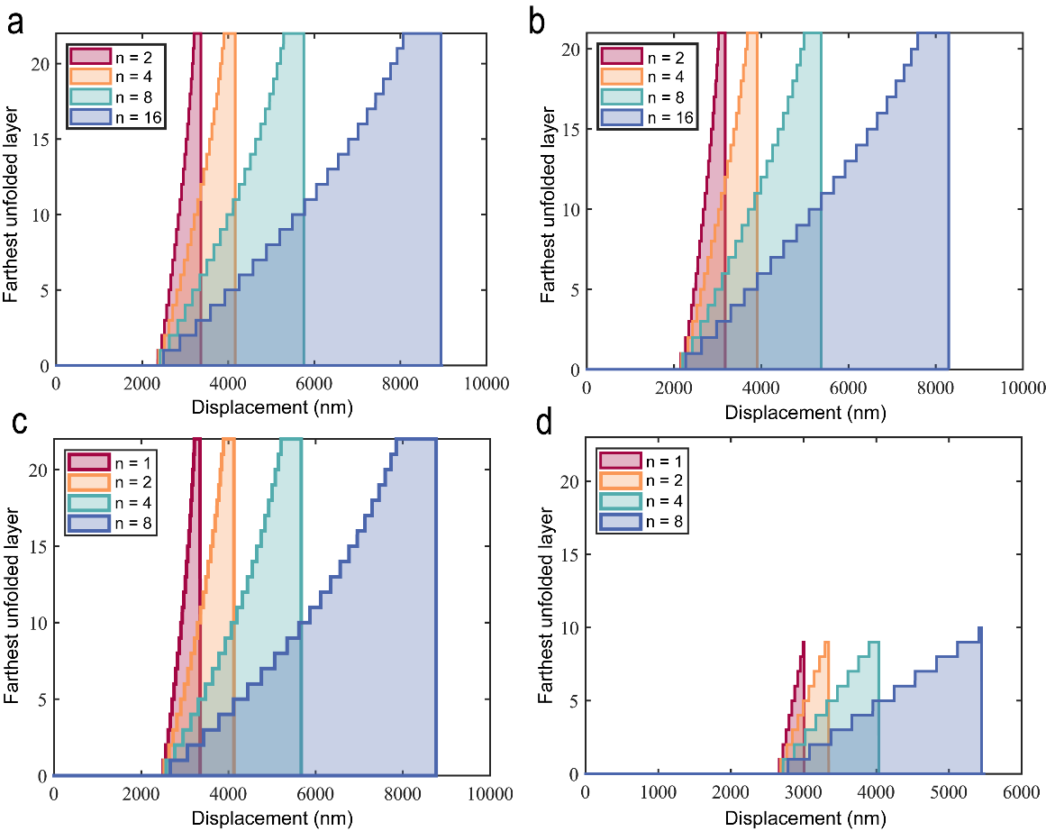

Supplementary Figure 7. Simulated farthest unfolded layer upon stretching within the force-response tree model for hydrogels made of protein GB1 (a), NuG2 (b), SdrGB1-EDTA (c) and SdrGB1-Ca²⁺ (d) respectively.

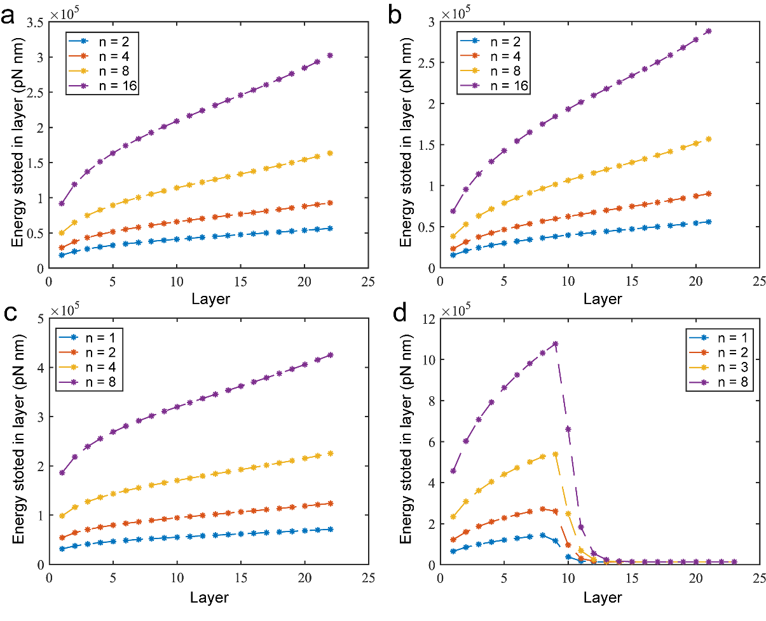
Supplementary Figure 8 Simulated energy stored in each layer right before the chain breaking in the first layer within the force-response tree model for hydrogels made of protein GB1 (a), NuG2 (b), SdrGB1-EDTA (c) and SdrGB1-Ca²⁺ (d) respectively.

Reference
Bell, G.I., 1978. Models for the specific adhesion of cells to cells: A theoretical framework for adhesion mediated by reversible bonds between cell surface molecules. Science 200, 618–627. https://doi.org/10.1126/science.347575
Cao, P., Chen, B., Cao, Y., Gao, H., 2025. Micropores can enhance the intrinsic fracture energy of hydrogels. Soft Matter 21, 2355–2362. https://doi.org/10.1039/D4SM00973H
Fan, Q., Chen, B., Cao, Y., 2019. Constitutive model reveals the defect-dependent viscoelasticity of protein hydrogels. J. Mech. Phys. Solids 125, 653–665. https://doi.org/10.1016/j.jmps.2019.01.015
Irwin, G.R., 1957. Analysis of Stresses and Strains Near the End of a Crack Traversing a Plate. J. Appl. Mech. 24, 361–364. https://doi.org/10.1115/1.4011547
Lin, S., Ni, J., Zheng, D., Zhao, X., 2021. Fracture and fatigue of ideal polymer networks. Extreme Mech. Lett. 48, 101399. https://doi.org/10.1016/j.eml.2021.101399
Lin, S., Zhao, X., 2020. Fracture of polymer networks with diverse topological defects. Phys. Rev. E 102, 052503. https://doi.org/10.1103/PhysRevE.102.052503
Marko, J.F., Siggia, E.D., 1995. Stretching DNA. Macromolecules 28, 8759–8770.
Williams, M.L., 1957. On the Stress Distribution at the Base of a Stationary Crack. J. Appl. Mech. 24, 109–114. https://doi.org/10.1115/1.4011454

