SUPPLEMENTARY MATERIAL

Christia vespertilionis extract induced antiproliferation and apoptosis in breast cancer (MCF7) cells

Noor Zafirah Ismail¹, Ismail Abiola Adebayo², Wan Ahmad Syazani Mohamed¹, Nur Nadhirah Mohamad Zain¹, Hasni Arsad^{1,*}

¹Advanced Medical and Dental Institute, Universiti Sains Malaysia, Bertam, 13200 Kepala Batas, Penang, Malaysia.

²Microbiology and Immunology Department, School of Biomedical Sciences, Kampala International University, Western Campus, P.O. Box 71, Ishaka-Bushenyi, Uganda.

*Corresponding author: Hasni Arsad
Affiliation: Advanced Medical and Dental Institute, Universiti Sains Malaysia, Bertam, 13200 Kepala Batas, Penang, Malaysia.
Email: hasniarsad@usm.my
Phone no: +60-4562-2415

Picture of herbarium
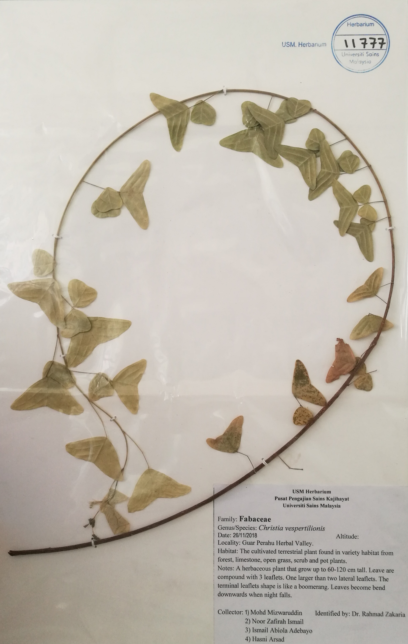

Picture of Label
Herbarium No.: 11777

^{Picture of plant}
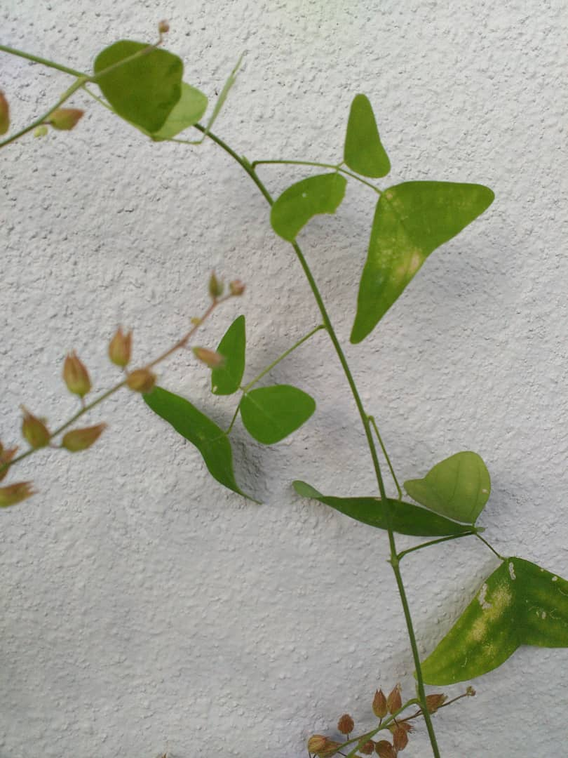

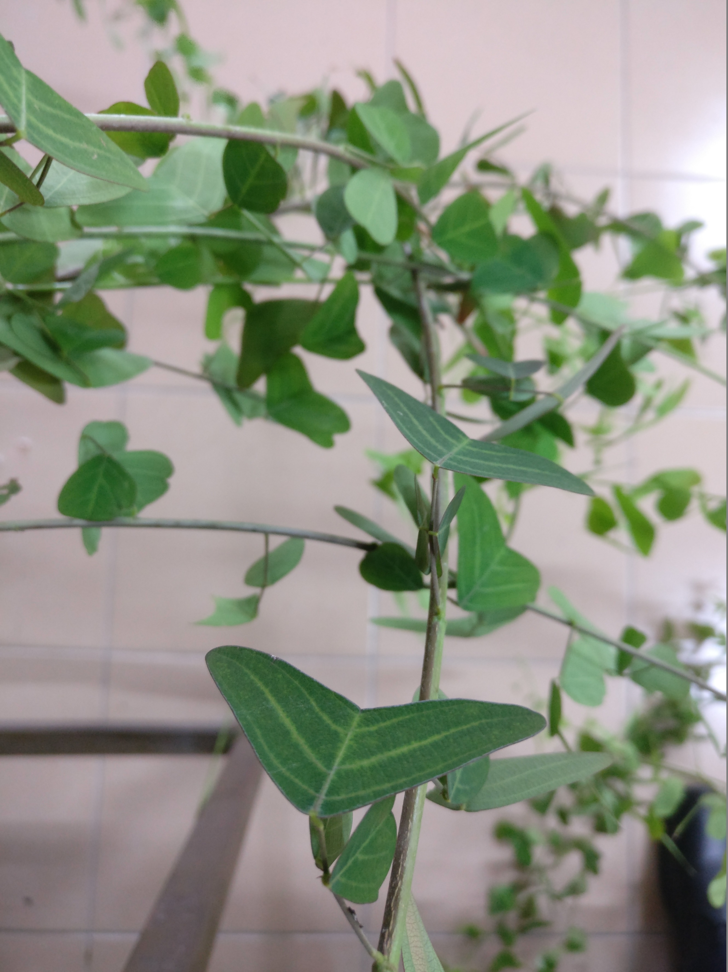

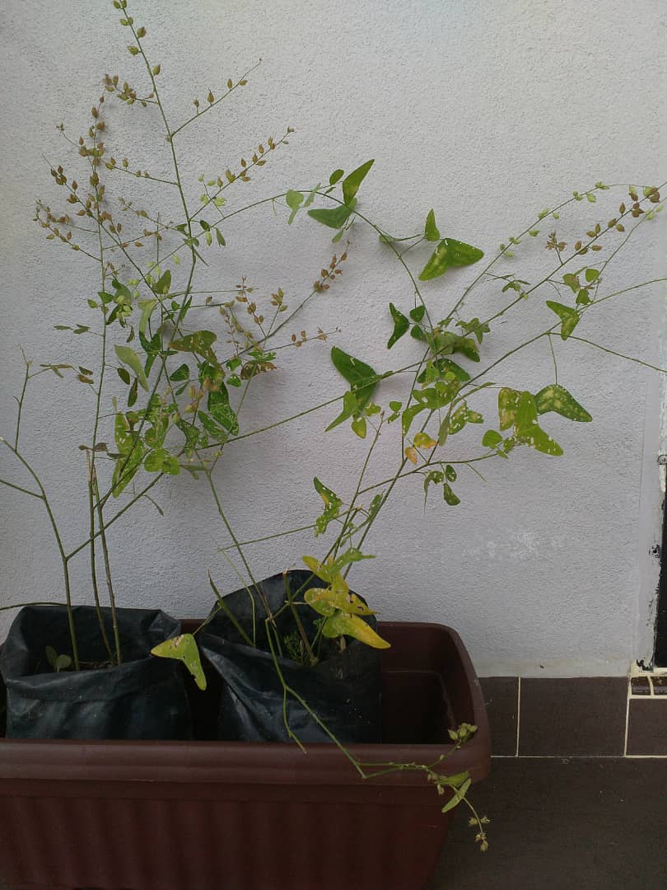

Fig. S1. Herbarium specimen voucher form.

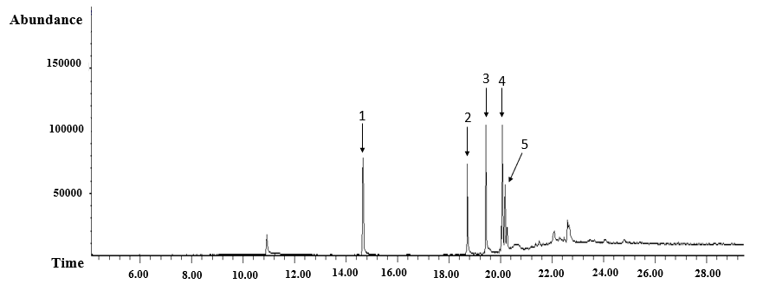
Fig S2. The compounds chromatogram of the CV-Dcm extract by GC-MS. The numbers of each peak in the chromatogram were stated in Table 2.

Table S1. Primer sequences used for qualitative RT-PCR assay.

Gene | Primer sequences | References
β-actin | Forward:  5’–AGTTGCGTTACACCCTTTC–3’  Reverse:  5’–CCTTCACCGTTCCAGTTT–3’ | Ferreira and Cronjé (2012)
P53 | Forward:  5’–TCAACAAGATGTTTTGCCAACTG–3’  Reverse:  5’–ATGTGCTGTGACTGCTTGTAGATG–3’ | De et al. (2019)
BAX | Forward:  5’–TTTGCTTCAGGGTTTCATCCA–3’  Reverse:  5’–CTCCATGTTACTGTCCAGTTCGT–3’ | De et al. (2019)
BCL-2 | Forward:  5’–CATGTGTGTGGAGAGCGTCAAC–3’  Reverse:  5’–CAGATAGGCACCCAGGGTGAT–3’ | De et al. (2019)
PCNA | Forward:  5′–TTTGGTGCA GCTCACCCTG–3’  Reverse:  5′–CGCGTTATCTTCGGCCCTTA–3’ | Ngoc et al. (2020)
Cytochrome C | Forward:  5′–GGAGGCAAGCATAAGACTGG–3’  Reverse:  5′–GTCTGCCCTTTCTCCCTTCT–3’ | (Priyadarsini et al. (2010)
Caspase-8 | Forward:  5’–CTACCAACTCATGGACCACAG–3’  Reverse:  5’–GTGACTGGATGTACCAGGTTC–3’ | De et al. (2019)
Caspase-3 | Forward:  5’–TTAATAAAGGTATCCATGGAGAACACT–3’  Reverse:  5’–TTAGTGATAAAAATAGAGTTCTTTTGTGAG–3’ | Devarajan et al. (2002)

