Free-roaming cheetah conservation under predicted climate and land-use change in southern Africa
Authors and Affiliations
Nynke Wemer^{1,2} · Vincent N. Naude^{2,3} · Orly Razgour⁴ · Marna Smit⁵ · Deon Cilliers⁶ · Alison J. Leslie² · Jan Komdeur¹

Nynke Wemer
nynkewemer@gmail.com
Vincent Naude
vnaude@sun.ac.za
¹ Behavioural Physiology and Ecology Group, Groningen Institute for Evolutionary Life Sciences (GELIFES), University of Groningen, Groningen, the Netherlands
² Department of Conservation Ecology and Entomology, Stellenbosch University, Matieland, South Africa
³ African Parks Network, Johannesburg, South Africa
⁴ Department of Biosciences, University of Exeter, Exeter, United Kingdom
⁵ Ashia Cheetah Conservation, Paarl, South Africa
⁶ Cheetah Outreach Trust, Somerset West, South Africa

SUPPLEMENTARY MATERIALS
TABLE S1 The 19 Bioclim predictor variables
Predictor variable | Short name | Unit | Scale | Offset | Explanation
Mean annual air temperature | BIO1 | °C | 0.1 | -273.15 | Mean annual daily mean air temperatures averaged over 1 year
Mean diurnal air temperature | BIO2 | °C | 0.1 | 0 | Mean diurnal range of temperatures averaged over 1 year
Isothermality | BIO3 | °C | 0.1 | 0 | Ratio of diurnal variation to annual variation in temperatures
Temperature seasonality | BIO4 | °C/100 | 0.1 | 0 | Standard deviation of the monthly mean temperatures
Mean daily maximum air temperature of the warmest month | BIO5 | °C | 0.1 | -273.15 | The highest temperature of any monthly daily mean maximum temperature
Mean daily minimum air temperature of the coldest month | BIO6 | °C | 0.1 | -273.15 | The lowest temperature of any monthly daily mean maximum temperature
Annual range of air temperature | BIO7 | °C | 0.1 | 0 | The difference between the Maximum Temperature of Warmest month and the Minimum Temperature of Coldest month
Mean daily mean air temperatures of the wettest quarter | BIO8 | °C | 0.1 | -273.15 | The wettest quarter of the year is determined (to the nearest month)
Mean daily mean air temperatures of the driest quarter | BIO9 | °C | 0.1 | -273.15 | The driest quarter of the year is determined (to the nearest month)
Mean daily mean air temperatures of the warmest quarter | BIO10 | °C | 0.1 | -273.15 | The warmest quarter of the year is determined (to the nearest month)
Mean daily mean air temperatures of the coldest quarter | BIO11 | °C | 0.1 | -273.15 | The coldest quarter of the year is determined (to the nearest month)
Annual precipitation amount | BIO12 | kg m⁻² | 0.1 | 0 | Accumulated precipitation amount over 1 year
Precipitation amount of the wettest month | BIO13 | kg m⁻² | 0.1 | 0 | The precipitation of the wettest month.
Precipitation amount of the driest month | BIO14 | kg m⁻² | 0.1 | 0 | The precipitation of the driest month.
Precipitation seasonality | BIO15 | kg m⁻² | 0.1 | 0 | The Coefficient of Variation is the standard deviation of the monthly precipitation estimates expressed as a percentage of the mean of those estimates (i.e. the annual mean)
Mean monthly precipitation amount of the wettest quarter | BIO16 | kg m⁻² | 0.1 | 0 | The wettest quarter of the year is determined (to the nearest month)
Mean monthly precipitation amount of the driest quarter | BIO17 | kg m⁻² | 0.1 | 0 | The driest quarter of the year is determined (to the nearest month)
Mean monthly precipitation amount of the warmest quarter | BIO18 | kg m⁻² | 0.1 | 0 | The warmest quarter of the year is determined (to the nearest month)
Mean monthly precipitation amount of the coldest quarter | BIO19 | kg m⁻² | 0.1 | 0 | The coldest quarter of the year is determined (to the nearest month)

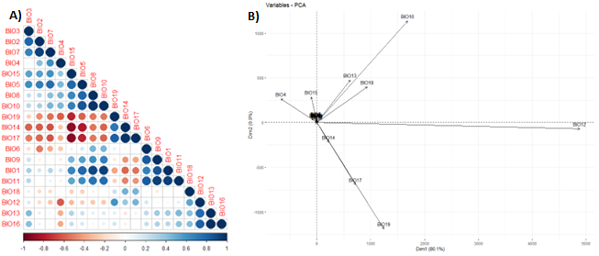FIGURE S1: A) Correlation plot to detect multicollinearity between the 19 Bioclim variables. B) A PCA analysis to further reduce the correlated Bioclim variables to BIO4, BIO12, BIO18 and BIO19.

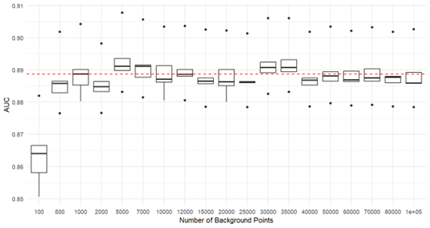
FIGURE S2 10 cross-validations using the Cloglog output on 20 different background numbers (100, 500, 1.000, 2.000, 5.000, 7.000, 10.000, 12.000, 15.000, 20.000, 25.000, 30.000, 35.000, 40.000, 50.000, 60.000, 70.000, 80.000 and 100.000 respectively) to determine the optimal number of background points (12,000).

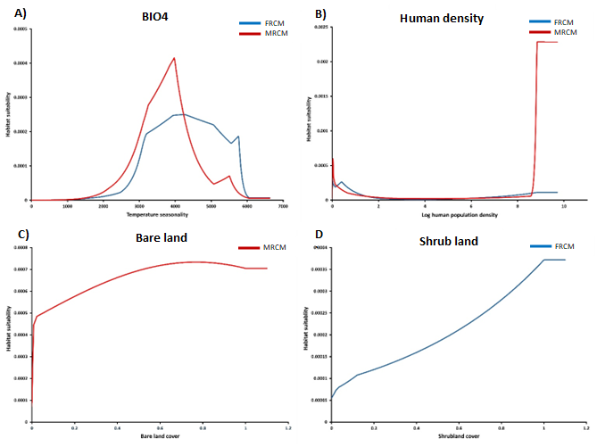
FIGURE S3: A) Predicted effect of temperature seasonality in both FRCM (46%) and MRCM (39%). B) Predicted effect of human population density in both FRCM (24%) and MRCM (18%). C) Predicted effect of bare land cover on the MRCM (19%). D) Predicted effect of shrub land cover on the FRCM (10%).

