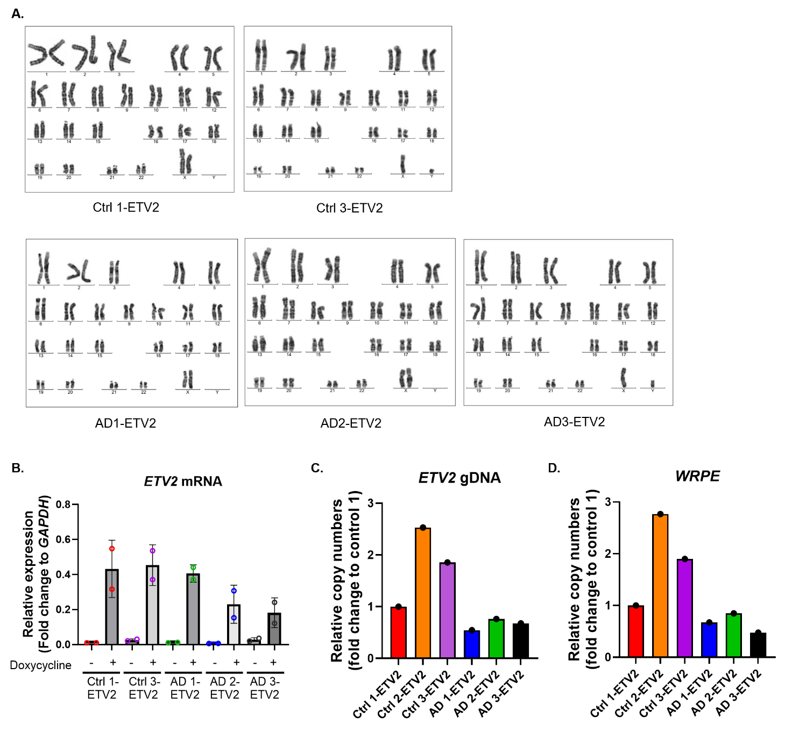
Supplementary Figure 1. Confirmation of karyotypic integrity and ETV2 expression in ETV2-transduced lines.
(A) Representative karyograms from Ctrl1, Ctrl3, AD1, AD2, and AD3 transduced with ETV2 reveal normal euploid karyotypes (46,XX for Ctrl1, AD1, and AD2; 46,XY for Ctrl3 and AD3). (B) ETV2 expression levels confirmed by qPCR two days after hiPSC lines were exposed to doxycycline or left untreated. Expression levels are normalized to GAPDH and expressed as fold change. (C–D) Relative copy numbers of ETV2 and WRPE sequences in ETV2-transduced lines. Expression levels were normalized to GAPDH (used as a single-copy reference in hypoploid cells) and presented as fold change relative to Ctrl 1. Dot plots represent the average of technical replicates for each differentiation batch, color-coded by hiPSC line. Data are presented as mean ± SD.
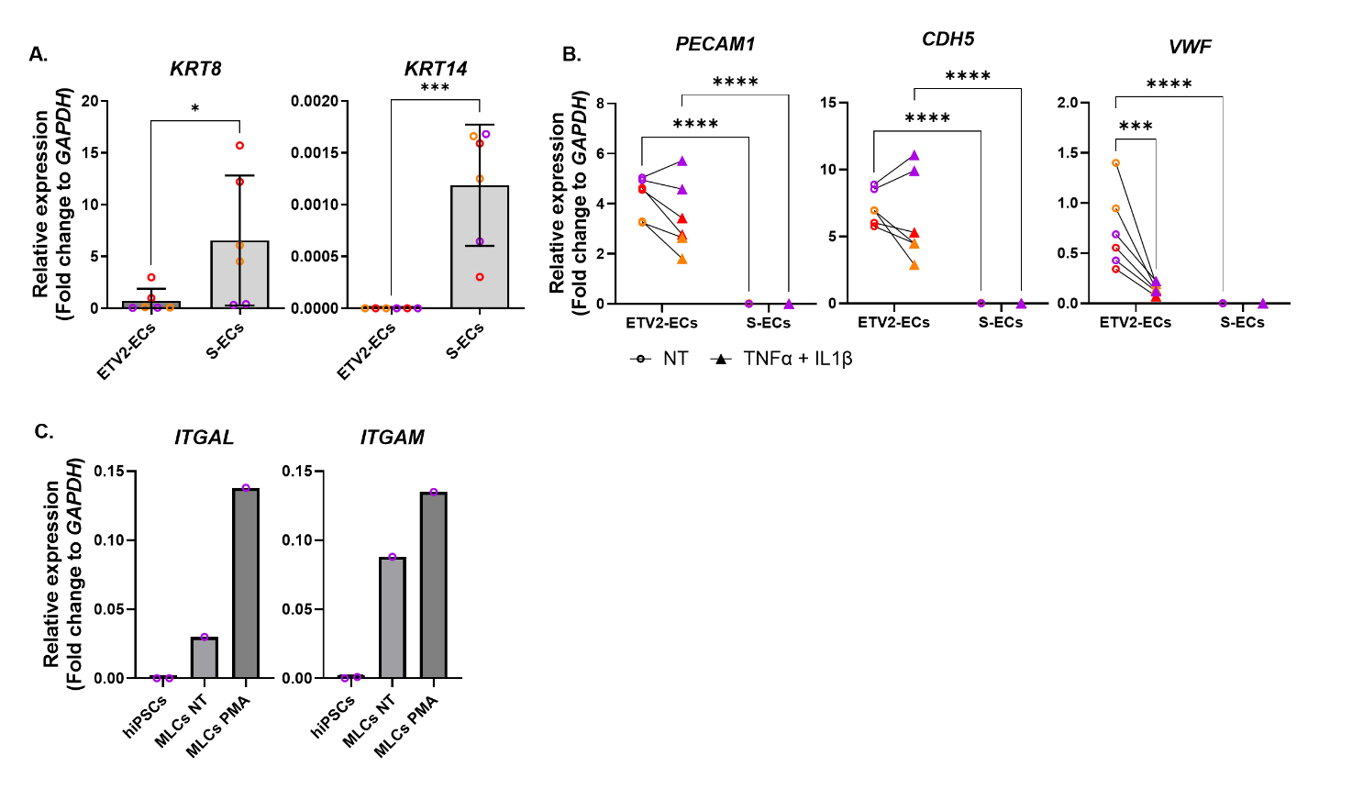
Supplementary Figure 2. Changes in EC markers in S and ETV2 ECs before and after inflammatory exposure.
(A) Relative gene expression levels of KRT8 and KRT14 in S and ETV2 ECs normalized to GAPDH and expressed as fold change. (B) Analysis of relative gene expression levels for PECAM1, CDH5, and VWF in S and ETV2 ECs before and after cytokine exposure, normalized to GAPDH and expressed as fold change. (C) Relative gene expression levels of ITGAL and ITGAM in MLCs before and after 4 hours of PMA exposure, with hiPSCs as controls, presented as fold change relative to GAPDH. Dot plots represent the average of technical replicates for each differentiation batch, color-coded by hiPSC line. Data are presented as mean ± SD. Statistical analysis was performed using two-way ANOVA with Bonferroni’s multiple comparison test. Significance levels are denoted as *p < 0.05, **p < 0.01, ***p < 0.001, ****p < 0.0001.
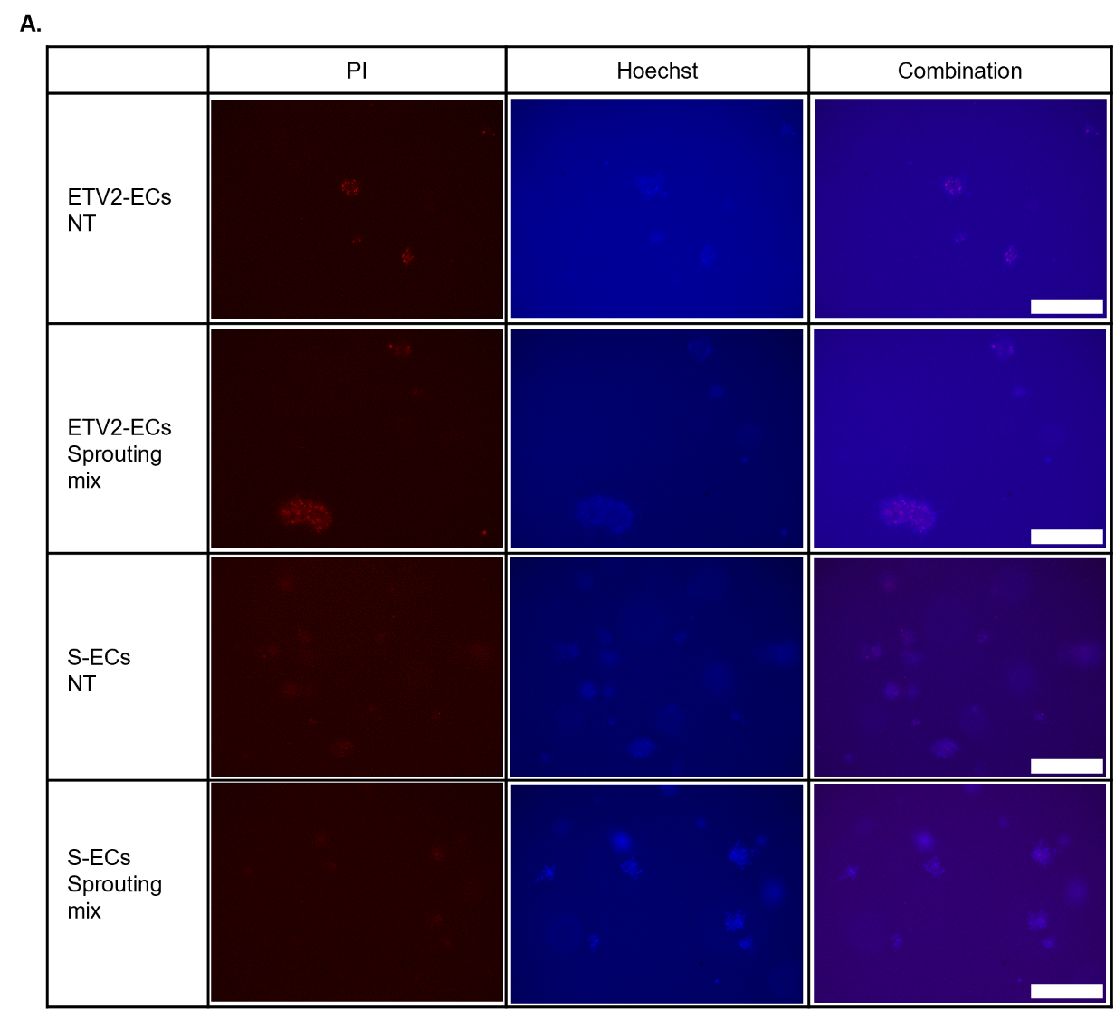
Supplementary Figure 3. Distinguishing live and dead cells in S and ETV2 spheroids before and after application of the sprouting mix.
(A) Propidium iodide (PI, red) was used to stain dead cells, while Hoechst (blue) stained both live and dead populations, enabling the distinction between live and dead cells in S and ETV2 spheroids, with or without exposure to sprouting mix. Scale bars: 300 µm.

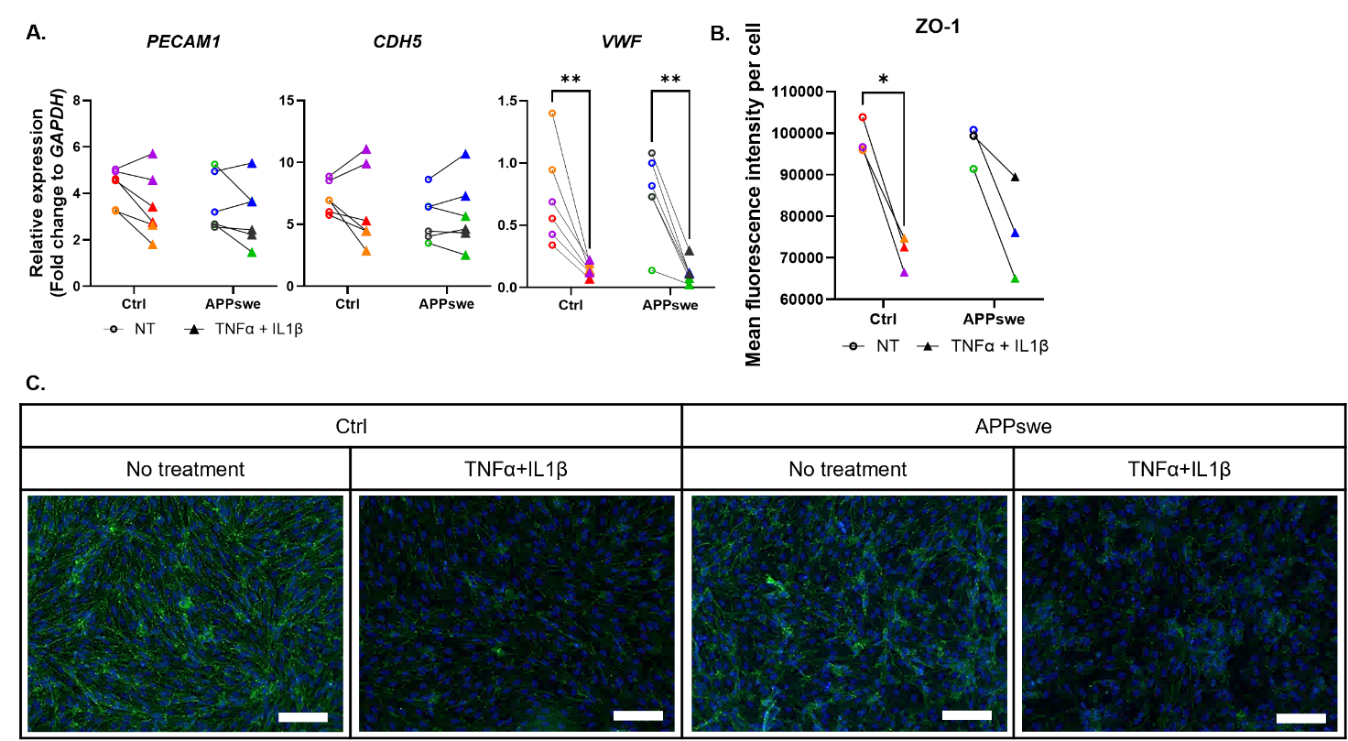Supplementary Figure S4. Reduction of EC marker and ZO-1 expression in both control and APPswe ETV2-ECs following cytokine exposure
(A) Analysis of relative gene expression levels for PECAM1, CDH5, and VWF in control and APPswe ECs before and after cytokine exposure, normalized to GAPDH and expressed as fold change. (B) Quantification of ZO-1 mean fluorescence intensity per cell, calculated as integrated intensity normalized to cell number. (C) Immunofluorescence staining of ZO-1 in control and APPswe ECs before and after exposure to TNF-α and IL-1β. Nuclei were counterstained with DAPI. Scale bars, 100 μm. Dot plots represent the average of technical replicates for each differentiation batch, color-coded by hiPSC line. Data are presented as mean ± SD. Statistical significance was assessed using student t-test (A-D) or two-way ANOVA with Bonferroni’s multiple comparison test (E), indicated as *p < 0.05, **p < 0.01, ***p < 0.001, ****p < 0.0001.

