Supporting Information
Selective pathway dynamics of transient helical inversion in supramolecular polymers under non-equilibrium conditions

Hyeon Min Han,¹ Minjoo Kim,¹ Jong Hwa Jung*^{,1,2} and Sung Ho Jung,*^{,1,2}
^{[a]} Department of Chemistry, Gyeongsang National University, Jinju 52828, Republic of Korea
^{[b]} Research Institute of Advanced Chemistry, Gyeongsang National University, Jinju 52828, Republic of Korea

Table of Contents
Synthesis and Characterization
Synthesis of R-4 ············································································································· 2
Synthesis of R-3 ············································································································· 2
Synthesis of R-2 ············································································································· 3
Synthesis of R-1 ············································································································· 3
Supplementary Scheme and Figures
Scheme 1 ····················································································································· 5
Figures 1-23 ················································································································· 7
Analytical Data
¹H- and ¹³C-NMR Spectrum ····························································································· 29
ESI-MS Spectrum·········································································································· 33

Synthesis and Characterization
Unless otherwise noted, chemical reagents and solvents were purchased from commercial suppliers (Tokyo Chemical Industry (TCI), Sigma Aldrich) and used without further purification.
Synthesis of R-4 and S-4
(R or S)-2-amino-1-propanol (0.126 g, 1.68 mmol) was added to a stirred suspension of KOH (0.31 g, 5.6 mmol) in anhydrous DMSO (4 mL) at 60 °C. After 60 min, 4’-chloro-2,2’:6’,2”-terpyridine (0.3 g, 1.12 mmol) in anhydrous DMSO (10 mL) was added to the mixture, which was maintained with stirring for 4 h at 70 °C. Distilled water (600 mL) was then added to the reaction mixture, and the product was extracted with CH₂Cl₂ (3 × 200 mL). Residual water in the CH₂Cl₂ was removed using Na₂SO₄, and the CH₂Cl₂ was removed using a rotary evaporator. Yield: 69.5%; IR (KBr pellet): 2366, 1579, 1561, 1468, 1440, 1405, 1353, 1204,1035, 799 cm⁻¹; ¹H NMR (300 MHz, CDCl₃-d₆) δ 8.70 (ddd, J = 4.8, 1.8, 0.9 Hz, 2H), 8.62 (dt, J = 8.0, 1.1 Hz, 2H), 8.02 (s, 2H), 7.86 (ddd, J = 8.0, 7.5, 1.8 Hz, 2H), 7.34 (ddd, J = 7.5, 4.8, 1.2 Hz, 2H), 4.18 (m, 1H), 3.97 (dd, J = 9.0, 7.6 Hz, 1H), 3.46 (dddd, J = 10.7, 7.5, 6.5, 4.0 Hz, 1H), 1.99 (s, 2H), 1.25 (d, J = 6.5 Hz, 3H); ¹³C NMR (125 MHz, CDCl₃-d₆) δ ppm 167.12, 157.16, 156.09, 149.06, 136.83, 123.87, 121.37, 107.36, 74.69, 46.27, 19.78; HR-Mass (m/z): Calculated for C₁₈H₁₈N₄O [M]⁺ 306.14, Found [M+H]⁺ 307.240.

Synthesis of R-3 and S-3
Compounds R-4 or S-4 (0.5 g, 2 mmol), elaidic acid (0.5 g, 2 mmol), SOCl₂ (1 mL, 20 mmol), and triethylamine (TEA, 2.5mL, 20 mmol) were added to a 50-mL flask. Anhydrous toluene (10 mL) was then injected, and the reaction mixture was stirred for 2 hours at 80 °C. Then, solvents were removed using a rotary evaporator. After the crude product was partitioned in CH₂Cl₂/H₂O, the organic layer was separated and dried over Na₂SO₄. Then, the organic solvent was removed using a rotary evaporator. The crude product was purified by silica gel column chromatography (Ethyl acetate / Hexane 1 : 2 v/v as the eluent) to give a white crystalline solid. Yield: 52%; ¹H NMR (300 MHz, DMSO-d₆) δ 8.71 (ddd, J = 4.8, 1.8, 0.9 Hz, 2H), 8.62 (dt, J = 8.0, 1.1 Hz, 2H), 8.06 – 7.96 (m, 4H), 7.89 (d, J = 7.4 Hz, 1H), 7.50 (ddd, J = 7.5, 4.8, 1.2 Hz, 2H), 5.36 – 5.18 (m, 2H), 4.32 – 4.06 (m, 3H), 2.07 (t, J = 7.2 Hz, 2H), 1.85 (dd, J = 13.1, 5.5 Hz, 4H), 1.47 (s, 2H), 1.21 (d, J = 5.5 Hz, 24H), 0.84 (s, 3H); ¹³C NMR (125 MHz, CDCl₃-d₆) δ 172.69, 166.90, 157.24, 155.92, 149.05, 136.86, 123.94, 121.36, 107.28, 70.79, 44.25, 36.95, 31.93, 29.70, 29.63, 29.50, 29.37, 29.28, 25.77, 22.70, 17.65, 14.13; HR-Mass (m/z): Calculated for C₃₆H₅₀N₄O₂ [M]⁺ 571.401, Found [M]⁺ 571.4018 and [M+H]⁺ 572.4050.

Synthesis of R-2 and S-2
Dichloro(1,5-cyclooctadiene)platinum(II) (0.18 g, 0.5 mmol) was added to a suspension of R-3 or S-3 (0.3 g, 0.5 mmol) in a mixture of 10 mL anhydrous methanol. The reaction mixture was stirred for 2 hours at 90 °C. Then solvents were removed using a rotary evaporator. Then desired product was recrystallized from methanol and ethyl ether. Yield: 91.2%; IR (KBr pellet): 3065, 2924, 2853, 1730, 1661, 1653, 1647, 1609, 1547, 1460, 1416, 1364 cm-1; ¹H NMR (300 MHz, DMSO-d6) δ 8.78 (d, J = 5.6 Hz, 2H), 8.69 (d, J = 8.0 Hz, 2H), 8.49 (td, J = 7.9, 1.5 Hz, 2H), 8.31 (s, 2H), 8.14 (s, 1H), 7.91 (t, J = 6.8 Hz, 2H), 5.31 (s, 2H), 4.28 (q, J = 8.8, 7.5 Hz, 3H), 2.11 (td, J = 7.3, 2.6 Hz, 2H), 1.89 (s, 4H), 1.61 – 1.39 (m, 3H), 1.25 (d, J = 14.9 Hz, 27H), 0.85 (t, J = 6.4 Hz, 4H); ¹³C NMR (125 MHz, DMSO-d₆) δ 172.65, 169.53, 158.51, 155.70, 151.49, 142.94, 129.72, 126.33, 111.45, 73.39, 44.02, 25.94, 31.76, 29.53, 29.52, 29.48, 29.34, 29.18, 29.15, 25.75, 22.57, 17.45, 14.43; HR-Mass (m/z): Calculated for C₃₆H₅₀ClN₄O₂Pt [M]⁺ 800.334, Found [M]⁺ 800.3342 and [M+H]⁺ 801.3344; Anal. Calcd for C₃₆H₅₀ClN₄O₂Pt: C, 53.96; H, 6.29; N, 6.99. Found: C, 53.88; H, 6.25; N, 7.01.

Synthesis of R-1 and S-1
R-2 or S-2 (0.5 g, 0.50 mmol) and 4-Ethynylbiphenyl (0.71 g, 6.94 mmol) were dissolved in anhydrous dichloromethane (20 mL). Diisopropylamine (0.5 mL) was added to the solution mixture and degassed by N₂ bubbling with sonication. Added a catalytic amount of copper iodide (20 mg) to the mixture. Stirred the mixture in the dark for 10 h. Excess water was added to the reaction mixture. Then solvents were removed using a rotary evaporator. Then desired product was recrystallized from chloroform and ethyl acetate. Yield: 84.3%; ¹H NMR (300 MHz, DMSO-d₆) δ 8.97 (d, J = 5.5 Hz, 2H), 8.65 (d, J = 7.9 Hz, 2H), 8.44 (t, J = 7.6 Hz, 2H), 8.29 (s, 2H), 8.10 (d, J = 6.4 Hz, 1H), 7.85 (t, J = 6.5 Hz, 2H), 7.77 – 7.63 (m, 4H), 7.58 – 7.45 (m, 4H), 7.45 – 7.34 (m, 1H), 5.40 – 5.25 (m, 2H), 4.33 – 4.16 (m, 3H), 2.09 (dt, J = 7.2, 3.9 Hz, 2H), 1.88 (s, 3H), 1.48 (s, 2H), 1.27 – 1.15 (m, 23H), 0.89 – 0.78 (m, 3H); ¹³C NMR (75 MHz, DMSO-d₆) δ 172.65, 158.69, 155.20, 142.06, 140.11, 138.23, 132.70, 132.55, 130.49, 130.42, 129.45, 126.88, 126.79, 126.43, 126.22, 111.13, 43.99, 35.94, 32.41, 31.73, 29.48, 29.29, 29.17, 28.97, 25.76, 22.55, 17.46, 14.42; HR-Mass (m/z): Calculated for C₅₀H₅₉N₄O₂Pt [M]⁺ 941.133, Found [M]⁺ 941.1334 and [M+H]⁺ 942.4335; Anal. Calcd for C₅₀H₅₉N₄O₂Pt: C, 53.96; H, 6.29; N, 6.99. Found: C, 53.88; H, 6.25; N, 7.01.

Supplementary Schemes and Figures.

Supplementary Scheme 1. Synthetic methods of desired products R-1, and S-1.

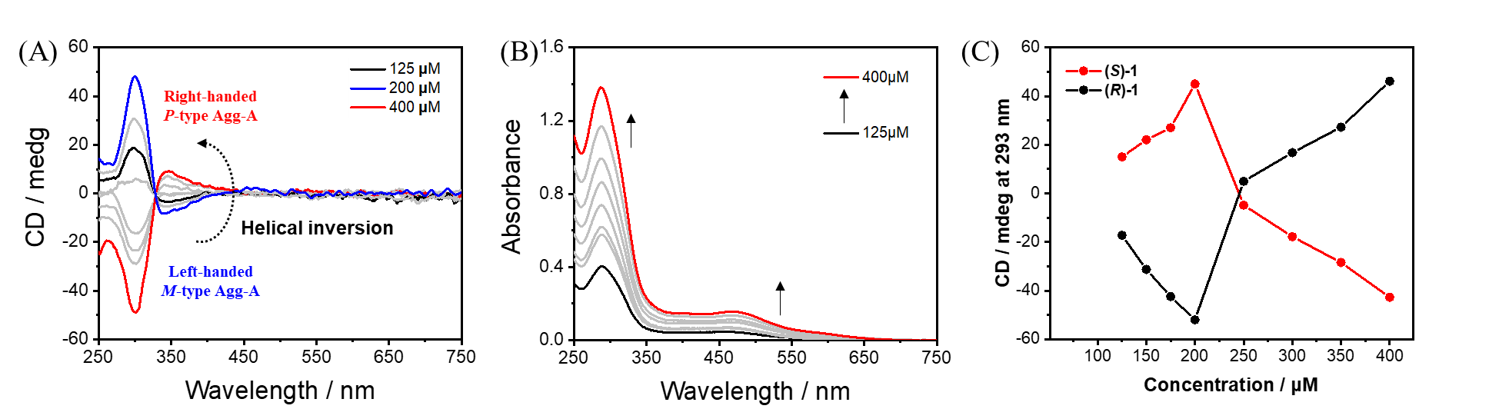
Supplementary Fig. 1 Concentration-dependent (A) CD and (B) UV-Vis spectra changes of (S)-1 in DMSO and H₂O (6:4 v/v) at 293 K. (C) Plot of initial CD intensity at 293 nm versus concentrations of (R)- and (S)-1 at 293 K.

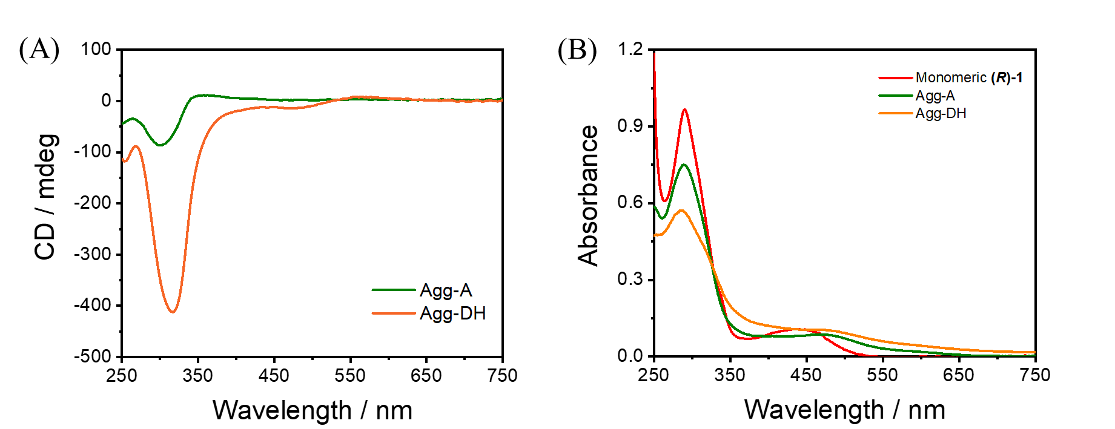
Supplementary Fig. 2 (a) CD and (b) UV spectra of Agg-A and Agg-DH in DMSO and H2O (6:4 v/v) at 298 K. Condition: [(R)-1] = 200 μM.

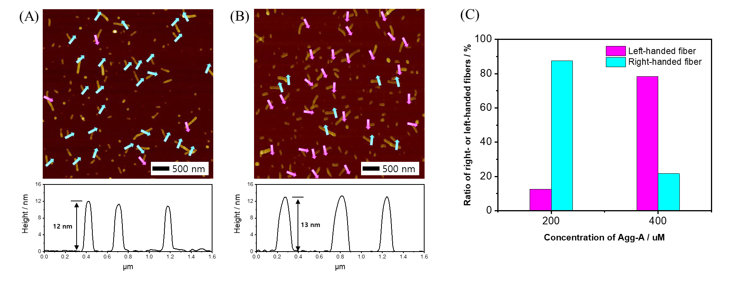
Supplementary Fig. 3 AFM images and height profile of (A) Agg-A (200 µM) and (B) Agg-A (400 µM). (C) The plot of the ratio of right- or left-handed helical fiber versus concentration of (R)-1; the green and red colors indicate right and left-handed Agg-A, respectively.

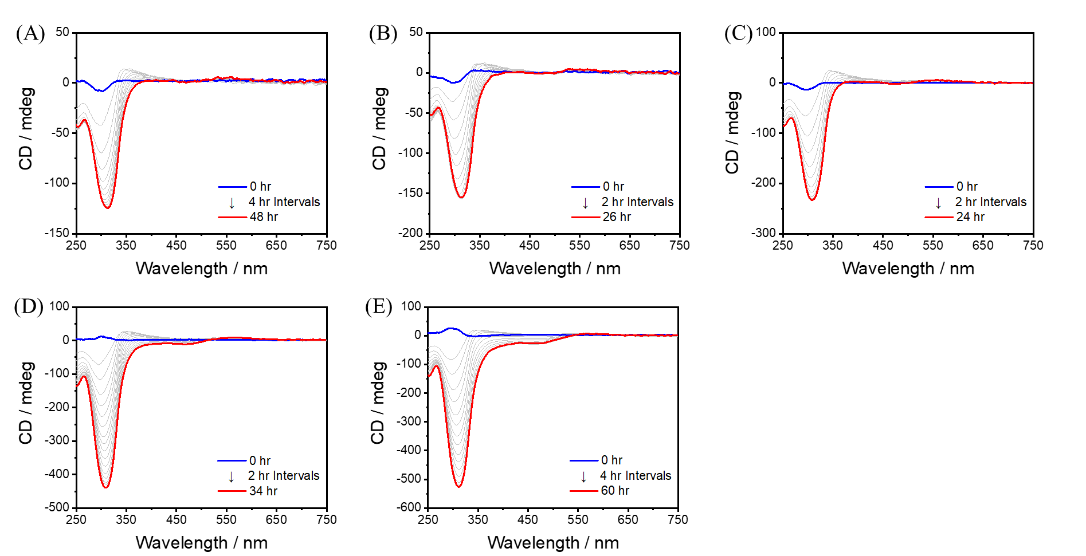
Supplementary Fig. 4 Time-dependent CD spectra change for Agg-A of (R)-1 at different concentrations of (A) 125 μM, (B) 150 μM, (C) 175 μM, (D) 300 μM, and (E) 400 μM in DMSO and H₂O (6:4 v/v) at 308 K.

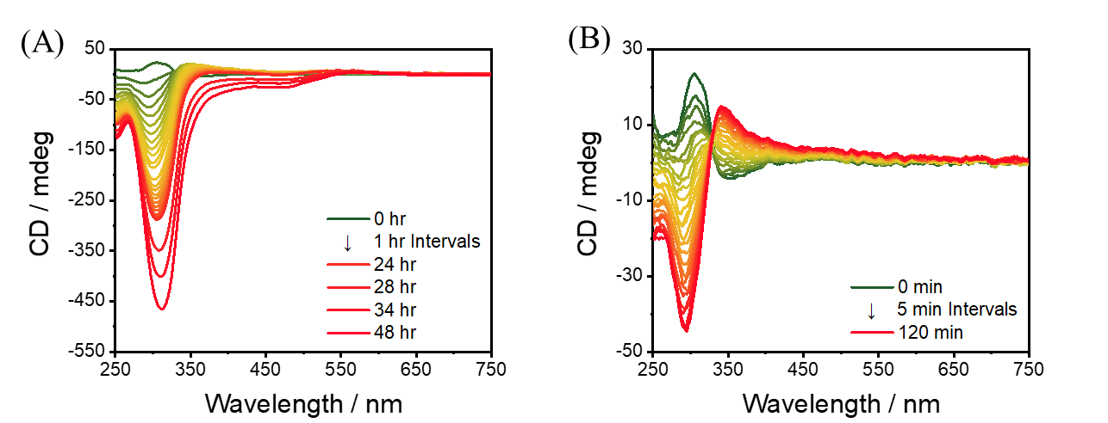
Supplementary Fig. 5 (A) Time-dependent CD spectra change of (R)-1 (400 μM) at 308 K in DMSO and H₂O (6:4 v/v). (B) Zoom in for the initial stages of the helical inversion at 308 K in (A).

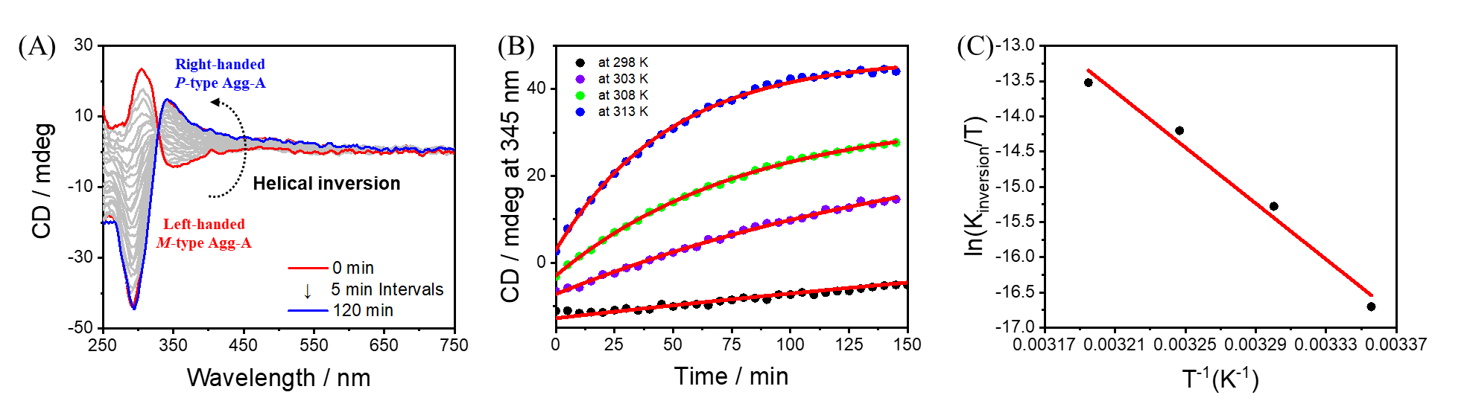
Supplementary Fig. 6 (A) Time-dependent CD spectra change of (R)-1 (400 μM) at 313 K. (B) Plot of CD signal at 345 nm of (R)-1 (400 μM) in DMSO and H₂O (6:4, v/v) at 298 K, 303 K, 308 K and 313 K. (C) Eyring plot of ln(k_{inv}/T) versus T⁻¹ K⁻¹. The rate constants at 298, 303, 308, and 313 K were determined to be 1.16 × 10⁻⁵, 7.02 × 10⁻⁵, 2.09 × 10⁻⁴, and 4.20 × 10⁻⁴ s⁻¹, respectively.

Note: The change in the first Cotton effect at 345 nm was monitored during M-type Agg-A to P-type Agg helical inversion processes.

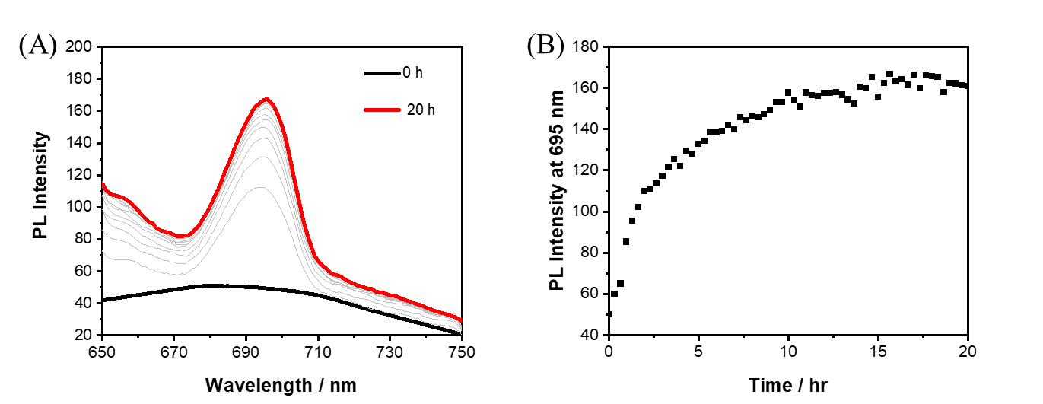
Supplementary Fig. 7 Time-dependent PL spectra changes of (R)-1 (200 μM) at 308 K in DMSO and H₂O (6:4 v/v). (B) Plot of PL intensity of (R)-1 (200 μM) at 695 nm.

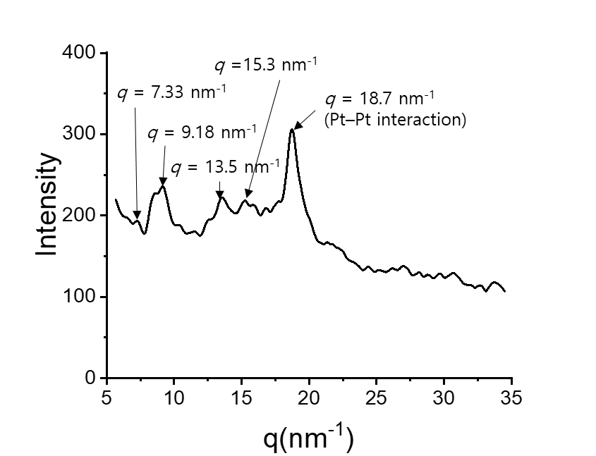
Supplementary Fig. 8 XRD data of Agg-DH.

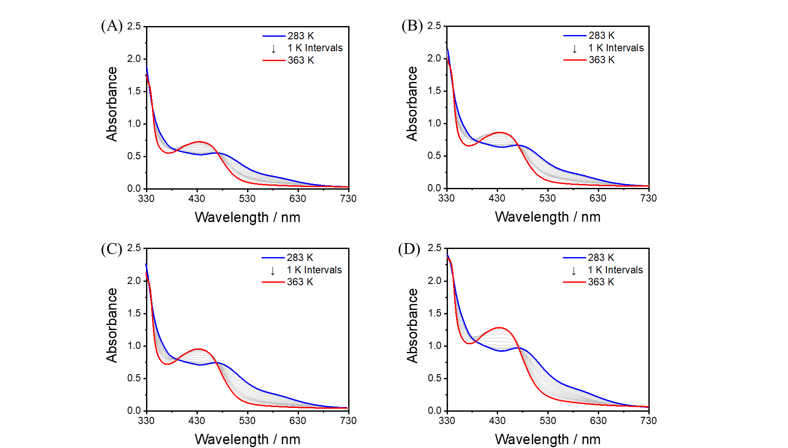
Supplementary Fig. 9 Temperature-dependent UV-Vis spectra changes of Agg-A in DMSO and H₂O (6:4 v/v). (A) 125μM. (B) 150μM. (C) 175μM. (D) 200μM.

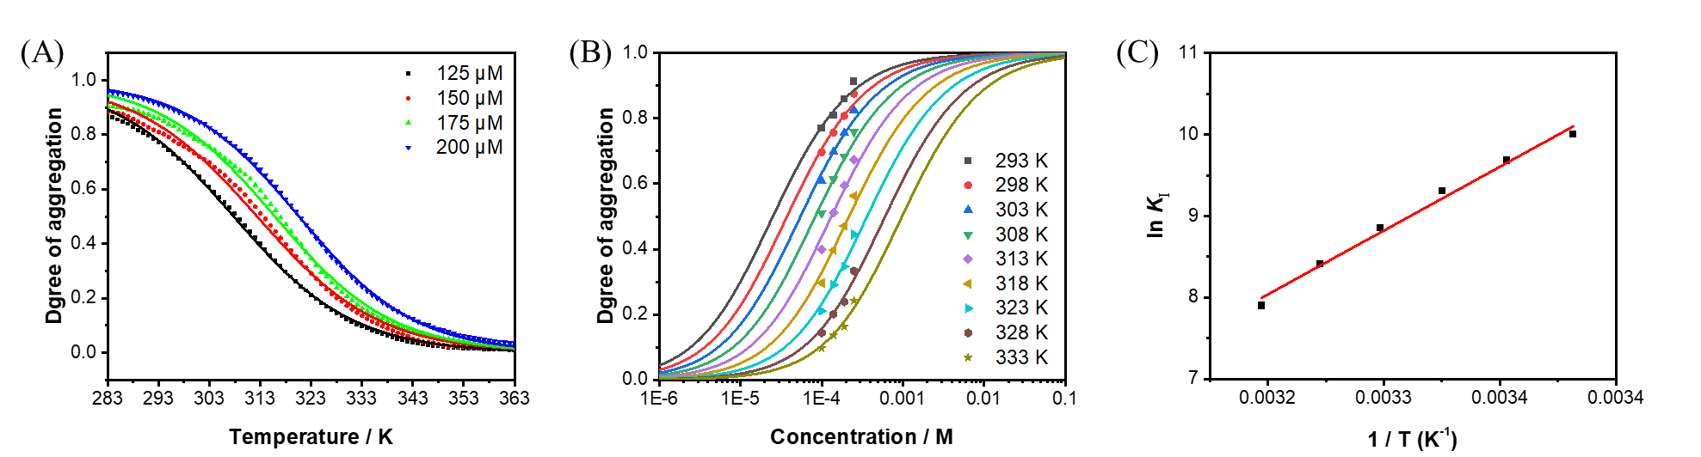
Supplementary Fig. 10 (A) Degree of aggregation for Agg-A of (R)-1 as a function of temperature. (B) Degree of aggregation for Agg-A as a function of the total concentration of (R)-1 obtained by fitting to isodesmic model. The fitting to the isodesmic model yielded K_{I} at different temperatures. (C) Plot of the natural logarithm K_{I} as a function of the reciprocal temperature. From the linear trend of van’t Hoff plot, standard enthalpy ( Hº) and standard entropy ( Sº) for Agg-A are estimated as follows: Hº = - 65.1 kJmol⁻¹ and Sº = -138 Jmol⁻¹ K ⁻¹.

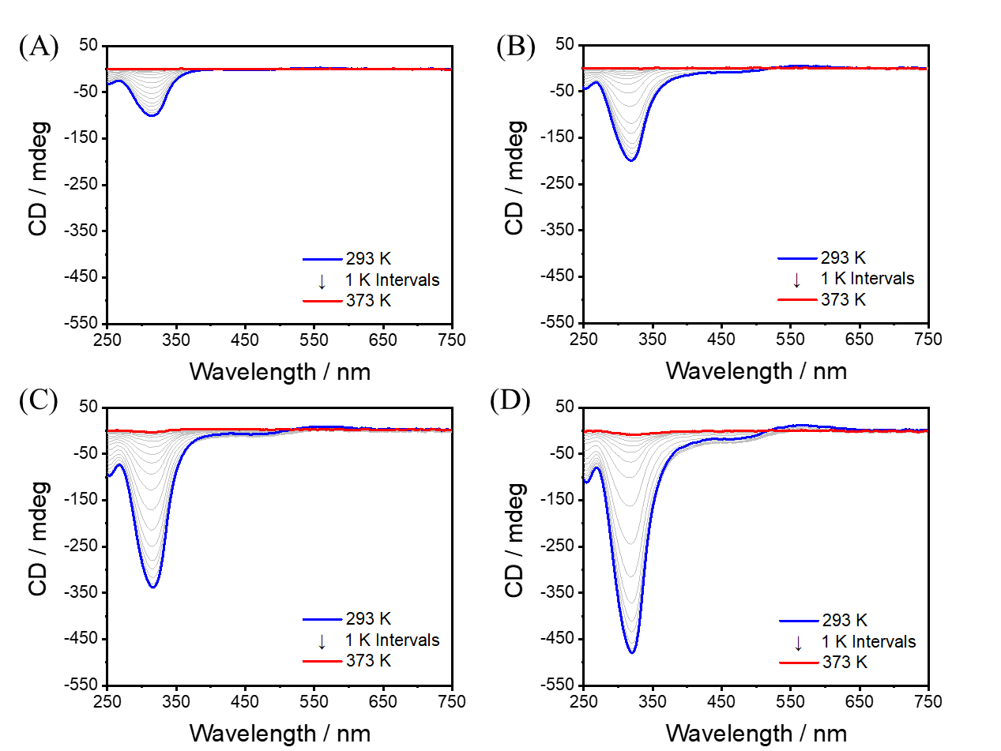
Supplementary Fig. 11 Temperature-dependent CD spectra of Agg-DH in DMSO and H2O (6:4 v/v). (A) 100μM, (B) 150μM, (C) 200μM, and (D) 250μM.

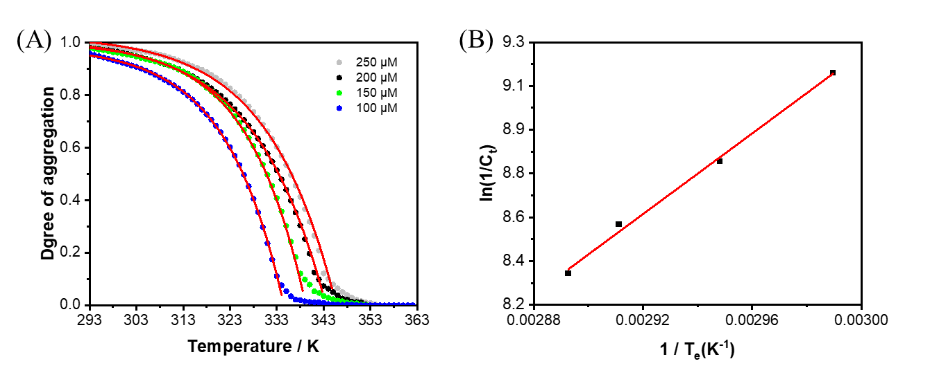
Supplementary Fig. 12 (A) Degree of aggregation for Agg-DH of (R)-1 as a function of temperature by following the CD intensity changes at 320 nm, fitted to a cooperative model. (B) Plot of the natural logarithm of reciprocal c_{t} as a function of the reciprocal temperature. From the linear trend of van’t Hoff plot, standard enthalpy (Hº) and standard entropy (Sº) for Agg-DH are estimated as follows: Hº = - 76.6 kJmol⁻¹ and Sº = -152.6 Jmol⁻¹ K ⁻¹.

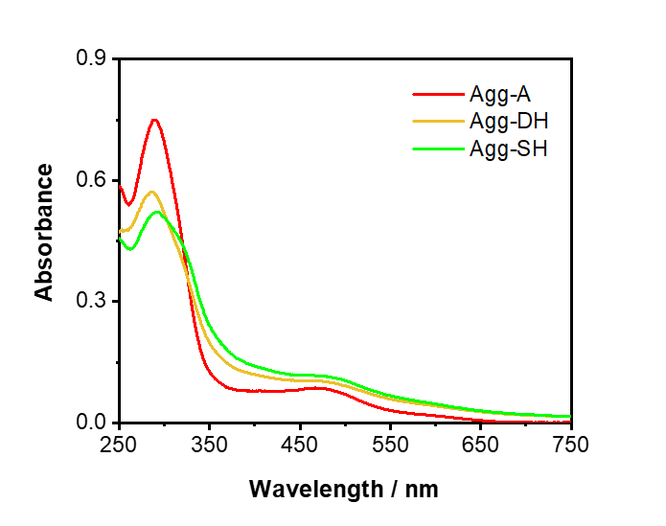
Supplementary Fig. 13 UV-Vis spectra of Agg-A, Agg-DH, and Agg-SH in DMSO and H₂O (6:4 v/v) at 293 K. Condition: [(R)-1] = 200 μM.

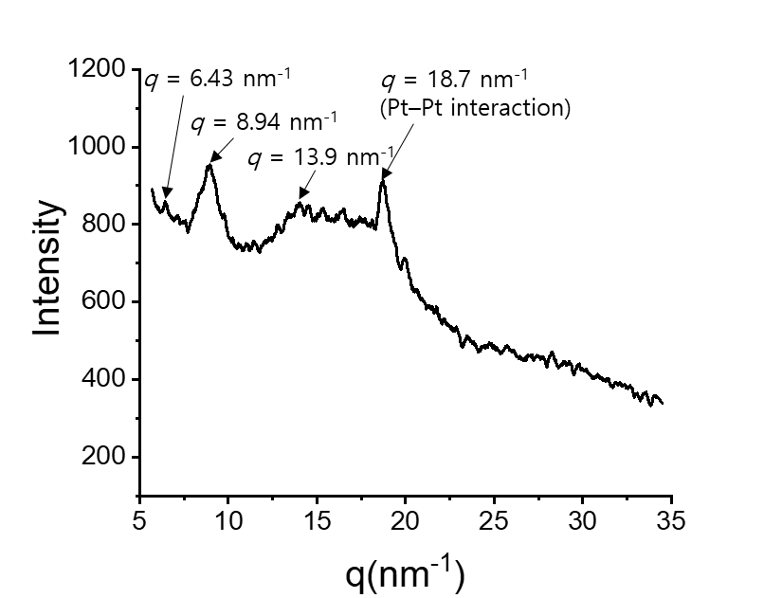
Supplementary Fig. 14 XRD data of Agg-SH.

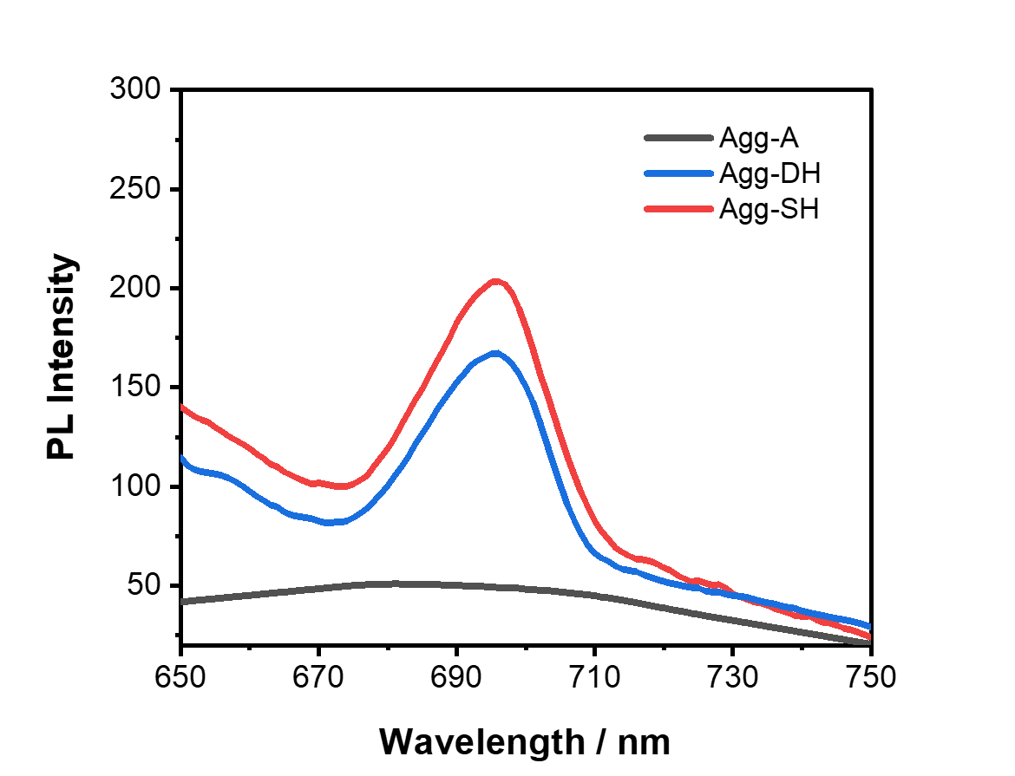
Supplementary Fig. 15 PL spectra for Agg-DH and Agg-SH at 308 K in DMSO and H₂O (6:4 v/v). Condition: [(R)-1] = 200 μM.

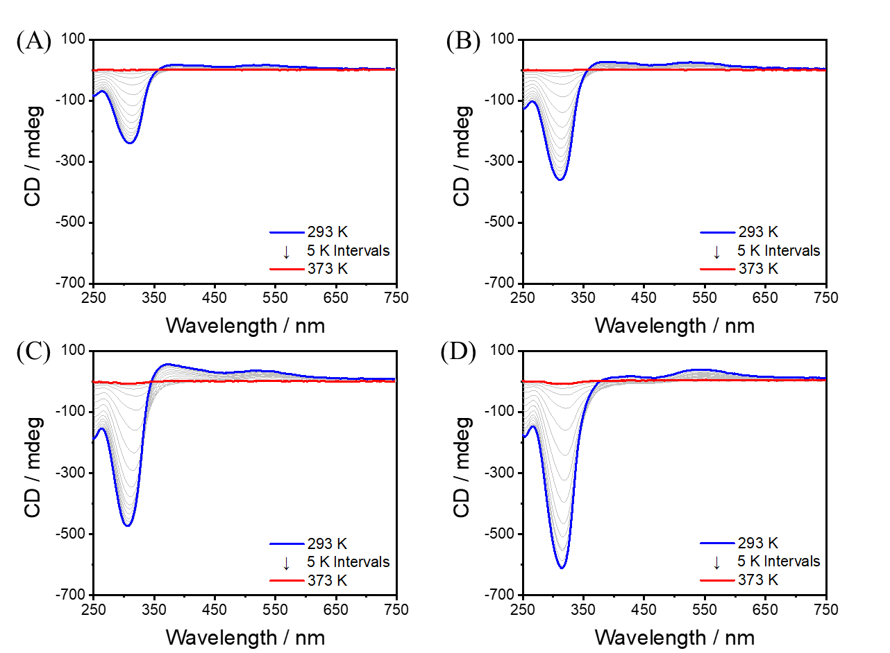
Supplementary Fig. 16 Temperature-dependent CD spectra of Agg-SH in DMSO and H₂O (6:4 v/v). (A) 100μM, (B) 150μM, (C) 200μM, and (D) 250μM.

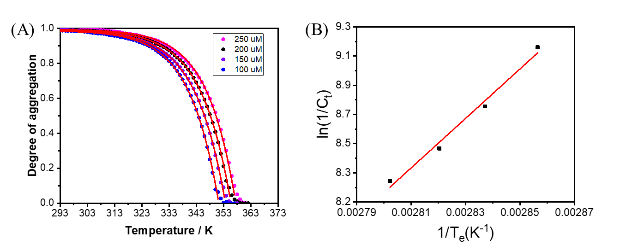
Supplementary Fig. 17 (A) Degree of aggregation for Agg-SH of (R)-1 as a function of temperature by following the CD intensity changes at 310 nm, fitted to a cooperative model. (B) Plot of the natural logarithm of reciprocal c_{t} as a function of the reciprocal temperature. From the linear trend of van’t Hoff plot, standard enthalpy (Hº) and standard entropy (Sº) for Agg-SH are estimated as follows: Hº = - 140.9 kJmol⁻¹ and Sº = -325.6 Jmol⁻¹ K ⁻¹.

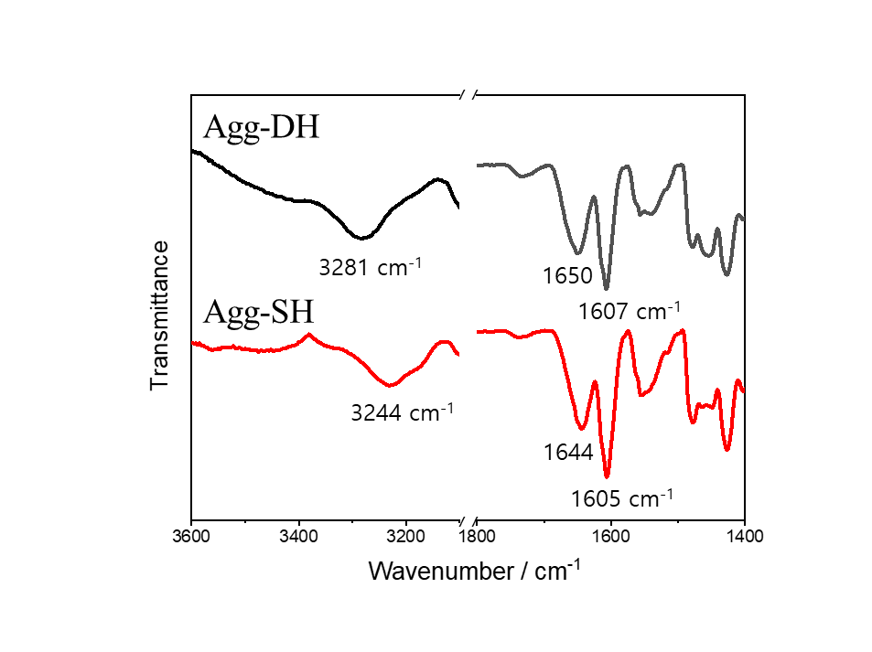 Supplementary Fig. 18 FT-IR spectra of Agg-DH (black line) and Agg-SH (red line).

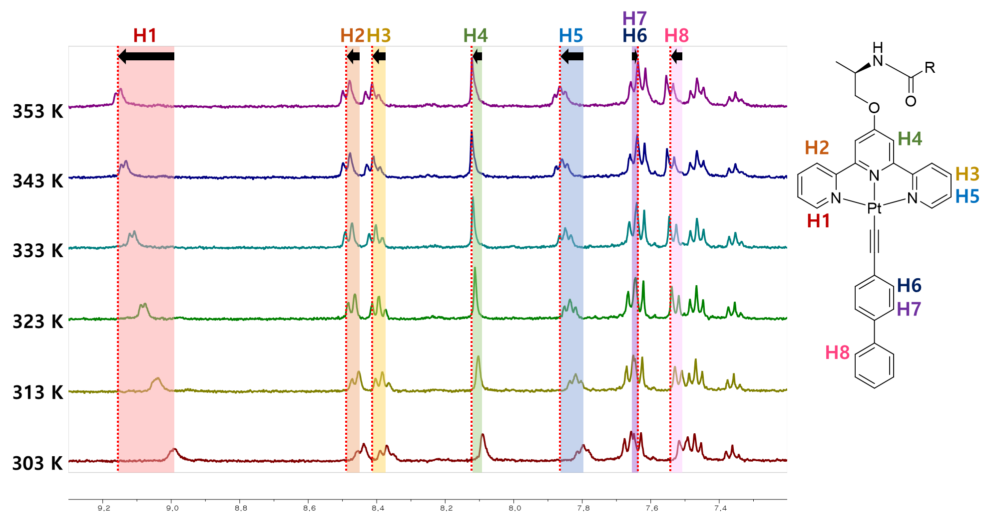
Supplementary Fig. 19 VT-NMR spectra of Agg-DH in DMSO-d₆ and D₂O (6:4 v/v). Condition: [(R)-1] = 1.0 mM.

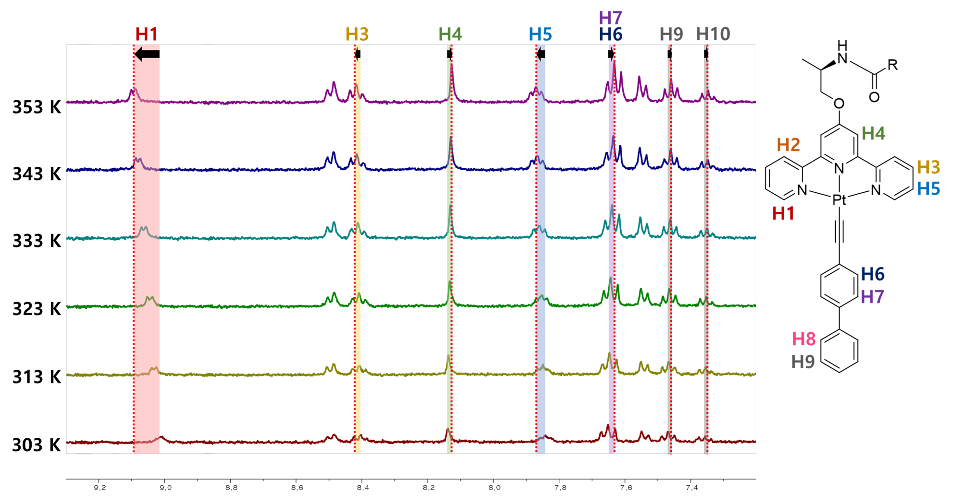
Supplementary Fig. 20 VT-NMR spectra of Agg-SH in DMSO-d₆ and D₂O (6:4 v/v). Condition: [(R)-1] = 1.0 mM.

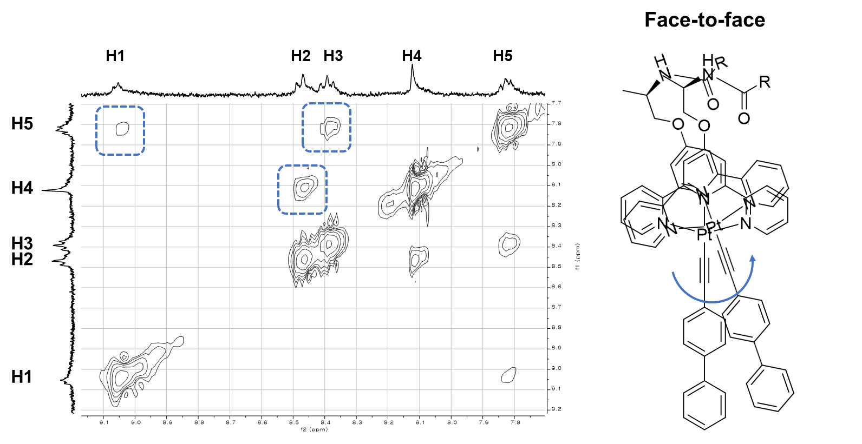
Supplementary Fig. 21 Partial NOESY spectra of Agg-SH at 333K.

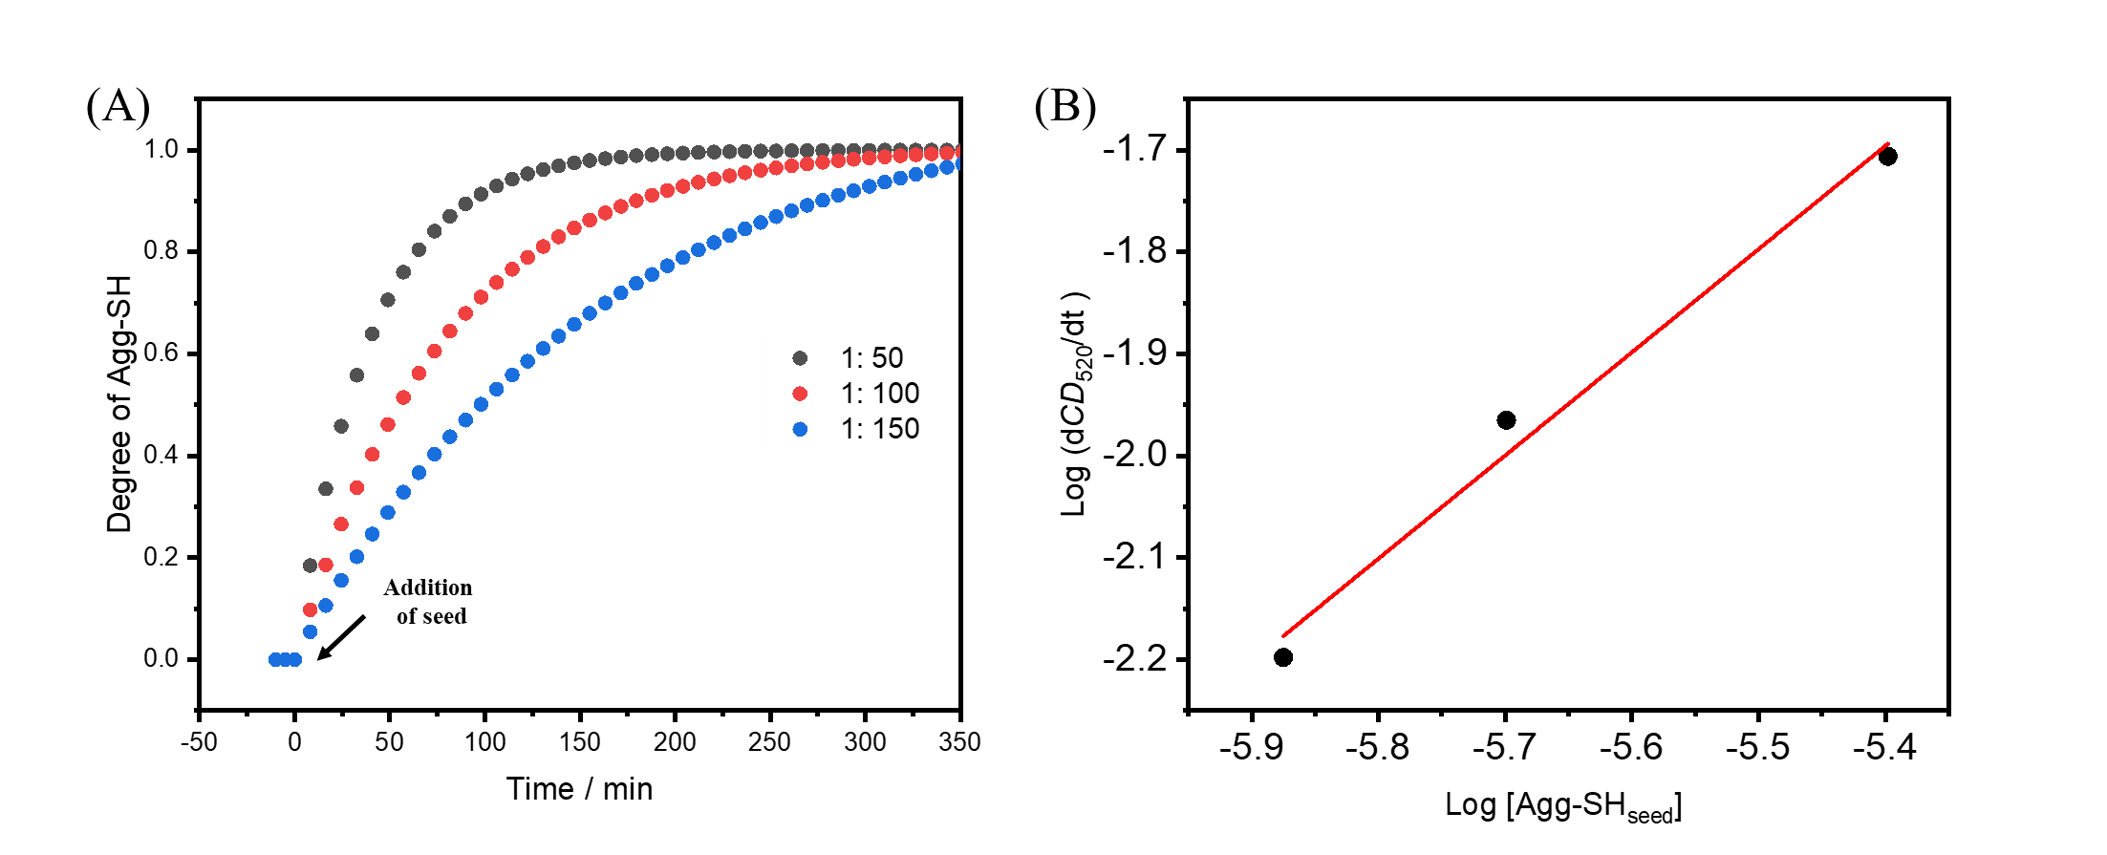
Supplementary Fig. 22 (A) Time-dependent CD spectra of Agg-A with Agg-SH_{seed} under conditions of [Agg-SH_{seed}]:[Agg-DH] = 1:50, 1:100, and 1:150 in DMSO and H₂O (6:4 v/v) at 308 K. (B) Log–log plot of the decrease rate at 520 nm (s⁻¹) as a function of seed concentration.

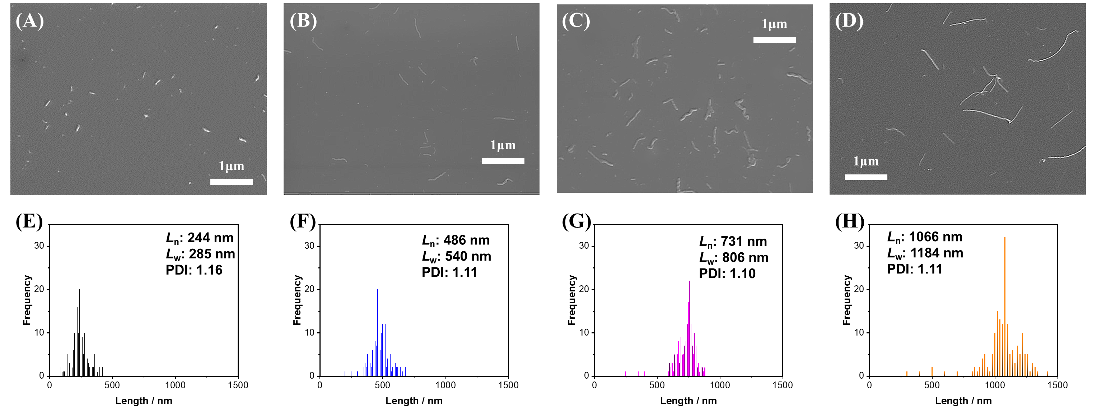
Supplementary Fig. 23 SEM images and length distribution of Agg-SH obtained through seeded supramolecular polymerization (ratio of [Agg-SH_{seed}]:[Agg-DH]; (A and E) seed, (B and F) 1:1, (C and G) 1:2, (D and H) 1:3). (Corresponding to Figure 5)

Analytic Data
¹H-NMR and ¹³C-NMR Spectra

Supplementary Fig. 24 ¹H NMR spectrum (300 MHz) of R-4 in DMSO-d₆ at 25 °C.

Supplementary Fig. 25 ¹³C NMR spectrum (75 MHz) of R-4 in DMSO-d₆ at 25 °C.

Supplementary Fig. 26 ¹H NMR spectrum (300 MHz) of R-3 in DMSO-d₆ at 25 °C.

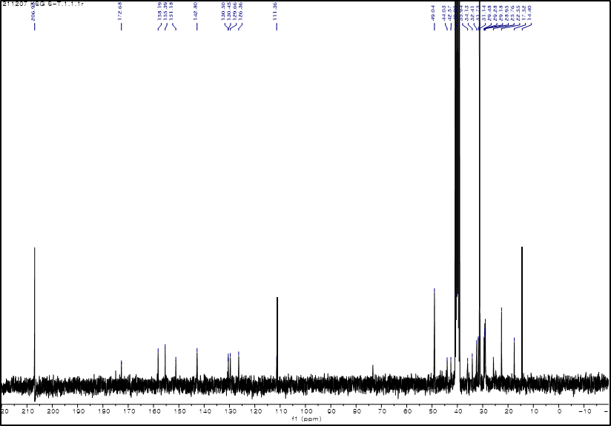

Supplementary Fig. 27 ¹³C NMR spectrum (75 MHz) of R-3 in DMSO-d₆ at 25 °C.

Supplementary Fig. 28 ¹H NMR spectrum (300 MHz) of R-2 in DMSO-d₆ at 25 °C.

Supplementary Fig. 29 ¹³C NMR spectrum (75 MHz) of R-2 in DMSO-d₆ at 25 °C.

Supplementary Fig. 30 ¹H NMR spectrum (300 MHz) of R-1 in DMSO-d₆ at 25 °C.

Supplementary Fig. 31 ¹³C NMR spectrum (75 MHz) of R-1 in DMSO-d₆ at 25 °C.

ESI Mass Spectrum

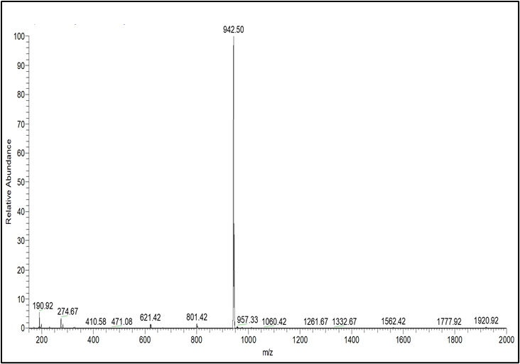

Supplementary Fig. 32 ESI mass spectrum of R-1 in MeOH.

