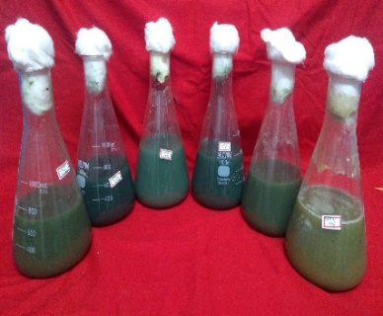
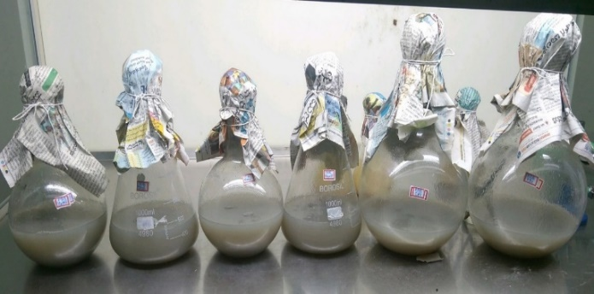
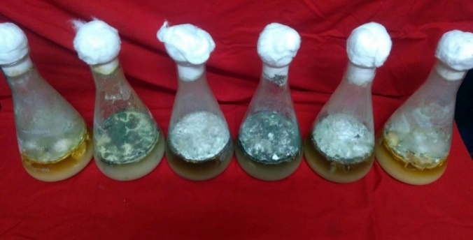
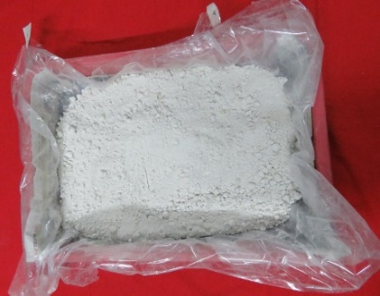
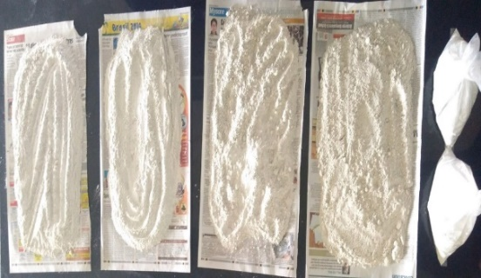
1 2 3 4 5 6

Plate 1: Effect of insecticide chlorpyrifos 50% EC on mycelial growth of native isolates of Trichoderma spp. at different concentrations.
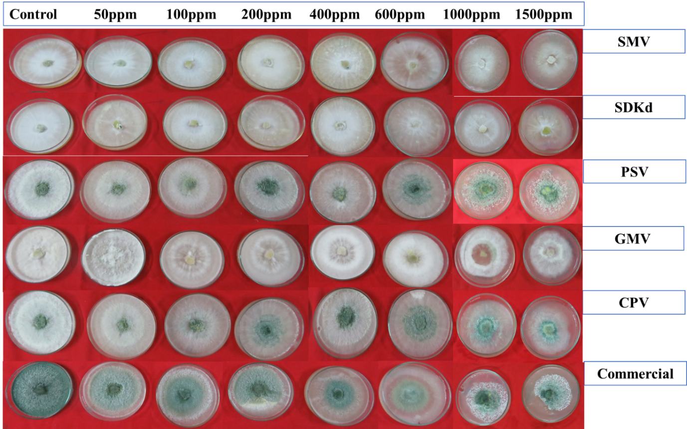

Plate 2: Mass multiplication of Trichoderma isolates

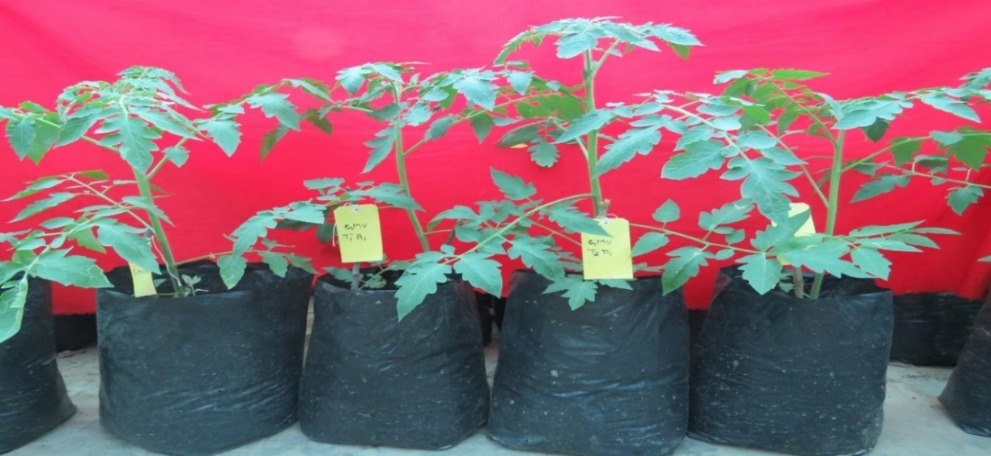 Plate 3: Growth of tomato plants influenced by the isolate GMV at 30 days after transplanting
Control T1 T2 T3

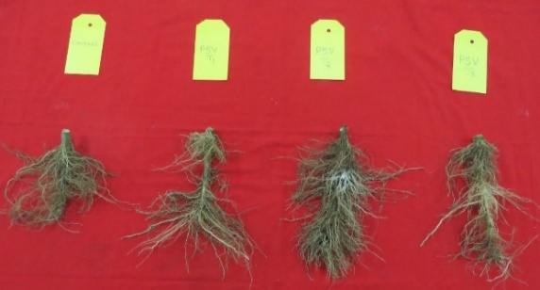
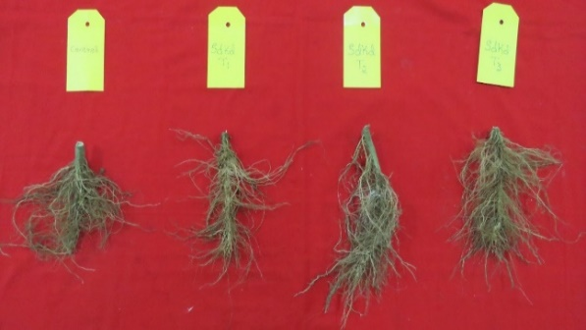
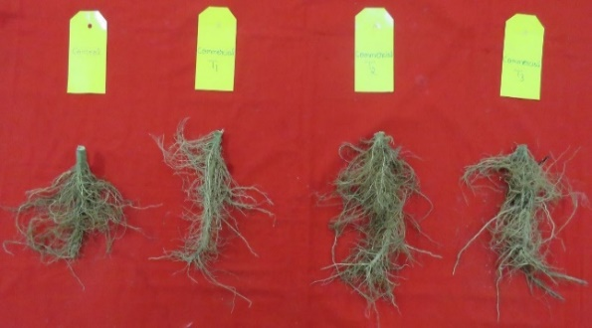
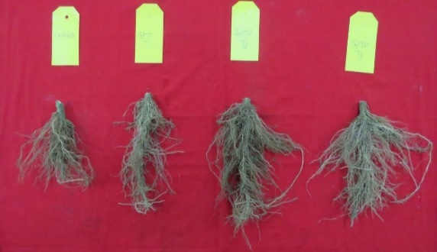
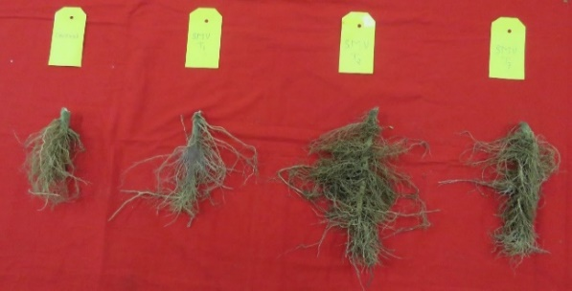
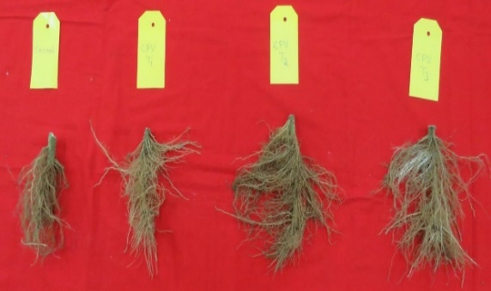
Commercial isolate
CPV
PSV
SDKd
SMV
GMV
Control T1 T2 T3
Control T1 T2 T3
Control T1 T2 T3
Control T1 T2 T3
Control T1 T2 T3

Plate 4: A) Effect of native isolates of Trichoderma spp. on tomato root growth in different treatments at 90 DAT, B) measuring of root length in 1) control treatment, 2) Trichoderma treatment.

