Appendix A

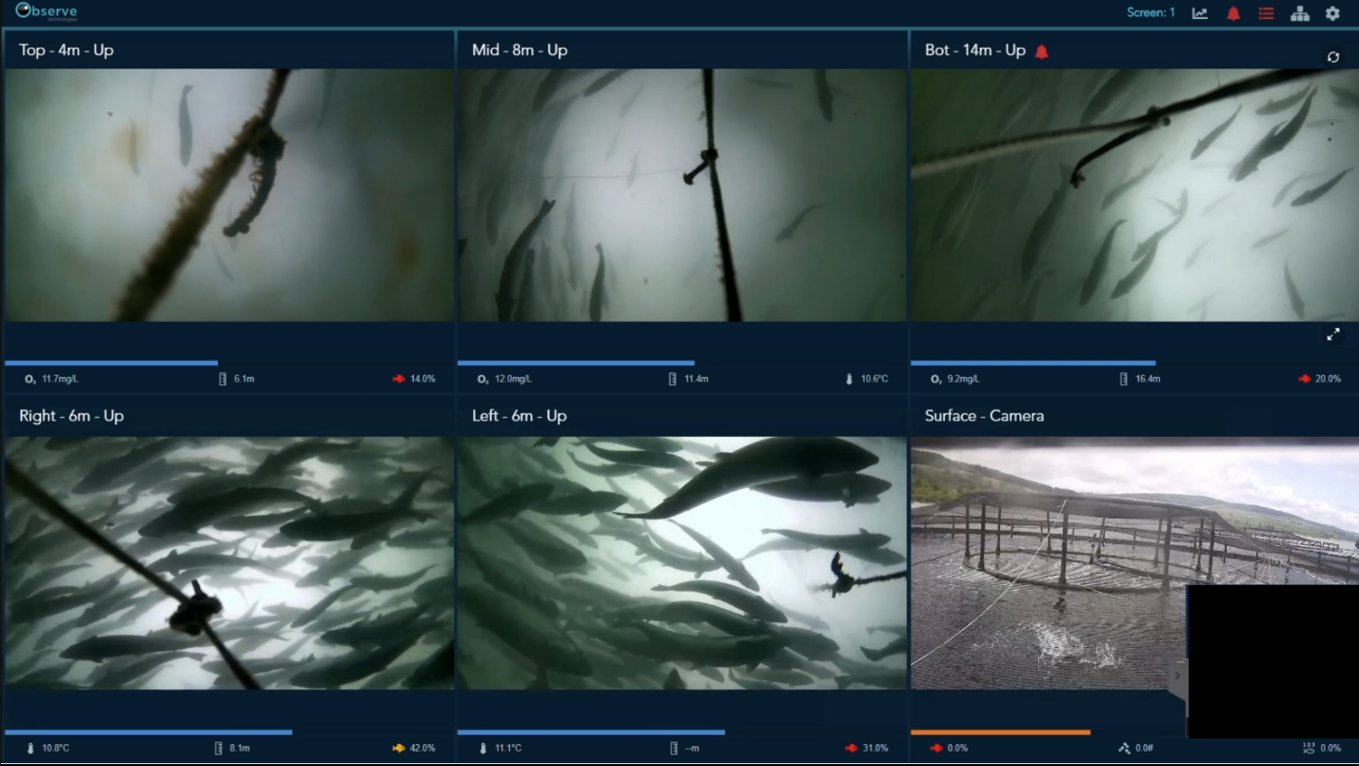
Figure A.1 Example of a screenshot from a video showing the five cameras at Farm A. Each panel displays temperature, depth, and oxygen (when available), with the coloured fish icon in the bottom right indicates the calculated activity (%) at that moment.

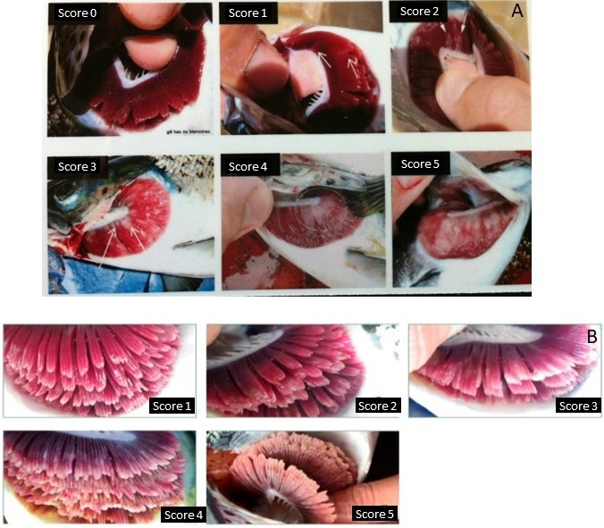
Figure A.2 The scorecards used by farmers to assess AGD (A) and PGD (B) scores on-site. Images courtesy of Bakkafrost Scotland, with contributions from Skretting (Mark Adams and Vet-Aqua International; A) and Marine Harvest Scotland (now Mowi Scotland; B).

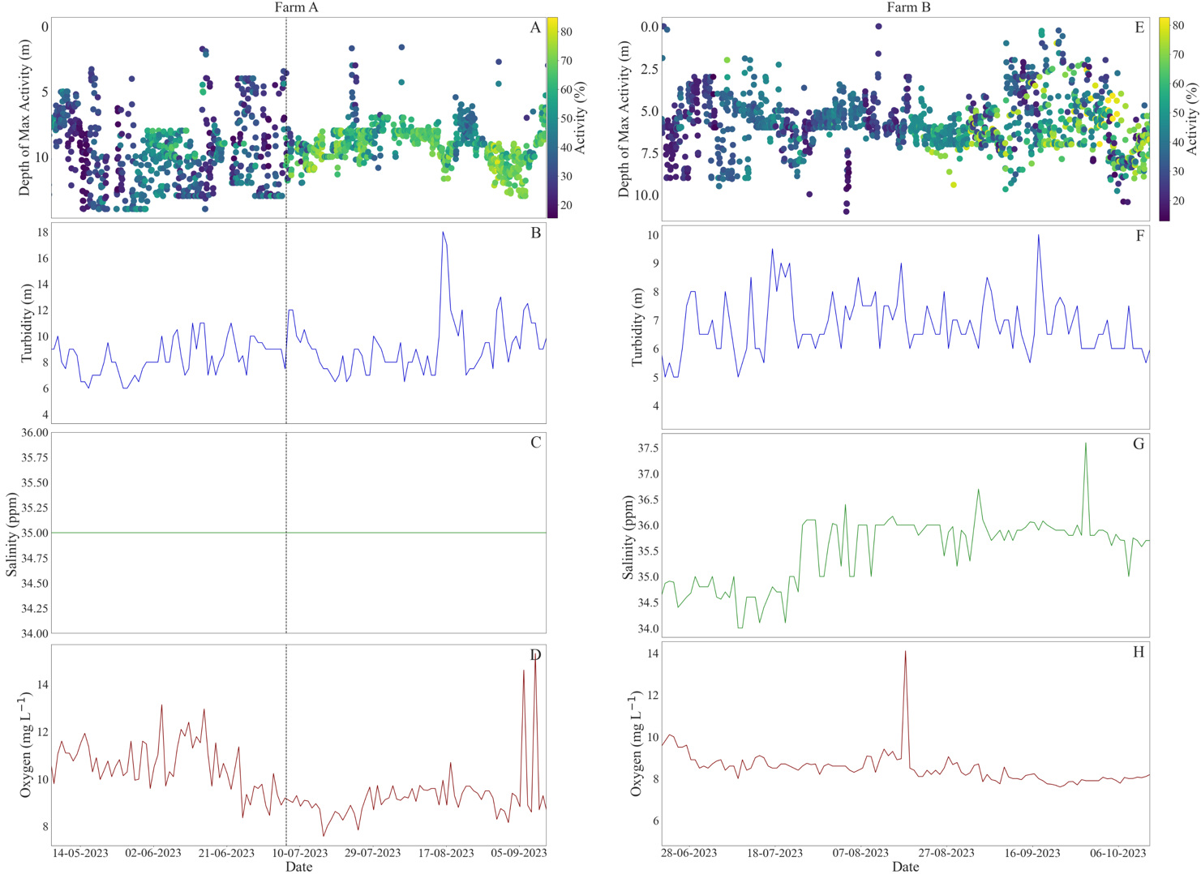
Figure A.3 Water quality parameters measured daily throughout the study period from the barge visible in Fig. 1 at each site. Panels show the depth of maximum activity with colours indicating the hourly-averaged activity levels observed at that depth (a,e), turbidity (m) measured with a Secchi disk (b, f), salinity (ppm), and dissolved oxygen (mg L⁻¹). Note: given the consistent reading of salinity at Farm A, this suggests it was an approximation rather than precisely measured.

