Supplementary information
Optoelectronic Dual Mode Encryption for High Security Biometric Identification
Yuxiao Zhang ª, Yue Liu ^{a,}*, Juan Tao ^{e}, Yepei Mo ^{c}, Yuke Deng ª, Jiahui Tong ^{e}, Rongrong Bao ^{c}, Jianbei Qiu ^{a,b}, Ji Zhou ^{b,d,}*, Caofeng Pan ^{c,}*, Zhengwen Yang ^{a,b,}*
ª College of Materials Science and Engineering, Kunming University of Science and Technology, Kunming, 650093, China.
^{b} Southwest United Graduate School, Kunming, 650093, China.
^{c} Institute of Atomic Manufacturing, Beihang University, Beijing 100191, P. R. China.
^{d} School of Materials Science and Engineering, State Key Lab of New Ceramics and Fine Processing, Tsinghua University, Beijing 100084, China.
^{e} Jiashan Fudan Institute, Jiaxing, Zhejiang Province 314100, China.
*Corresponding Author E-mails: yangzw@kmust.edu.cn; pancaofeng@buaa.edu.cn; zhouji@tsinghua.edu.cn; liuyue2023@kust.edu.cn.

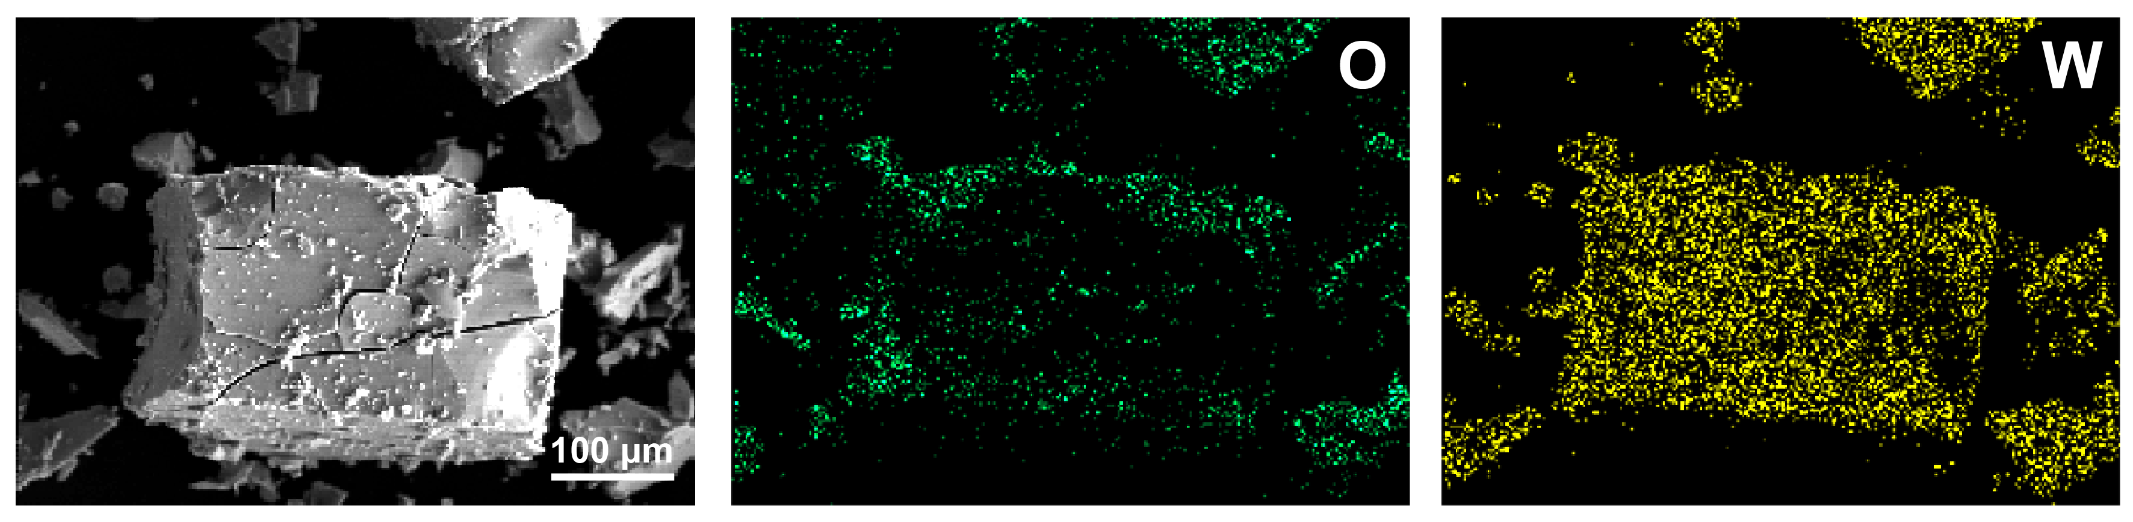
Supplementary Figure 1. Internal morphological characteristics and elemental distribution of the WO₃ precursor.

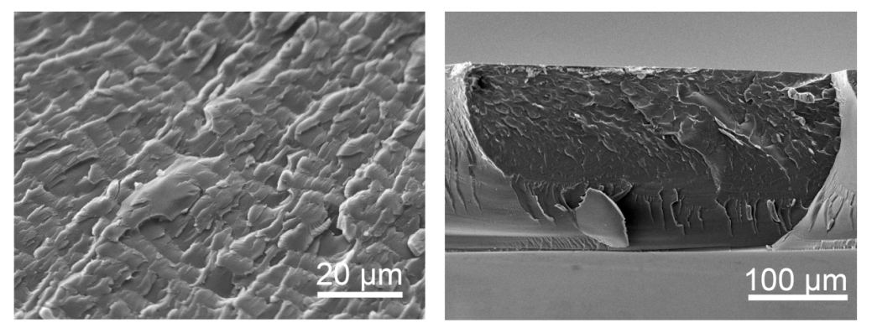
Supplementary Figure 2. Surface morphological characteristics of the lyophilized PAAm-LiCl hydrogel.

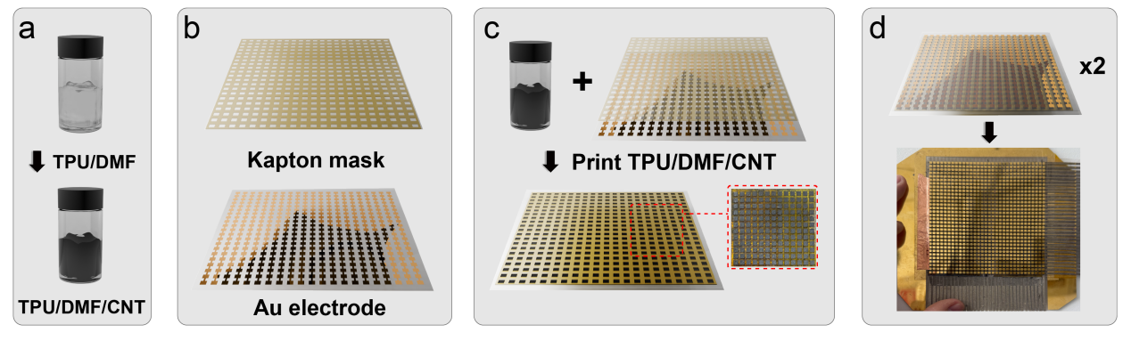
Supplementary Figure 3. Schematic diagram of the preparation process of resistive pressure sensing array.

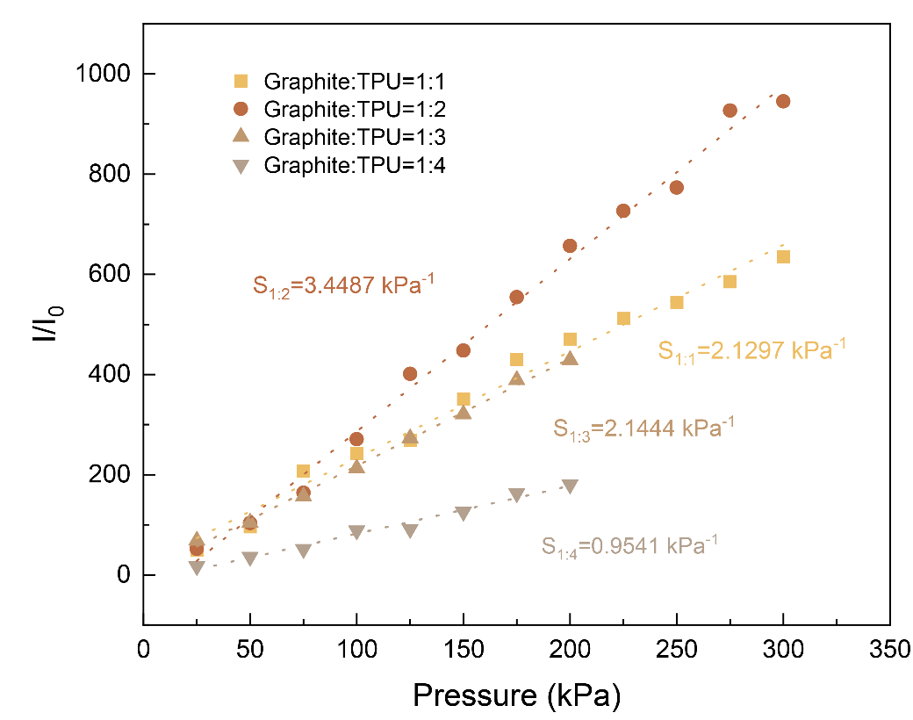
Supplementary Figure 4. Performance comparison of pressure-sensitive layer materials with different doping ratios.

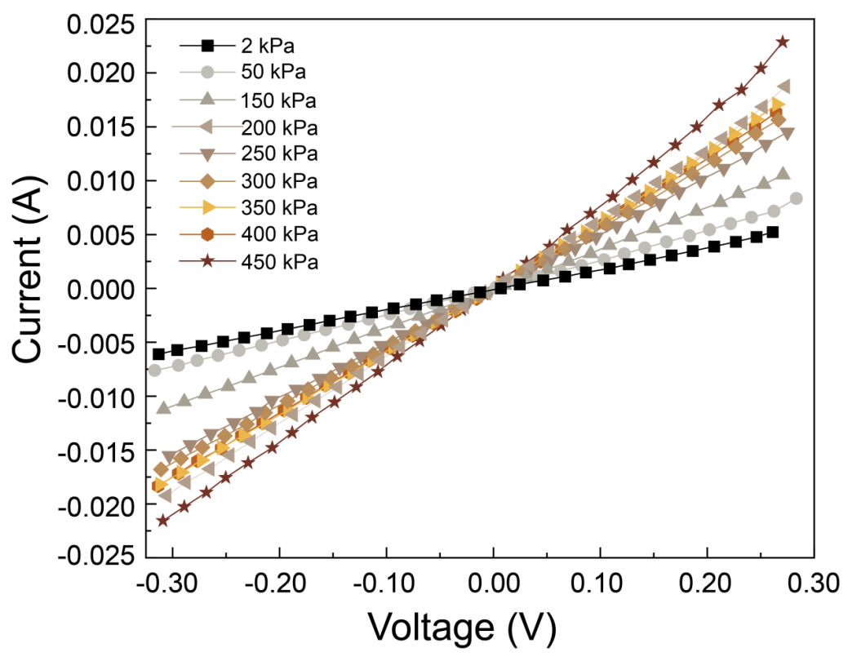
Supplementary Figure 5. Current-voltage variations of the individual sensing unit under varying applied pressures.

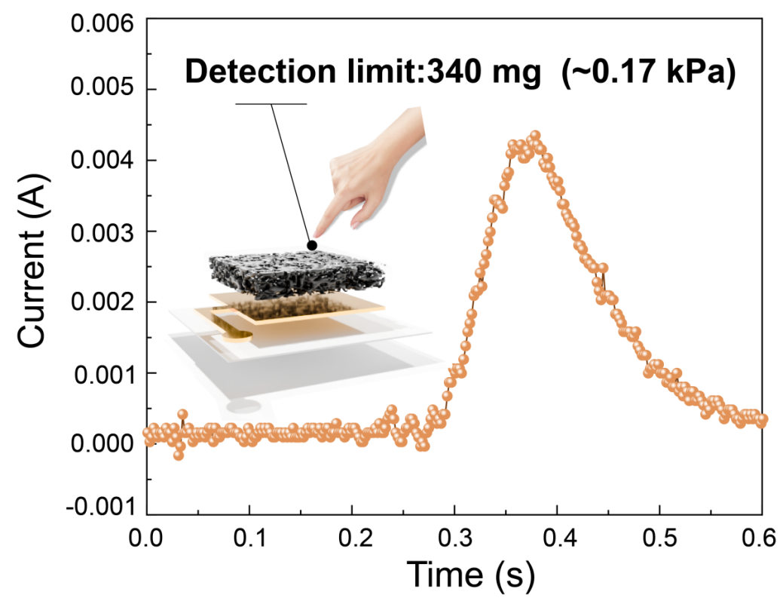
Supplementary Figure 6. Response threshold characterization of the individual sensing unit.minimum detectable mass: 340 mg (0.17 kPa).

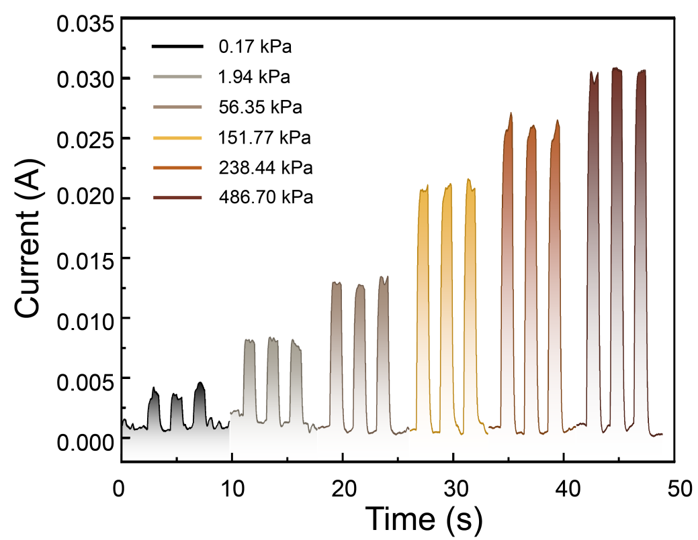
Supplementary Figure 7. Dynamic response characterization of the individual sensing unit.Experimental findings reveal stable real-time response characteristics spanning from 0.17 to 486 kPa,validating effective pressure transduction across broad pressure regimes.

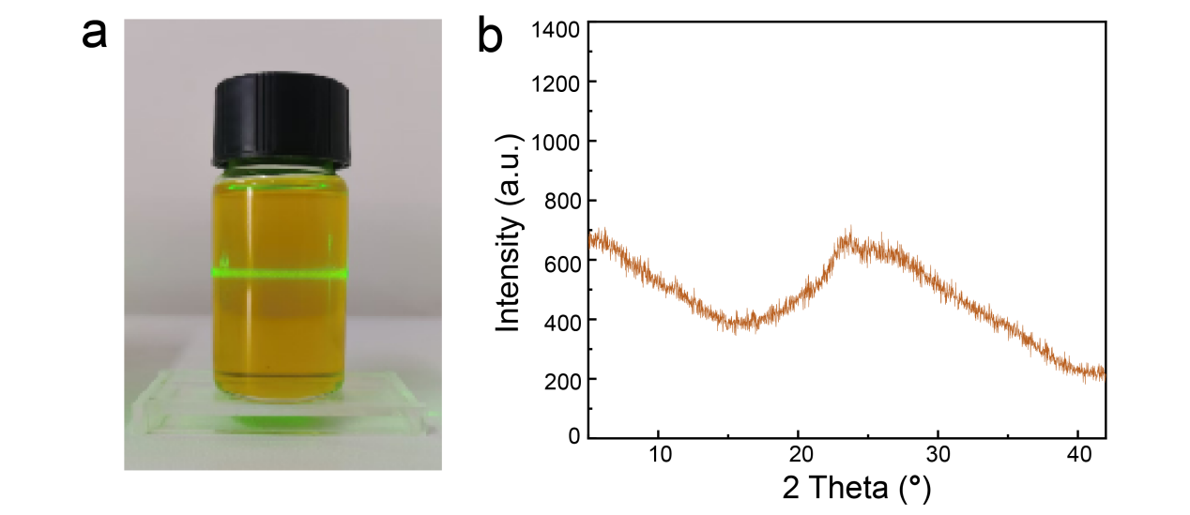
Supplementary Figure 8. Liquid functional layer basic characterization. (a) Colloidal state of liquid functional layer. (b) XRD analysis of the liquid functional layer shows that the interior is composed of amorphous particles.

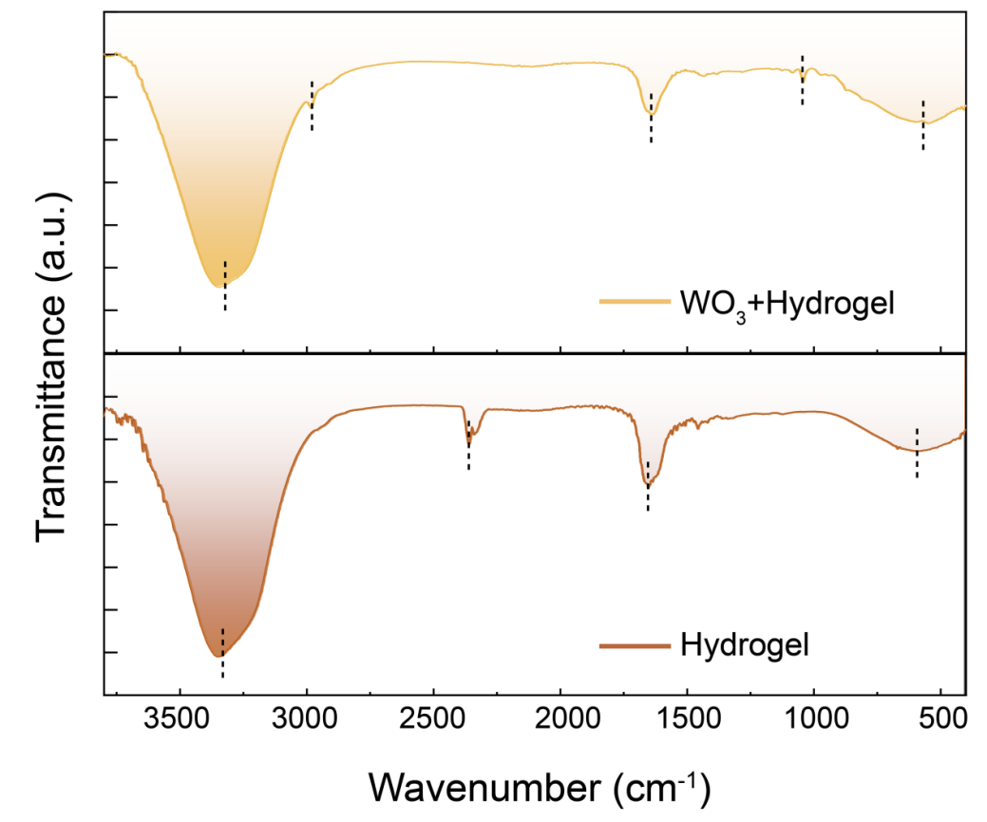
Supplementary Figure 9. Comparative FTIR analysis of hybrid ink formulation (upper) and PAAm-LiCl hydrogel (lower).FTIR analysis of the hybrid ink (upper) and PAAm-LiCl hydrogel (lower) demonstrated that both systems exhibited prominent O-H stretching vibrations in the 3200-3400 cm⁻¹ range, while a weak Li⁺-associated vibration emerged at 2300 cm⁻¹ in the hydrogel spectrum. Incorporation of WO₃ perturbed the original vibrational modes, though both materials retained characteristic C=O stretching vibrations of amide groups near 1600 cm⁻¹. Distinctive W-O stretching vibrations at 1038 cm⁻¹ and potential W-O bending vibrations within 500-700 cm⁻¹ were exclusively observed in the hybrid ink, whereas Li-O vibrational signatures around 570 cm⁻¹ were common to both systems, confirming interfacial interactions and structural modifications.

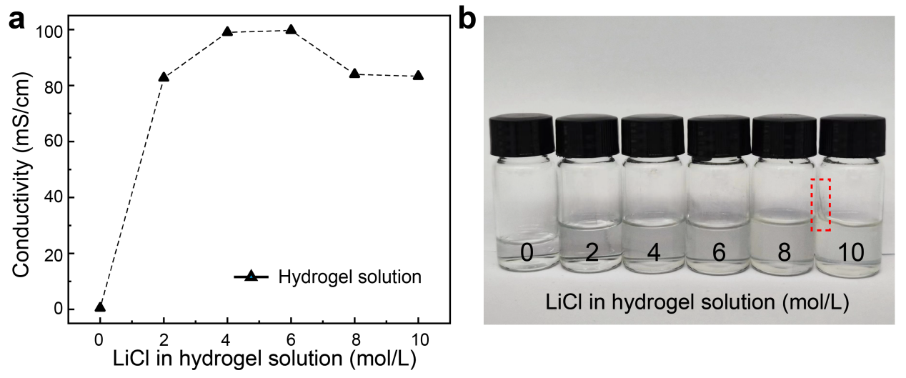
Supplementary Figure 10. Hydrogel solutions doped with varying concentrations of LiCl. (a) Conductivity tests revealed a gradual increase in electrical conductivity with rising LiCl concentration, peaking at 6 mol/L. (b) Observations of hydrogel solution states across concentrations demonstrated significant wall-adhering phenomena at 10 mol/L LiCl.

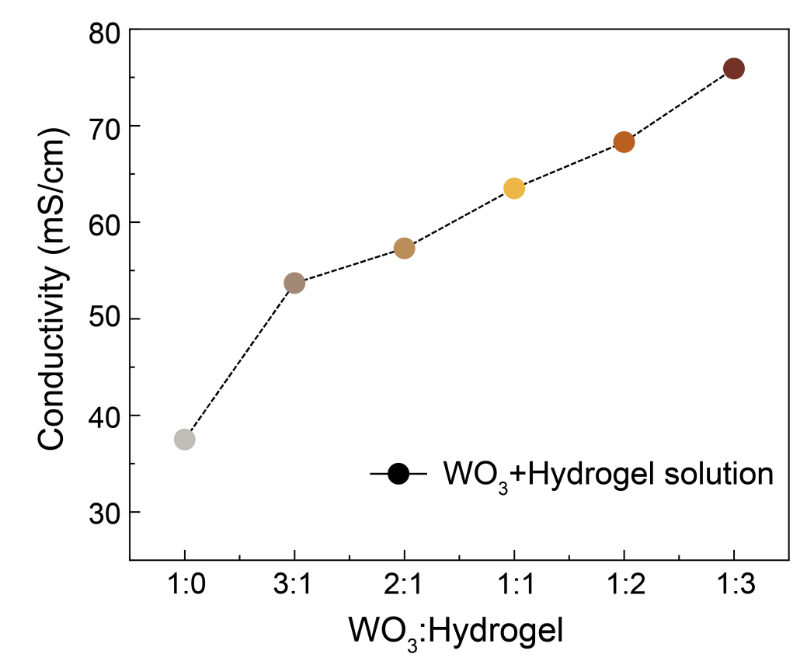
Supplementary Figure 11. Conductivity characterization of electrochromic inks with varying concentrations was conducted. A progressive enhancement in electrical conductivity was observed with increasing hydrogel content.

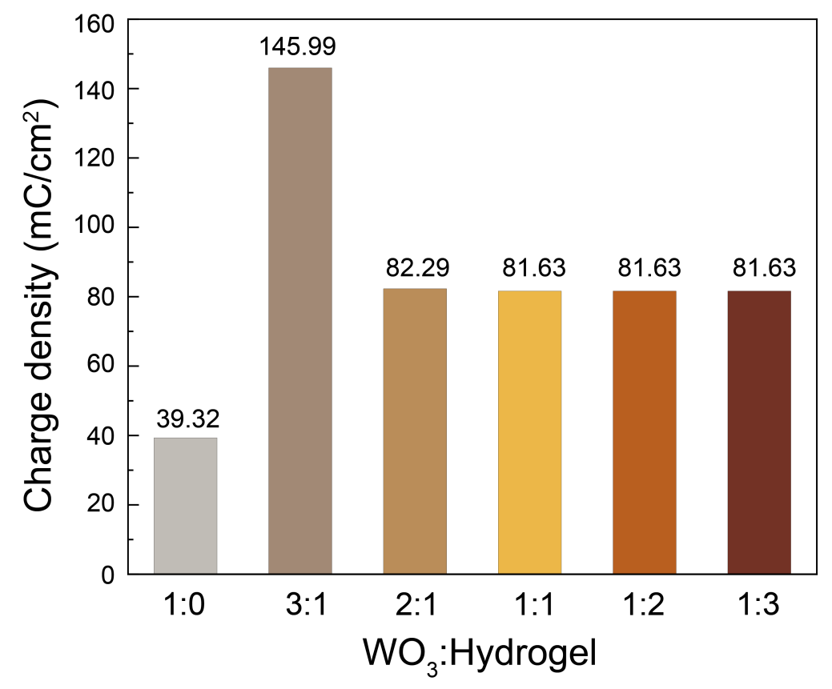
Supplementary Figure 12. Charge density of electrochromic inks with varying concentrations.

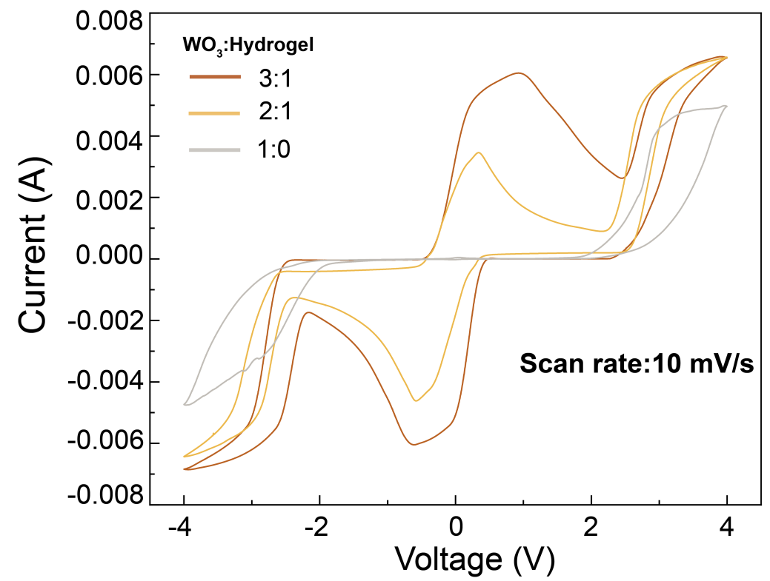
Supplementary Figure 13. Cyclic voltammetry profiles of hybrid ink formulations with varying concentrations.

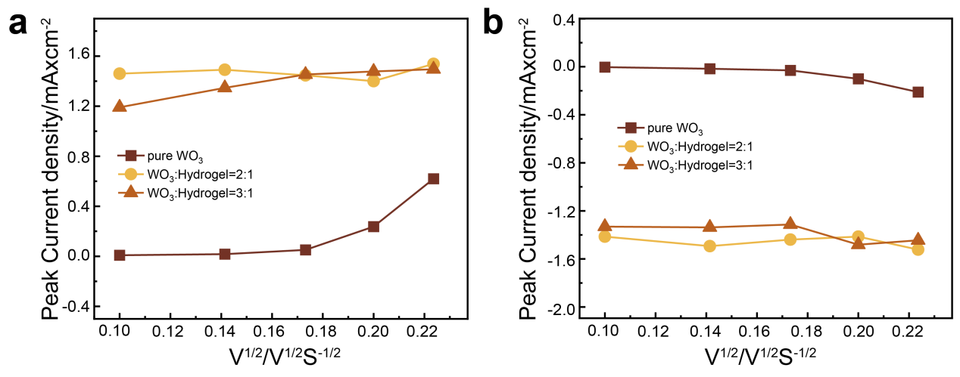
Supplementary Figure 14. Peak current density versus square root of scan rate for hybrid ink formulations with varying concentrations in the oxidized state (left) and reduced state (right).

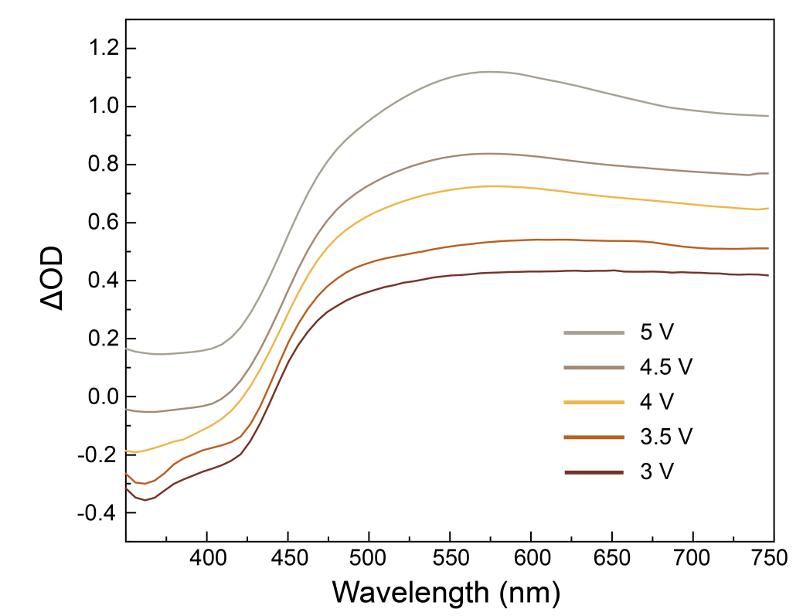
Supplementary Figure 15. Optical density variations of the hybrid electrochromic ink formulation (WO₃-to-hydrogel mass ratio 3:1) under varying applied voltages.

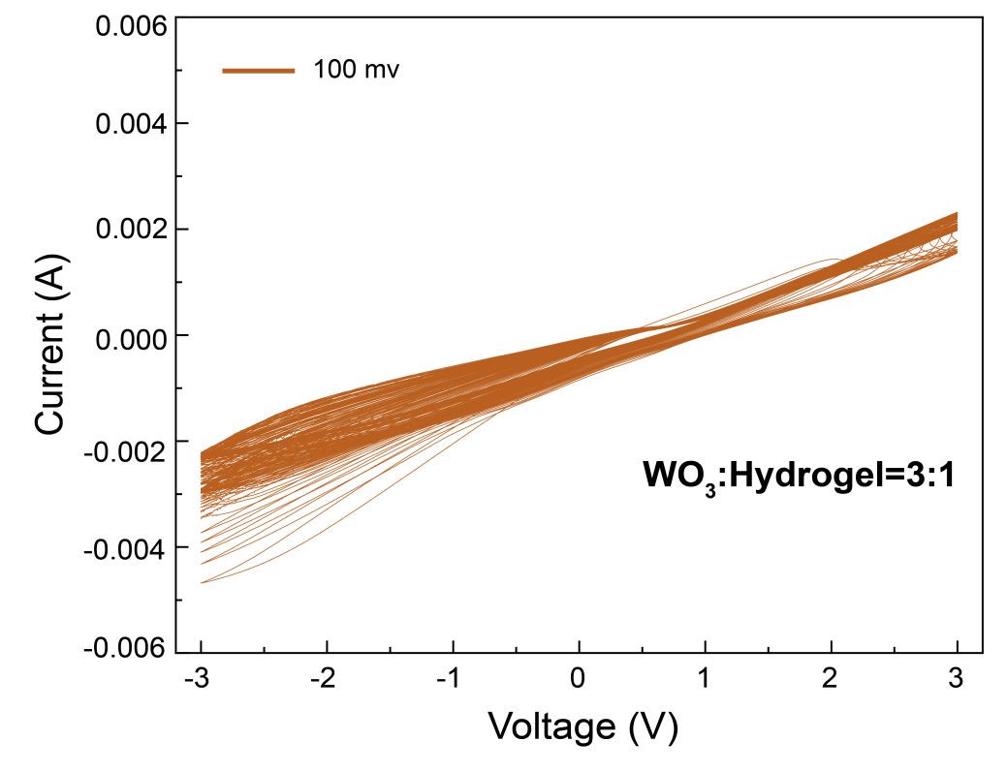
Supplementary Figure 16. Cyclic voltammetry (CV) cycling tests (latter 40 cycles).

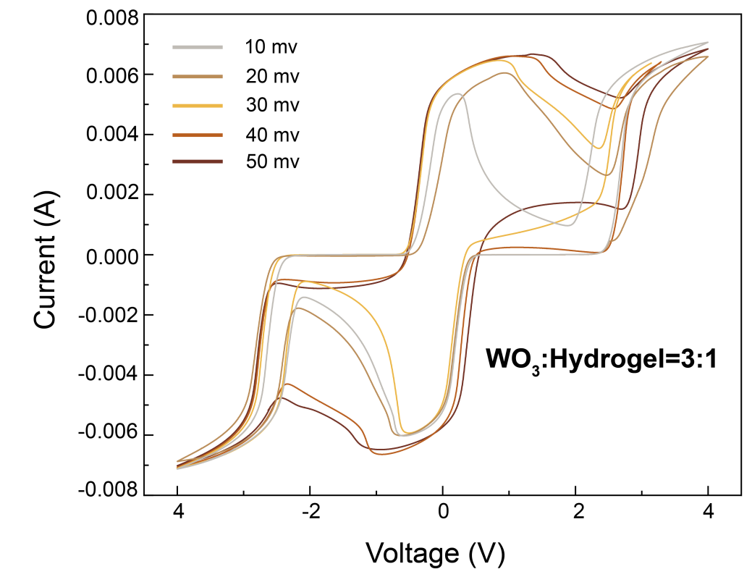
Supplementary Figure 17. Cyclic voltammetry (CV) profiles of the hybrid electrochromic ink formulation with a WO₃-to-hydrogel mass ratio of 3:1 at varying scan rates.

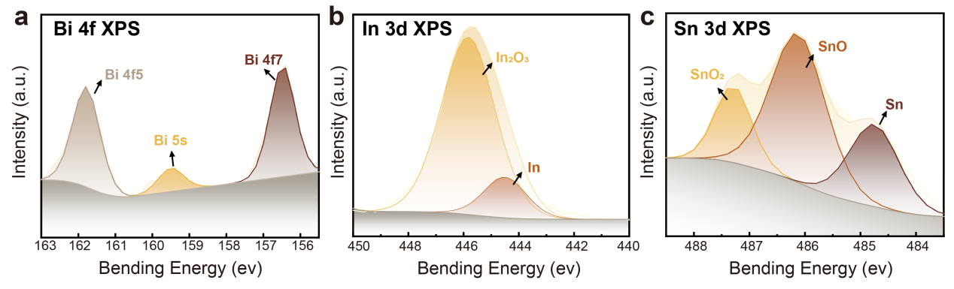
Supplementary Figure 18. XPS surface analysis of liquid metal. (a) Bi, (b) In,(c) Sn.

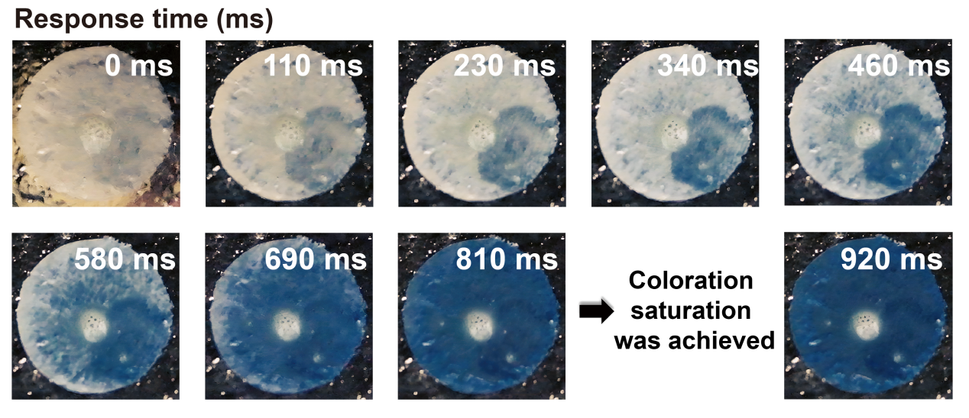
Supplementary Figure 19.The total response time of the liquid functional layer on the liquid metal was measured. No significant difference in coloration state was observed between 810 ms and 920 ms, indicating that the liquid functional layer had reached its fully colored state by 810 ms​​.

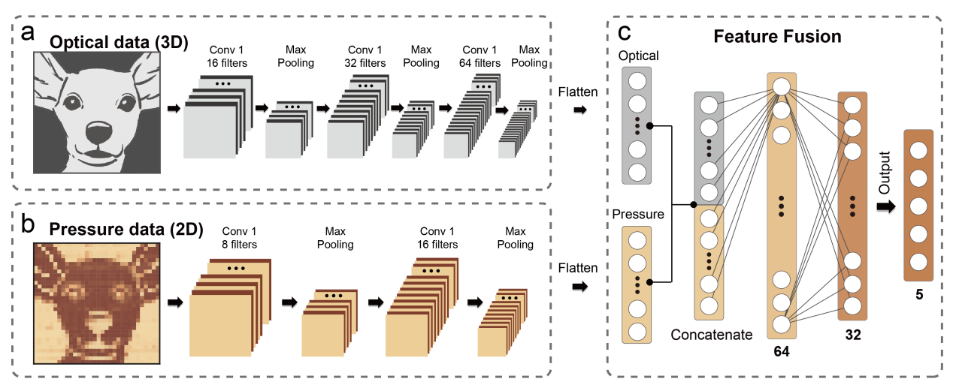
Supplementary Figure 20. Schematic diagram of the machine learning process for optical bimodal signals. (a) 2D convolutional network machine learning process for optical signals. (b) 3D convolutional network machine learning process for electrical signals. (c) Bimodal signal feature-level fusion machine learning process.

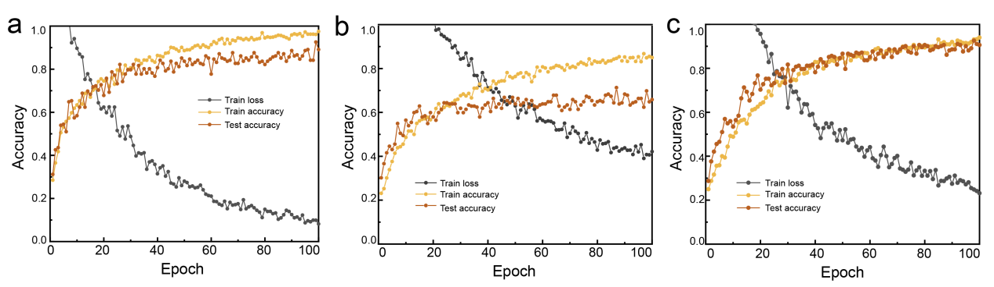
Supplementary Figure 21. Demonstration of the Learning Process for Optical Information, Pressure Mapping, and Feature-Level Fusion. (a) Optical Data. (b) Pressure Data. (c) Feature-Level Fusion.

