Supplement file 1: Questionnaire for the study of changes in antibody responses and immune persistence in healthcare workers after COVID-19 infection (Baseline)

Dear healthcare workers:
We sincerely invite you to join us in conducting the study on changes in antibody responses and immune persistence of healthcare workers after COVID-19 infection. This questionnaire will take you 10 minutes, and we will keep the personal information you provide in the questionnaire absolutely confidential. We hope to get your support, thank you!

Shanghai Pudong New Area Center for Disease Control and Prevention (Shanghai Pudong New Area Health Supervision Institute)

- Are you in any of the following circumstances between December 19 and December 25, 2022?
(1) You have never experienced COVID-19-related symptoms previously, you tested positive for antigen or nucleic acid;
(2) You tested positive for antigen or nucleic acid after initially experiencing COVID-19-related symptoms.
2. Name: .
3. ID number: .
4. Mobile phone number: .
5. Age: .
6. Gender：
7. Your height is ＿＿＿cm and weight is ＿＿＿kg.
8. Name of unit： .
9. Type of unit:
- Secondary and third-level medical institutions
- Community health care centers
- Department: .
- Category of job:
- Physicians
- Nurses
- Technicians
- Administrative staff
- Logisticians
- Others
- Do you have any underlying diseases?
- NO
- Cardiovascular and cerebrovascular diseases (including hypertension)
- Long-term respiratory conditions
- Diabetes
- Chronic liver disease
- Kidney disease
- Tumor
- Have you long used immunosuppressive medications such as corticosteroids?
- Yes (2) No
- The date on which your first positive test result for COVID-19 (antigen/nucleic acid) in this epidemic round (which has been going on since December 2022) was .
- Have you experienced any symptoms related to COVID-19 in this epidemic round (referring to the epidemic since December 2022)?
- Yes (2) No
COVID-related symptoms include but are not limited to fever, cough, dry/sore throat, nasal congestion/runny nose, abdominal pain/diarrhea, muscle aches, changes in taste/smell, difficulty breathing, hypoxemia, etc.
- Did you get COVID-19 treatment during this epidemic?
(1) Yes (2) No
17. Were you hospitalized for COVID-19 during this epidemic?
(1) Yes (2) No
18. Have you taken the following antiviral drugs due to infection with COVID-19 during this epidemic?
(1) No
(2) Paxlovid, an anti-COVID-19 drug that is a combination of Nirmatrelvir and Ritonavir
(3) Azvudine
19. Do you currently have any COVID-19 related symptoms, such as cough, changes in taste/smell, memory loss/cognitive delay, muscle aches/fatigue, shortness of breath/difficulty breathing, insomnia, etc.?
(1) Absence of symptoms
(2) Symptoms are still there but do not interfere with day-to-day task
(3) Symptoms are present but interfere with day-to-day task
20. Have you ever been infected with COVID-19?
(1) Yes (2) No
21. Have you had a COVID-19 vaccination prior to this pandemic? If you answered yes, could you kindly provide the date of the most recent COVID-19 vaccination dose?
(1) Yes, the date was .
(2) No

*Questionnaire was used in Chinese. Translation to English has not been validated yet.
Supplement file 2: Questionnaire for the study of changes in antibody responses and immune persistence in healthcare workers after COVID-19 infection (Follow-up)

Dear healthcare workers:
We sincerely invite you to join us in conducting the study on changes in antibody responses and immune persistence of healthcare workers after COVID-19 infection. This questionnaire will take you 10 minutes, and we will keep the personal information you provide in the questionnaire absolutely confidential. We hope to get your support, thank you!

Shanghai Pudong New Area Center for Disease Control and Prevention (Shanghai Pudong New Area Health Supervision Institute)

- Name: .
- ID number: .
- The date of blood sample collection for this follow-up was .
- Has COVID-19 (nucleic acid/antigen) been tested positive again during this follow-up? If yes, could you kindly provide the earliest date of positive?
(1) Yes, the date was .
(2) No
- Did you re-experience any symptoms that could be associated with COVID-19 during this follow-up?
- Yes (2) No
COVID-related symptoms include but are not limited to: fever, cough, dry/ sore throat, nasal congestion/ runny nose, abdominal pain/ diarrhea, muscle aches, changes in taste/ smell, difficulty breathing, hypoxemia, etc.
- Do you still have the following symptoms?
- Fever
- Coughing/ sputum
- Changes in taste/ smell
- Memory loss/ delayed reaction
- Weariness/ muscular pains
- Shortness of breath/ difficulty breathing/ changes in heart rate
- Hypoxemia
- Insomnia/ trouble falling asleep
- Tightness/ pain in your chest
- Other discomforts
- Given the question above, which of the following scenarios do you believe you currently find yourself in?
(1) Absence of symptoms
(2) Symptoms are still there but do not interfere with day-to-day task
(3) Symptoms are present but interfere with day-to-day task
8. During this follow-up period, were you diagnosed with any other diseases? If you answered yes, please list the diagnosed diseases.
(1) Yes, the diagnosed diseases were .
(2) No

*Questionnaire was used in Chinese. Translation to English has not been validated yet.

Supplement file 3: Informed consent for the study of changes in antibody responses and immune persistence in healthcare workers after COVID-19 infection

Dear healthcare workers:
We sincerely invite you to participate in our study on changes in antibody responses and immune persistence in healthcare workers after COVID-19 infection.
Objective
Healthcare workers serve as the research subjects for the study in Pudong New Area, Shanghai. The study carries out 6-month antibody level monitoring on healthcare workers after infected with COVID-19 and analyzes the changing trends of antibody, COVID-19 symptoms, and related influencing factors. The study is not for commercial purposes and was approved by the Ethics Committee of Shanghai Pudong New Area Center for Disease Control and Prevention.
Content
The purpose of this study is to monitor IgG, IgM, and neutralizing antibodies in individuals infected with COVID-19 using 64 medical facilities, including 47 villages and 17 secondary and tertiary hospitals. 5 milliliters (ml) of venous blood will be collected each time, for a total of thirty milliliters, and antibody monitoring will be done once a month for six times in the study. Blood will be collected for this study at the end of each month between February 2023 and July 2023. A questionnaire containing your name, gender, occupation, general health, history of COVID-19 infection, COVID-19 vaccination, and the duration of COVID-19 symptoms will also be required of you.
All operations in the study are performed by specially trained investigators and healthcare workers.
Confidentiality
All information collected in the study, including test results and personal information, will be kept strictly confidential. All monitoring information, including inspection reports and sampling sheets, will be secured. The pertinent data gathered throughout your monitoring will be input into the computer in an anonymous manner. Electronic data will be password-protected and kept on a secure computer. The data analysis findings could have to be submitted to the appropriate government agencies or might be included in conference reports or scholarly publications for the sake of scientific study. No identifying information will be included in publications, lectures, or monitoring reports.
Withdrawal‌
Your participation in the study is completely voluntary. You have the right to decline participation and to leave the research at any point. None of your benefits will be impacted if you decline to participate or withdraw.
Risk
This research test is harmless. Blood collection may cause mild discomfort, bruising, or exhaustion, but these side effects are transient.
Benefit
The study offers you free COVID-19 antibody testing and consultations on vaccinations, helping you quickly understand your immunological state and relevant information. The data gathered from the study will be used to update and enhance pertinent vaccination plans.
The validation work for the study is expected to be completed by the end of the year. If necessary, we may provide you with test results feedback whenever the test is finished. We will notify you as quickly as possible and offer pertinent advice and consultation if the test results fall short of the expected value.

Contact unit：__________________ Contact number：__________________

Please date this informed consent form and sign your name if you consent to participate in this study.
Signature： | Date：
If the participant was illiterate or otherwise incapable of reading and signing the informed consent form, we asked an independent notary public to sign and date it. The signature of the notary public indicates that the participant has received an accurate explanation of the information in the informed consent and understands it.
Signature of notary public (if necessary)：
Relationship with participants：
Date：

――――――――――――――――――――――――――――――――――
The investigator (or staff who performed the informed consent), please fill in the following.
The statement from the investigator (or staff who performed the informed consent procedure)
I confirm that the purpose of the study has been explained to the above individuals. I have answered all questions asked and have witnessed the above signature. The study was explained to the above participants on the date stated in the informed consent.
Signature： | Date：

*Informed consent was used in Chinese.

Supplement table 1. ESS of parameter estimates for models fitted to IgG, IgM and NAb against Omicron.

ESS | IgG | IgM | NAb
mu_0 | 1934.16 | 5359.27 | 14400.00
mu_1 | 2086.27 | 2157.43 | 14400.00
omega | 1538.10 | 1851.43 | 14400.00
tau | 13499.00 | 13853.13 | 14268.03
The ESS of all parameters was more than 200, considered that the model has basically converged. ESS = Effective Sample Size. NAb = neutralizing antibodies.

Supplement figure 1. MCMC diagnostics for 3 chains fitted to IgG, IgM and NAb against Omicron.
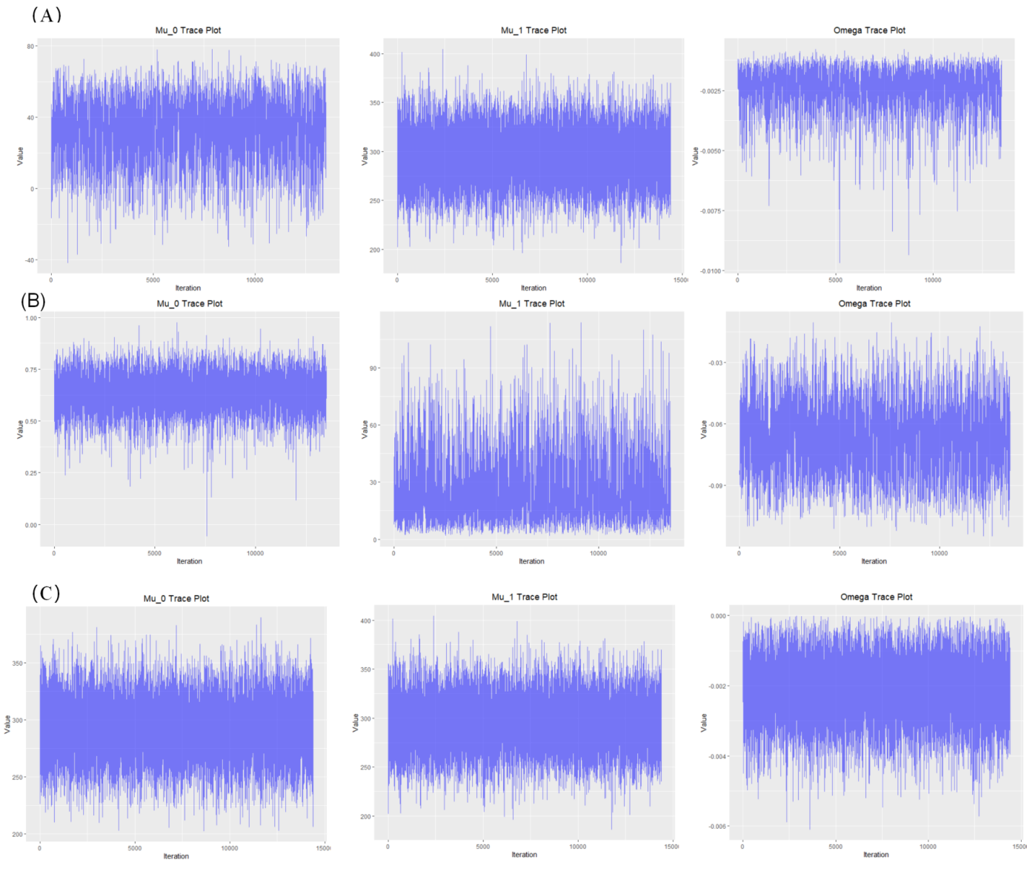

(A) MCMC diagnostics for IgG. (B) MCMC diagnostics for IgM. (C) MCMC diagnostics for NAb. MCMC = Markov chain Monte Carlo, NAb = neutralizing antibodies.

