Supplemental Material

Table of Contents
Figure S1. Study design and time frame definitions 2
Figure S2. Flowchart of selection patients 3
Figure S3. Flowchart of selection patients of incident-RASi and incident-CCB users 4
Table S1. List of RASi and other medications included in the analyses 5
Table S2. Definitions of outcomes and covariates 7
Table S3. Clinical profiles of patients by incident-RASi use before and after overlap-weighting in the register-based cohort. 8
Table S4. Clinical profiles of patients by RASi treatment regimen after overlap-weighting in the population-based cohort 9
Table S5. Clinical profiles of patients among ACEi-only and ARBs-only users after overlap-weighting in the population-based cohort 10
Table S6. Clinical profiles of patients between incident RASi and CCBs users in the population-based cohort 11
Table S7. Sensitivity analysis of RASi use with risk of outcomes in type 2 diabetes (n=250,816) 12

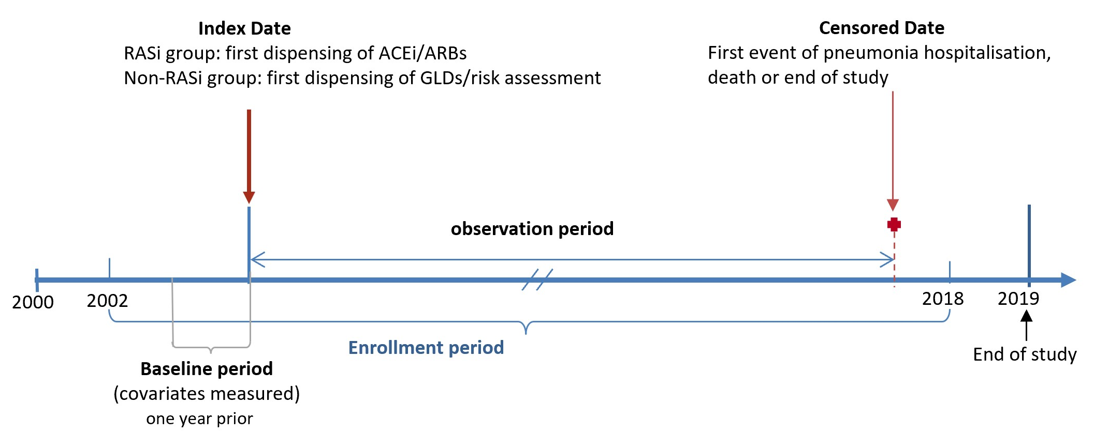

Figure S1. Study design and time frame definitions

The Population-based Cohort | The Diabetes Register-based Cohort
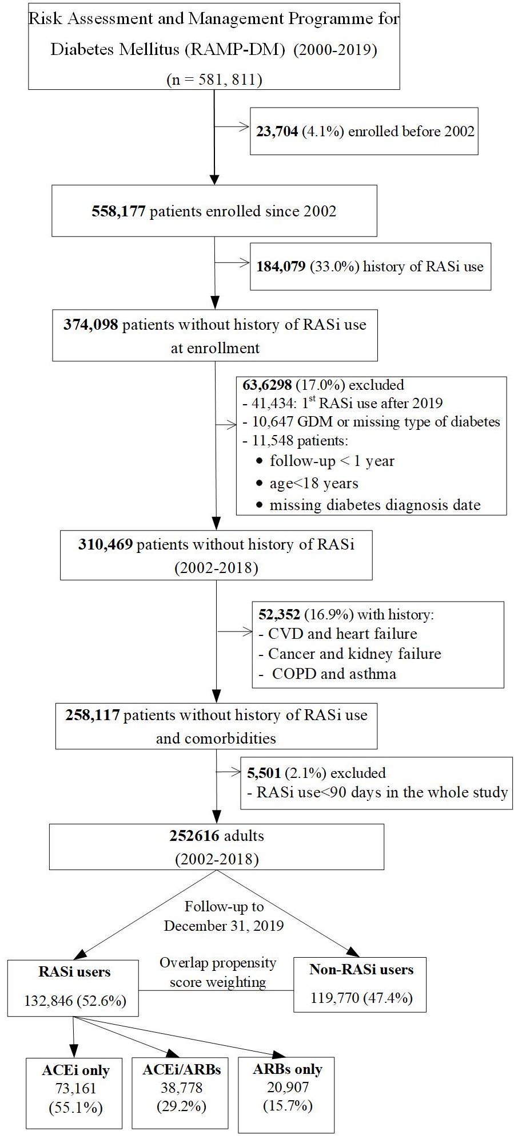 | 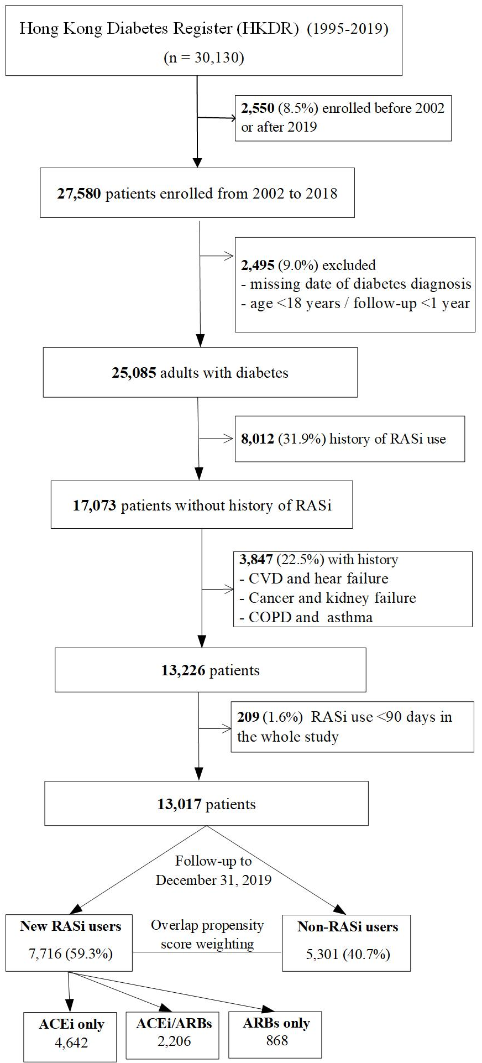

Figure S2. Flowchart of selection patients

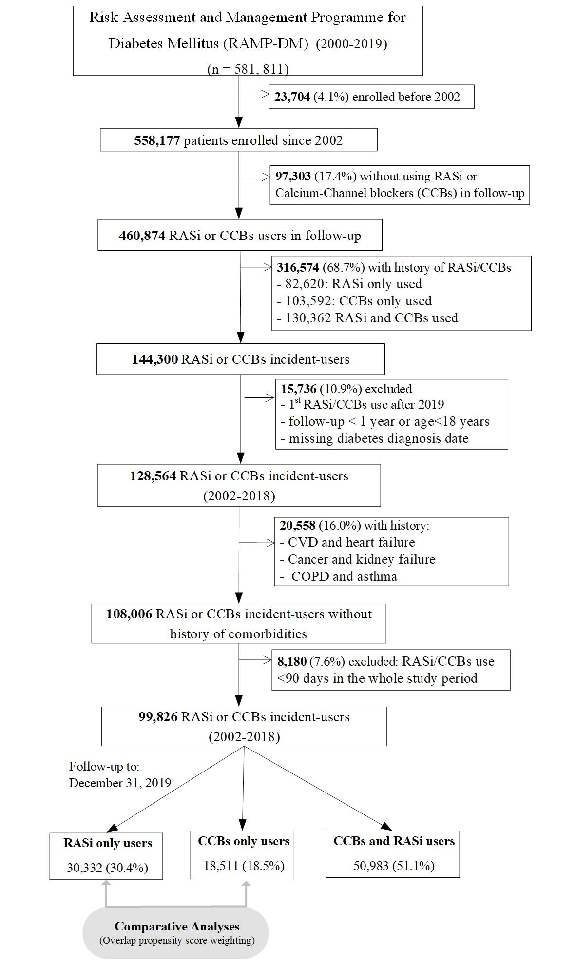

Figure S3. Flowchart of selection patients of incident-RASi and incident-CCB users

Table S1. List of RASi and other medications included in the analyses

Groups | ATC Codes | Labels
RASi | C09 | AGENTS ACTING ON THE RENIN-ANGIOTENSIN SYSTEM
ACEi | C09A | ACE INHIBITORS, PLAIN
 | C09AA | ACE inhibitors, plain
 | C09B | ACE INHIBITORS, COMBINATIONS
 | C09BA | ACE inhibitors and diuretics
ARBs | C09C | ANGIOTENSIN II RECEPTOR BLOCKERS (ARBs), PLAIN
 | C09CA | Angiotensin II receptor blockers (ARBs), plain
 | C09D | ANGIOTENSIN II RECEPTOR BLOCKERS (ARBs), COMBINATIONS
 | C09DA | Angiotensin II receptor blockers (ARBs) and diuretics
 | C09DX | Angiotensin II receptor blockers (ARBs), other combinations
Antihypertensives | C02 | ANTIHYPERTENSIVES
 | C02A | ANTIADRENERGIC AGENTS, CENTRALLY ACTING
 | C02AA | Rauwolfia alkaloids
 | C02AB | Methyldopa
 | C02AC | Imidazoline receptor agonists
 | C02C | ANTIADRENERGIC AGENTS, PERIPHERALLY ACTING
 | C02CA | Alpha-adrenoreceptor antagonists
 | C02D | ARTERIOLAR SMOOTH MUSCLE, AGENTS ACTING ON
 | C02DB | Hydrazinophthalazine derivatives
 | C02DC | Pyrimidine derivatives
 | C02K | OTHER ANTIHYPERTENSIVES
 | C02KX | Antihypertensives for pulmonary arterial hypertension
Diuretics | C03 | DIURETICS
 | C03A | LOW-CEILING DIURETICS, THIAZIDES
 | C03AA | Thiazides, plain
 | C03B | LOW-CEILING DIURETICS, EXCLUDING THIAZIDES
 | C03BA | Sulfonamides, plain
 | C03C | HIGH-CEILING DIURETICS
 | C03CA | Sulfonamides, plain
 | C03D | POTASSIUM-SPARING AGENTS
 | C03DA | Aldosterone antagonists
 | C03DB | Other potassium-sparing agents
 | C03E | DIURETICS AND POTASSIUM-SPARING AGENTS IN COMBINATION
 | C03EA | Low-ceiling diuretics and potassium-sparing agents
Beta-blockers | C07 | BETA BLOCKING AGENTS
 | C07A | BETA BLOCKING AGENTS
 | C07AA | Beta blocking agents, non-selective
 | C07AB | Beta blocking agents, selective
 | C07AG | Alpha and beta blocking agents
 | C07B | BETA BLOCKING AGENTS AND THIAZIDES
 | C07BB | Beta blocking agents, selective, and thiazides
Ca-channel blockers | C08 | CALCIUM CHANNEL BLOCKERS
 | C08C | SELECTIVE CALCIUM CHANNEL BLOCKERS WITH MAINLY VASCULAR EFFECTS
 | C08CA | Dihydropyridine derivatives
 | C08D | SELECTIVE CALCIUM CHANNEL BLOCKERS WITH DIRECT CARDIAC EFFECTS
 | C08DA | Phenylalkylamine derivatives
 | C08DB | Benzothiazepine derivatives
Lipid-modifying | C10A | LIPID MODIFYING AGENTS, PLAIN
Stains | C10AA | HMG CoA reductase inhibitors
Non-statins | C10AB | Fibrates
 | C10AC | Bile acid sequestrants
 | C10AD | Nicotinic acid and derivatives
 | C10AX | Other lipid modifying agents
Glucose lowering drugs (GLDs) | A10 | DRUGS USED IN DIABETES
Insulin | A10A | INSULINS AND ANALOGUES
 | A10AB | Insulins and analogues for injection, fast-acting
 | A10AC | Insulins and analogues for injection, intermediate-acting
 | A10AE | Insulins and analogues for injection, long-acting
 | A10B | BLOOD GLUCOSE LOWERING DRUGS, EXCLUDING INSULINS
Metformin | A10BA | Biguanides
Sulfonylureas | A10BB | Sulfonylureas
AGIs | A10BF | Alpha glucosidase inhibitors
TZD | A10BG | Thiazolidinediones
DPP-4i | A10BH | Dipeptidyl peptidase 4 (DPP-4) inhibitors
GLP-1RA | A10BJ | Glucagon-like peptide-1 (GLP-1) analogues
SGLT2i | A10BK | Sodium-glucose co-transporter 2 (SGLT2) inhibitors
Combinations | A10BD | Combinations of oral blood glucose lowering drugs
All drugs were classified using the Anatomical Therapeutic Chemical (ATC) code

Table S2. Definitions of outcomes and covariates

Variables | Definition
Pneumonia hospitalisation | ICD-9 codes: 480-486
Death from pneumonia | ICD-10 cause of death from Hong Kong Death Register: J12-J18
Acute myocardial infarction (AMI) | ICD-9 code: 410
Ischemic heart disease (IHD) | ICD-9 code: 410-414
Heart failure | ICD-9 code: 428
Stroke | ICD-9 code: 430-434, 436
Cardiovascular diseases (CVD) | IHD; stroke; diabetes with peripheral circulatory disorders (250.7); gangrene (785.4); peripheral angiopathy in diseases classified elsewhere (443.81); peripheral vascular disease, unspecified (443.9); 2); other (peripheral) vascular shunt or bypass (procedure code: 39.29); insertion of non-drug-eluting peripheral vessel stent(s) (procedure code: 39.90); amputation of lower limb (procedure code of 84.1) ); other procedure codes (surgical revascularization: 38.08, 38.18, 38.38, 38.48, 38.68, 38.88, 39.25, 39.49, 39.56, 39.57, 39.58, 39.59, 39.99; endovascular revascularization: 00.55, 17.56, 39.50, 39.79)
Kidney failure | eGFR < 15 mL/min/1.73 m² on at least two occasions at least 90 days apart and that is not associated with acute kidney injury (AKI). eGFR values contained within AKI episodes were first removed (top 15 ICD-9 code 584).  Peritoneal dialysis (procedure code: 54.98)  Transplant of kidney (procedure code: 55.6)  Complications of transplanted kidney (996.81)  Persons with a condition influencing their health status; organ or tissue replaced by transplant; kidney (V42.0)
Cancer | ICD-9 code: 140-208
Chronic obstructive pulmonary disease (COPD) | ICD-9 code: 194, 492, 496
Asthma | ICD-9 code: 493
Estimated glomerular filtration rate (eGFR) | The serum creatinine-based CKD-Epidemiological Collaboration (CKD-EPI) Equation
CKD stages | Stage 1: eGFR >90 mL/min/1.73 m²  Stage 2: eGFR 60-90 mL/min/1.73 m²  Stage 3: eGFR 30-59 mL/min/1.73 m²  Stage 3a: eGFR 45-59 mL/min/1.73 m²  Stage 3b: eGFR 30-44 mL/min/1.73 m²  Stage 4: eGFR 15-29 mL/min/1.73 m²
ICD, the International Classification of Diseases

Table S3. Clinical profiles of patients by incident-RASi use before and after overlap-weighting in the register-based cohort.
Variables | Before overlap-weighting |  |  |  | After overlap-weighting
Variables | Non-RASi | RASi | SMD |  | Non-RASi | RASi | SMD
N | 5,301 | 7,716 |  |  | 5,301 | 7,716
Men, % | 2784 (52.5) | 3837 (49.7) | 0.056 |  | 52.2 | 52.2 | <0.001
Age at index date, years | 56.9 (10.8) | 61.4 (11.3) | 0.408 |  | 56.9 (10.8) | 56.9 (10.8) | <0.001
Duration of diabetes, years | 5.9 (6.4) | 10.9 (7.6) | 0.706 |  | 5.9 (6.4) | 5.9 (6.4) | <0.001
Family history of diabetes, % | 0.6 (0.5) | 0.5 (0.5) | 0.161 |  | 0.6 (0.5) | 0.6 (0.5) | <0.001
Use of tobacco, % |  |  | 0.020 |  |  |  | <0.001
Never | 3797 (71.6) | 5457 (70.7) |  |  | 70.9 | 70.9
Ever | 814 (15.4) | 1230 (15.9) |  |  | 15.6 | 15.6
Current | 690 (13.0) | 1029 (13.3) |  |  | 13.5 | 13.5
Body mass index, kg/m² | 24.6 (3.8) | 25.7 (4.1) | 0.275 |  | 24.6 (3.8) | 24.6 (3.8) | <0.001
Waist, cm | 85.3 (10.5) | 87.5 (10.4) | 0.213 |  | 85.3 (10.5) | 85.3 (10.5) | <0.001
Systolic BP, mmHg | 124.4 (16.2) | 135.5 (18.1) | 0.643 |  | 124.4 (16.2) | 124.4 (16.2) | <0.001
Diastolic BP, mmHg | 73.6 (10.1) | 77.8 (10.4) | 0.412 |  | 73.6 (10.1) | 73.6 (10.1) | <0.001
HDL-C, mmol/L | 1.4 (0.4) | 1.3 (0.4) | 0.152 |  | 1.4 (0.4) | 1.4 (0.4) | <0.001
LDL-C, mmol/L | 2.7 (0.8) | 2.7 (0.9) | 0.028 |  | 2.7 (0.8) | 2.7 (0.8) | <0.001
Total cholesterol, mmol/L | 4.7 (1.0) | 4.7 (1.0) | 0.009 |  | 4.7 (1.0) | 4.7 (1.0) | <0.001
Triglyceride, mmol/L | 1.5 (1.3) | 1.6 (1.3) | 0.135 |  | 1.5 (1.3) | 1.5 (1.3) | <0.001
Blood haemoglobin, g/dL | 13.9 (1.4) | 13.8 (1.5) | 0.035 |  | 13.9 (1.4) | 13.9 (1.4) | <0.001
HbA1c, % | 7.3 (1.5) | 7.6 (1.6) | 0.193 |  | 7.3 (1.5) | 7.3 (1.5) | <0.001
eGFR, mL/min/1.73m2 | 89.3 (17.3) | 79.8 (21.7) | 0.486 |  | 89.3 (17.3) | 89.3 (17.3) | <0.001
Albumin-to-creatinine ratio (ACR) | 4.3 (28.5) | 15.2 (55.9) | 0.247 |  | 4.3 (28.5) | 4.3 (28.5)
Medications
Statins | 1506 (28.4) | 3081 (39.9) | 0.245 |  | 35.3 | 35.3 | <0.001
Glucose-lowering drugs (GLDs)
Insulin | 578 (10.9) | 1888 (24.5) | 0.361 |  | 15.1 | 15.1 | <0.001
Metformin | 2847 (53.7) | 5641 (73.1) | 0.411 |  | 63.8 | 63.8 | <0.001
Sulfonylureas | 1852 (34.9) | 4293 (55.6) | 0.425 |  | 44.7 | 44.7 | <0.001
AGIs | 28 ( 0.5) | 193 ( 2.5) | 0.162 |  | 1.0 | 1.0 | <0.001
TZD | 67 ( 1.3) | 196 ( 2.5) | 0.094 |  | 1.8 | 1.8 | <0.001
DPP-4i | 237 ( 4.5) | 362 ( 4.7) | 0.011 |  | 5.2 | 5.2 | <0.001
GLP-1RA | 5 ( 0.1) | 7 ( 0.1) | 0.001 |  | 0.1 | 0.1 | <0.001
SGLT2i | 39 ( 0.7) | 19 ( 0.2) | 0.070 |  | 0.5 | 0.5 | <0.001
Number of GLDs |  |  | 0.608 |  |  |  | <0.001
0 | 1945 (36.7) | 1109 (14.4) |  |  | 25.1 | 25.1
1 | 1551 (29.3) | 2015 (26.1) |  |  | 30.1 | 30.1
2 | 1378 (26.0) | 3379 (43.8) |  |  | 33.9 | 33.9
≥3 | 427 ( 8.1) | 1213 (15.7) |  |  | 10.9 | 10.9
Antihypertensives | 1278 (24.1) | 3501 (45.4) | 0.458 |  | 35.0 | 35.0
Hypertension history | 1771 (33.4) | 4790 (62.1) | 0.599 |  | 48.0 | 48.0 | <0.001
ASCVD 10-year risk score |  |  | 0.516 |  |  |  | <0.001
low (<7.5) | 1483 (28.0) | 1047 (13.6) |  |  | 20.3 | 20.3
medium (7.5-19.9) | 2129 (40.2) | 2399 (31.1) |  |  | 37.5 | 37.5
High (≥20) | 1689 (31.9) | 4270 (55.3) |  |  | 42.2 | 42.2
Period of index year |  |  | 0.504 |  |  |  | <0.001
2002-2006 | 635 (12.0) | 2390 (31.0) |  |  | 15.5 | 15.5
2007-2010 | 1392 (26.3) | 1561 (20.2) |  |  | 25.9 | 25.9
2011-2014 | 1669 (31.5) | 2322 (30.1) |  |  | 32.8 | 32.8
2015-2018 | 1605 (30.3) | 1443 (18.7) |  |  | 25.8 | 25.8

Table S4. Clinical profiles of patients by RASi treatment regimen after overlap-weighting in the population-based cohort
Variables | Non-RASi | ACEi only | ARBs only | SMD
N | 119770 | 73,161 | 21,178
Men, % | 47.3 | 48.0 | 47.6 | 0.009
Age at index date, years | 63.2 (11.6) | 63.2 (11.9) | 63.2 (11.2) | 0.004
Duration of diabetes, years | 5.8 (7.7) | 6.0 (5.8) | 5.6 (5.5) | 0.043
Family history of diabetes, % | 45.3 | 45.3 | 45.8 | 0.006
Use of tobacco, % |  |  |  | 0.014
Never | 74.0 | 73.2 | 73.5
Ever | 14.0 | 14.7 | 14.3
Current | 12.0 | 12.1 | 12.2
Use of alcohol, % |  |  |  | 0.010
Never | 21.1 | 20.7 | 21.2
Ever | 73.2 | 73.7 | 73.2
Current | 5.6 | 5.6 | 5.5
Body mass index, kg/m² | 26.4 (4.5) | 26.1 (4.2) | 26.4 (4.2) | 0.048
Waist, cm | 90.9 (10.4) | 90.3 (10.2) | 90.9 (10.1) | 0.038
Systolic BP, mmHg | 135.9 (14.5) | 133.3 (12.1) | 134.6 (12.2) | 0.134
Diastolic BP, mmHg | 76.0 (9.2) | 75.2 (8.4) | 75.7 (8.6) | 0.061
HDL-C, mmol/L | 1.3 (0.3) | 1.3 (0.4) | 1.3 (0.3) | 0.019
LDL-C, mmol/L | 2.6 (0.8) | 2.5 (0.8) | 2.6 (0.8) | 0.055
Total cholesterol, mmol/L | 4.6 (1.0) | 4.5 (0.9) | 4.6 (0.9) | 0.056
Triglyceride, mmol/L | 1.7 (1.3) | 1.6 (1.2) | 1.6 (1.2) | 0.032
Blood haemoglobin, g/dL | 13.7 (1.5) | 13.7 (1.6) | 13.7 (1.6) | 0.011
HbA1c, % | 7.2 (1.3) | 7.2 (1.3) | 7.2 (1.3) | 0.024
eGFR, mL/min/1.73m² | 83.4 (18.7) | 83.6 (18.8) | 83.6 (18.6) | 0.007
Medications
Antihypertensives | 7.5 | 7.8 | 7.8 | 0.007
Diuretics | 9.9 | 8.8 | 9.5 | 0.025
Beta-blockers | 26.1 | 26.0 | 27.1 | 0.016
Calcium-channel blockers | 55.2 | 55.2 | 57.1 | 0.026
Statins | 47.3 | 49.6 | 49.2 | 0.031
Non-statins lipid-modifying | 3.2 | 2.8 | 3.1 | 0.016
Alpha-blockers | 2.9 | 2.9 | 2.9 | 0.001
Glucose-lowering drugs (GLDs)
Insulin | 5.8 | 5.9 | 5.7 | 0.006
Metformin | 69.4 | 74.4 | 70.0 | 0.074
Sulfonylureas | 35.1 | 39.0 | 35.3 | 0.055
AGIs | 0.3 | 0.2 | 0.2 | 0.006
TZD | 1.0 | 0.9 | 1.0 | 0.003
DPP-4i | 2.7 | 2.6 | 2.8 | 0.008
GLP-1RA | 0.8 | 0.7 | 0.7 | 0.004
SGLT2i | 0.2 | 0.2 | 0.2 | 0.007
Number of GLDs |  |  |  | 0.090
0 | 25.2 | 19.7 | 24.8
1 | 40.6 | 42.9 | 40.7
2 | 28.9 | 32.1 | 29.0
≥3 | 5.3 | 5.4 | 5.4
Hypertension history | 76.0 | 72.2 | 75.5 | 0.058
ASCVD 10-year risk score |  |  |  | 0.043
low (<7.5) | 8.2 | 9.8 | 8.5
medium (7.5-19.9) | 28.8 | 29.7 | 29.3
high (≥20) | 63.0 | 60.5 | 62.1
Period of index year |  |  |  | 0.074
2002-2006 | 1.5 | 0.9 | 1.0
2007-2010 | 7.3 | 5.8 | 5.8
2011-2014 | 28.9 | 28.8 | 26.8
2015-2018 | 62.4 | 64.4 | 66.4

Table S5. Clinical profiles of patients among ACEi-only and ARBs-only users after overlap-weighting in the population-based cohort
Variables | ACEi-only | ARBs-only | SMD
N | 74,083 | 21,178
Men, % | 48.2 | 48.2 | <0.001
Age at index date, years | 64.0 (12.0) | 64.0 (11.2) | <0.001
Duration of diabetes, years | 6.9 (6.8) | 6.9 (6.6) | <0.001
Family history of diabetes, % | 46.3 | 46.3 | <0.001
Use of tobacco, % |  |  | <0.001
Never | 72.8 | 72.8
Ever | 15.1 | 15.1
Current | 12.0 | 12.0
Use of alcohol, % |  |  | <0.001
Never | 20.7 | 20.7
Ever | 73.6 | 73.6
Current | 5.6 | 5.6
Body mass index, kg/m² | 26.4 (4.3) | 26.4 (4.2) | <0.001
Waist, cm | 91.1 (10.4) | 91.1 (10.2) | <0.001
Systolic BP, mmHg | 135.4 (12.8) | 135.4 (12.5) | <0.001
Diastolic BP, mmHg | 75.7 (8.7) | 75.7 (8.7) | <0.001
HDL-C, mmol/L | 1.3 (0.3) | 1.3 (0.3) | <0.001
LDL-C, mmol/L | 2.5 (0.8) | 2.5 (0.8) | <0.001
Total cholesterol, mmol/L | 4.5 (0.9) | 4.5 (0.9) | <0.001
Triglyceride, mmol/L | 1.6 (1.2) | 1.6 (1.2) | <0.001
Blood haemoglobin, g/dL | 13.7 (1.6) | 13.7 (1.6) | <0.001
HbA1c, % | 7.2 (1.3) | 7.2 (1.3) | <0.001
eGFR, mL/min/1.73m² | 82.1 (19.5) | 82.1 (19.2) | <0.001
Medications
Antihypertensives | 8.9 | 8.9 | <0.001
Diuretics | 10.5 | 10.5 | <0.001
Beta-blockers | 29.0 | 29.0 | <0.001
Calcium-channel blockers | 61.1 | 61.1 | <0.001
Statins | 52.1 | 52.1 | <0.001
Non-statins lipid-modifying | 3.1 | 3.1 | <0.001
Alpha-blockers | 3.1 | 3.1 | <0.001
Glucose-lowering drugs (GLDs)
Insulin | 7.0 | 7.0 | <0.001
Metformin | 75.1 | 75.1 | <0.001
Sulfonylureas | 41.4 | 41.4 | <0.001
AGIs | 0.3 | 0.3 | <0.001
TZD | 1.2 | 1.2 | <0.001
DPP-4i | 3.6 | 3.6 | <0.001
GLP-1RA | 0.8 | 0.8 | <0.001
SGLT2i | 0.3 | 0.3 | <0.001
Number of GLDs |  |  | <0.001
0 | 19.5 | 19.5
1 | 39.5 | 39.5
2 | 34.0 | 34.0
≥3 | 7.0 | 7.0
Hypertension history | 78.2 | 78.2 | <0.001
ASCVD 10-year risk score |  |  | <0.001
low (<7.5) | 7.7 | 7.7
medium (7.5-19.9) | 27.4 | 27.4
high (≥20) | 64.9 | 64.9
Period of index year |  |  | <0.001
2002-2006 | 0.8 | 0.8
2007-2010 | 5.0 | 5.0
2011-2014 | 27.2 | 27.2
2015-2018 | 67.0 | 67.0

Table S6. Clinical profiles of patients between incident RASi and CCBs users in the population-based cohort
Variables | Before overlap-weighting |  |  |  | After overlap-weighting
 | CCBs | RASi | SMD |  | CCBs | RASi | SMD
Number | 18,511 | 30,332 |  |  | 18,511 | 30,332
Men, % | 8265 (44.6) | 16727 (55.1) | 0.211 |  | 49.0 | 49.0 | <0.001
Age at index date, years | 63.7 (10.8) | 58.0 (11.4) | 0.511 |  | 63.7 (10.8) | 63.7 (10.8) | <0.001
Duration of diabetes, years | 6.6 (6.5) | 6.9 (6.5) | 0.041 |  | 6.6 (6.5) | 6.6 (6.5) | <0.001
Family history of diabetes, % | 8378 (45.3) | 15732 (51.9) | 0.132 |  | 48.1 | 48.1 | <0.001
Use of tobacco, % |  |  | 0.157 |  |  |  | <0.001
Never | 13877 (75.0) | 20854 (68.8) |  |  | 72.6 | 72.6
Ever | 2583 (14.0) | 4617 (15.2) |  |  | 14.6 | 14.6
Current | 2051 (11.1) | 4861 (16.0) |  |  | 12.8 | 12.8
Use of alcohol, % |  |  | 0.130 |  |  |  | <0.001
Never | 3418 (18.5) | 6985 (23.0) |  |  | 20.5 | 20.5
Ever | 14015 (75.7) | 21225 (70.0) |  |  | 73.4 | 73.4
Current | 1078 ( 5.8) | 2122 ( 7.0) |  |  | 6.1 | 6.1
Body mass index, kg/m² | 25.3 (3.7) | 25.6 (4.1) | 0.084 |  | 25.3 (3.7) | 25.3 (3.7) | <0.001
Waist, cm | 88.3 (9.6) | 88.9 (10.2) | 0.067 |  | 88.3 (9.6) | 88.3 (9.6) | <0.001
Systolic BP, mmHg | 133.9 (11.4) | 130.2 (11.7) | 0.321 |  | 133.9 (11.4) | 133.9 (11.4) | <0.001
Diastolic BP, mmHg | 75.3 (7.9) | 75.3 (7.8) | 0.006 |  | 75.3 (7.9) | 75.3 (7.9) | <0.001
HDL-C, mmol/L | 1.3 (0.4) | 1.3 (0.4) | 0.125 |  | 1.3 (0.4) | 1.3 (0.4) | <0.001
LDL-C, mmol/L | 2.6 (0.8) | 2.7 (0.8) | 0.050 |  | 2.6 (0.8) | 2.6 (0.8) | <0.001
Total cholesterol, mmol/L | 4.6 (0.9) | 4.7 (1.0) | 0.040 |  | 4.6 (0.9) | 4.6 (0.9) | <0.001
Triglyceride, mmol/L | 1.6 (1.1) | 1.7 (1.5) | 0.103 |  | 1.6 (1.1) | 1.6 (1.1) | <0.001
Blood haemoglobin, g/dL | 13.6 (1.6) | 13.9 (1.6) | 0.151 |  | 13.6 (1.6) | 13.6 (1.6) | <0.001
HbA1c, % | 7.2 (1.3) | 7.6 (1.5) | 0.277 |  | 7.2 (1.3) | 7.2 (1.3) | <0.001
eGFR, mL/min/1.73m2 | 84.0 (17.7) | 89.3 (17.3) | 0.302 |  | 84.0 (17.7) | 84.0 (17.7) | <0.001
Medications
Antihypertensives | 1246 ( 6.7) | 1108 ( 3.7) | 0.139 |  | 5.2 | 5.2 | <0.001
Diuretics | 1729 ( 9.3) | 1502 ( 5.0) | 0.171 |  | 7.2 | 7.2 | <0.001
Beta-blockers | 4301 (23.2) | 3719 (12.3) | 0.290 |  | 18.2 | 18.2 | <0.001
Statins | 7412 (40.0) | 11084 (36.5) | 0.072 |  | 40.1 | 40.1 | <0.001
Non-statins lipid-modifying | 450 ( 2.4) | 1171 ( 3.9) | 0.082 |  | 2.8 | 2.8 | <0.001
Alpha-blockers | 454 ( 2.5) | 669 ( 2.2) | 0.016 |  | 2.5 | 2.5 | <0.001
Glucose-lowering drugs (GLDs)
Insulin | 949 ( 5.1) | 3545 (11.7) | 0.238 |  | 6.6 | 6.6 | <0.001
Metformin | 13219 (71.4) | 23913 (78.8) | 0.172 |  | 75.0 | 75.0 | <0.001
Sulfonylureas | 7927 (42.8) | 15312 (50.5) | 0.154 |  | 45.9 | 45.9 | <0.001
AGIs | 47 ( 0.3) | 171 ( 0.6) | 0.049 |  | 0.3 | 0.3 | <0.001
TZD | 98 ( 0.5) | 358 ( 1.2) | 0.071 |  | 0.7 | 0.7 | <0.001
DPP-4i | 408 ( 2.2) | 1103 ( 3.6) | 0.085 |  | 2.7 | 2.7 | <0.001
GLP-1RA | 194 ( 1.0) | 121 ( 0.4) | 0.077 |  | 0.7 | 0.7 | <0.001
SGLT2i | 14 ( 0.1) | 73 ( 0.2) | 0.042 |  | 0.1 | 0.1 | <0.001
Number of GLDs |  |  | 0.278 |  |  |  | <0.001
0 | 3936 (21.3) | 4009 (13.2) |  |  | 17.9 | 17.9
1 | 7271 (39.3) | 10985 (36.2) |  |  | 38.7 | 38.7
2 | 6443 (34.8) | 12779 (42.1) |  |  | 37.7 | 37.7
≥3 | 861 ( 4.7) | 2559 ( 8.4) |  |  | 5.7 | 5.7
Hypertension history | 5845 (31.6) | 6625 (21.8) | 0.221 |  | 27.6 | 27.6 | <0.001
ASCVD 10-year risk score |  |  | 0.390 |  |  |  | <0.001
low (<7.5) | 1642 ( 8.9) | 5639 (18.6) |  |  | 11.6 | 11.6
medium (7.5-19.9) | 6022 (32.5) | 12223 (40.3) |  |  | 36.4 | 36.4
High (≥20) | 10847 (58.6) | 12470 (41.1) |  |  | 52.0 | 52.0
Period of index year |  |  | 0.295 |  |  |  | <0.001
2002-2006 | 366 ( 2.0) | 1911 ( 6.3) |  |  | 2.6 | 2.6
2007-2010 | 2369 (12.8) | 5773 (19.0) |  |  | 14.2 | 14.2
2011-2014 | 7729 (41.8) | 10551 (34.8) |  |  | 39.1 | 39.1
2015-2018 | 8047 (43.5) | 12097 (39.9) |  |  | 44.1 | 44.1

Table S7. Sensitivity analysis of RASi use with risk of outcomes in type 2 diabetes (n=250,816)
Outcome | Total events (%) | Event/No. at risk |  |  | Hazard Ratio (95% CI)ª
Outcome | Total events (%) | RASi user | Non-RASi |  | Model 1 | Model 2 | Model3
First pneumonia hospitalisation
Overall | 12985 (5.2) | 8909/132280 | 4076/118536 |  | 0.93 (0.89, 0.97) | 0.79 (0.76, 0.82) | 0.78 (0.75, 0.82)
Sex
Men | 6839 (5.7) | 4605/64750 | 2234/54230 |  | 0.87 (0.82, 0.92) | 0.74 (0.70, 0.78) | 0.72 (0.68, 0.76)
Women | 6146 (4.7) | 4304/67530 | 1842/64306 |  | 0.99 (0.93, 1.05) | 0.85 (0.80, 0.90) | 0.87 (0.82, 0.93)
eGFR categories (G)
eGFR ≥60 (G1-G2) | 8950 (4.0) | 5916/113447 | 3034/111003 |  | 1.00 (0.95, 1.04) | 0.83 (0.79, 0.88) | 0.79 (0.75, 0.84)
eGFR 15-59 (G3-G4) | 4035 (15.3) | 2993/18833 | 1042/7533 |  | 0.89 (0.83, 0.95) | 0.77 (0.72, 0.83) | 0.81 (0.76, 0.87)
eGFR 45-59 (G3a) | 2435 (13.4) | 1798/12841 | 637/5363 |  | 0.90 (0.82, 0.99) | 0.78 (0.71, 0.86) | 0.81 (0.73, 0.89)
eGFR 30-44 (G3b) | 1218 (19.2) | 937/4772 | 281/1574 |  | 0.93 (0.81, 1.05) | 0.80 (0.70, 0.91) | 0.82 (0.72, 0.93)
eGFR 15-29 (G4) | 382 (21.0) | 258/1220 | 124/596 |  | 0.88 (0.70, 1.10) | 0.84 (0.67, 1.05) | 0.80 (0.64, 1.00)
Death from pneumonia
Overall | 5463 (2.2) | 3626/132280 | 1837/118536 |  | 0.54 (0.50, 0.57) | 0.44 (0.41, 0.47) | 0.49 (0.46, 0.53)
Sex
Men | 3053 (2.6) | 1956/64750 | 1097/54230 |  | 0.50 (0.45, 0.54) | 0.40 (0.37, 0.44) | 0.45 (0.41, 0.50)
Women | 2410 (1.8) | 1670/67530 | 740/64306 |  | 0.58 (0.53, 0.64) | 0.48 (0.44, 0.53) | 0.56 (0.50, 0.62)
eGFR categories (G)
eGFR ≥60 (G1-G2) | 3467 (1.5) | 2207/113447 | 1260/111003 |  | 0.57 (0.53, 0.62) | 0.44 (0.41, 0.48) | 0.48 (0.44, 0.53)
eGFR 15-59 (G3-G4) | 1996 (7.6) | 1419/18833 | 577/7533 |  | 0.55 (0.50, 0.61) | 0.48 (0.43, 0.53) | 0.54 (0.49, 0.61)
eGFR 45-59 (G3a) | 1166 (6.4) | 821/12841 | 345/5363 |  | 0.58 (0.50, 0.66) | 0.48 (0.42, 0.55) | 0.54 (0.47, 0.62)
eGFR 30-44 (G3b) | 626 (9.9) | 472/4772 | 154/1574 |  | 0.60 (0.50, 0.73) | 0.52 (0.43, 0.62) | 0.57 (0.47, 0.70)
eGFR 15-29 (G4) | 204 (11.2) | 126/1220 | 78/596 |  | 0.46 (0.32, 0.66) | 0.45 (0.31, 0.65) | 0.44 (0.31, 0.63)
ª Data were from the population-based cohort. Model 1: results were yielded using Cox proportional hazards model in the overlap-weighted cohort; Model 2: fitted with time-varying RASi use in the overlap-weighted cohort; Model 3: adjusted for time-dependent HbA1c, lipids, eGFR, and medications (antihypertensive, diuretics, statins and non-statins lipids modifying drugs, beta-blocking, calcium-channel blockers, alpha-blockers, insulin, metformin, and sulfonylureas) and comorbidities (CVD and cancer) based on Model 2.

