Gut microbiota derived L-ornithine promotes resistance to obesity through metabolites mediated immunosuppressive macrophages

Yuanyuan Li¹ , Juanjuan Wang¹, Yuanhuan Gao¹, Yuan Zhang¹, and Rongcun Yang^{1,3,4}
¹Department of Immunology, Nankai University School of Medicine; Nankai University, Tianjin 300071, China;
²State Key Laboratory of Medicinal Chemical Biology, Nankai University, Tianjin 300071, China;
³Translational Medicine Institute, Tianjin Union Medical Center of Nankai University, Tianjin, 300121, China;

Correspondence

Correspondence and requests for materials should be addressed to Rongcun Yang (ryang@nankai.edu.cn).

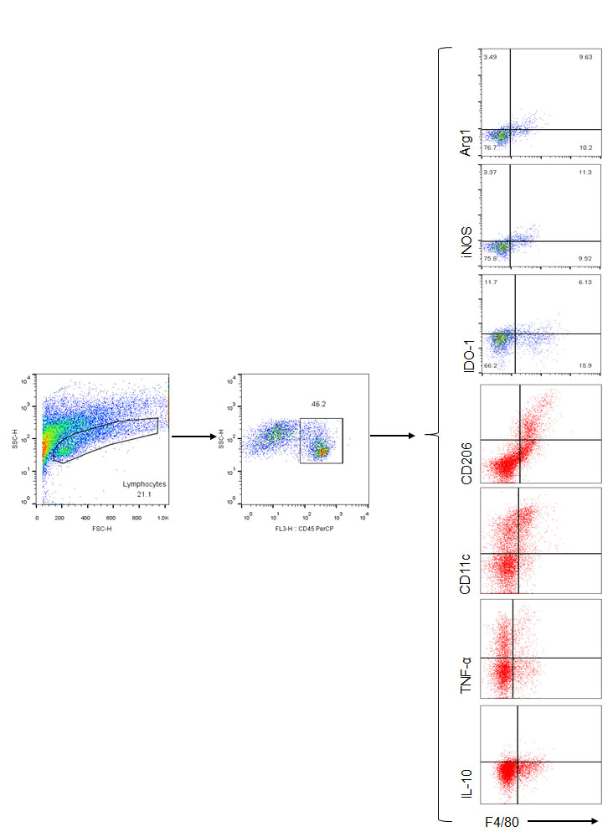

Figure S1. Gated strategies for flow cytometry.

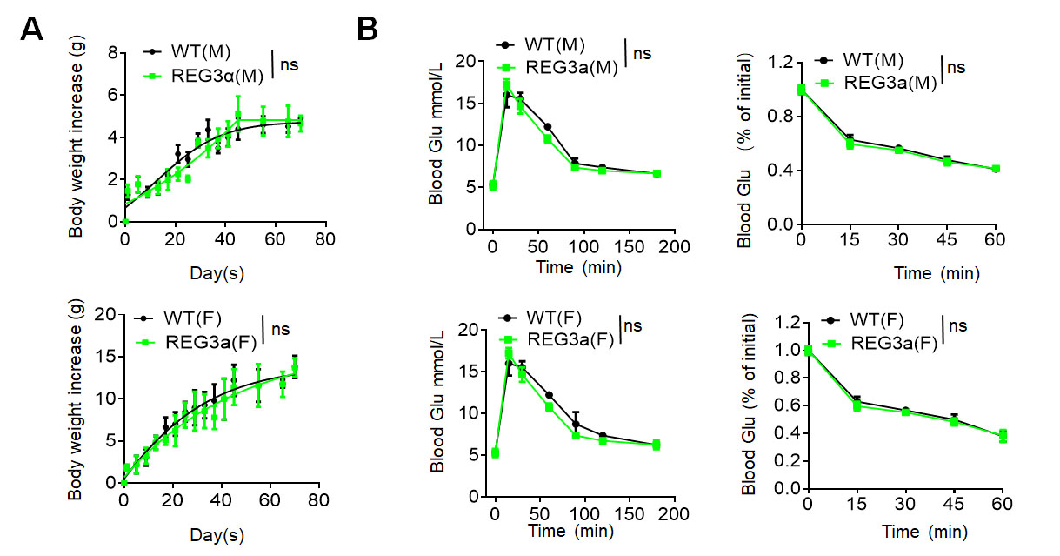

Figure S2. Human Reg3a does not affect body weights after giving normal diet.
- Body weight of male (upper) or female (lower) WT and HuREG3α^{tgIEC} mice fed normal diets (n=15). (B) Glucose tolerance and insulin sensitivity of WT and HuREG3α^{tgIEC} mice fed normal diets for three months (n=15).
- Error bars indicate mean ± SD. Statistic test: Two-way ANOVA test NS, no significance.

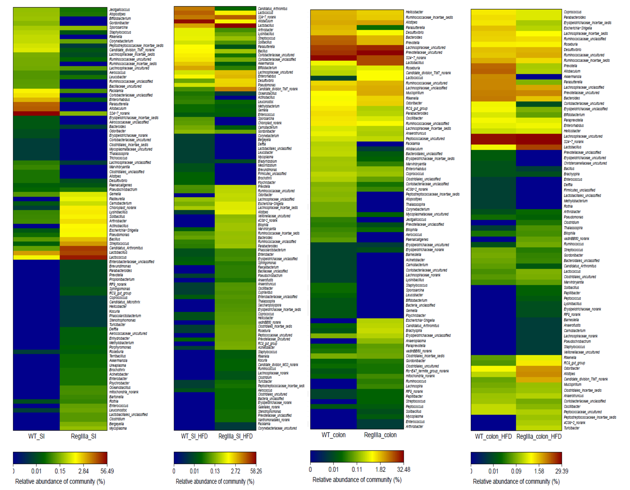

Figure S3. The comparison of gut bacteria in the colon contents between wt and huREG3^{IECtg} mice. Comparison of gut bacteria after 16S rRNA-seq of gut microbiota from pooled ileum content and colon content samples of WT (WT_SI, WT-SI_HFD, WT_colon and WT_colon_HFD) and huREG3^{IECtg} (HuREG3^{tg}) (Reg IIIa_SI, Reg IIIa_SI_HFD, RegIIIa_colon and RegIIIa_colon_HFD) mice before (WT_SI, WT_colon, Reg IIIa_SI and and RegIIIa_colon) and after (WT_SI_HFD, WT_colon_HFD, RegIIIa_SI_HFD and RegIIIa_colon-HFD) giving HFD for three months.

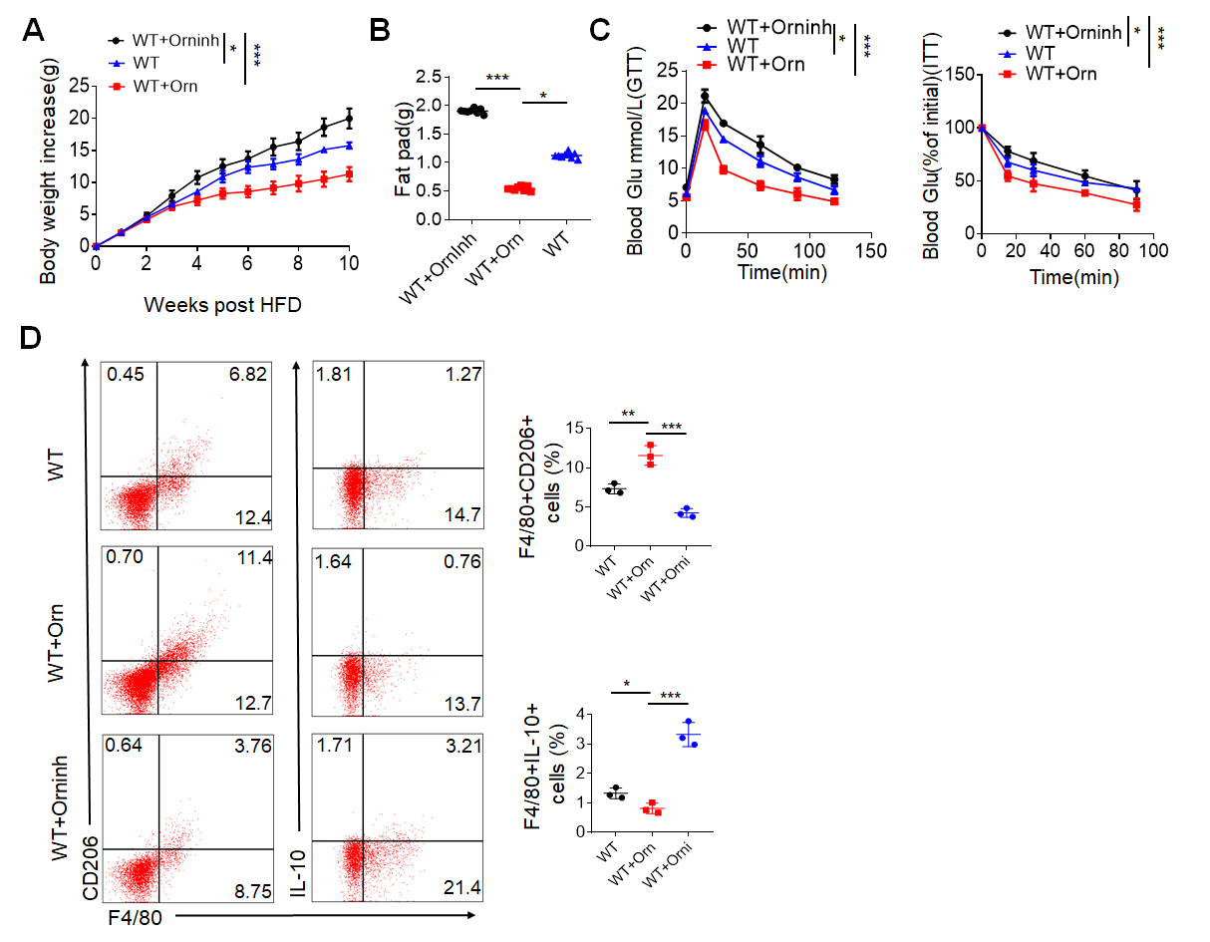
Figure S4. L-ornithine promotes resistance to high fat diet mediated obesity.
(A and B) Body weight (A) and Fat pad (B) increases of mice after feeding HFD with L-ornithine (Orn) or L-ornithine inhibitor (Orninh) for three months(n=15). (C) Glucose tolerance and insulin sensitivity of mice after feeding HFD with L-ornithine (Orn) or L-ornithine inhibitor (Orninh) (n=15). (D) Flow cytometry of F4/80⁺CD206⁺, and F4/80⁺ IL-10⁺ cells in the fat tissues of mice fed HFD with L-ornithine (Orn) or L-ornithine inhibitor (Orninh) for three months. One sample from 5 mice. Error bars indicate mean ± SD. Statistic test: Two-way ANOVA test (A and C); One-way ANOVA followed by Tukey post hoc test (B), *P < 0.05, **P < 0.01, and ***P < 0.001; NS, no significance.

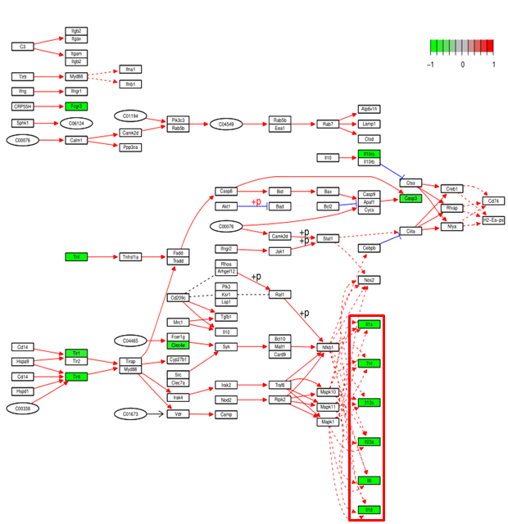

Figure S5. Down regulated inflammatory genes of macrophages upon exposure to L-ornithine. L-ornithine (L-orn) treated and control mouse peritoneal macrophages were analyzed by RNA sequencing. The expression of inflammatory genes such as IL-6 and TNF-α, which were related to the NF-κB inflammatory signaling pathway was down-regulated in the L-orn treated macrophages.

Supplementary Table S1
REAGENT or RESOURCE | SOURCE | IDENTIFIER
Antibodies for immunoblotting and immunostaining
β-Actin (C4) mouse | Santa Cruz | Cat: sc-47778 RRID:AB_626632
Mucin2 (H-300) mouse/human | Santa Cruz | Cat: sc-15334 RRID:AB_2146667
Src (Clone 327) mouse | Abcam | Cat: ab16885 RRID:AB_443522
Src (phospho Y418) antibody | Abcam | Cat: ab4816 RRID:AB_304652
AKT Polyclonal antibody | Proteintech | Cat: 10176-2-AP RRID: AB_2224574
Phospho-Akt(ser473) | Proteintech | Cat: 66444-1-Ig RRID: AB_2782958
NF-κB p65 Polyclonal antibody | Proteintech | Cat: 10745-1-AP RRID: AB_2178878
Phospho-NF-κB p65 (Ser468) | Proteintech | Cat: 82335-1-RR RRID: AB_3083091
IDO1 Monoclonal antibody | Proteintech | Cat: 66528-1-Ig RRID: AB_2881891
REG3A Polyclonal Antibody | Invitrogen | Cat: PA5-76091 RRID: AB_2719818
F4/80 Polyclonal antibody | Proteintech | Cat: 29414-1-AP RRID: AB_2918300
CD206 Polyclonal antibody | Proteintech | Cat: 18704-1-AP RRID: AB_10597232
FITC-Goat Anti-Rat IgG(H+L) | Proteintech | Cat: SA00003-11 RRID:AB_2890989
Alexa Fluor 488-Goat Anti-Mouse IgG(H+L) | Invitrogen | Cat: A28175 RRID: AB_2536161
Alexa Fluor 594-Goat Anti-Rabbit IgG(H+L) | Invitrogen | Cat: A11012 RRID: AB_2534079
Alexa Fluor 488-Goat Anti-Rabbit IgG(H+L) | Invitrogen | Cat: A11008 RRID: AB_143165
Antibodies for flow cytometry
Percp/Cy5.5-CD45(30-F11) mouse | Biolegend | Cat:103132 RRID: AB_893340
FITC-F4/80 (BM8) mouse | Biolegend | Cat:123108 RRID: AB_893500
APC-CD11c (N418) mouse | Biolegend | Cat:117310 RRID: AB_313778
APC anti-mouse CD206 | Biolegend | Cat: 141707 RRID: AB_10896057
PE-Arg-1 mouse | eBioscience | Cat: 12-3697-82 RRID: AB_2734839
APC-iNOS mouse | eBioscience | Cat: 17-5920-82 RRID: AB_2573244
PE anti-IDO1 Antibody | Biolegend | Cat: 654005 RRID: AB_3097459
PE anti-mouse IL10(JES5-16E3) | eBioscience | Cat: 12-7101-82 RRID: AB_466176
APC anti-mouse TNFa | eBioscience | Cat: 17-7321-82 RRID: AB_469508
Primers for Real-time PCR
Murine GAPDH-Fs | BGI | 5’-TCAACGGCACAGTCAAGG-3’
Murine GAPDH-Rs | BGI | 5’-TACTCAGCACCGGCCTCA-3’
Murine TNFa-Fs | BGI | 5’-GGTCTGGGCCATAGAACTGA-3’
Murine TNFa-Rs | BGI | 5’-CAGCCTCTTCTCATTCCTGC-3’
Murine IL-6-Fs | BGI | 5’-TCTGAAGGACTCTGGCTTTG-3’
Murine IL-6-Rs | BGI | 5’-GATGGATGCTACCAAACTGGA-3’
Murine IL-1β-Fs | BGI | 5’-GTGTCTTTCCCGTGGACCTT-3’
Murine IL-1β-Rs | BGI | 5’-AATGGGAACGTCACACACCA-3’
Murine IDO-1-Fs | BGI | 5’- AGAGGACACAGGTTACAGCG -3’
Murine IDO-1-Rs | BGI | 5’- AAGACAGAATAGGAGGCAGG -3’
Perimers for detection of bacteria
Total Lactobacillus-Fs | BGI | 5’-TGGATGCCTTGGCACTAGGA -3’
Total Lactobacillus-Rs | BGI | 5’-AAATCTCCGGATCAAAGCTTACTTAT -3’
L.NK2-Fs | BGI | 5’-AGCTAGTTGGTGAGGTAAAG -3’
L.NK2-Rs | BGI | 5’-TAGGATTGTCAGAAGATGTC -3’
Other reagents
Mouse Ornithine ELISA KIT | JiangSu Meibiao | Cat: MB-5610A
Mouse IL-6 ELISA KIT | Elabscience | Cat: E-EL-M0044
Mouse TNFα ELISA KIT | Elabscience | Cat: E-EL-M3063
Mouse IL-1β ELISA KIT | Elabscience | Cat: E-EL-M0037
Mouse Glu ELISA KIT | Lengton | Cat: BPE20294
Ampicillin | Sigma | Cat: BP021
Vancomycine | Sigma | Cat: V2002
Neomycin sulfate | Sigma | Cat: N6386
Metronidazole | Sigma | Cat: M3761
L-ornithine | Sigma | Cat: O2375
Eflornithine (DFMO) | MCE | Cat: HY-B0744B
Spermine (SPM) | MCE | Cat: HY-B1777
Spermindine (SPD) | MCE | Cat: HY-B1776
High-fat diet | Research Diets | Cat: D12492
Rogosa SL selective medium | Sigma | Cat: R1148
MRS | 3M US | Cat: BP0275500
Trizol | Life Technologies | Cat: 15596026
QIAquick PCR Purification Kit | Qiagen | Cat:28104
QuantiTect SYBR Green PCR Master Mix | Qiagen | Cat:208052
FBS | Gibco | Cat:10099141
Collagenase IV | Sigma | Cat: C5138
Dnase I | Solarbio | Cat: D8071
DMEM | Gibco | Cat:11965118
Permeabilization Buffer | eBioscience | Cat: 00-8333-56

