Appendices
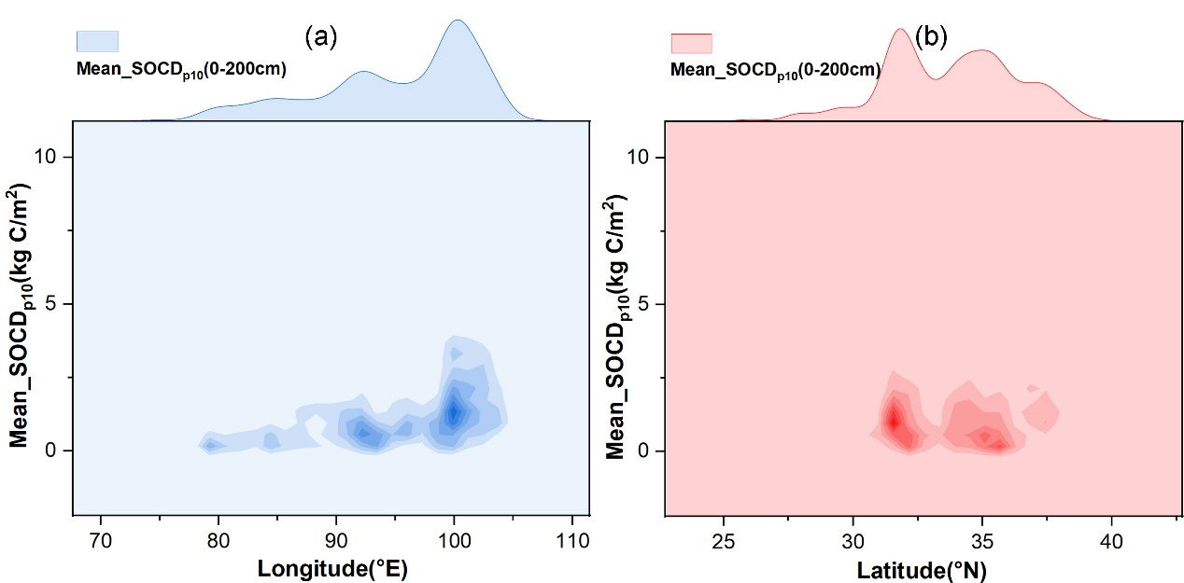
Fig. A.1. The distribution of average soil organic carbon density per 10 cm thickness (SOCD_{p10}) along the longitude and latitudinal directions, based on soil organic carbon sample data.
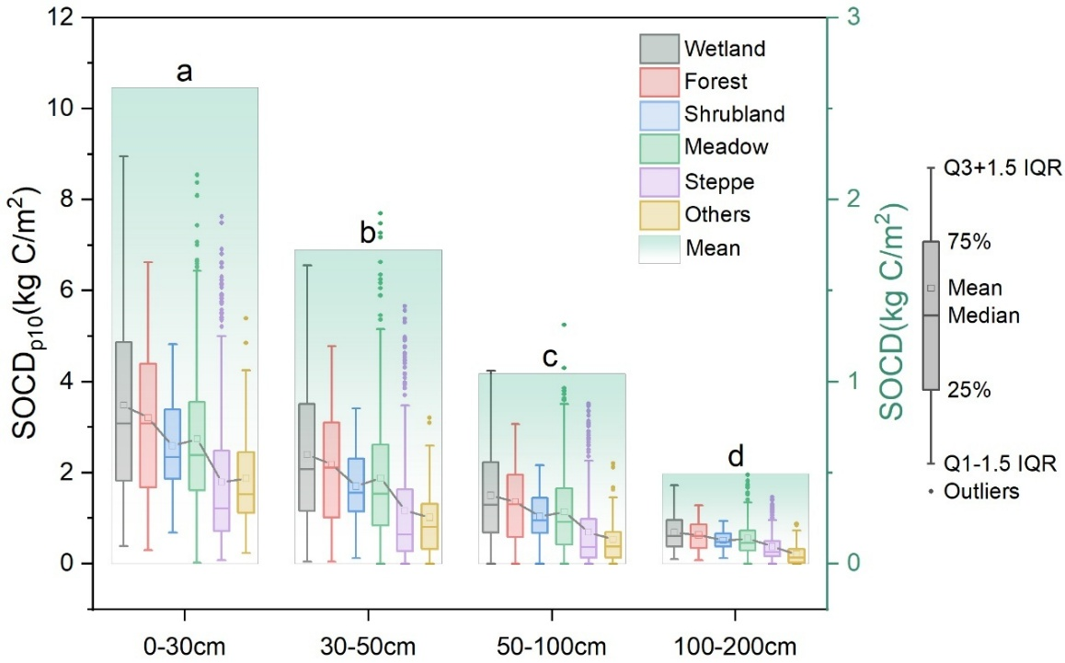
Fig. A.2. The distribution differences in soil organic carbon density per 10cm thickness (SOCD_{p10}) across various depths and vegetation types. The gradient cyan histograms represent the mean SOCD_{p10} across different vegetation types. The histograms correspond to the secondary y-axis.
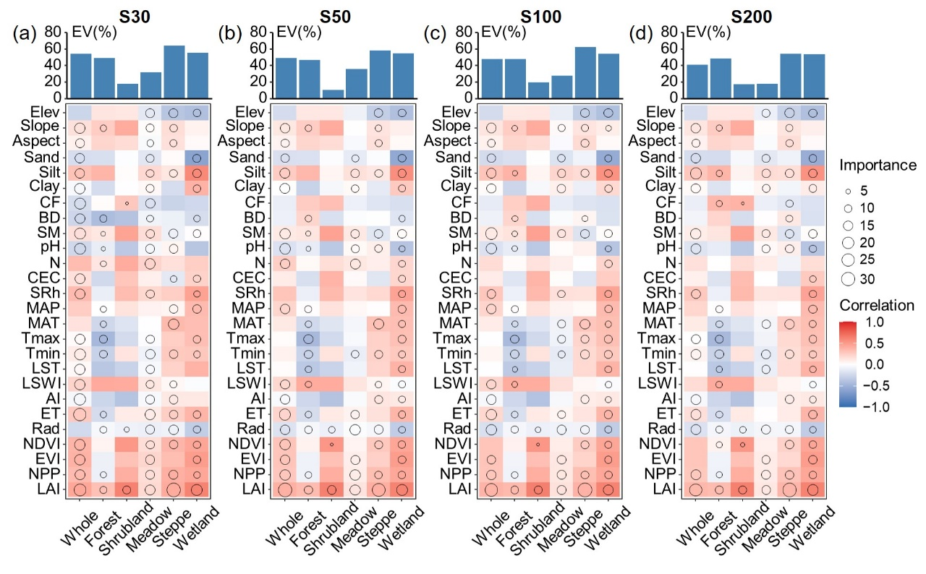
Fig. A.3. Contributions of influencing factors to soil organic carbon density, and differences across
vegetation types and soil depth intervals based on correlations and Random Forest models. Circle size represents the variable importance and colors represent Spearman correlations. S30, S50, S100, and S200 represent SOCDp10 for soil depth intervals of 0-30cm, 30-50cm, 50-100cm, and 100-200cm, respectively. EV, explained variation; other abbreviations accorded to figure 6.

