Fig. S1 The greening trend of LAI (leaf area index) identified through a linear fitted model (a) and the Non-parametric Mann-Kendall Test (b). The slopes derived from the analysis are displayed in Fig. S1a, while Kendall's τ (u) values are presented in Fig. S1b. The dashed lines C₁ and C₂ represent the 95% confidence intervals, respectively.
Fig. S2 The temporal trends for average ET (a), T_{a} (b), Pre (c), S_{m} (d), and R_{n} (e) during the growing season (from May to September). Robust average of ET was deduced from the ET product of the GLEAM, GLDAS, and GLASS.

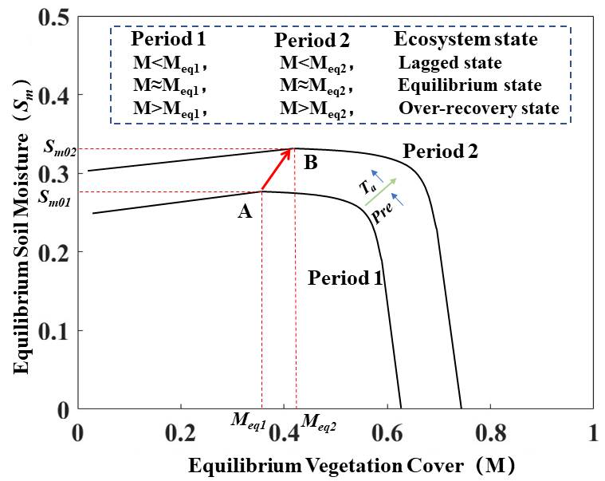
Fig. S3 Shift of the equilibrium vegetation cover and soil moisture with alteration of climate regimes. Period 1 represents the original climate regime; and Period 2 represents the warming and wetting climate regimes. Ecosystem states are classified into three types in the two periods: lagged state, equilibrium state, and over-recovery state (after Zhang et al., 2018).

References:
Zhang, S., et al. Excessive Afforestation and Soil Drying on China's Loess Plateau. Journal of Geophysical Research: Biogeosciences, 123(3), 923-935 (2018).

